RTSP Client Project Report
Project No.10
Version 1.0
Student ID: 201920081203009 Student Name: Yang Rui
2019-12-23
College of Computer Science and Cybersecurity, CUC

I declare that the assignment here submitted is original except for source material explicitly acknowledged. I also acknowledge that I am aware of University policy and regulations on honesty in academic work, and of the disciplinary guidelines and procedures applicable to breaches of such policy and regulations.

Name: Yang Rui Student ID: 201920081203009
Notes:

Section I Problem Specification
In this project, we should write a RTSP client that should work with LIVE555 Media Server.

At first, our implementation of RTSP Client should follow the specification in the Real Time Streaming Protocol (RTSP, RFC 2326, http://tools.ietf.org/html/rfc2326) to work together with the LIVE555 Media Server.
Secondly, our implementation of RTSP Client should follow the specification in the Real-time Transport Protocol (RTP, RFC 3550, 3551) and RTP Payload Format for MPEG1/MPEG2 Video (RFC 2250) to handle RTP packets correctly.
Thirdly, our newly developed application should be a MFC application on Windows platform, we can choose any mechanisms for socket I/O multiplexing (Blocking with Multi-threading, the Select system call or any other models). It is important that we should implement the RTSP client to be independent of the LIVE555 libraries. Using any source codes of LIVE555 in our implementation is not permitted.
Fourth, our RTSP Client must accomplish basic and advanced functions:
- Basic function: Visit the on-demand file stream from the Live555MediaServer with URL: “rtsp://127.0.0.1:554/test.mp3” (Linux version). The file “test.mp3” will be ready for our RTSP request. The basic task of our RTSP Client is that it can record the steam as a local media file.
- Advanced function: The advanced task of oour RTSP Client is that it can play the media file (mp3 only) from the on-demand streaming server. We can do this by taking advantage of the libvlc-library, which is the core component of the VLC media player. We should use libvlc-library to play mp3 only, we must write our own code to interpret RTSP/RTP and stream down the mp3 file.

RTSP
The Real Time Streaming Protocol is a network control protocol designed for use in entertainment and communications systems to control streaming media servers.
The protocol is used for establishing and controlling media sessions between end points.
Clients of media servers issue VCR-like commands, such as play and pause, to facilitate real-time control of playback of media files from the server.
Default ports are 554(Linux) and 8554(Windows).

Detailed Message can be found in https://tools.ietf.org/html/rfc2326. So I don’t paste it here.

An OPTIONS request returns the request types the server will accept.

A DESCRIBE request includes an RTSP URL (rtsp://...), and the type of reply data that can be handled. The default port for the RTSP protocol is 554 or 8554 for both UDP and TCP transports. This reply includes the presentation description,
typically in Session Description Protocol (SDP, RFC 4566) format.

A SETUP request specifies how a single media stream must be transported. This must be done before a PLAY request is sent. The request contains the media stream URL and a transport specifier. This specifier typically includes a local port for receiving RTP data (audio or video), and another for RTCP data (meta information).

A PLAY request will cause one or all media streams to be played. A range can be specified. If no range is specified, the stream is played from the beginning and plays to the end, or, if the stream is paused, it is resumed at the point it was paused.

The GET_PARAMETER request retrieves the value of a parameter of a presentation or stream specified in the URI. GET_PARAMETER with no entity body may be used to test client or server liveness ("ping").

A PAUSE request temporarily halts one or all media streams, so it can later be resumed with a PLAY request. A range parameter on a PAUSE request specifies when to pause. When the range parameter is omitted, the pause occurs immediately and indefinitely.

A TEARDOWN request is used to terminate the session. It stops all media streams and frees all session related data on the server.

RTP
The transmission of streaming data itself is not a task of the RTSP protocol. But RTP.
Most RTSP servers use the Real-time Transport Protocol for media stream delivery. (however some vendors implement proprietary transport protocols.)

More detailed info can be found in https://tools.ietf.org/html/rfc3550.

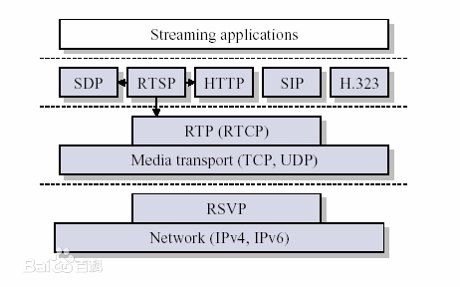

RTCP
RTCP provides out-of-band statistics and control information for an RTP session.
It partners with RTP in the delivery and packaging of multimedia data, but does not transport any media data itself.

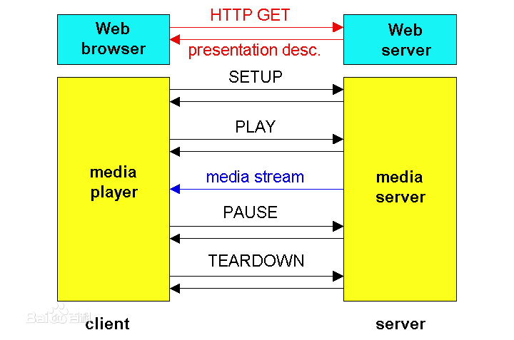

Demand

I'll explain the completion, problems and solutions for demand tasks.

- Your implementation should follow the specification in the Real Time Streaming Protocol (RTSP, RFC 2326, http://tools.ietf.org/html/rfc2326), so that your version of RTSP Client is able to work together with the LIVE555 MediaServer.
- Your implementation should follow the specification in the Real-time Transport Protocol (RTP, RFC 3550, 3551) and RTP Payload Format for MPEG1/MPEG2 Video (RFC 2250), so that your version of RTSP Client is able to handle RTP packets correctly.
3. The example version RTSP Client (openRTSP, http://www.live555.com/openRTSP/) is a linux command-line program that can be used to open, stream, receive, and (optionally) record media streams that are specified by a RTSP URL - i.e., an URL that begins with rtsp://.
Your newly developed application should be a MFC application on Windows platform, but you are free to choose any mechanisms for socket I/O multiplexing (Blocking with Multi-threading, the Select system call or any other models). It is important that you should implement the RTSP client to be independent of the LIVE555 libraries (that means using any source codes of LIVE555 in your implementation is not permitted.).

Yes, all of these are OK. And I deploy LIVE555 service in my server. You can use it by
rtsp://rtsp.yunyoujun.cn:554/not-afraid.mp3.(Other song: test.mp3, adamas.mp3, before-my-body-is-dry.mp3, oyasumi.mp3, will.mp3, riya.mp3, overfly.mp3)

4. Your RTSP Client Must accomplish basic and advanced functions:
- Basic function: Visit the on-demand file stream from the Live555MediaServer with URL:“rtsp://127.0.0.1:8554/mp3AudioTest” (Windows version) or “rtsp://127.0.0.1:554/test.mp3” (Linux version). The file “test.mp3” will be ready for your RTSP request. The basic task of your RTSP Client is that it can record the stream as a local media file.
- Advanced function: The advanced task of your RTSP Client is that it can play
the media file (mp3 only) from the on-demand streaming server. You can do this by taking advantage of the libvlc-library, which is the core component of the VLC media player. Note: You should use libvlc-library to play mp3 only, you must write your own code to interpret RTSP/RTP and stream down the mp3 file.

5. Implementations that do not use Object-Oriented Programming will not be accepted. That also means it is not acceptable to write this project in a single function (or even just a couple of functions).

Yes, it can record the stream as a local media file, also can play the media file (mp3 only) from the on-demand streaming server. I think my code is well-architected and readable.

- [√] Basic function goes well
- [√] Advanced function goes well
- [√] Dealing with impolite requests, unexpected messages
- [√] Error handling, Style/Code structure, etc.
- [√] Extra credits:
- [√] Well defined project report
- [√] Elegant GUI interface

Question:
In fact, the campus wireless network(like CUC-WIFI) prohibits UDP port forwarding. So I cannot use RTP on UDP to play music. And the net in my dormitory is OK.
The reason why the VLC player can play is it found that the UDP timed out, then terminated the RTSP by TEARDOWN, and resent the RTSP request(Transport: RTP/AVP/TCP) to get the RTP packet based on TCP.
Using TCP does solve this problem very well. But TCP sends RTSP packet and RTP packet on the same port at the same time. So we have to distinguish it by channel. We can find more info here.(https://tools.ietf.org/html/rfc2326#page-40)
I distinguished them according to RFc2326 and stored them. But the music played was strange. Due to timing issues, I cannot continue to debug it. Instead, use simple UDP to complete it.

Section II Solution Method and Design

Development Environment:
- OS: Microsoft Windows 10
- Language: C++
- Tool: Microsoft Visual Studio 2017

Configure LIVE555:
We will use LIVE555 as the streaming server for testing your RTSP Windows client player. LIVE555 is an open source (LGPL) C++ library for multimedia streaming. This code forms a set of C++ libraries for multimedia streaming, using open standard protocols (RTP/RTCP, RTSP, SIP).
Because the link given by the teacher is invalid, I built the LIVE555 on my server(Linux).

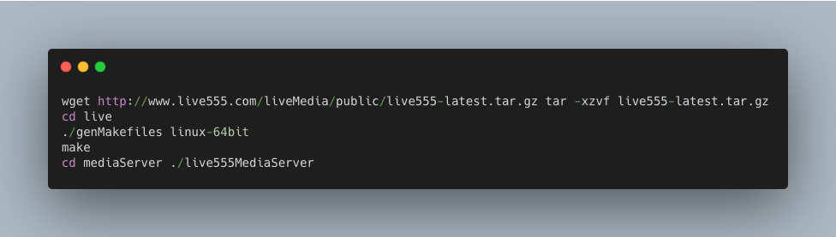

I uploaded some songs I like to my server.

We can use it by type rtsp://rtsp.yunyoujun.cn:554/not-afraid.mp3.
(Other song: test.mp3, adamas.mp3, before-my-body-is-dry.mp3, oyasumi.mp3, will.mp3, riya.mp3, overfly.mp3)

Configure VLC:

I use VLC lib to play music.
Download vlc v2.1.5 from ftp://ftp.videolan.org/pub/videolan/vlc/2.1.5/.
Copy include/vlc folder to RTSPClient/include/vlc. And set include path for it in VS2017.
Copy lib folder to RTSPClient/lib. And set lib path for it in VS2017.
Copy plugins, libvlc.dll, libvlccore.dll to Debug folder.

This is the project structure(use Object Oriented Programming with C++):
Some files are automatically generated:
- pch.cpp: source file corresponding to the precompiled header; required for successful compilation
- pch.h: header file corresponding to the cpp
- stdafx.cpp: standard application fram extend generated by MFC

My class:
- URL: Parse RTSP URL for it.
- VLCPlayer: Wrap VLC API to control media.
- RTSP: Send RTSP request and Check response.
- RTP: I don’t write it because we use UDP. There is almost no need to deal with him, and it is not worth opening a new class. If we use tcp, it might be more convenient.
- ClientSocket: Open TCP or UDP connection, send and recv message. Modify and inherited from previous socket class.
- CRTSPUrlDlg: Dialog for inputing RTSP Url.
- CRTSPClientDlg: Main Dialog.

Some const variable.

BOOL g_init; // judge if it has been initialized
BOOL g_rtsp;// judge if RTSP is run
BOOL g_play;// judge if it is playing (so we don’t need stop)
BOOL g_pause;// judge if it is paused
BOOL g_local; // judge if it is local
BOOL g_adjust; // judge if progress bar is adjusted
BOOL g_mute; // judge if it is muted
string c_filePath; // cache FilePath to play
string c_fileName;// cache FileName to play
string c_clientRtpPort; // client RTP port
string c_serverRtpPort; // server RTP port
libvlc_time_t c_fileLength; // audio file time length

Class Diagram:

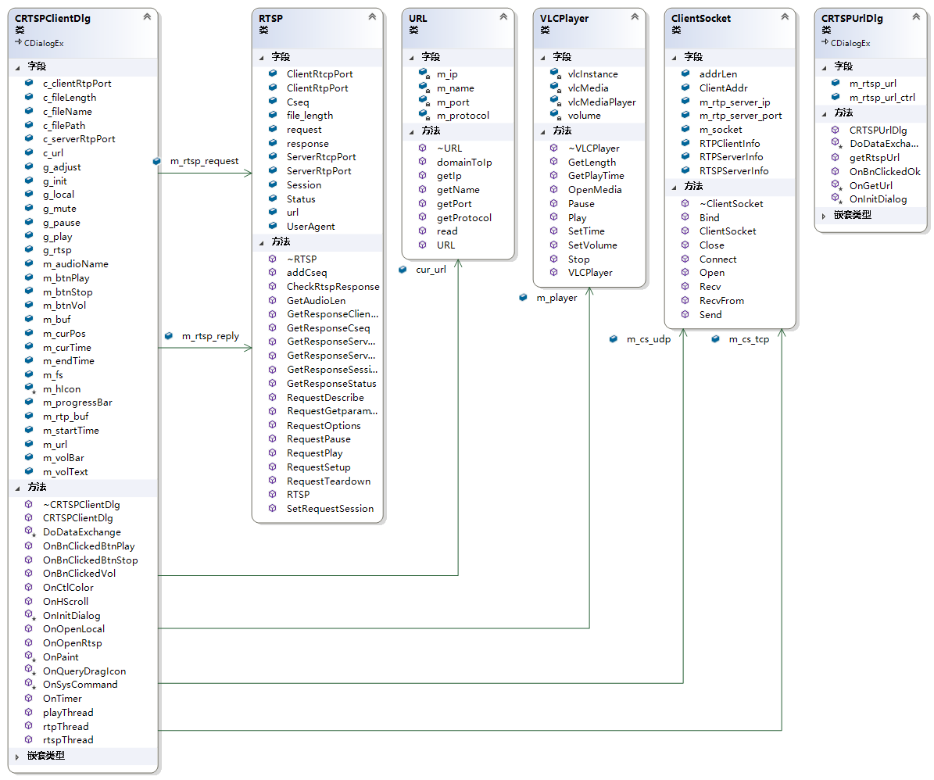

Functions
Play RTSP Audio:

Open RTSP Menu. Input RTSP URL. When RTSPUrlDlg return IDOK, play Music by URL.
Parse RTSP URL.
Start rtspThread (Send and Check OPTIONS, DESCRIBE, SETUP, PLAY Request)
Send GET_PARAMETER (every 60s) to keep connection. (timeout = 65)
Start rtpThread to receive RTP packets and save it to local file `_cache.mp3`.
Start playThread to play audio.
Send TEARDOWN when click stop button or close window.

Other implemented functions:

- Clean UI
- Custom Icon Button.
- The icon changes as the volume is adjusted。
- Set Mute
- Play local audio.
- Display audio name in Dialog Title.
- Drag the progress bar to play music at different time.

This is the sequence diagram:
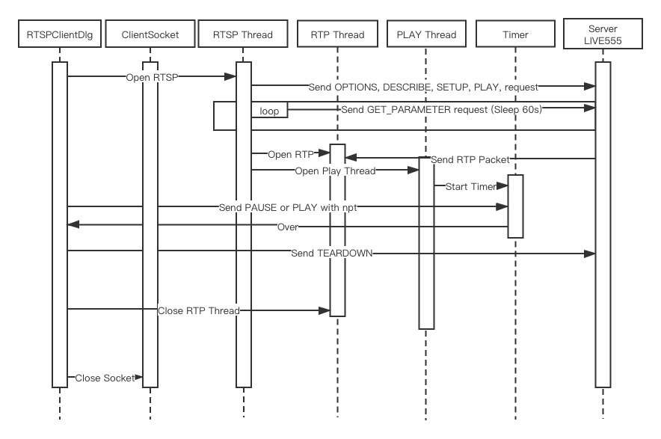

This is flow chart in RTSPClient:
(More details introduction about code and part function in appendix.)

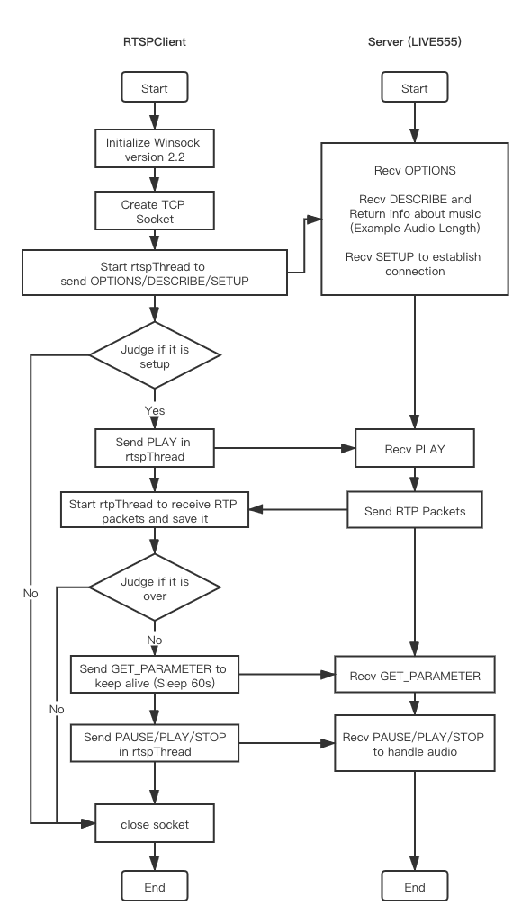

Section III Test Cases and Results Analysis

This is my test result:

In order to better show the experimental results, I recorded a video for it. You can watch it by clicking on the link.
https://bizsec-auth.alicdn.com/a9b5b21ee64d2b47/Qe9k4XSEr4zqvIg7131/Z312c0OuZO7nEgYHip1_248911683718___hd.mp4?auth_key=1577029791-0-0-1b623ead088a8b2d700b0cbc7edaa559

1. Open RTSPClient.exe.(This is the simple style interface that I designed.)

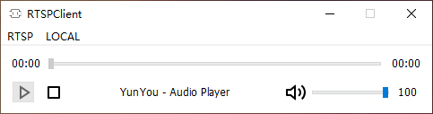

2. Click RTSP Menu. It will pop up a window to let people enter the link.

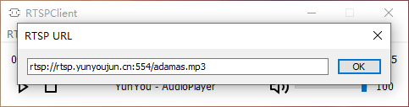

3. Click OK to play it. (Play icon change to Pause icon.)

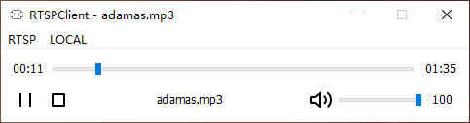

4. Click Pause icon to pause. (Change from Pause Icon back to Play Icon.)

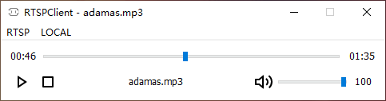

5. Adjust Volume. (Icons can change as the volume changes.)

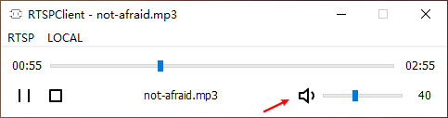
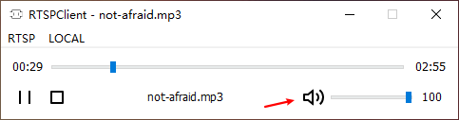
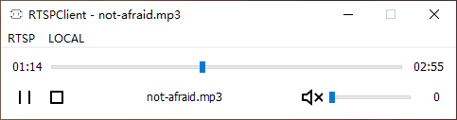

We also can click this icon to set it mute.
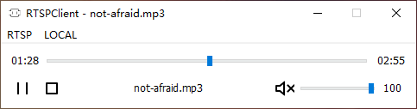

- We can also play local music by click LOCAL menu.

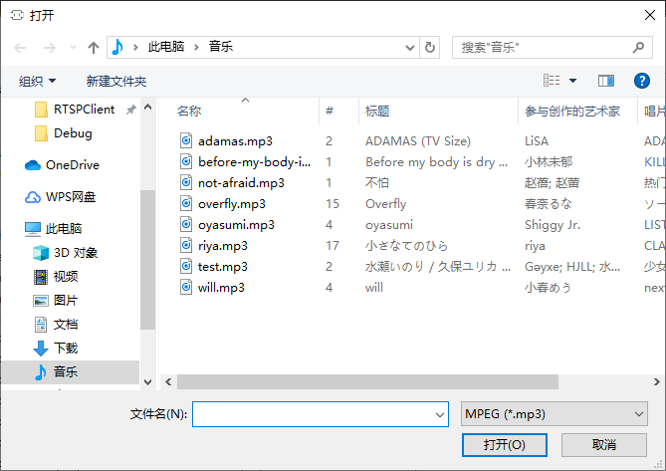

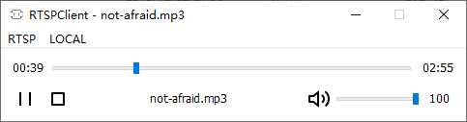

6. We can use Wireshark to see RTSP message.

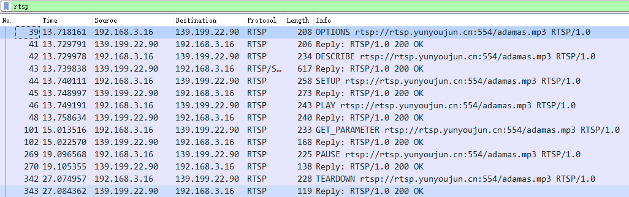

We can get audio length from Describe Reply.

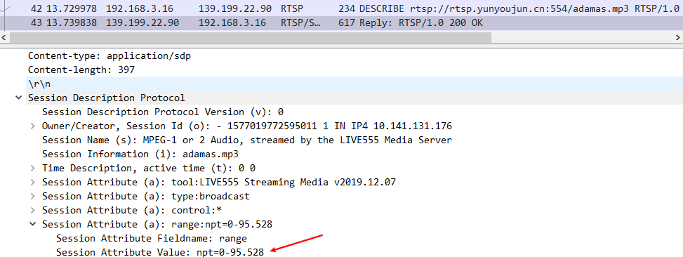

We can set local client port by Setup Request.

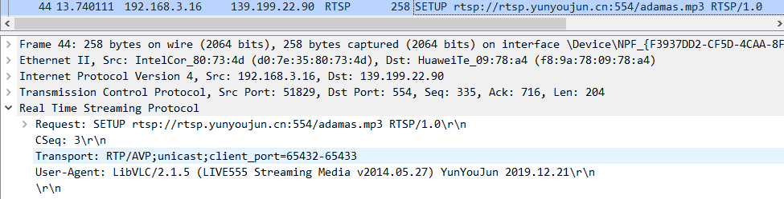

We can get server port from Setup Reply.

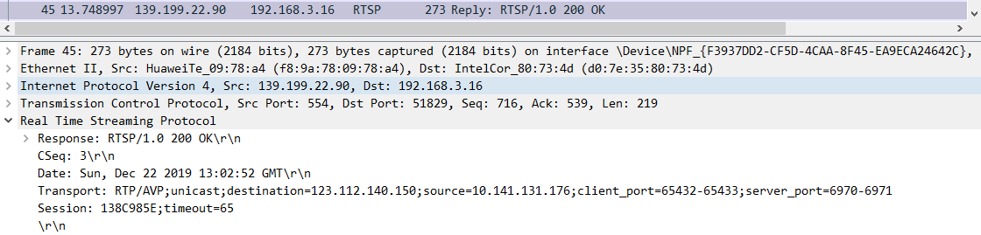

Audio data is transmitted by RTP. Save it to local file `_cache.mp3`.

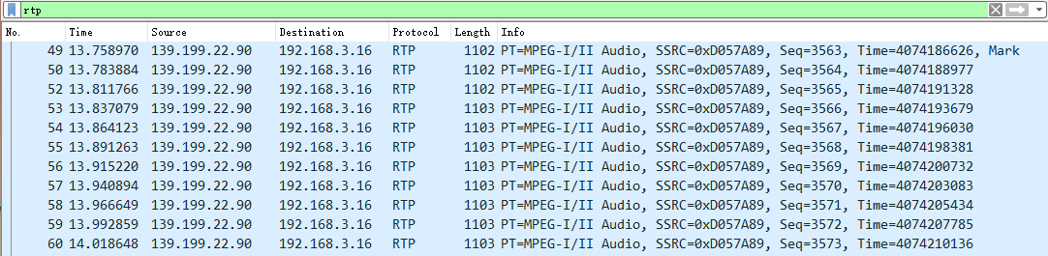

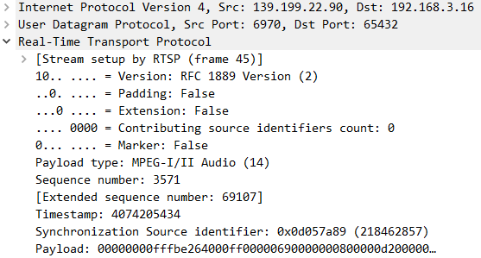

Section IV Conclusion
Through this experiment, I have a preliminary understanding of RTSP/RTP/RTCP protocol..
I wrote this project by an object-oriented approach. Object-oriented is really great. Therefore, I can write ClientSocket easily.
We don't need to write a server program for this experiment. So I deploy LIVE555 service in my server, and upload some nice song to it.
I wrote a user interface(MFC) for RTSPClient, designed a neat UI for it and added some small features like mute and open local file, etc. It's more interesting than previous experiments. I felt a sense of accomplishment to complete a program.
I originally wanted to implement the function of automatically switching to TCP when UDP was disabled or timed out. I wrote half of it, but due to limited time, it could not be completed completely. So I still need to improve my efficiency.
At last, VLC and wireshark are two very good tools. VLC in particular, I always use it as a video transcoder on my computer.

Section V References
- Windows Socket Get Started.pdf http://tlc.cuc.edu.cn/Course/Course/showAction/id/30
- Windows Socket Modern System Calls.pdf http://tlc.cuc.edu.cn/Course/Course/showAction/id/30
- Windows Sockets 2 | MSDN https://docs.microsoft.com/zh-cn/windows/win32/api/_winsock/
- Recvfrom https://docs.microsoft.com/en-us/previous-versions/aa916174(v=msdn.10)?redirectedfrom=MSDN
- SetTimer function https://docs.microsoft.com/zh-cn/windows/win32/api/winuser/nf-winuser-settimer?redirectedfrom=MSDN
- RekiLiu/Computer-Network | GitHub https://github.com/RekiLiu/Computer-Network/
- 计算机网络高级软件编程技术（第2版） 清华大学出版社 吴功宜 董大凡 王珺 刘乾等 编著
- RFC 3550 - RTP: A Transport Protocol for Real-Time Applications https://tools.ietf.org/html/rfc3550
- RFC 2326 - Real Time Streaming Protocol (RTSP) https://tools.ietf.org/html/rfc2326
- VLC: LibVlC media player https://www.videolan.org/developers/vlc/doc/doxygen/html/group__libvlc__media__player.html
- VLC: LibVLC audio controls https://www.videolan.org/developers/vlc/doc/doxygen/html/group__libvlc__audio.html
- VlC lib: ftp://ftp.videolan.org/pub/videolan/vlc/2.1.5/win32/
- VLCWrapper Example http://www.codeproject.com/Articles/38952/VLCWrapper-A-Little-C-wrapper-Around-libvlc
- Remix icon - Open source icon library https://remixicon.com/

Section VI Appendix

URL
Parse Protocol/IP/Port/File name from URL
Main read function
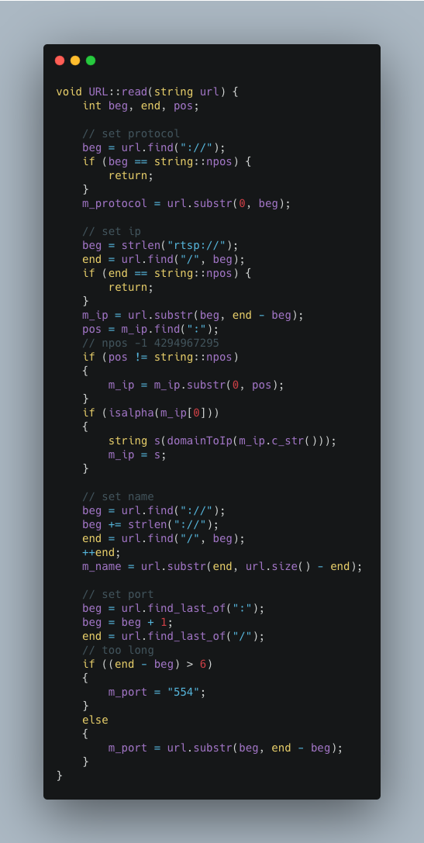

ClientSocket (establish TCP or UDP connection) Similar to previous experiments, omitted.

RTSP Error Handling.

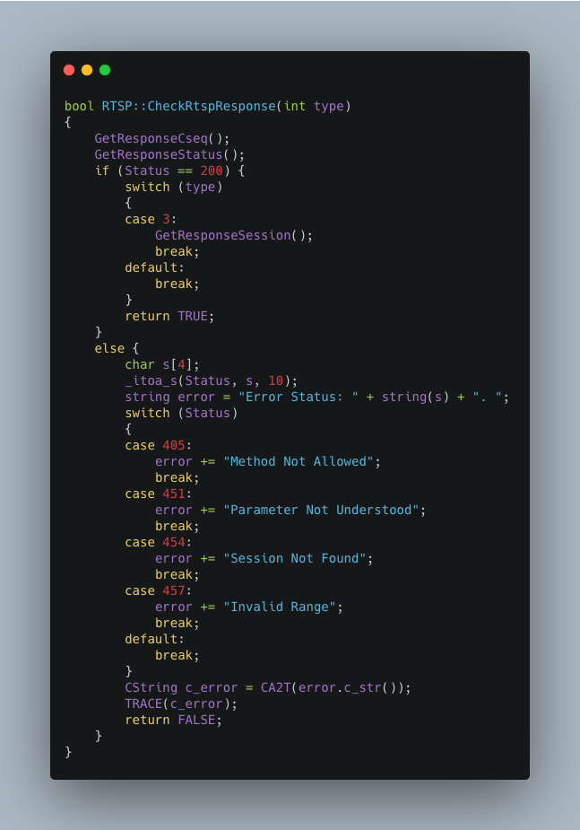

It is the main part of RTSPClientDlg (match the flowchart.).

Destructor function to Close connection in Dlg.
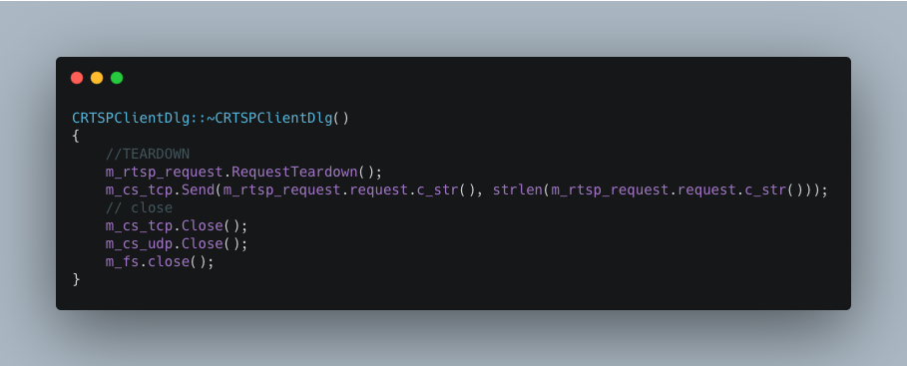

Load some icon in OnInitDialog.
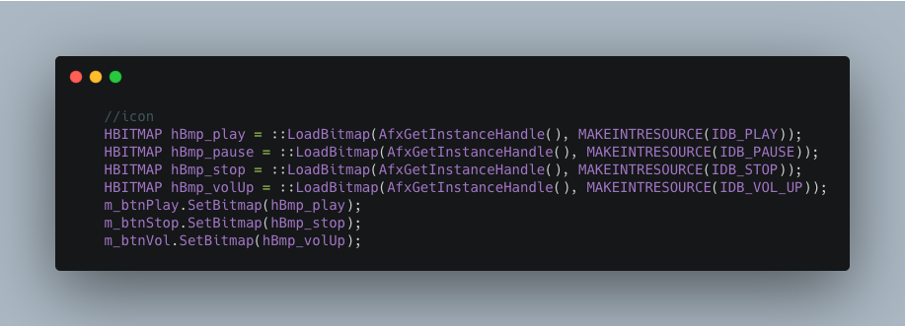

Repaint white background for Dialog.
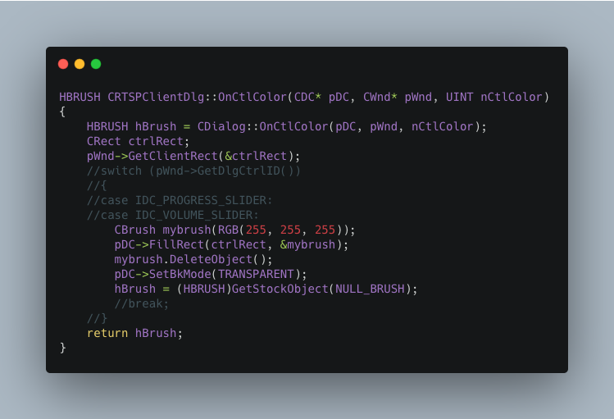

OnBnClickedBtnPlay logic

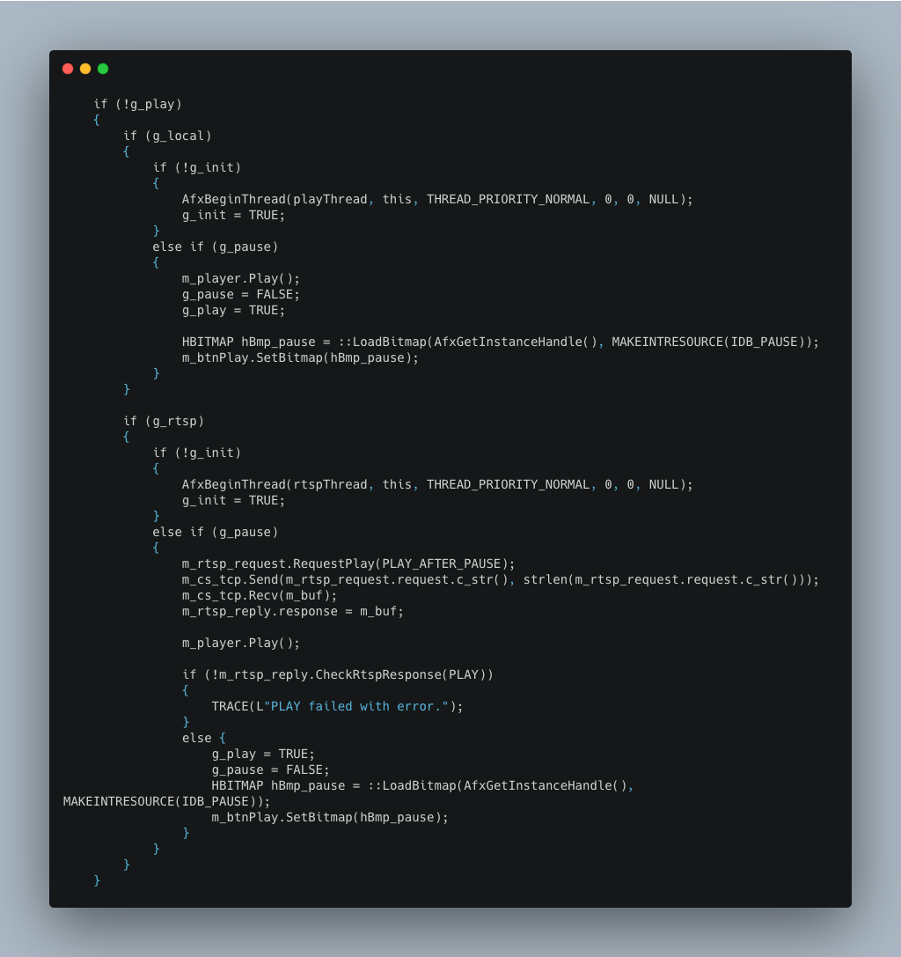
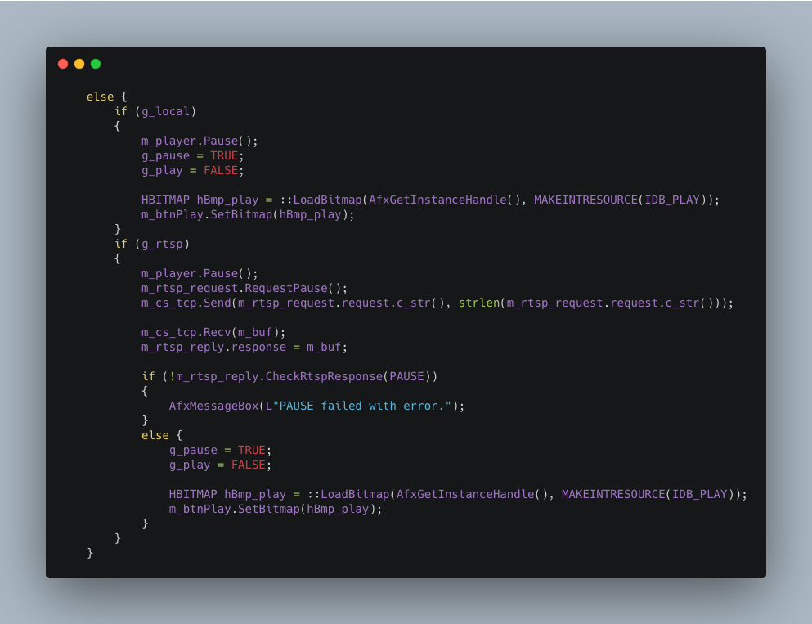

Judge Local (media.stop) or RTSP (by TEARDOWN) and close all connections.

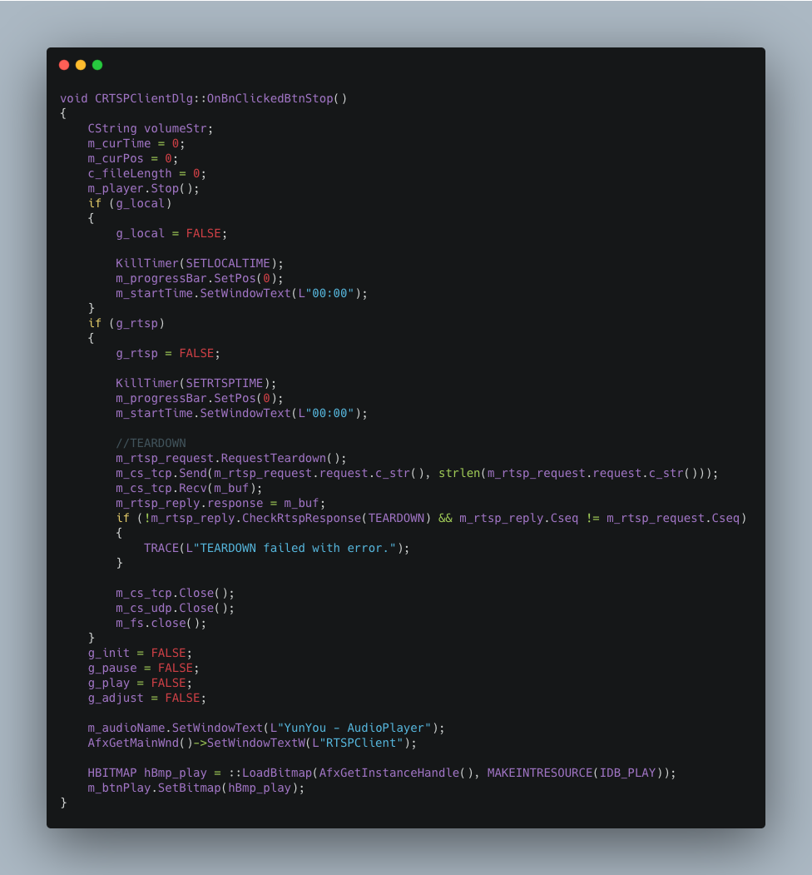

rtspThread function

Get audio length in DESCRIBE reply.
Start rtpThread after SETUP successfully.
Sleep some time to recv RTP packets.
Start playThread.

Send GET_PARAMETER in a loop to keep connection active. (every 60s)
Stop sending when it is not playing.

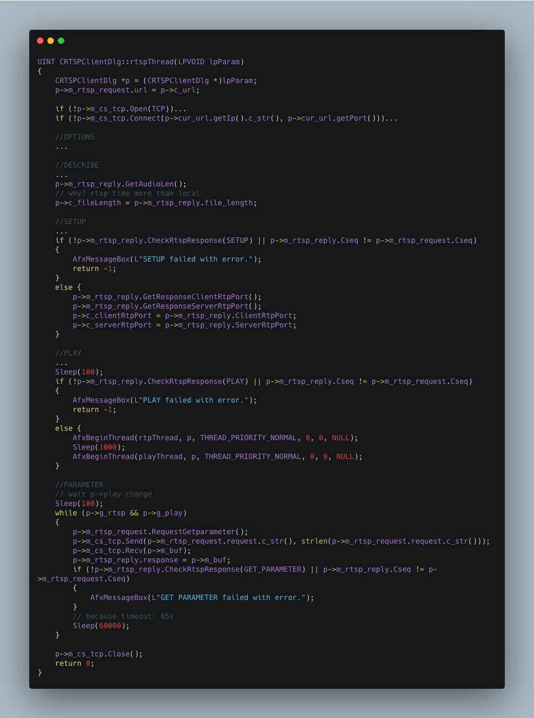

rtpThread function

Get RTP packet and save it in local file _cache.mp3.

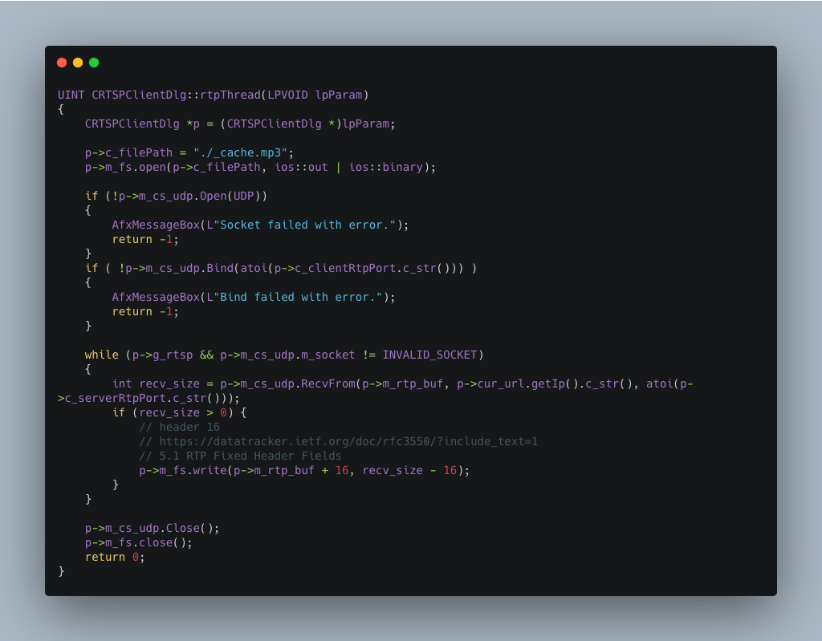

playThread function
Start playing, display end time and start timer for display progress in slider bar. We also need to judge local or RTSP.

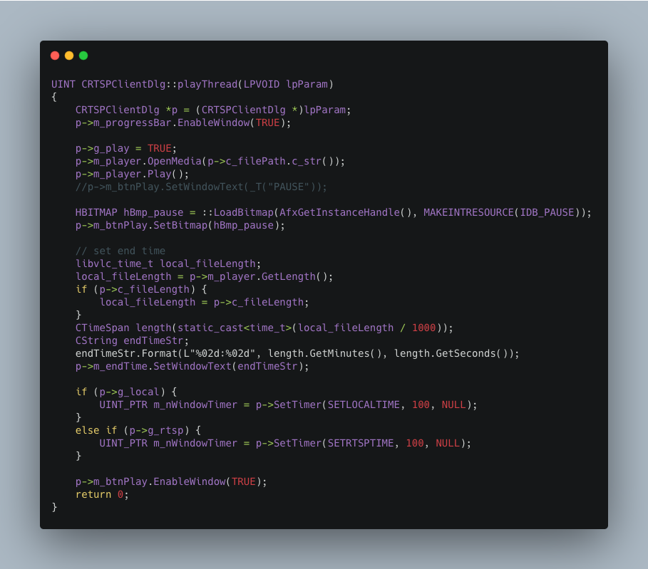
OnHScroll function

Callback function when the scroll bar slides.
Volume Slider Bar: change audio volume and icon
Progress Slider Bar: start playing from slider position
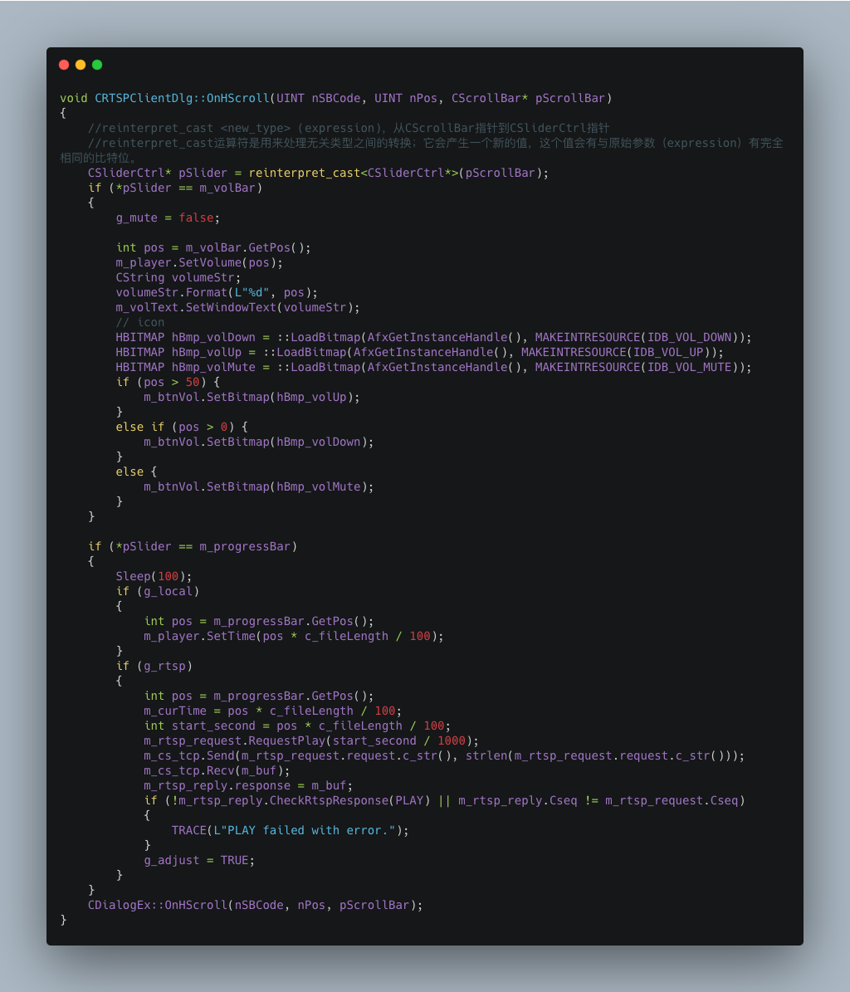

OnTimer function
Update the current playback time and progress bar
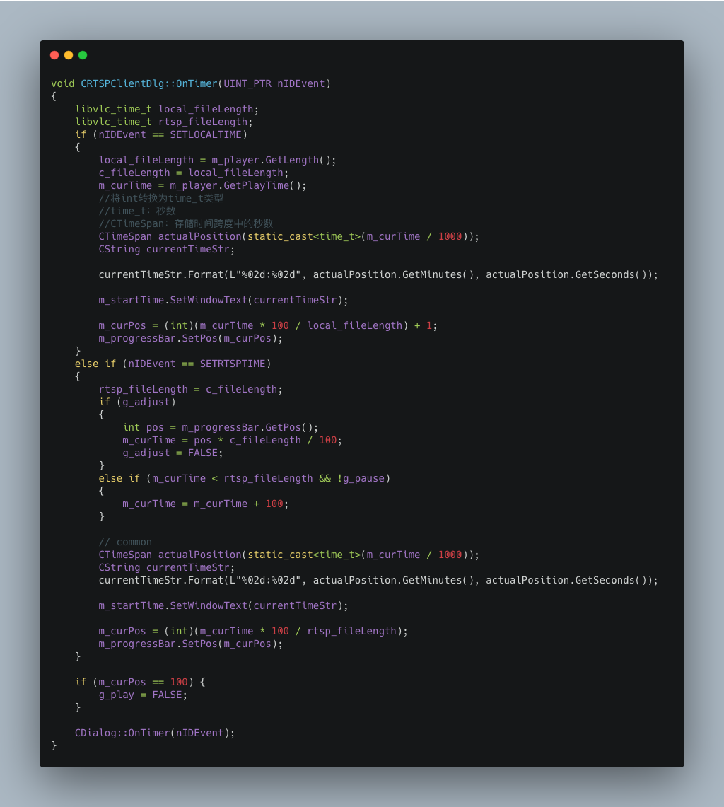

OnOpenRtsp: Open Dialog to input RTSP URL
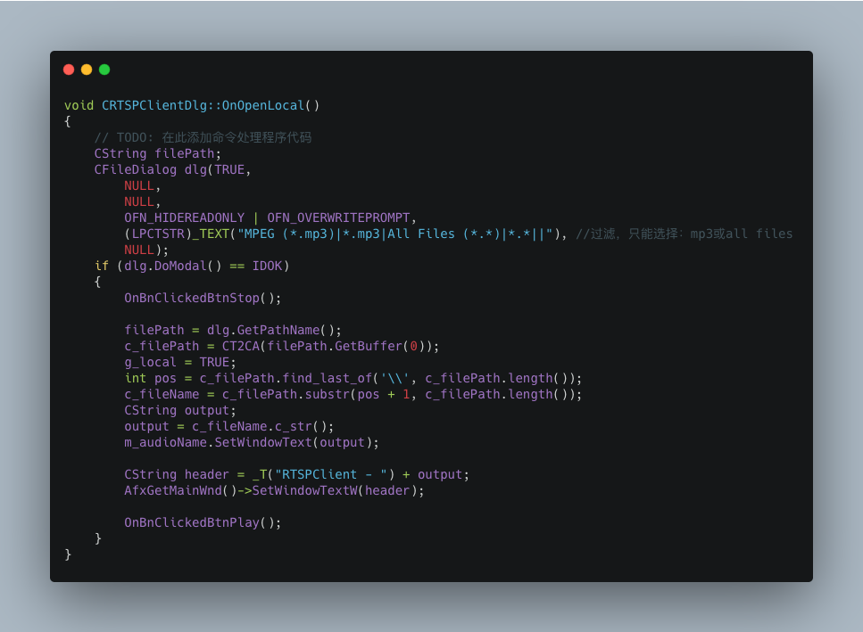
OnOpenLocal: Open local file by dialog, filter by .mp3, and change main dialog title.

Other function
OnBnClickedOk: get RTSP URL from edit control in CRTSPUrlDlg
OnBnClickedVol: Mute and Change volume icon.
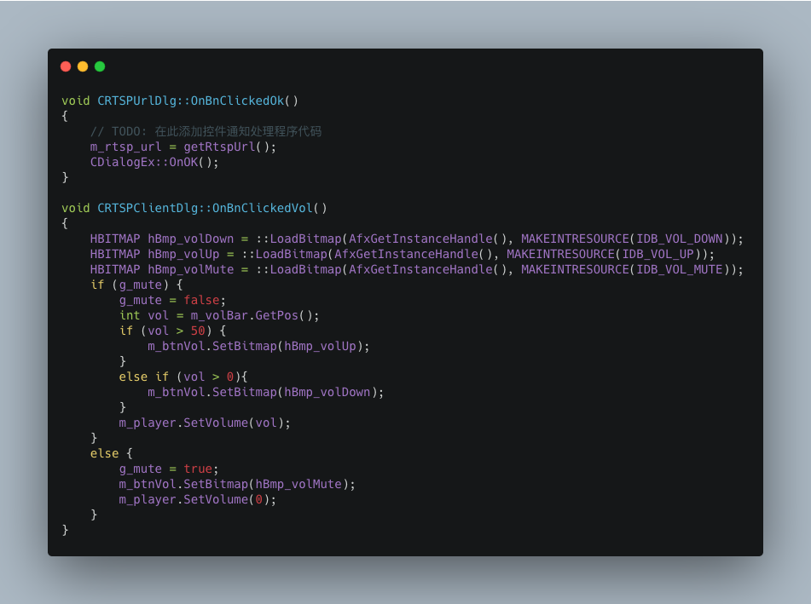
That's all the important parts, thank you for reading my report.

