Frame Parser Project Report
Project No.1
Version 1.0
Student ID: 201920081203009 Student Name: Yang Rui
2019-9-23
College of Computer Science and Cybersecurity, CUC

I declare that the assignment here submitted is original except for source material explicitly acknowledged. I also acknowledge that I am aware of University policy and regulations on honesty in academic work, and of the disciplinary guidelines and procedures applicable to breaches of such policy and regulations.

Name: Yang Rui Student ID: 201920081203009
Notes:

Section I Problem Specification

The purpose of this project is to develop a program to read the file and parse the frames out. At the same time, the program supports CRC-32 as FCS (Frame Check Sum).
Understand the significance of each field in Ethernet frame structure and the implementation of CRC verification, by analyzing the encapsulated Ethernet frame data.
The structure of an Ethernet frame (RFC 1042) is:

Preamble | Start | Destination Address | Source Address | Type | Data | Pad | Check-sum
7B | 1B | 6B | 6B | 2B | 0-1500B | 0-64B | 4B

Field Definition:

Preamble == 7 bytes of 10101010
Start == 1 byte of 10101011
Destination == 6 bytes of MAC address
Source == 6 bytes of MAC address
Length == number of bytes of data <= 1500
Data == comes down from network layer(<=1500 B)
Pad == ensures 64 bytes from destination address through check-sum.
Check-sum == 4 bytes of CRC. (FCS, frame check sequence) the FCS is calculated based on the header and the data field in the frame.

The thought of Cyclic Redundancy Check:

CRC treats blocks of input bits as coefficient-sets for polynomials.
A second polynomial, with constant coefficients, is called the "generator polynomial". This is divided into the message polynomial, giving a quotient and remainder. The coefficients of the remainder form the bits of the final CRC.

Section II Solution Method and Design

The structure of the Ethernet frame:

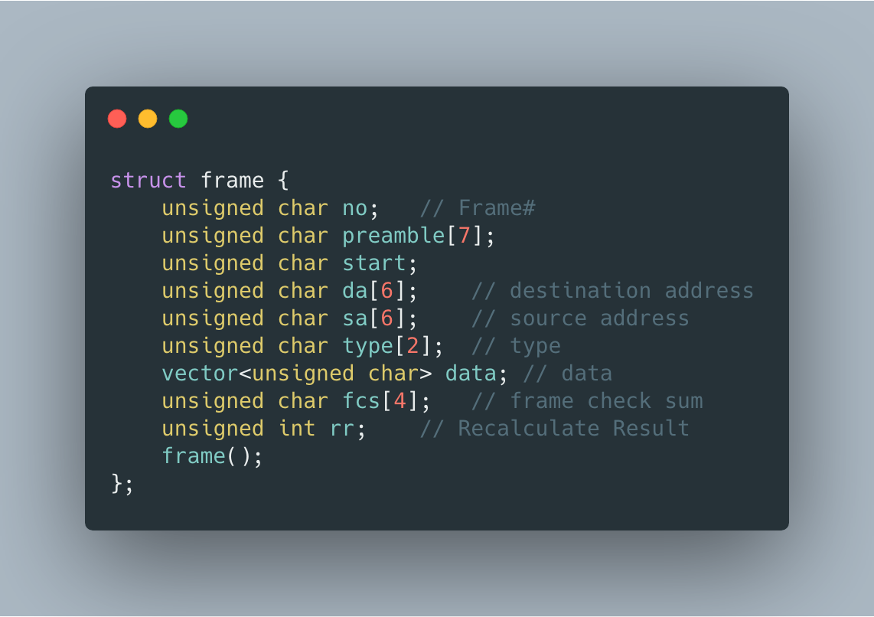
The reason for using `unsigned char` type is that it takes up 1 byte.

These are the variables and functions that are used:

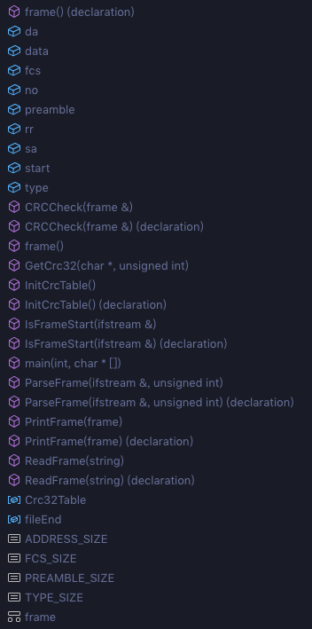

The main flow of analyzing Ethernet frame:（The picture is too long, please see next page.）

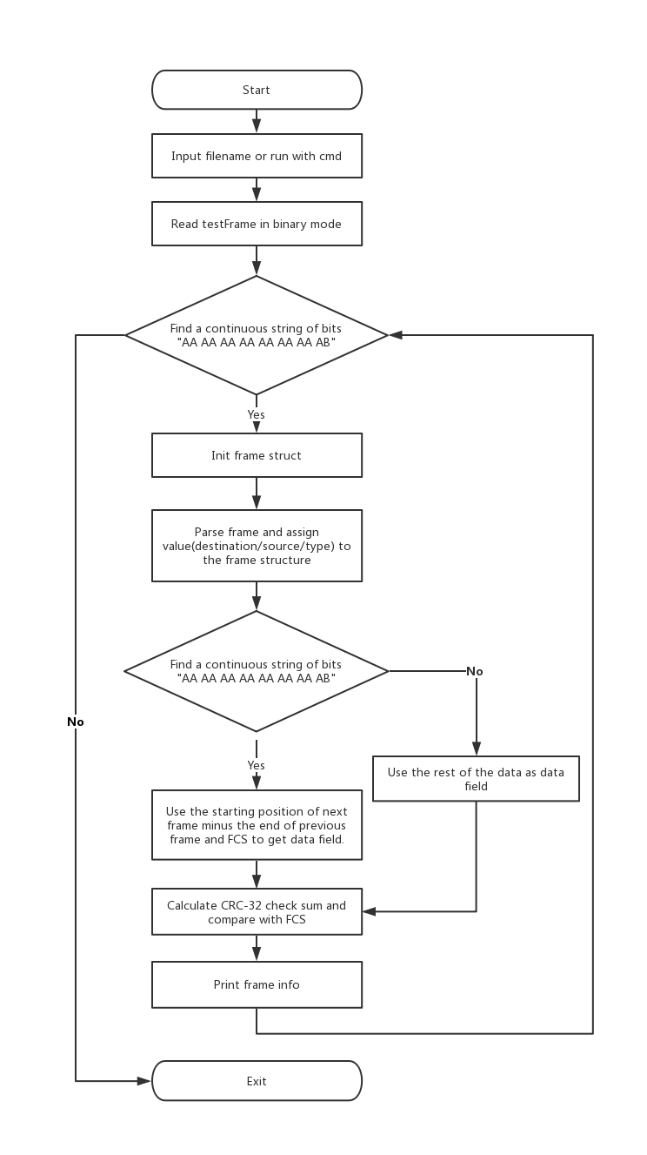

Section III Test Cases and Results Analysis

Test case is `testFrame` which contains 3 pseudo Ethernet II frames.

We can input frame filename to parse it:
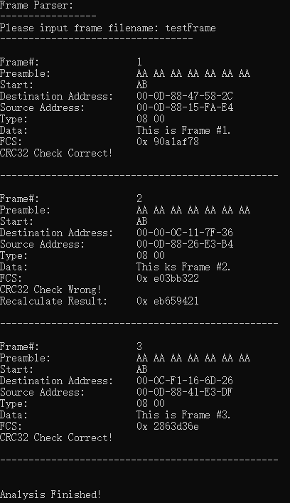

Or just run it with CMD:

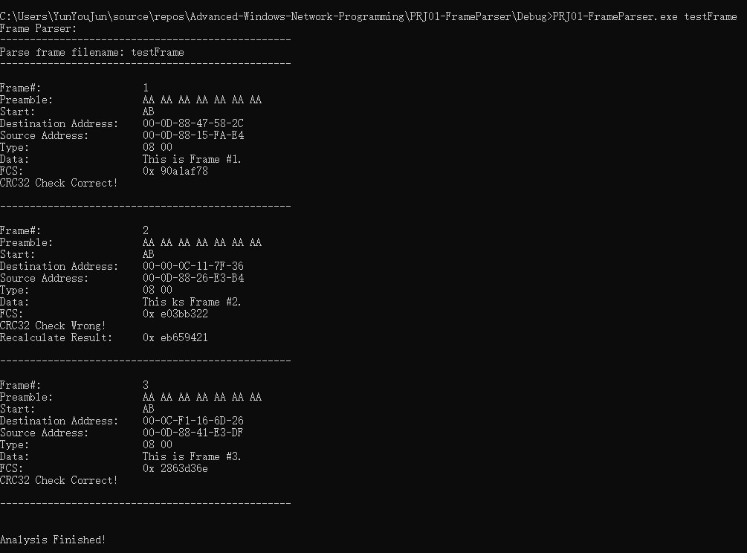

Section IV Conclusion

Through this experiment, I have more deeper understanding of the Ethernet frame structure. At the same time, I improved the ability of my C++ programming. But there are still some shortcomings, such as the calculation of CRC. I learned how it worked and referred to some of the code on the web to implement it.
Of course, most of this experiment was completed by me independently. However, due to time and power issues, I was unable to encapsulate it into a more generic class library.

Section V References

- CRC32 校验原理及实现https://blog.csdn.net/u013898698/article/details/78864161
- CRC32 - 百度百科 https://baike.baidu.com/item/CRC32

Section VI Appendix

Some header files and global variables are required.
Crc32Table is prepared for later CRC-32.
It’s ok to use `int` type for `fileEnd`. The reason I use `long long` is to avoid warning `fin.tellg()` might cause.

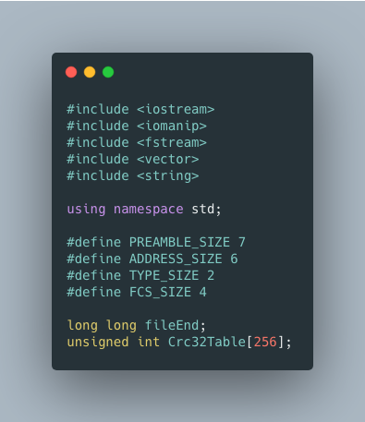

Judge argv[1] exits or not, then parse ethernet frame.
Now, we can input filename or just run it with CMD.
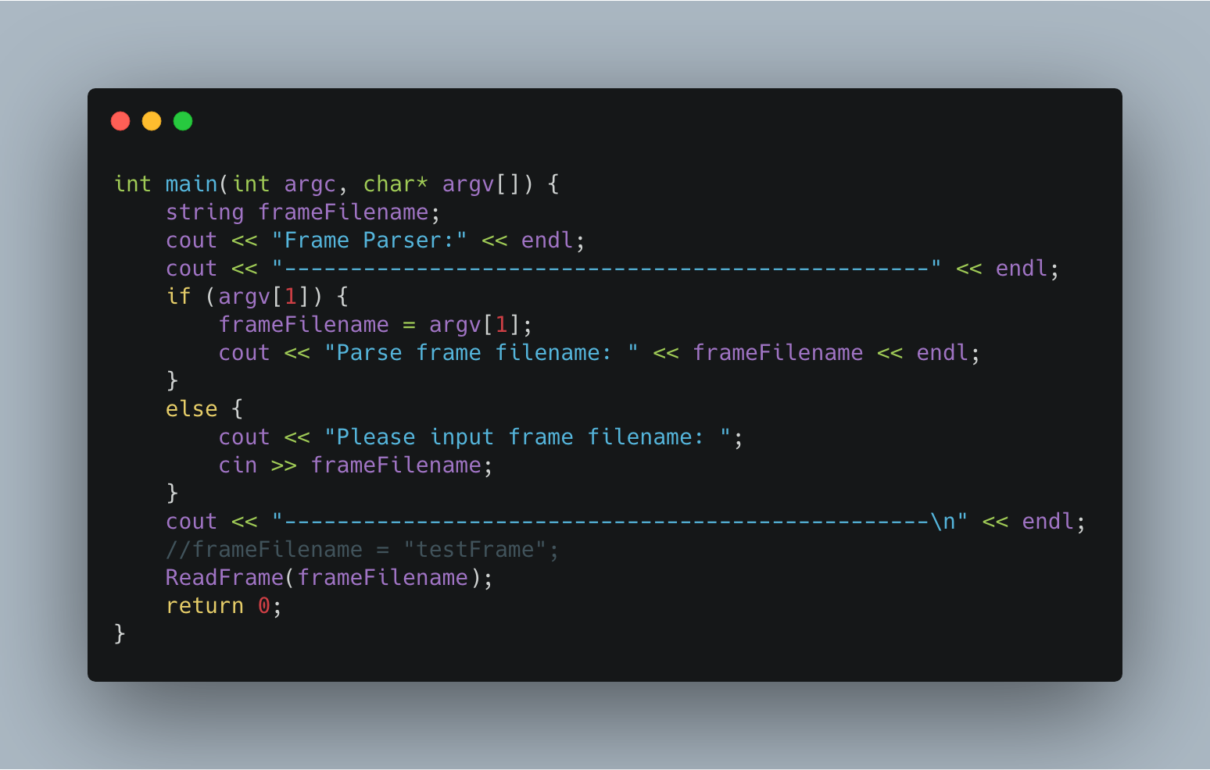
Parse frame data field by searching the preamble of next frame. If it doesn’t exist, use the rest (remove FCS) as data field.
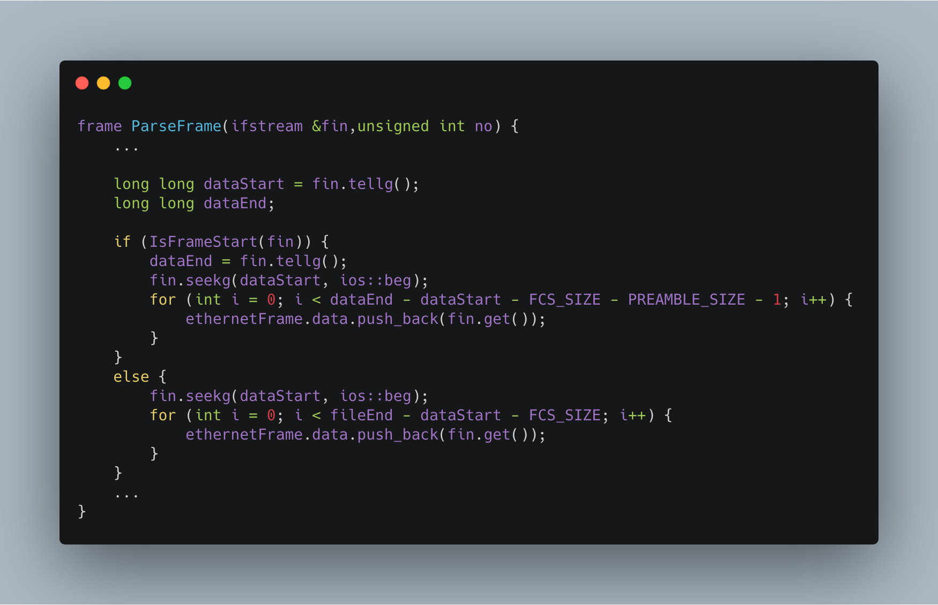

Search the preamble field of frame (a continuous string of bits “AA AA AA AA AA AA AA AB”).
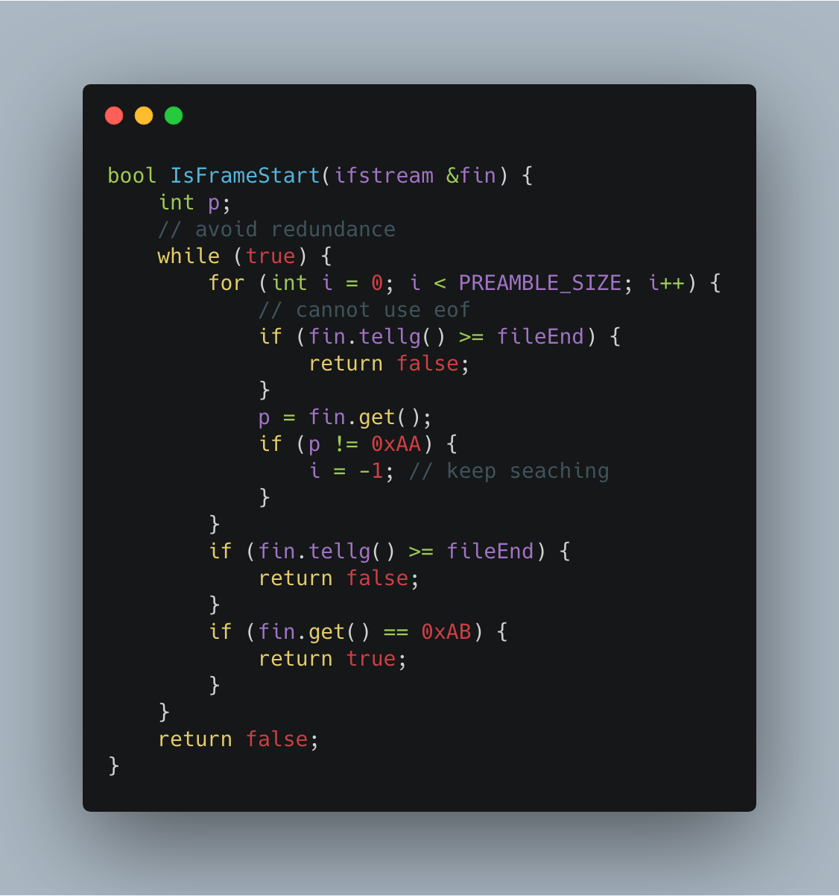

Generate CRC32 table.
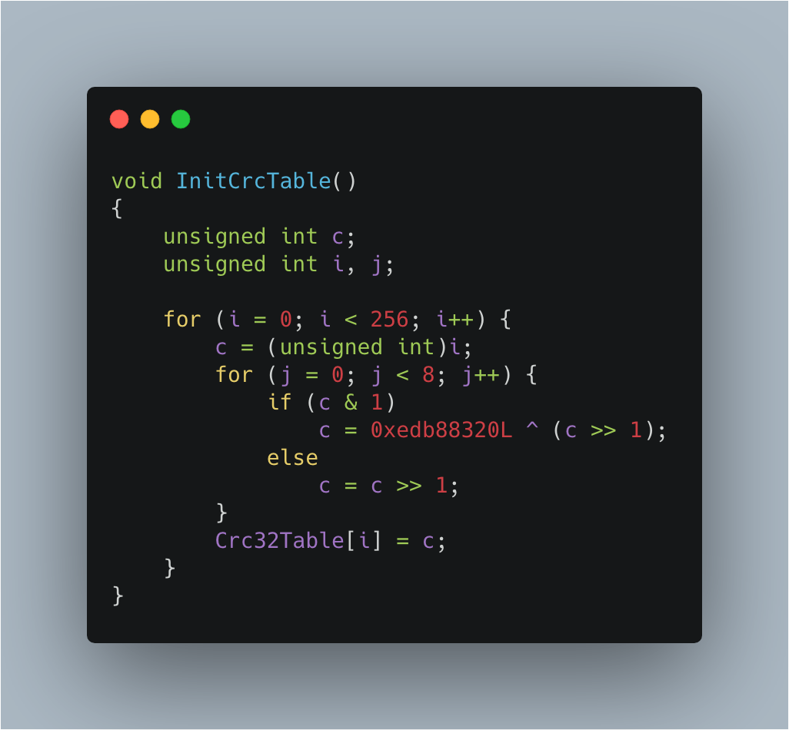

Calculate the CRC32 check-sum of frame data (include destination address, source address, type, data).
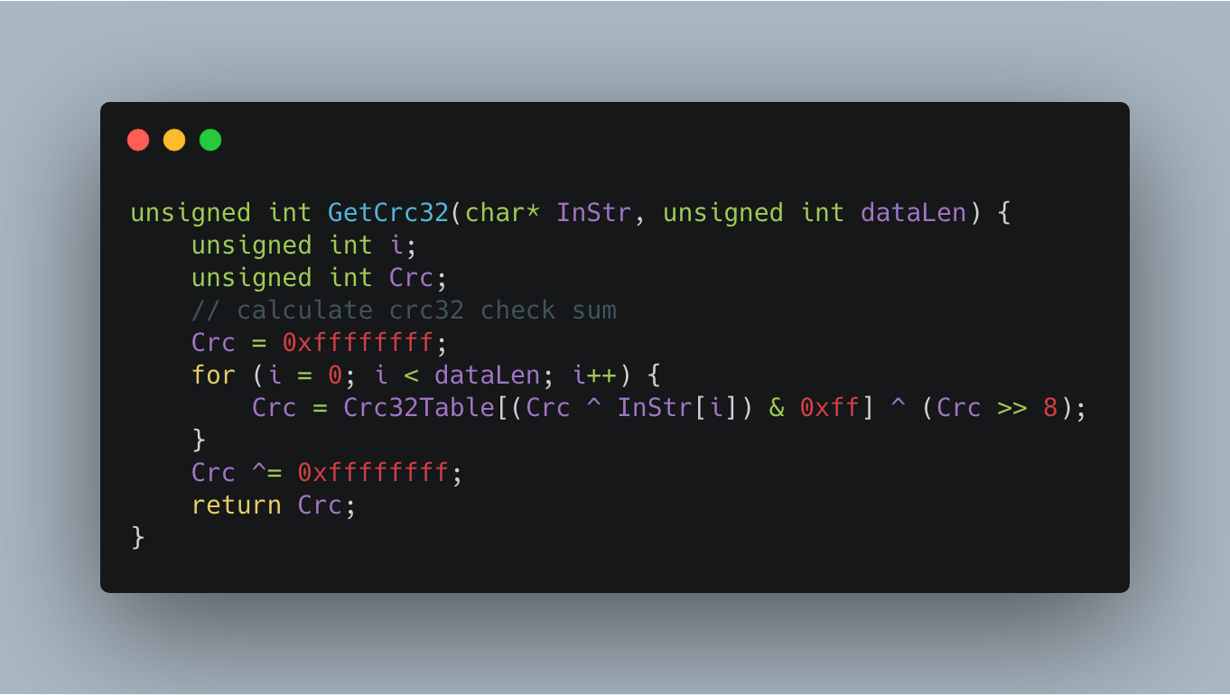
Then compare it with FCS.
The output part is relatively simple, no more paste.
That’s all, thanks.

