PortScanner Project Report
Project No.6
Version 1.0
Student ID: 201920081203009 Student Name: Yang Rui
2019-11-02
College of Computer Science and Cybersecurity, CUC

I declare that the assignment here submitted is original except for source material explicitly acknowledged. I also acknowledge that I am aware of University policy and regulations on honesty in academic work, and of the disciplinary guidelines and procedures applicable to breaches of such policy and regulations.

Name: Yang Rui Student ID: 201920081203009
Notes:

Section I Problem Specification
The purpose of this project is to develop a software tool “PortScanner” which is used to discover the active ports on the designated machine.
We don’t open a full TCP connection. We send a SYN packet, as if we are going to open a real connection and then wait for a response. A SYN/ACK indicates the port is listening (open), while a RST (reset) is indicative of a non-listener. If no response is received after several retransmissions, the port is marked as filtered. The port is also marked filtered if an ICMP unreachable error (type 3, code 1, 2, 3, 9, 10, or 13) is received.
This program should be able to perform scans on predefined port range. The “Scan” function should be processed through threads, and post messages to the main thread for updating user interface.

Protocol Data Unit Encapsulation (IP Packet):
Ethernet Header | IP Header | ICMP Header | Data | Ethernet Trailer
14B | 20B | 8B | 4B | 4B

IP Header + TCP Header + Application Data = 46 to 1500 B

The IPv4 (Internet Protocol) header:

A row is 32 bit.
Version | IHL | Differentiated Services | Total length
Identification |  |  |  | DF | MF | Fragment offset
Time to live |  | Protocol | Header check sum
Source address
Destination address
Options(0 or more words)

TCP Format:
A row is 32 bit.
Source Port  (16bits) |  |  |  |  |  |  |  |  |  | Destination Port  (16bits)
Sequence Number
(32bits)
Acknowledgment Number
(32bits)
Header  Length  (4bits) | Reserved  (4bits) | CWR | ECE | UGR | ACK | PSH | RST | SYN | FIN | Window Size  (16bits)
TCP Check-sum  (16bits) |  |  |  |  |  |  |  |  |  | Urgent Pointer  (16bits)
Options(variable)

- Urgent pointer (URG) :If set, the urgent pointer field contains a valid pointer. The urgent message in the range: SeqNo <= urgent message <= SeqNo+urgent pointer
- The ACK bit is set to 1 to indicate that the Acknowledgement number is valid.
- The PSH bit indicates PUSHed data. The receiver is hereby kindly requested to deliver the data to the application upon arrival and not buffer it until a full buffer has been received
- The RST bit is used to reset a connection that has become confused due to a host crash or some other reason. In general, if you get a segment with the RST bit on, you have a problem on your hands.
- The SYN bit is used to establish connections.The connection request has SYN = 1 and ACK = 0 to indicate that the piggyback acknowledgement field is not in use.
- The FIN bit is used to release a connection. Both sides of a connection must send a FIN

Pseudo-header Format:
A row is 32 bit.
Source address
Destination address
00000000 | Protocol = 6 | TCP segment length

Header fields: Checksum (16 bits)
- Checksum of the pseudo-header and the TCP Segment (TCP header and data).
- The information in the pseudo header comes from the IP datagram header. This is data passed down to the IP Layer and is included in the checksum.
- To calculate the TCP segment header’s Checksum field, the TCP pseudo header is first constructed and placed, logically, before the TCP segment. The checksum is then calculated over both the pseudo header and the TCP segment. The pseudo header is then discarded.

Section II Solution Method and Design

At first, we need install WinPcap. Download it and link it with VS 2019.
- Property Pages -> C/C++ -> General -> Additional Include Directories -> Add `..\WpdPack\Include`
- Property Pages -> Linker -> General -> Additional Library Directories -> Add `..\WpdPack\Lib`
- Property Pages -> Linker -> Input -> Additional Dependencies -> Add `wpcap.lib`&`ws2_32.lib`&`Iphlpapi.lib`

This is the project structure(use Object Oriented Programming with C++):

Some files are automatically generated:

- Resource.h: define interface element id
- stdafx.h: precompiled header file
- TraceRouter.cpp: main dialog and control message and thread

This is class diagram:

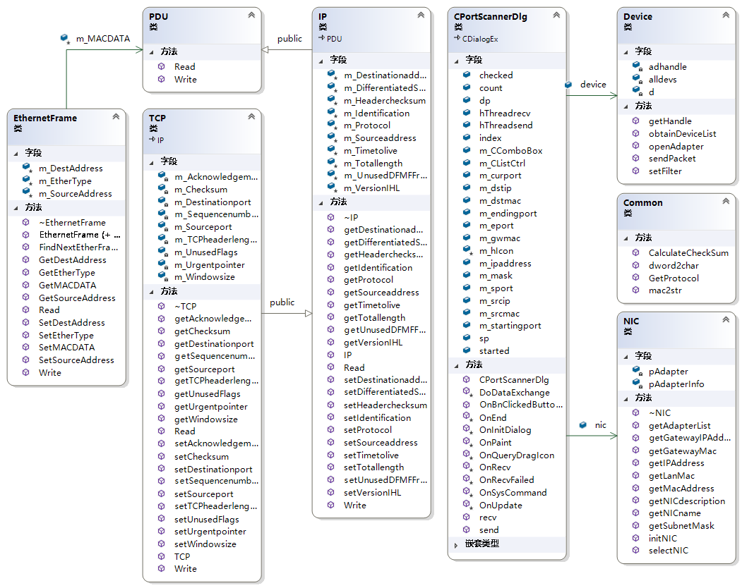

This is sequence diagram:(This is very similar to the previous project figure, just adding the sending part.)

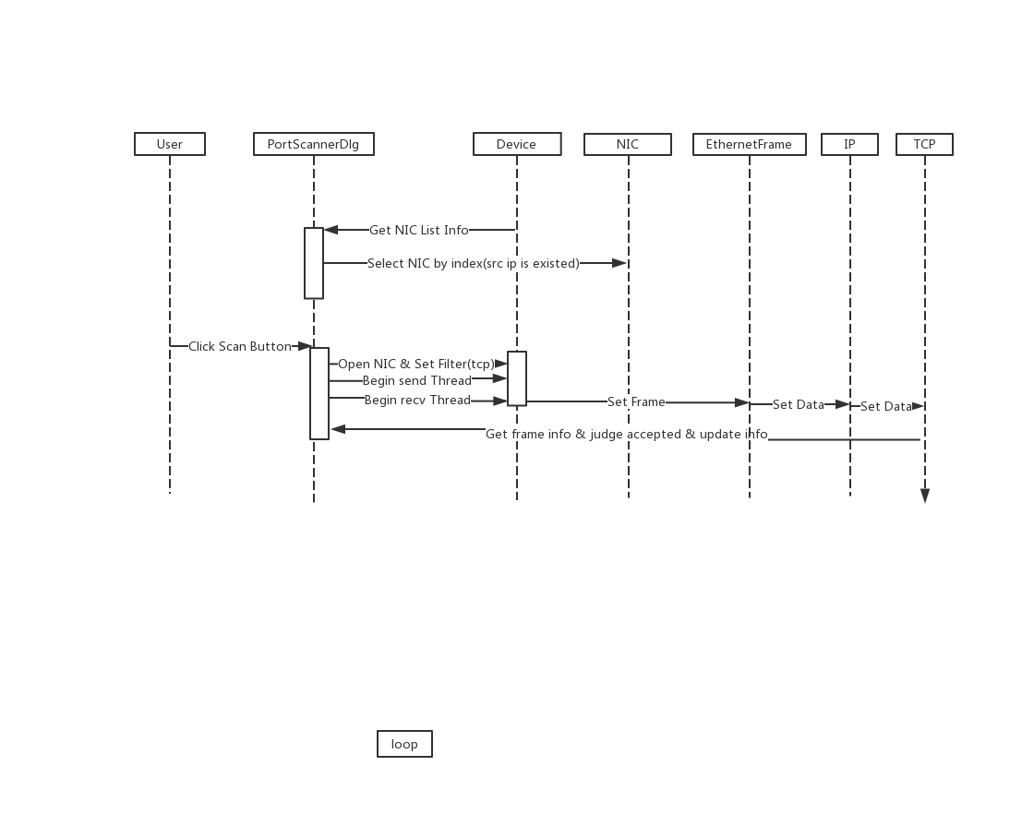

This is flow chart in PortScannerDlg file:

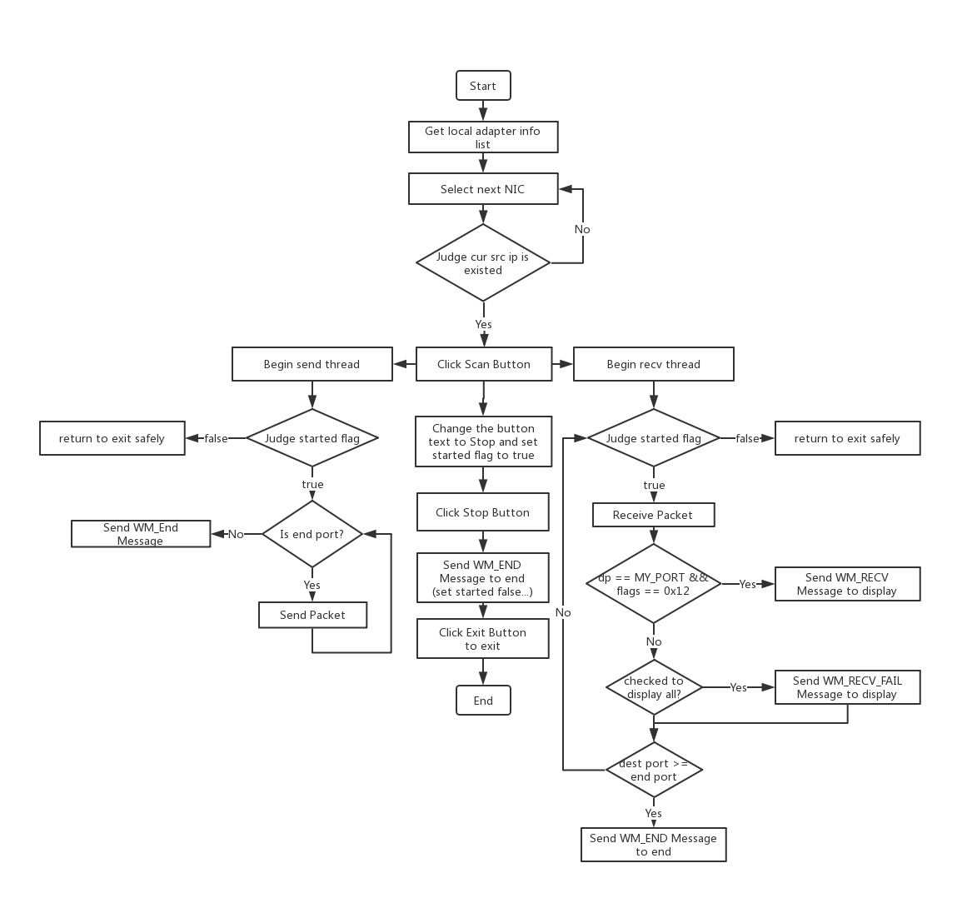

Section III Test Cases and Results Analysis

This is my test result:

1. Input start and end port, then click Scan button.
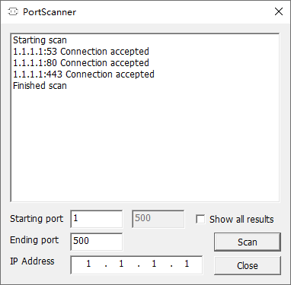
(53: DNS, 80: http, 443: https)
I use 1.1.1.1 because it is the fastest DNS resolver on Earth.

2. Check Show all results and Click Scan Button.
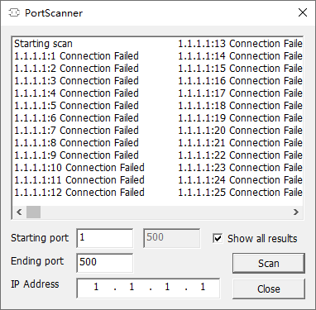

3. Click left corner menu and choose about item.(This is my logo. XP )
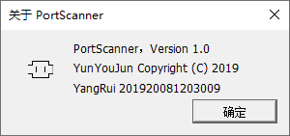

Section IV Conclusion
Through this experiment, I have more deeper understanding of the operation of IP and TCP protocol. I didn’t know about pseudo TCP header before.I have a deeper understanding of TCP's three-way handshake, and learned how it worked and referred to some of the code on the web to implement it. At the same time, I made extensive use of classes and improved the re-usability of the program code.
I have to once again praise the benefits of object orientation.

Section V References
- WinPcap: Exported function https://www.winpcap.org/docs/docs_40_2/html/group__wpcapfunc.html
- TCP Port Scanner.pdf http://tlc.cuc.edu.cn/Course/Course/showAction/id/30
- EtherType: 以太网类型字段及值 ｜ CSDN https://blog.csdn.net/eydwyz/article/details/65446328
- IP 协议（Protocol）字段描述 https://blog.csdn.net/weixin_40552292/article/details/90417931
- TCP 协议及帧格式 https://blog.csdn.net/marywang56/article/details/76151064

Section VI Appendix
Common\NIC\PDU\Device\IP is similar to last last project, so I don’t paste it here again.

Common.h (Common Helper)
It is used to convert some formats or get protocol and check-sum.

NIC(Network Interface Card class)
It is used to display nic info.

Device
It is used to do some operation related to device like opening adapter or setting filter, etc.

PDU(Protocol Data Unit)
Just interface for PDU.

IP(IP class)
It is used to encapsulate and parse IP packet.

TCP(TCP class)

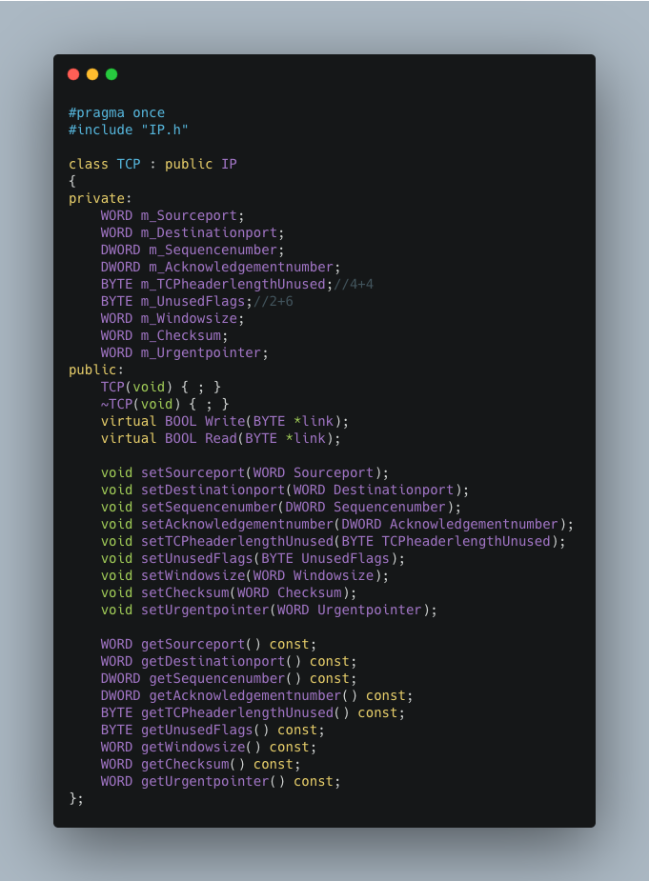

This is the basic flow that matches the flowchart.(main content in PortScannerDlg.cpp)

Bind Variable to MFC components(IPAddressCtrl can input IP with format):
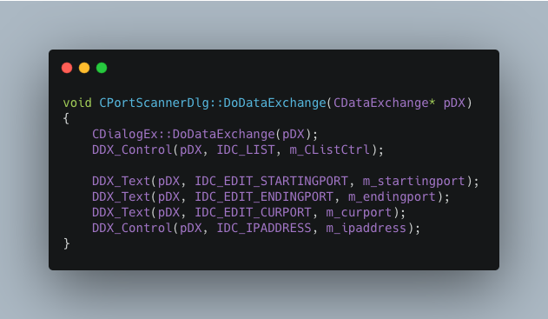
Use UpdateData(FALSE) to update variable to interface, use UpdateData(True) to get variable from interface.

Bind Message with function:
WM_RECV message is used to trigger OnRecv function.
WM_RECV_FAIL message is used to trigger OnRecvFailed function.
WM_END message is used to trigger OnEnd function.
WM_UPDATE message is used to trigger OnUpdate function.
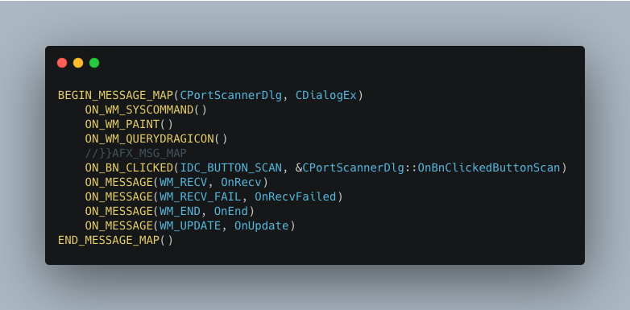
Initialize dialog (auto select NIC by source IP is existed):
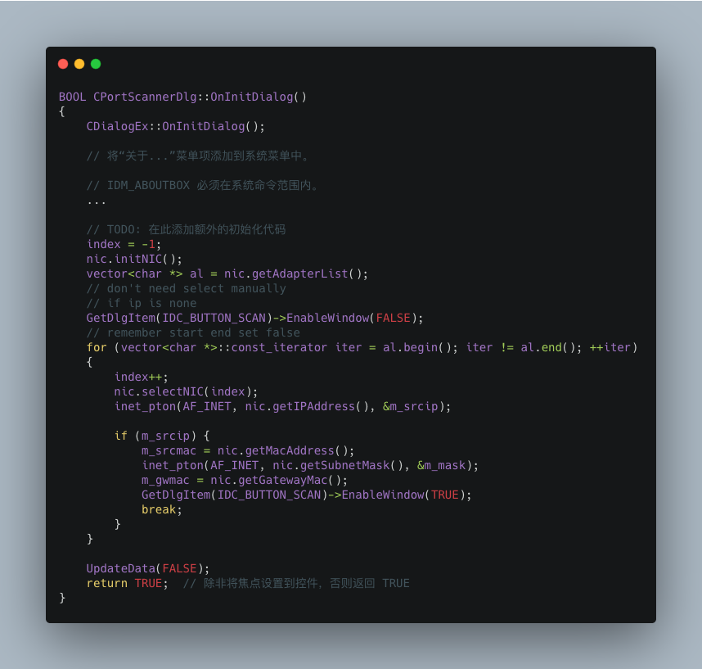

Scan Funtion(Run when the scan button is clicked):
Create the ‘send’ and ‘recv’ thread to handle packets.
End by sending WM_END message to trigger OnEnd function.
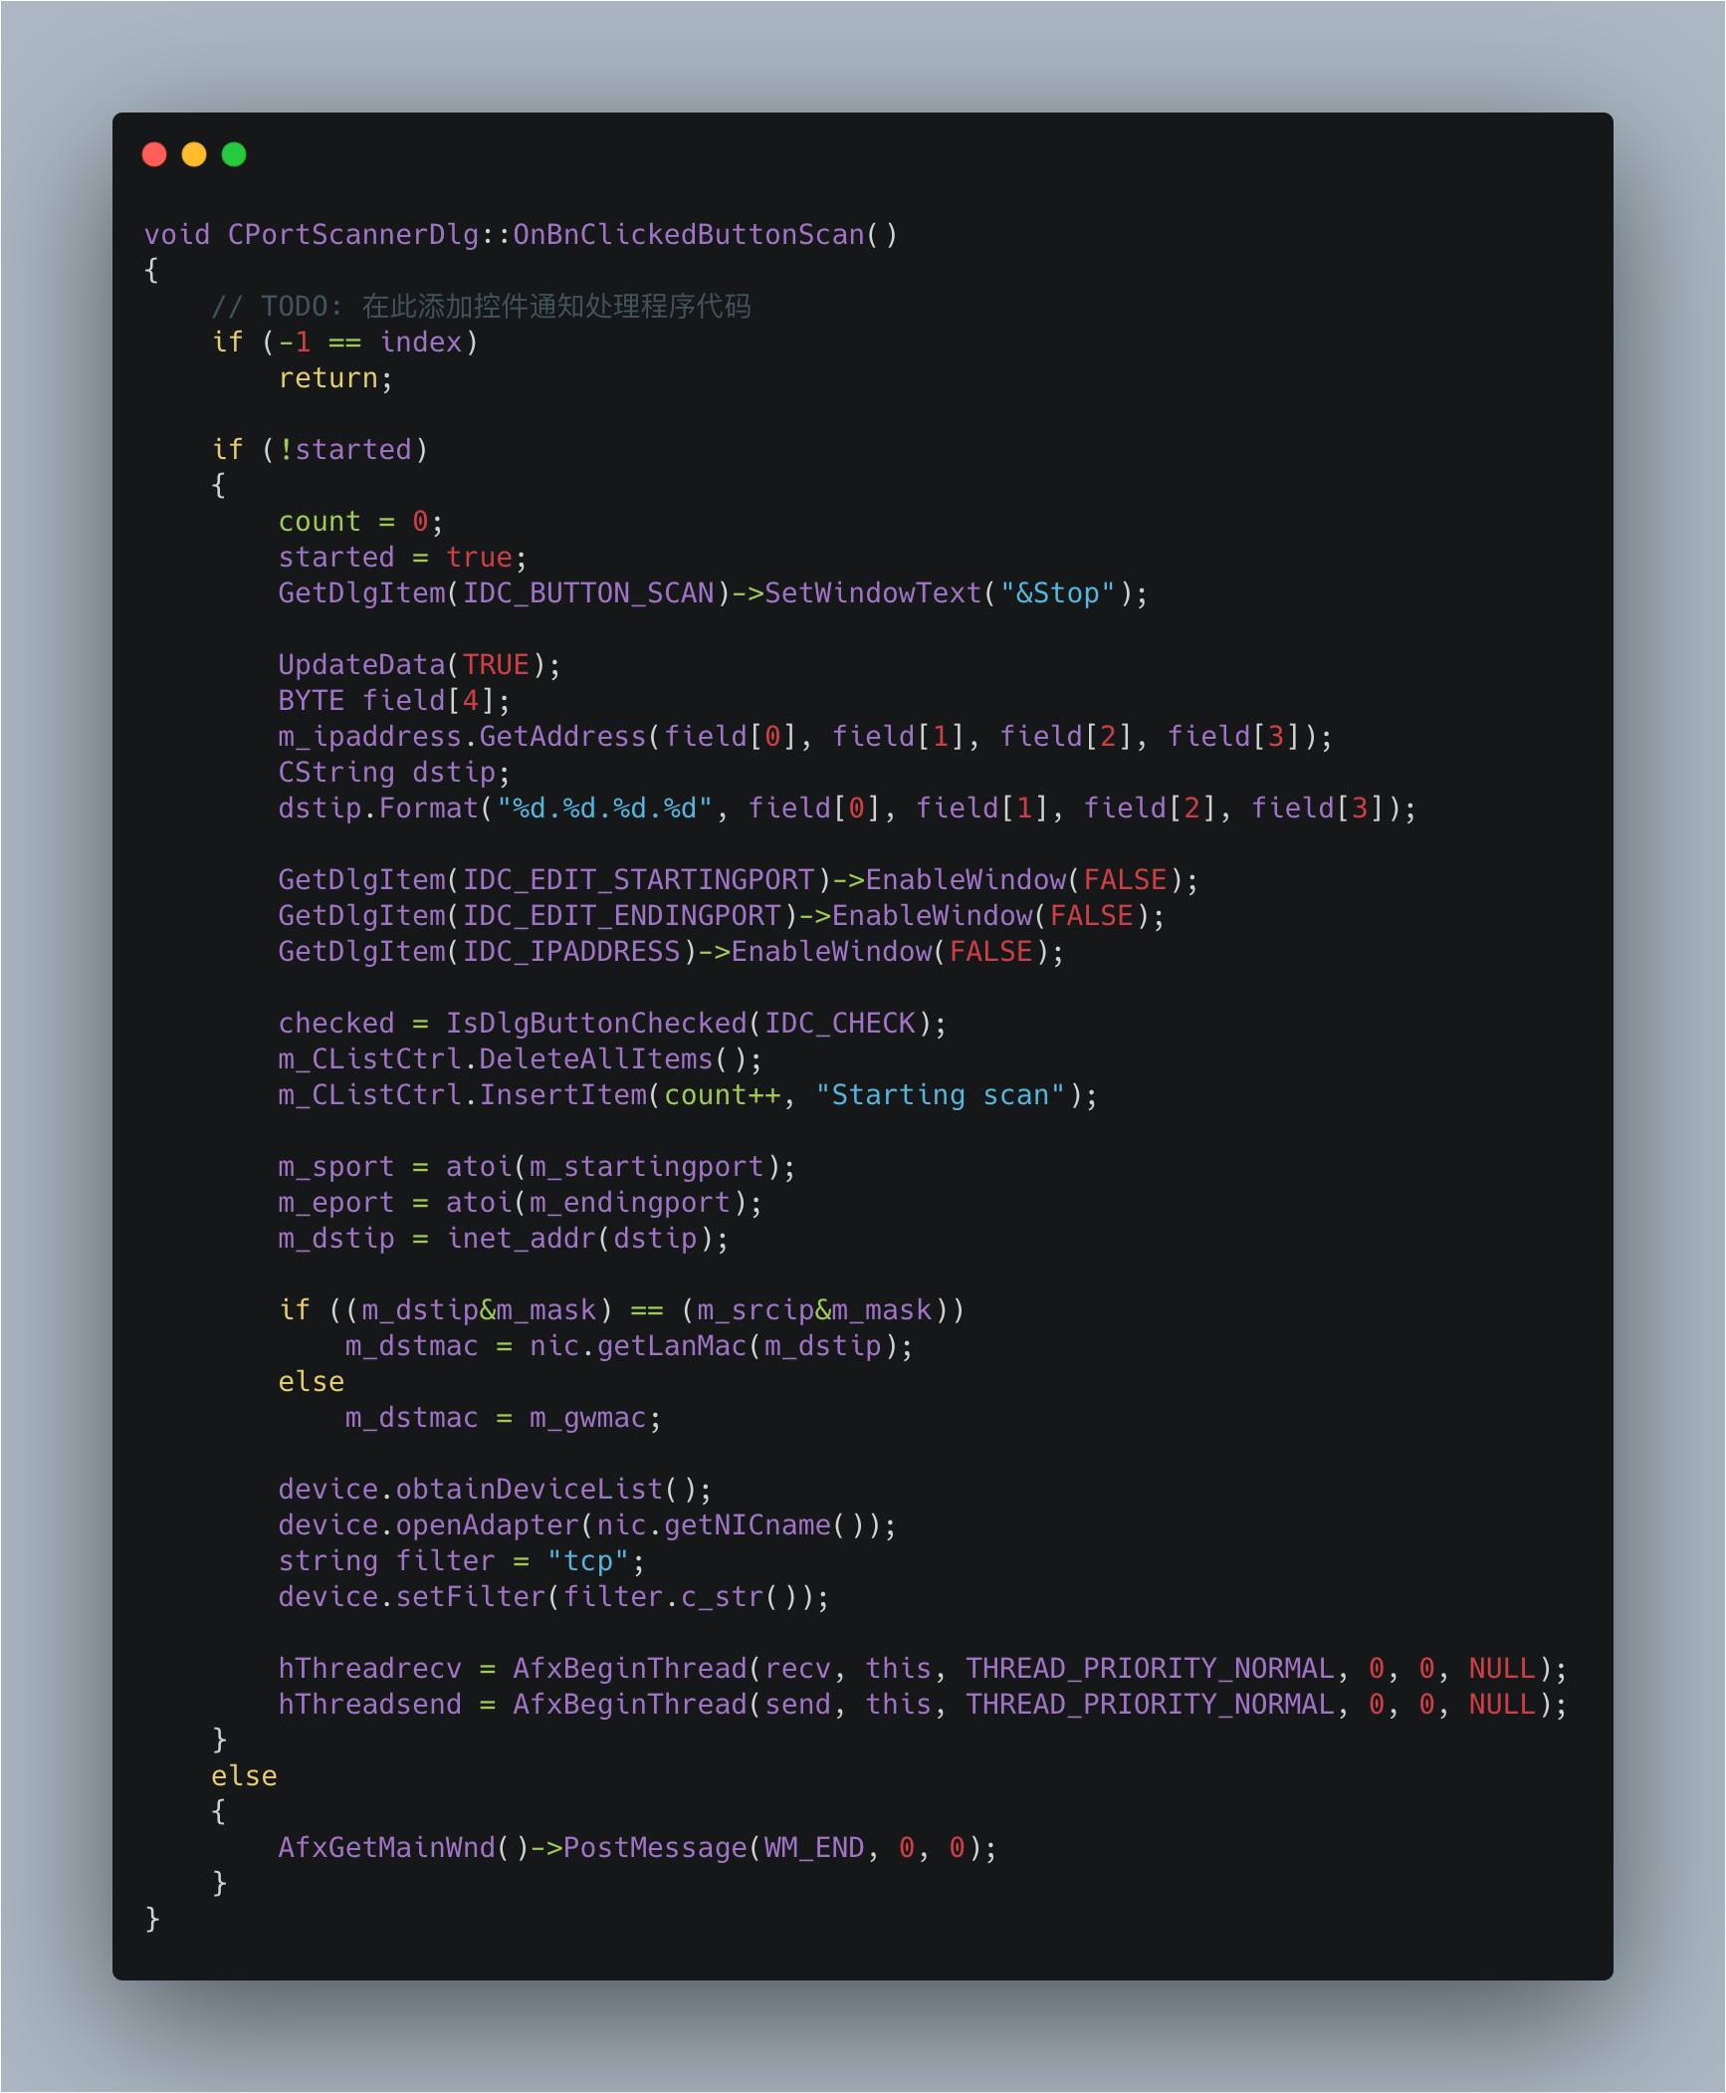

Send packets from start port to end port, I use m_curport to record the port when we click Stop button.
We need calculate pseudo TCP header check-sum and pack them to packet.
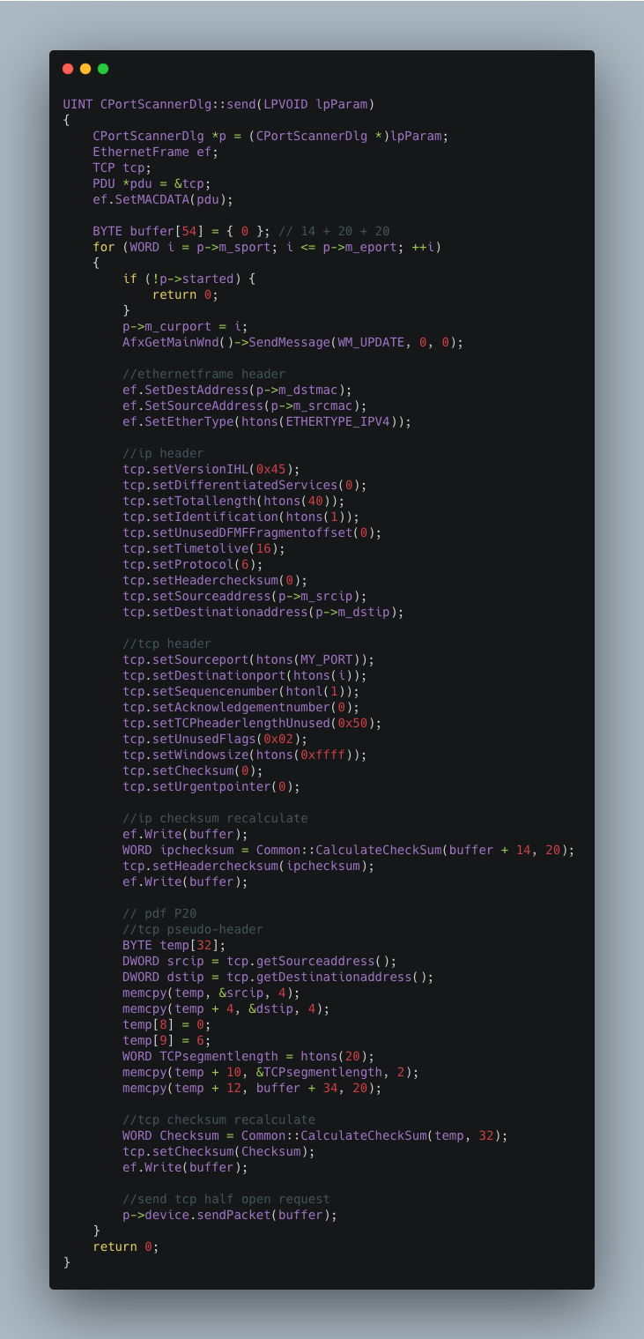

Receive packets and judge their type & code(judge accepted or failed), then display it.
To avoid wasting time, we use messages to process a series of updating.
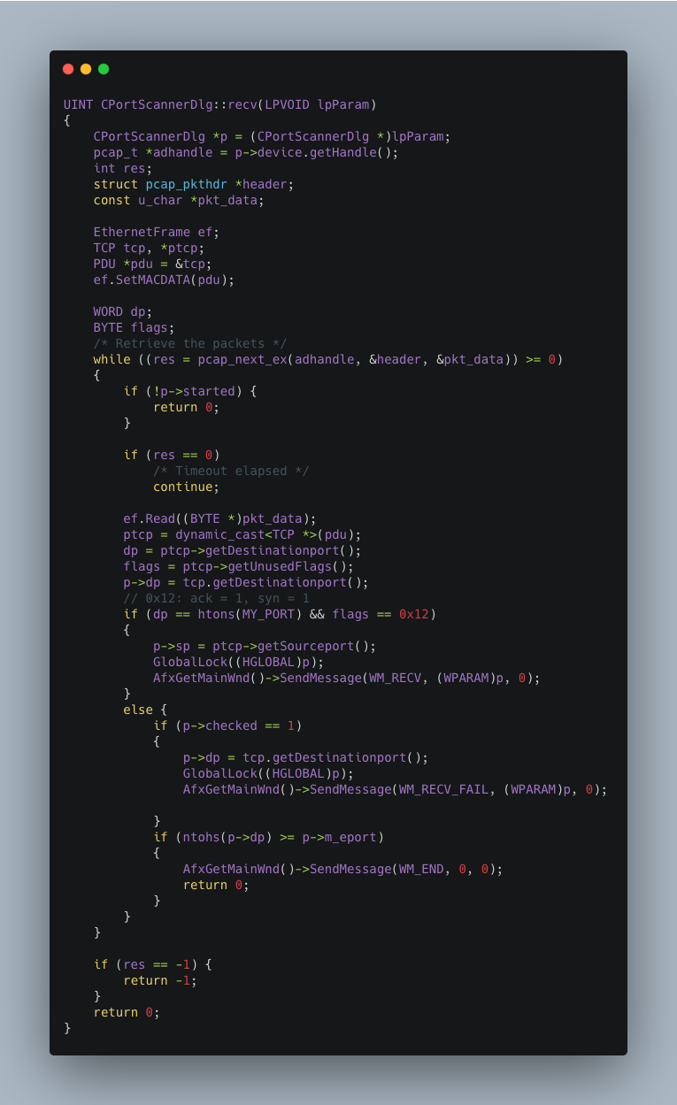

OnRecv & OnRecvFailed:
Display status info in interface.
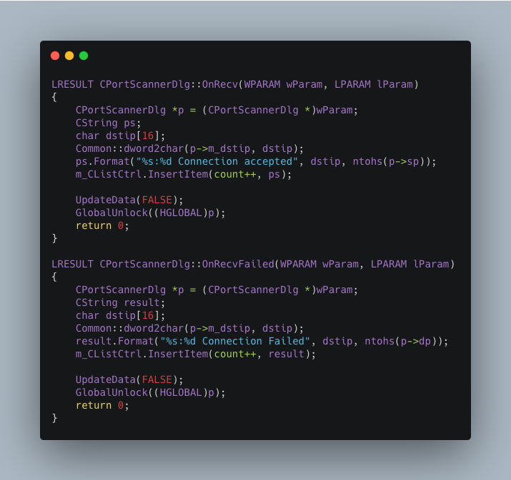

OnEnd:
Set started flag and enable edit box(because I disable window when we scan).

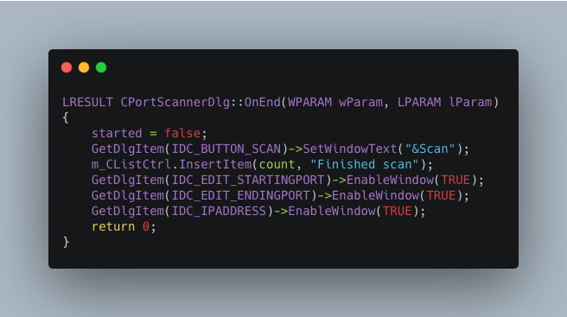

I use OnUpdate because I want to display cur port in interface.You can realte it to send function.
I write ‘m_curport = i’ and i is from m_sport to m_eport.
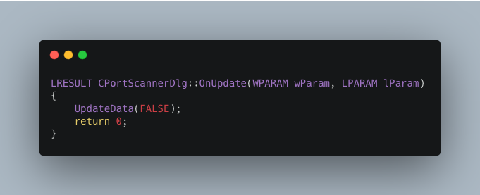

That's all the important parts, thank you for reading my report.

