Blocking Project Report
Project No.8
Version 1.0
Student ID: 201920081203009 Student Name: Yang Rui
2019-11-18
College of Computer Science and Cybersecurity, CUC

I declare that the assignment here submitted is original except for source material explicitly acknowledged. I also acknowledge that I am aware of University policy and regulations on honesty in academic work, and of the disciplinary guidelines and procedures applicable to breaches of such policy and regulations.

Name: Yang Rui Student ID: 201920081203009
Notes:

Section I Problem Specification
The purpose of this project is to develop two simple console mode programs: FileServer and FileClient, when the Fileclient sends a string as a file name requested to the FileServer, the FileServer will send back the file to the FileClient if the file exists.
We should develop the server and the client with blocking sockets - by default, a Winsock call blocks, meaning that it will not return until it has completed its task or has failed while trying. And consider the Windows socket as a transport entity; encapsulate all the properties and functions into a CBlockingSocket class, declare the interface like the following:
class CBlockingSocket{
public:
CBlockingSocket();
virtual ~ CBlockingSocket();
BOOL Open (const char *ip, const char *port ); BOOL Close ();
BOOL Listen (const char *port);
BOOL Accept ();
BOOL Send (BYTE*s, UINT count);
INT Read(BYTE *s, UINT count);
......
}
The FileServer should be listening on a given port 8888, and waiting for the client to ask for a file (use a large text file for testing, at least > 1MB)(I use a file which is bigger than 400MB and success.). After getting the file name from the client, the server opens the file and then enters a loop that alternately reads blocks from the file and writes them to the socket until the entire file has been copied. Then the server closes the file and the current connection and waits for the next connection to show up. It repeats this loop forever. The FileServer Must be implemented in a mode of concurrent, connection-oriented server, so that the server can handle multiple file client request at the same time.
The FileClient should establish a connection to the FileServer and send a filename to it and ask for the file, if the file exists on the server machine, the file is transferred over the connection back to the client program, and the client can choose to save the file to disk or print out on the console.
For easier use, I implemented it with Windows graphic user interface. Of course, I also use Object Oriented Programming with C++ and modern Windows socket system calls. The only regret is that I use `inet_ntoa` when get server ip address. I try use `InetNtop` to replace it, but something wrong. So I used `InetNtop` in other places besides here.

WinSock Background Content is similiar to last lab, so I don’t paste it here.

Section II Solution Method and Design

Development Environment:
- OS: Microsoft Windows 10
- Language: C++
- Tool: Microsoft Visual Studio 2017

This is the project structure(use Object Oriented Programming with C++):

Some files are automatically generated:

- pch.cpp: source file corresponding to the precompiled header; required for successful compilation
- pch.h: header file corresponding to the cpp
- stdafx.cpp: standard application fram extend generated by MFC

I added two console applications FileClient and FileServer to the solution called FileCS. So I can manage them in a solution.(It is also similiar to last lab EchoCS.)

Class Diagram:(I just write a class: CBlockingSocket follow pdf requirements)

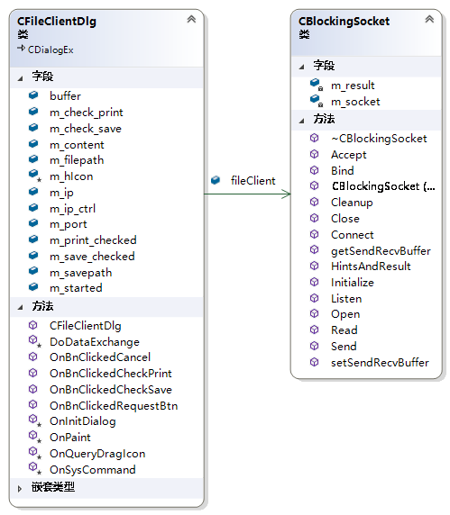

This is the sequence diagram:

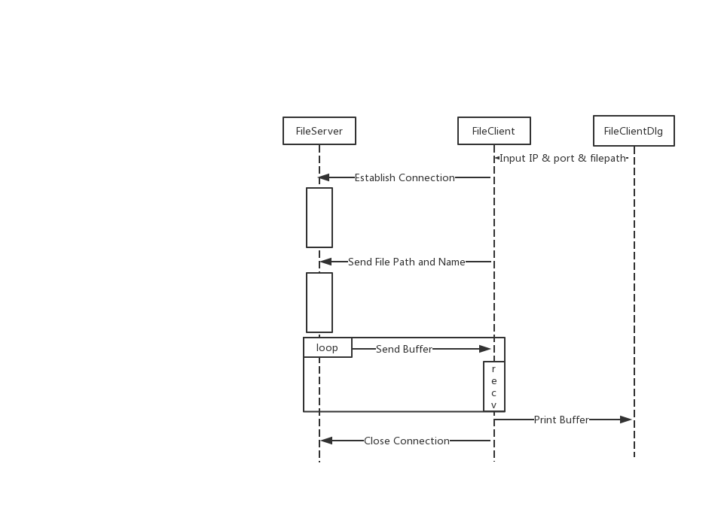

This is flow chart in FileServer & FileClient:

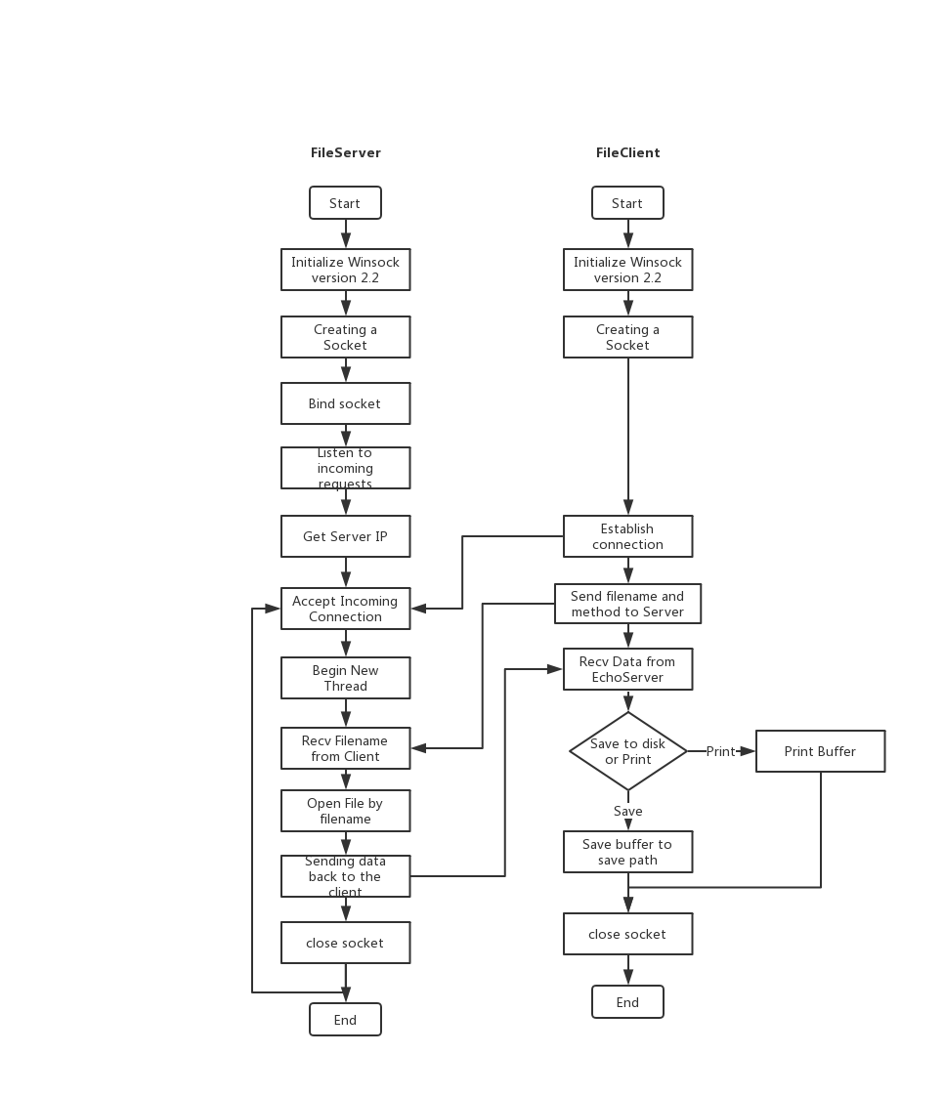

Section III Test Cases and Results Analysis

This is my test result:

- Input ‘FileServer.exe 8888’ to open server in CMD. (Listen on 8888, other customized port is ok. I use 8888 as default port, so just input FileServer.exe can work too.)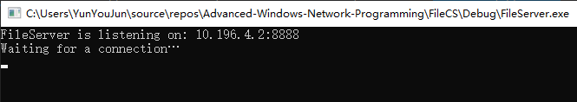

- I write a MFC program for FileClient. So we just need to input some necessary params(ip/port/filepath/method) and click request button.

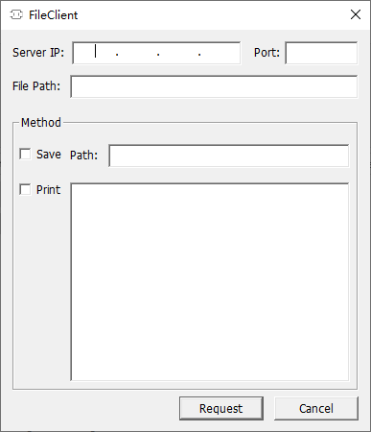

- Then click request button to get info.(I placed test.txt to Debug Folder. Absolute path can also work.) And it display my info in text.txt and save it to disk..
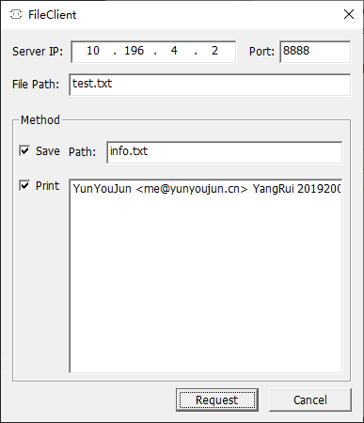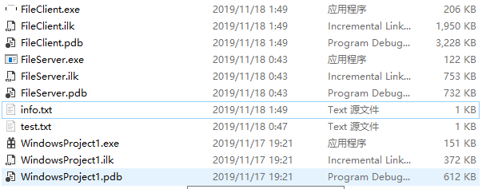

- Now, try a very big file and start 3 clients.(It is bigger than 400 Mb.) It worked well and fast.
(Off topic, This big file is consist of many copies of the Lord of the Rings. :-P)
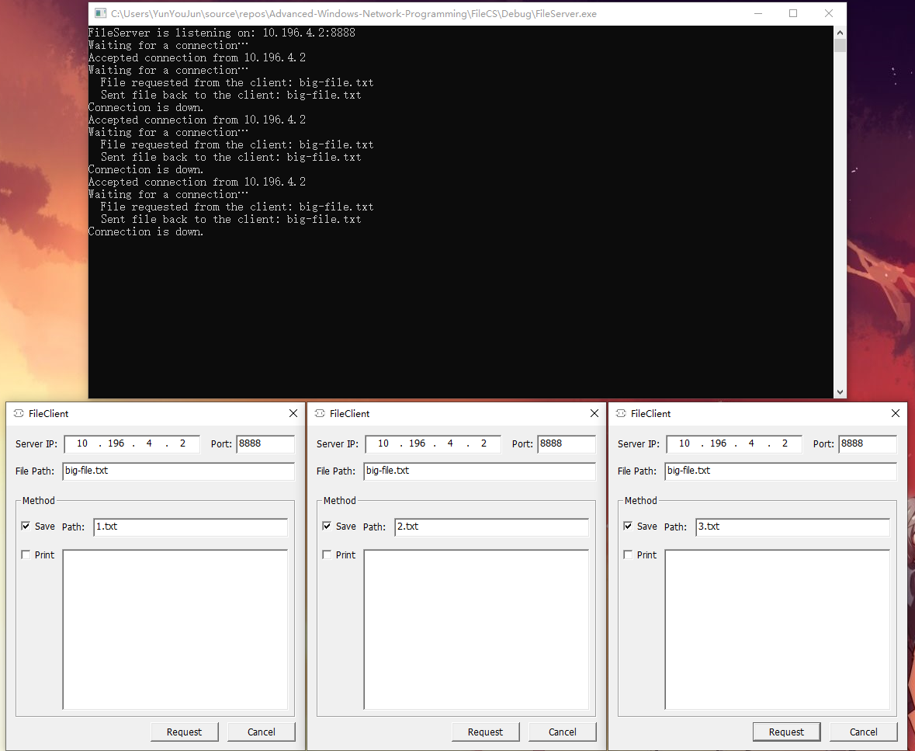
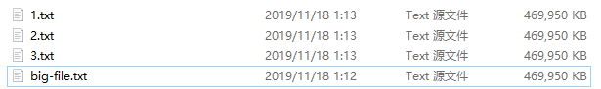

Section IV Conclusion
Through this experiment, I have a preliminary understanding of socket programming. The amount of code for socket programming is less and easier than the previous underlying protocol. But there are also many places that need to be carefully and meticulously. I think I prefer to use high-level language to quickly implement the features I want, which will be very rewarding.
I wrote this project by an object-oriented approach, and wrote a user interface for FileClient. That’s very intersting. I didn’t write interface for FileServer, because I think server is controlled by geeks and it can be easier without an interface. Client is for users, so we need a user interface. If I have enough time, I want to implement image and other types of files transmission.
Problem: In fact, when the file is very big, the interface cannot display it.

Section V References
- Windows Socket Get Started.pdf http://tlc.cuc.edu.cn/Course/Course/showAction/id/30
- Windows Socket Modern System Calls.pdf http://tlc.cuc.edu.cn/Course/Course/showAction/id/30
- Windows Sockets 2 | MSDN https://docs.microsoft.com/zh-cn/windows/win32/api/_winsock/
- C++ open 打开文件（含打开模式一览表）http://c.biancheng.net/view/294.html
- 为 Bandwidth Delay Product 调节 TCP 窗口https://blog.csdn.net/hzrandd/article/details/50578373
- 揭秘！为何要用_beginthreadex，而不用CreateThread和_beginthread https://msd.misuland.com/pd/2884250137616455570
- __stdcall | MSDN https://docs.microsoft.com/en-us/cpp/cpp/stdcall?redirectedfrom=MSDN&view=vs-2019

Section VI Appendix

This is the class CBlockingSocket to handle socket.
I follow the structure in pdf to design it. And most code is similar to last lab, so I don’t paste it here.
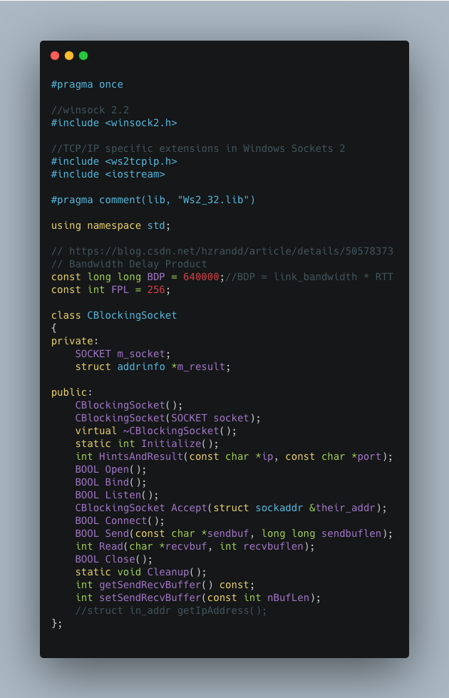

This is the FileServer file matches the flowchart.
FileClient and FileServer use same class file CBlockingSocket. So include it by ‘../CBlockingSocket.h’.
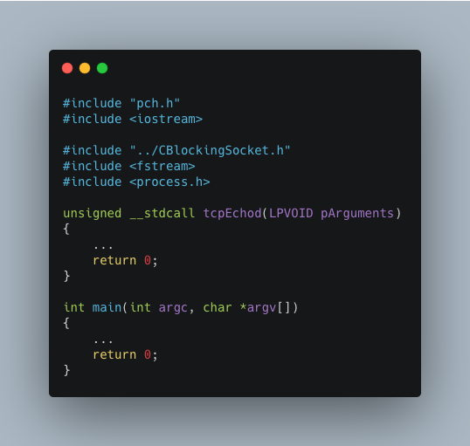

It is the main part of FileServer.
We begin new thread in it to connect multiple clients.
Use 8888 as default port to increase robustness.
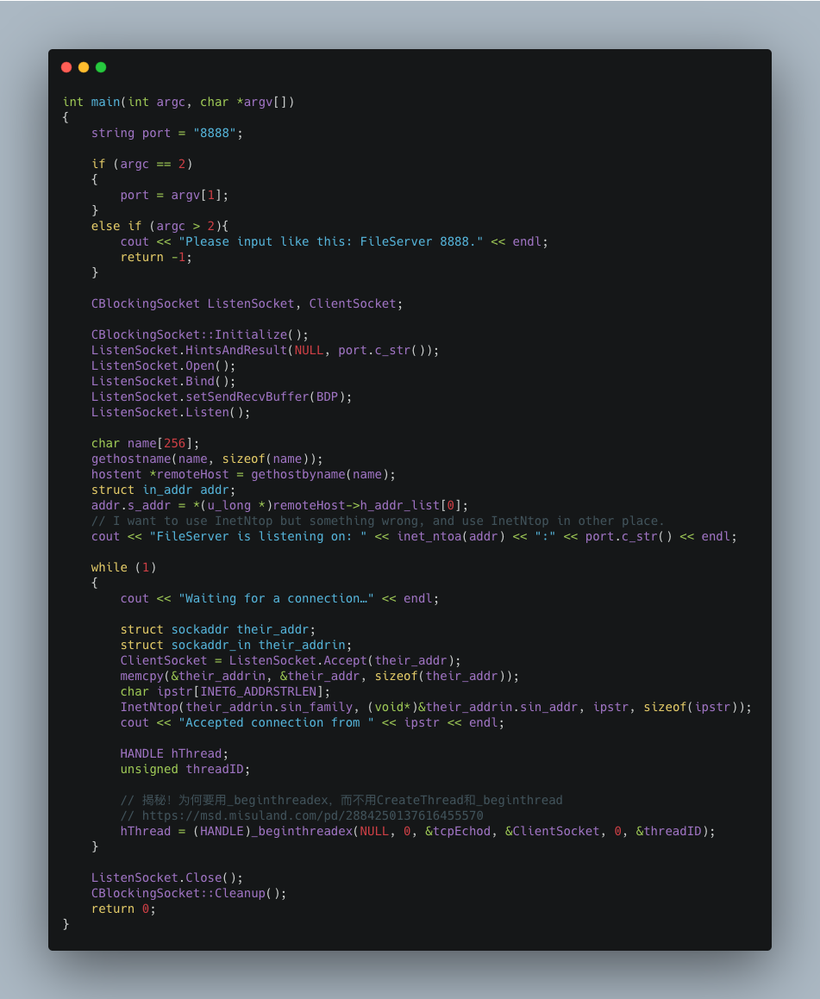

It is the thread function.
The __stdcall calling convention is used to call Win32 API functions. The callee cleans the stack, so the compiler makes vararg functions __cdecl. Functions that use this calling convention require a function prototype.
I use loop to send buffer. Judge if the file length is longer than the buffer length.
If ios::binary is specified to be turned on, the newline character is single-character, otherwise it is opened with two-character windows operating system.
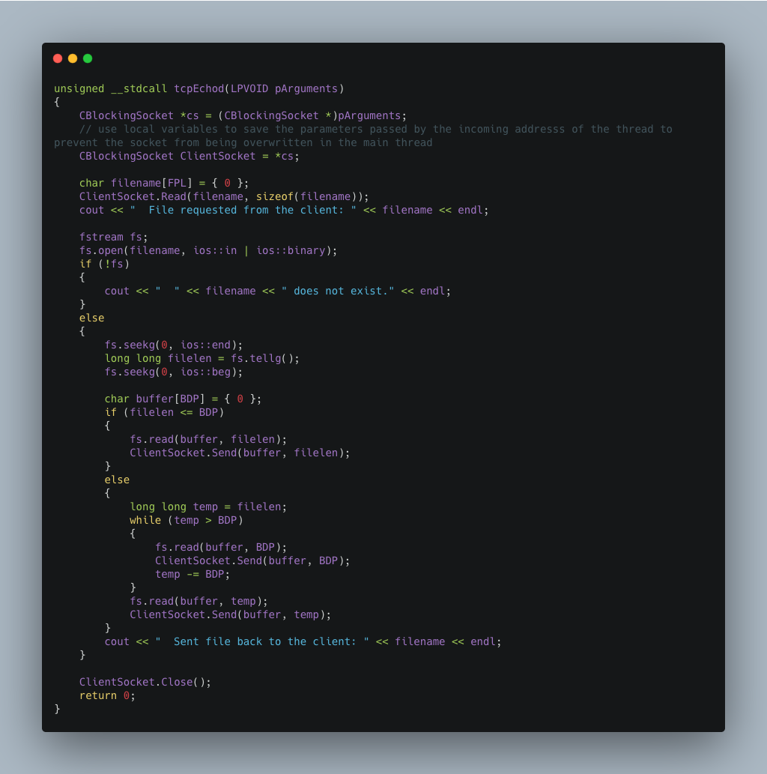

FileClient is a MFC program (Single Dialog).
This is the header file of FileClientDlg.
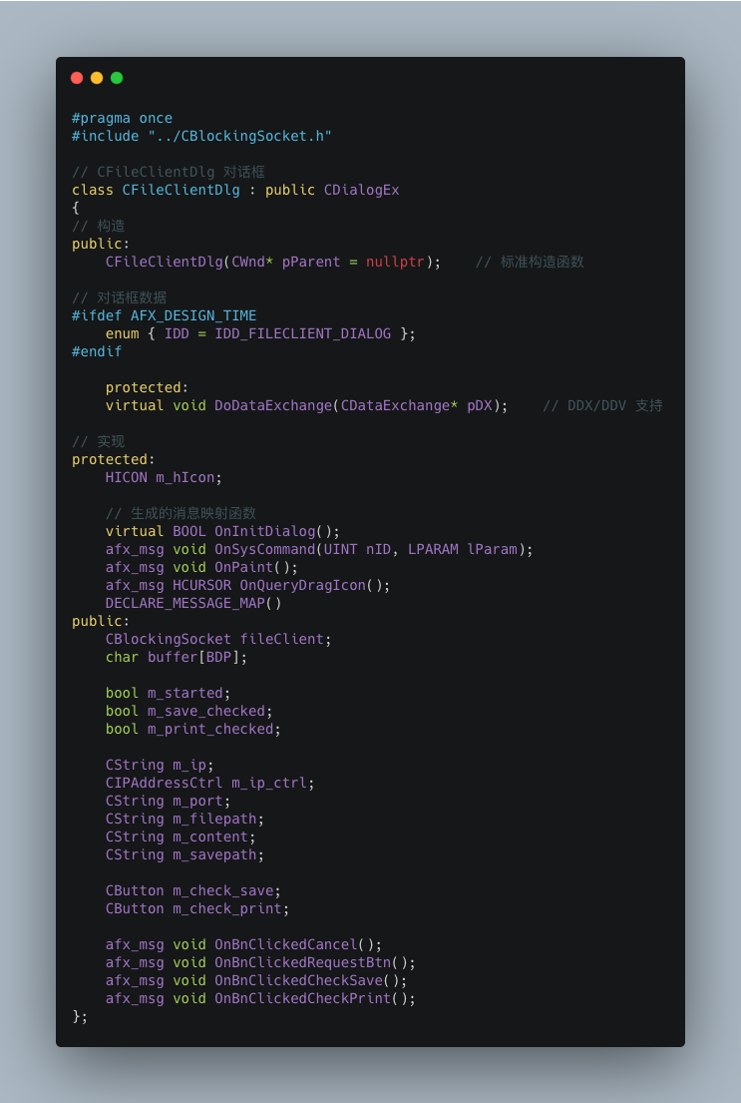

Bind data and message function.
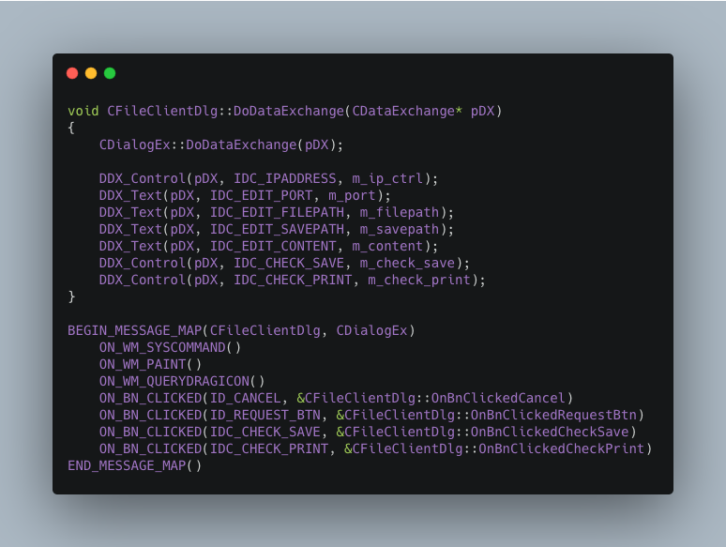

Init dialog.
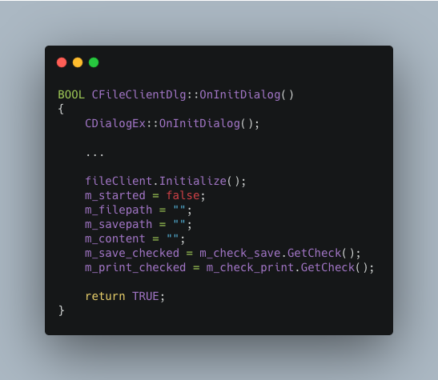

I use ios:app to open a file to add data to the end of it. If the file does not exist, create it.

Receive data from EchoClient and send same data back to EchoClient. Then wait EchoClient to close connection.
Judge if save to disk or print.(In fact, when the file is very big, the interface cannot display it.)
Also receive buffer by loop.
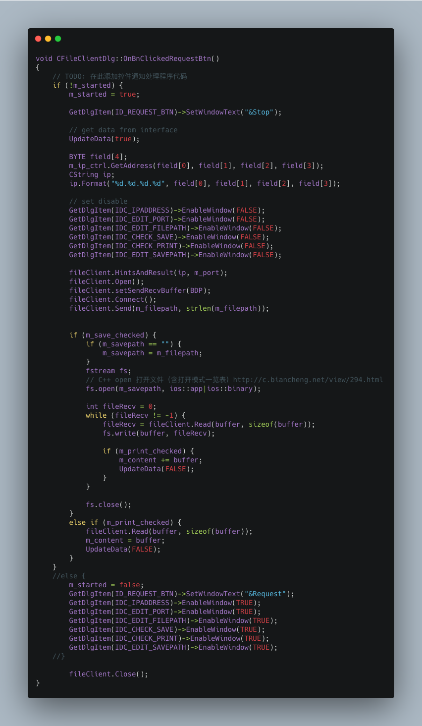
That's all the important parts, thank you for reading my report.

