FileTransfer Project Report
Project No.9
Version 1.0
Student ID: 201920081203009 Student Name: Yang Rui
2019-12-02
College of Computer Science and Cybersecurity, CUC

I declare that the assignment here submitted is original except for source material explicitly acknowledged. I also acknowledge that I am aware of University policy and regulations on honesty in academic work, and of the disciplinary guidelines and procedures applicable to breaches of such policy and regulations.

Name: Yang Rui Student ID: 201920081203009
Notes:

Section I Problem Specification
In this project, we should develop a file transfer server application and a client application. The application will run on top of UDP to transfer file and run on top of TCP to send/receive file name request/response commands, and we will need to implement a reliable protocol (similar to TCP) for the file transfer. The application client will be able to download a set of files from a server, which is directly connected to the client’s host. And get the application finish the transferring task as soon as possible.
This project is loosely based on a traditional file transfer application, the client requests a file name list from the server and sends a request to that server for the given file. In this project, since we can only use UDP as the underlying file data transfer protocol, we should implement the reliability control for our application, i.e., we have to design a retransmission mechanism to make sure the file downloaded is exactly the same as the copy in the server.

Windows Socket I/O background content is similiar to last 2 lab, so I don’t paste it here.

Basic Tasks
1. The first task is to implement a 100% reliable protocol for file transfer (ie: UDP DATA packets) between the server and the client with a simple error-control protocol (ie: stop and wait protocol ).
2. Client connect from a random unprivileged port ( 8026) to the servers command port (2121) and sends command to Request a file name list and Retrieve ( download ) the file from server over TCP.
3. The server would use port n-1 to send file data to the client port (n+1) over UDP.
4. The server should use the select I/O model to manage the incoming connections from the client over TCP.
5. The server should be a concurrent server that can provide downloading file service simultaneously for multi-clients (please write test cases in your report).
6. The Server should display relevant information about the current connection and downloading status.
7. The client should use multi-thread to download files.
8. The client should display relevant information about the current connection and downloading status (e.g. the downloading process information).

Below are the typical types of file sets to be transferred:
- A single huge file, e.g., a movie file, which is usually several GB in size;
- A mass of tiny files, e.g., log files, which are usually one or two KB in size;
- A combination of large files and tiny files.

Section II Solution Method and Design

Development Environment:
- OS: Microsoft Windows 10
- Language: C++
- Tool: Microsoft Visual Studio 2017

This is the project structure(use Object Oriented Programming with C++):
Some files are automatically generated:
- pch.cpp: source file corresponding to the precompiled header; required for successful compilation
- pch.h: header file corresponding to the cpp
- stdafx.cpp: standard application fram extend generated by MFC

I added three applications FileClientCmd(Console Application), FileClient(Dialog Application) and FileServer(Console Application) to the solution called FileTranasfer. So I can manage them in a solution.(It is also similiar to last lab FileCS.)

I'll explain the completion, problems and solutions for each task.

1. The first task is to implement a 100% reliable protocol for file transfer (ie: UDP DATA packets) between the server and the client with a simple error-control protocol (ie: stop and wait protocol ).

I use stop and wait protocol to ensure the realibility of my program.Due to time, I didn't implement the sliding window protocol, but I reserved some parameters for the sliding window at the header of message.
In fact, I let the server resend the message as long as it didn't receive the ACK within a certain time(I use 40ms).

- Client connect from a random unprivileged port ( 8026) to the servers command port (2121) and sends command to Request a file name list and Retrieve ( download ) the file from server over TCP.

I make the server listen to port(2121) by default. Of course, custom port is ok. At the same time, the port of UDP server is the result of the port of TCP server minus 1.
My client connect from a random unprivileged port to the server.
And we can input different commands in FileClientCmd to get a file name list or download a file from server.
When I open FileClientCmd, it will establish TCP connection to remote server on 2121 or custom port from a random unprivileged local port. (If I open FileClient(Dialog), it only connect server when I click Request button.)
Then if I input dir command, I can get file list info in server, not client.
If I input download command, I can input filename and save path to download it by UDP.
If I input exit command, the client will close TCP connect and exit. And the server will know the client is closed.
I use TCP to get file list, and send file name by client to server. Then server receive the file name, read it and send file data to client over UDP.

- The server would use port n-1 to send file data to the client port (n+1) over UDP.

The port in pdf is 2020. Maybe it's a pen error. So I make the server use port n-1 to send file data over UDP. For example, if the server TCP port is 2121, the server UDP port will be 2120.
If the server TCP port is 2333, the server UDP port will be 2332.
Because the client is connected from a random unprivileged port, so I get the client TCP port n first. Then send data to the client port(n+1). For example, if the client TCP port is 9999, then the client UDP port is 10000.

4. The server should use the select I/O model to manage the incoming connections from the client over TCP.

Select is a good thing. I write select in TCP socket class file. And the fifth argument is set to empty, which is to block all the time. Beacause we need wait client connect request.
I also use it in server UDP recvfrom to implement the function of time-out resend. I set the fifth argument(const timeval *timeout) to 40ms. When combined with the `while`, we don't even need to use SetTimer function.

- The server should be a concurrent server that can provide downloading file service simultaneously for multi-clients (please write test cases in your report).

We just need start a server, and it can provide connectivity for multiple clients.
I use while to wait for the initial connection over TCP server port. Once a tcp connection is established with the client, the program starts a thread to do the rest of the work. (Include UDP connection, receive command and download file. etc.)
The result of test cases see Section 3.

- The Server should display relevant information about the current connection and downloading status.

The server console can display current listen IP, port, and connection info from client. And I write a progress bar to show the progress of sending in server. It is also able to display the number of send bytes, check-error, resend packet(when not receive the ACK), file size, etc.(I hid them because it might affect normal display. )

7. The client should use multi-thread to download files.

In client, I use while to receive user command. And use thread to complete the work of download a file. This is better reflected in my MFC(FileClient(Dlg)).
For the console(FileClientCmd), I think it might be more convenient to open multiple clients.

8. The client should display relevant information about the current connection and downloading status (e.g. the downloading process information).

In client console, it display TCP&UDP connection info(ip & port) and download info(file size & download status).At first, I showed the data bytes of each download. But when you download a big file, it's tedious.
So I write a progress bar to display the progress of downloading in client. Of course, MFC can display status in edit box by UpdateData(FALSE).Due to timing issues, I did not further refine the MFC status bar.

Besides, I've had some minor problems.

When I use sendto function to send data, I use strlen(buf) as the third argument. But the message was sent only in part.
Reason: The strlen function encounters ''0' and doesn't go backwards.
Solution: msg.getSize() + MSG_HEADER_LENGTH

When I tested a large file, I found that the file size would be a little skewed.
After I added `Sleep(1)` before sendto function, i stopped the problem. It could be a problem that server sends too fast.

Class Diagram:
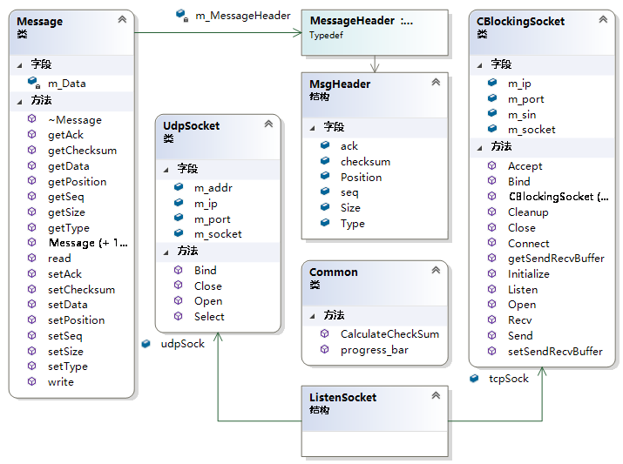
CBlockingSocket is the class that was used in the previous experiment. (Maybe TcpSocket Name is more appropriate for her.)
UdpSocket simply encapsulates some operation used to initialize and display info. (I didn't encapsulate sendto and recvfrom, because I want more flexible parameter settings, and it wasn't necessary, instead it could cause some errors.)
Message class is the format of message I define to send and recv.

This is the header of Message, total 19B.

Type | Seq | Ack | Position | Size | Checksum
Message Type | Sequence Number | Acknowledge character | Identities the relative position in the downloading file | The size of the Data field of current Msg | Check data
1B | 4B | 4B | 4B | 4B | 2B
Char | Unsigned int | Unsigned int | Unsigned long | Unsigned long | Unsigned short

Seq, Ack, Position. These three fields are mainly for the purpose of sliding the window.
The protocol of stop and waiting don’t need them.(I use seq to prevent the duplication of same packets caused by resend and loss of packets.)

I have predefined some command types for Type field.
When the client and the service side communicate, different types of files are generated because of different instructions.

#define COMMAND_DIR 1 // display file list
#define COMMAND_DOWNLOAD 2 // download file
#define COMMAND_EXIT 3 // exit client
#define COMMAND_TEST 4 // do test
#define FILE_DATA_SIZE 5 // msg content is file size, Data field is Null, and the Size field will store the size of file (instead data size)
#define FILE_DATA_REPLY 6 // the file data of server sending
#define FILE_DATA_ACK 7 // this msg is ACK
#define FILE_DATA_END 8 // this is the end of file

Then these are some constant number for buffer.

#define MSG_HEADER_LENGTH 19 // 1 + 4 + 4 + 4 + 4 + 2
#define MAX_COMMAND_SIZE 256 // enough
#define MAX_BUF_SIZE 65535 - 20 - 8 // MAX IP Length is 65535, we need minus IP header 20 and UDP header 8
#define MAX_DATA_SIZE (MAX_BUF_SIZE - MSG_HEADER_LENGTH) // then minus custom msg header 19 is our max data size

#define MAX_SEQ 15 // max seq and the max size of send window
#define NR_BUFS ((MAX_SEQ+1)/2) // half of seq, the max size of receiving window

#define TIMEOUT_RESEND 40 // 40ms the time for resend

This is the sequence diagram:

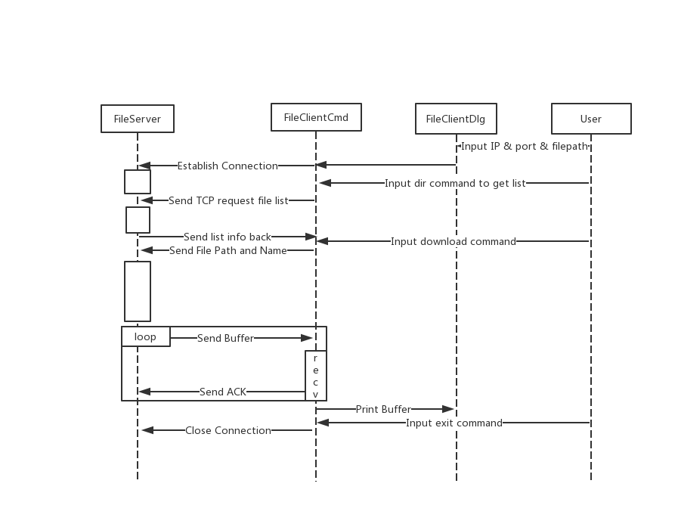

This is flow chart in FileServer & FileClient:
(More details about code and part function in appendix.)
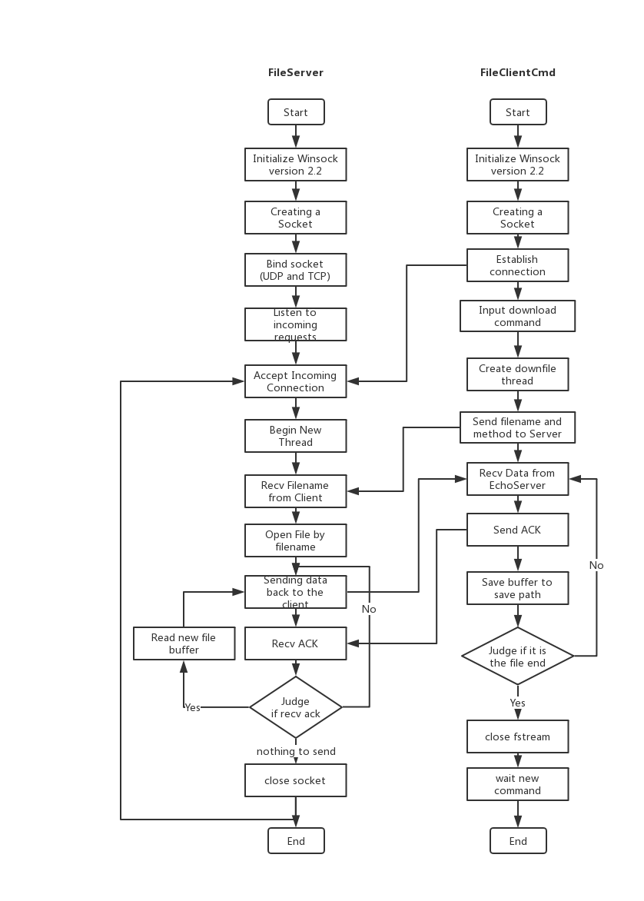

Section III Test Cases and Results Analysis

This is my test result:

1. Open FileServer.exe. (Listening on 2121, other customized port is ok.)It was listening on 2020 over UDP. (Use TCP port - 1)

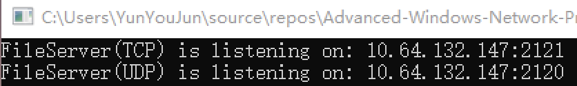

2. Open FileClientCmd.exe (You need start it in CMD by input IP.)
Example: FileClientCmd 10.64.132.147
It waits for our command. And Server showed the connection from where.

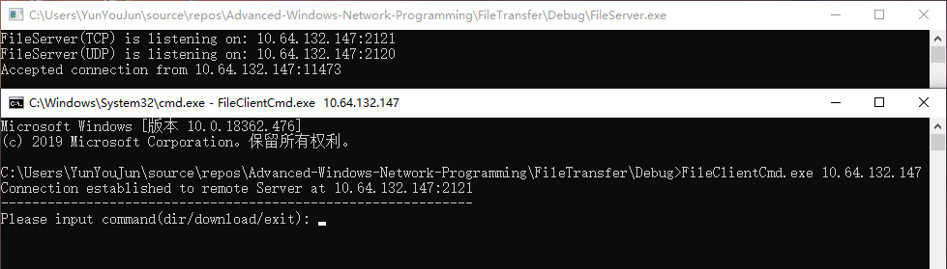

3. Input dir command to get file list. (This is showed in client. And the info is from server folder.) I took advantage of the system's dir command, and send the information back.

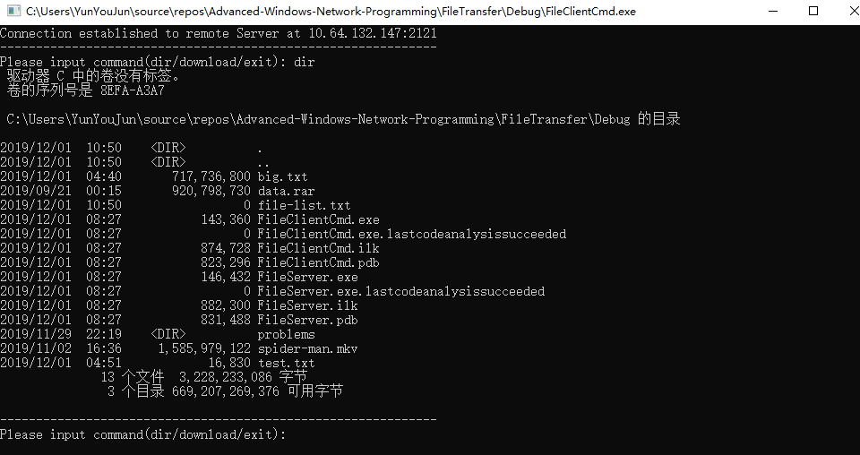

4. Input download command to download file. (This is a small file.) And it worked.

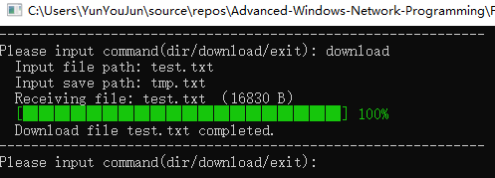
I put them in a same folder to see difference easily. (Their number of Bytes is exactly the same.)
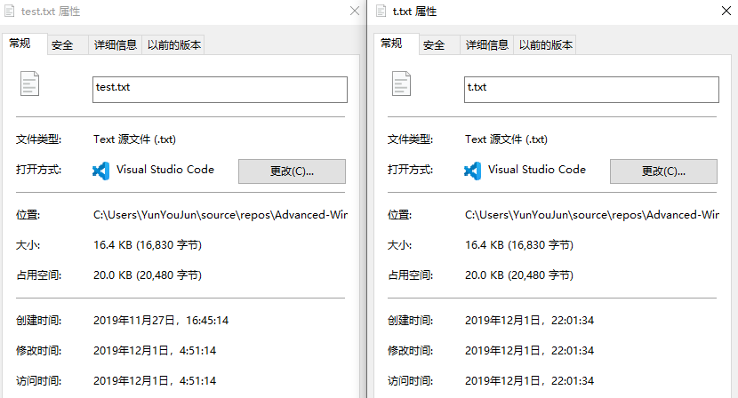

5. Now, let’s test some big files.
big.txt is ok. About 685 MB.

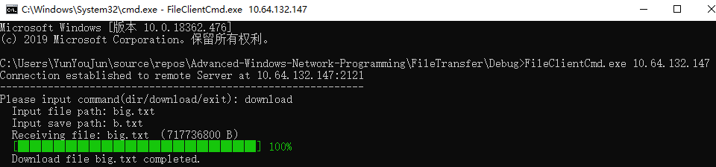

The movie of spider man: spider-man.mkv. About 1.5 GB.
We can see the percent of progress in console. And it worked too.

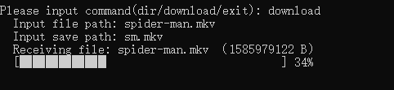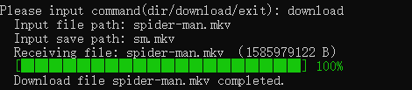

We can even watch it in the player. This means that this file is not corrupted.
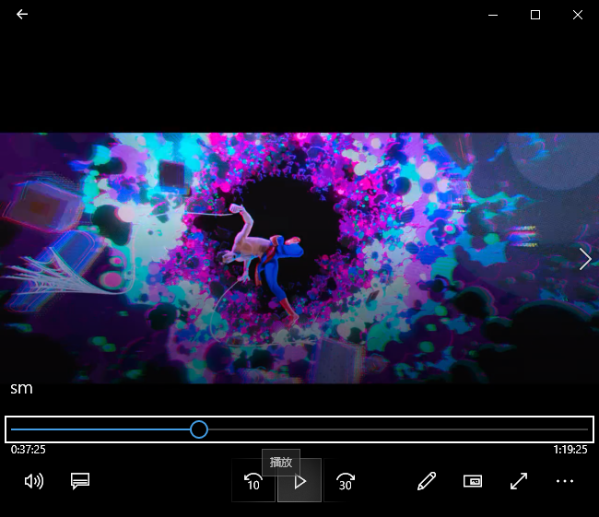

Just in case, I tested the compressed file. (data.rar) It is a collection of many small files.
About 878 MB.

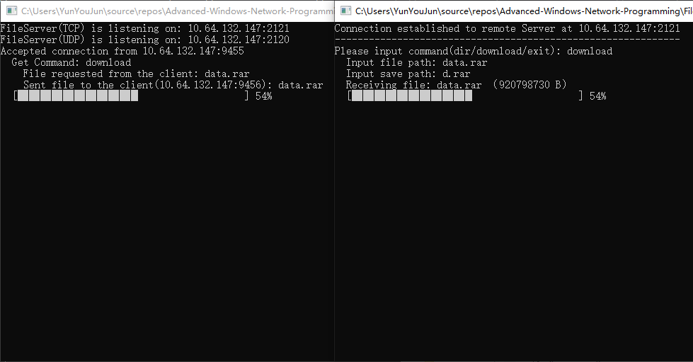

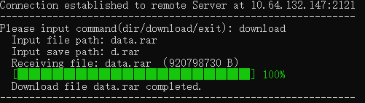

It can also be successfully opened.
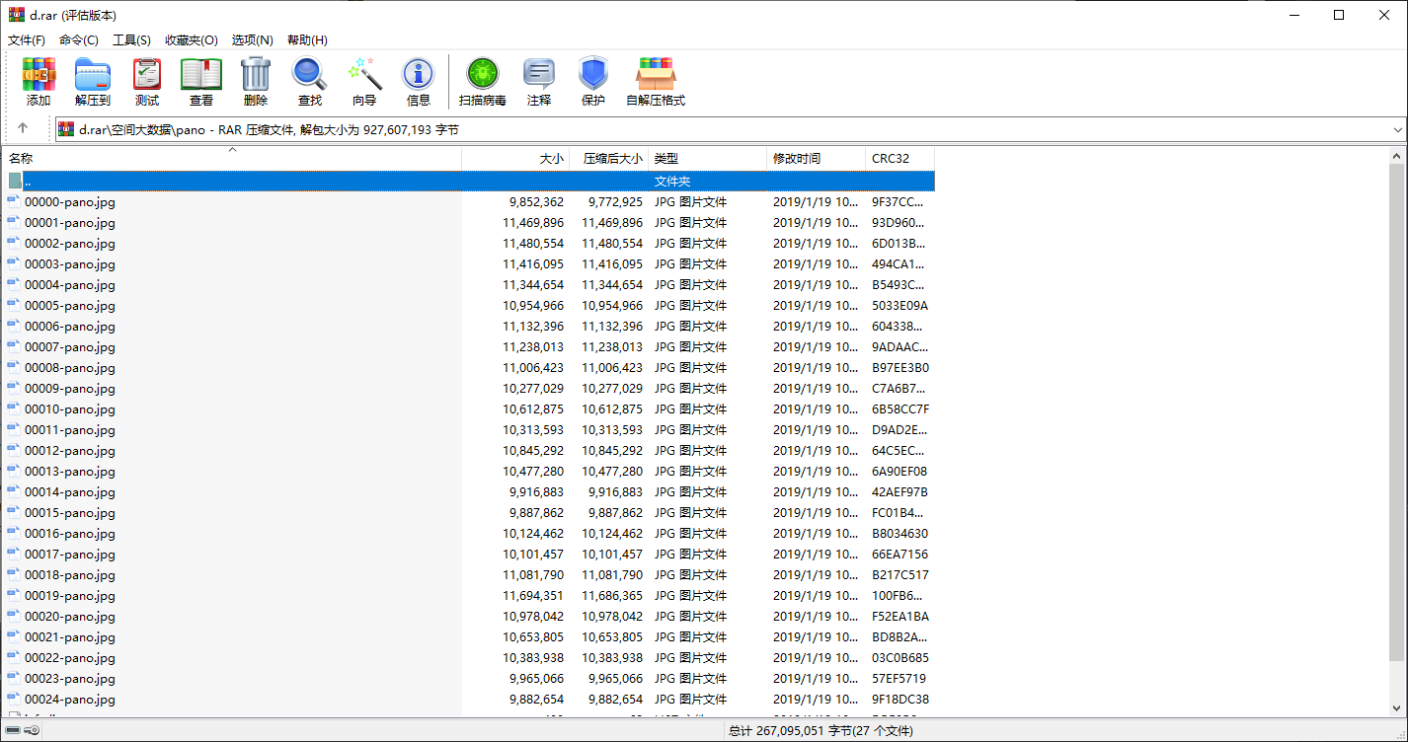

Here's some information from the server side.
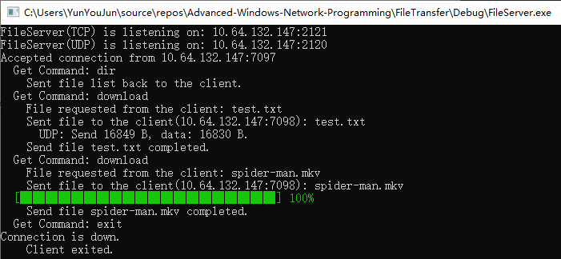

6. We also need to test the concurrency of the program.

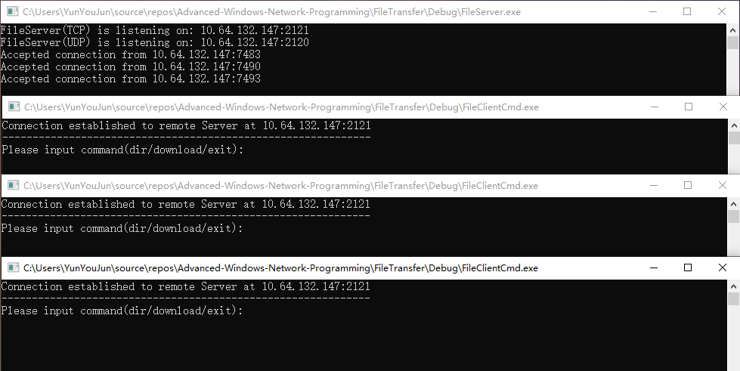

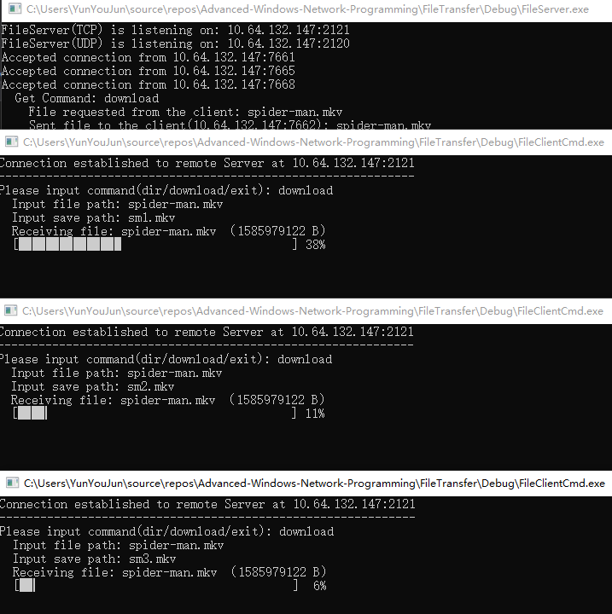

We can input exit command to close FileClientCmd.

7. I also write a MFC program for FileClient.(But due to time, it may not be perfect enough. ) Test with small file and big file.

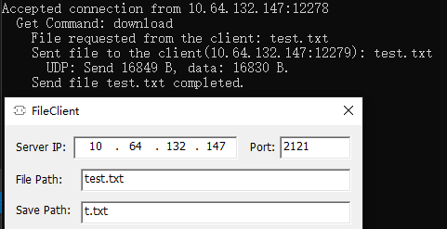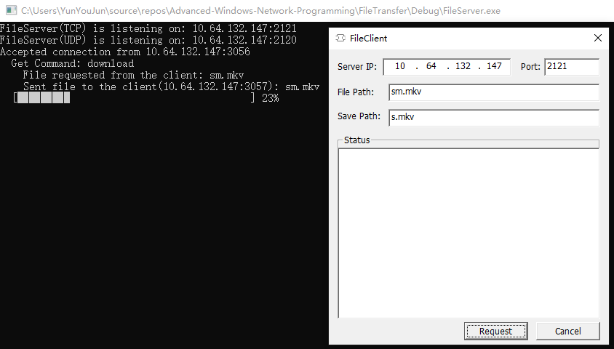

Section IV Conclusion
Through this experiment, I have a preliminary understanding of socket programming. The amount of code for socket programming is less and easier than the previous underlying protocol. But there are also many places that need to be carefully and meticulously.
I think I prefer to use high-level language to quickly implement the features I want, which will be very rewarding. And I've found that this content can actually be written using Node.js net, which eliminates some of the hassle of c++ debugging. Its core idea comes from C++. And its new async/await mathod makes it easy to realize synchronization and asynchronization; mechanism. It's also a cross-platform. If you allow it, I'd like to try Node.js to write the next experiment.
I wrote this project by an object-oriented approach. Object-oriented is really great. And I wrote a Console Application and a user interface(MFC) for FileClient. That’s very intersting. I didn’t write interface for FileServer, because I think server is controlled by geeks and it can be easier without an interface.

Section V References
- Windows Socket Get Started.pdf http://tlc.cuc.edu.cn/Course/Course/showAction/id/30
- Windows Socket Modern System Calls.pdf http://tlc.cuc.edu.cn/Course/Course/showAction/id/30
- Windows Sockets 2 | MSDN https://docs.microsoft.com/zh-cn/windows/win32/api/_winsock/
- C++ open 打开文件（含打开模式一览表）http://c.biancheng.net/view/294.html
- 为 Bandwidth Delay Product 调节 TCP 窗口https://blog.csdn.net/hzrandd/article/details/50578373
- 揭秘！为何要用_beginthreadex，而不用CreateThread和_beginthread https://msd.misuland.com/pd/2884250137616455570
- __stdcall | MSDN https://docs.microsoft.com/en-us/cpp/cpp/stdcall?redirectedfrom=MSDN&view=vs-2019
- Listing the Files in a Directory | MSDN https://docs.microsoft.com/zh-cn/windows/win32/fileio/listing-the-files-in-a-directory
- Recvfrom https://docs.microsoft.com/en-us/previous-versions/aa916174(v=msdn.10)?redirectedfrom=MSDN
- select function (winsock2.h) - Win32 apps | Microsoft Docs https://docs.microsoft.com/zh-cn/windows/win32/api/winsock2/nf-winsock2-select
- SetTimer function https://docs.microsoft.com/zh-cn/windows/win32/api/winuser/nf-winuser-settimer?redirectedfrom=MSDN
- 计算机网络高级软件编程技术（第2版） 清华大学出版社 吴功宜 董大凡 王珺 刘乾等 编著
- strlen遇上小端模式 https://www.cnblogs.com/renzhuang/articles/6952905.html

Section VI Appendix

Common.h
Calculate Check-sum function and progress bar function

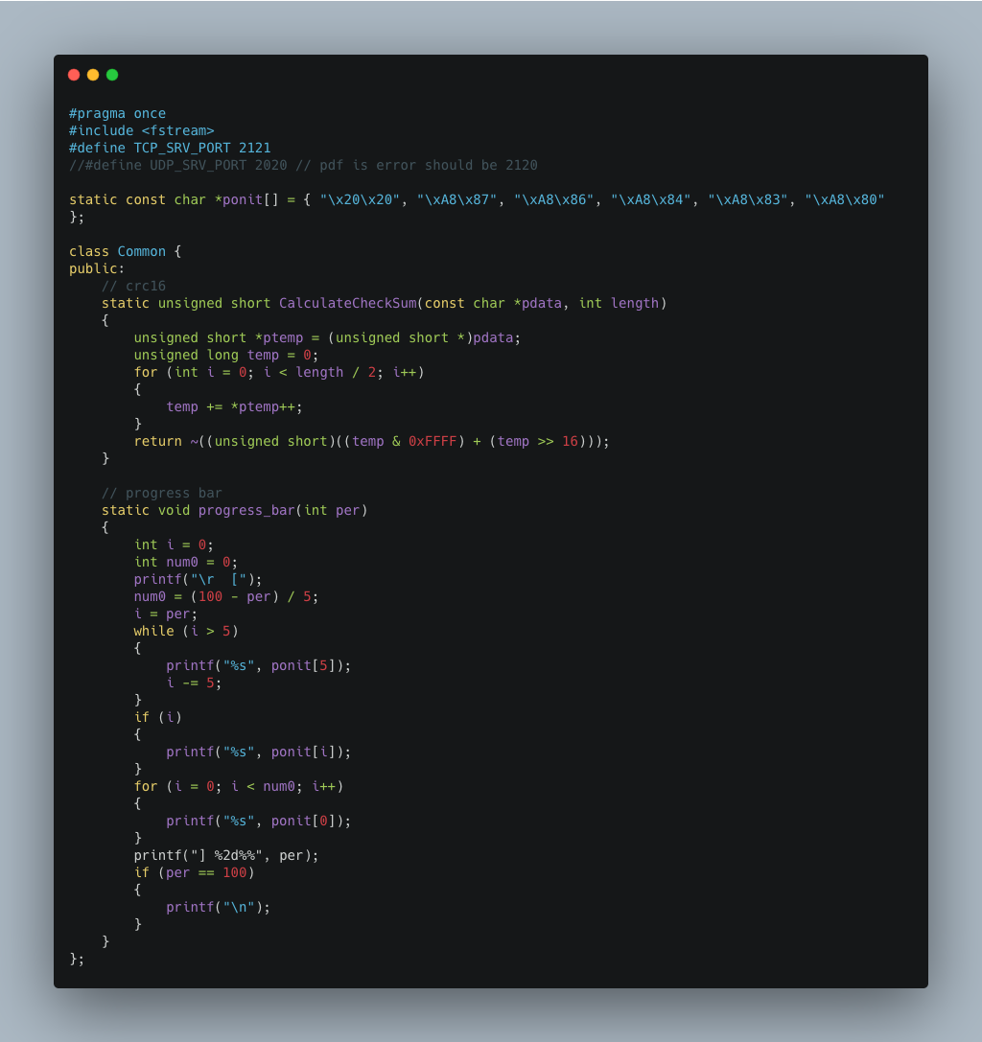

This is the class CBlockingSocket to handle socket.
I follow the structure in pdf to design it. And most code is similar to last lab, so I don’t paste it here.
CBlockingSocket for TCP.
I add select function in Accept method.
The fifth argument is Null, it means always blocking.

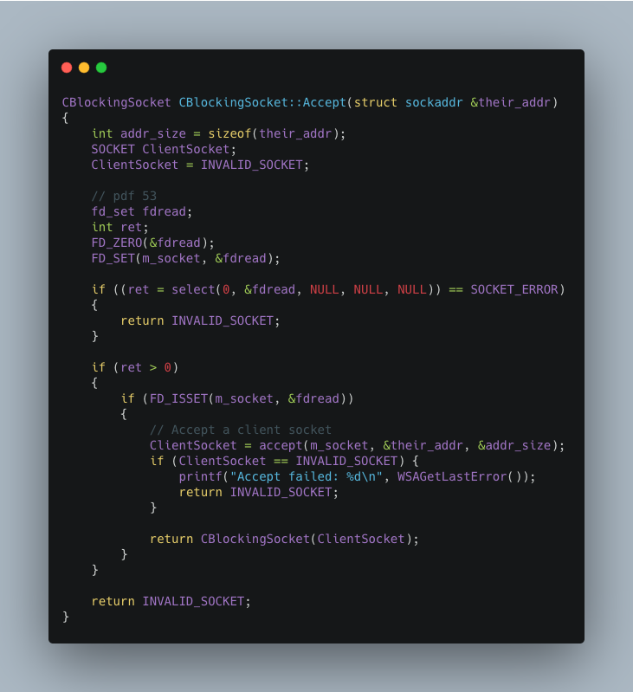

This is main code in FileServer.

This is the FileServer file matches the flowchart.
FileClient and FileServer use same class file CBlockingSocket. So include it by ‘../CBlockingSocket.h’. Of course, we should include “UdpSocket.h” & “Message.h”.

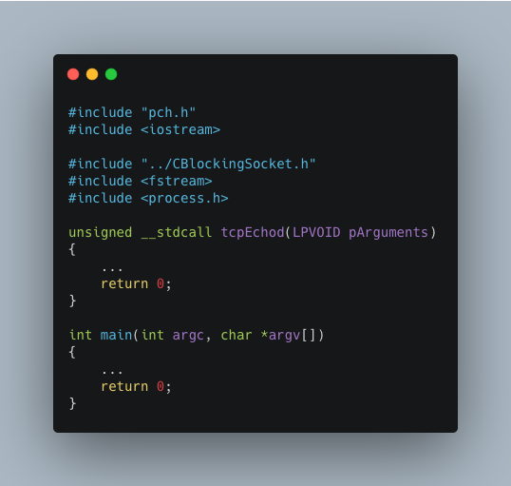

It is the main part of FileServer.
We begin new thread in it to connect multiple clients.
Use 2121 as default port to increase robustness.

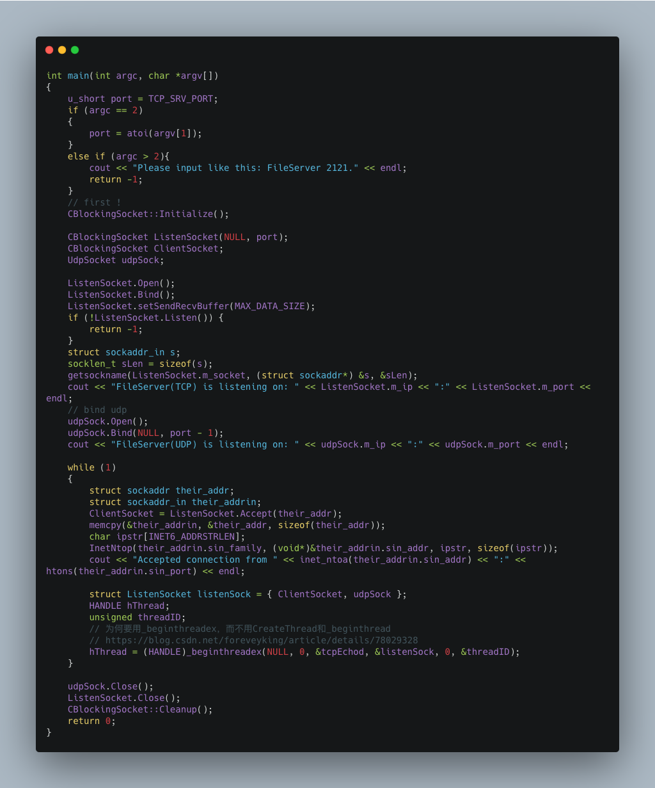

It is the thread function.
The __stdcall calling convention is used to call Win32 API functions. The callee cleans the stack, so the compiler makes vararg functions __cdecl. Functions that use this calling convention require a function prototype.
I use loop to send buffer. Judge if the file length is longer than the buffer length.
If ios::binary is specified to be turned on, the newline character is single-character, otherwise it is opened with two-character windows operating system.

Get file name list. I took advantage of the system's dir command, and send the information back.
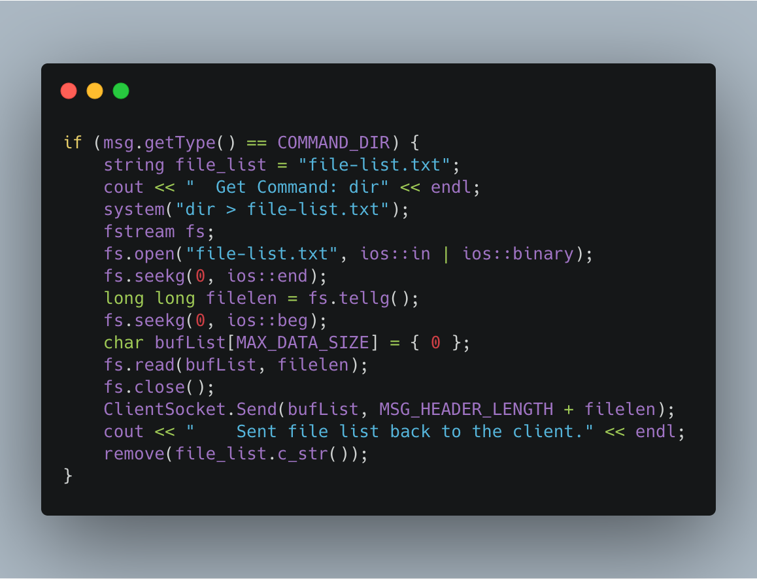

If server get download command, it first confirms the existence of the file. And send the msg which store file size info back to client.

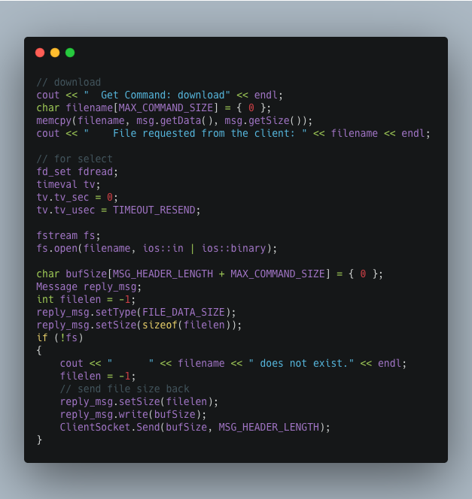

Then use select to implement the function of timeout resend.
Encapsulating the file data in message.
The server will stop re-sending only when accept the ACK from client.
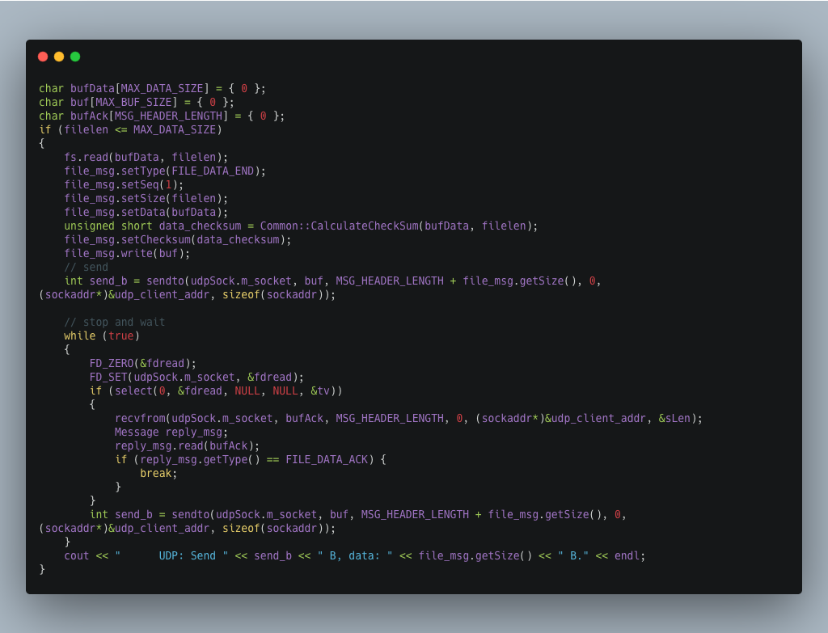
(If the file size larger then MAX_DATA_SIZE, we can add a loop for it.)

FileClient is a MFC program (Single Dialog).
Bind data and message function.
Init dialog.
Some content is similar to last lab. Can be seen in last project report.

FileClientCmd is a Console Application program. (can see download progress bar)

I use ios:app to open a file to add data to the end of it. If the file does not exist, create it.
Before write it, I use this way(ios::out) to clean the data of file.

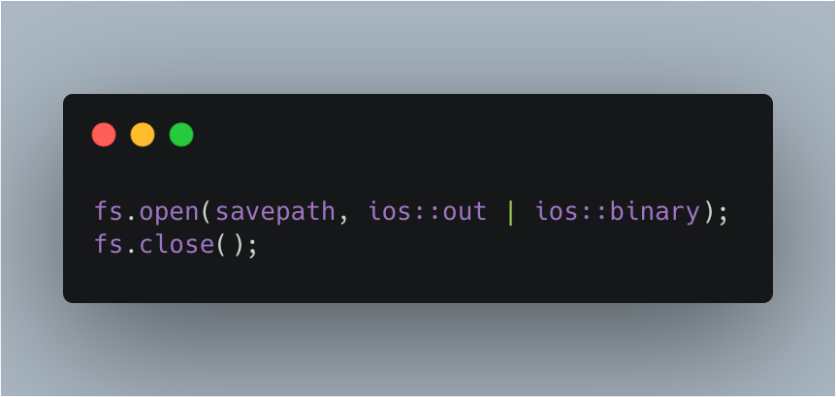

FileClient also receive data buffer by loop. And send ACK back to server. If client get a same packet is same as last packet(This situation is caused by the loss of ACK.), drop it and send ACK again.
Calculate check sum to ensure packet is right. (In fact, UDP itself has been verified.)
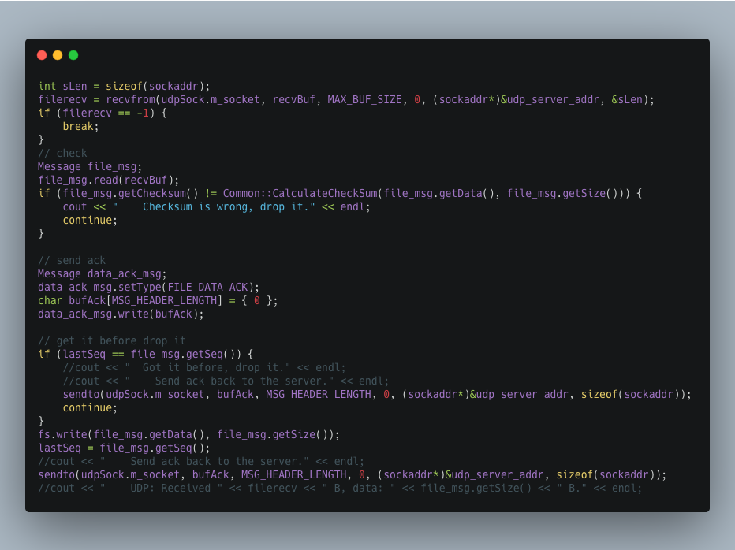
That's all the important parts, thank you for reading my report.

