TraceRoute Project Report
Project No.5
Version 1.0
Student ID: 201920081203009 Student Name: Yang Rui
2019-10-27
College of Computer Science and Cybersecurity, CUC

I declare that the assignment here submitted is original except for source material explicitly acknowledged. I also acknowledge that I am aware of University policy and regulations on honesty in academic work, and of the disciplinary guidelines and procedures applicable to breaches of such policy and regulations.

Name: Yang Rui Student ID: 201920081203009
Notes:

Section I Problem Specification
The purpose of this project is to develop a software tool “TraceRoute” that is used to discover the routes that packets actually take when traveling to their destination.
The more traditional traceroute sends out either UDP or ICMP ECHO packets with a TTL of one (Unix and CISCO IOS traceroute does UDP tracerouting, while Windows ‘tracert’ does ICMP), and increments the TTL until the destination has been reached. By printing the gateways that generate ICMP time exceeded messages along the way, it is able to determine the path packets are taking to reach the destination.
I plan to run it in windows, so I use ICMP.
This program should be able to list out the intermediate gateway and the time-delay to that gateway.The “Trace” function should be processed through threads, and post messages to the main thread for updating user interface.

Protocol Data Unit Encapsulation (IP Packet):
Ethernet Header | IP Header | ICMP Header | Data | Ethernet Trailer
14B | 20B | 8B | 4B | 4B

IP Header + TCP Header + Application Data = 46 to 1500 B

The IPv4 (Internet Protocol) header:

A row is 32 bit.
Version | IHL | Differentiated Services | Total length
Identification |  |  |  | DF | MF | Fragment offset
Time to live |  | Protocol | Header check sum
Source address
Destination address
Options(0 or more words)

ICMP Format:

4 byte header:
• Type (1 byte): type of ICMP message
• Code (1 byte): sub-type of ICMP message
• Check-sum (2 bytes): similar to IP header check-sum. Check-sum is calculated over entire ICMP message
If there is no additional data, there are 4 bytes set to zero. Each ICMP message is at least 8 bytes long.
Ping Frame Format：

Type(8 or 0) | Code(0) | Check-sum | ID | Seq. No. | Data
1B | 1B | 2B | 2B | 2B | 4B

ICMP (timeout error message) Format:

ICMP Header | IP (error) Header | ICMP(error) Header
8B | 20B | 8B

Section II Solution Method and Design

At first, we need install WinPcap. Download it and link it with VS 2019.
- Property Pages -> C/C++ -> General -> Additional Include Directories -> Add `..\WpdPack\Include`
- Property Pages -> Linker -> General -> Additional Library Directories -> Add `..\WpdPack\Lib`
- Property Pages -> Linker -> Input -> Additional Dependencies -> Add `wpcap.lib`&`ws2_32.lib`&`Iphlpapi.lib`

This is the project structure(use Object Oriented Programming with C++):

Some files are automatically generated:

- Resource.h: define interface element id
- stdafx.h: precompiled header file
- TraceRouter.cpp: main dialog and control message and thread

This is class diagram:

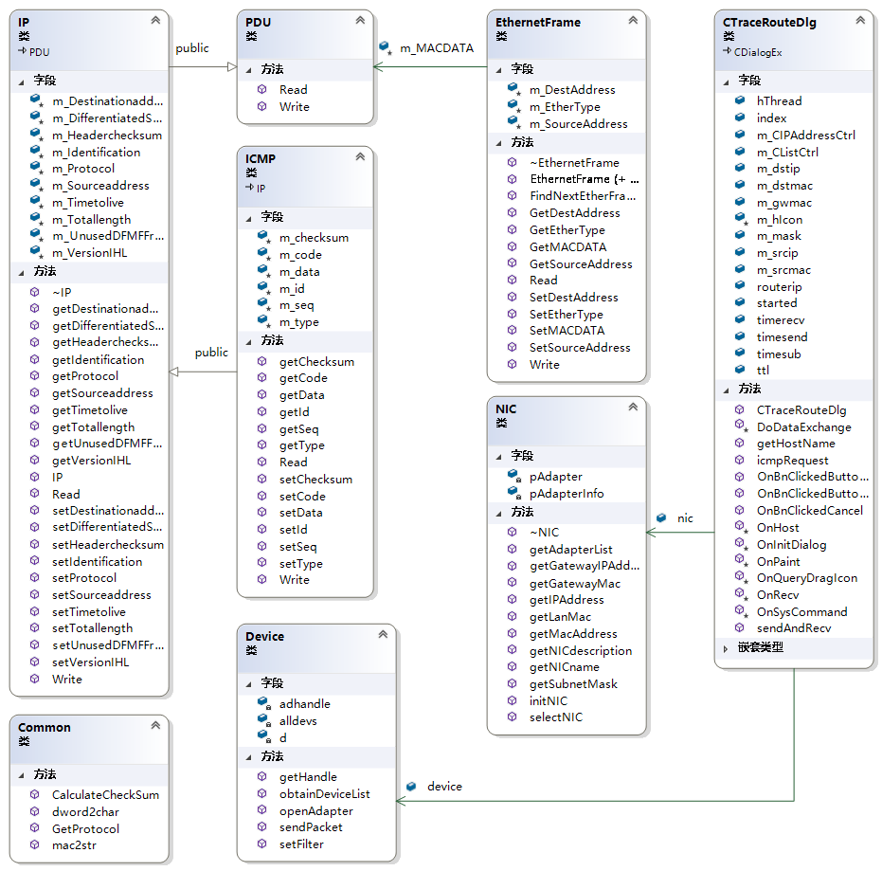

This is sequence diagram:(This is very similar to the previous project figure, just adding the sending part.)
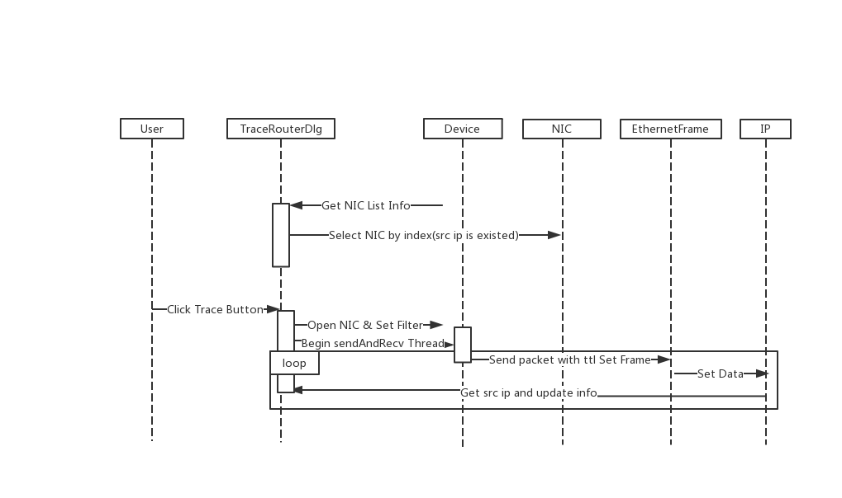

This is flow chart in TraceRouterDlg file:
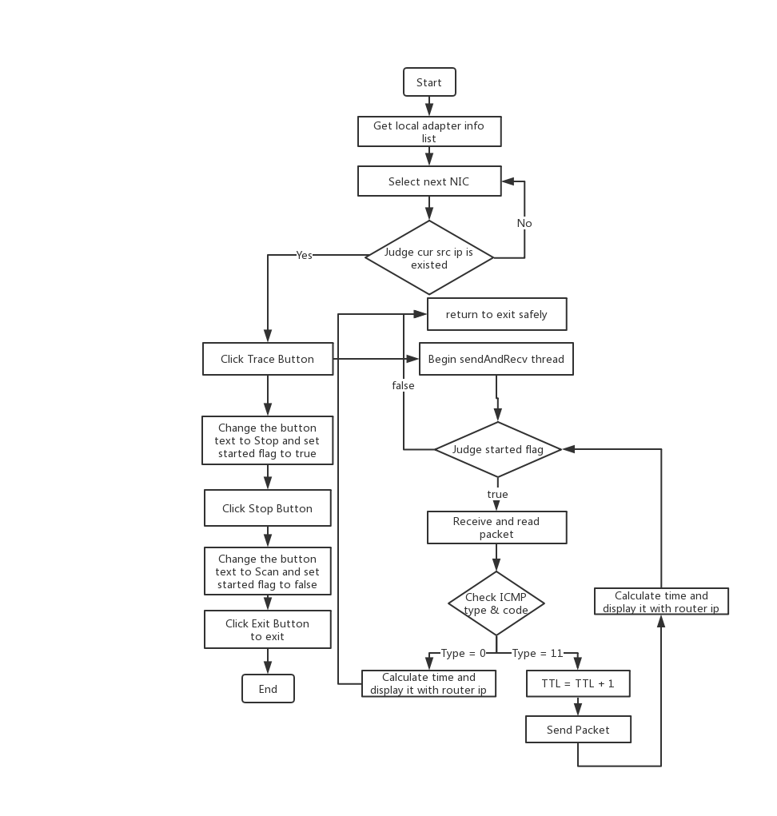

Section III Test Cases and Results Analysis

This is my test result:

- Basic Interface

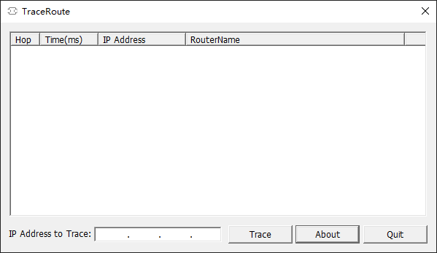

- Input IP and Click Trace Button.
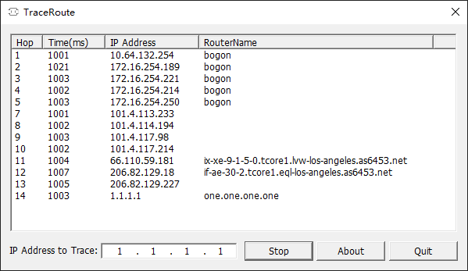

- Click About Button (This is my logo. XP )

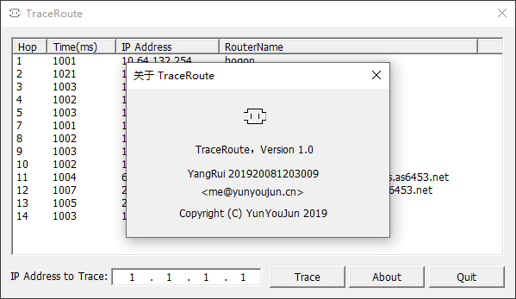

- Use ‘tracert’ command in windows CMD.
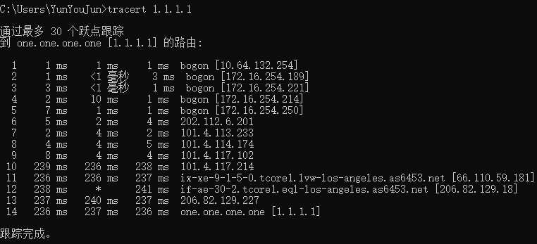

Section IV Conclusion
Through this experiment, I have more deeper understanding of the operation of IP protocol and ICMP format. I learned how it worked and referred to some of the code on the web to implement it. At the same time, I made extensive use of classes and improved the re-usability of the program code.
In this experiment, I found some problems and solved them.
Example 1:
When testing on our campus LAN, I found that sometimes packets sent to the router would not receive a response. In order to solve this problem, I calculated consumed time. When it exceeds 3s, it judges that it is timeout and sends packet with (ttl + 1) again. Then, we can continue to trace it.
Example 2:
The ICMP packet with timeout error message also contains the error IP header and ICMP header in the part of its data. So we can just memcpy its id by calculating the offset of id.
I also learned the benefits of object-oriented language, and now the experiment is easier to complete.

Section V References
- WinPcap: Exported function https://www.winpcap.org/docs/docs_40_2/html/group__wpcapfunc.html
- Unit 5. Internet Control Message Protocol.pdf http://tlc.cuc.edu.cn/Course/Course/showAction/id/30
- EtherType: 以太网类型字段及值 ｜ CSDN https://blog.csdn.net/eydwyz/article/details/65446328
- IP 协议（Protocol）字段描述 https://blog.csdn.net/weixin_40552292/article/details/90417931
- ICMP 百度百科 https://baike.baidu.com/item/ICMP/572452?fr=aladdin

Section VI Appendix
This is the basic flow that matches the flowchart.(main content in TraceRouteDlg.cpp)

NIC\PDU\Device\IP is similar to last project.

Common.h (Common Helper)
It is used to convert some formats or get protocol and check-sum.

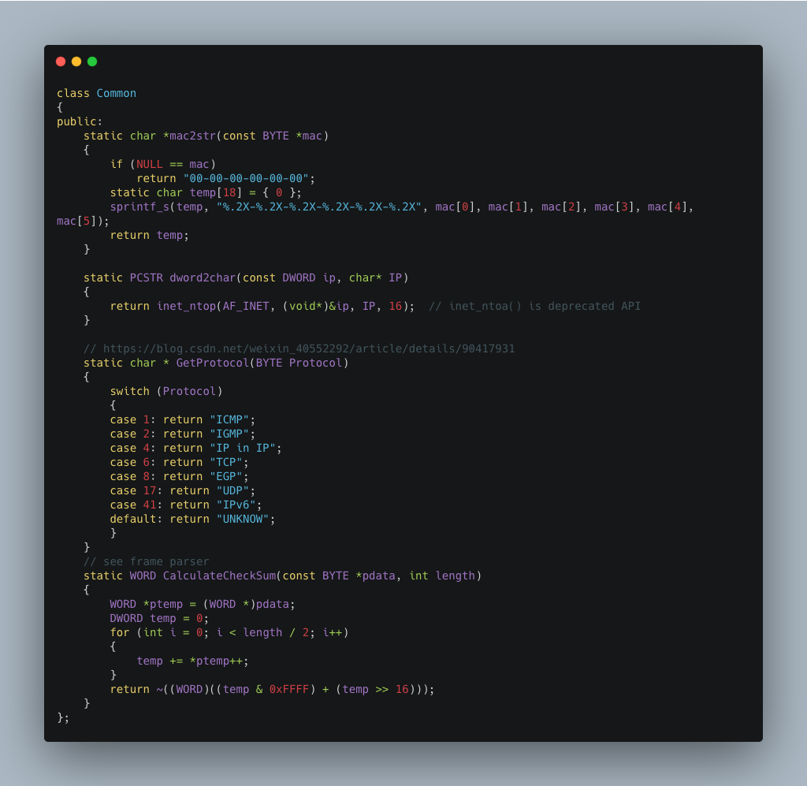

Bind Variable to MFC components(IPAddressCtrl can input IP with format):
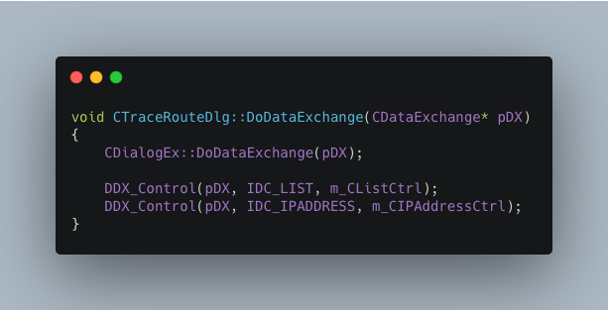

Bind Message with function:
WM_RECV message is used to trigger OnRecv & OnHost function.
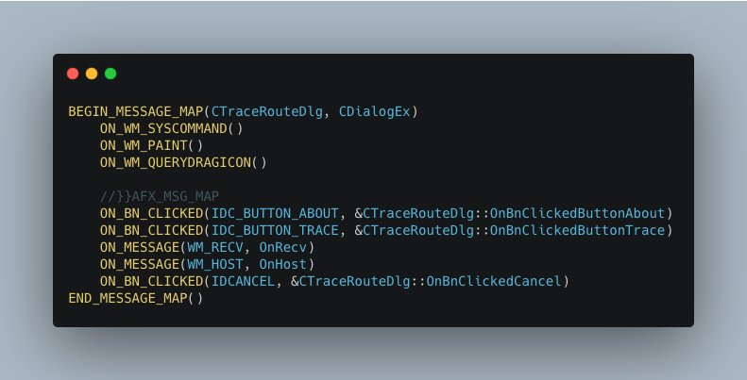
Initialize dialog (auto select NIC by source IP is existed):
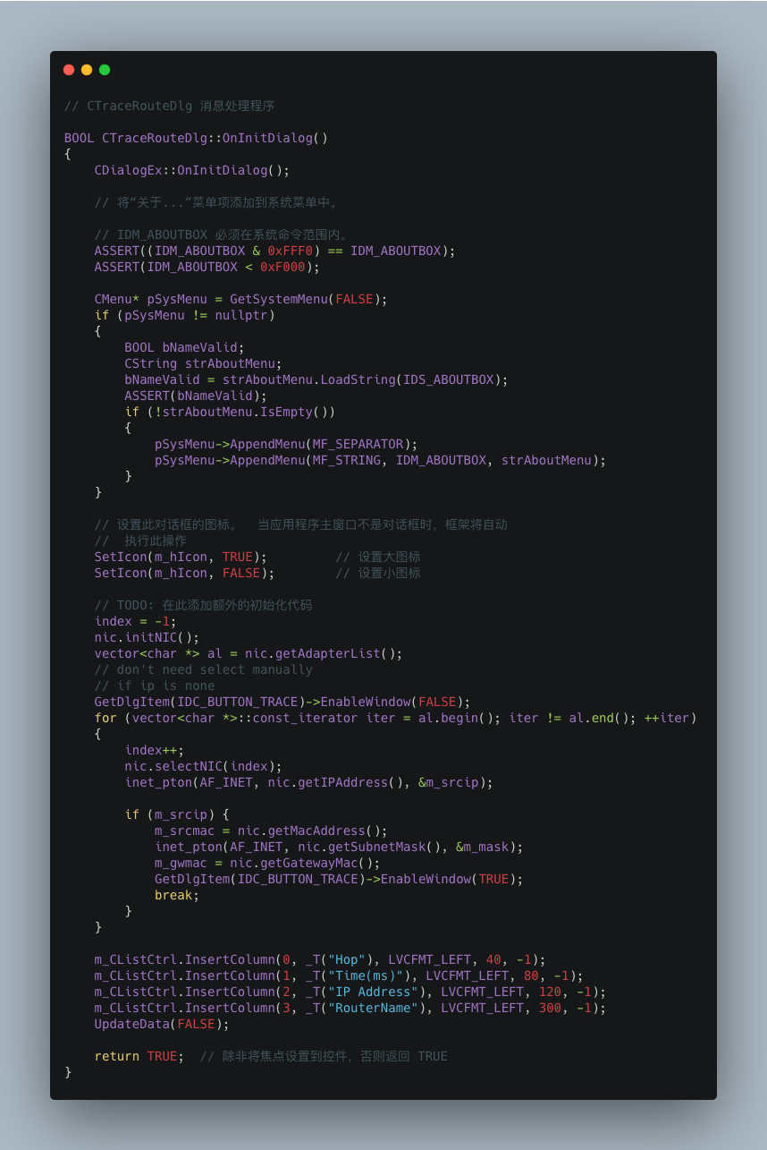

Trace Funtion(Run when the scan button is clicked):
Create the thread of receiving packets.
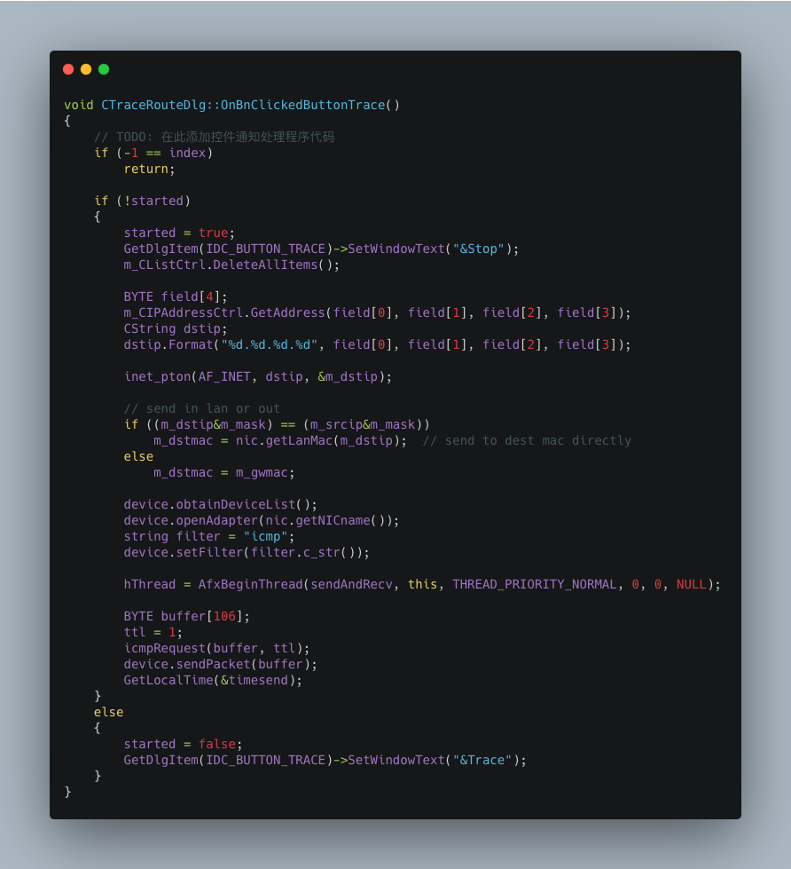

Receive packets and judge their type & code(send packet with ++TTL), then display it.
It also starts a thread to get host-name.

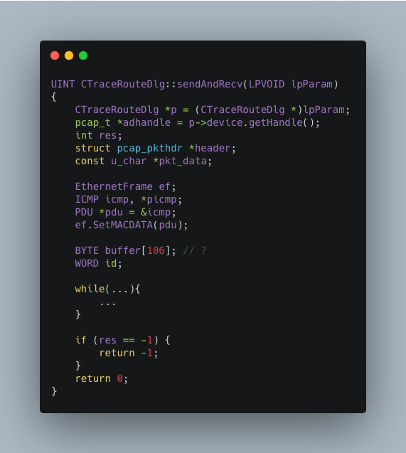

Next is the part of while:
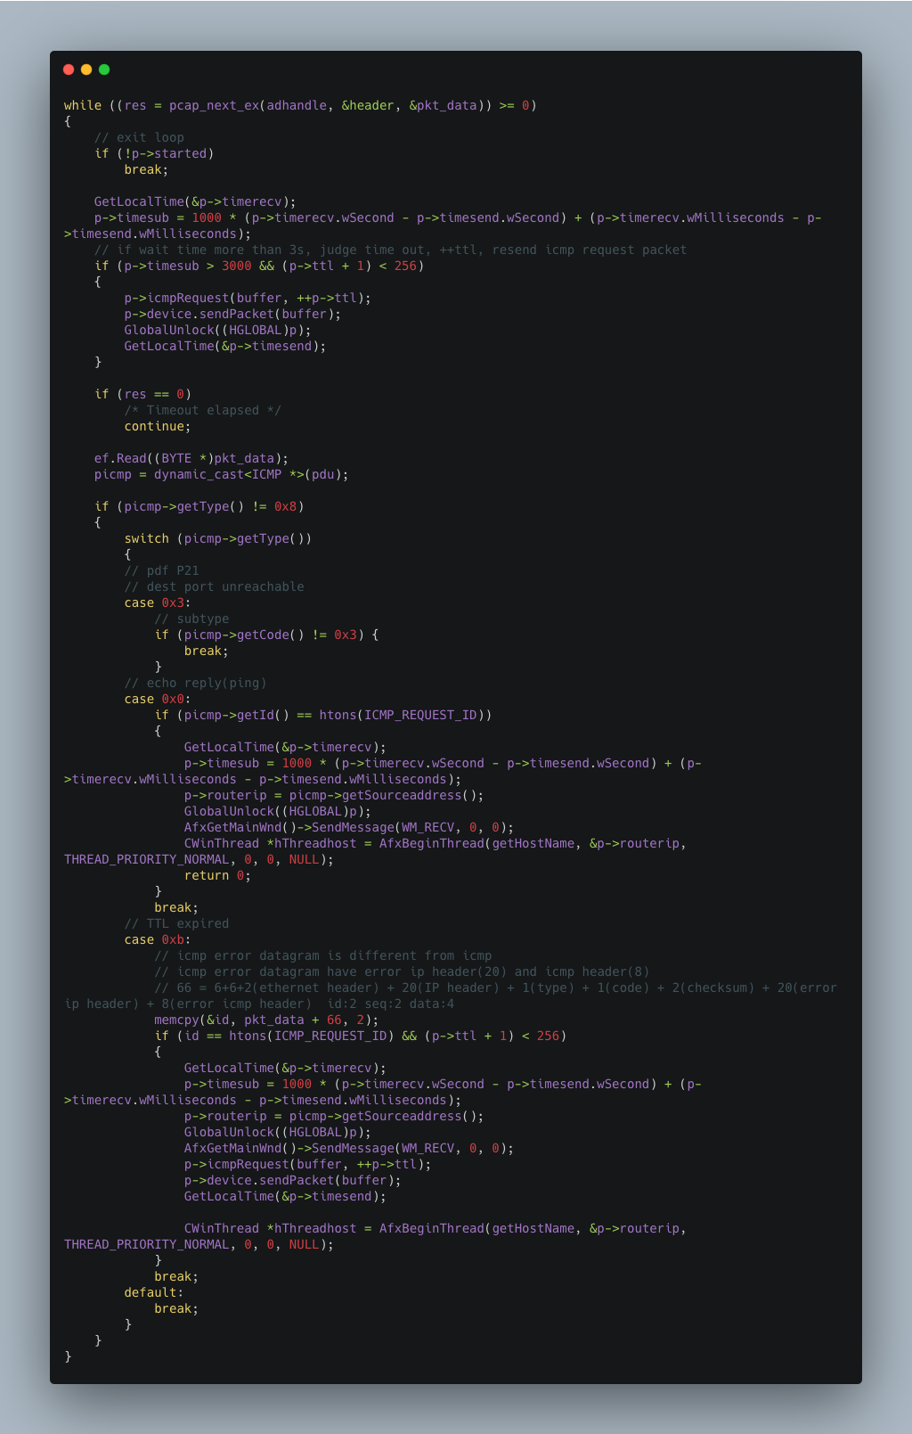

Triggered by the message, update the interface.
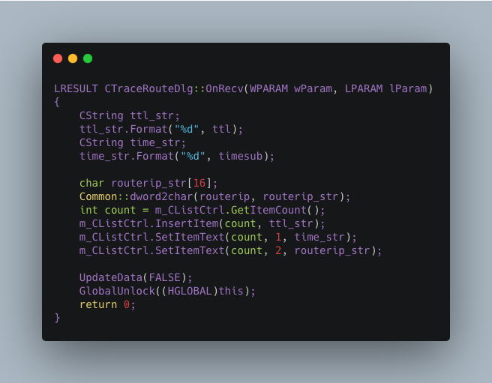

Get host-name(It is separated as an independent function because it may take some time.)
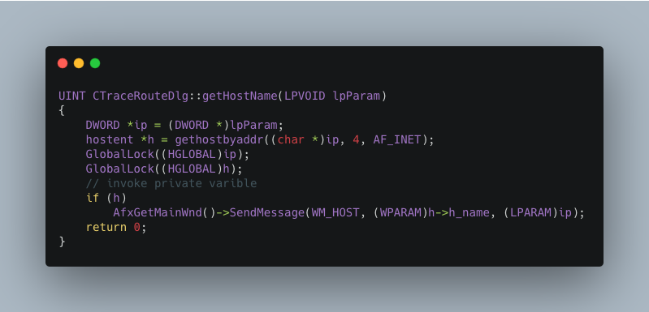

Update host name to CListCtrl by comparing IP.
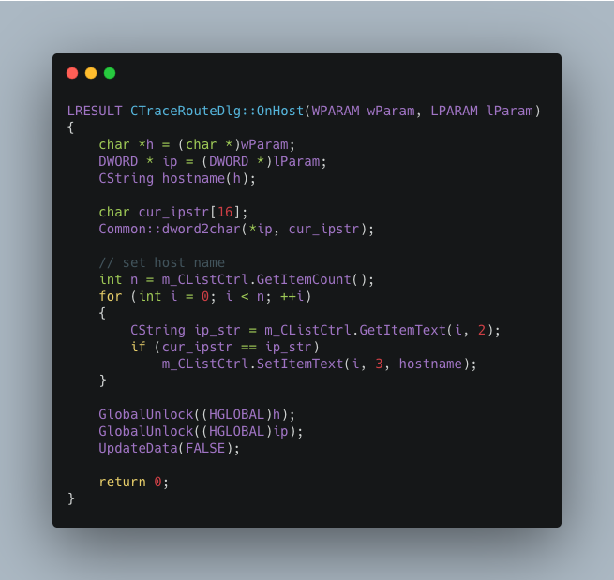

Encapsulate ICMP request package.

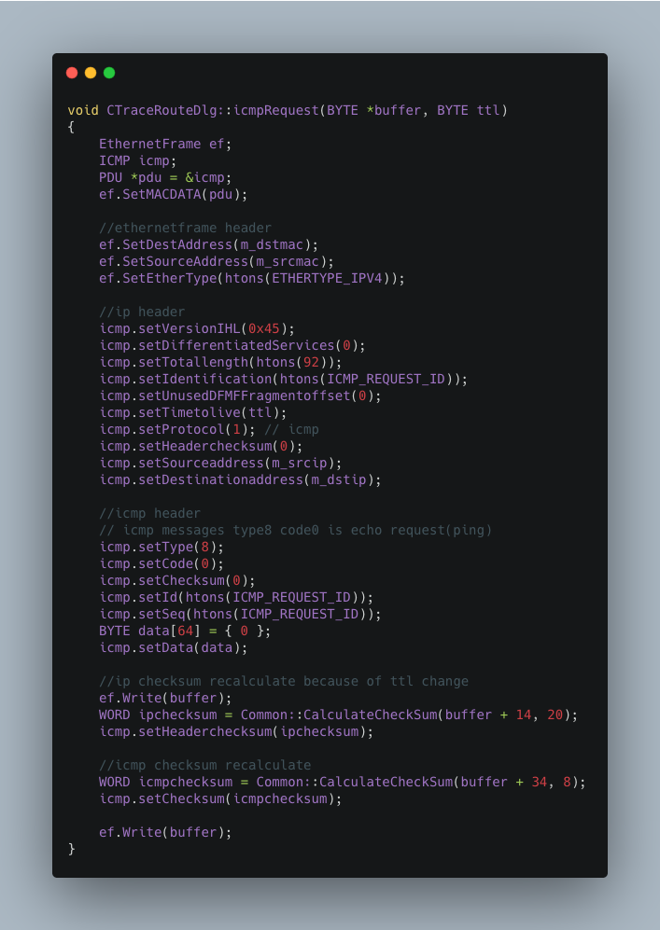
That's all the important parts, thank you for reading my report.

