**Artificial Intelligence I**, *prof. Pasquale Caianiello 22.01.17*

Project: Logical Agents. *Presented by: Yuna Frolov*

After researching the book *Artificial Intelligence, A Modern Approach - 2nd Edition (Russel - Norvig)* – I found and introduction of the game, and I had the idea to work on it from there.

Hunt the Wumpus

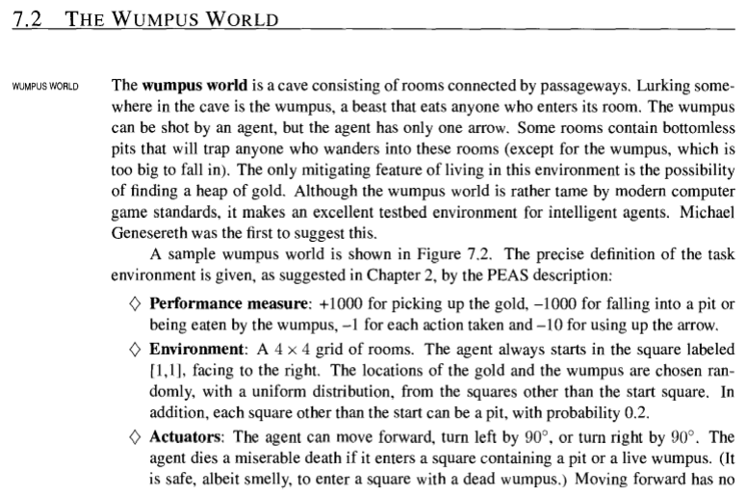

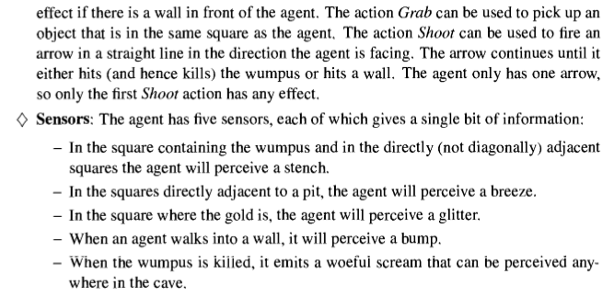

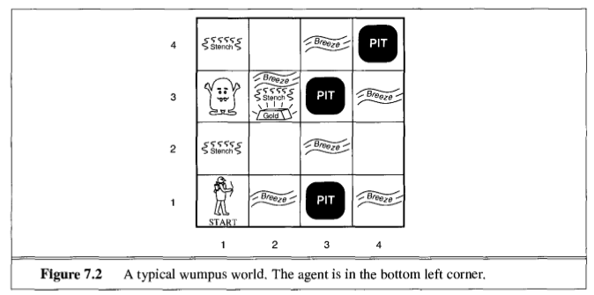

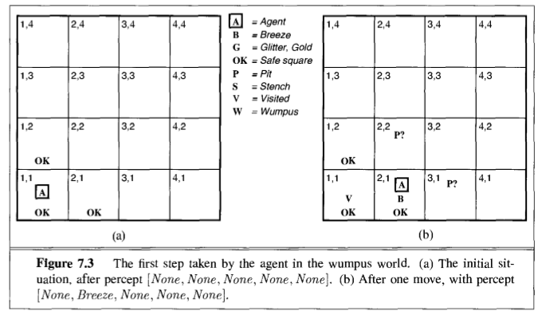

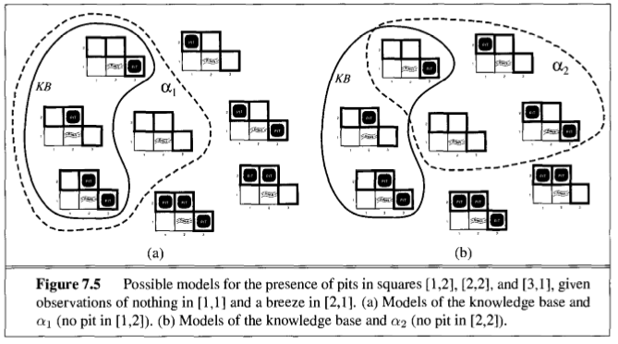

[Explanation taken from the book mentioned above]

**__init__.py**

**\*In my implementation I have not considered the possibility to kill the wampus, or his movement.**

I have worked with 1 Prolog file:

**wumpus.pl:**

The File starts with the **initialization** of the world and placements of the objects and agent. You can play with the locations to get different outcomes.

Next come the **states** the agent can be in; fallen to a pit, eaten, found the gold or just continuing the search.

Then, to help us combat the perception we have the part of **Perceptors** and **Perception –** we can know what perception the adjacent squares have – can the agent feel a stench, a breeze, a glitter – to know if he is close to a wampus, pit or gold respectively.

Then, we have the **Knowledge Base** part – which uses the perception to identify where there is no threat or there is a possibility for a pit or a wampus (or gold) – and these are added to the knowledge base to avoid (or go towards gold).

**Updates** take care of time elapsed and score gained. Also, each time the agent moves, his location is updated.

The **Start** of the game is the finalizing code of the file, queueing the initialization and running the simulation: Following the first-order logic, each time a step is taken by the agent the visited list, and all following updates, are updated. The **simulation** reports what the agent is seeing and where it is going, and when a game is over the result is printed.

**__init__.py**

Here are some runs of the program on my machine: (To start the game just type ‘start.’)

**In case of a win:**

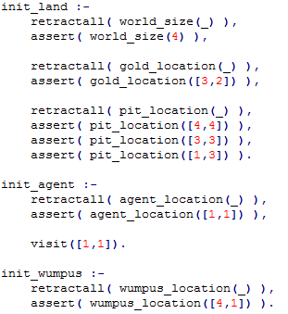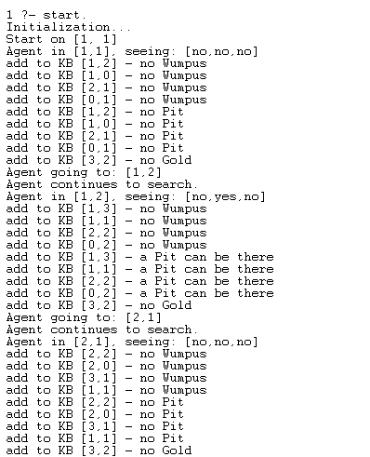

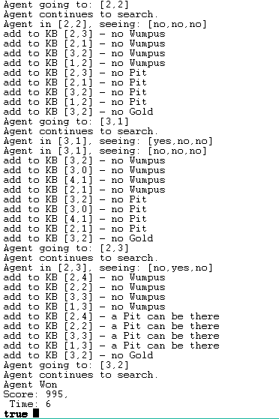

**__init__.py**

**In case of a Loss:**

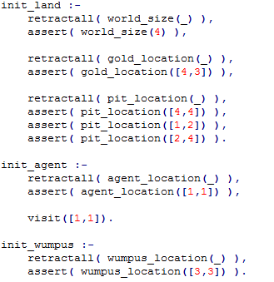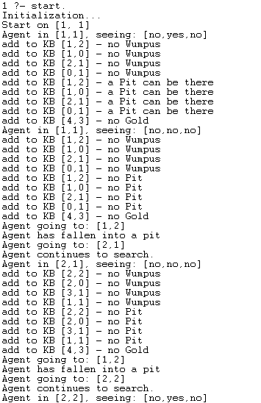

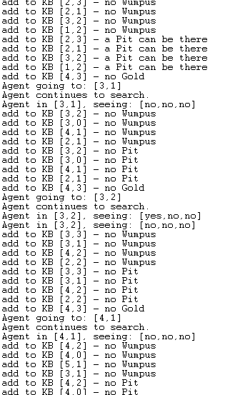

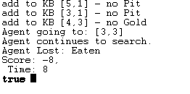

**__init__.py**

In my research I found those sites most useful:

* [Wikipedia page](https://en.wikipedia.org/wiki/Hunt_the_Wumpus) – to study about the game
* *Artificial Intelligence, A Modern Approach - 2nd Edition (Russel - Norvig)* – The game was introduced and explained, starting from page 197. 225. 258.
* [Hunt the Wumpus by Richard O. Legendi](https://github.com/rlegendi/wumpus-prolog) – I have studied his project and used some assets from his implementation.
* Also I have studied the implementations of the following users, but did not use their code for mine: [dineshbilla](https://github.com/dineshbilla/WumpusWorld), [shalinipiya](https://github.com/shalinipriya/WumpusWorld), [drbeco](https://github.com/drbeco/wumpus)