ROI-Aligned Vision-Language Verification and SOP-Guided State Machine for Manual Assembly Monitoring

Y.C. CAI, B.H. Liu, A.Y.C. Nee, S.K. Ong
Department of Mechanical Engineering, College of Design and Engineering, National University of Singapore, 117576, Singapore

Abstract
Manual assembly monitoring requires action recognition, visible completion evidence, and explicit procedural constraints. We study one shared vision-language model for full-frame action-tool-part (ATP) recognition and region-of-interest (ROI) completion verification, coupled to an SOP-guided orchestration layer. On 285 endpoint test sources, paired Full/ROI training achieves 98.36% Full and 99.30% ROI accuracy over three fixed seeds. A four-group shared-task study controls additional verification supervision and update budget: replacing repeated Full examples with paired Full/ROI examples raises mean ROI completion accuracy from 94.27% to 97.43% and reduces false acceptance from 11.34% to 0.46%, with Finish recall changing from 100.00% to 95.27% and ATP accuracy from 91.13% to 90.15%. Strong shared visual baselines remain competitive or better, and VLM inference is more costly. Symmetric ROI perturbations characterize condition-dependent error tradeoffs. An executable Java adapter enforces explicit SOP admission and binds verification responses to scheduled targets; 576 legal orderings, 60 premature-transition cases, and 6,840 real-prediction conditional integration cases are checked. These software and image-level results support reproducible use of local evidence in procedural state management. A separate limited public-video pilot does not establish improved alarms, and full continuous-execution validation remains open.

Keywords: manual assembly monitoring, vision-language model, region-of-interest supervision, finite state machine, standard operating procedure

Nomenclature
VLM | Vision-language model
FSM | Finite-state machine
SOP | Standard operating procedure
ROI | Region of interest
ATP | Joint action, tool, and part recognition task
SFT | Supervised fine-tuning
FPR | False-positive (false-acceptance) rate
IoU | Intersection over union
ECE | Expected calibration error
MCE | Maximum calibration error
xₜ | RGB frame observed at time t
𝒮 | SOP steps with a prerequisite relation
sᵢ | The i-th SOP step
yₜᴳ | General-mode prediction at time t
yₜⱽ | Verification-mode prediction at time t
ρₜ | Token-level confidence associated with a VLM response
Cᵢ(t) | Soft completion mass of SOP node i
Pᵢ(t) | Instantaneous probability of SOP node i
Fᵢ(t) | Readiness of SOP node i
Eᵢ | Ordering-violation error mass of SOP node i
Dᵢ | Timeout mass of SOP node i
πᵢ | Set of parent steps of SOP node i
τᵢ | Timing quota of SOP node i
qₜ | Most probable active SOP state at time t

1. Introduction

1.1 Background and Motivation
Modern manufacturing increasingly relies on flexible, high-mix, low-volume production to accommodate changing products and customer requirements. In this setting, manual assembly remains indispensable because human operators can adapt more readily than fully automated lines to component variation and procedural change. This flexibility, however, increases cognitive load and creates opportunities for errors in assembly sequence, tool selection, part alignment, and step completion, with direct consequences on product quality, throughput, and rework [1]. Online, scene-aware monitoring of manual operations, particularly the micro-actions involved in inserting, fastening, aligning, and seating components, is therefore an important enabler of Industry 4.0 quality assurance and operator assistance [2, 3].
Existing vision-based systems have made substantial progress in recognizing manual assembly actions, localizing task stages, and tracking execution progress using object detection, pose estimation, temporal models, and state-based reasoning [2-10]. Nevertheless, recognizing an action or stage does not by itself establish that the corresponding operation has been completed correctly. A system may correctly recognize that an operator is installing an end cover while remaining unable to determine whether the cover is fully seated and acceptable for the next process step.
Industrial assembly monitoring therefore involves two related but distinct task requirements. First, the system must understand what is being performed by the human worker, i.e., the current action, the tool being used, and the manipulated part, at the granularity of individual standard-operating-procedure (SOP) steps. Second, and more demanding, it must verify whether the step has actually been completed correctly, for example whether an end cover is fully seated, a gear is properly aligned, or a fastener has reached its expected state. The second requirement is the ultimate focus of this work. Its decisive visual cues are commonly local and subtle, including small gaps, edge contact, hole alignment, and residual offsets, and their interpretation depends on the current procedural context.
Recent vision-language models (VLMs), including the Qwen-VL family [11], provide a promising basis for addressing these requirements through a shared multimodal model and a natural-language-controlled output interface. Their prompt-addressable vocabulary is attractive for production environments in which tools, parts, and SOP variants evolve, while recent industrial applications demonstrate the potential of adapting vision-language representations to specialized visual domains [12, 13]. However, pretrained visual-language knowledge alone does not guarantee reliable fine-grained assembly verification. In the proposed framework, these requirements are handled by two prompt-conditioned modes of the same VLM: General mode for full-frame action-tool-part recognition and Verification mode for ROI-based completion verification. Reliable completion verification, in particular, is hindered by three coupled technical problems deliberated in the following sections.

1.2 Problem Statement
Problem 1: Joint task representation and adaptation requirements. Action-tool-part recognition and completion verification require different observations and outputs. A shared VLM provides a prompt-conditioned interface for these tasks, but a shared visual backbone with multiple heads can also support them. Both approaches may require new supervision when products or completion criteria change. We therefore compare these alternatives empirically; neither lower maintenance cost nor reliable zero-shot completion verification follows from using a VLM alone.

Problem 2: Spatial mismatch between supervision and completion evidence.
Completion evidence can occupy a small part of the image. A crop changes the scale and surrounding context of visible gaps, contact boundaries, alignment cues, and fastener regions. This motivates comparing Full, ROI and paired supervision. It does not establish that full-frame gradients are dominated by background, and the difficulty can also be addressed by conventional visual architectures. The new experiments test the supervision choice within each model family rather than assuming a VLM-specific spatial mechanism.

Problem 3: Procedural inconsistency of uncertain frame-level predictions.
Predictions produced by learned visual models are probabilistic and largely frame-wise. An individually plausible prediction may nevertheless conflict with the current SOP state, prerequisite dependencies, expected timing, or required completion condition. Directly converting such predictions into process transitions can therefore produce premature state advancement or false alarms. A process-monitoring system must determine when verification is required, which part should be inspected, and whether accumulated perceptual evidence is sufficiently consistent with the SOP to permit a state transition.

These problems are coupled at system level, i.e., adaptable visual perception must preserve both global task understanding and local completion evidence, while uncertain frame-level outputs must be interpreted within a coherent procedural model. The proposed framework addresses them through a shared dual-mode VLM, ROI-aligned supervision, and an SOP-guided state machine, respectively.

1.3 Key Contributions
This paper studies the integration of dual-mode visual perception, mixed full-frame/ROI supervision, and SOP-conditioned scheduling. These components build on established methods; the empirical questions are whether the chosen supervision supports both perception tasks, how the system behaves under input-view changes, and what evidence is available for procedural monitoring.
- Shared task and view configuration. The study uses one set of Qwen2.5-VL-7B weights for full-frame ATP recognition and ROI-based completion verification through task prompts. The new four-group experiment separates additional verification supervision, repeated Full examples, and paired Full/ROI examples. A shared visual backbone with multiple heads is included because unified perception is not unique to VLMs.
- Controlled local-completion evaluation. Paired Full/ROI supervision is evaluated on a recovered endpoint split, with strong visual baselines, equal-update controls, symmetric crop perturbations, and explicit false-acceptance and false-rejection accounting. ROI cropping is an established technique; the contribution under investigation is its role in this shared task and view configuration, not the cropping operation itself.
- Executable evidence-to-state interface. The revision provides a Java adapter that selects General or Verification requests, binds responses to their target, and admits steps under explicit SOP prerequisites. Author-confirmed parallel dependencies, request rejection, alarm lifecycles, real endpoint-prediction integration and CPU component cost are evaluated separately. This is a reproducible orchestration contribution, not a new standalone FSM algorithm or a claim of improved real-video alarm performance.

The remainder of the paper is organized as follows. Section 2 reviews related work. Section 3 presents the system overview, ROI-aligned supervision, the dual-mode VLM, and SOP-conditioned system integration with deployment-time ROI provision. Section 4 reports experimental evaluation. Section 5 discusses the findings and limitations, and Section 6 concludes the paper and outlines future work.

2. Related Work
The proposed framework builds upon and differentiates from three lines of prior work, namely, deep-learning approaches to action recognition and process monitoring in manual assembly, the recent emergence of vision-language and multimodal models for industrial scene understanding, and neuro-symbolic process monitoring that couples learned visual perception with explicit workflow models.

2.1 Action Recognition and Process Monitoring in Manual Assembly
Assembly action understanding has been studied using object detection, pose estimation, hand motion, and explicit state representations. Chen et al. [2] address repetitive assembly action recognition using object detection and pose estimation. Ay and Emel [3] combine object-triggered task segmentation with operator hand-joint trajectories and an LSTM for assembly-task recognition. Selvaraj et al. [9], published in JMS, study real-time assembly action localization using deep learning and augmented inference state machines. These works establish that combining visual perception with procedural structure is prior practice; a task-recognition score must also be distinguished from a completion-state score or event-level alarm metric.
Compositional representations further weaken a simple contrast between fixed-class visual systems and structured VLM outputs. Zheng et al. [23] introduce CoDuAR, which predicts per-hand tuples of verb, manipulated object, target object, and tool through a shared encoder and hand-specific decoders. Their Assembly Copilot combines deterministic symbolic task tracking and operational-error detection with a separate LLM assistant. Thus structured observations, shared perception, and symbolic assistance are established alternatives. The present study asks whether paired local completion supervision provides measurable value alongside full-frame ATP recognition, using matched task and view controls.

2.2 Vision-Language and Multimodal Models in Industrial Scenarios
Manufacturing VLMs and language-driven assembly assistance are related but distinct settings. Fan et al. [22] introduce MaViLa for manufacturing visual understanding, with retrieval-augmented domain knowledge used during dataset creation and a two-stage training procedure. Zheng et al. [23] keep the LLM outside the latency-critical perception and symbolic tracking path, while Liu et al. [15] investigate VLM-enhanced embodied agents for digital-twin-assisted collaborative assembly. These examples motivate comparison at the level of model inputs, task outputs, procedural interface, and measured computation rather than a broad claim that VLMs replace conventional visual recognition.
Zheng et al. [24] provide a particularly close VLM comparison: Compositional Context Fine-Tuning decomposes assembly-video actions into verb, object, and tool queries, while Layer-Partitioned Alternating Training specializes element-specific low-rank adapters. Their Qwen2.5-VL-7B experiments use HA-ViD-VQA and IKEA-ASM-VQA and evaluate action elements and holistic action recognition. Our distinct empirical question is the joint training of action recognition with local Finish/Unfinish evidence, including a repeated-Full control for the paired ROI supervision. This is not a claim to introduce compositional assembly VLMs. The published task settings and metrics differ, so their reported scores are not ranked against our endpoint scores.
The present work focuses on paired full-frame and part-centered views for ATP and completion-state supervision. The recovered experiment has a small number of endpoint sources, but a claim of superior data efficiency would require matched learning curves and annotation budgets. No such advantage over manufacturing VLM training or existing region-focused methods is inferred from dataset size alone.

2.3 Neuro-Symbolic Process Monitoring
Explicit workflow representations, including Petri nets [16] and process-mining methods [17], provide established foundations for procedural constraints. Assembly monitoring that combines learned observations with state-based reasoning is also represented by Selvaraj et al. [9]. Ding et al. [21] model spatial part connections and temporal beliefs for detecting assembly mistakes, including corrective actions. Their action-driven reasoning evaluation must be distinguished from autonomous video perception. Consequently, SOP constraints, symbolic state, and corrective-action reasoning are not individually new contributions here.
Human-robot collaborative assembly additionally concerns assistance and execution, beyond recognizing isolated observations. Liu et al. [15] study VLM-enhanced embodied agents in a digital-twin-assisted collaborative setting. Zheng, Xia, and Xu [30] combine real-time dual-hand action segmentation with adaptive robot assistance and in-process quality checking after critical steps. Completion and quality checking are therefore also prior concerns; the comparison must identify the particular observation and training interface. The present study concerns visual monitoring and does not evaluate robot control, human workload, or collaborative cycle time. Its structured observations could form an input to an assistance system, but that downstream value has not been measured here.
The SOP-guided state machine is a procedural orchestration design rather than a standalone algorithmic contribution. Nodes represent assembly steps with dependencies and timing parameters. The model outputs must be mapped to specific SOP nodes, including repeated parts, and completion verification must be bound to the internally selected target. Generated-token confidence is used as a proposed observation weight; it is not a calibrated probability of step completion. Neither robust alarm behavior nor improved detection follows from that weighting without a matched causal evaluation. The historical sequence study and the new small public-video diagnostic are distinguished from a validated complete online assembly-monitoring system.
Assembly-task recognition and procedural error detection must be compared at their actual observation interfaces. Ay and Emel (2025) combine object-triggered task segmentation with hand-joint trajectories and an LSTM for assembly-task recognition; this is a relevant visual alternative, and its task-recognition score is not a direct completion-verification or alarm baseline. Ding et al., Every Mistake Counts in Assembly (arXiv:2307.16453, 2023), model part-to-part spatial and temporal beliefs, including corrective actions. Their reported action-driven reasoning comparisons must not be treated as autonomous video-perception results. Our proposed distinction is to request local visual completion evidence through a shared model interface; whether this helps procedural monitoring remains an empirical question, not an established consequence of using a VLM.

3. Methodology
Section 3.1 presents the architecture and completion-verification interface. Section 3.2 defines paired Full/ROI supervision. Section 3.3 describes the two prompt-conditioned tasks of Qwen2.5-VL-7B. Section 3.4 specifies the SOP scheduling design and possible ROI providers; new annotated-ROI measurements and the separate public-video adaptation are distinguished from the complete deployment proposal.

3.1 System Overview
The proposed system is composed of three cooperating modules, as shown in Fig. 1.

Module 1: The first component is a single Qwen2.5-VL-7B model, full-parameter fine-tuned and operated in two complementary inference modes, namely, a General-mode that consumes a full red-green-blue (RGB) frame and emits a JavaScript Object Notation (JSON) tuple {action, tool, part}, and a Verification-mode that consumes an ROI crop centered on the SOP-active part and emits a JSON tuple {part, verification ∈ {Finish, Unfinish}}; a single set of weights serves both modes, with the modes differing only in the prompt template and the input view, and each call additionally returns a token-level confidence score ρₜ ∈ [0, 1] as a sibling field of the JSON response (Section 3.3).

Module 2: The second component is an SOP-guided procedural orchestration layer that maintains the active process state, identifies the part requiring verification, and organizes frame-level predictions under step dependencies and timing constraints.

Module 3 is the ROI interface: it localizes a target selected by the orchestration layer and returns the crop for completion verification. Grounding DINO Tiny is one proposed provider. The new controlled endpoint experiments use annotated boxes, while the public-video pilot uses a fixed workspace crop defined from training material; neither setting measures a newly validated automatic detector cascade.

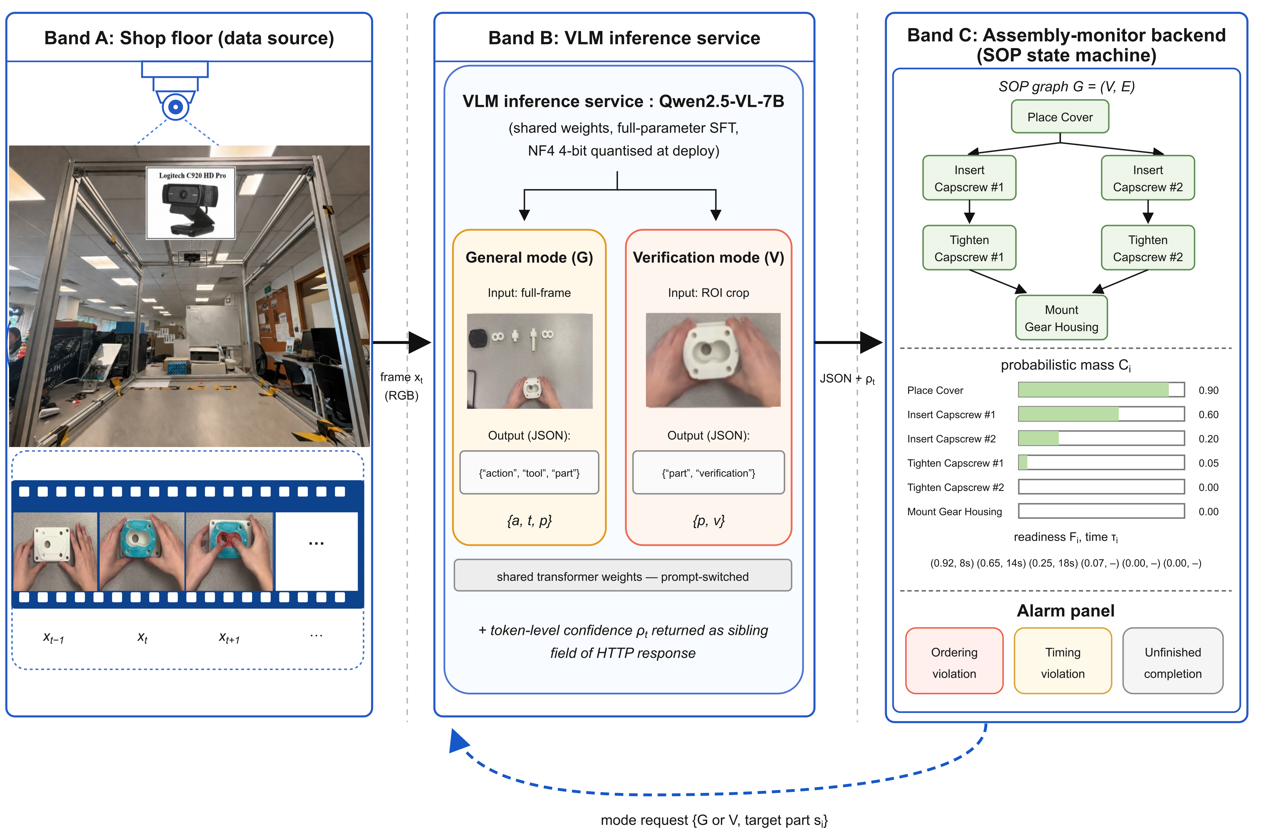
Fig. 1: System overview of the proposed VLM + SOP-guided FSM framework.

The proposed feedback loop connects General observations, SOP state, target selection, ROI provision, and Verification observations. Each request is chosen from the current state, and its response is bound to that requested target before any state update. The loop can emit ordering, timing or completion warnings according to its specified rules. Alternating or refreshing General requests is a scheduling choice whose benefit must be evaluated; an ROI view is not assumed to improve every observation or to guarantee alarm coverage.

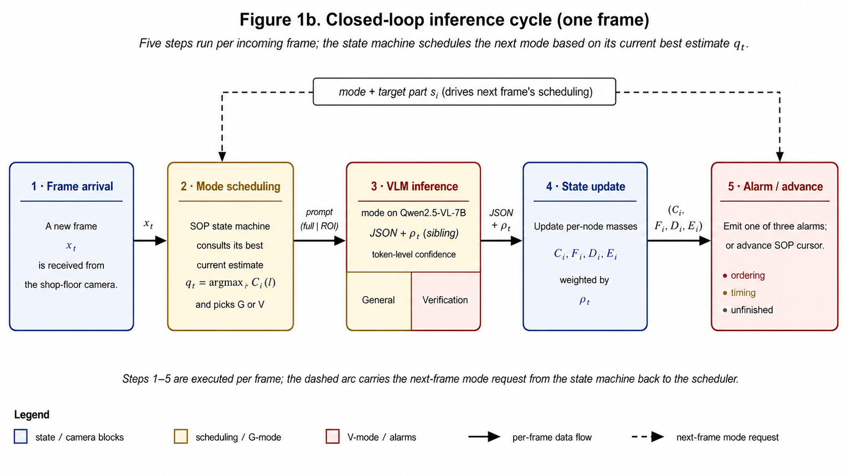
Fig. 2: Closed-loop inference cycle (one frame).

Let the SOP be a set of steps with a directed acyclic prerequisite relation
𝒮 = {s₁, s₂, …, s_N} (1)
In Eq. (1), each step sᵢ = (aᵢ*, uᵢ*, pᵢ*, cᵢ*, πᵢ, τᵢ) specifies the expected action aᵢ*, tool uᵢ*, manipulated part pᵢ*, completion condition cᵢ*, set of parent steps πᵢ ⊆ 𝒮, and timing quota τᵢ. At each frame xₜ, the General-mode predicts
yₜᴳ = (aₜ, uₜ, pₜ), (2)
and, when scheduled, the Verification mode predicts
yₜⱽ = (pₜ, vₜ), vₜ ∈ {Finish, Unfinish}. (3)
The state representation uses an accumulated observation score Cᵢ(t) in [0,1]. It is a heuristic evidence mass, not a calibrated probability of physical completion. For the revised causal diagnostic, define Gᵢ as the configured verification-gate indicator and Vᵢ(t) as the target-specific confirmation flag. Effective evidence is C̃ᵢ(t) = Cᵢ(t)[(1 − Gᵢ) + GᵢVᵢ(t)], so an unconfirmed gated parent contributes no readiness. Parent readiness is then
Fᵢ(t) = ∏ⱼ ∈ πᵢ C̃ⱼ(t). (4)
A node with no parents has readiness one by the empty-product convention. Ordering evidence uses Eᵢ = Cᵢ(1 − Fᵢ). Replacing ungated parent mass by effective mass is an explicit revision of the operational definition: a read-only probe of the surviving repository Python path showed that an unverified parent could otherwise give its child full readiness. The revised public-video code also binds a Finish observation to one requested node, rather than every node with the same part name. These are software-contract corrections; they are not proof of an alarm-performance gain or of equivalence to historical Java results.
The downstream objective is twofold. First, perceptually, the model must recover yₜᴳ (Eq. (2)) and yₜⱽ (Eq. (3)) correctly under industrial conditions. Second, procedurally, the state machine must convert the time-series of predictions into a single coherent process state qₜ and emit alarms whenever the prediction stream is inconsistent with 𝒮. Crucially, completion verification is not equivalent to action classification; visually similar frames can correspond to entirely different process states, and a frame may legitimately show the correct action being performed while the step itself remains unfinished.
For evaluation, completion verification is treated as a binary classification problem with Finish as the positive class. The metric of primary practical importance is the false-positive rate (FPR), i.e., the rate at which truly Unfinish states are accepted as Finish, because false acceptance is what allows defective sub-assemblies to flow downstream.
The recovered endpoint task uses Finish/Unfinish labels for the specified visible completion criterion. An autonomous scheduler cannot guarantee that it queries only after physical completion; intermediate states and occlusion remain possible inputs in continuous monitoring. Unknown or invalid evidence must therefore not release a completion gate. The external public-video pilot explicitly permits Unknown as an abstention, while the endpoint classification tables retain the original binary schema. A monocular image also cannot establish hidden torque or other unobservable completion properties without additional sensing or task assumptions.

3.2 ROI-aligned supervision
Paired supervision presents each labelled endpoint source as a full frame and a part-centered crop, with the same part and completion label. The crop emphasizes a different visual scale and context. Class labels can be reused across the pair, but obtaining and checking ROI coordinates has an annotation cost; this study does not claim zero total annotation effort or a measured reduction in it. Related part-aware recognition methods [19] motivate localized observations, while the empirical benefit here is assessed through the fixed view and update-budget controls.
Let R(x,p*) return the crop for target part p*. The paired samples are (x,p*,v*) and (R(x,p*),p*,v*), where v* is Finish or Unfinish. The new controlled protocol expands the annotated box by p = 0.10 max(width,height) on each side, clips it to the image, truncates nonnegative coordinates to integers, and uses an exclusive right/bottom crop boundary. Full and ROI views share the same task text and labels. Comparing them measures the effect of this input/supervision configuration; it does not directly measure attention or procedural knowledge in the model.
The formulation is related to weakly supervised part-aware fine-grained categorization [19], in which local part regions focus representation learning, but it requires neither an attention module nor a change to the base VLM’s forward pass. It is also distinct from the look-twice token-selection mechanism of Anomaly-OV [13] because the local prior is introduced through the supervision views rather than through model architecture.
The training and deployment interfaces both accept a target and return a visual region, but that shared interface does not make their error distributions identical. New endpoint results use annotated boxes and controlled perturbations. Detector outputs, missing detections, or a fixed workspace crop must each be evaluated under their own input conditions. They cannot inherit the annotated-ROI scores without a matched experiment.

3.3 Dual-mode VLM
The dual-mode VLM uses one set of weights for ATP recognition and completion verification, with task-specific prompts and image views. A shared visual encoder with separate heads is another way to share representation and model storage, and is included as a baseline. The common VLM interface is a design feature; its accuracy, memory requirements, adaptation effort and inference cost must be measured rather than inferred from the number of named tasks.
The model is initialized from Qwen2.5-VL-7B-Instruct and adapted by full-parameter supervised fine-tuning. The reported experiments use fixed four-epoch final checkpoints; Appendix B summarizes the audited configuration and Appendix G distinguishes each task mixture and baseline recipe. Fig. 3 illustrates the shared-weight two-mode design. Generated-token confidence is logged separately where it is analyzed.

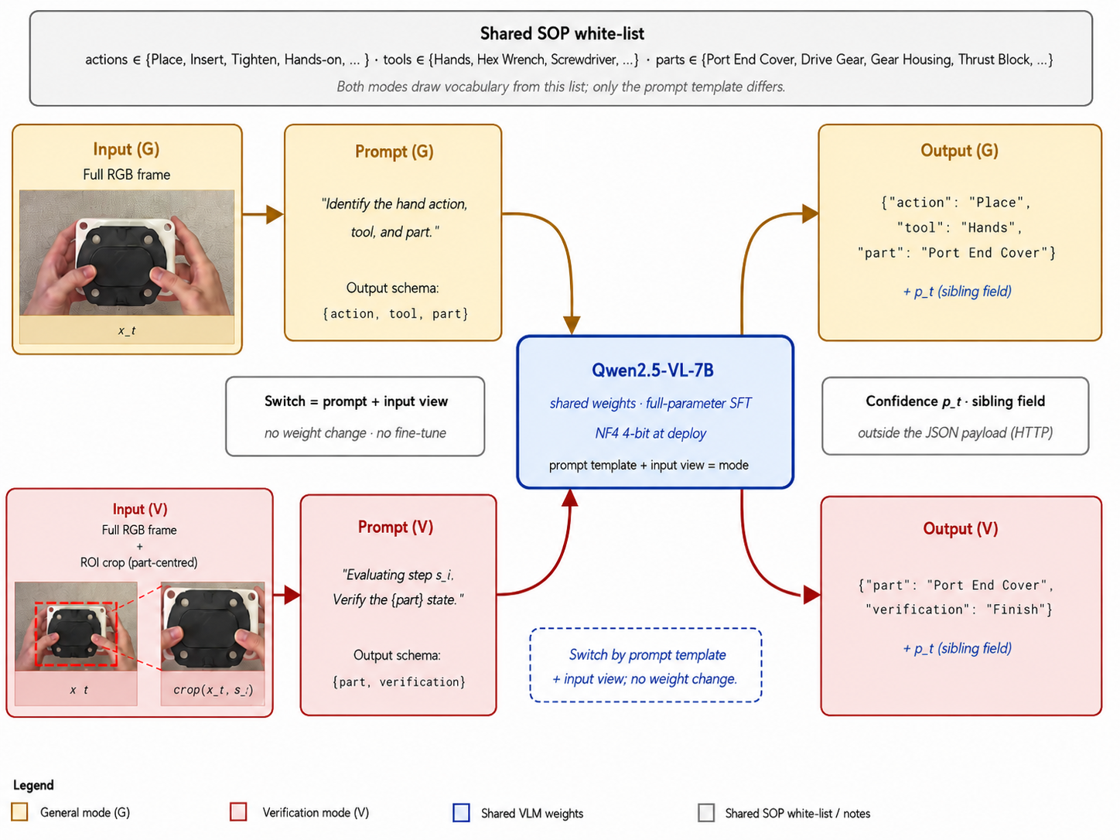
Fig. 3: Dual-mode VLM adaptation under a shared set of weights.

At inference time, the task prompt specifies the requested structured observation. General mode requests action, tool, and part from a full frame; Verification mode requests part and Finish/Unfinish from the supplied view. The new shared-task ATP prompt fixes the four action labels and the part vocabulary, and the endpoint prompt is identical across Full and ROI conditions. Appendix A describes the task interface; Appendix G and the frozen run files identify the prompts actually used for the new experiments. The public-video diagnostic uses its separately documented toy-part vocabulary and completion criterion.
The two inference modes use structured output fields: {action, tool, part} for General mode and {part, verification} for Verification mode. JSON-only prompting does not guarantee valid output, so parsing failures and illegal labels must be counted explicitly. Confidence is reported outside the task JSON. In the new diagnostics it is the exponential of the mean generated-token log probability, including the termination token, under greedy decoding. This sequence score is not a calibrated probability that the predicted assembly state is correct. Static recognition metrics do not depend on FSM weighting. Its possible role in procedural updates must be tested separately; the confidence and causal-replay diagnostics added in this revision do not establish an alarm benefit.
The SOP target belongs to the scheduling request and must remain bound to its returned observation. This does not imply that every experimental prompt contains a literal SOP-step identifier: the static endpoint comparisons use a fixed target prompt, while the public-video diagnostic names the internally selected pair of parts. Neither experiment tests an additional benefit from including a step identifier in the model text.
Both tasks access the same model weights, but their prompts and visual inputs differ. Shared parameter storage does not imply identical peak memory or latency: activation size and generated output length can differ between views and tasks. The procedural target identifier is carried by the scheduling interface and must be bound explicitly to the returned observation. Whether training the two tasks together helps or interferes with either task is measured by the M0–M3 ablation. Shared-backbone task conditioning itself is established practice [18].
In the complete system, General-mode outputs provide the action-tool-part observations consumed by the SOP-guided state machine, whereas Verification-mode outputs confirm whether the SOP-active part has reached its required completion state. The shared model therefore connects global semantic perception to the ROI-aligned local evidence required for procedural state updates.

3.4 SOP-conditioned system integration and ROI provision
The FSM is a procedural orchestration layer, drawing on explicit workflow and state-based monitoring concepts [16,17]. It relates observations to the current SOP state, prerequisite dependencies, elapsed time, and required completion conditions. The proposed confidence-weighted accumulation is a heuristic state update; its scores are not Bayesian posterior probabilities or calibrated completion probabilities. The observation-to-node mapping and treatment of repeated operations are explicit parts of the system design.
The SOP is encoded as a directed acyclic graph whose nodes specify action whitelists, prerequisites, an optional observable completion condition, and lower/nominal/upper timing quotas. The revised Java adapter maintains an admitted set A independently of the original core completion flags. A currently observed node i is newly admitted only if all parents were in A before the update, the current accepted response pertains to i, and the core reports sufficient action evidence and any required positive verification. Synthetic quotas test software semantics; training retained-image counts used by the separate phase replay are not production cycle times.
In the Java core, General observations accumulate confidence-weighted evidence over nonnegative intervals between General results; intervening Verification time is included in that interval. Verification does not add action duration. A target-specific Finish at or above the configured threshold latches confirmation; Unfinish or Unknown does not release the gate or revoke an earlier confirmation. The core uses local evidence readiness and the confirmation flag to compute local completion. Hard prerequisite admission belongs to the revised adapter and must not be inferred from the core flag alone. These heuristics are not calibrated probabilities of physical completion.
The design distinguishes prerequisite-order violations, timing violations, and missing verification of an explicit completion condition. The historical implementation uses error-mass and timeout-mass thresholds of 0.05. These thresholds are implementation settings, not established risk guarantees. A wrong tool, action, or part need not automatically produce a prerequisite-order violation; complete coverage of those error types requires explicit observation mappings and type-specific evaluation. Appendix D does not provide evidence that confidence weighting improves these alarms. The public-video diagnostic in Appendix G uses its disclosed adaptation and generic-event matching rule, and does not establish a complete error taxonomy.
Two procedural implementations are distinguished. The public-video diagnostic in Section 4.4 uses a separately documented toy-task adaptation; it is not claimed equivalent to the gear-pump Java backend. Section 4.5 evaluates a revised Java scheduling adapter around the unchanged coauthor-supplied state-update core. The core retains soft predecessor readiness and local completion evidence; the adapter separately enforces hard admission. The author-confirmed SOP allows any order within steps 8–11 after step 7, and any order within steps 12–15 only after all four insertion steps. Applying these instance-level constraints requires trustworthy distinct events: categorical capscrew predictions alone do not establish physical screw identity.
In the proposed causal loop, the current state determines which perception mode and verification target to request from the current image. The returned structured observation updates the state, after which progress and any alarms are emitted. Fig. 2 illustrates this scheduling interface. Adaptive invocation frequency is a deployment design option whose cost and transition-detection effects are not measured here. The new public-video diagnostic instead uses a fixed 1 Hz schedule, one selected-mode call per sampled time, and no future frame or frame-level ground-truth input.
Fig. 4 gives the author-confirmed 15-node gear-pump SOP used by the revised dependency checks. Steps 1–7 form the observed prefix: mounting flange, gear housing, first thrust block, drive gear, driven gear, second thrust block and port end cover. Insertions 8–11 may be reordered after step 7. Every tightening step 12–15 requires all four insertions; tightening order is also unrestricted. There is no additional numbered final-verification node or assumed physical pairing between insertion and tightening identifiers. Verification requirements belong to a separate node-condition configuration, not to the dependency arrows. Repeated screw events require identity or a justified procedural disambiguation contract beyond a category label.
The proposed scheduler distinguishes action-driven nodes from nodes requiring an explicit completion check. The choice is an SOP configuration: a verification-gated node must identify a specific target and observable completion condition. The earlier wording assigned gear insertion to both classes and is not treated as an executable partition. The recovered endpoint experiments directly supervise Port End Cover completion; they do not validate seating or fastening checks for every schematic node. Whether another step benefits from an additional ROI check requires matched evidence, rather than an assumption based on its node name.
The revised Java adapter first requests Verification for the earliest SOP-listed, unadmitted node whose parents are admitted and whose action evidence is ready. If none exists it requests General; after all nodes are admitted it emits Complete. It binds each response to the current request identifier, mode, node and condition, rejecting duplicates, stale requests, wrong targets, invalid times and invalid values without state changes. Verification is retried after Unfinish/Unknown, so an unresolved target can block General requests. This explicit blocking policy is evaluated as a software contract, not as an optimized asynchronous deployment policy. The separate public-video pilot instead uses its declared 1 Hz interleaving policy.

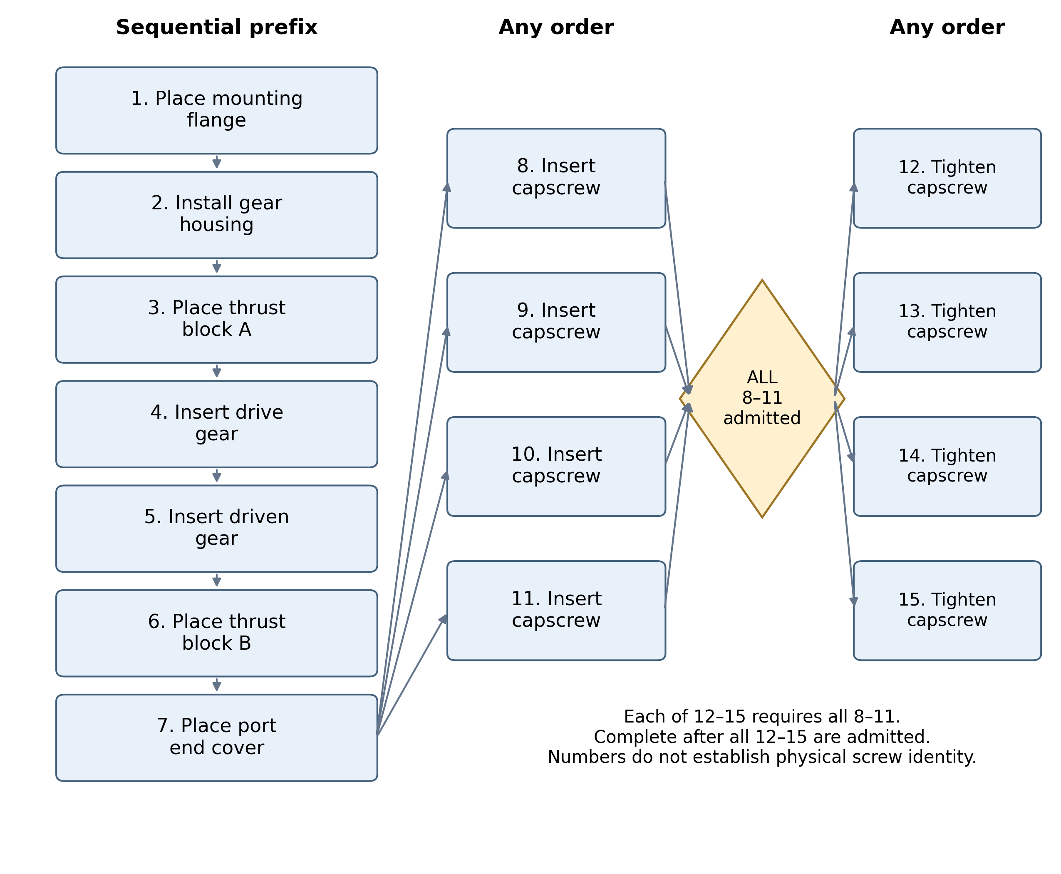
Fig. 4. Author-confirmed 15-step SOP. The prefix 1–7 is sequential; insertion steps 8–11 are unordered after 7; every unordered tightening step 12–15 requires all four insertions. The ALL diamond abbreviates the complete prerequisite set. Verification requirements are configured separately; instance numbers do not identify screws visually.

Static ATP and endpoint tables evaluate perceptual predictions directly and do not depend on a process graph. The historical ordered-replay comparison and the new causal public-video diagnostic are separate procedural studies. Within each new causal comparison, the graph and scoring rule are held fixed across configurations; each configuration evolves its own state and selects its own observations.
The prototype separates a Python VLM inference interface from a Java assembly-monitor backend through HTTP. The intended backend responsibilities are SOP state, mode/target selection, ROI provision, and alarm presentation; the inference interface returns the requested structured visual observation. The new accuracy and component-timing experiments use BF16 Qwen2.5-VL-7B-Instruct. NF4 quantization is a proposed deployment optimization and is not the precision used for these reported new results. The isolated component measurements and Python public-video diagnostic do not constitute a new measurement of the complete Python/Java/camera deployment.
SOP-conditioned localization requests a region for a selected target, rather than requiring the ROI service to select the next procedural step. A part name can still correspond to several physical instances, so context alone does not resolve repeated screws or other identical objects. The deployment contract must specify instance identity, localization failure handling, and what visible criterion is being checked. The controlled crop study assesses only its declared transformations; it does not certify a new ROI provider.
Grounding DINO Tiny [14] is one proposed open-vocabulary ROI provider: a selected SOP part name is supplied as a text query, and the returned box defines a candidate verification region. A fixed-camera ROI lookup is another possible interface. Extending the query vocabulary does not establish reliable localization of a new part. The new controlled endpoint experiments use annotated boxes; their crop perturbations do not establish upper or lower bounds on an arbitrary detector error distribution. The historical detector cascade is qualified separately, and simultaneous detector/VLM memory use and complete deployment latency have not been measured in the new study.
The historical detector proposal uses Grounding DINO thresholds of 0.25 for boxes and 0.20 for text, expands the selected box by 10% of its longer side, and proposes a full-frame fallback when no box is returned. Those settings and the fallback are design details, not newly validated deployment results. Any fallback weighting and effect on false acceptance, missed transitions, latency and memory require a separately documented test. The new endpoint comparisons do not change their ROI source according to detector success.

4. Experiments and Results

4.1 Experimental setup

4.1.1 Data acquisition and recording protocol
The dataset that supports both the perceptual and the procedural components of the proposed framework is collected in a laboratory mock-up cell that mirrors the physical layout of an in-line manual-assembly workstation. The cell is intentionally instrumented with consumer-grade sensing in order to demonstrate that the framework does not depend on specialized industrial vision hardware. This section details the camera setup, the assembly workpiece, the catalogue of operator actions captured in the dataset, and the recording protocol.
A single fixed-pose RGB camera is mounted directly above the operator’s workspace at a top-down viewing angle. The camera records at 1080p resolution and 30 frames per second, with auto-exposure and white-balance disabled in order to avoid frame-to-frame appearance drift. The viewing distance and field of view are chosen so that all parts laid out on the workbench, the operator’s hands, and the active assembly zone fall within a single frame; no pan or zoom is applied during data collection. The resulting hardware setup and camera coverage are shown in Fig. 5. A second auxiliary view was considered during preliminary scoping but discarded; the proposed framework treats the perception module as a single-camera, monocular pipeline so that deployment generalizes to a wide class of low-cost shop-floor cells that do not require multi-camera calibration. A sample frame from the top-down camera is shown in Fig. 6.

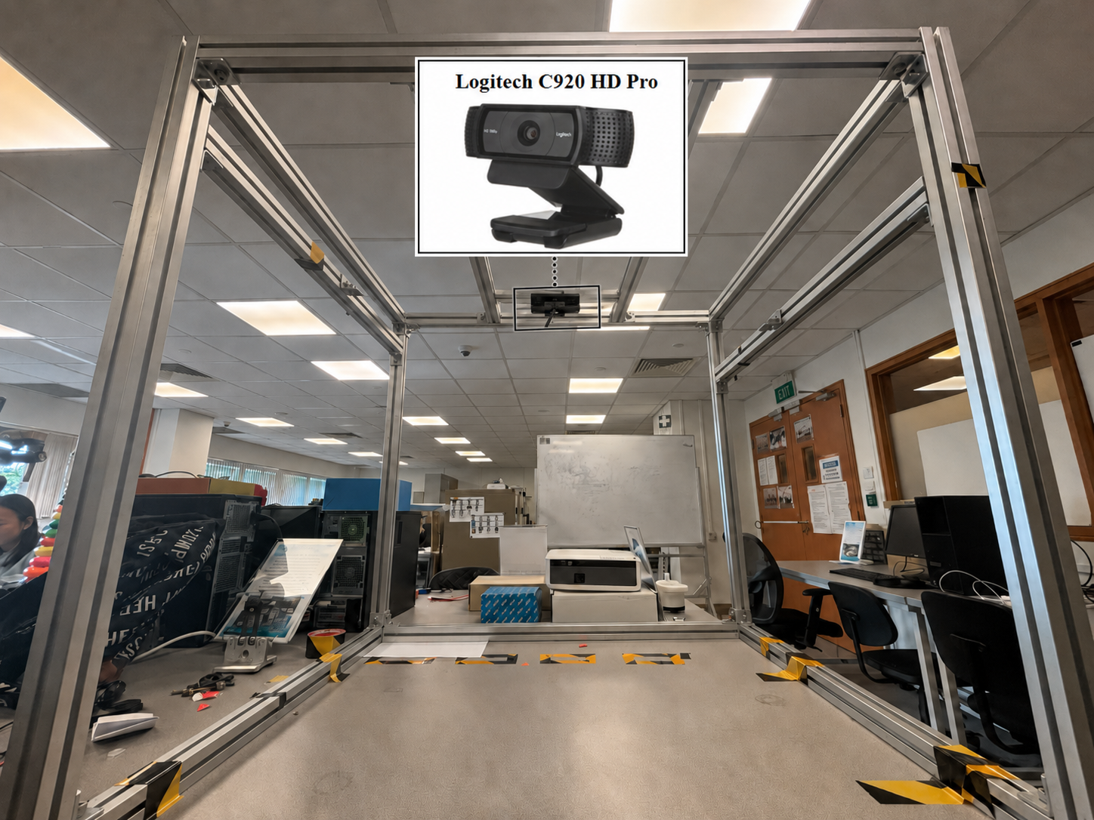
Fig. 5: Data acquisition setup.

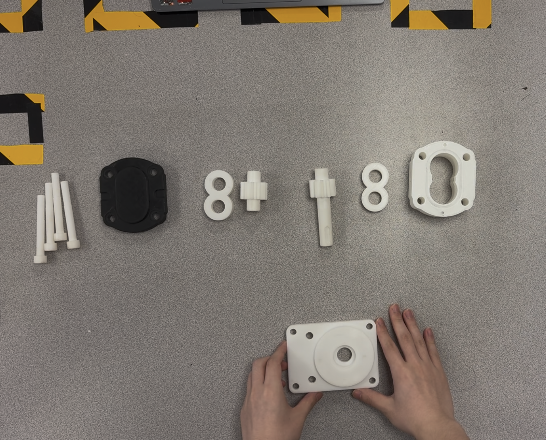
Fig. 6: Sample frame from the top-down camera.

The workpiece is a 3D-printed reproduction of a Parker gear-pump assembly based on the component architecture documented in the manufacturer's service literature [20]. The reproduction preserves the standard external gear-pump architecture, i.e., a mounting flange, a gear housing containing a meshing drive/driven gear pair supported by pressure-balanced bushing blocks, and a port end cover fastened by capscrews, with dimensions and an assembly sequence adapted for the laboratory demonstrator. A 3D-printed reproduction allows both correct and intentionally erroneous executions to be captured repeatably without consuming or damaging production parts, and avoids any constraints associated with a specific commercial workpiece.
The recovered ATP labels use four action classes: Place, Install, Insert, and Tighten. Place describes placement of a part on a work or staging surface; Install describes assembly operations such as seating the gear housing; Insert covers the annotated insertion of the drive gear, driven gear, and capscrews; and Tighten describes capscrew tightening. In the 545-example ATP test, the class counts are Place 162, Install 36, Insert 200, and Tighten 147. Capscrew insertion is therefore assigned to Insert, not Install. The new experiments use this four-class vocabulary consistently. Fig. 7 illustrates three of these classes, while Fig. 8 includes all four. Recovering the labels does not independently recover every historical inference configuration.
The original collection procedure included standard and intentionally abnormal assembly executions of the laboratory workpiece. The complete videos and historical sample-level prediction archives could not be recovered for this revision. Consequently, the original recording-level independence and the historical four-part evaluation denominators cannot be re-established from the surviving assets alone. New experiments identify their recovered image sources and splits explicitly, preserve paired views within their source split, and distinguish image-level evidence from independent complete executions.

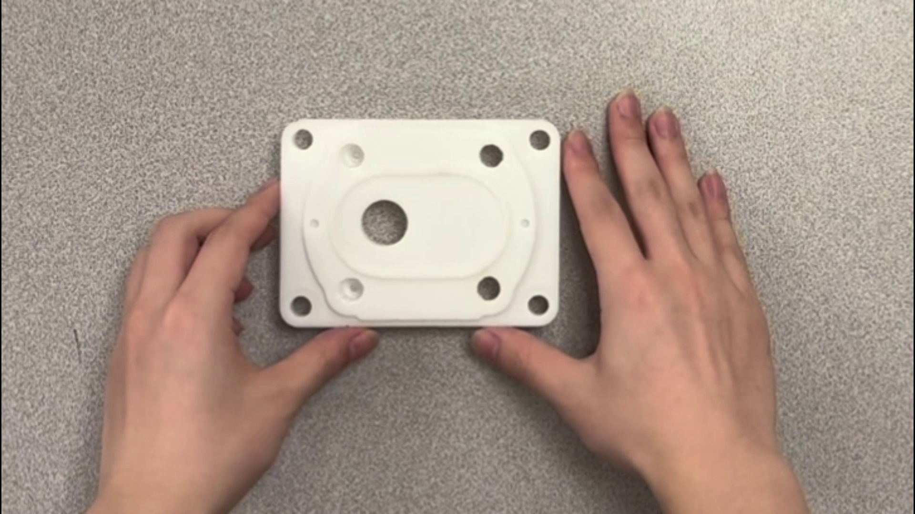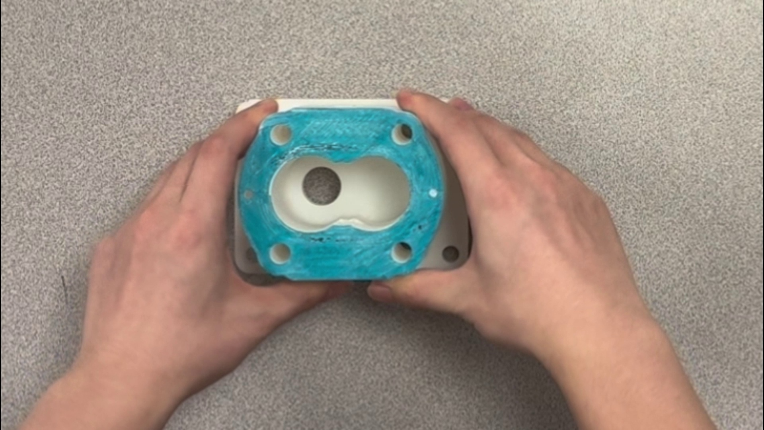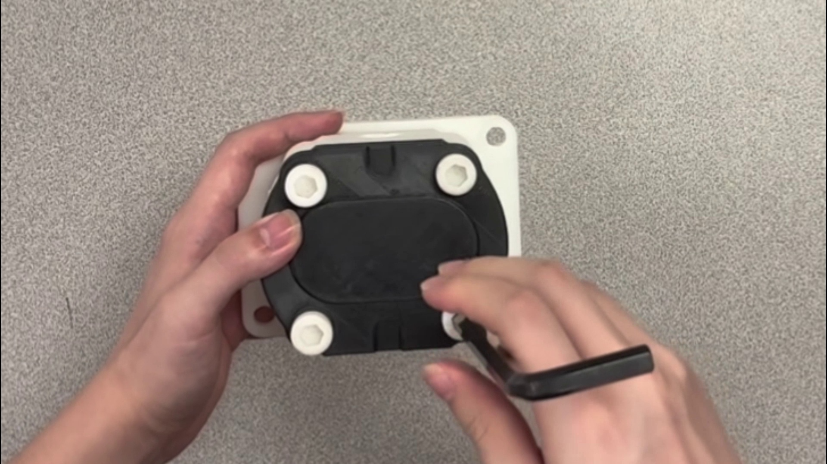
(a)
(b)
(c)
Fig. 7: Illustrative frames for three of the four operator-action classes: (a) Place; (b) Install; (c) Tighten. Insert is the fourth class in the recovered labels and is not illustrated in this figure.

4.1.2 Dataset partitions, implementation, and metrics
The original study described standard and abnormal gear-pump recordings. The continuous videos and some result archives are no longer available. The new experiments therefore distinguish recovered static endpoint and ATP images from the separately acquired public Assembly101 video diagnostic. An observed result in one of these settings is not treated as an evaluation of the others.
The surviving assets contain image-level part/completion labels and ATP instruction examples. The new runs preserve those labels and record their source identities and hashes; ATP targets retain action, tool and part. The historical manuscript described a second-annotator check on 10% of the data and hard-case subcategories, but the underlying agreement records and complete hard-case membership are not available for independent reconstruction. We therefore do not report that historical agreement percentage as a new audit, or present an easy/near-finished subgroup result without its sample manifest.
For the new auditable experiments, the recovered endpoint dataset contains 212 training and 285 test source images (141 Finish and 144 Unfinish). Mixed training presents both Full and ROI views of each training source. The historical 218-image development source overlaps other recovered sources and is not an independent validation set; it is excluded from model selection. The recovered ATP split contains 1,709 training and 545 test images. New shared-task runs combine this ATP split with the 212-source endpoint training split. The historical 519/112-source four-part benchmark and its sample-level predictions could not be recovered, so it is not represented as reproduced by these new experiments. Recording-level temporal independence cannot be independently verified from the surviving static files.
The recovered endpoint experiments concern Port End Cover within the original gear-pump task. Unrecoverable historical numeric result tables and figures are excluded from the current empirical evidence. LOCO and Assembly101 extensions concern different products and tasks, are reported separately, and do not establish general cross-product superiority.
The new VLM experiments use Qwen2.5-VL-7B-Instruct and full-parameter supervised fine-tuning. The final checkpoint after four epochs is selected by a fixed rule, without test-based selection. Dataset composition, update counts, execution configuration, and training-seed coverage are reported with each experiment in Appendix G. The new accuracy and timing evaluations use BF16 inference; the NF4 deployment option described elsewhere is not the configuration used for these new measurements. Finish is the positive class. Accuracy includes invalid outputs as errors; false acceptance is the number of true Unfinish images predicted Finish divided by all true Unfinish images. Invalid outputs are additionally reported, so false acceptance and Unfinish accuracy need not sum to one. ATP evaluation reports per-field and joint correctness.

4.2 Unified perception and system adaptability

4.2.1 Experimental setup
The new shared-task experiment compares four conditions of the same Qwen2.5-VL-7B initialization and ATP split (1,709 training and 545 test sources). M0 trains ATP only. M1 adds the 212 endpoint training sources in Full view. M2 presents each added Full endpoint example twice. M3 instead adds paired Full and ROI views. M2 and M3 match example counts and update budgets. All groups use fixed four-epoch final checkpoints, and all are evaluated on ATP plus both endpoint views. A shared ResNet50 with multiple heads is evaluated with the corresponding mixtures. Replacement Tables 1 and 4 report the new shared-model results; the original table entries remain in the archived submission and are not reconstructed.
The recovered ATP labels contain four action classes. Fig. 8 is regenerated directly from the archived predictions of the matched single-GPU M3 seed42 checkpoint, with panels (a) Part, (b) Action and (c) Tool. Tables 1 and 4 retain all groups and all three fixed training seeds; the figure is a descriptive fixed-checkpoint illustration, not model selection.
The unadapted VLM is evaluated separately on the recovered endpoint and ATP tasks. Literal schema validity and complete outer-code-fence normalization are reported separately. These fixed-task diagnostics do not establish unseen-product adaptation; Appendix F clarifies the prompting scope.

4.2.2 Results and comparative analysis
Replacement Table 1 reports every action, tool, part and joint ATP score for all four fixed shared-model mixtures. Both model families report three completed fixed runs; all VLM runs in these tables use the same one-GPU configuration. The families have different pretraining and optimization recipes, so this is not an equal-compute comparison. M2 versus M3 isolates repeated Full examples versus paired Full/ROI examples at the same example and update budget within the VLM protocol. Its measured differences, including any task tradeoff, must be read together with completion results in Table 4 and all paired contrasts in Appendix G; these three fixed seeds alone do not establish independent-recording generalization. In the three fixed VLM runs, M3 ATP joint accuracy is 90.15% versus 91.13% for repeated-Full M2. The corresponding Full and ROI completion results must be considered with this recognition score.

Table 1. New shared-model ATP comparison on545 fixed test sources. Both families report mean ± sample standard deviation over seeds42/43/44. All VLM seeds42/43/44 use one GPU at global batch32. The original two-GPU seed42 models are retained separately in all12 same-seed configuration comparisons, not counted as another seed. Training repeats do not establish independent-recording generalization. All fields and mixtures are retained; invalid outputs count as incorrect.
Model / mixture | Action % | Tool % | Part % | ATP joint %
VLM / M0 | 92.17 ± 1.58 | 96.45 ± 0.59 | 93.21 ± 3.35 | 89.66 ± 3.06
VLM / M1 | 93.15 ± 1.30 | 96.94 ± 0.83 | 94.31 ± 2.02 | 91.07 ± 1.64
VLM / M2 | 92.66 ± 0.49 | 96.64 ± 0.38 | 94.50 ± 0.49 | 91.13 ± 0.42
VLM / M3 | 92.29 ± 0.97 | 97.00 ± 0.69 | 93.15 ± 0.46 | 90.15 ± 0.28
ResNet50 / M0 | 94.43 ± 0.56 | 98.90 ± 0.37 | 95.17 ± 0.59 | 92.78 ± 0.64
ResNet50 / M1 | 93.03 ± 3.26 | 97.74 ± 2.03 | 94.92 ± 0.38 | 90.64 ± 3.06
ResNet50 / M2 | 95.96 ± 1.39 | 99.51 ± 0.46 | 96.21 ± 1.94 | 94.37 ± 1.39
ResNet50 / M3 | 94.68 ± 0.49 | 99.69 ± 0.38 | 94.07 ± 0.42 | 92.11 ± 0.00

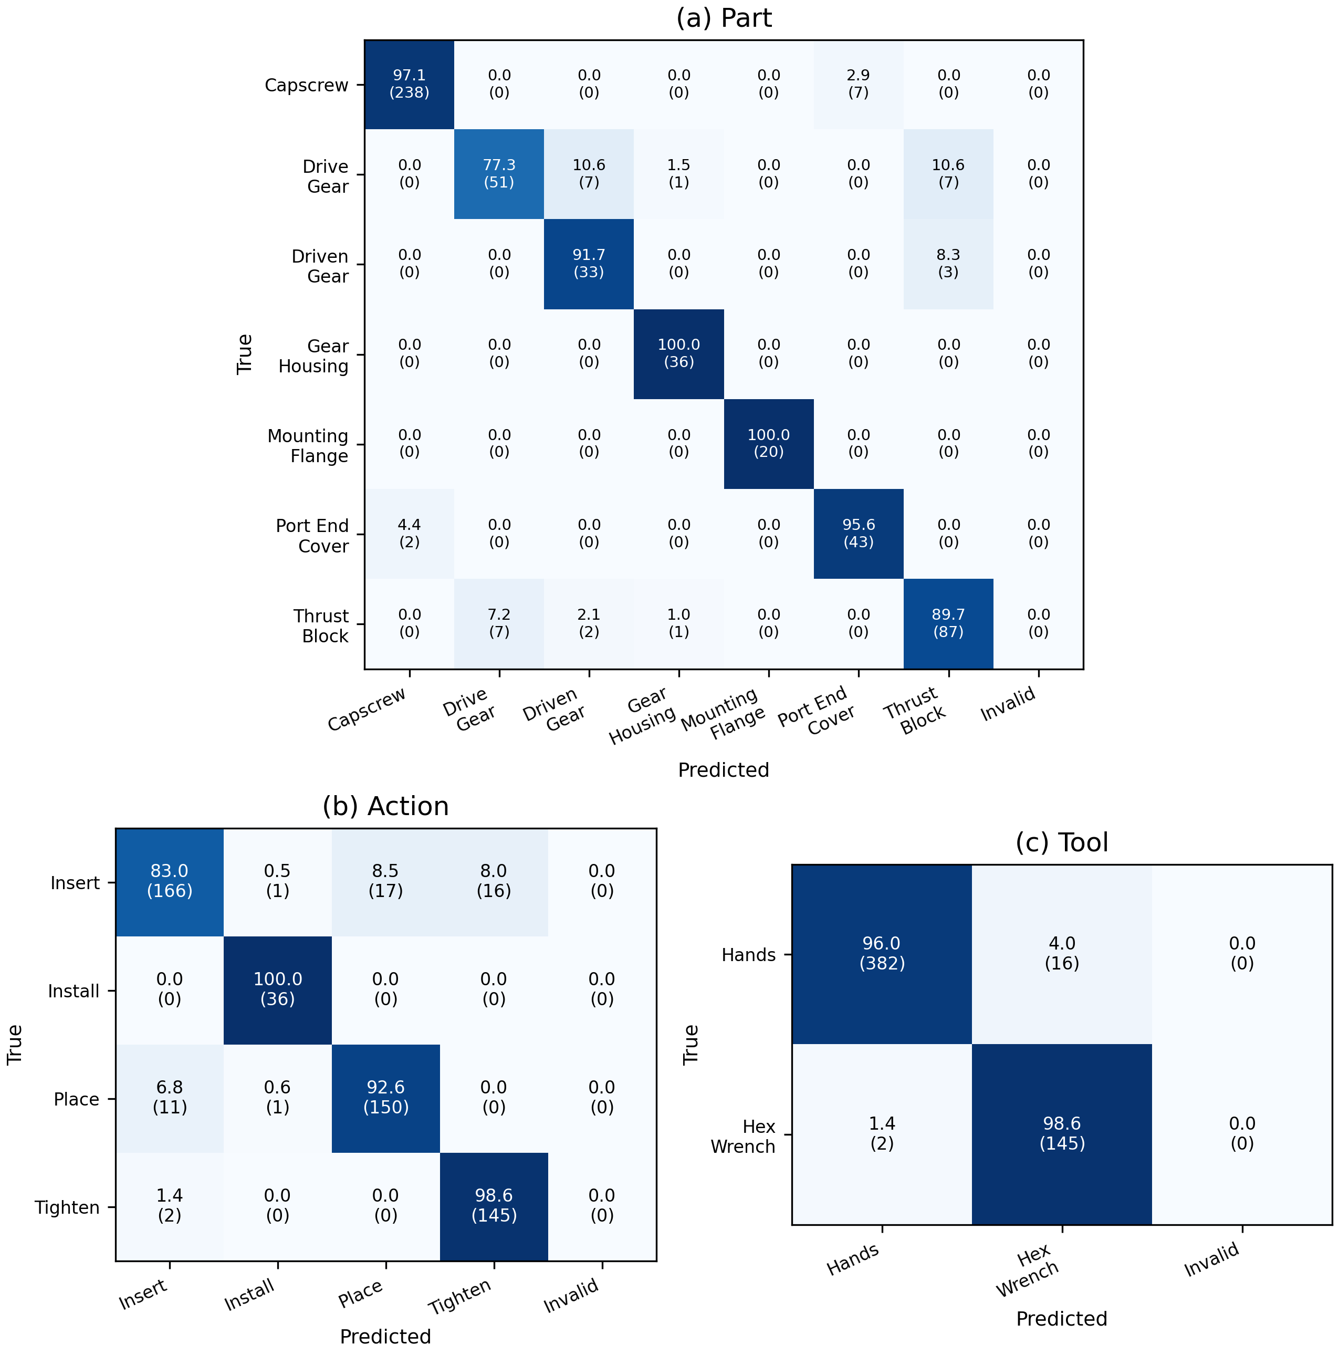
Fig. 8. Audited M3 single-GPU seed42 predictions on all 545 ATP test sources: (a) Part, (b) Action, and (c) Tool. Each cell shows row-normalized percent and count; invalid predictions have a separate column. The fixed checkpoint is illustrative; Tables 1 and 4 report all three seeds and groups.

Fig. 8 provides traceable field-level confusion counts for a fixed shared checkpoint. Such a matrix does not identify an action-boundary failure or its visual cause without corresponding temporal annotations. Complete per-group metrics and action matrices remain in the supporting results.
Introducing a part name in a prompt does not by itself demonstrate recognition of a new product or its completion condition. The available fixed-task and external-task experiments are therefore interpreted within their declared label and source coverage.

4.3 ROI-aligned completion verification and spatial robustness

4.3.1 Experimental setup
The new endpoint experiment compares Full-only, ROI-only, and Full/ROI Mixed supervision, together with a repeated-Full control for presentation and update budget. Annotated boxes define the controlled ROI interface using the frozen expansion and image-boundary rules. The 212/285-source training/test boundary is preserved. The unrecovered historical four-part benchmark and guided-prompt study are identified separately rather than assumed to have been reproduced.
The new shared-task experiment tests whether ATP recognition and endpoint verification can coexist under the M0–M3 mixtures. A shared ResNet50 with separate action, tool, part, and state heads supplies an explicit visual alternative. Additional endpoint ResNet18, ResNet50, and frozen-CLIP linear-head comparisons evaluate the fixed binary task. The historical YOLO few-shot table is preserved in the archived submission; replacement Table 5 instead reports measured inference cost, without implying a new data-efficiency study.
The new spatial test applies the original crop, left/right/up/down shifts of 10%, and scales of 80% and 120% to all compared Mixed-trained model families and seeds. This controlled test uses fixed annotated coordinates. It does not reproduce the historical four-part offset grid or measure an automatic detector; the two protocols must not be pooled.

4.3.2 Results and comparative analysis
The overlapping historical development source is excluded from independent validation and model selection. Replacement Table 2 reports the newly audited endpoint experiment, preserving the 212/285 training/test source boundary, three fixed training seeds, both evaluation views, and the repeated-Full budget control. The four-epoch final checkpoint is fixed in advance. This replaces the historical single-part table rather than reconstructing its missing sample-level predictions.

Table 2. New VLM endpoint supervision comparison on 285 test sources. Accuracy and FPR are percentages, mean ± sample standard deviation across seeds 42/43/44. Full ×2 repeats each Full training example to match the Mixed presentation budget. Invalid outputs are counted across both views and all three seeds (1,710 predictions per row, not independent source images).
VLM training | Full accuracy | ROI accuracy | Full FPR | ROI FPR | Invalid outputs
Full-only | 94.15 ± 4.97 | 96.02 ± 1.73 | 11.57 ± 9.83 | 6.94 ± 4.22 | 0
ROI-only | 97.31 ± 1.33 | 97.43 ± 0.54 | 2.78 ± 1.20 | 3.24 ± 0.40 | 0
Mixed | 98.36 ± 0.73 | 99.30 ± 0.35 | 1.62 ± 0.40 | 0.69 ± 0.69 | 0
Full ×2 | 81.87 ± 28.07 | 82.34 ± 28.48 | 35.88 ± 55.56 | 34.95 ± 56.36 | 0

Mixed supervision has higher mean Full and ROI accuracy than Full-only and ROI-only under the evaluated VLM recipe. Fig. 9 retains every seed, including the Full ×2 seed43 run that predicts Finish for all sources. The failure has no identified coverage or finite-loss/gradient violation; a very low teacher-forced training loss does not establish correct free generation or explain its cause. Consequently, the repeated-Full control is informative but does not isolate a uniquely causal ROI mechanism. The complete paired statistics are reported in Appendix G; mean improvements must not be interpreted as significant replication across every seed.

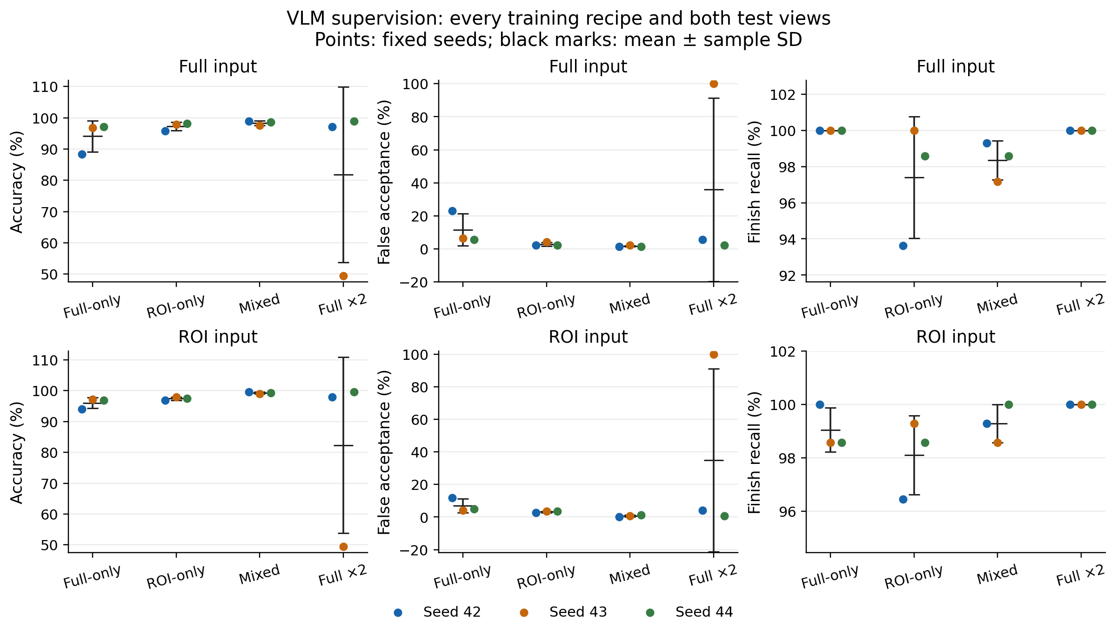
Fig. 9: New within-VLM endpoint comparison for all four training recipes, both test views, and all three fixed seeds. Points show individual seeds and black marks show mean ± sample standard deviation. SD bars are not confidence intervals and can extend beyond valid percentage ranges. Full ×2 seed43 is retained. This replaces the historical single-part chart.

The reported experiments use fixed task prompts without test-based prompt selection. They do not establish the best achievable prompting strategy or prove that prompting cannot substitute for additional supervision. Appendix E distinguishes unmeasured prompting and localization claims from the controlled experiments.
The four-part Table 3 in the original submission contained internally inconsistent metrics, and its missing sample-level archive prevents a verified numerical correction. The replacement Table 3 reports a different, explicitly identified experiment: Mixed training evaluated on both views of the recovered 285-source endpoint test, for the VLM and all three visual baselines. It does not reproduce the four-part benchmark. The original four-part numbers remain available in the archived source manuscript; Fig. 10 visualizes all seeds of the replacement comparison. The former 1.67% bound based on treating paired views as independent is withdrawn. Across the new fixed binary comparisons, the strong visual baselines remain competitive or better; the complete training-view grid is retained in Table G.1.

Table 3. New endpoint comparison under Mixed supervision: three fixed training seeds, 285 test sources (141 Finish, 144 Unfinish) evaluated separately in Full and ROI views. All values are percentages, mean ± sample standard deviation. FPR denotes false acceptance and recall denotes Finish recall. This replaces the unrecoverable historical four-part table; model families use their disclosed training recipes, not matched training compute.
Model / Mixed | Full accuracy | ROI accuracy | Full FPR | ROI FPR | Full recall | ROI recall
VLM | 98.36 ± 0.73 | 99.30 ± 0.35 | 1.62 ± 0.40 | 0.69 ± 0.69 | 98.35 ± 1.08 | 99.29 ± 0.71
ResNet18 | 95.44 ± 7.60 | 99.65 ± 0.61 | 9.03 ± 15.04 | 0.69 ± 1.20 | 100.00 ± 0.00 | 100.00 ± 0.00
ResNet50 | 99.77 ± 0.20 | 99.88 ± 0.20 | 0.23 ± 0.40 | 0.23 ± 0.40 | 99.76 ± 0.41 | 100.00 ± 0.00
CLIP | 96.37 ± 0.54 | 98.01 ± 0.81 | 0.00 ± 0.00 | 0.00 ± 0.00 | 92.67 ± 1.08 | 95.98 ± 1.64

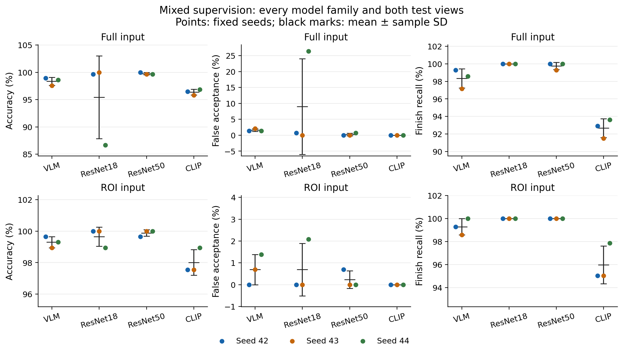
Fig. 10: New Mixed-training endpoint comparison corresponding to Table 3. All four model families, both input views, and all three fixed seeds are shown. Black marks denote mean ± sample standard deviation, not confidence intervals; axes have different labelled ranges, and SD bars can extend beyond the valid percentage range. Other training recipes remain in Table G.1. This figure replaces the unreproduced historical four-part chart.

Shared-model completion retention. Replacement Table 4 reports both endpoint views for the same four mixtures and two model families as Table 1, on 285 fixed test sources (141 Finish and 144 Unfinish). M0 has no completion supervision; its state predictions are diagnostic rather than a fully supervised verification baseline. Full and ROI are paired views of the same sources, not additional independent recordings.

Table 4. New shared-model endpoint comparison on285 paired-view sources: accuracy, false-acceptance rate and Finish recall. Both families report mean ± sample standard deviation over seeds42/43/44. All VLM seeds42/43/44 use one GPU at global batch32. The original two-GPU seed42 models are retained separately in all12 same-seed configuration comparisons, not counted as another seed. Training repeats do not establish independent-recording generalization. M0 lacks completion supervision.
Model / mixture | Full acc. | ROI acc. | Full FPR | ROI FPR | Full recall | ROI recall
VLM / M0 | 44.21 ± 7.60 | 51.11 ± 2.34 | 78.47 ± 20.28 | 59.26 ± 32.11 | 67.38 ± 35.43 | 61.70 ± 28.73
VLM / M1 | 94.97 ± 3.26 | 94.85 ± 3.69 | 9.95 ± 6.45 | 9.95 ± 7.65 | 100.00 ± 0.00 | 99.76 ± 0.41
VLM / M2 | 93.92 ± 1.07 | 94.27 ± 0.41 | 11.57 ± 2.44 | 11.34 ± 0.80 | 99.53 ± 0.41 | 100.00 ± 0.00
VLM / M3 | 96.37 ± 2.94 | 97.43 ± 2.34 | 3.70 ± 0.40 | 0.46 ± 0.40 | 96.45 ± 5.54 | 95.27 ± 4.56
ResNet50 / M0 | 42.11 ± 14.59 | 39.65 ± 17.34 | 31.02 ± 53.73 | 21.53 ± 34.32 | 14.66 ± 25.39 | 0.00 ± 0.00
ResNet50 / M1 | 97.78 ± 2.98 | 62.46 ± 16.27 | 3.70 ± 6.42 | 74.31 ± 32.19 | 99.29 ± 1.23 | 100.00 ± 0.00
ResNet50 / M2 | 99.42 ± 1.01 | 54.15 ± 2.03 | 1.16 ± 2.00 | 90.74 ± 4.01 | 100.00 ± 0.00 | 100.00 ± 0.00
ResNet50 / M3 | 100.00 ± 0.00 | 99.88 ± 0.20 | 0.00 ± 0.00 | 0.23 ± 0.40 | 100.00 ± 0.00 | 100.00 ± 0.00

Read completion accuracy together with false acceptance and Finish recall: a model can avoid false acceptance by rejecting completed assemblies. The complete M0–M3 comparison distinguishes missing completion supervision, adding Full supervision, repeating Full examples, and adding paired ROI supervision. The within-VLM contrasts and conditional source-image intervals are reported together in Appendix G; neither the repeated runs nor the recovered image provenance establishes recording-level generalization. Replacement Table 5 reports the separately measured inference cost. In the three fixed VLM runs, M3 versus M2 gives 96.37% versus 93.92% Full accuracy and 97.43% versus 94.27% ROI accuracy. These are observed differences under the declared recipes, not evidence of universal VLM superiority. The ROI false-acceptance rate changes from 11.34% to 0.46%, while Finish recall changes from 100.00% to 95.27%; accuracy must be interpreted jointly with both error types.

Table 5. New verification-component latency: mean milliseconds per call, batch size one, 150 fixed sources per view, Mixed seed42 models. H200 rows use the same device and measurement protocol; the RTX 4090 row is a separate deployment measurement. Precision is stated per model. Timing includes image loading, preprocessing, transfer, inference and parsing, and excludes model loading, detector, camera, network and FSM. These are not complete monitoring latencies or repeated-run estimates.
Device / model | Full ms | ROI ms | Precision
H200 / ResNet18 | 15.06 | 12.82 | FP32
H200 / ResNet50 | 16.69 | 14.47 | FP32
H200 / CLIP | 31.92 | 24.56 | FP32
H200 / VLM | 986.17 | 471.82 | BF16
RTX 4090 / VLM | 1369.46 | 619.45 | BF16

Replacement Table 5 makes the computational cost explicit. The visual baselines are substantially faster than the VLM in the matched H200 component measurement. The separate RTX 4090 measurement demonstrates feasibility of this verification component at the reported precision, not high-frame-rate operation of the complete monitoring architecture. Concurrent host activity and different measurement sessions preclude treating the device rows as a controlled hardware speedup study. The new endpoint baselines and shared multihead comparison address recognition and task coexistence separately; no data-efficiency advantage is inferred from this latency table or from the unreproduced historical few-shot curves.
The new symmetric perturbation experiment evaluates the original ROI, four directional shifts of 10%, and scales of 80% and 120% for all compared model families and training seeds. The complete grid is retained. At 80% scale, the VLM has lower false acceptance but lower Finish recall than ResNet50; other conditions often favor visual baselines. This supports a condition-dependent tradeoff. It does not establish background robustness, uniform superiority, or a validated tolerance contract for an automatic detector.

Table 6. New symmetric ROI perturbations of Mixed-trained endpoint models. All four model families and seven conditions are retained, with mean ± sample standard deviation across seeds 42/43/44. Metrics are percentages on the same 285 test sources per condition. Directional shifts are 10% of ROI size; scale conditions are 80% and 120%. This replaces the historical four-part perturbation grid.
Model / condition | Accuracy % | FPR % | Finish recall %
VLM / Original | 99.30 ± 0.35 | 0.69 ± 0.69 | 99.29 ± 0.71
ResNet18 / Original | 99.65 ± 0.61 | 0.69 ± 1.20 | 100.00 ± 0.00
ResNet50 / Original | 99.88 ± 0.20 | 0.23 ± 0.40 | 100.00 ± 0.00
CLIP / Original | 98.01 ± 0.81 | 0.00 ± 0.00 | 95.98 ± 1.64
VLM / Left 10% | 99.18 ± 0.73 | 0.93 ± 0.80 | 99.29 ± 0.71
ResNet18 / Left 10% | 99.53 ± 0.54 | 0.23 ± 0.40 | 99.29 ± 1.23
ResNet50 / Left 10% | 100.00 ± 0.00 | 0.00 ± 0.00 | 100.00 ± 0.00
CLIP / Left 10% | 97.08 ± 0.81 | 0.00 ± 0.00 | 94.09 ± 1.64
VLM / Right 10% | 98.71 ± 0.73 | 0.23 ± 0.40 | 97.64 ± 1.08
ResNet18 / Right 10% | 99.30 ± 0.93 | 1.39 ± 1.84 | 100.00 ± 0.00
ResNet50 / Right 10% | 99.77 ± 0.41 | 0.46 ± 0.80 | 100.00 ± 0.00
CLIP / Right 10% | 95.09 ± 0.61 | 0.00 ± 0.00 | 90.07 ± 1.23
VLM / Up 10% | 98.36 ± 1.01 | 1.85 ± 0.40 | 98.58 ± 1.88
ResNet18 / Up 10% | 99.18 ± 1.13 | 1.62 ± 2.23 | 100.00 ± 0.00
ResNet50 / Up 10% | 99.65 ± 0.35 | 0.69 ± 0.69 | 100.00 ± 0.00
CLIP / Up 10% | 96.26 ± 0.54 | 0.00 ± 0.00 | 92.43 ± 1.08
VLM / Down 10% | 99.06 ± 0.41 | 0.46 ± 0.40 | 98.58 ± 0.71
ResNet18 / Down 10% | 98.71 ± 1.66 | 2.55 ± 3.28 | 100.00 ± 0.00
ResNet50 / Down 10% | 99.30 ± 0.61 | 1.39 ± 1.20 | 100.00 ± 0.00
CLIP / Down 10% | 97.31 ± 0.88 | 0.69 ± 0.00 | 95.27 ± 1.78
VLM / Scale 80% | 98.13 ± 0.54 | 0.00 ± 0.00 | 96.22 ± 1.08
ResNet18 / Scale 80% | 97.43 ± 4.16 | 5.09 ± 8.23 | 100.00 ± 0.00
ResNet50 / Scale 80% | 96.73 ± 3.55 | 6.48 ± 7.02 | 100.00 ± 0.00
CLIP / Scale 80% | 97.31 ± 0.41 | 0.00 ± 0.00 | 94.56 ± 0.82
VLM / Scale 120% | 98.95 ± 0.93 | 1.16 ± 0.80 | 99.05 ± 1.08
ResNet18 / Scale 120% | 98.48 ± 1.33 | 0.69 ± 1.20 | 97.64 ± 2.17
ResNet50 / Scale 120% | 100.00 ± 0.00 | 0.00 ± 0.00 | 100.00 ± 0.00
CLIP / Scale 120% | 96.96 ± 0.81 | 0.00 ± 0.00 | 93.85 ± 1.64

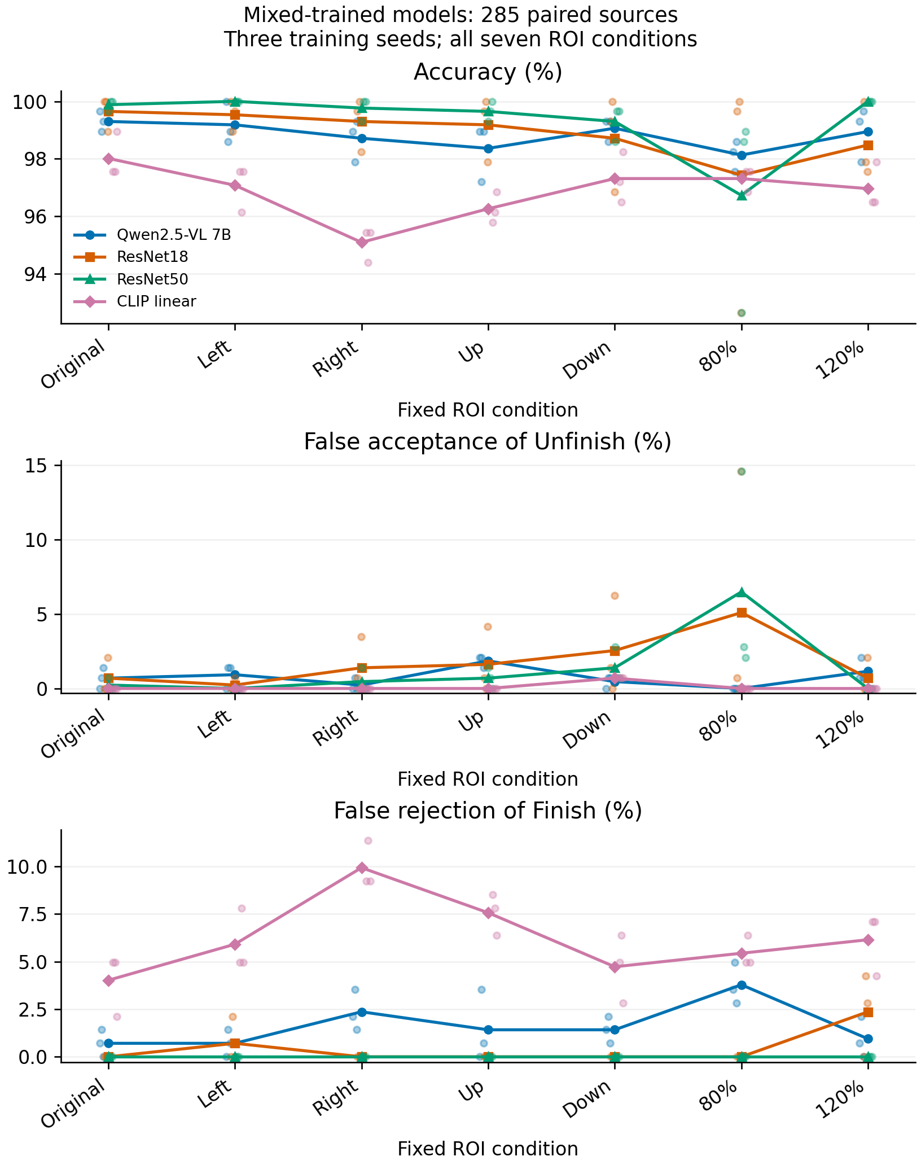
Fig. 11: New symmetric ROI perturbations for all four model families and three training seeds. Lines show means; small points show individual seeds. Accuracy, false acceptance and false rejection are shown together. These are paired conditions on the same endpoint sources, not additional independent recordings.

The historical Grounding DINO cascade scores have not been independently reproduced from the missing four-part archive. They are not used to establish complete system performance in the revised conclusions. The new controlled perturbations use annotated boxes and therefore do not include automatic localization errors or detector latency.

4.4 Causal procedural monitoring diagnostic

4.4.1 Experimental setup
The original ATP-only ordered sequence study did not evaluate the proposed causal verification gate. Its underlying gear-pump videos and prediction archive are unavailable. Replacement Table 7 therefore reports a separately defined Assembly101 diagnostic, not a reconstruction of those historical results. Five c13a training recordings supply vocabulary and references for a minimal dependency graph; one validation and one test recording window are evaluated with an unadapted base VLM. The windows contain three and six annotated mistake events, respectively, and there is no entirely normal test execution.
The three original configurations are unit-weight action-only monitoring, unit-weight verification gating, and confidence-weighted verification gating. Each operates at 1 Hz and chooses its own mode and target from its current state, without future images or frame-level ground truth supplied to inference. All 1,464 inference records and state updates have been audited under the declared complete-JSON-fence normalization. A later exploratory confidence-only configuration reuses the identical General-query output bank, reproducing the original state updates before adding the fourth condition; it adds no model calls or independent recording. Event matching is one-to-one for the same connection, from annotated action start to annotated end plus five seconds, capped at the window end. Every unmatched alarm counts as FP and every unmatched mistake event as FN.

4.4.2 Results and comparative analysis
Table 7 reports both recording windows and all four configurations. On the six test mistake events, action-only and confidence-only each yield TP/FP/FN of 2/20/4; both gated variants yield 1/21/5. No validation mistake is detected. Mean annotation-start delay is 4.42 s for the two detected action-only events and 12.80 s for the one detected event in each gated variant; the four or five misses are retained explicitly. These are detected-only annotation-start delays, not independently established first-visible-error delays or end-to-end live deployment latency. This external-task adaptation does not demonstrate a gating or confidence benefit. Appendix G.5 provides the output diagnostics, matching details and adaptation limits; the historical globally ordered ATP replay is not used as evidence for this causal loop.

Table 7. New causal public-video diagnostic. A: action-only; A+C*: confidence-only; G: unit-weight gate; G+C: confidence-weighted gate. A+C* is an exploratory cached replay added after inspecting the original pilot. Precision, recall and F1 are percentages. Delay is the mean annotated-start delay among detected events only; a dash denotes no detected event, not zero delay. Val and Test are one recording window each, not repeated independent trials.
Split / policy | TP / FP / FN | Precision % | Recall % | F1 % | Delay s
Test / A | 2 / 20 / 4 | 9.09 | 33.33 | 14.29 | 4.42
Test / A+C* | 2 / 20 / 4 | 9.09 | 33.33 | 14.29 | 4.42
Test / G | 1 / 21 / 5 | 4.55 | 16.67 | 7.14 | 12.80
Test / G+C | 1 / 21 / 5 | 4.55 | 16.67 | 7.14 | 12.80
Val / A | 0 / 4 / 3 | 0.00 | 0.00 | 0.00 | —
Val / A+C* | 0 / 4 / 3 | 0.00 | 0.00 | 0.00 | —
Val / G | 0 / 11 / 3 | 0.00 | 0.00 | 0.00 | —
Val / G+C | 0 / 11 / 3 | 0.00 | 0.00 | 0.00 | —

A low ECE on a small, almost perfectly classified frame set does not establish reliable error discrimination or improved FSM alarms. The new perturbation study includes erroneous predictions, and the public-video replay directly compares unit and confidence-weighted gating. Neither diagnostic establishes a confidence-weighting benefit under the evaluated conditions.

4.5 Executable SOP orchestration and evidence integration
This experiment evaluates the orchestration responsibilities independently of the perceptual ranking. A newly implemented Java scheduling adapter is compiled against the unchanged coauthor-supplied state-update binary. It implements mode selection, target/request binding and a hard admission set; original soft node-completion flags remain separately visible. Inputs to the software fixtures contain synthetic unique node identities and artificial quotas/times. They cannot validate physical screw-instance recognition or real alarm accuracy.
All 576 legal insertion/tightening permutations and 60 proper-subset premature-tightening cases satisfy the declared SOP contract. An independent checker audits all 11,174 commands, including resets and rejected responses. Additional checks cover G/V transitions, Finish/Unfinish/Unknown, the 0.6 threshold boundary, wrong targets/modes, old/duplicate responses, repeated actions and reset. A further 27-command suite checks unfinished, wrong-order and cumulative-quota timeout alarm behavior and invalid transport values. Open episodes are recorded as censored or unresolved rather than falsely resolved.
Table 8. Executable contract checks for the revised Java adapter. Counts are software cases, not independent assembly executions or estimates of alarm accuracy.
Responsibility | Fixture/check | Observed result
SOP partial order | 576 legal permutations; 60 incomplete-insertion premature transitions | All expected admission decisions satisfied
G/V mode and target | Request selected before response; strict request/mode/node/condition binding | Wrong, stale and duplicate returns rejected
Completion evidence | Finish/Unfinish/Unknown; threshold 0.6 | Only accepted threshold-qualified Finish confirms
State/session | Repeated actions and reset; all transition invariants | No duplicate admission; reset clears state
Alarm lifecycle | Unfinished, wrong-order and cumulative timeout fixtures | Expected onset, deduplication and resolution/persistence
Input validity | Invalid time, missing/out-of-range confidence, illegal label | Rejected without changing state
Next, all twelve shared-VLM checkpoints contribute their existing held-out endpoint predictions to the exact Java adapter: 285 images × two views × twelve checkpoints gives 6,840 conditional integration cases. Each image is attached to an independently initialized, synthetic action-ready endpoint context. Ground truth is used only by a separate scorer. The scheduler requests Verification and consumes the recorded strict prediction; every resulting release agrees with a valid Finish prediction. This verifies the evidence-to-decision interface, not a natural temporal assembly sequence or an additional independent classification experiment.
Table 9. Conditional static endpoint integration of all shared-VLM mixtures. Values are three-seed mean percentages on the same 285 images per view, comprising 144 Unfinish and 141 Finish sources. False release is the fraction of Unfinish sources released; correct release is the fraction of Finish sources released. M0 has no completion supervision and is a diagnostic. These decisions inherit perception errors and are not real-video alarm metrics.
Mixture | View | False release % | Correct release %
M0 | Full | 78.47 | 67.38
M0 | ROI | 59.26 | 61.70
M1 | Full | 9.95 | 100.00
M1 | ROI | 9.95 | 99.76
M2 | Full | 11.57 | 99.53
M2 | ROI | 11.34 | 100.00
M3 | Full | 3.70 | 96.45
M3 | ROI | 0.46 | 95.27
For M2 versus M3 with ROI input, false releases are respectively 15/17/17 versus 0/1/1 across seeds, each out of 144 Unfinish images. False blocks are 0/0/0 versus 4/14/2, each out of 141 Finish images. The mean false-release decrease from 11.34% to 0.46% therefore accompanies a correct-release decrease from 100.00% to 95.27%. This demonstrates how the measured perception tradeoff propagates into a completion decision; it does not attribute that improvement to the FSM itself.
The full CPU scheduling path was measured on the local Intel Core Ultra 7 265K with a four-logical-CPU container quota. Two complete workload passes warmed the same JVM before five formal passes. Across 52,520 accepted-response calls, mean/median/P95/P99 time is 35.25/34.57/37.09/38.51 µs; maximum is 4.94 ms. The interval includes JSON parsing, validation, core update, admission, alarm-state differences, next-request selection, snapshots and primary serialization. It excludes model inference, network, final log framing/file output and process startup. Reset calls are measured separately. This is a component measurement, not a complete monitoring latency or physical alarm-delay guarantee.
The implementation evidence is bounded by its declared inputs. Unique fixture actions do not supply real screw identity. Unfinish/Unknown retries can block General observations. The core retains prior out-of-order evidence and includes intervening Verification time between General updates; hard admission does not erase this evidence. Positive confirmation is latched without rework rollback. Handling-timeout, asynchronous fairness and real continuous-execution alarm evaluation remain outside these checks. Appendix G.15 provides the execution and audit scope.

5. Discussion
The discussion first interprets the complementary perceptual roles of ROI-aligned supervision and the dual-mode VLM, then considers SOP-conditioned orchestration and deployment ROI provision, before stating the limitations of the present evidence.

5.1 Perceptual findings: ROI-aligned supervision and unified perception
The recovered endpoint task is close to saturation for both the VLM and strong visual classifiers. Paired Full/ROI supervision remains a testable way to expose global context and local completion cues, but its value must be evaluated against ROI-only training and equal-update controls, including all seeds and evaluation views. The historical development source is not independent validation evidence, and unreproduced four-part numbers are not used to strengthen this argument.
Prompt optimization is outside the controlled experiments. Fixed prompts allow the view and supervision comparisons to be interpreted within their specified recipes; they do not isolate a uniquely learned spatial mechanism or establish an upper bound on prompt engineering.
The new shared-task experiment directly tests the addition of endpoint verification supervision to ATP recognition. Its repeated-Full control separates additional presentation and update budget from the inclusion of a paired ROI view. Both model families use three fixed training seeds. Repeated training seeds do not establish independent-recording generalization, and their different pretraining and optimization recipes remain relevant to cross-architecture interpretation.
The new perturbation results show that crop changes can affect false acceptance and false rejection differently. They quantify behavior within the predefined transformations, but cannot be extrapolated to arbitrary occlusion, unseen backgrounds, or detector-produced boxes.
A shared visual backbone with task-specific heads can support ATP recognition and completion classification. It is therefore included as a direct alternative to the shared VLM. Structured categorical outputs can be serialized for the same procedural interface; JSON formatting is not an exclusive VLM capability. Prompt-conditioned vocabulary offers flexibility, but its adaptation benefit and annotation cost require measurement.

5.2 System integration and deployment implications
The perceptual findings inform the system design: which knowledge belongs in the prompt, the symbolic state machine, and the perceptual layer. The implications below distinguish measured component behavior from the proposed complete monitoring architecture.
Mixed supervision is the proposed configuration for combining global and local views. Its deployment suitability depends on the shared-task results, the required balance between false acceptance and false rejection, localization reliability, and inference cost. The current evidence does not justify calling it the only suitable configuration.
An ROI changes both the spatial context and the scale at which local completion cues are presented to the VLM. Paired supervision exposes both views of the same source. These are possible explanations to investigate; the present classification comparisons do not independently identify background suppression, attention allocation, or a particular learned representation as the cause of a result. The equal-update and symmetric-perturbation controls narrow the empirical question without proving an internal mechanism.
Separating the task prompt from explicit SOP dependencies makes the procedural assumptions inspectable. This is a design choice rather than evidence that all procedural knowledge must be excluded from prompts. Confidence weighting remains an experimental option whose benefit has not been demonstrated by the current causal diagnostic.
Procedural state can represent prerequisites and distinguish repeated operations, but its practical value depends on reliable observations and appropriate correction semantics. The historical offline sequence numbers do not validate the causal gated loop. In the new single-recording public-video diagnostic, gating does not improve alarm metrics. Further task-specific perception and independent normal/abnormal executions are needed before a stronger deployment claim is justified.
The system comparison must include both strong endpoint classifiers and shared visual alternatives. The VLM supplies a common prompt-conditioned interface, but this does not establish lower total cost, better accuracy, or unique access to structured observations. Its higher measured inference cost must be justified by a demonstrated task or adaptation benefit. The current external experiments and small causal replay do not establish that benefit generally.
Local completion perception and procedural reasoning address different requirements. The revised Java adapter now gives an executable evidence-to-state contract: it schedules the mode and target, rejects unrelated returns, and maintains hard SOP admission. The software and conditional-image checks support that orchestration behavior. The public-video pilot evaluates a different external adaptation and does not show alarm improvement. These results support a reproducible system interface while delimiting the still-unvalidated complete online loop.
The deployment design exposes General and Verification requests through a shared checkpoint, with SOP state and mode selection managed by the monitor backend. All new VLM accuracy and timing results reported in this revision use BF16 inference, batch size one for timing, and the stated decoding configuration. NF4 is not used to explain those results. The measurements below evaluate the inference component; camera acquisition, automatic ROI detection, HTTP communication, scheduling, and alarm handling are outside the measured interval.
The new controlled verification experiments use annotated ROI coordinates and symmetric perturbations. Automatic ROI provision remains a separate deployment requirement. Neither a measured perturbation grid nor the unverified historical detector cascade proves performance for a new camera, product, or localization method.
The new RTX 4090 component measurement uses the fixed Mixed seed42 model in BF16, batch size one, and greedy decoding on 150 predefined source images in both views, with ten warm-up calls. Mean Full/ROI times are 1,369.50/619.40 ms; medians are 1,357.70/602.40 ms and 95th percentiles 1,392.90/705.90 ms. Peak PyTorch allocated memory is approximately 16.50/16.02 GiB, with about 17.68 GiB peak reserved memory in the interleaved process. Timing includes JPEG reading, decoding, known-coordinate ROI cropping, preprocessing, transfer, generation, and parsing. It excludes model loading, automatic localization, camera, network, and FSM processing. These component times do not establish high-frame-rate online monitoring or an alarm-delay guarantee. The matched H200 comparison with visual baselines is reported separately in Appendix G.
A new SOP variant may require new label definitions, dependency and timing constraints, target-to-node mappings, ROI policies, and completion-state supervision. Adding a name to a prompt does not establish reliable recognition or completion verification. The annotation effort and adaptation cost for a new product have not been measured in this study.

5.3 Limitations
The surviving assets permit a new endpoint evaluation with 212 training sources and 285 test sources, but do not recover the historical four-part prediction archive. The original Table 3 Full-only row is internally inconsistent and cannot be corrected by guessing one metric from another. New results report counts, denominators, invalid outputs, views, and seed identities separately. Multiple views and perturbations of one source are not independent recordings. The shared VLM, endpoint, and shared visual comparisons now include all three fixed training seeds. This does not recover independent recording provenance, and cross-model pretraining and optimization recipes still differ.
The principal unresolved limitation is complete procedural validation. The historical ATP-only sequence replay is not the proposed causal, confidence-weighted, verification-gated monitoring system. The added Assembly101 pilot executes a causal loop on one validation and one test recording, but uses an unadapted base VLM and a minimal toy-specific dependency graph. On the six test mistake events, action-only monitoring yields TP/FP/FN of 2/20/4, while both gated variants yield 1/21/5. This small external adaptation does not establish a gating or confidence benefit, and does not measure error-free complete-run behavior. Its label semantics, perception reliability, and corrective-detachment handling differ from the original gear-pump task. Broader procedural claims require reliable task-specific observations, appropriate state supervision, and independent normal and abnormal executions.

6. Conclusions and Future Work
This study evaluates shared ATP/completion perception, paired Full/ROI supervision and explicit SOP-guided use of visual evidence. The equal-update shared-task comparison shows that paired views increase mean ROI accuracy from 94.27% to 97.43% and reduce false acceptance from 11.34% to 0.46%, while decreasing Finish recall from 100.00% to 95.27% and ATP accuracy from 91.13% to 90.15%. Strong visual models remain competitive or better and are faster; the result supports the tested supervision configuration rather than universal VLM superiority. The revised Java adapter makes mode/target selection and prerequisite admission executable and auditable. Legal/illegal SOP fixtures, real static prediction integration and scoped CPU timings verify its implementation behavior. These results do not establish real-video alarm gains: the separate public-video pilot remains unfavorable under its external-task adaptation. The contribution is an evaluated shared observation-and-view configuration with a reproducible procedural interface, with full continuous-execution validation still required.
Further work must first address the unresolved procedural evaluation: completion-state supervision and reliable action/part perception on continuous recordings, repeated-part and corrective-action semantics, normal-run false alarms, and event-level detection delay with independently defined observable onsets. Independent continuous-recording evaluation and cross-product adaptation remain priorities. Public static anomaly detection and synthetic corruption cannot substitute for this system-level evidence.

References
- Y. Torres, S. Nadeau, K. Landau, Classification and quantification of human error in manufacturing: a case study in complex manual assembly, Appl. Sci. 11 (2) (2021) 749, https://doi.org/10.3390/app11020749.
- C. Chen, T. Wang, D. Li, J. Hong, Repetitive assembly action recognition based on object detection and pose estimation, J. Manuf. Syst. 55 (2020) 325-333, https://doi.org/10.1016/j.jmsy.2020.04.018.
- O. Ay, E. Emel, Real-time assembly task validation using deep learning-based object detection and operator's hand-joints trajectory classification, IEEE Access 13 (2025) 57009-57029, https://doi.org/10.1109/ACCESS.2025.3554263.
- G. Cicirelli, R. Marani, L. Romeo, M.G. Dominguez, J. Heras, A.G. Perri, The HA4M dataset: multi-modal monitoring of an assembly task for human action recognition in manufacturing, Sci. Data 9 (2022) 745, https://doi.org/10.1038/s41597-022-01843-z.
- A. Riedel, N. Brehm, T. Pfeifroth, Hand gesture recognition of Methods-Time Measurement-1 motions in manual assembly tasks using graph convolutional networks, Appl. Artif. Intell. 36 (1) (2022) 2014191, https://doi.org/10.1080/08839514.2021.2014191.
- Z. Kang, J. Cui, Z. Chu, Manual assembly actions segmentation system using temporal-spatial-contact features, Robot. Intell. Autom. 43 (5) (2023) 509-522, https://doi.org/10.1108/RIA-04-2023-0048.
- M. Al-Amin, W. Tao, D. Doell, R. Lingard, Z. Yin, M.C. Leu, R. Qin, Action recognition in manufacturing assembly using multimodal sensor fusion, Procedia Manuf. 39 (2019) 1011-1018, https://doi.org/10.1016/j.promfg.2020.01.288.
- J. Oyekan, A. Fischer, W. Hutabarat, C. Turner, A. Tiwari, Utilising low cost RGB-D cameras to track the real time progress of a manual assembly sequence, Assem. Autom. 40 (6) (2020) 925-939, https://doi.org/10.1108/AA-06-2018-078.
- V. Selvaraj, M. Al-Amin, X. Yu, et al., Real-time action localization of manual assembly operations using deep learning and augmented inference state machines, J. Manuf. Syst. 72 (2024) 504-518, https://doi.org/10.1016/j.jmsy.2023.12.007.
- Q. Ye, Y.Q. Niu, A.Y.C. Nee, S.K. Ong, Spatiotemporal perception and motion similarity learning for real-time assembly verification, Robot. Comput.-Integr. Manuf. 100 (2026) 103258, https://doi.org/10.1016/j.rcim.2026.103258.
- S. Bai, K. Chen, X. Liu, et al., Qwen2.5-VL Technical Report, arXiv preprint arXiv:2502.13923 (2025), https://arxiv.org/abs/2502.13923.
- H. Wang, C. Li, Y.-F. Li, Large-scale visual language model boosted by contrast domain adaptation for intelligent industrial visual monitoring, IEEE Trans. Ind. Inform. 20 (12) (2024) 14114-14123, https://doi.org/10.1109/TII.2024.3441638.
- J. Xu, S.Y. Lo, B. Safaei, et al., Towards zero-shot anomaly detection and reasoning with multimodal large language models, in: Proc. IEEE/CVF Conf. Comput. Vis. Pattern Recognit. (CVPR), 2025, pp. 20370-20382.
- S. Liu, Z. Zeng, T. Ren, F. Li, H. Zhang, J. Yang, Q. Jiang, C. Li, J. Yang, H. Su, J. Zhu, L. Zhang, Grounding DINO: marrying DINO with grounded pre-training for open-set object detection, in: Proc. Eur. Conf. Comput. Vis. (ECCV), 2024, pp. 38-55, https://doi.org/10.1007/978-3-031-72970-6_3.
- C. Liu, J.Y. Song, D. Tang, et al., From insight to autonomous execution: VLM-enhanced embodied agents towards digital twin-assisted human-robot collaborative assembly, Robot. Comput.-Integr. Manuf. 98 (2026) 103176, https://doi.org/10.1016/j.rcim.2025.103176.
- T. Murata, Petri nets: properties, analysis and applications, Proc. IEEE 77 (4) (1989) 541-580, https://doi.org/10.1109/5.24143.
- W. van der Aalst, Process Mining: Data Science in Action, second ed., Springer, Berlin, Heidelberg, 2016, pp. 3-23, https://doi.org/10.1007/978-3-662-49851-4.
- W. Zhong, J. Han, C. Ding, C. Wang, L. Luo, Multi-task prompt adapter for vision-language model, Appl. Soft Comput. 178 (2025) 113254, https://doi.org/10.1016/j.asoc.2025.113254.
- Y. Zhang, K. Jia, Z. Wang, Part-aware fine-grained object categorization using weakly supervised part detection network, IEEE Trans. Multimedia 22 (5) (2020) 1345-1357, https://doi.org/10.1109/TMM.2019.2939747.
- Parker Hannifin Corporation, PGP020 Service Manual, Service Manual HY09-SM020/US, Gear Pump Division, Youngstown, OH, USA, 2022. URL: https://www.parker.com/content/dam/Parker-com/Literature/Pump---Motor-Division/Service-Manuals/PDFs/HY09-020SM929_US%20OOS.pdf (accessed 23 July 2026).
[21] G. Ding, F. Sener, S. Ma, A. Yao, Every Mistake Counts in Assembly, arXiv:2307.16453 (2023), https://arxiv.org/abs/2307.16453.
[22] H. Fan, C. Liu, N. E. Janvisloo, S. Bian, J. Y. H. Fuh, W. F. Lu, B. Li, MaViLa: Unlocking new potentials in smart manufacturing through vision language models, Journal of Manufacturing Systems 80 (2025) 258–271, https://doi.org/10.1016/j.jmsy.2025.02.017.
[23] H. Zheng, J. Huang, J. Xue, X. Li, X. W. Xu, A compositional dual-hand action recognition method for LLM-driven assembly assistance, Journal of Manufacturing Systems (2026), https://doi.org/10.1016/j.jmsy.2026.07.017.
[24] H. Zheng, J. Huang, T. Zheng, X. Xu, T. Alhanai, Compositional Context Fine-Tuning Vision-Language Model for Complex Assembly Action Understanding from Videos, IEEE International Conference on Robotics and Automation (2026), https://doi.org/10.1109/ICRA57385.2026.11695916. Author version: arXiv:2607.10797.
[25] K. He, X. Zhang, S. Ren, J. Sun, Deep Residual Learning for Image Recognition, Proceedings of CVPR (2016) 770–778.
[26] A. Radford, J. W. Kim, C. Hallacy, et al., Learning Transferable Visual Models From Natural Language Supervision, Proceedings of Machine Learning Research 139 (2021) 8748–8763.
[27] K. Roth, L. Pemula, J. Zepeda, B. Schölkopf, T. Brox, P. Gehler, Towards Total Recall in Industrial Anomaly Detection, Proceedings of CVPR (2022) 14318–14328.
[28] P. Bergmann, K. Batzner, M. Fauser, D. Sattlegger, C. Steger, Beyond Dents and Scratches: Logical Constraints in Unsupervised Anomaly Detection and Localization, International Journal of Computer Vision 130 (2022) 947–969, https://doi.org/10.1007/s11263-022-01578-9.
[29] F. Sener, D. Chatterjee, D. Shelepov, K. He, D. Singhania, R. Wang, A. Yao, Assembly101: A Large-Scale Multi-View Video Dataset for Understanding Procedural Activities, arXiv:2203.14712 (2022).
[30] H. Zheng, W. Xia, X. Xu, A human-robot collaborative assembly framework with quality checking based on real-time dual-hand action segmentation, Robotics and Computer-Integrated Manufacturing 94 (2025) 102976, https://doi.org/10.1016/j.rcim.2025.102976.
Appendix A. Exact prompts for the controlled shared-task experiments
A.1 General-mode ATP prompt
You are an assembly quality inspector. Observe this frame. Identify the hand action, tool, and part.
Allowed Actions: ["Place", "Install", "Insert", "Tighten"]
Allowed Parts: ["Mounting Flange", "Gear Housing", "Thrust Block", "Drive Gear", "Driven Gear", "Port End Cover", "Capscrew"]
Output only JSON: {"action": "...", "tool": "...", "part": "..."}.
A.2 Endpoint verification prompt
You are an assembly quality inspector. Determine whether the Port End Cover assembly state is Finish or Unfinish. Output only JSON: {"part": "...", "verification": "Finish/Unfinish"}.
The endpoint text is identical for Full and ROI inputs. It supervises Port End Cover only. The public-video and vocabulary-supplement diagnostics use their separately archived prompts and label sets; their parser and task differences are disclosed in Appendix G.
Appendix B. Audited training configuration
The primary shared-VLM runs use Qwen2.5-VL-7B-Instruct full-parameter SFT, four epochs, AdamW with learning rate 2 × 10⁻⁵ and weight decay 0.01, linear scheduling with 3% warm-up, gradient-norm clipping at 1.0, BF16 and effective global batch 32. Each primary seed42/43/44 run uses one H200; original two-GPU seed42 models are analyzed separately. The fixed final-epoch selection rule does not use the test set. M0/M1/M2/M3 have respectively 216/244/268/268 optimizer updates. Per-example assistant-plus-termination-token losses are averaged under the declared global-batch weighting.
Endpoint-only VLM comparisons use four fixed full-parameter epochs under the corresponding recipe and source mixture. Primary visual baselines use the distinct 30-epoch settings specified in Appendix G.2; the disclosed four-epoch shared-ResNet supplements retain both prefix30 and cosine4 schedules. Source presentations and updates do not make architectures compute matched. All reported new VLM inference results use BF16; the historical NF4 deployment option is not used to explain these measurements.
Appendix C. Cross-product evaluation scope
Historical four-part transfer counts cannot be reconstructed from recovered predictions and are excluded from the current empirical comparison. The LOCO splicing-connectors evaluation in Appendix G.4 is a separate static external task with its own reference budgets and normal-validation thresholds; it is not a reconstruction of the lost transfer experiment. Cross-product completion adaptation and annotation budgets remain unmeasured.
Appendix D. Confidence interpretation
Generated-token confidence is the exponential of the mean generated-token log probability, including the termination token, under the declared decoding configuration. It is not a calibrated physical-completion probability. On the recovered endpoint perturbation diagnostic, erroneous VLM predictions retain approximately 0.989 mean confidence over the three seeds. Calibration on a nearly saturated task does not establish reliable error discrimination or a benefit in procedural alarms. The unrecoverable historical 112-example reliability figure is excluded; the perturbation and causal diagnostic results are reported in Appendix G.
Appendix E. Prompting and localization scope
The historical overlapping development source is excluded from independent model selection. Unrecoverable guided-prompt, automatic-detector cascade and few-shot prediction archives are not used as current numerical evidence. The controlled new experiments use fixed prompts and annotated ROI coordinates. Symmetric crop perturbations do not bound the errors of an arbitrary detector. Grounding DINO thresholds and full-frame fallback remain deployment design choices requiring a matched causal test; they do not establish complete-system latency or a data-efficiency ranking.
Appendix F. Unadapted-model and vocabulary scope
The old Part-only zero-shot aggregate is not ranked as a newly verified baseline because its per-example predictions are unavailable. New endpoint and ATP base-model diagnostics use identified sources and prompts, retain strict and outer-code-fence-normalized results separately, and count invalid predictions explicitly. The disclosed tool-vocabulary supplement is post-inspection and is not a preregistered same-prompt comparison. Detailed counts appear in Appendix G.6–G.9 and the supporting files.
Appendix G. Auditable experimental protocols and supplementary results
G.1 Protocol and scope
The reconstructed endpoint split preserves 212 training and 285 test source images (141 Finish, 144 Unfinish). The overlapping historical validation source is not used as an independent selection set. Fixed configurations and final checkpoints are used. Full-frame and ROI predictions are paired observations of the same test sources, not independent additional recordings. A Finish prediction on a true Unfinish image is a false acceptance; invalid outputs are counted separately and as incorrect in overall accuracy.
The shared ATP task has 1,709 training and 545 test sources. M0 uses ATP only; M1 adds 212 Full endpoint examples; M2 repeats each added Full example; M3 adds 212 Full and 212 paired ROI examples. M2/M3 have equal presentation and update budgets. The primary three-seed tables use seeds 42/43/44, each with one GPU and global batch 32. Original two-GPU seed42 models are retained only in the separate configuration-sensitivity analysis; interrupted partial attempts are not pooled with completed runs. The four-epoch final checkpoint rule is fixed independently of test results.
All eight ATP label triples in the recovered test set occur among the nine training triples. The action/part, action/tool and tool/part test combinations are also represented in training. This benchmark therefore measures recognition of known label combinations and task coexistence; it is not an unseen-composition generalization test.
Exact ATP prompt for the new experiments: You are an assembly quality inspector. Observe this frame. Identify the hand action, tool, and part.
Allowed Actions: ["Place", "Install", "Insert", "Tighten"]
Allowed Parts: ["Mounting Flange", "Gear Housing", "Thrust Block", "Drive Gear", "Driven Gear", "Port End Cover", "Capscrew"]
Output only JSON: {"action": "...", "tool": "...", "part": "..."}.
A technical M1 recovery fixed synchronization for its one-example final global batch: the empty rank performs a zero-weight synchronization forward, while the single real example retains its original optimization weight. No example is dropped or counted twice; extra synchronization computation is logged separately. The repair resumes a hashed full checkpoint in a separate versioned directory, retains the failed logs and prior resource usage, and does not use test outcomes for model selection.
G.2 Strong endpoint baselines and input perturbations
Table G.1. All endpoint training and test views. Each row summarizes three fixed training seeds; accuracy and false acceptance are percentages. Full ×2 repeats the Full training examples to match the Mixed presentation budget.
Model / train | Full accuracy | ROI accuracy | Full false accept | ROI false accept
VLM / Full | 94.15 ± 4.97 | 96.02 ± 1.73 | 11.57 ± 9.83 | 6.94 ± 4.22
VLM / ROI | 97.31 ± 1.33 | 97.43 ± 0.54 | 2.78 ± 1.20 | 3.24 ± 0.40
VLM / Mixed | 98.36 ± 0.73 | 99.30 ± 0.35 | 1.62 ± 0.40 | 0.69 ± 0.69
VLM / Full ×2 | 81.87 ± 28.07 | 82.34 ± 28.48 | 35.88 ± 55.56 | 34.95 ± 56.36
ResNet18 / Full | 67.37 ± 15.93 | 66.43 ± 23.01 | 64.58 ± 31.53 | 66.44 ± 45.55
ResNet18 / ROI | 50.88 ± 0.61 | 95.56 ± 7.70 | 0.00 ± 0.00 | 8.80 ± 15.24
ResNet18 / Mixed | 95.44 ± 7.60 | 99.65 ± 0.61 | 9.03 ± 15.04 | 0.69 ± 1.20
ResNet18 / Full ×2 | 65.85 ± 13.69 | 57.89 ± 7.81 | 67.59 ± 27.10 | 56.71 ± 50.86
ResNet50 / Full | 97.89 ± 3.35 | 50.88 ± 2.43 | 4.17 ± 6.62 | 97.22 ± 4.81
ResNet50 / ROI | 50.99 ± 0.81 | 100.00 ± 0.00 | 0.00 ± 0.00 | 0.00 ± 0.00
ResNet50 / Mixed | 99.77 ± 0.20 | 99.88 ± 0.20 | 0.23 ± 0.40 | 0.23 ± 0.40
ResNet50 / Full ×2 | 98.25 ± 1.95 | 51.23 ± 2.74 | 3.47 ± 3.87 | 96.53 ± 5.42
CLIP / Full | 97.08 ± 0.73 | 95.32 ± 1.07 | 0.00 ± 0.00 | 0.00 ± 0.00
CLIP / ROI | 56.49 ± 0.93 | 68.89 ± 1.07 | 0.00 ± 0.00 | 0.00 ± 0.00
CLIP / Mixed | 96.37 ± 0.54 | 98.01 ± 0.81 | 0.00 ± 0.00 | 0.00 ± 0.00
CLIP / Full ×2 | 98.95 ± 0.00 | 99.30 ± 0.00 | 2.08 ± 0.00 | 0.69 ± 0.00
Within the VLM family, paired Mixed supervision raises mean Full/ROI accuracy from 94.15/96.02% under Full-only training to 98.36/99.30%, and exceeds the ROI-only means of 97.31/97.43%. This supports the usefulness of local supervision within the evaluated VLM recipe. The Full ×2 seed43 run predicts Finish for every test source and is retained; its large variability prevents attributing the entire mean gap to a uniquely isolated ROI mechanism. Under ROI-only training, the VLM also retains higher Full-view accuracy than the evaluated visual baselines. This is a descriptive view-transfer observation under different pretrained models and training recipes, not proof of background invariance or new-product generalization. The Mixed ResNet50 results remain stronger on both views.
The visual baselines use ResNet18/50 [25] initialized from ImageNet1K V1/V2, or a frozen CLIP ViT-B/32 [26] encoder with an L2-normalized 512-dimensional feature and trained linear head. ResNets use AdamW with learning rate 1e-4; the CLIP head uses 1e-3. All use weight decay 0.01, batch32, 30 epochs, cosine scheduling, FP32, and a fixed final checkpoint. ResNets directly resize to 224 × 224 with ImageNet normalization and no augmentation; CLIP uses its standard processor. The VLM uses four full-parameter epochs, AdamW at 2e-5, linear scheduling with 3% warm-up, and BF16. Thus model families share sources, evaluation conditions, and fixed selection rules, but not training-compute budgets or preprocessing. Repeated-Full/Mixed equal-update controls operate within each model family.
Values are mean ± sample standard deviation. The endpoint task is close to saturation, so these results do not show general VLM accuracy superiority. The symmetric perturbation study applies seven conditions to all four model families and all three seeds: original ROI, four directional 10% shifts, and 80%/120% scale. At 80% scale, VLM accuracy is 98.13 ± 0.54%, false acceptance 0.00%, and Finish recall 96.22%; corresponding ResNet50 values are 96.73 ± 3.55%, 6.48%, and 100.00%. Other conditions often favor visual models. The complete condition grid is retained in the supporting results; this example describes a tradeoff, not uniform robustness superiority.
The post-hoc uncertainty supplement retains the full 63 model/condition/seed accuracy comparisons with Holm adjustment. Source-image bootstrap intervals are conditional on the fixed trained models and unverified frame exchangeability; they do not quantify independent-recording or new-training-seed uncertainty. For a fixed model with zero false acceptances among 144 Unfinish sources, a conditional Wilson 95% interval still has an upper limit of 2.60%.
Fig. G.1. All seven predefined ROI conditions, all four model families, and all three training seeds. Accuracy, false acceptance, and false rejection are reported together. Lines show three-seed means and small points show individual seeds; these are not independent recordings.
A post-hoc within-VLM paired diagnostic retains all six training-recipe pairs, both test views, and all three seeds: 36 exact McNemar comparisons use one Holm adjustment within this diagnostic family. Mixed exceeds Full-only in each fixed seed in both views, with mean differences of 4.21 percentage points for Full and 3.27 for ROI. Pointwise source-image bootstrap intervals, conditional on the three fixed model pairs, are [2.11, 6.43] and [1.64, 5.15] points. These intervals do not quantify training-seed uncertainty or recover recording independence. Only seed42 remains below adjusted p = 0.05 in each of these two view comparisons; the other seeds do not establish an independently replicated significant difference. Mixed versus ROI-only gives a smaller Full-view mean difference of 1.05 points, with a conditional interval of [-0.23, 2.46] and a slight decrease for seed43. The complete contrast grid, including the FullRepeat2 collapse and all unfavorable contrasts, is retained in the statistical supplement.
G.3 Shared-task comparison
Table G.2. Shared ResNet50, mean ± sample standard deviation over seeds 42/43/44. All four conditions are retained.
Shared ResNet50 group | ATP joint (%) | Full state (%) | ROI state (%)
M0 | 92.78 ± 0.64 | 42.11 ± 14.59 | 39.65 ± 17.34
M1 | 90.64 ± 3.06 | 97.78 ± 2.98 | 62.46 ± 16.27
M2 | 94.37 ± 1.39 | 99.42 ± 1.01 | 54.15 ± 2.03
M3 | 92.11 ± 0.00 | 100.00 ± 0.00 | 99.88 ± 0.20
Each shared ResNet50 group has three seeds. M0 has no state-head supervision, so its state outputs are diagnostic rather than a trained verification baseline. All VLM seeds42/43/44 use one GPU at global batch32. The original two-GPU seed42 models are retained separately in all12 same-seed configuration comparisons, not counted as another seed. Training repeats do not establish independent-recording generalization. No numerical comparison is inferred from historical H100 runs.
Table G.3. Shared VLM, mean ± sample standard deviation over all fixed seeds42/43/44. All four groups and all three tasks/views are retained. All VLM seeds42/43/44 use one GPU at global batch32. The original two-GPU seed42 models are retained separately in all12 same-seed configuration comparisons, not counted as another seed. Training repeats do not establish independent-recording generalization.
Shared VLM group | ATP joint (%) | Full state (%) | ROI state (%)
M0 | 89.66 ± 3.06 | 44.21 ± 7.60 | 51.11 ± 2.34
M1 | 91.07 ± 1.64 | 94.97 ± 3.26 | 94.85 ± 3.69
M2 | 91.13 ± 0.42 | 93.92 ± 1.07 | 94.27 ± 0.41
M3 | 90.15 ± 0.28 | 96.37 ± 2.94 | 97.43 ± 2.34
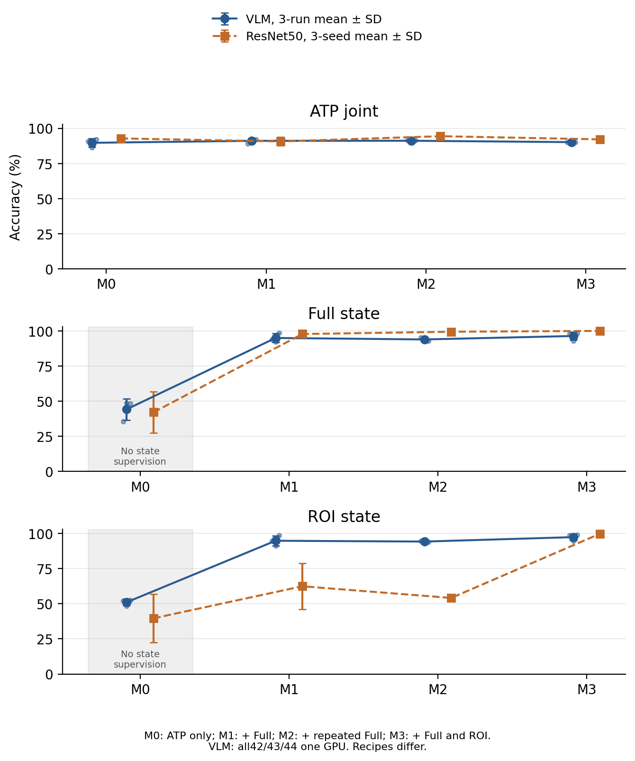
Fig. G.2. All four shared-task groups and both endpoint views. Both model families show three-seed means and sample standard deviations. M0 state outputs are unsupervised diagnostics; model recipes are not compute matched.
Table G.4. Shared VLM ATP fields and joint accuracy, mean ± sample standard deviation over all three seeds. Invalid outputs count as incorrect in every field and in joint accuracy.
VLM group | Action (%) | Tool (%) | Part (%) | Joint (%)
M0 | 92.17 ± 1.58 | 96.45 ± 0.59 | 93.21 ± 3.35 | 89.66 ± 3.06
M1 | 93.15 ± 1.30 | 96.94 ± 0.83 | 94.31 ± 2.02 | 91.07 ± 1.64
M2 | 92.66 ± 0.49 | 96.64 ± 0.38 | 94.50 ± 0.49 | 91.13 ± 0.42
M3 | 92.29 ± 0.97 | 97.00 ± 0.69 | 93.15 ± 0.46 | 90.15 ± 0.28
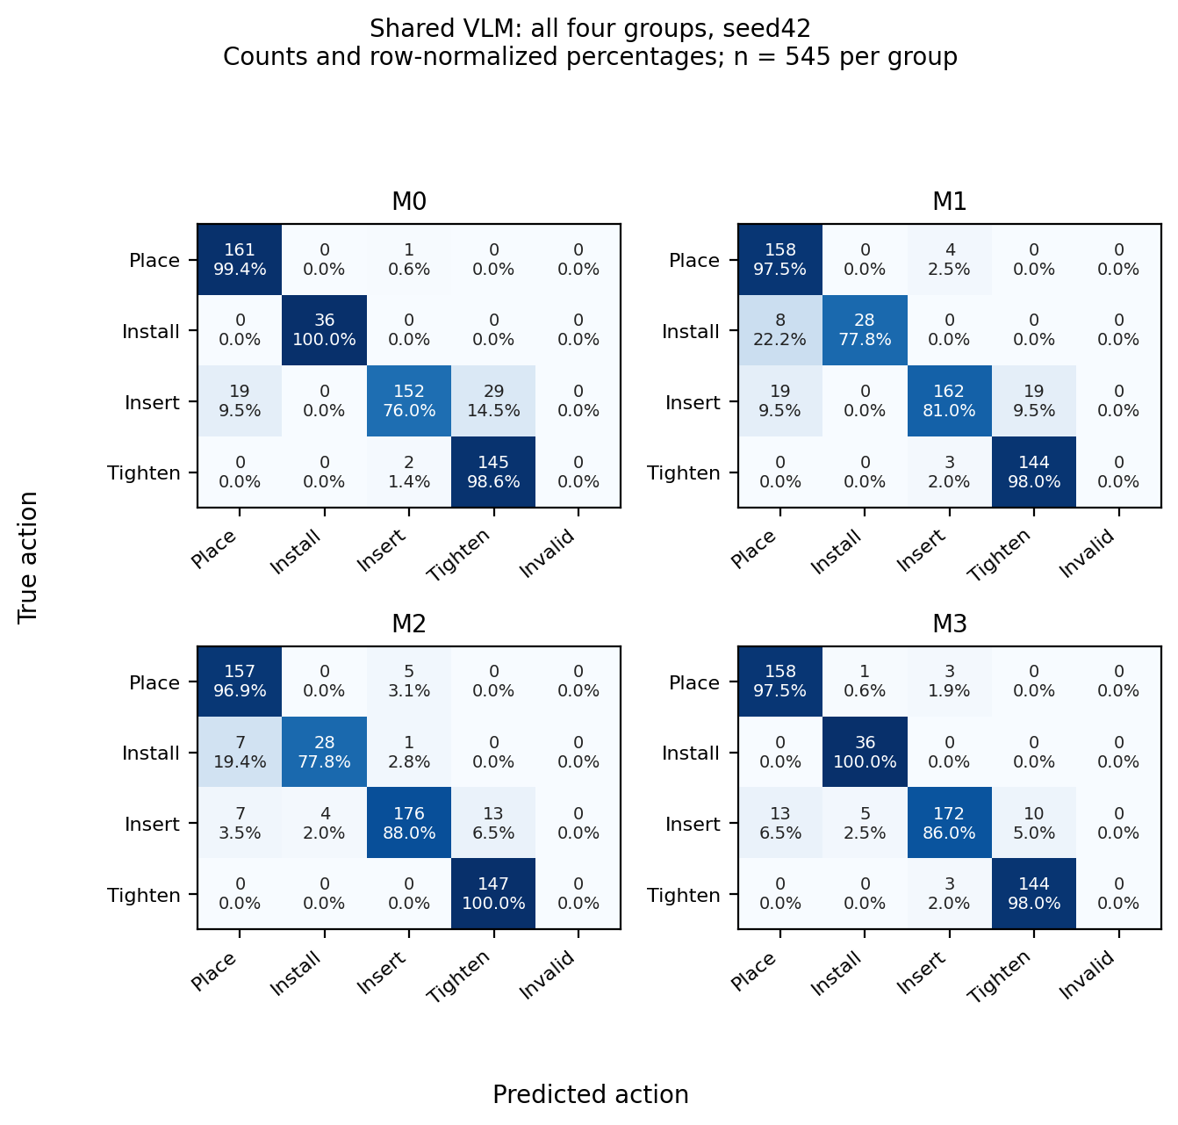
Fig. G.3. Original core seed42 (two-GPU) action confusion matrices for all four shared VLM groups. Cells report counts and row-normalized percentages, including invalid outputs. This retained configuration illustration is separate from the matched one-GPU numerical tables and the one-GPU M3 illustration in Fig. 8.
The complete paired supplement includes all six group pairs, all three tasks/views, and all three seeds, giving 54 exact McNemar comparisons with one global Holm correction. Source-image paired bootstrap intervals average over the three fixed model pairs and condition on those trained weights; they do not establish recording independence or estimate training-randomness uncertainty. All 12 exact sample orders, four-epoch coverage, outputs and prediction hashes are independently audited.
G.4 Confidence and computational cost
Across the seven endpoint perturbations, erroneous VLM predictions have mean generated-token confidence approximately 0.989 in all three seeds. Confidence weighting is therefore not justified solely by low overall ECE. On matched H200 measurements with 150 sources, two views, batch size one, and ten warm-up inputs per model, mean Full/ROI times are 15.06/12.82 ms for ResNet18, 16.69/14.47 ms for ResNet50, 31.92/24.56 ms for CLIP, and 986.17/471.82 ms for the BF16 VLM. Timing includes reading, preprocessing, transfer, inference, and parsing, but excludes the detector, camera, network, FSM, and model loading. Other GPUs were concurrently occupied. These are component measurements, not complete online monitoring latency.
G.5 External static and causal diagnostics
MVTec LOCO [28] splicing_connectors uses 360 normal training images, 60 normal validation images, and 312 test images. The VLM extension uses three fixed training references with candidate-response likelihood scoring; PatchCore [27] and CLIP [26] baselines are reported with both 360-reference and matched three-reference budgets. The same 60 normal validation images set each threshold. The ROI rule returns the full image for this category, so the study cannot establish ROI benefit. Strong 360-reference PatchCore AUROC is 85.15%, 85.37%, and 84.93%; the Mixed VLM values are 73.19%, 69.52%, and 69.80%. This static single-category extension does not demonstrate broad cross-product or alarm superiority.
Table G.5. Test-event alarms for all four configurations on the same Assembly101 recording. Precision, recall, and F1 use the same fixed matching rule. *Confidence only is an exploratory follow-up after initial test inspection, replaying the same frozen General predictions.
Test configuration | TP | FP | FN | Precision (%) | Recall (%) | F1 (%)
Action only | 2 | 20 | 4 | 9.09 | 33.33 | 14.29
Confidence only* | 2 | 20 | 4 | 9.09 | 33.33 | 14.29
Verification gate | 1 | 21 | 5 | 4.55 | 16.67 | 7.14
Confidence + gate | 1 | 21 | 5 | 4.55 | 16.67 | 7.14
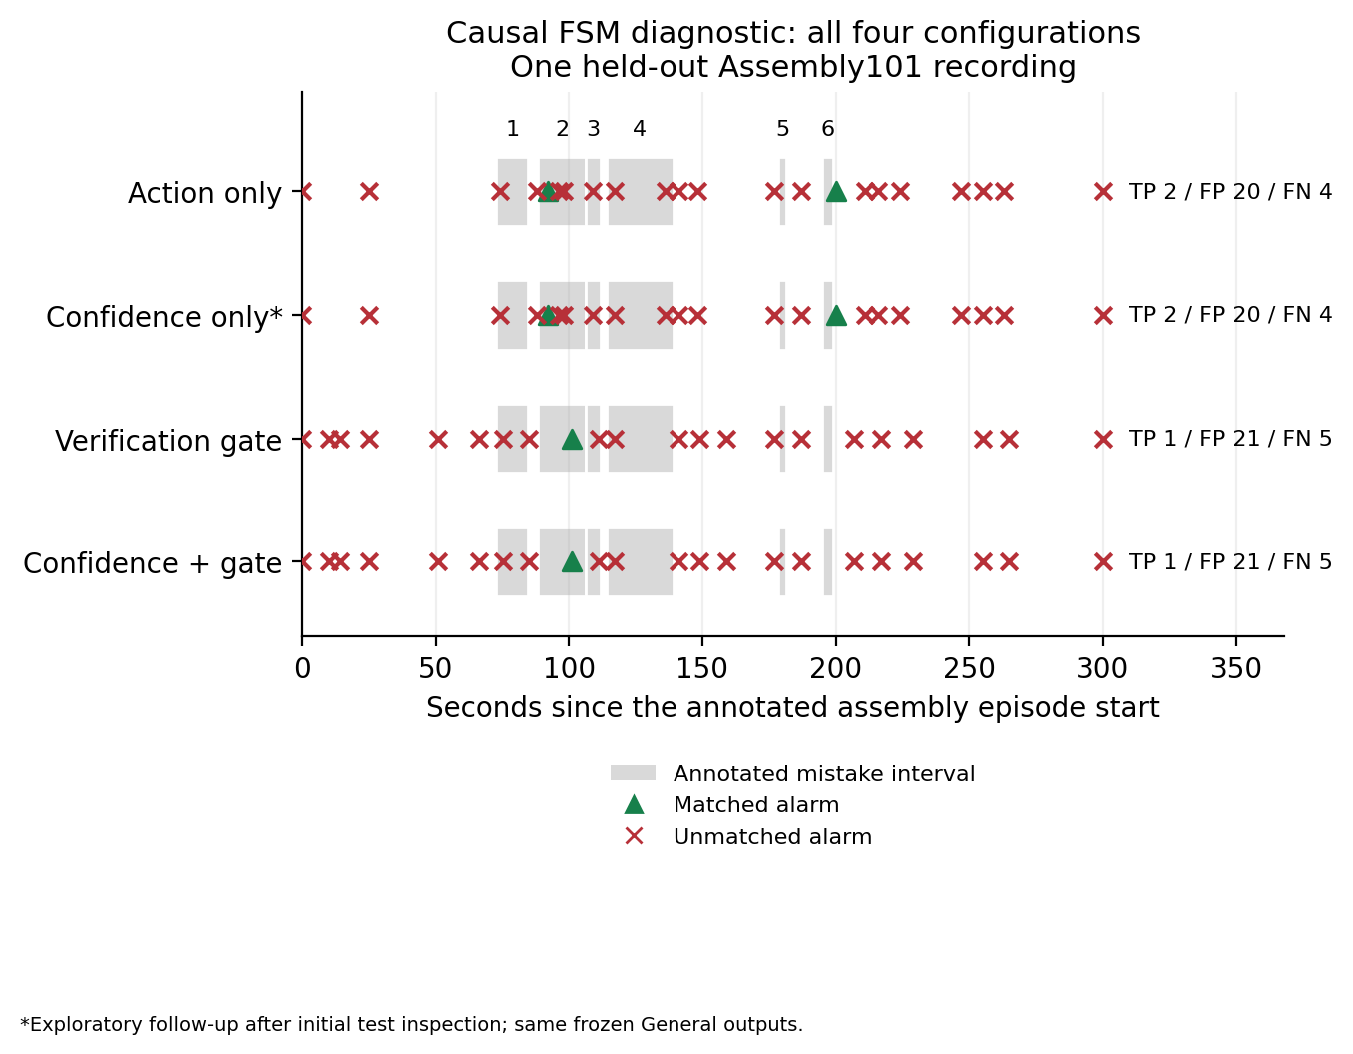
Fig. G.4. Causal public-video test replay with all annotated mistake intervals and alarms from all four configurations. The confidence-only row is an exploratory cached-output follow-up. This single-recording diagnostic does not establish improved gated monitoring or normal-run false-alarm performance.
The causal Assembly101 [29] diagnostic uses five c13a training recordings to define vocabulary, references, and minimal dependencies, one validation recording, and one test recording. At 1 Hz, each configuration makes one model call per sample and selects its own mode and target; frame-level ground truth and future images are not inference inputs. The test has six annotated mistake events. Alarm matching uses the same connection and the annotation interval plus five seconds; this generic-error metric does not establish correct error-type classification. Neither gated configuration improves the result. There is no all-normal test recording, and annotation-start delay is not independently established first-visible-error delay. The unadapted base VLM, minimal dependency graph, incomplete corrective-detachment semantics, and single test recording prevent a strong system-level conclusion.
The pilot parser was fixed after the training-only inspection: it removes a complete outer JSON code fence and then validates the complete object, keys, and allowed values. It does not extract an answer from arbitrary prose. All 1,464 pilot calls require this fence normalization; all pass the normalized schema, while none pass the literal no-fence schema. Both counts are retained. This declared pilot interface differs from the strict parser used for the new endpoint and shared-task accuracy tables.
Measured annotation-start delays for the two detected action-only events are 3.80 and 5.03 s (mean 4.42 s), with four of six events missed. Each gated configuration detects one event at 12.80 s and misses five. These detected-only delays are not an overall success-delay statistic or a first-visible-onset measure. During the 190.87 s labelled correct action intervals within this abnormal test recording, action-only and gated variants produce 12 and 16 false alarms, respectively (3.77 and 5.03 per labelled-correct minute). Those intervals do not substitute for independent entirely normal executions.
An exploratory follow-up, specified after inspecting the initial pilot, completes the confidence × gating comparison with confidence weighting alone. Both ungated variants request identical General inputs at every fixed tick, so the follow-up replays the same frozen real model outputs without new inference calls. The original 1,464 inference records and corresponding state updates are reproduced exactly, together with the event scores before adding 488 cached state updates. Confidence weighting alone gives the same test TP/FP/FN of 2/20/4 and F1 of 14.29% as unit-weight action-only monitoring; both gated variants remain 1/21/5. Thus neither the ungated nor gated comparison shows an event-metric benefit from confidence weighting in this pilot. The follow-up adds a configuration, not an independent test recording, and is not described as a test-blind preplanned experiment.
A further exploratory audit compares the frozen General outputs with official action-interval labels, without changing the policy. In the action-only test run, 265 queries have exactly one covering action interval; 112 agree on action, 36 on the unordered part pair, and 25 on both. The remaining 42 General queries lack interval coverage and are not assigned a synthetic none label. Each gated test run makes 161 General and 146 Verification calls; all 161 General queries shared across the three runs yield identical parsed outputs. This exposes limited agreement under the external-task adaptation and different observation opportunities, but interval labels are not independent frame-visible-action truth. Verification produces 7 Finish, 138 Unfinish, and 1 Unknown response in each gated run; without independent completion-state labels, these frequencies are not verification accuracy. This diagnostic cannot identify a single causal source of the alarm failures.
Table G.8. Unadapted base-VLM ATP diagnostic on the same 545 test sources and frozen shared-task prompt, BF16 greedy decoding. The primary strict schema and complete outer-code-fence normalization are reported separately; invalid responses count as incorrect in every field and joint accuracy. This diagnostic evaluates the stated ATP task and does not reconstruct the unavailable historical Part-only probe. Duplicate-key outputs retain the original shared parser behavior and are counted separately.
Parsing rule | Valid / total | Action % | Tool % | Part % | Joint % | Duplicate keys
Primary strict | 87/545 | 6.61 | 0.00 | 2.57 | 0.00 | 0
Complete-fence diagnostic | 186/545 | 15.60 | 0.00 | 6.24 | 0.00 | 0
Ten fixed ATP training sources warm up this measurement and do not enter its accuracy denominator. Its recorded generation-only times exclude image reading, preprocessing, transfer, parsing and model loading; they are not Table 5 component totals or complete monitoring latencies. Source identities, hashes, ground truth, coverage and both parsing definitions are independently checked. No base-model training or prompt selection is performed.
Table G.9. Post-inspection base-VLM interface diagnostic: the prompt adds the complete training-derived tool vocabulary (Hands, Hex Wrench, Screwdriver) and the Hands convention. The original prompt did not state these categories. This is a disclosed supplementary diagnostic, not a preregistered same-prompt model ranking. The original baseline and the initial variant that failed its vocabulary assertion before inference are retained.
Parsing rule | Valid / total | Action % | Tool % | Part % | Joint % | Duplicate keys
Primary strict | 540/545 | 38.72 | 73.03 | 24.59 | 14.50 | 0
Complete-fence diagnostic | 545/545 | 39.45 | 73.94 | 24.77 | 14.68 | 0
A zero exact-match tool score under the original underspecified interface cannot by itself establish absence of visual understanding. The supplementary run keeps the same 545 sources, unadapted model and decoding, changes only the stated tool contract, and preserves strict and complete-fence parsing results separately. Its timing is generation-only. No synonyms are mapped after prediction.
G.10 Supplemental four-epoch shared visual baseline
Table G.10. Disclosed post-inspection budget supplement, fixed after the core seed42 VLM and primary visual results were known. Both four-epoch schedules and all three seeds are retained: prefix30 is the first four epochs of the original 30-epoch cosine schedule; cosine4 completes cosine decay in four epochs. The original fixed-final-30-epoch strong ResNet50 baseline remains the primary comparator, rather than being replaced by shorter training. Values are mean ± sample standard deviation in percent. M0 state outputs remain unsupervised diagnostics.
Schedule / group | ATP joint % | Full state % | ROI state % | Full FPR % | ROI FPR %
prefix30 / M0 | 91.44 ± 1.06 | 41.87 ± 14.99 | 39.18 ± 16.70 | 29.40 ± 50.92 | 22.92 ± 33.30
prefix30 / M1 | 89.91 ± 3.12 | 99.18 ± 0.73 | 56.73 ± 6.52 | 1.62 ± 1.45 | 85.65 ± 12.90
prefix30 / M2 | 90.34 ± 0.76 | 99.30 ± 1.22 | 61.05 ± 3.35 | 1.39 ± 2.41 | 77.08 ± 6.62
prefix30 / M3 | 91.93 ± 0.49 | 99.65 ± 0.35 | 99.88 ± 0.20 | 0.00 ± 0.00 | 0.23 ± 0.40
cosine4 / M0 | 91.31 ± 1.04 | 42.81 ± 13.07 | 36.73 ± 18.17 | 29.40 ± 50.32 | 29.40 ± 37.94
cosine4 / M1 | 89.48 ± 2.39 | 99.77 ± 0.20 | 63.27 ± 17.72 | 0.46 ± 0.40 | 72.69 ± 35.07
cosine4 / M2 | 91.31 ± 1.58 | 99.88 ± 0.20 | 65.61 ± 2.46 | 0.23 ± 0.40 | 68.06 ± 4.86
cosine4 / M3 | 91.99 ± 0.42 | 99.77 ± 0.41 | 100.00 ± 0.00 | 0.00 ± 0.00 | 0.00 ± 0.00
primary30 / M0 | 92.78 ± 0.64 | 42.11 ± 14.59 | 39.65 ± 17.34 | 31.02 ± 53.73 | 21.53 ± 34.32
primary30 / M1 | 90.64 ± 3.06 | 97.78 ± 2.98 | 62.46 ± 16.27 | 3.70 ± 6.42 | 74.31 ± 32.19
primary30 / M2 | 94.37 ± 1.39 | 99.42 ± 1.01 | 54.15 ± 2.03 | 1.16 ± 2.00 | 90.74 ± 4.01
primary30 / M3 | 92.11 ± 0.00 | 100.00 ± 0.00 | 99.88 ± 0.20 | 0.00 ± 0.00 | 0.23 ± 0.40
The supplement preserves source splits, ImageNet initialization, 224 × 224 resizing, per-example field-averaged losses, AdamW settings and final-epoch selection. Each four-epoch group matches its VLM mixture in source presentations and global-batch optimizer updates. This does not match pretraining, resolution, precision, optimizer schedule, parameter count, wall time or FLOPs across model families and does not establish data efficiency. A CPU audit verifies all 24 prediction banks, four exact epoch shuffles, final checkpoint hashes, and identical same-seed initialization and first-epoch fingerprints between the two supplemental schedules. All per-seed results are retained in the supporting evidence.
G.11 Annotation-assisted action-only FSM diagnostic
Table G.11. Disclosed post-inspection CPU diagnostic on the same fixed validation and test windows. Only action-only observations are replaced by official temporal-action tuples; the original graph, policy, thresholds and event scorer are unchanged. The original488 cached observations and states/alarms/scores are reproduced. No new model calls, completion-state labels or independent recordings are added. This annotation-assisted control is not a deployable system, a true oracle upper bound, or a test of verification-gating benefit.
Diagnostic input / split | TP | FP | FN | Detected-only delay s
Original / test | 2 | 20 | 4 | 4.42
Original / val | 0 | 4 | 3 | NA
Annotation-assisted / test | 1 | 0 | 5 | 0.80
Annotation-assisted / val | 1 | 0 | 2 | 0.80
Official intervals uniquely cover 265/307 test and 167/181 validation ticks. Uncovered or overlapping ticks remain invalid rather than being labelled none or normal. The assisted test trajectory still misses five of six mistake events; reduced false alarms do not establish complete recognition or normal-run performance. 3/6 test mistake segments and 1/3 validation mistake segments share their action tuple with correct segments in the same window. This concerns a memoryless tuple, not an identifiability bound for a policy with full history. Temporal-action labels do not supply independently visible Finish truth. These results do not isolate a single failure cause or demonstrate that the current visual gate resolves the remaining errors.
G.12 Original-core configuration sensitivity
Table G.12. Retained original two-GPU seed42 versus the separately completed one-GPU seed42, all four groups and three tasks/views. The one-GPU42/43/44 models form the three-seed main summary regardless of score direction. The original core42 is not a fourth seed. Differences below are one-GPU minus two-GPU accuracy in percentage points. All12 tests receive one Holm correction.
Group / task | Two-GPU % | One-GPU % | Difference pp | Holm12
M0 / ATP | 89.17 | 90.64 | 1.47 | 1
M0 / Full | 25.26 | 35.44 | 10.18 | 0.01689
M0 / ROI | 33.68 | 52.28 | 18.60 | 1.556e-07
M1 / ATP | 88.62 | 89.17 | 0.55 | 1
M1 / Full | 97.89 | 94.04 | -3.86 | 0.01074
M1 / ROI | 95.44 | 94.74 | -0.70 | 1
M2 / ATP | 91.01 | 91.38 | 0.37 | 1
M2 / Full | 94.39 | 95.09 | 0.70 | 1
M2 / ROI | 92.63 | 94.74 | 2.11 | 0.5625
M3 / ATP | 92.29 | 89.91 | -2.39 | 0.2171
M3 / Full | 97.54 | 97.89 | 0.35 | 1
M3 / ROI | 98.60 | 98.60 | 0.00 | 1
These paired fixed-model observations also contain numerical-reduction and execution randomness; they do not isolate a causal effect of parallelism. Conditional source-image intervals and update-only timing records are retained in the evidence JSON. They neither establish independent-recording generalization nor measure total billed training cost. The original model outputs and scheduled noon snapshot are preserved.
G.13 Complete repeated cross-family diagnostic
The exploratory complete-grid supplement compares all12 same-configuration VLM models with the12 primary30 and24 four-epoch ResNet50 models, retaining all groups, tasks, views and seeds. All108 fixed-model source-image paired comparisons receive Holm108 correction as one disclosed analysis family. The36 three-seed summary rows, every per-seed correct count and discordant pair, adjusted p values and conditional source intervals are provided in the supporting JSON/CSV. The original30 strong baseline remains primary; shorter training does not establish equal FLOPs, pretraining, resolution or optimization. M0 state outputs are unsupervised diagnostics. These source-conditional intervals are not uncertainty over new recordings or training randomness, and this is not an isolated causal architecture comparison.
G.14 Executable Java replay and explicit SOP admission
The updated candidate is independently executable offline. We reran 25 direct Java core assertions and 34 process checks. Software checks cover declared interfaces, reset behavior, prefix independence and episode recording; they do not measure real alarm benefit. The CLI replays supplied General/Verification modes and has no closed-loop mode selection. Unknown historical production parameters remain unspecified rather than being guessed.
The author-confirmed SOP contains a chain through steps 1–7, unordered insertion steps 8–11 after step 7, and unordered tightening steps 12–15, each requiring all four insertions. The unchanged candidate maintains soft predecessor readiness; its local done flag is not hard dependency admission. Three illegal synthetic sequences reproduce local completion at zero predecessor readiness for a tightening node. A distinct event-admission prototype passes all 576 legal insertion/tightening permutations and 60 incomplete-insertion early-tightening cases. It rejects premature events and requires unique, trustworthy upstream completion candidates. These tests do not establish visual screw identity or true-video alarm precision/recall.
The recovered two indexed ATP test sequences contain 545 retained images, with gaps rather than continuous capture. Repeated capscrew labels do not identify physical instances. We therefore score nine observable phases: steps 1–7 separately, insertion as one phase, and tightening as one phase. The two thrust-block placements remain distinct contextual phases. Ground-truth step and phase are excluded from inference streams and used only for scoring. All VLM seeds use one GPU at global batch 32; the original two-GPU seed42 remains separate.
An exploratory ordered context decoder uses training-sequence retained-image counts for stay/advance priors and both fixed emission settings epsilon=0.1/0.01. Causal filtering, a duration-prior-only control and future-dependent Viterbi decoding are separately retained. The causal maximum-probability phase can move backwards and is not a hard admission state. Separately, actual unchanged Java execution uses the 15-node author graph, mean training-image counts as exploratory per-step quotas, an artificial one-interval-per-retained-image clock, unit confidence and verification disabled. Node probabilities are grouped into the nine phases, with Handling and unresolved ties scored incorrect. This is not a restoration of production times, next-query accuracy or completion-verification performance.
Table G.14. Exploratory nine-phase accuracy on all 545 retained test images, all 24 models; mean ± sample SD over three fixed trained models. Context and actual Java are distinct methods. Full conditions and traces remain in the supporting package.
Family / group | Causal eps .1 % | Causal eps .01 % | Actual Java %
VLM / M0 | 90.34 ± 4.06 | 90.03 ± 4.37 | 86.91 ± 2.34
VLM / M1 | 92.72 ± 2.05 | 92.66 ± 2.12 | 87.22 ± 1.48
VLM / M2 | 91.99 ± 1.01 | 91.62 ± 0.69 | 88.26 ± 1.02
VLM / M3 | 91.93 ± 0.84 | 91.68 ± 0.69 | 86.73 ± 0.56
ResNet50 / M0 | 93.58 ± 1.15 | 93.15 ± 1.12 | 90.89 ± 1.73
ResNet50 / M1 | 92.11 ± 3.61 | 91.68 ± 3.34 | 87.16 ± 3.79
ResNet50 / M2 | 95.54 ± 2.50 | 95.35 ± 2.80 | 91.31 ± 1.06
ResNet50 / M3 | 94.25 ± 0.28 | 93.82 ± 0.38 | 90.15 ± 0.28
The duration-only score is 47.34%. Whole-sequence M3 accuracy is 97.19 ± 0.21% for the VLM and 97.13 ± 0.87% for ResNet50; these use future observations and are not online results. Independent scoring checks recompute the saved context traces and all 48 real-output Java per-video results, totaling 13,080 actual Java observations. All groups and unfavorable results are retained.
These results establish reproducible procedural execution under a declared exploratory configuration. They do not show overall VLM superiority, verification-gating benefit, independent-recording generalization, true screw-count completion, physical alarm delay, or real-event precision/recall. The unfavorable Assembly101 alarm results in Table 7 remain the available real-video alarm evidence and are not replaced by software pass rates or phase scores.
A separate CPU microbenchmark reuses all 24 original Java replay input banks on an Intel Core Ultra 7 265K, with a four-logical-CPU quota, two warm-up passes and ten formal passes per bank. Across 130,800 formal calls, updateStateProbability alone takes mean 27.84 microseconds, median 20.34, P95 43.79 and P99 65.60; the maximum 11.23 ms is retained. Every timed SOP-node result matches its original trace. This excludes observation construction, input parsing, initialization, target selection, alarm-episode management, snapshots, serialization, VLM inference and startup. It is an original-input G-only kernel benchmark, not a complete FSM-component or end-to-end latency result, and is not added to the different-device visual timings in Table 5.
G.15 Revised Java scheduler: reproducibility and audit scope
Section 4.5 reports the revised adapter separately from the original replay CLI in G.14. The original fsm-cli.jar SHA-256 is 20a3cd9ffc7ec9b84035cd6d2c58c62529b6d476bb4ef34533e1c3d634bebaa7 and is unchanged. The archived adapter source, SOP fixtures, input/trace JSONL, independent expectations, prediction source hashes and audits identify this new revision. Its first-ready-target blocking policy is declared before the results and is not selected for a favorable score.
The 6,840 endpoint cases reuse the original held-out images across views and checkpoints. They are not 6,840 independent source images or video executions. Parsing requires the exact part/verification schema and requested part; invalid outputs become Unknown without release. Real predictions use unit confidence because these archived shared-task outputs do not provide a calibrated response confidence. Manual confidence values are used only in the synthetic threshold test. Ground-truth labels remain in a scorer-only file and never enter Java state or scheduling.
The formal timing report uses two warm-up and five measured passes within one JVM. An earlier per-process timing attempt is retained as a diagnostic, not cited as valid within-JVM warm-up. Per-call timing excludes final envelope serialization/reparse and disk output; all measured long tails are retained. Repetitions are a deterministic computational workload, not new independent trials. The separate original-core update-only benchmark in G.14 has a different scope and is not added to different-device VLM timings.
Alarm episodes are derived independently from recorded onset/resolution deltas. Events active at reset are censored and events active at EOF remain open. This offline audit does not imply a Java end-session transport API. Cumulative evidence exceeding a synthetic quota is not a measurement of physical dwell time; the dedicated handling-timeout path is not covered. Software pass rates, conditional endpoint decisions and nine-phase retained-frame replay must not be substituted for precision, recall and first-visible-onset delay on annotated continuous normal/abnormal executions.
G.16 Additional public-data state diagnostics
Additional exploratory Assembly101 queries and official action-event-derived state proxies are archived separately from the c13a alarm pilot. After conservative event-state derivation and ambiguity exclusion, the retained state truth contains only Finish cases. A constant-Finish rule is therefore perfect by construction, making this proxy non-discriminative for false acceptance or gate benefit. An annotated correct connection event ending does not guarantee that the designated connection is visibly identifiable in the sampled image. These proxies are not independent human visibility or first-visible-error annotations.
A separate unadapted-model IndustReal diagnostic uses two available RGB slices, not the complete dataset or complete execution videos. The dataset project is https://github.com/TimSchoonbeek/IndustReal; the recovered third-party artifacts and fixed source hashes are identified in the supporting manifest. The 123 fixed sampled frames support 2,829 archived queries, but only 15 frames have legal binary component-state vectors, yielding 165 component bits. For the disclosed outer-code-fence-normalized joint single-query output, 68/165 bits are correct (41.21%) with Unknown counted incorrect. The strict and normalized parsers are both retained. Requiring a complete legal state vector produces no effective Verification replacements in the downstream replay, so unchanged replay scores are not evidence that visual verification maintains or improves performance. The small, incomplete source and incompatible label coverage prevent a reliable real-alarm conclusion. These negative adaptation diagnostics are not prerequisites for, or substitutes for, the software functionality checks.

