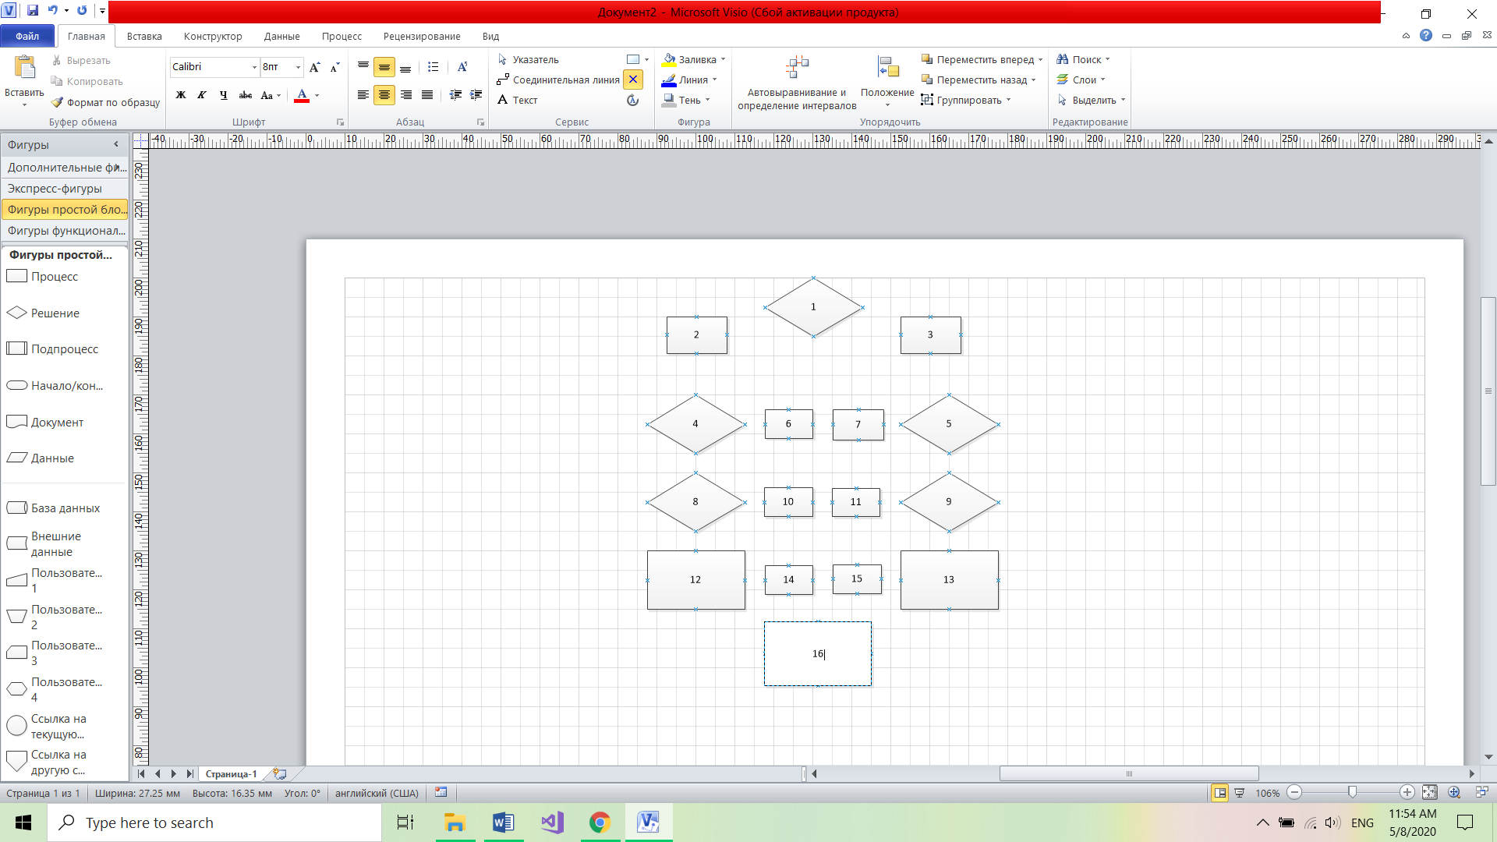

|  |  |  |  |  |  |
| --- | --- | --- | --- | --- | --- |
| Неструктурована модель | | | Структурована модель | | |
| 1 | 0 | 0 | 1 | 0 | 0 |
| 2 | 1 | 1 | 2 | 1 | 1 |
| 3 | 1 | 1 | 3 | 1 | 1 |
| 4 | 12 | 2 | 4 | 1 | 1 |
| 5 | 13 | 2 | 5 | 13 | 2 |
| 6 | 123457 | 6 | 6 | 1457 | 4 |
| 7 | 123465 | 6 | 7 | 1246 | 4 |
| 8 | 1246 | 4 | 8 | 12 | 2 |
| 9 | 1357 | 4 | 9 | 13 | 2 |
| 10 | 12468 | 5 | 10 | 246 | 3 |
| 11 | 124679 | 6 | 11 | 14689 | 5 |
| 12 | 12468 | 5 | 12 | 1468 | 4 |
| 13 | 13559711 | 8 | 13 | 135711 | 6 |
| 14 | 1234812 | 7 | 14 | 13248 | 7 |
| 15 | 136791113 | 8 | 15 | 1361113 | 8 |
| 16 | 1.2345789121314 | 13 | 16 | 1.234578912131415 | 13 |
|  |  | 78 |  |  | 63 |