1. Write a program to add, subtract, multiply and divide two integers using user defined function add(), sub(), mul() and div().

**Code:**

#include<stdio.h>

float add(float num1, float num2)

{

return num1 + num2;

}

float sub(float num1, float num2)

{

return num1 - num2;

}

float mul(float num1, float num2)

{

return num1 * num2;

}

float div(float num1, float num2)

{

return num1 / num2;

}

int main()

{

int choice;

float results, num1, num2;

printf("Enter your numbers:");

scanf("%f%f",&num1, &num2);

printf("1.Add\n");

printf("2.Subtract\n");

printf("3.Multiply\n");

printf("4.Divide\n");

printf("Enter your choice:");

scanf("%d", &choice);

switch (choice)

{

case 1:

results = add(num1, num2);

break;

case 2:

results = sub(num1, num2);

break;

case 3:

results=mul(num1, num2);

break;

case 4:

results = div(num1, num2);

break;

default:

break;

}

printf("%f",results);

return 0;

}

**Output**

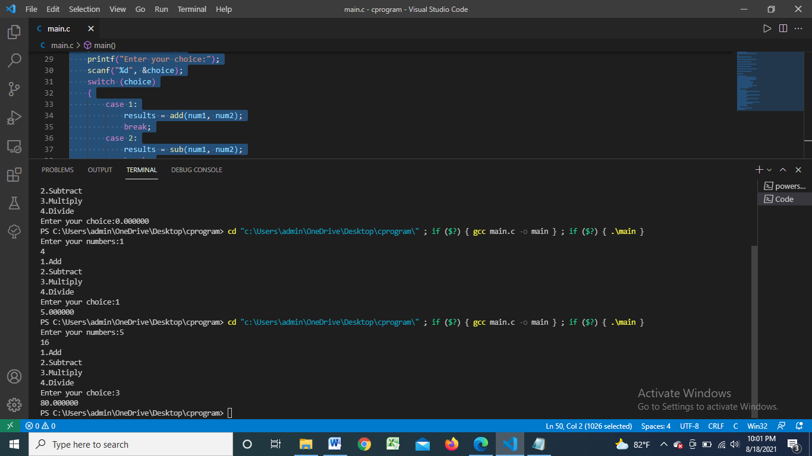

2.WAP to display sum of series: x + x2/2! + x3/3! + x4/4! + x5/5! ... xn/n!. User defined function factorial() and power() should be used to calculate the factorial and power.

**Code:**

#include<stdio.h>

int factorial(int n)

{

int fact =n, result;

int num = n;;

for(int i=1; i<n;i++)

{

fact = fact * --num;

}

result = fact;

return result;

}

int power(int n, int pow)

{

int multiply = 1;

int ans;

for(int i =1; i<=pow; i++)

{

multiply = multiply * n;

}

ans = multiply;

return ans;

}

int main()

{

int n;

float sum =0 ;

printf("Enter The value of n:");

scanf("%d", &n);

for(int i = 1; i<=n ;i++)

{

sum += (float)power(n,i) / factorial(i);

}

printf("%f\n", sum);

return 0;

}

**Output:**

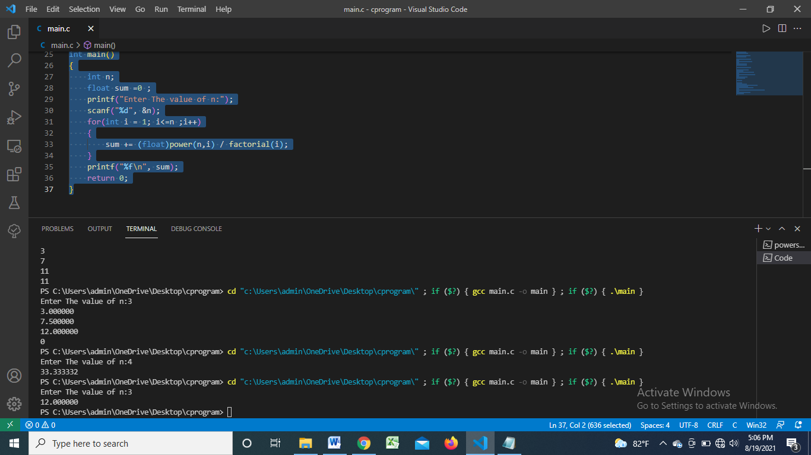

3. WAP to calculate factorial using Recursion.

**Code:**

#include<stdio.h>

int fact(int num){

if (num==1)

{

return 1;

}

else

{

return num * fact(num-1);

}

}

int main(){

int num, factorial;

printf("Enter a number:");

scanf("%d", &num);

factorial = fact(num);

printf("Its Factorial: %d", factorial);

return 0;

}

**Output:**

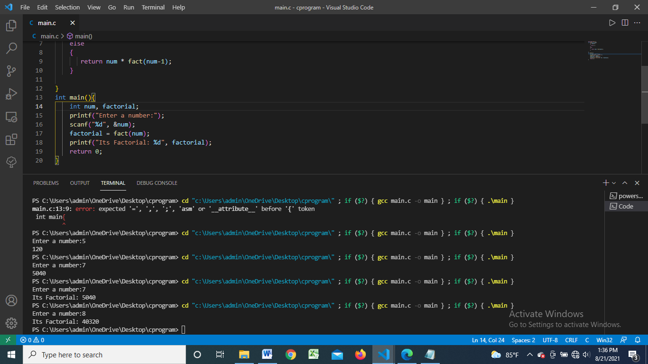

4. . WAP to display the nth Fibonacci number using recursion.

**Code:**

#include<stdio.h>

int fibo(int n){

if(n==0)

{

return 0;

}

else if(n==1)

{

return 1;

}

else

{

return fibo(n-1) + fibo(n-2);

}

}

int main(){

int n;

printf("How many fibonacci series?:");

scanf("%d", &n);

for(int i=0; i<n ;i++){

printf("%d\t", fibo(i));

}

}

**Output:**

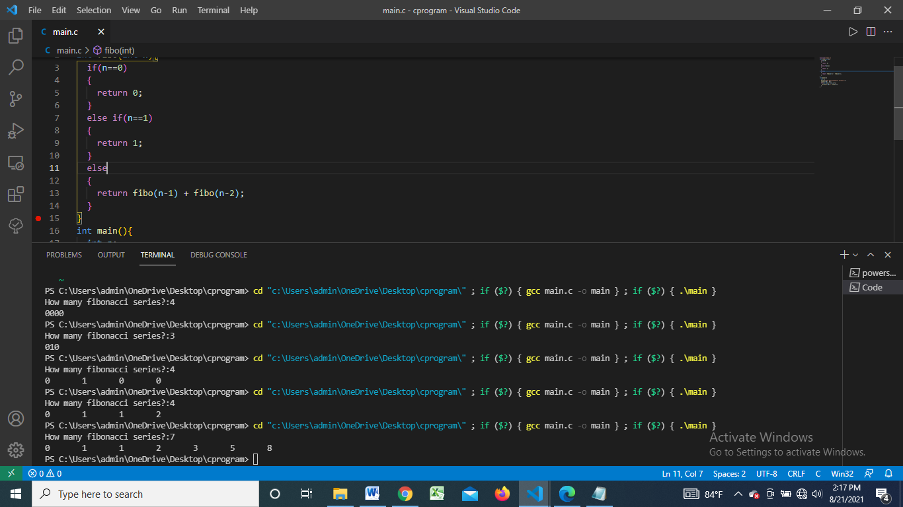

5.WAP to take two numbers in main(). Write a function Swap() to swap the values of the variables. Print the swapped values in main().

**Code:**

#include<stdio.h>

void swap(int *num1, int *num2)

{

int temp;

temp = *num1;

*num1 = *num2;

*num2 = temp;

}

int main()

{

int num1, num2;

printf("1.Enter a number:");

scanf("%d", &num1);

printf("2.Enter a number:");

scanf("%d", &num2);

printf("Initially:\n");

printf("First Num: %d \t", num1);

printf("Second Num: %d\n", num2);

swap(&num1, &num2);

printf("After Swap:\n");

printf("First Num: %d \t", num1);

printf("Second Num: %d\n", num2);

return 0;

}

**Output:**

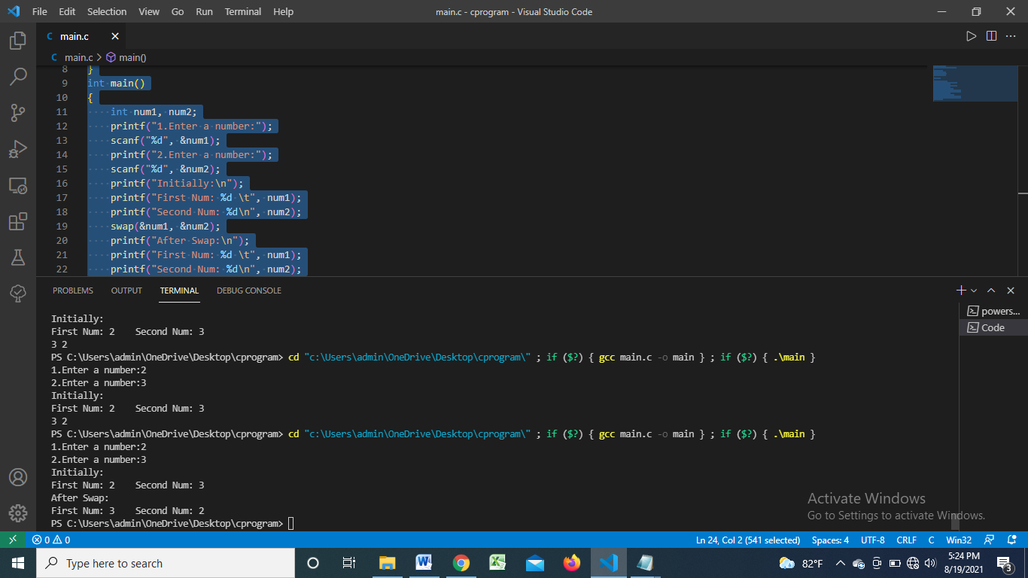

6. WAP to take two float number in main(). Write a function single user define function calculator() to perform the addition, subtraction and multiplication. The sum, difference and product should be displayed from the main() function. [Use the concept of pass by reference.]

**Code:**

#include<stdio.h>

float calculator(int choice, float *num1, float *num2)

{

float result;

if(choice==1)

{

result = *num1 + *num2;

}

else if(choice==2)

{

result = *num1 - *num2;

}

else

{

result = *num1 * *num2;

}

return result;

}

int main()

{

int choice;

float results, num1, num2;

printf("Enter your numbers:");

scanf("%f%f",&num1, &num2);

printf("1.Add\n");

printf("2.Subtract\n");

printf("3.Multiply\n");

printf("Enter your choice:");

scanf("%d", &choice);

results = calculator(choice, &num1, &num2);

printf("%f",results);

return 0;

}

**Output:**

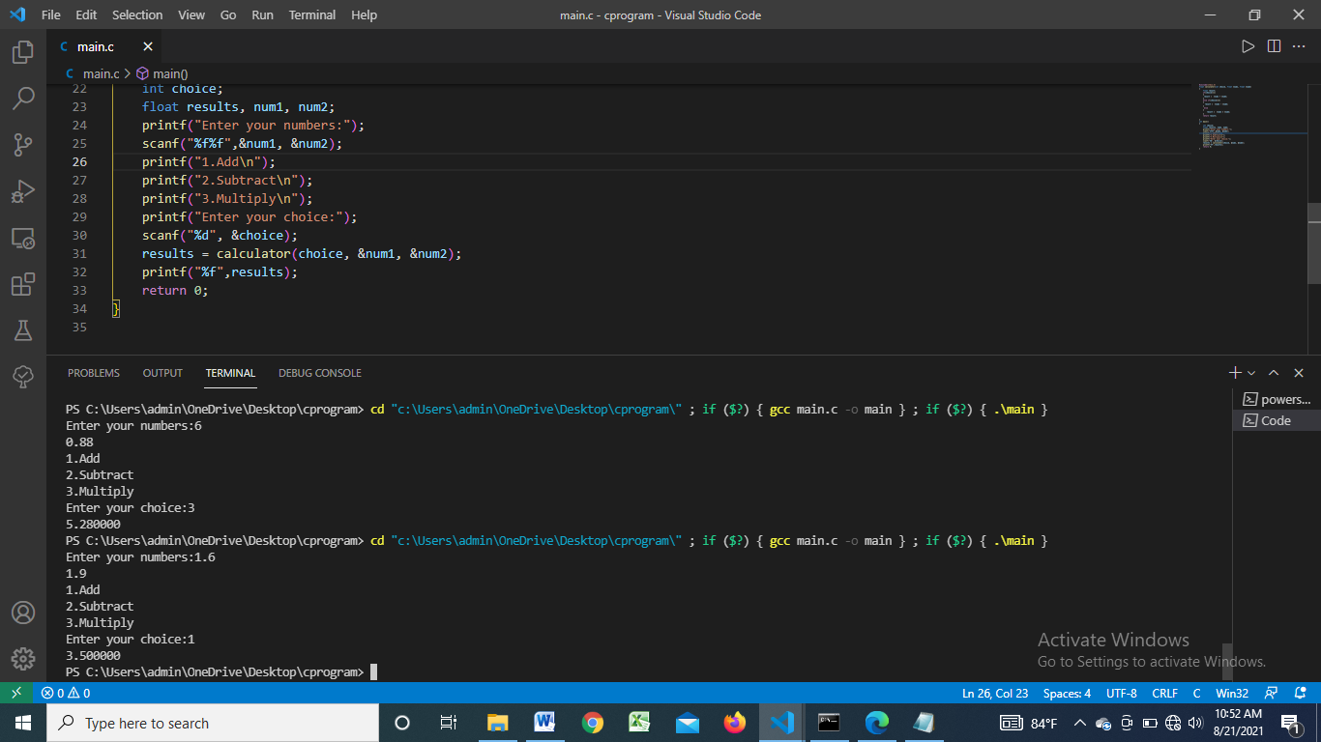

7. WAP to input a integer number in main(). Write a user define function isPrime() to calculate whether the number is prime of not. Print whether the number is prime or not from the main().

**Code:**

#include<stdio.h>

int isPrime(int num)

{

int flag = 0;

for(int i = 2; i<=num/2; i++)

{

if(num % i == 0)

{

flag = 1;

}

}

return flag;

}

int main(){

int num, check;

printf("Enter a number:");

scanf("%d", &num);

check = isPrime(num);

if(check == 1)

{

printf("Not a Prime Number.");

}

else{

printf("Prime Number.");

}

return 0;

}

Output:

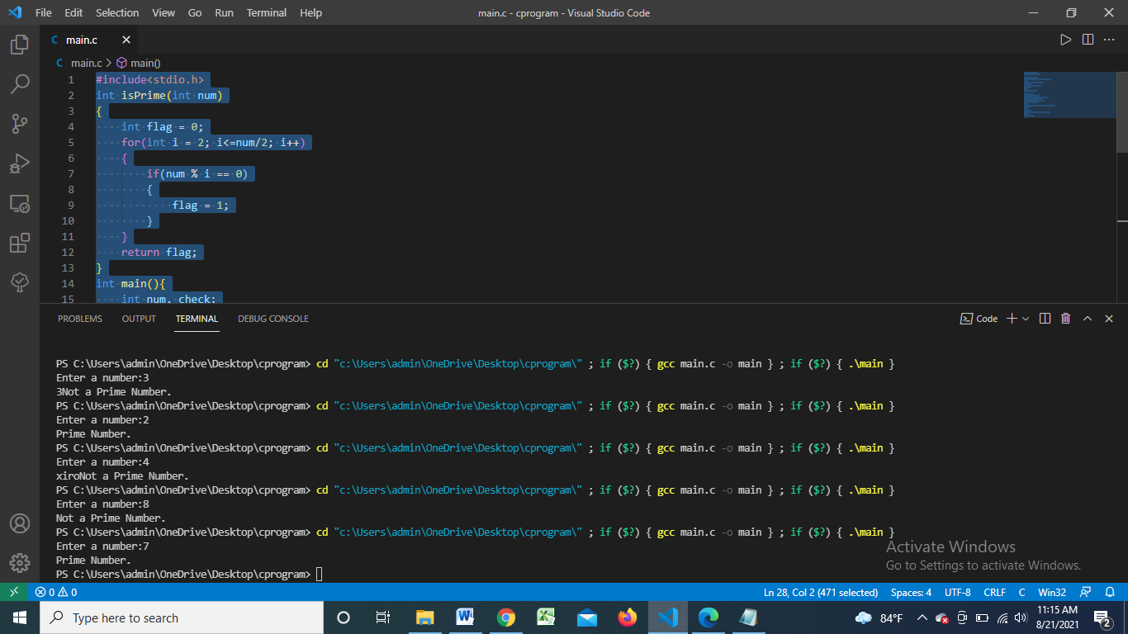

8. WAP to illustrate the concept of global and static variables.

**Code:**

#include<stdio.h>

#include<conio.h>

void global_fn(){

int a = 0;

a++;

printf("Call Global: %d\n",a);

}

void static_fn(){

static int a = 0;

a++;

printf("Call Static : %d\n",a);

}

int main()

{

int n;

printf("How many times?:");

scanf("%d",&n);

for(int i =1; i<=n;i++)

{

static_fn();

}

printf("\n");

for(int j =1; j<=5;j++)

{

global_fn();

}

return 0;

}

**Output:**

