Image Encryption based on Channel Splitting and Summations

Prepared by
Randy Lopez

Computer Vision
CAP4410.01I&T
March 27, 2017
Table of Contents
Table of Contents ii
List of Figures 1

1. Introduction 1
1.1 Abstract 1
1.2 Product Scope 1
2. Image Cryptography 2
2.1 Applications 2
2.2 State of the Art 2
3. A Novel Image Encryption Algorithm Based on Convolutions 3
3.1 Algorithm 3
3.2 Security and Performance 3
3.3 Conclusions 3

References 2

List of Figures
Figure 1 Encryption Software Test………………………………………………………….................... 2
Figure 2 Histogram Analysis……............................................................................................................. 3

Introduction

Abstract
This paper presents a method for the symmetric encryption and decryption of images based on pixel summations. In recent years, there has been a rapid growth in multimedia communications that has resulted in vast amounts of image data being shared. This has led to an increased focus on cyber security and specifically cryptography. Although most encryption techniques are complicated or better suited for alphanumerical data, the encryption and decryption method presented in this paper is both simple and effective. Additionally, the method presented has been tested and implemented in a C++ program, in hopes that others may also contribute to this work.

Product Scope
The image encryption and decryption method presented can be implemented in various commercial and non-commercial products where security is critical. Additionally, this method can be applied to non-image data with relatively few modifications to the algorithm. The objective of this paper was to create a method that required little overhead, as it uses pixel operations to perform encryption and decryption which is relatively simple to comprehend. This would make it easy to implement in a wide range of fields from cyber security and information systems to health care. Specifically, this technique can be applied to encryption and decryption of medical data, confidential military information, and data being exchanged throughout the internet. The implementation for this method was written in C++ for its speed, and utilizes OpenCV libraries for image processing.

Image Cryptography

Applications
Innovations in technology and information systems have led most industries to rely heavily on their data. The bulk of that data comes from videos, audio, and various other forms of multimedia [1]. Some industries have significant benefits over others when it comes to cyber security and image encryption. One example is health insurance and medicine; an area where security of patient data and health records is quickly becoming outdated. Military and defense can also benefit from advancements in image cryptography, since there is a clear need to keep sensitive information hidden. Regardless of the industry, images are mostly vulnerable if they are transferred through unsecure networks or kept in unreliable repositories. Image encryption techniques can prevent such vulnerabilities in addition to the costly damages and serious security threats they could lead to.

State of the Art
It is difficult to precisely determine the state of the art for image cryptography, given that it is a relatively new area of research. In addition, most work published is not aimed at industry applications. Overall the current state of the art includes algorithms such as chaotic image scrambling and neural networks [4]. It can be stated that the most successful image encryption techniques can be represented as either highly dimensional or highly erratic functions [1]. This is because most image encryption algorithms currently involve some form of pixel shifting [2]. One of the primary drawbacks of pixel shifting is typically runtime efficiency. Poor runtime efficiency have also kept some of the most secure image encryption algorithms from being applied to video cryptography [2].

A Novel Image and Video Encryption Method

Algorithm
The algorithm for the method presented in this paper was implemented in C++. First an image of arbitrary size is read as a matrix, where each value in the matrix corresponds to a single pixel intensity. For testing, color images were used, such that each pixel mapped to a vector, I, such that V = < b, g, r > where b, g, and r correspond to blue, green, and red, color channels, respectively. An encryption key was then generated by filling a 32x32 matrix with individual vectors such that each color channel in each vector is a computer-generated random number modulo 255. It is important to note that the encryption key can be generated at any given time and is not reliant on any other part of this algorithm. Next, the encryption key matrix that was generated is resized according to the size of the input image. This is done either by scaling down or scaling up the matrix. However, it is preferable to scale up the key matrix so that it losses no information. The final output is an image of equal size as the input image as show in Figure 1. The key is also stored in a text file to preserve encoding.

Security and Performance
Histogram analysis was used to qualitatively measure security performance and vulnerability. A histogram provides useful information about the frequency distributions of pixels in an image. Ideally, an encryption algorithm should output an image which has a histogram that does not correlate to the input histogram [1]. This is easy to measure qualitatively because the histogram would have a fairly uniform distribution, as seen in Figure 2.

One slight drawback of the image encryption method described is that the key cannot be compressed. All attempts at compression using standard PNG and JPEG compression models made the key essentially useless. But to compensate for this, key matrices of 32x32 pixel values are recommended. It has not been determined whether key matrices with greater area would increase security or performance.

Conclusions
The method presented in this paper meets most of the key criteria for robust image and video encryption. However, further work will include more extensive testing such as differential analysis and entropy calculations [1]. These measurements will be able to better quantify the level of effectiveness. It was concluded that overall the encryption method is better than most of the common methods. In addition, it was concluded that for video encryption the program has a faster runtime than current state of the art [3]. The average runtime was calculated to be approximately 3ms per frame, for both encryption and decryption. Improvements to the algorithm will include quantifying entropy, and the optimizing the ratio of input image area to encryption key area.


Figure 1. Lena raw input image (left), and encrypted image (right)

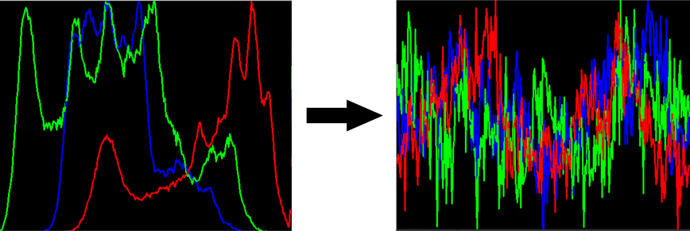

Figure 2. Histogram of Lena raw input image (left), and encrypted image histogram (right)

References

[1] Kumar, Mohit, Akshat Aggarwal, and Ankit Garg. "A Review on Various Digital Image Encryption Techniques and Security Criteria." International Journal of Computer Applications 96, no. 13 (2014).
[2] Pakshwar, Rinki, Vijay Kumar Trivedi, and Vineet Richhariya. "A survey on different image encryption and decryption techniques." International journal of computer science and information technologies 4, no. 1 (2013): 113-116.
[3] Raju, C. Narsimha, Ganugula Umadevi, Kannan Srinathan, and C. V. Jawahar. "Fast and secure real-time video encryption." In Computer Vision, Graphics & Image Processing, 2008. ICVGIP'08. Sixth Indian Conference on, pp. 257-264. IEEE, 2008.
[4] Bao, Long, Yicong Zhou, CL Philip Chen, and Hongli Liu. "A new chaotic system for image encryption." In System Science and Engineering (ICSSE), 2012 International Conference on, pp. 69-73. IEEE, 2012.

