# ADHDeer - Work Documentation

### Links:

[Lecture Slides](https://docs.google.com/presentation/d/1uxUK1sf2_PjlGNpzBidpsCK-MUUXxQP-VlXUSdL9L2c/edit#slide=id.g14aca0a47a5_0_11354)

[Team’s Miroboard Link](https://miro.com/app/board/uXjVPE2vEFE=/?share_link_id=205479317583)

[Figma](https://www.figma.com/file/XJZe9gLj6NkgA05QERnsmD/ADHDeer---Group?node-id=1%3A2&t=6ugVK4fjzsfPf3sj-1)

### Task Description:

* Choose a "super cool" Design Thinking Project name and use it!
* List all members of your project group and describe your chosen roles with this Design Thinking Project
* Document the work you have completed from our first Design Session, which includes:
  + INSPIRATION: Capture all your thoughts, ideas, (inspiration) surrounding the “proposed project” (or an existing project);
  + EMPATHIZE: Conduct research: - Talk with potential users (engage in user research) and record (document) what you learn;
  + DEFINING the PROBLEM: Formulate a “design problem” which you are addressing, write it down!

Start developing "Personas" for those you are developing this project for. (Stay tuned for more on Personas!)

TIPS: You can use the following methods to help you with this assignment:

Conduct interviews, survey, focus groups;

Engage in digital ethnography, Observe "Online Forums" (like Reddit, Quora) to understand the problem(s) you want to address, Binge on YouTube video which highlight the problem(s) you want to address. Brainstorm; Braindump; Brainwrite,; SCAMPER; Mindmap; Sketch or Sketchstorm; Storyboarding, Gamestorming, (any ideation method!)

NOTE: Most of these Design Thinking methods are available as a "template" on Miro, which includes a description on how to use these methods.

DELIVERABLE:

An online document (collaboration space) or Miro Board highlighting your work.

(Place a link to your work within the comments section or create a doc with the link when submitting your assignment.)

Invite myself and Florian Jindra to your online collaboration space, document and/or Miro Board with the following email(s):

mkramer.lba@fh-salzburg.ac.at &

florian.jindra@fh-salzburg.ac.at

Project Description:

Help children with ADHD and their families to understand and master their everyday life with ADHD.

# Group Members:

* Anica Hummel: UX/UI-Designer, ADHD Expert
* Lucia Migacová: HCI Research, Graphic Designer, ADHD Expert
* Vincent Göke: Project Manager, UX Researcher

**INSPIRATION:**

* Anica and Lucia both are diagnosed with and have lots of pre knowledge in the field of ADHD
* Personal connection to the ADHD and understanding of the issues, goals and needs possibly supporting the “future” solutions
* In school it sometimes was hard to get through the day when really tired or excited
* With our increased usage of entertainment technology we are often distracted from everyday activities that we would profit from (Homework, Laundry, Cooking, Sports, Social Meetups)

**EMPATHIZE:**

* If you have a mental illness - deviation from normal/ general understanding as neurodivergent type of brain, it is quite hard to figure out how you deal with it properly
* Children’s problems often get neglected or nodded of as symptoms of puberty causing even more issues for the patients and their social environment
* Lucia and Anica - ADHD “experts”
* One of the members of the team has an experience with working with children with the special needs including ADHD - understanding of the needs, personal insights, practical and theoretical knowledge
* Girl wants to run away Crazy post - forum: <https://qr.ae/pvLs3K>
* Best Worst parts of having ADHD: <https://qr.ae/pvL2RG>
* Looking for help: <https://qr.ae/pvL2T8>
* Tips for concentration: <https://adhdwomen.quora.com/What-are-some-tips-for-improving-concentration-for-people-with-ADHD>

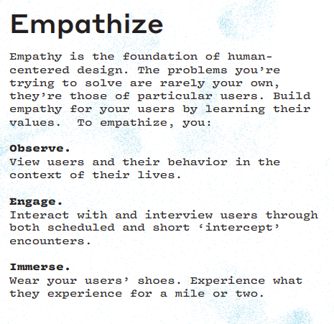

# DEFINING the PROBLEM:

* Parents sometimes are too close or too distant to make the right decision for their child/ juvenile
* Talking to your parents in a heart-to-heart discussion might be more difficult than you think
* ADHD has multiple symptoms, but not all are necessarily developed during the course of the illness -> hard to assess the proper the degree/ therapy for ADHD
* People with the ADHD are often misdiagnosed or not diagnosed at all, therefore they may develop a mental health issues such as anxiety or depression (from puberty to young adulthood) → no prevention and support causes future problems

1. For children and parents it is difficult to communicate if the child has ADHD or not. If the ADHD is “ignored” and not treated by medications or therapy (practice and pattern learning for the child), it might raise issues in the future development of the child.
2. What are the issues and main points dealing with the communication between parents, children and institutions? (school)
3. People with the ADHD are often misdiagnosed or not diagnosed at all, therefore they may develop a mental health issues such as anxiety or depression, meaning, no treatment and support causes mental health issues in the future. Children also might not fit to the society according to their misunderstood differences, which might also raise social interaction issues in their future development.
4. Understanding of challenges within the communication, diagnostication, and treatment of ADHD by supportive UX design for children and their parents.

Transcribe Miro Ideas to Word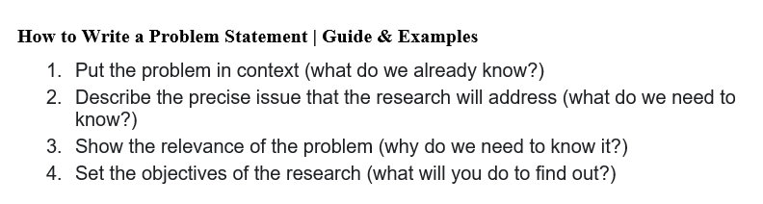

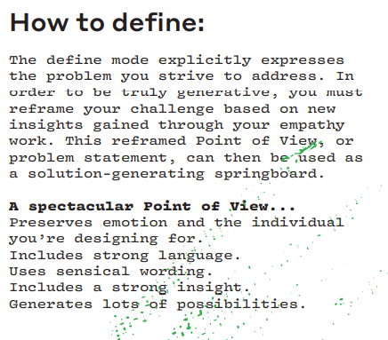

IDEATION:

The problem defined is the alteration of the brain of ADHD patients, especially young adults causing problems meeting their own expectations and goals. To tackle this problem we conceptualized an application that helps with scheduling and education to promote and support self care in young ADHD adults.

We came up with 3 core dimensions for ADHD.

1. Mental health
   1. Low self esteem
   2. Emergency help hotline
   3. Learning how to communicate needs and emotions
   4. Handling and tracking emotions
2. Self assessment
   1. Sticking to routines
   2. Problems concentrating
   3. Setting priorities
   4. problems managing time
   5. Managing situations (studying, stress management)
   6. Setting & achieving goals
   7. Fighting overstimulation and understimulation
   8. Problems remembering
3. Awareness
   1. ADHD type assessment
   2. problems with learning
   3. spreading knowledge about ADHD
   4. Therapy and medication advice

Because the scope of the self assessment is quite big we narrow it down to “Awareness” and “Mental Health”.

Finishing up Ideation.

Prototyping:

ADHDeer

<https://www.figma.com/file/XJZe9gLj6NkgA05QERnsmD/ADHDeer---Group?node-id=0%3A1&t=6w3xRceRhENYjoNi-1>

