Exploratory Data Analysis
House Prices Dataset
Kaggle – House Prices: Advanced Regression Techniques
This report summarizes a basic exploratory data analysis (EDA) of the Kaggle training dataset. The focus is on understanding the dataset, describing numerical variables, examining distributions and exploring correlations. No predictive model is developed.

1. Dataset overview
The training file contains 1,460 observations (houses) and 81 variables. Each row represents a house and its recorded characteristics. SalePrice is the target variable used in this analysis.
The dataset contains 38 numerical columns and 43 non-numerical columns (based on pandas data types). It includes housing characteristics such as lot area, living area, overall quality, year built and garage information.

2. Descriptive analysis of SalePrice
Statistic | SalePrice
Count | 1,460
Mean | $180,921.20
Median (50th percentile) | $163,000.00
Standard deviation | $79,442.50
Minimum | $34,900
25th percentile | $129,975
75th percentile | $214,000
Maximum | $755,000
The mean selling price is $180,921.20, while the median is $163,000. The standard deviation is $79,442.50, showing that sale prices vary considerably around the mean. The middle 50% of prices lie between $129,975 and $214,000. Because the mean is higher than the median, the distribution may be influenced by some higher-priced homes.

3. Distribution analysis

3.1 SalePrice
The skewness of SalePrice is 1.883. This positive value indicates a positively skewed distribution: observations are more concentrated at lower and middle price levels, with a longer tail extending towards higher prices. The high maximum relative to the upper quartile also suggests that some houses have unusually high selling prices.

3.2 Selected numerical variables
Variable | Skewness | Basic interpretation
SalePrice | 1.883 | Positive skew; longer upper-price tail
LotArea | 12.208 | Very strong positive skew; a few very large lots
GrLivArea | 1.367 | Positive skew; some houses have much larger living areas
OverallQual | 0.217 | Relatively close to symmetrical by skewness
YearBuilt | -0.613 | Negative skew; more observations among newer build years
GarageArea | 0.180 | Relatively close to symmetrical by skewness
Skewness describes asymmetry, not whether a variable is good or bad. The boxplot can flag potential outliers, but points beyond the whiskers are not automatically data errors; they may represent genuine properties with unusual characteristics.

4. Correlation analysis
Pearson correlation was calculated for numerical variables. A positive coefficient indicates that two variables tend to increase together; a negative coefficient indicates that one tends to decrease as the other increases. Values closer to +1 or -1 indicate stronger linear relationships, while values near zero indicate weaker linear relationships.
Variable | Correlation with SalePrice
OverallQual | 0.791
GrLivArea | 0.709
GarageCars | 0.640
GarageArea | 0.623
TotalBsmtSF | 0.614
1stFlrSF | 0.606
FullBath | 0.561
TotRmsAbvGrd | 0.534
YearBuilt | 0.523
YearRemodAdd | 0.507
The strongest positive numerical correlation with SalePrice is OverallQual (r = 0.791), followed by GrLivArea (r = 0.709). Other notable positive associations include GarageCars (r = 0.640), GarageArea (r = 0.623), TotalBsmtSF (r = 0.614), 1stFlrSF (r = 0.606).
These results indicate that overall quality, living area and several garage/basement or size-related measures are positively associated with sale price in this sample. Correlation does not establish causation, and Pearson correlation captures linear relationships only.
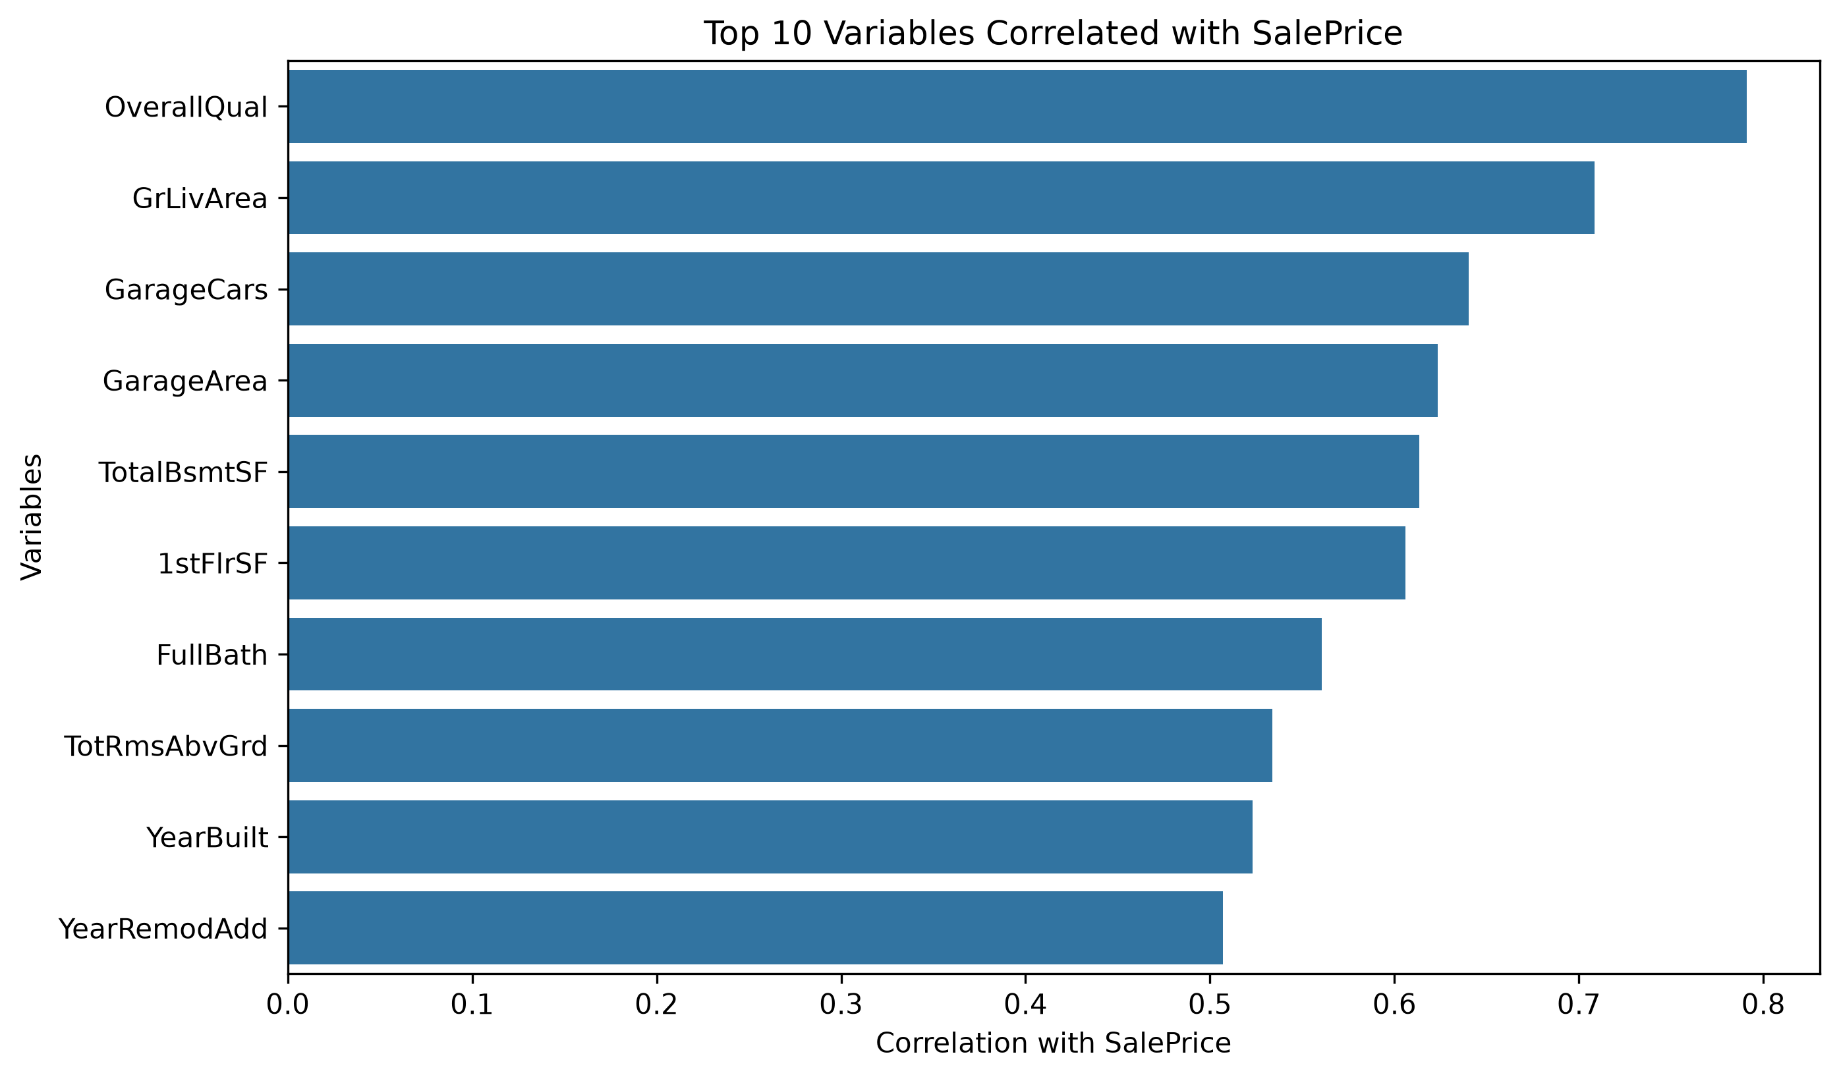

5. Overall findings and conclusion
The EDA shows that the dataset contains 1,460 house observations and a broad set of numerical and categorical characteristics. SalePrice has a positive skew and substantial variation. Some other variables, particularly LotArea and GrLivArea, are also positively skewed, while the selected variables do not all share the same distribution.
The numerical correlation analysis identifies OverallQual and GrLivArea as the two variables most strongly positively associated with SalePrice. This suggests that house quality and above-ground living area are particularly useful characteristics to examine when describing differences in selling prices. Other positive relationships are also present among garage and basement-related variables.
Overall, the dataset shows meaningful variation in house characteristics and selling prices, as well as several positive linear associations with SalePrice. These findings describe patterns in the training sample; they do not prove that any individual feature causes a higher selling price.

Scope note
This is a basic numerical EDA summary. The correlation matrix excludes categorical variables because they are not directly represented as numeric measurements in the original file. A fuller exploration could compare SalePrice across categories such as Neighborhood, HouseStyle, KitchenQual and ExterQual.

