**CIS 285: Software Engineering Tools**

**University of Michigan – Dearborn**

**Lab 4**

**Github, Jenkins**

Due Date: Thursday 02/10 – Submission is due by 3:45pm on Canvas

Laboratory tasks:

**GitHub**

1. Create a Github account if you don’t have one then login to your github account
2. Create a Lab4 folder and open GitBash over this folder
3. Create new remote repository
   * 1. Git init
     2. Touch Hello.java
     3. Git add .
     4. Git commit –m “Some message”
     5. Goes to github.com to add a new repository (click on “+” sign on the right top corner of the page)
     6. Follow screen instruction to work on creation process
     7. Copy git remote and git push commands on the creation page to your local gitBash window. After running these 2 commands, your remote repository is created successfully.
4. Open Atom and choose File -> Add Project Folder then navigator to \Lab4
5. Run command [ git checkout –b NameofBranch ] to create a new branch and switch to it
6. Use Atom editor to make whatever change to the Hello.java (A sample Hello.java in appendix 3)
7. In Atom, choose view->Toggle Git Tab to display git and github tab on the right
8. In git tab, stage Hello.java and commit it with a message
9. In github tab, Publish and open new pull request (when you do it first time, it will ask you to enter a token to authenticate, just follow screen instruction to connect Atom to your github account)
10. Step 9 will lead you to github site to create a pull request.
11. After create the pull request, go to review changes and make a screenshot of the review change page. Appendix 1 is an example screenshot
12. Go to Merge pull request page and take a screenshot then merge. Appendix 2 is an example.
13. Now master branch on github has the latest Hello.java but your local master still not update. Run command [git checkout master ] to switch to master branch and then [ git pull ] to synchronize local master to github

**Jenkins**

1. Login

<http://cis285.mooo.com:8090/>

user name: cis285

password: cis285

You will need campus VPN when accessing the site from off campus. Below is the VPN instructions.

<https://umdearborn.teamdynamix.com/TDClient/2019/Portal/KB/?CategoryID=8824>

1. Click on ‘New Item’ to create a freestyle project. The project Name must be **HelloWorld_YOUR_Name**. Please **DO NOT touch** other student’s project.
2. Config your project, the followings are example, you must connect to your own github in the step i and ii
   * 1. 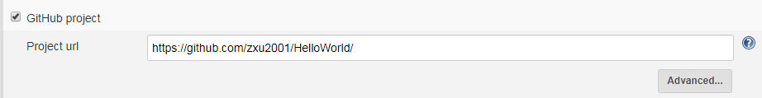
     2. 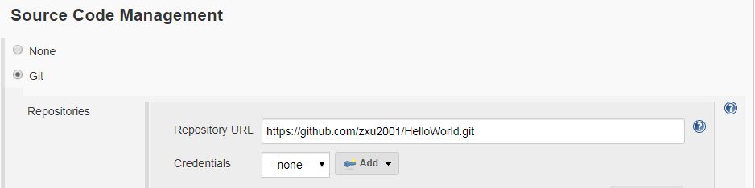
     3. 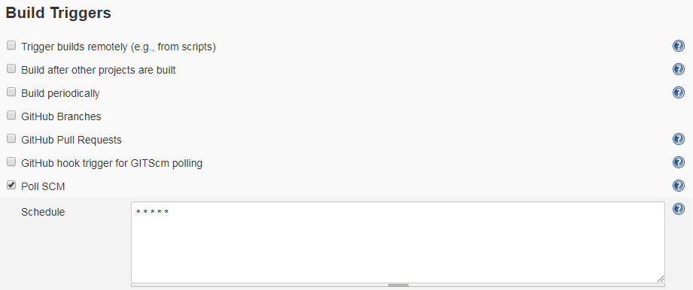
     4. 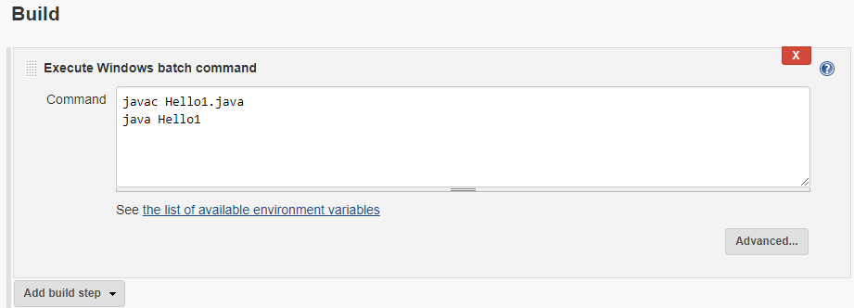
3. Update Hello.java from Atom (make sure you are on master branch).
4. Commit to master branch and then push to GitHub
5. After pushing, wait up to 1 min, Jenkins should build your project automatically. You screenshot the latest build Console Output

Submission items:

**Github**

* 1. Screenshots in step 11, 12

**Jenkins**

* 1. Screen shot of step 6

You are to submit ONE zip file for Github and Jenkins

Appendix 1 screenshot of review change

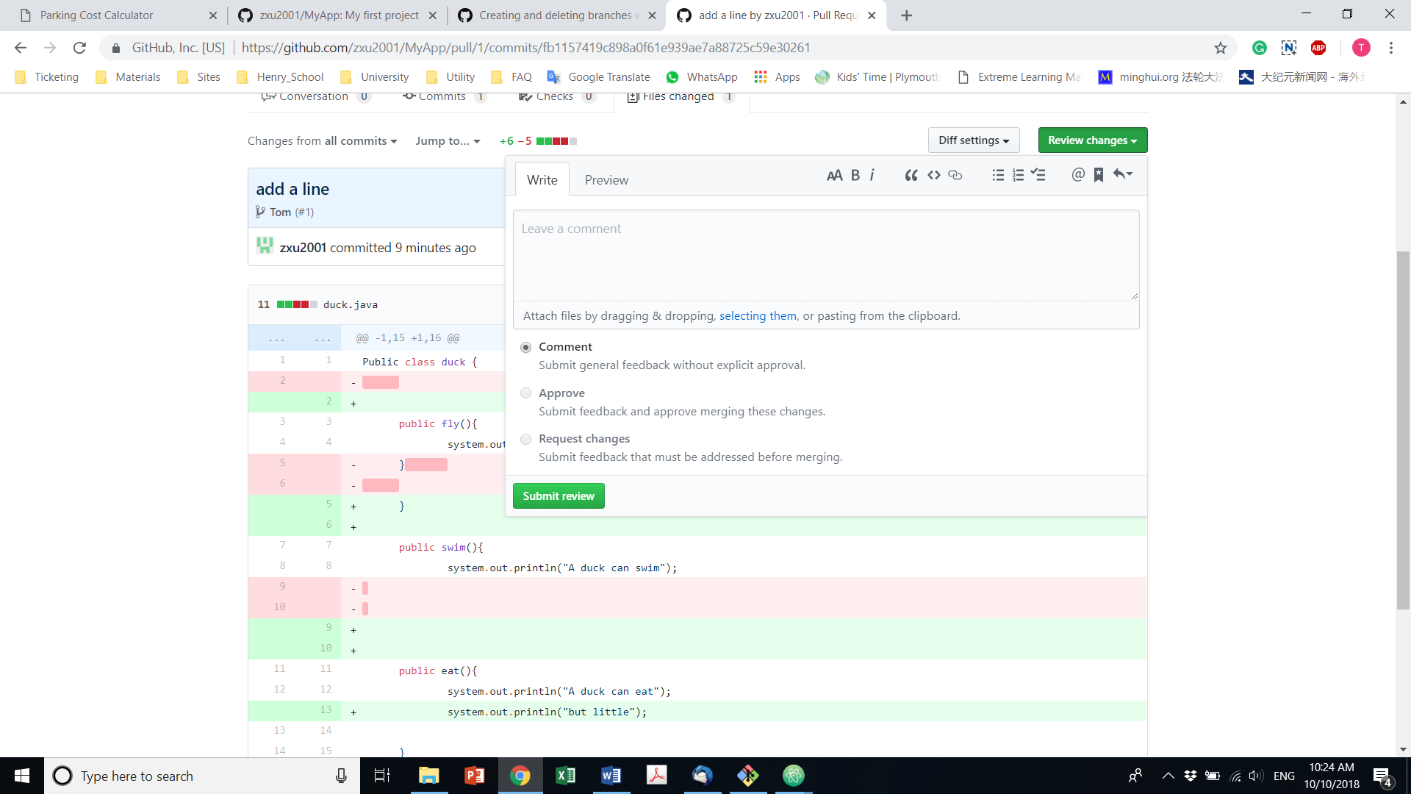

Appendix 2 Screenshot of Merge request page

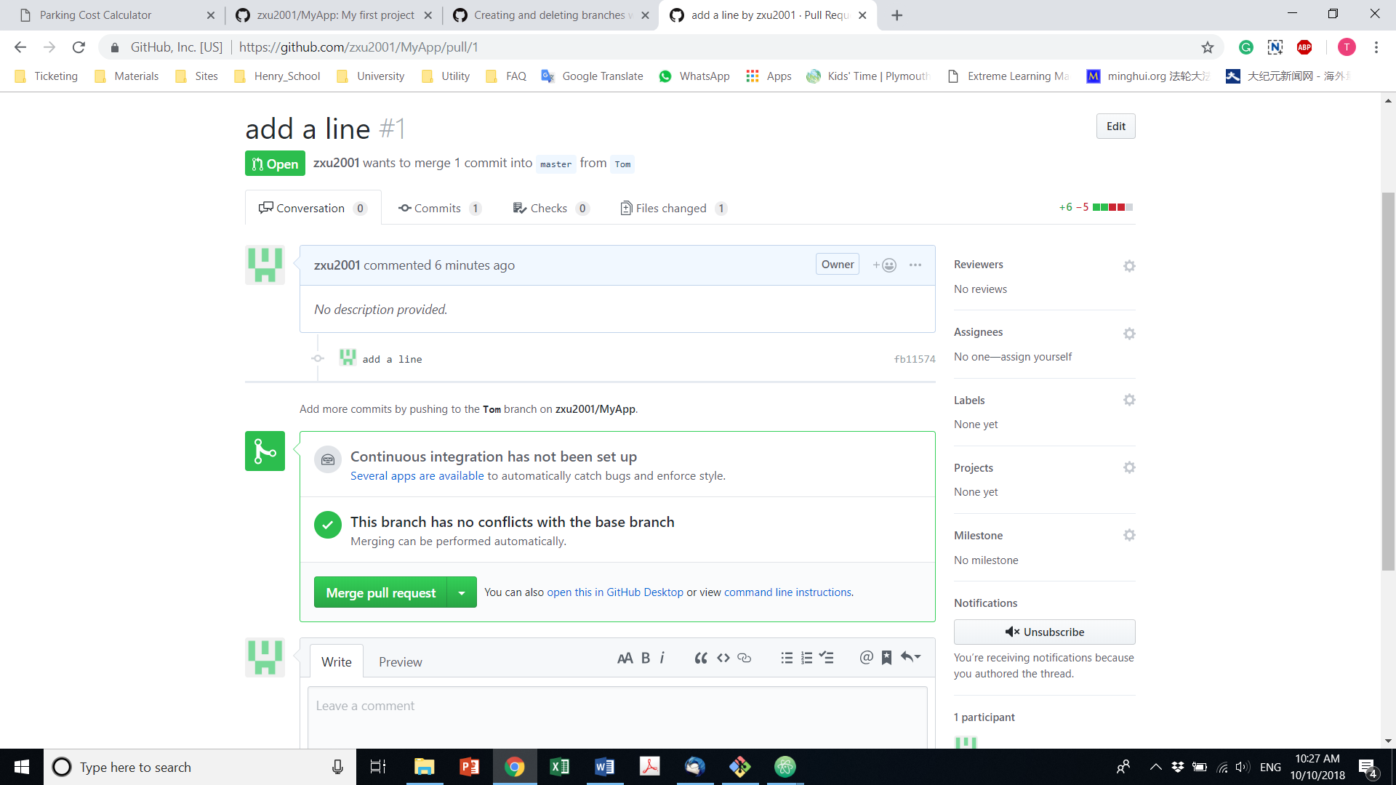

Appendex 3: Sample Hello.java

public class Hello {

public static void main(String[] args) {

for(int i=1;i<=10;i++) {

System.out.println("Hello World..."+i);

}

}

}