Question no.1

Analyze the following program, explain each statement, and comment on the statement in red. Finally, run the program and type in appropriate inputs from the standard input device to show the running result.

* Answer:
* The code:

These lines include necessary header files for input-output operations and namespace declaration for “std” to avoid writing “std:” before the standard library function.

This defines a class named “A” with constructors, destructors, assignment operators, and member functions for printing. It also contains a public integer member “x.”

These are the definition of the contractors, where “x” is initialized. In the default constructor implementation initializes “x” to 0. Then the parameterized constructor implementation initializes x with the provided value. and it copies the constructor implementation and initializes x with the value of the object being copied.

The destructor implementation prints a message when an object of class A is destroyed.

The assignment operator, which assigns the value of x from the right-hand side object to the current object and prints a message.

The member functions “Print()” and “PrintC()”, which print the value of x. The “PrintC()” function is declared as const since it doesn't modify the object's state.

The functions demonstrate the different ways of passing the object of (‘A’) to the function by the value by the reference, by constant reference, and by the pointer.

The main function initializes four objects, a0, a1, a2, and a3, of class A using different constructors. Subsequently, the value of a1 is assigned to a3 using the assignment operator. To showcase various parameter passing mechanisms, different functions are invoked with these objects as arguments. Additionally, the X() member function is utilized on object a1 to modify its x value. Furthermore, the program illustrates the capability of passing a constant value (20) to a function expecting a constant reference parameter. Ultimately, the program concludes execution and returns 0.

* The output:

Question no.2

Write the program based on the following requirements

1. Define a class called Student that has the following data members:
   * 1. Int student number
     2. String student number.
     3. Double student average.

* Answer:

The code:

1. The following member functions:
2. Constructor that initialize the data members with the default values.
3. Set and get the functions for each data member.
4. Print the function to print the values of the data member.

* Answer:

Code:

1. Define a class called graduate student that inherits data members and functions from the class student, and then declare the following data members :
2. int level
3. int year.

* Answer:

Code:

1. member functions:

constructor.

set and get functions for each data member.

Print function.

* Answer:

Code:

1. Define a class called master that inherits data members and functions from the Graduate student class, and then declare the following data member:
2. int newid

* Answer:

Code:

1. Member function:
2. Constructor
3. set and get function for the data member.
4. Print function.

* Answer:

Code:

1. Write a driver program(i.e. main function) that:
2. Declare the object of type student with suitable values then print it.
3. Declare the object of type master with your information then print it.

* Answer:

Code:

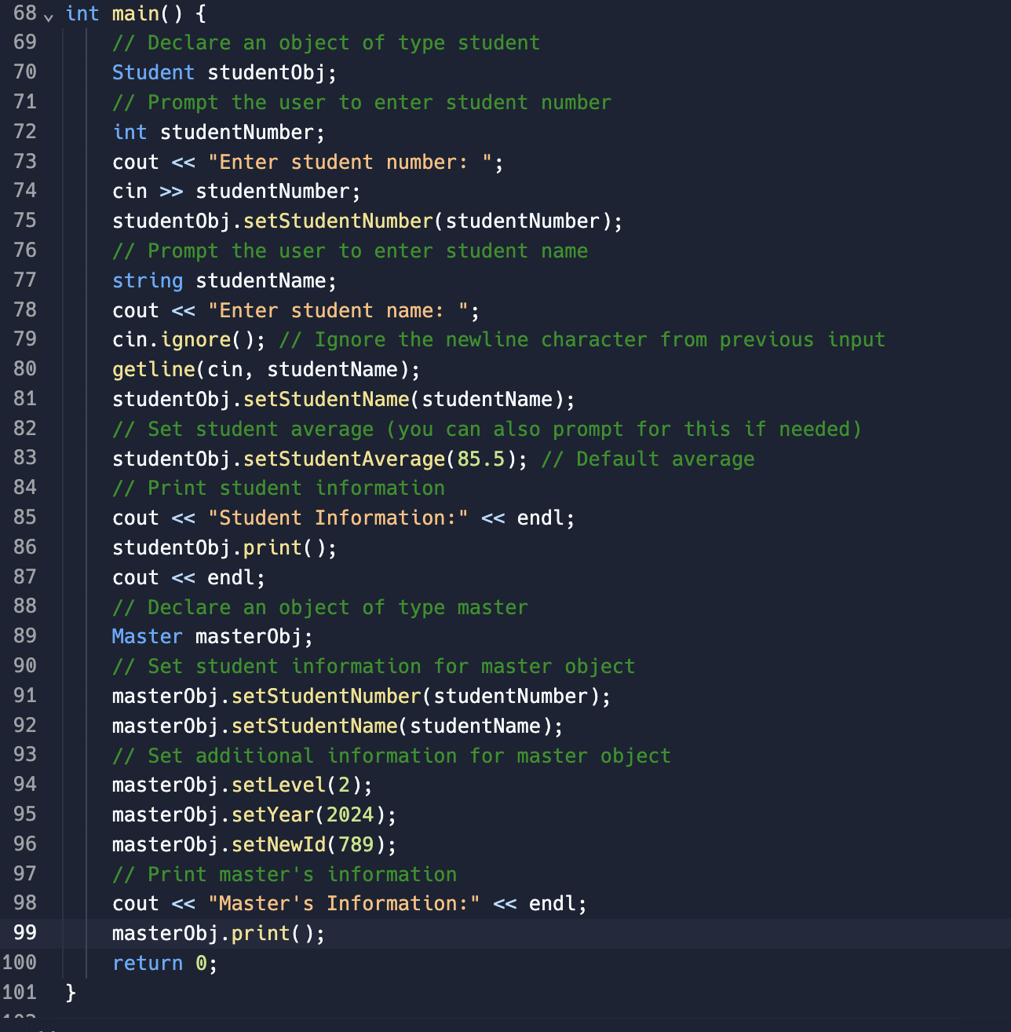

The result:

Question no.3

Answer the questions after going through the following class:

1. Write statements in C++ that would execute Function 1 and Function 3 of class Seminar.

* Answer:

To execute the function 1 and function 3 of class seminar we can use this code:

// Function 1

Seminar seminar1;

// Function 3

Seminar seminar2(45); // Assuming 45 as the duration parameter

1. In Object Oriented Programming, what is Function 4 referred as, and when does it get invoked/called?

* Answer:

Function 4 in Object Oriented Programming is referred to as the destructor. It gets invoked automatically when an object goes out of scope or is explicitly deleted. The destructor is called to perform cleanup tasks such as releasing memory, closing files, or releasing other resources allocated during the object's lifetime.

1. In Object Oriented Programming, which concept is illustrated by Function 1 and Function 3 together?

* Answer:

Function 1 and Function 3 together illustrate the concept of constructor overloading in Object Oriented Programming. Constructor overloading allows multiple constructors within a class, each with a different set of parameters. In this case, Function 1 is a default constructor with no parameters, while Function 3 is a parameterized constructor with one parameter (duration). This allows objects of the Seminar class to be instantiated with or without specifying the duration of the seminar.

Question no.4

Answer the questions after going through the following class:

1. Write statements in C++ that execute Function 1, Function 2, Function 3, and Function 4 of class Test.

* Answer:

To execute Function 1, Function 2, Function 3, and Function 4 of the class test we can use below code:

// Function 1

Test test1;

// Function 2

char paper2[] = "Physics";

Test test2(paper2);

// Function 3

Test test3(85);

// Function 4

char paper4[] = "Mathematics";

Test test4(paper4, 75);

1. Which feature of Object-Oriented Programming is demonstrated using Function 1, Function 2, Function 3, and Function 4 together in the above class Test?

* Answer:

Function 1, Function 2, Function 3, and Function 4 together demonstrate the feature of constructor overloading in Object Oriented Programming. Constructor overloading allows the creation of multiple constructors within a class, each with a different set of parameters. In this case, the Test class has four constructors, each with different parameter lists, providing flexibility in object initialization.

Question no.5

Consider the definition of the following class.

1. Write the definition of the constructor 1 so that the private member variables are initialized to 0.

* The answer:

Code:

Sample::Sample() {

x = 0;

y = 0.0;

}

1. Write the definition of the constructor 2 so that the private member variable x is initialized according to the parameter's value, and the private member variable y is initialized to 0.

* The answer:

Code:

Sample::Sample(int value) {

x = value;

y = 0.0;

}

1. Write the definition of the constructors 3 and 4 so that the private member variables are initialized according to the values of the parameters.

* The answer:

Sample::Sample(int value1, int value2) {

x = value1;

y = static_cast<double>(value2);

}

Sample::Sample(int value1, double value2) {

x = value1;

y = value2;

}