**Objectives**

* 전면 등교의 영향
* 사회적 거리두기를 풀면 확진자 수, 위중증 환자 수 및 사망자 수 어떻게 증가?

**Model**

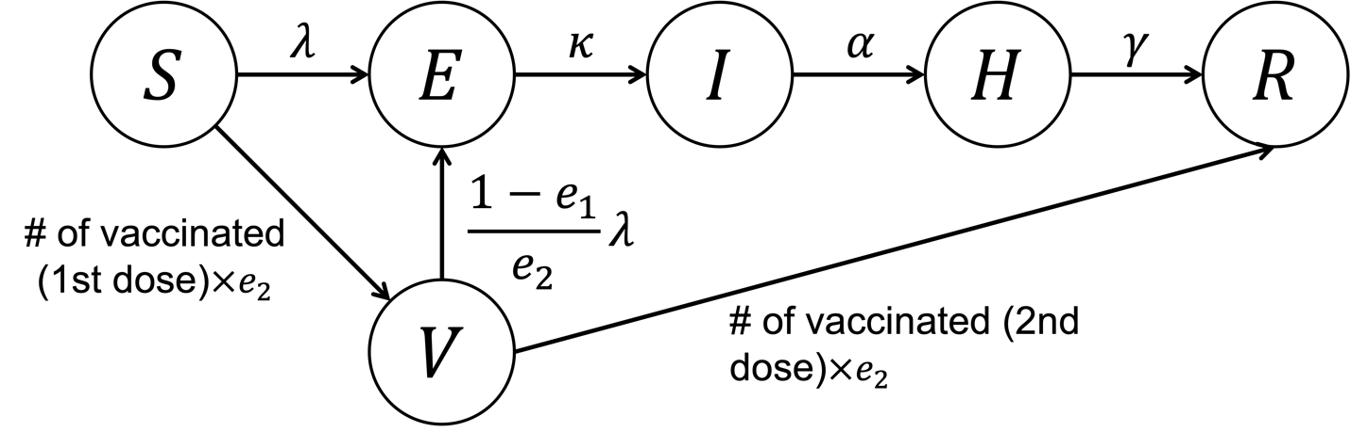

**State**

|  |  |
| --- | --- |
| State | Interpretation |
| S | Susceptible |
| E | Exposed |
| I | Infected |
| H | Hospitalized |
| R | Removed |
| V | Vaccinated (between 1st dose and 2nd dose) |

**Parameter**

|  |  |  |  |
| --- | --- | --- | --- |
| Parameter | Interpretation | Value | Reference |
|  | Transmission rate | Estimated |  |
|  | Latent period | 1/4 | [1-3] |
|  | Duration from infectiousness to hospitalization | 1/4 | [1-3] |
|  | Infectious period | 1/14 | [1-3] |
|  | Efficacy of 1st dose vaccination |  |  |
|  | Efficacy of 2nd dose vaccination |  |  |

**Form of**

: Proportion of -variant at time

: social distancing function

: contact matrix

: transmission rate for -variant  
: increment of transmission rate because of -variant

**Data to be used**

1. Daily confirmed cases (Seoul, Gyeonggi)
2. Vaccinated data

**Historical social distancing**

|  |  |  |
| --- | --- | --- |
| Date | Social distancing Stage | Proportionate |
| 2021.02.15-2021.06.30 | 2 |  |
| 2021.07.01-2021.07.11 | 1.5 | x1.685 |
| 2021.07.12-2021.08.31 | 3 | x0.67x0.33 |

**Vaccine efficacy (-variant)**

|  |  |  |  |  |
| --- | --- | --- | --- | --- |
|  | AZ | Pfizer | Moderna | Reference |
| after 1st Dose | 48.7%  (CI: 45.2–51.9%) | 47.5%  (CI: 41.6–52.8%) | 80.2% | [4-5]  5:Moderna |
| After 2nd Dose | 74.5%  (CI: 68.4–79.4%) | 93.7%  (CI: 91.6–95.3%) | 95.6% | [4-5]  5:Moderna |

**Vaccine efficacy (-variant)**

|  |  |  |  |  |
| --- | --- | --- | --- | --- |
|  | AZ | Pfizer | Moderna | REFERENCE |
| after 1st Dose | 30%  (CI: 24.3-35.3%) | 35.6%  (CI: 22.7-46.4%) |  | [4] |
| After 2nd Dose | 67%  (CI: 61.3-71.8%) | 88% (CI: 85.3-90.1%) |  | [4] |

**Vaccine schedule**

|  |  |  |  |
| --- | --- | --- | --- |
| 접종시작날짜 | 1차 접종완료예정날짜 | 접종대상 | 백신종류 |
| 2021/04/01 |  | 75세 이상 | 아스트라제네카 |
| 2021/05/27 | 2021/06/19 | 65-74세 | 아스트라제네카 |
| 2021/06/07 | 2021/06/19 | 60-64세 | 아스트라제네카 |
| 2021/07/26 | 2021/08/28 | 55-59세 | 화이자 및 모더나 |
| 2021/08/16 | 2021/08/28 | 50-54세 | 화이자 및 모더나 |
| 2021/08/26 |  | 18-49세 | 화이자 및 모더나 |

**Hospitalization prevention (-variant)**

|  |  |  |  |  |
| --- | --- | --- | --- | --- |
|  | AZ | Pfizer | Moderna | REFERENCE |
| after 1st Dose | 71%  (CI: 51-83%) | 94%  (CI: 46-99%) |  | [6] |
| After 2nd Dose | 92%  (CI: 75-97%) | 96%  (CI: 86-99%) |  | [6] |

**Case fatality rate by age**

|  |  |
| --- | --- |
| Age | Case fatatlity rate |
| 0-39 | 0% |
| 40-49 | 0.1% |
| 50-59 | 0.2% |
| 60-69 | 0.8% |
| 70-79 | 4.4% |
| 80+ | 14.2% |

**Proportion of severe illness by age**

|  |  |  |
| --- | --- | --- |
| Age | Proportion of severe illness | REFERENCE |
| 0-9 | 0.01% | [7] |
| 10-19 | 0.02% |  |
| 20-29 | 0.15% | [7] |
| 30-39 | 0.53% | [7] |
| 40-49 | 1.19% | [7] |
| 50-59 | 2.53% | [7] |
| 60-69 | 4.88% | [7] |
| 70-79 | 11.45% | [7] |
| 80+ | 14.91% |  |

**Proportion of -variant**

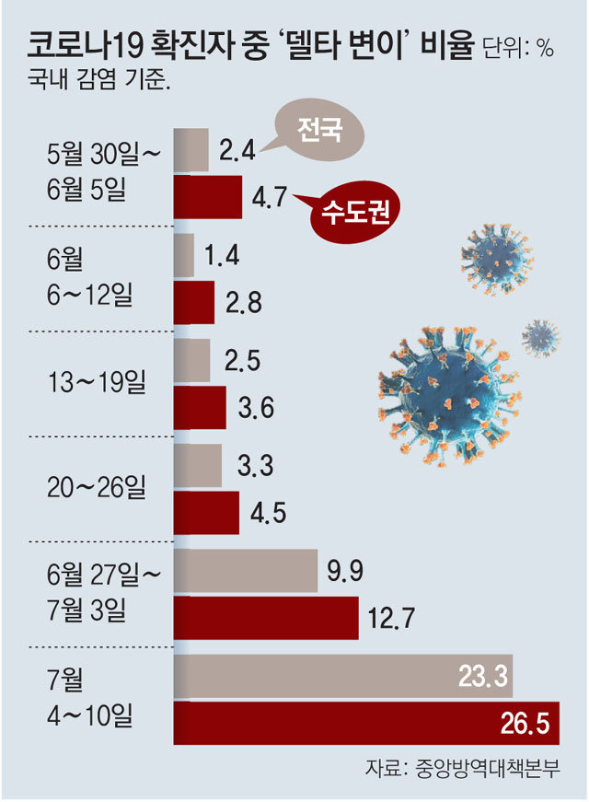

**References**

1. Choi S, Ki M. Estimating the reproductive number and the out-break size of COVID-19 in Korea. Epidemiol Health 2020;42: e2020011.
2. Ki M; Task Force for 2019-nCoV. Epidemiologic characteristics of early cases with 2019 novel coronavirus (2019-nCoV) disease in Korea. Epidemiol Health 2020;42: e2020007
3. Sunhwa Choi, Moran Ki. Analizing the effects of social distancing on the COVID-19 pandemic in Korea using mathematical modeling. Epidemiology and Health; 42: e2020064
4. Bernal et al. Effectiveness of Covid-19 Vaccines against the B.1.617.2 (Delta) Variant. N Engl J Med 2021;385:585-94
5. FDA. Vaccines and Related Biological Products Advisory Committee Meeting December 17, 2020. 2020
6. Stowe et al. Effectiveness of COVID-19 vaccines against hospital admission with the Delta (B.1.617.2) variant. Submitted.