Yunjia He

5/21/25

IT FND 110 A

Assignment05

Advanced Collections and Error Handling

# Introduction

This week, I learned the using dictionaries, json files, and exception handling. I created a script with menu, and user can make selection. User can register students for course or save data to a file. This script can save data in dictionaries and json file. The following information is a breakdown of how I wrote this program.

# Creating the Program

I start my program off by defining constants and variables with type hints. I set “MENU” and “FILE_NAME” as string type data constant. I set others data variables.(Figure 1.1)

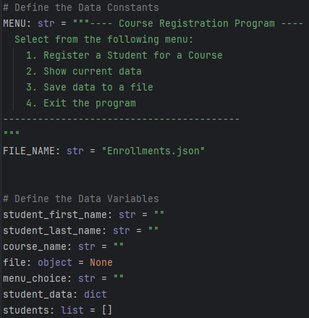

Figure 1.1: Define the data

Next step,I need to load data from file to this program. First, I import json to processes the the contents of a file. Second, I use “try-except” to handle program error. When file is not exist, the program will show error info and stop running. Third, I use “json.load” to load json file data to “students” variable. Last, I use “close()” to close file.(Figure 1.2)

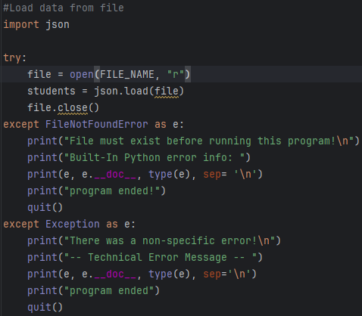

Figure 1.2: Load the data

Now I need to present the menu of choices and capture the selection. I use “while” to keep user in program until they choose exit.(Figure 1.3)

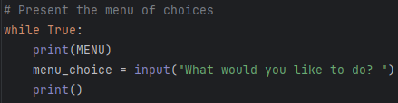

Figure 1.3: Present the menu of choices

After getting selection, I use “if” and “elif” in different choices. If user enter “1”, user can input their name and course name. I use “name.isalpha()” to check user’s input. The program will end input step and remind user to enter name correctly, if user’s name contain number. If name is alpha, the data will be saved in “student_data” dictionary. If user enter “2”, the program will present the current data from “students”. If user enter “3”, the program will write the “students” into json file and show the current data that in the “students” variable. I use “try-except” to handle program error in data saving step. If user enter “4”, the “while” loop will break, and the program will end. If user enter other things, the program will remind user to choose option.(Figure 1.4~1.7)

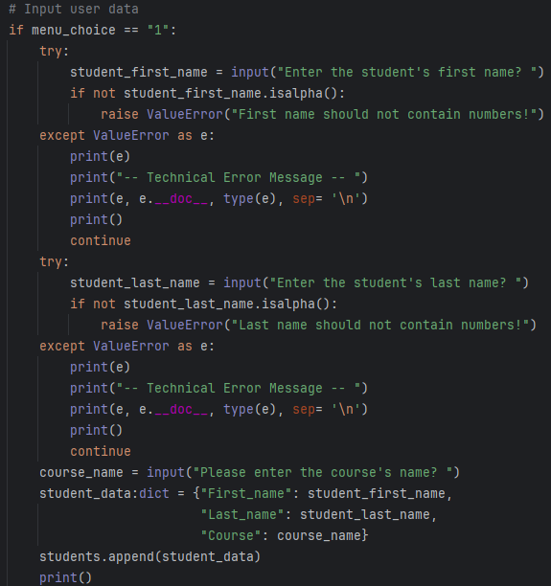

Figure 1.4: Menu_choice 1: Input user data

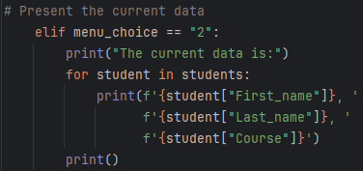

Figure 1.5: Menu_choice 2: Present the current data

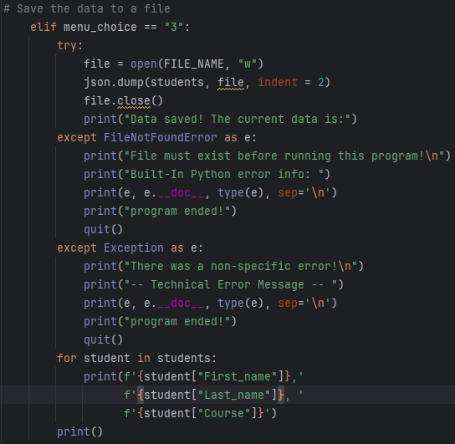

Figure 1.6: Menu_choice 3: Save data

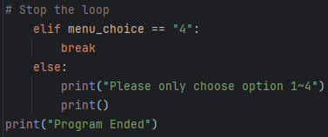

Figure 1.7: Menu_choice 4: Exit program

# Testing the Program

Now that the code is complete. It’s time to run and test it. First, I save the script and run it in Pycharm and CMD. The following information is test result.(Figure 2.1~2.5)

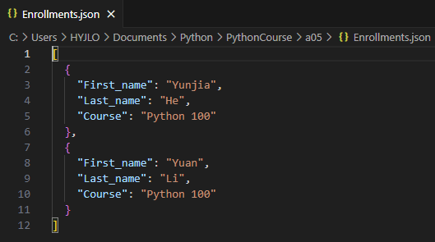

Figure 2.1: Enrollments.json

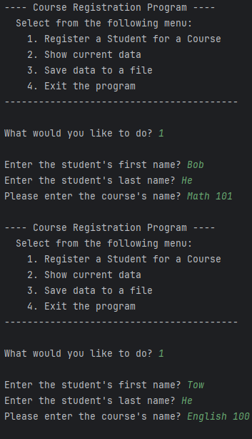

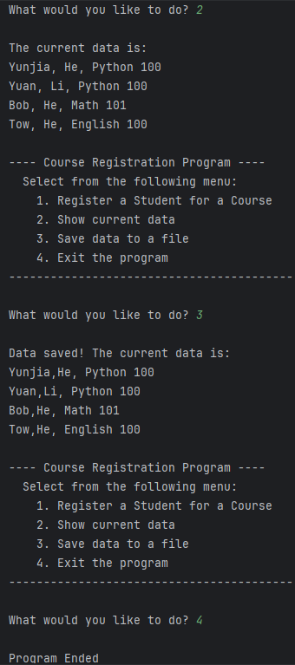

Figure 2.2: Pycharm test result

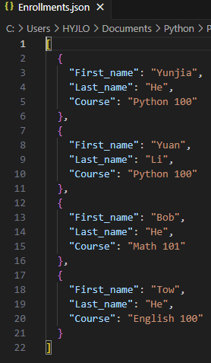

Figure 2.3: Enrollments.json(after Pycharm test)

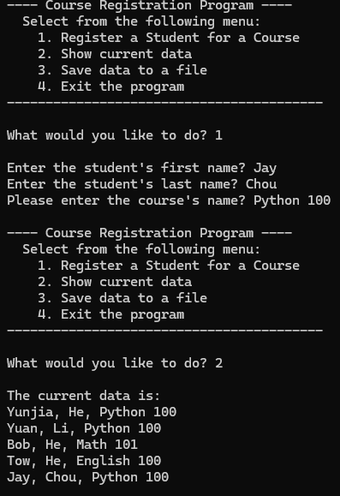

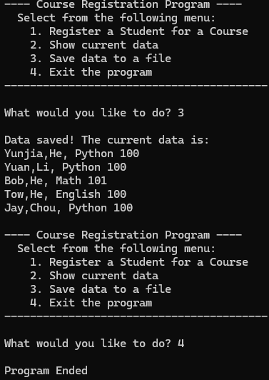

Figure 2.4: CMD test result

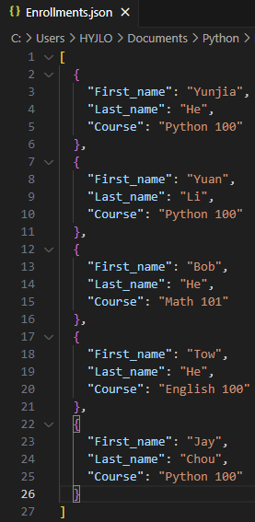

Figure 2.5: Enrollments.json(after CMD test)

# Summary

I review using dictionaries, json files, and exception handling by writing this program. I learn that dictionaries have “keys” and “values” can help data management. It is convenient to processes files contents with dictionaries. I grasp using “try-except” to handle or customs error. I also review lists using, file handling, and looping in Python. Lastly, this practice helped me start programming with Python and review knowledge.