P8106_HW4_yz4184

Yunlin Zhou

Table of Contents

library(tidyverse)  
library(ISLR)  
library(caret)  
library(rpart)  
library(rpart.plot)  
library(party)  
library(partykit)  
library(randomForest)  
library(ranger)  
library(gbm)  
library(pdp)  
library(pROC)

# Problem 1

# Import and clean the data  
college_df = read.csv("./College.csv")%>%  
 janitor::clean_names()%>%  
 drop_na()%>%  
 relocate("outstate")%>%  
 select(-college)  
  
# Partition data into training/test sets  
set.seed(1)  
college_train = createDataPartition(y = college_df$outstate,  
 p =0.8,  
 list = FALSE)  
train_df = college_df[college_train,]  
test_df = college_df[-college_train,]

## Part a

### Build a regression tree on the training data to predict the response.

ctrl <- trainControl(method = "cv")  
  
set.seed(1)  
tree1 <- train(outstate ~ .,  
 train_df,   
 method = "rpart",  
 tuneGrid = data.frame(cp = exp(seq(-6,-2, length = 50))),  
 trControl = ctrl)  
tree1$bestTune

## cp  
## 8 0.004389362

ggplot(tree1, highlight = TRUE)

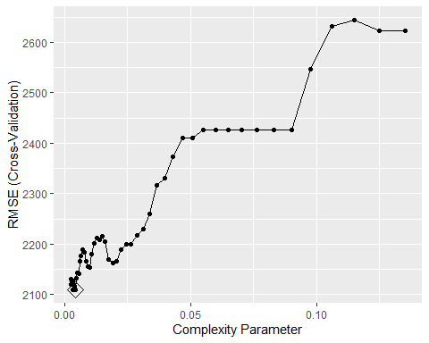

In the pruned tree regression model, the tune parameter cp is 0.0043894.

### Create a plot of the tree.

rpart.plot(tree1$finalModel)

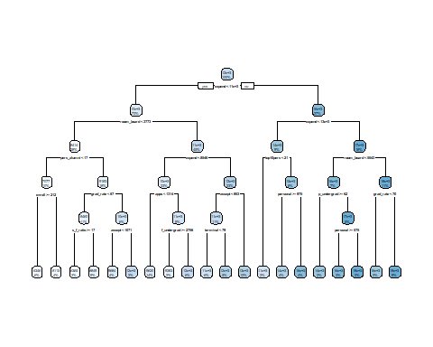

## Part b

### Perform random forest on the training data.

set.seed(1)  
rf.grid <- expand.grid(mtry = 1:16,  
 splitrule = "variance",  
 min.node.size = 1:6)  
  
rf1 <- train(outstate ~ .,  
 train_df,  
 method = "ranger",  
 tuneGrid = rf.grid,  
 trControl = ctrl)  
  
ggplot(rf1, highlight = TRUE)

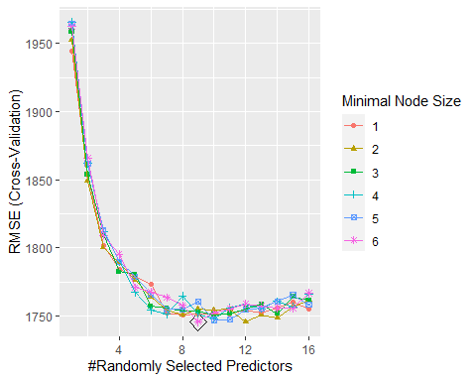

rf1$bestTune

## mtry splitrule min.node.size  
## 54 9 variance 6

In this random forest model, the best model is with minimum node size 6 and 9 selected predictors.

### Report the variable importance.

set.seed(1)  
rf1.final.per <- ranger(outstate ~ . ,   
 train_df,  
 mtry = rf1$bestTune[[1]],   
 splitrule = "variance",  
 min.node.size = rf1$bestTune[[3]],  
 importance = "permutation",  
 scale.permutation.importance = TRUE)   
  
barplot(sort(ranger::importance(rf1.final.per), decreasing = FALSE),   
 las = 2, horiz = TRUE, cex.names = 0.7,  
 col = colorRampPalette(colors = c("cyan","blue"))(16))

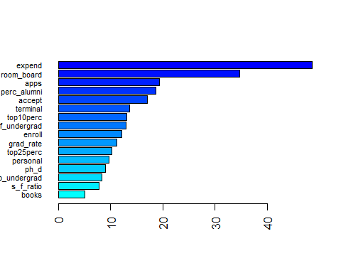

Using the permutation method, the most important predictors are expend and room_board.

### Report the test error.

pred.rf <- predict(rf1, newdata = test_df)  
te_rf = RMSE(pred.rf, test_df$outstate)  
te_rf

## [1] 1651.307

The test error is 1651.3069135.

## Part c

### Perform boosting on the training data.

gbm.grid <- expand.grid(n.trees = c(2000,3000,4000,5000),  
 interaction.depth = 1:5,  
 shrinkage = c(0.001,0.003,0.005),  
 n.minobsinnode = c(1,10))  
set.seed(1)  
gbm1 <- train(outstate ~ . ,  
 train_df,  
 method = "gbm",  
 tuneGrid = gbm.grid,  
 trControl = ctrl,  
 verbose = FALSE)  
  
gbm1$bestTune

## n.trees interaction.depth shrinkage n.minobsinnode  
## 40 5000 5 0.001 10

ggplot(gbm1, highlight = TRUE)

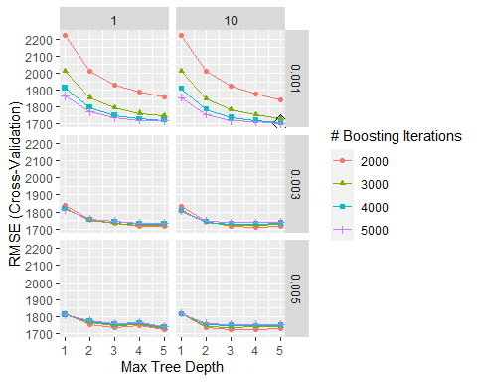

### Report the variable importance.

summary(gbm1$finalModel, las = 2, cBars = 16, cex.names = 0.6)

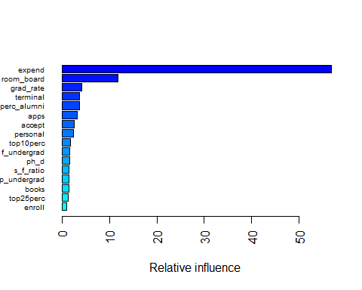

## var rel.inf  
## expend expend 56.839618  
## room_board room_board 11.763945  
## grad_rate grad_rate 4.097538  
## terminal terminal 3.740792  
## perc_alumni perc_alumni 3.692448  
## apps apps 3.212812  
## accept accept 2.606760  
## personal personal 2.368107  
## top10perc top10perc 1.812568  
## f_undergrad f_undergrad 1.605638  
## ph_d ph_d 1.562622  
## s_f_ratio s_f_ratio 1.445236  
## p_undergrad p_undergrad 1.436907  
## books books 1.415833  
## top25perc top25perc 1.361722  
## enroll enroll 1.037453

The most important predictors are expend and room_board.

### Report the test error.

pred.gbm <- predict(gbm1, newdata = test_df)  
te_gbm = RMSE(pred.gbm, test_df$outstate)  
te_gbm

## [1] 1620.551

The test error is 1620.5511732.

# Queation 2

# Import and clean the data  
data(OJ)  
oj_df=   
 OJ %>%   
 na.omit() %>%   
 janitor::clean_names()   
  
# Partition data into training/test sets  
set.seed(2)  
oj_train = createDataPartition(y = oj_df$purchase,  
 p = 700/1070,  
 list = FALSE)  
train_oj = oj_df[oj_train,]  
test_oj = oj_df[-oj_train,]

## Part a

### Build a classification tree using the training data

set.seed(2)  
tree2 <- rpart(formula = purchase ~ . ,   
 data = train_oj,   
 control = rpart.control(cp = 0))  
  
cpTable <- printcp(tree2)

##   
## Classification tree:  
## rpart(formula = purchase ~ ., data = train_oj, control = rpart.control(cp = 0))  
##   
## Variables actually used in tree construction:  
## [1] list_price_diff loyal_ch price_diff sale_price_ch   
## [5] sale_price_mm store store_id weekof_purchase  
##   
## Root node error: 273/701 = 0.38944  
##   
## n= 701   
##   
## CP nsplit rel error xerror xstd  
## 1 0.5201465 0 1.00000 1.00000 0.047291  
## 2 0.0219780 1 0.47985 0.49451 0.038243  
## 3 0.0097680 3 0.43590 0.48352 0.037916  
## 4 0.0073260 6 0.40659 0.50183 0.038457  
## 5 0.0045788 8 0.39194 0.48352 0.037916  
## 6 0.0036630 12 0.37363 0.49451 0.038243  
## 7 0.0012210 18 0.34799 0.49451 0.038243  
## 8 0.0000000 21 0.34432 0.50916 0.038668

plotcp(tree2)

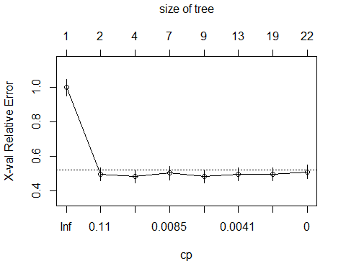

### Use cross-validation to determine the tree size and create a plot of the final tree.

# minimum cross-validation error  
minErr <- which.min(cpTable[,4])  
tree3 <- prune(tree2, cp = cpTable[minErr,1])  
rpart.plot(tree3)

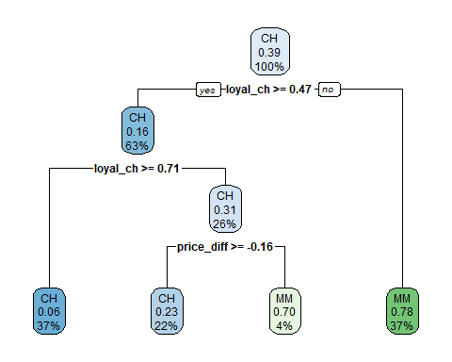

summary(tree3)

## Call:  
## rpart(formula = purchase ~ ., data = train_oj, control = rpart.control(cp = 0))  
## n= 701   
##   
## CP nsplit rel error xerror xstd  
## 1 0.52014652 0 1.0000000 1.0000000 0.04729133  
## 2 0.02197802 1 0.4798535 0.4945055 0.03824313  
## 3 0.00976801 3 0.4358974 0.4835165 0.03791591  
##   
## Variable importance  
## loyal_ch price_diff sale_price_mm pct_disc_mm disc_mm   
## 77 7 4 3 3   
## weekof_purchase price_ch special_mm price_mm store_id   
## 2 1 1 1 1   
##   
## Node number 1: 701 observations, complexity param=0.5201465  
## predicted class=CH expected loss=0.3894437 P(node) =1  
## class counts: 428 273  
## probabilities: 0.611 0.389   
## left son=2 (443 obs) right son=3 (258 obs)  
## Primary splits:  
## loyal_ch < 0.469289 to the right, improve=121.50000, (0 missing)  
## store_id < 3.5 to the right, improve= 32.47240, (0 missing)  
## price_diff < 0.015 to the right, improve= 21.38773, (0 missing)  
## store7 splits as RL, improve= 19.81980, (0 missing)  
## store < 0.5 to the left, improve= 19.81980, (0 missing)  
## Surrogate splits:  
## disc_mm < 0.57 to the left, agree=0.641, adj=0.023, (0 split)  
## pct_disc_mm < 0.264375 to the left, agree=0.641, adj=0.023, (0 split)  
## sale_price_mm < 1.385 to the right, agree=0.638, adj=0.016, (0 split)  
## price_diff < -0.575 to the right, agree=0.638, adj=0.016, (0 split)  
## sale_price_ch < 2.025 to the left, agree=0.633, adj=0.004, (0 split)  
##   
## Node number 2: 443 observations, complexity param=0.02197802  
## predicted class=CH expected loss=0.1647856 P(node) =0.6319544  
## class counts: 370 73  
## probabilities: 0.835 0.165   
## left son=4 (259 obs) right son=5 (184 obs)  
## Primary splits:  
## loyal_ch < 0.705699 to the right, improve=13.233360, (0 missing)  
## price_diff < -0.39 to the right, improve=11.999940, (0 missing)  
## sale_price_mm < 2.04 to the right, improve= 7.131761, (0 missing)  
## special_mm < 0.5 to the left, improve= 5.427963, (0 missing)  
## list_price_diff < 0.235 to the right, improve= 5.218477, (0 missing)  
## Surrogate splits:  
## price_ch < 1.775 to the right, agree=0.639, adj=0.130, (0 split)  
## weekof_purchase < 237.5 to the right, agree=0.634, adj=0.120, (0 split)  
## price_mm < 2.04 to the right, agree=0.630, adj=0.109, (0 split)  
## store_id < 2.5 to the right, agree=0.614, adj=0.071, (0 split)  
## sale_price_mm < 2.04 to the right, agree=0.605, adj=0.049, (0 split)  
##   
## Node number 3: 258 observations  
## predicted class=MM expected loss=0.2248062 P(node) =0.3680456  
## class counts: 58 200  
## probabilities: 0.225 0.775   
##   
## Node number 4: 259 observations  
## predicted class=CH expected loss=0.06177606 P(node) =0.3694722  
## class counts: 243 16  
## probabilities: 0.938 0.062   
##   
## Node number 5: 184 observations, complexity param=0.02197802  
## predicted class=CH expected loss=0.3097826 P(node) =0.2624822  
## class counts: 127 57  
## probabilities: 0.690 0.310   
## left son=10 (154 obs) right son=11 (30 obs)  
## Primary splits:  
## price_diff < -0.165 to the right, improve=10.915950, (0 missing)  
## list_price_diff < 0.235 to the right, improve= 8.137578, (0 missing)  
## store_id < 5.5 to the right, improve= 5.270274, (0 missing)  
## store7 splits as RL, improve= 5.270274, (0 missing)  
## store < 0.5 to the left, improve= 5.270274, (0 missing)  
## Surrogate splits:  
## sale_price_mm < 1.585 to the right, agree=0.891, adj=0.333, (0 split)  
## pct_disc_mm < 0.187437 to the left, agree=0.886, adj=0.300, (0 split)  
## disc_mm < 0.57 to the left, agree=0.880, adj=0.267, (0 split)  
## weekof_purchase < 274.5 to the left, agree=0.875, adj=0.233, (0 split)  
## special_mm < 0.5 to the left, agree=0.859, adj=0.133, (0 split)  
##   
## Node number 10: 154 observations  
## predicted class=CH expected loss=0.2337662 P(node) =0.2196862  
## class counts: 118 36  
## probabilities: 0.766 0.234   
##   
## Node number 11: 30 observations  
## predicted class=MM expected loss=0.3 P(node) =0.04279601  
## class counts: 9 21  
## probabilities: 0.300 0.700

When the tree size is 3 corresponds to the lowest cross-validation error.

### Using the 1 SE rule

tree4 <- prune(tree2, cp = cpTable[cpTable[,4]<cpTable[minErr,4]+cpTable[minErr,5],1][1])  
rpart.plot(tree4)

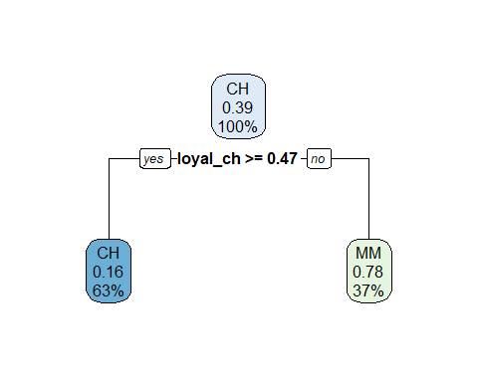

The tree is smaller when the tree size obtained using the 1 SE rule.

## Part b

### Perform boosting on the training data.

ctrl2 <- trainControl(method = "cv",  
 classProbs = TRUE,   
 summaryFunction = twoClassSummary)  
  
gbmA.grid <- expand.grid(n.trees = c(2000,3000,4000,5000),  
 interaction.depth = 1:6,  
 shrinkage = c(0.0005,0.001,0.002),  
 n.minobsinnode = 1)  
set.seed(2)  
gbmA.fit <- train(purchase ~ . ,  
 data = train_oj,  
 tuneGrid = gbmA.grid,  
 trControl = ctrl2,  
 method = "gbm",  
 distribution = "adaboost",  
 metric = "ROC",  
 verbose = FALSE)  
  
ggplot(gbmA.fit, highlight = TRUE)

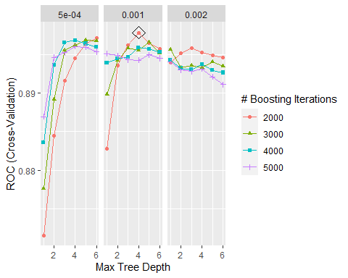

### Report the variable importance.

summary(gbmA.fit$finalModel, las = 2, cBars = 16, cex.names = 0.6)

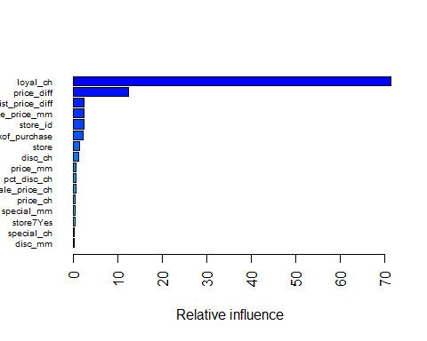

## var rel.inf  
## loyal_ch loyal_ch 71.5077135  
## price_diff price_diff 12.5439501  
## list_price_diff list_price_diff 2.4675725  
## sale_price_mm sale_price_mm 2.4288086  
## store_id store_id 2.3498719  
## weekof_purchase weekof_purchase 2.2994427  
## store store 1.4990614  
## disc_ch disc_ch 1.1872920  
## price_mm price_mm 0.6534050  
## pct_disc_ch pct_disc_ch 0.6014305  
## sale_price_ch sale_price_ch 0.5990112  
## price_ch price_ch 0.5322951  
## special_mm special_mm 0.3947971  
## store7Yes store7Yes 0.3494613  
## special_ch special_ch 0.2865049  
## disc_mm disc_mm 0.1970333  
## pct_disc_mm pct_disc_mm 0.1023489

The most important variables are loyal_ch and price_diff.

### Test error

gbmA.pred <- predict(gbmA.fit, newdata = test_oj)  
test.error = mean(gbmA.pred != test_oj$purchase)  
test_error_rate = test.error*100  
test_error_rate

## [1] 16.53117

The test error rate is16.5311653%.