P8131 HW7 yz4184

Yunlin Zhou

library(tidyverse)  
library(nlme)  
library(ggplot2)  
library (lattice)  
library(patchwork)  
library(lme4)

# import data  
pitch_df = read.csv("./HW7-politeness_data.csv")%>%  
 drop_na()%>%  
 janitor::clean_names()

# (a) Exploratory analysis

## provide boxplots to show the relation between gender/attitude and pitch (ignoring different scenarios).

a.p1 = pitch_df %>%   
 ggplot(aes(x = gender, y = frequency)) +  
 geom_boxplot()+  
 labs(title = "relationship between gender and pitch")  
  
a.p2 = pitch_df %>%   
 ggplot(aes(x = attitude, y = frequency)) +  
 geom_boxplot()+  
 labs(title = "relationship between attitude and pitch")  
  
(a.p1 + a.p2)

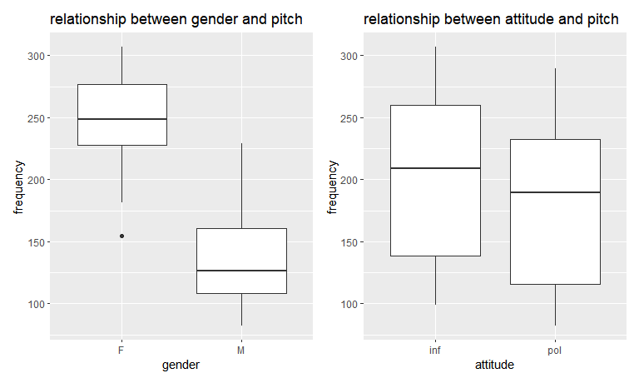

As the plot shows above, we can conclude that female and informal attitude are tending to have higher frequency.

# (b)

## Fit a mixed effects model with random intercepts for different subjects (gender and attitude being the fixed effects).

LMM1 <- lme (frequency ~ gender + attitude, random = ~1 | subject, data = pitch_df, method='REML')   
summary (LMM1)

## Linear mixed-effects model fit by REML  
## Data: pitch_df   
## AIC BIC logLik  
## 806.0805 818.0527 -398.0402  
##   
## Random effects:  
## Formula: ~1 | subject  
## (Intercept) Residual  
## StdDev: 24.45803 29.11537  
##   
## Fixed effects: frequency ~ gender + attitude   
## Value Std.Error DF t-value p-value  
## (Intercept) 256.98690 15.154986 77 16.957251 0.0000  
## genderM -108.79762 20.956235 4 -5.191659 0.0066  
## attitudepol -20.00238 6.353495 77 -3.148248 0.0023  
## Correlation:   
## (Intr) gendrM  
## genderM -0.691   
## attitudepol -0.210 0.000  
##   
## Standardized Within-Group Residuals:  
## Min Q1 Med Q3 Max   
## -2.3564422 -0.5658319 -0.2011979 0.4617895 3.2997610   
##   
## Number of Observations: 84  
## Number of Groups: 6

## What is the covariance matrix for a subject Yi?

VarCorr(LMM1)

## subject = pdLogChol(1)   
## Variance StdDev   
## (Intercept) 598.1953 24.45803  
## Residual 847.7049 29.11537

VarCorr(LMM1)[1]

## [1] "598.1953"

VarCorr(LMM1)[2]

## [1] "847.7049"

sigma_b^2 = 598.1953

sigma^2 = 847.7049

sigma_b^2 + sigma^2 = 598.1953 + 847.7049 = 1445.9

For every subject, we have 14 measurements, so the covariance matrix is a 14*14 matrix.

## What is the covariance matrix for the estimates of fixed effects?

vcov(LMM1)

## (Intercept) genderM attitudepol  
## (Intercept) 229.67362 -2.195819e+02 -2.018345e+01  
## genderM -219.58189 4.391638e+02 6.451438e-15  
## attitudepol -20.18345 6.451438e-15 4.036690e+01

## What are the BLUPs for subject-specific intercepts?

random.effects(LMM1)

## (Intercept)  
## F1 -13.575831  
## F2 10.170522  
## F3 3.405309  
## M3 27.960288  
## M4 4.739325  
## M7 -32.699613

## What are the residuals?

pitch_df$frequency-fitted(LMM1)

## F1 F1 F1 F1 F1 F1   
## -10.1086926 -38.9110735 61.6913074 16.2889265 -19.5086926 43.4889265   
## F1 F1 F1 F1 F1 F1   
## 27.3913074 33.3889265 8.4913074 8.9889265 -42.2086926 -12.7110735   
## F1 F1 F3 F3 F3 F3   
## -26.9110735 -68.6086926 -10.6898326 -23.0922136 -3.5898326 -9.3922136   
## F3 F3 F3 F3 F3 F3   
## 26.6101674 5.6077864 35.0101674 46.4077864 -7.7898326 -7.8922136   
## F3 F3 F3 F3 M4 M4   
## -13.8898326 18.4077864 4.0077864 -54.8898326 -22.2262298 -29.3286108   
## M4 M4 M4 M4 M4 M4   
## 96.0737702 -38.0286108 -20.7262298 60.6713892 60.4737702 9.9713892   
## M4 M4 M4 M4 M4 M4   
## -31.1262298 -26.0286108 -22.9262298 -16.7286108 -6.9286108 -6.4262298   
## M7 M7 M7 M7 M7 M7   
## -9.3872916 -16.3896725 -13.2872916 -11.1896725 -9.5872916 -5.2896725   
## M7 M7 M7 M7 M7 M7   
## 1.6127084 4.5103275 -1.7872916 -12.5896725 13.3127084 -7.2896725   
## M7 M7 F2 F2 F2 F2   
## 8.9103275 12.1127084 -14.4550462 -35.8574271 -0.8550462 -7.4574271   
## F2 F2 F2 F2 F2 F2   
## 42.2449538 34.6425729 -3.9550462 29.0425729 30.5449538 27.0425729   
## F2 F2 F2 F2 M3 M3   
## -39.1550462 -41.2574271 13.8425729 -19.9550462 -2.3471929 12.6504261   
## M3 M3 M3 M3 M3 M3   
## -13.7471929 23.5504261 4.0528071 9.9504261 51.3528071 14.7504261   
## M3 M3 M3 M3 M3 M3   
## 4.5528071 -19.6495739 -9.4471929 -18.1495739 -15.0495739 -2.8471929   
## attr(,"label")  
## [1] "Fitted values"

# (c)

## Fit a mixed effects model with intercepts for different subjects (gender, attitude and their interaction being the fixed effects).

LMM2 <- lme (frequency ~ gender + attitude + gender * attitude, random = ~1 | subject, data = pitch_df, method='REML')   
summary (LMM2)

## Linear mixed-effects model fit by REML  
## Data: pitch_df   
## AIC BIC logLik  
## 799.8018 814.094 -393.9009  
##   
## Random effects:  
## Formula: ~1 | subject  
## (Intercept) Residual  
## StdDev: 24.46382 29.04716  
##   
## Fixed effects: frequency ~ gender + attitude + gender * attitude   
## Value Std.Error DF t-value p-value  
## (Intercept) 260.68571 15.481307 76 16.838740 0.0000  
## genderM -116.19524 21.893875 4 -5.307203 0.0061  
## attitudepol -27.40000 8.964149 76 -3.056620 0.0031  
## genderM:attitudepol 14.79524 12.677221 76 1.167073 0.2468  
## Correlation:   
## (Intr) gendrM atttdp  
## genderM -0.707   
## attitudepol -0.290 0.205   
## genderM:attitudepol 0.205 -0.290 -0.707  
##   
## Standardized Within-Group Residuals:  
## Min Q1 Med Q3 Max   
## -2.2344163 -0.5454437 -0.1646159 0.4697182 3.1800944   
##   
## Number of Observations: 84  
## Number of Groups: 6

## Use likelihood ratio test to compare this model with the model in part (b) to determine whether the interaction term is significantly associated with pitch.

LMM.1 <- lme (frequency ~ gender + attitude, random = ~1 | subject, data = pitch_df, method='ML')  
  
LMM.2 <- lme (frequency ~ gender + attitude + gender * attitude, random = ~1 | subject, data = pitch_df, method='ML')  
  
anova(LMM.2,LMM.1)

## Model df AIC BIC logLik Test L.Ratio p-value  
## LMM.2 1 6 826.2508 840.8357 -407.1254   
## LMM.1 2 5 825.6363 837.7904 -407.8182 1 vs 2 1.385523 0.2392

Since the p-value for Likelihood ratio test is 0.2392 > 0.05, we fail to reject the null hypothesis and conclude that the interaction term is not significantly associated with pitch, at the significance level of 0.05.

# (d)

## Write out the mixed effects model with random intercepts for both subjects and scenarios (gender and attitude being the fixed effects).

## Fit the model using lmer in the lme4 package.

LMM3 = lmer(frequency ~ gender + attitude + (1 | subject) + (1 | scenario), data = pitch_df)  
summary(LMM3)

## Linear mixed model fit by REML ['lmerMod']  
## Formula: frequency ~ gender + attitude + (1 | subject) + (1 | scenario)  
## Data: pitch_df  
##   
## REML criterion at convergence: 784.1  
##   
## Scaled residuals:   
## Min 1Q Median 3Q Max   
## -2.2690 -0.6331 -0.0878 0.5204 3.5326   
##   
## Random effects:  
## Groups Name Variance Std.Dev.  
## scenario (Intercept) 224.5 14.98   
## subject (Intercept) 613.2 24.76   
## Residual 637.8 25.25   
## Number of obs: 84, groups: scenario, 7; subject, 6  
##   
## Fixed effects:  
## Estimate Std. Error t value  
## (Intercept) 256.987 16.101 15.961  
## genderM -108.798 20.956 -5.192  
## attitudepol -20.002 5.511 -3.630  
##   
## Correlation of Fixed Effects:  
## (Intr) gendrM  
## genderM -0.651   
## attitudepol -0.171 0.000

## Write out the covariance matrix for a subject Yi.

VarCorr(LMM3)

## Groups Name Std.Dev.  
## scenario (Intercept) 14.983   
## subject (Intercept) 24.763   
## Residual 25.254

VarCorr(LMM3)[1]

## $scenario  
## (Intercept)  
## (Intercept) 224.4994  
## attr(,"stddev")  
## (Intercept)   
## 14.9833   
## attr(,"correlation")  
## (Intercept)  
## (Intercept) 1

VarCorr(LMM3)[2]

## $subject  
## (Intercept)  
## (Intercept) 613.1903  
## attr(,"stddev")  
## (Intercept)   
## 24.76268   
## attr(,"correlation")  
## (Intercept)  
## (Intercept) 1

sigma_b^2 = 224.4994 + 613.1903 = 837.6897

sigma^2 = 25.254^2 = 637.7645

sigma_b^2 + sigma^2 = 837.6897 + 637.7645 = 1475.454

## What is the interpretation of the coefficient for the fixed effect term attitude?

fixed.effects(LMM3)

## (Intercept) genderM attitudepol   
## 256.98690 -108.79762 -20.00238

When the gender is fixed, the mean frequency of polite attitude will be 20.00238 units lower than informal attitude on average.