Problem Statement:
What does the topic cover?
This topic aims to achieve the goal that programming can answer the specific questions offered by user which related to a specific picture and provide the answer formed by some simple word, like yes or no, open or close, a specific color and so on. We should let the answer as closed as the answer provided by real person.

Why it is important?
In my opinion, the most important part in this program is step 2 because it can help computer turns abstract picture to readable word and elements. It can be widely used on today’s internet.

Applications
What are applications of the topic?
For example, on Twitter and Facebook, it can help the officer supervise the content on the internet. If there are some violents or even terrorists, the platform can easily find and stop them. In China, we have the serious restriction of pornographic content on the internet. By using this technology, it will be much easier to control this kind of content.
What is the societal significance of the research?
This technology can greatly enhance the supervision of the Internet world and decrease the harmful information on that. In China, there is no strict age classification system. Even the children in primary school can surf all the information online, as long as they understand the word. So this technology can not only ensure the social security but also protect our teenagers from harmful information.

Pick an area of focus that interests you in the topic:
As what I said in the Literature review part 1, the most important and difficult part in this program is step 2. It can help our computer understand the 2D pictures. If we can make this process accurate and efficient, It will completely improve our social environment.

Literature review:
As comprehensive as you can, research the different approaches and solutions in research community and industry:
- The easiest and most usual way:
This program focus on the machine learning and database. Machine learning can help computer to analyse all the details of the specific picture and turn these details into digital form which means use digital to present different parts of the picture. The database is used to combine the digital form with the standard picture or readable sentences. For example, There is a picture including a opening microwave. There are three steps in our program to deal with the picture and answer the question.
First, deeply analyse the all parts in the picture and save them as digital form and save as digital sets. In this step, analyse is very thoroughly, even based on each pixel. As we know, the most popular or maybe the only way for computer working is trying all the possibility. Secondly, comparing these digital sets with the database. In the database, there may be billions of standard pictures and examples and each of them have a digital form and human readable description(for example, there may be thousands pictures related to the description called doors and some of them also related to the elements like white, yellow, opening, closed, etc). Comparing these two digital form, the computer can relate two digital sets (one is the picture offered, another is the picture in database, may be more than one in database) that the similarity exceeds a certain degree and choose the most similar one in database. In this way, the digital set gotten in offered picture can have the readable description.
Finally, pick the key words from the question(like color, situation, etc) and comparing them with all the elements gotten in the second step, choose the answer. For example, elements including yellow, open, door can answer the question that what’s the situation of the door showed in the picture and what color it is. The answering should be open, yellow.

- A clever and more efficient way:
PS: I do not understand this paper too much because it includes many prior research and complex math processing.
Reference Paper: https://arxiv.org/pdf/1610.02391.pdf
Title: Grad-CAM: Visual Explanations from Deep Networksvia Gradient-based Localization
Grad-CAM: Gradient-weighted Class Activation Mapping, a class-discriminative localization technique.
The main idea of this paper is doing prediction when the program is given an input which called class prediction. It has a network and can generate Grad-CAM maps for each of the predicted classes. It will give a gradient to the major class as 1 while other classes as 0. In this way, through a complex math process, the program can get the guided Grad-CAM.
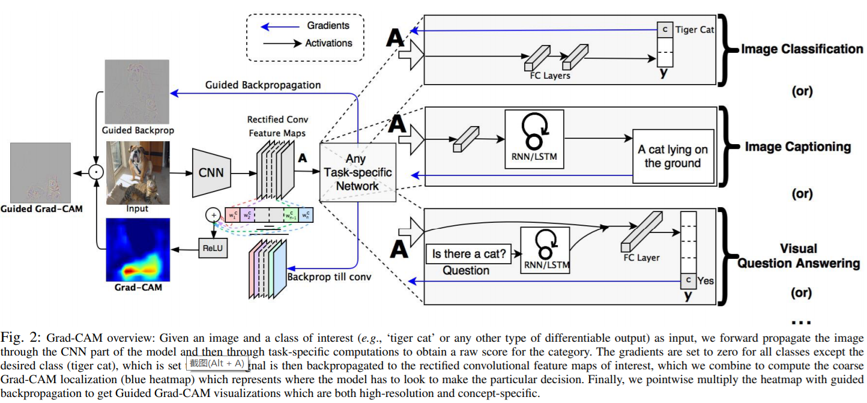
Picture 1: Screenshot from the reference paper, shows the detail of processing

Example: 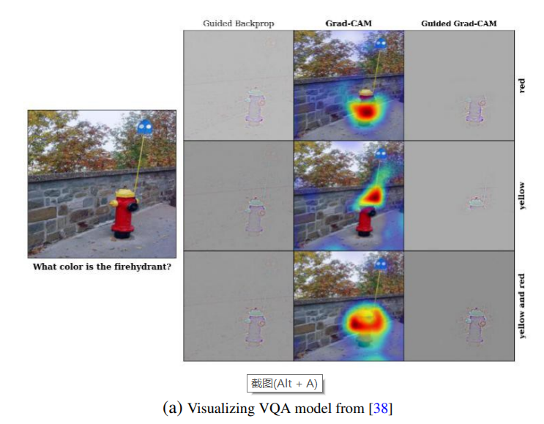
Picture 2: a result of an open source using Grad-CAM program.

- Another clever and more efficient way:
Reference Paper: https://arxiv.org/pdf/1603.08507.pdf
Title: Generating Visual Explanations
Introduction: this way is the same as second way I mentioned above in some parts. The input also includes an image and category predictions. Its model is based on LRCN(Long-term recurrent convolutional networks). They can use rich category specific features to generate relevant explanations.
Problems: Discriminative loss which means that there will be same description for the different object and the programming lose their characteristic. For example, there are two kinds of bird both with a white neck and black back in the water in Picture 3. But the description does not include the discriminative features.
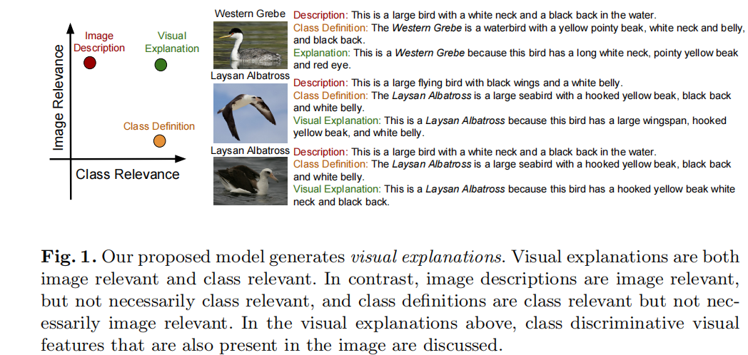
Picture 3: discriminative loss example(Screenshot from the paper).
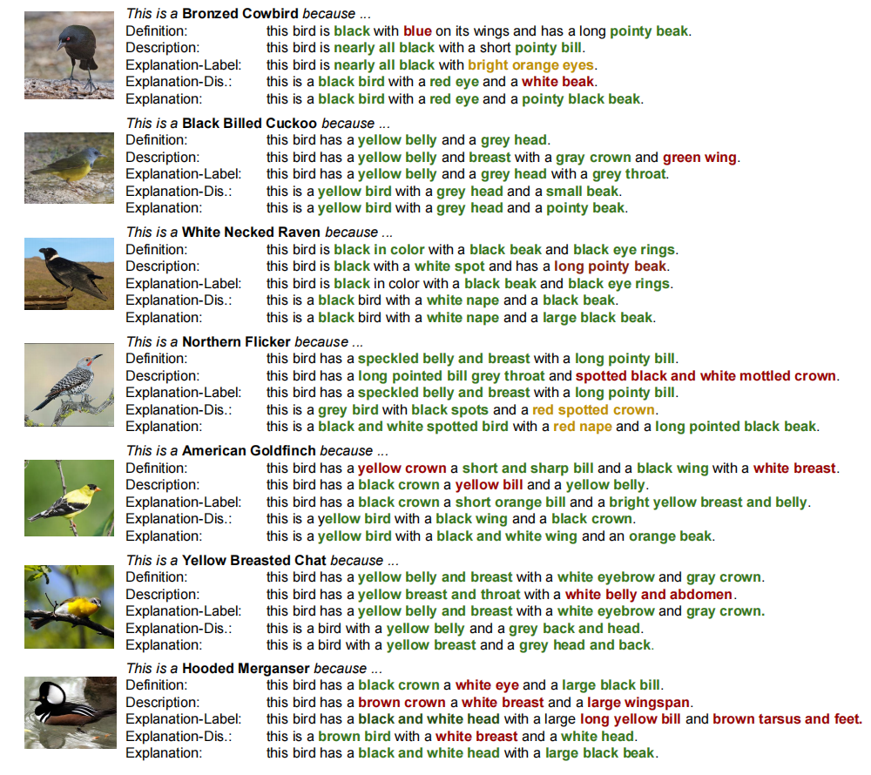
Picture 4: Output example of the model(Screenshot from the paper).
Output: Showing in the Picture 4, the correct information is in green, the wrong information is in red. The accuracy can be at most 59.13% and least 22.32%

Open Source research:
Research the different open source projects that touch the topic of your interest:
https://github.com/GT-Vision-Lab/VQA_LSTM_CNN :
Describtion: A model can train deeper LSTM and normalized CNN Visual Question Answering. This current code can get 58.16 on Open-Ended and 63.09 on Multiple-Choice on test-standard split.(Information gotten from readme.md in the program)
Requirement: This code is written in Lua and requires Torch. The preprocssinng code is in Python, and you need to install NLTK if you want to use NLTK to tokenize the question.(Information gotten from readme.md in the program)
License: BSD License, manually permission of patent grant and TM grant.

https://github.com/jiasenlu/HieCoAttenVQA :
Describtion:Train a Hierarchical Co-Attention model for Visual Question Answering. This current code can get 62.1 on Open-Ended and 66.1 on Multiple-Choice on test-standard split. For COCO-QA, this code can get 65.4 on Accuracy. (Information gotten from readme.md in the program)
Requirement: This code is written in Lua and requires Torch. The preprocssinng code is in Python, and you need to install NLTK if you want to use NLTK to tokenize the question.(Information gotten from readme.md in the program)
License: I did not find it’s license in all documents.

https://github.com/GT-Vision-Lab/VQA :
Describtion: An python API aims to build a database which includes:
- 82,783 MS COCO training images, 40,504 MS COCO validation images and 81,434 MS COCO testing images.
- 443,757 questions for training, 214,354 questions for validation and 447,793 questions for testing
- 4,437,570 answers for training and 2,143,540 answers for validation (10 per question)
(Information gotten from readme.md in the program)
Requirement: python 2.7
scikit-image
matplotlib
(Information gotten from readme.md in the program)
License: https://github.com/GT-Vision-Lab/VQA/blob/master/license.txt

