Google natural language processing(NLP)
Reference: https://codelabs.developers.google.com/codelabs/cloud-natural-language-python3#0
In order to use NLP, we should create a project on Google Could Platform and set up the Authenticate environment. After that, we can use the editor on that to write our script. I tried all four cases in the reference lab.
- Sentiment analysis:
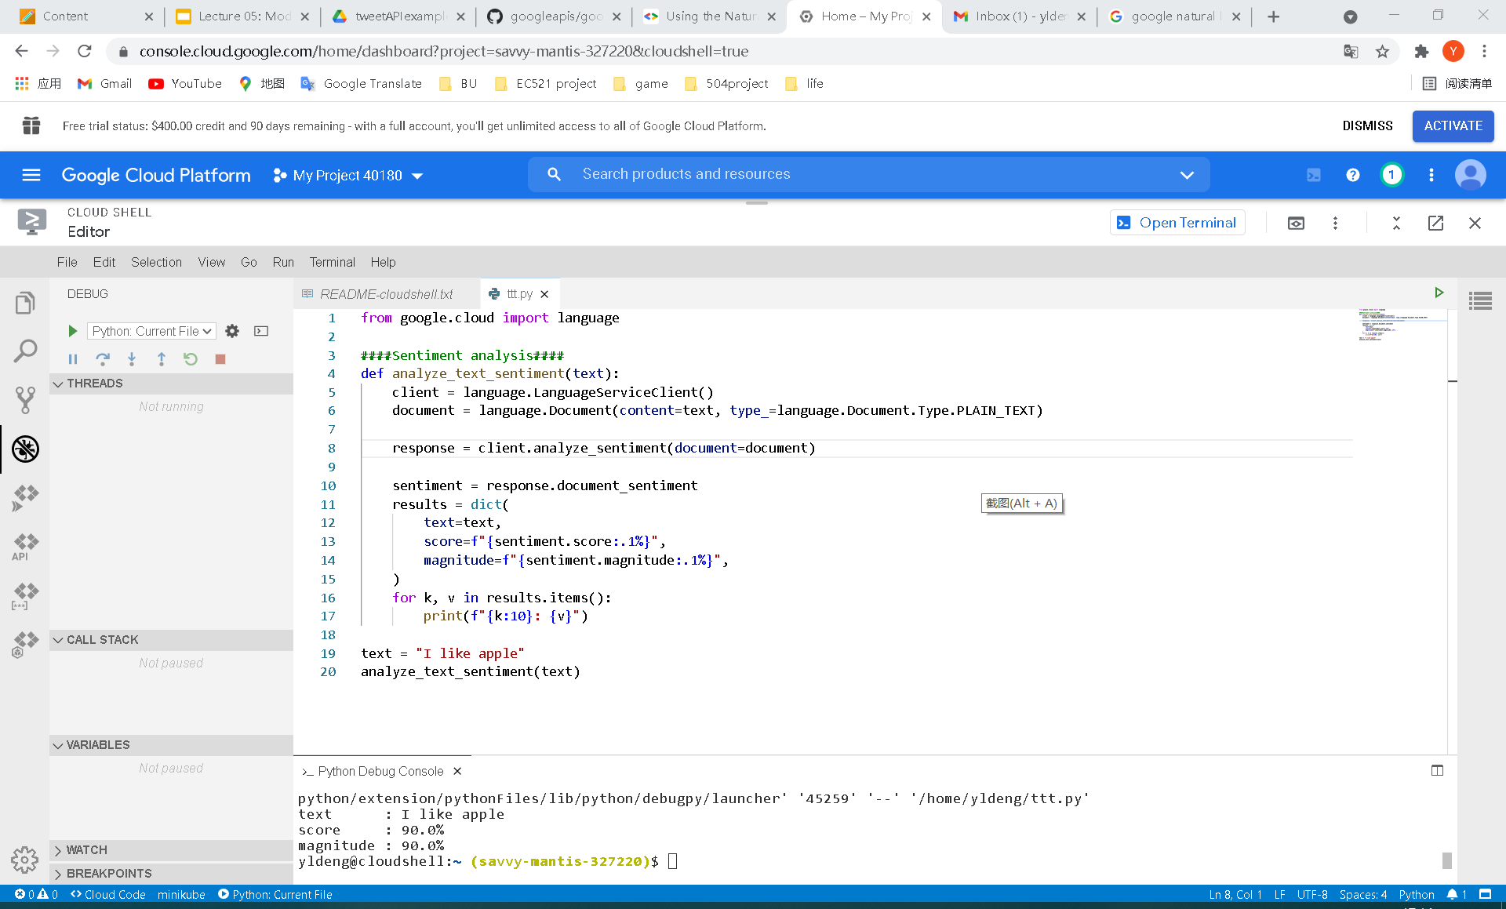
In the picture above, I send a text to the database and it sends a lot of information back. In this case, I choose sentiment analysis which can show the extent of detail of information. The more detail there are, the higher magnitude it shows. For score, it ranges from -1.0 to 1.0. The more positive text is, the higher score it shows. For example, on the contrary, I input “I do not like apple”. The score will become -80%.
- Entity analysis
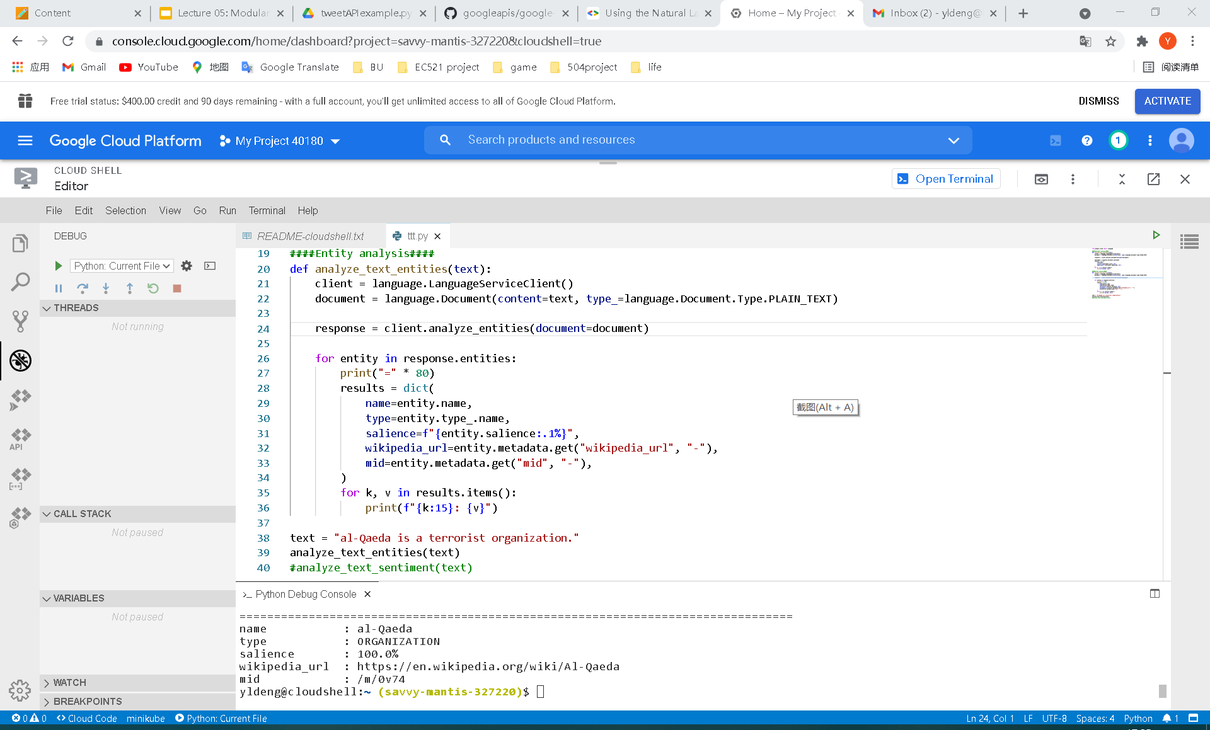
In this case, the database pick up the key word in the text and send back its attribute, including name, type, salience, wiki link, metadata. The salience means that the extent of importance of this word in the whole text and how much it will attract reader’s mind.
- Syntax analysis
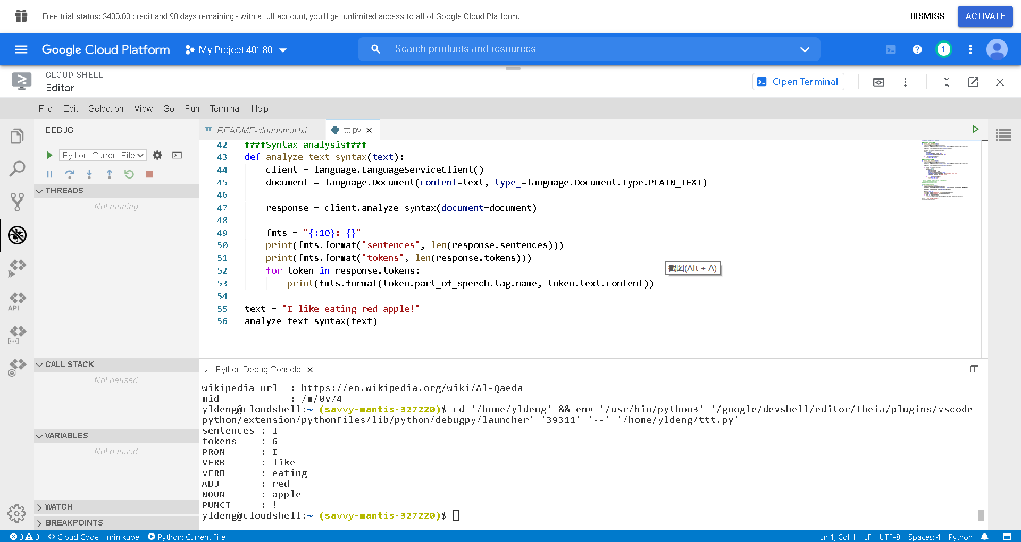
In this case, we can analyse each word and syntax in the text. The database will send back their name and type.
- Content classification
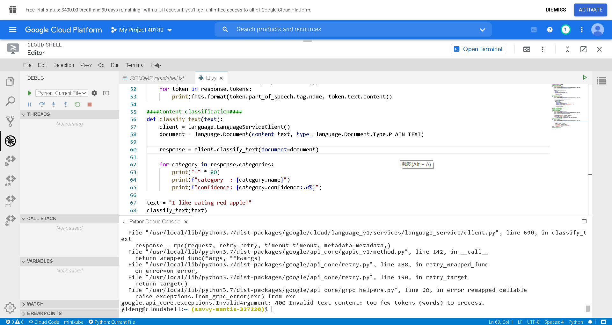
Failure test
In this case, we will send several sentences to the database. If there are not enough words being input, it will shows error, like the picture above. If success, it will send back possible category in the text and how confident the program is in this result.
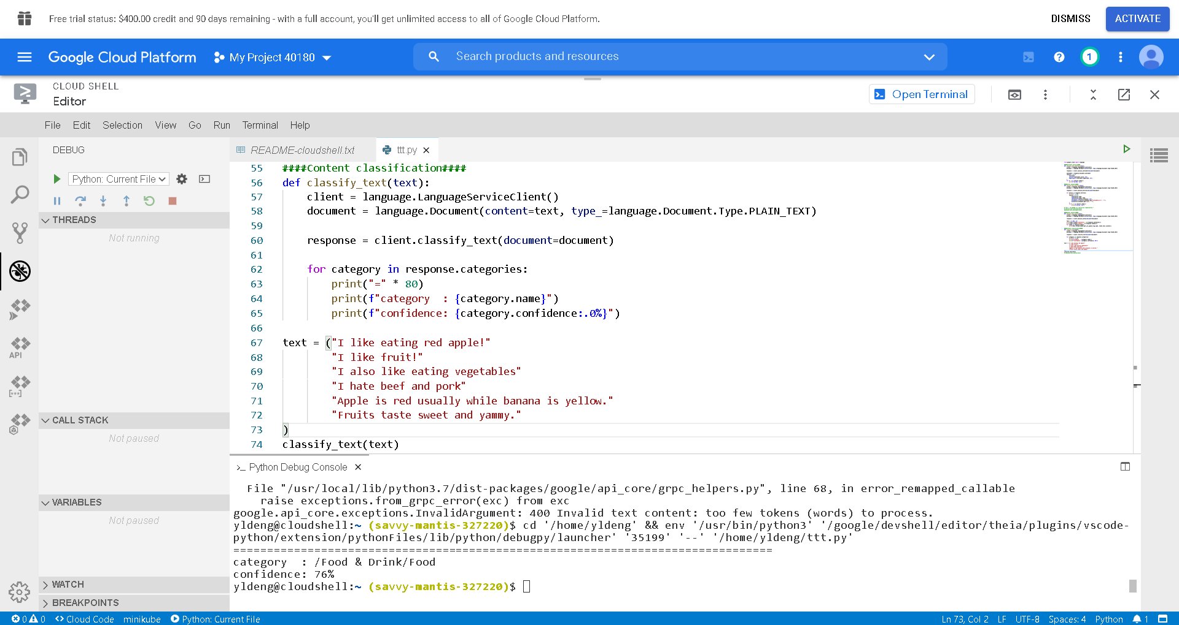
Success test

