Part 1:
This program is downloaded on the internet. It is a open source and based on a YouTube video. Most of my personal idea and modify is based on this program.
Video: https://www.youtube.com/watch?v=rfqEJpJtCzw
Program: https://github.com/Skill-Bits/twitter-api
The script under the UserBase directory allows me to get the tweet from a specific user if I know his username. I can control many elements of income information, such as the number of tweets, which part of tweets(login, logout, language, time, text, .etc) and so on. Here is the detail:
- Delete the emoji in the text. Reference:https://stackoverflow.com/a/49986645/3711660
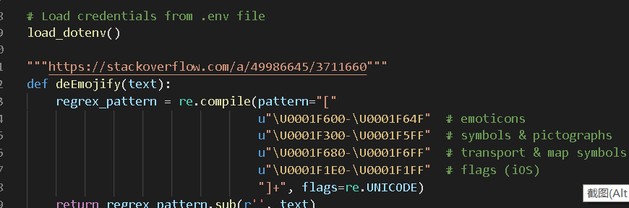
- Authenticate: Input your consumer key, consumer secret, access token, access token secret so that the program can connect with the API.
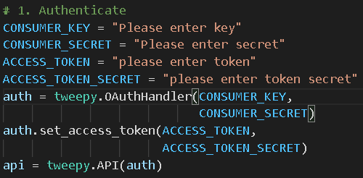
- Get data and save data: Using the function “user_timeline” can help us get the tweets of a specific user. The program choose to save it in a CSV document in utf-8 format, only save their create time and content.
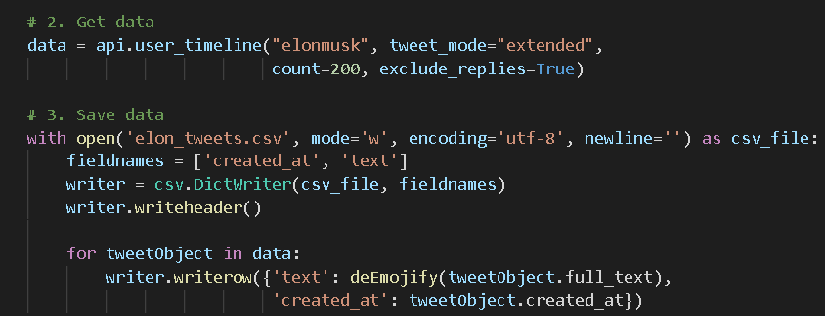
- Result:
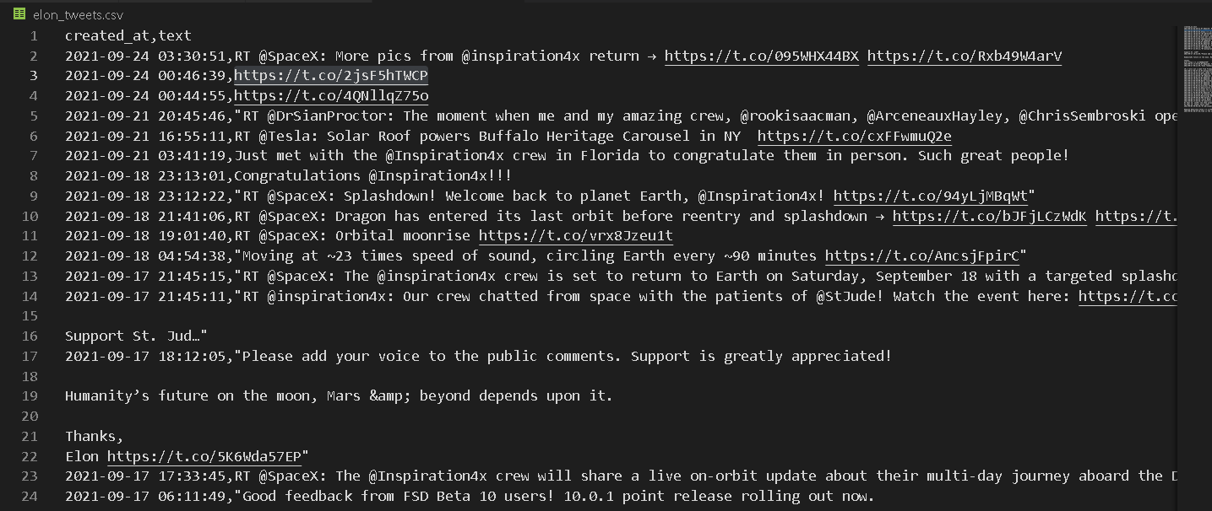

Part 2: My modify, Personal test cases
Case 2: I can get information of a specific user. The format of “user” is a Tweepy model class. The screen_name is in string. The followers_count is in int.
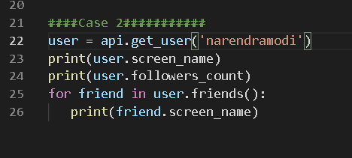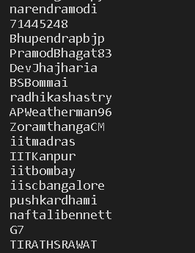
Case 4: Can only view n items or pages.
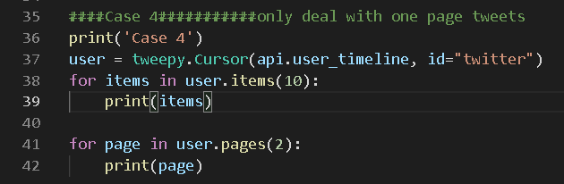

Case 5: Streaming and False.
This case aims to build a connection between the program and twitter API. The connection will not be canceled automatically unless it meets the situation you list at the beginning. For example, in the code below, if we face an error and the status code is equal to 420, the connection will be canceled.
420 means exceeding a limited number of attempts for some special part on twitter. There are also many other error code on API. It is an example.
It is also possible to set filter to the stream in order to get too much useless information. There are two examples shows in the picture below.
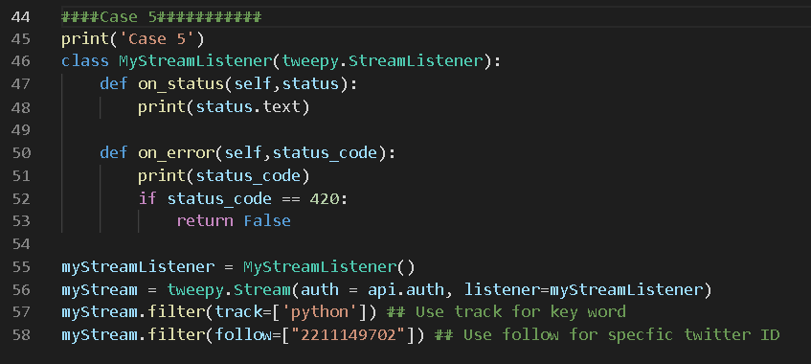

Data analysis
For the data I gotten from the twitter API, there could be a lot of ways to use. For example, if I am a twitter blogger with hundreds of thousands followers, I can use it to draw the picture of my follower, such as age, country, preferred language .etc. As a company manager, I can collect the information and feedback from my customers much easier than usual. As an ordinary twitter user, I can follow the specific topic and trends on platform whichever I like, just like choose keyword “dogs”, “cats”, “news” and so on.

