Reflection

Student Name: Lejie LIU ORCID: 0000-0002-4521-8594
Introduction
In this NAA research course, we intend to point out illustration and interpretation behind corporate decisions, specifically mergers and acquisitions (M&A) events, by means of statistical data analyzing and visualization technologies like Tableau, Python.
Method
At the begin of the research, I used an Economic and Financial Database, CSMAR, to download all the merge & acquisitions events happened in China in 2014 in form of Excel spreadsheet. In addition, I filter the spreadsheet and use the remaining Stock Symbol Code to get their ROA and ROE from 2013-2015. Next, with the great features of Excel, I did the data cleaning and preparing work. By means of Excel functions like LEFT(), FIND(), VLOOKUP() and Python pandas, numpy and re, I transform the dataset to fit the requirement of visualization tools. After dirty works in data cleaning procedure, we moved into the most important part, data visualization. I firstly use Python matplotlib and seaborn to make the charts including hist diagram, line chart, word-cloud chart and so on. In addition, with the help of teacher, I also learned the fundamental instructions and features of other powerful visualization tools, for instance, using Tableau to make an event city distribution chart with a China map under it, using Flourish to make Radar charts.

Result
Figure 1 is the Word-Cloud chart of M&A events Acquisition cities in 2014. Word-Cloud will firstly count the frequency of occurrence of every item. Moreover, this frequency determines the size of city name in the charts. In this way, the larger city name is, the more M&A events it has. According to the chart, apparently, Shenzhen, Beijing, Shanghai, Guangzhou and Hangzhou are the largest 5 city name, which indicates they have the most M&A events. Consider the economic situation of cities, those five cities have a developed economy with a larger number of listed companies. That might be one of the possible reasons of the chart. Move on to the figure 2, joint-plot chart of Return of Assets (ROA) and Return of Equity (ROE). This chart illustrates the distribution of every company’s ROA and ROE. According to the chart, most of companies have ROA in range of 0.02-0.08 and ROE in range of 0.00-0.10. Moreover, this overall chart presents a linear distribution, while Companies with a higher ROA and ROE may deviate much from this line. Figure 3 is a bar chart presents the number of M&A events of Provinces in 2014. Y axis demonstrates the provinces, while x axis refers the number of events. According to the chart, Guangdong is the city with far more M&A events, follows are Zhejiang, Jiangsu, Beijing and Shanghai, all of them have a relative more developed economy. The last one, figure 4 is a scatter-chart of every company’s ROA and ROE. In addition, these companies have been classified to five groups through a KMeans cluster model, different colors represents 5 categories.

Discussion
The ROA and ROE and acquisition city and province actually contains a large amount of information. This research is capable to well present the events province and cities, the change of companies’ stock prices. Except these results, this research is quite not enough to show all the influence of M&A events. In addition, ROA and ROE is not able to reflect whether it is a positive influence resulted by M&A event. It is suggested by Bruner that the measurement of M&A profitability should have comprehensive consideration of four aspects: Event studies, Accounting studies, Survey of executives and Clinical studies (Bruner, 2002). If the research continues to other progress, we need other data in detail, for instance, total revenue, net profit, cash flow and so on. We could try to use these data to fully present the change of company operation before and after the M&A event.

References:
Robert F. Bruner, “Does M&A Pay? A Survey of Evidence for the Decision-Maker,” Journal of applied Finance, 2002 - researchgate.net (2002): 4.
  Fig 1. Word Cloud Chart of Acquisition City | 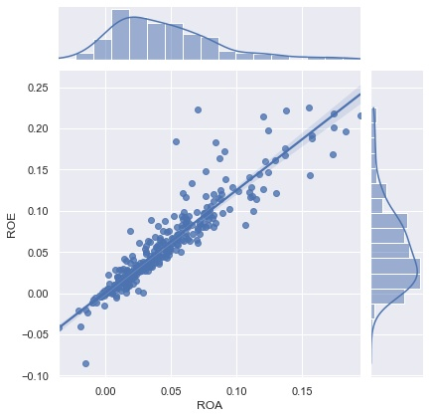  Fig 2. Jointplot chart of ROA and ROE
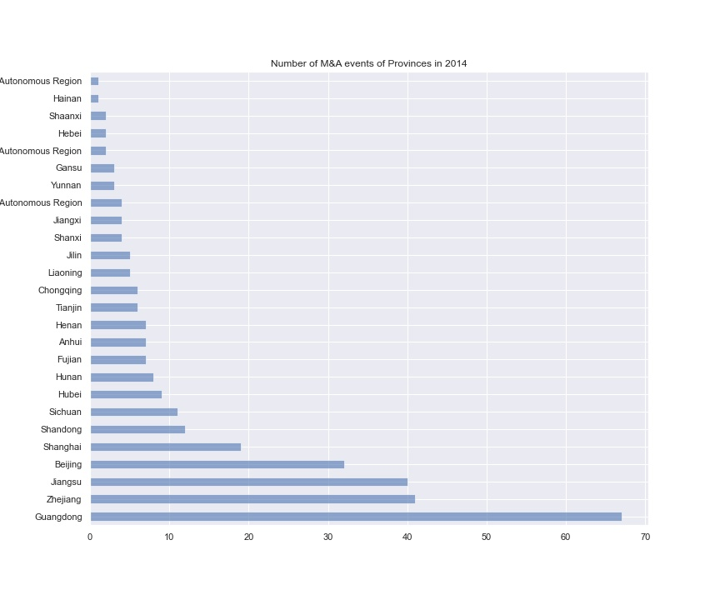  Fig 3. Number of M&A Events groupby Provinces bar chart | 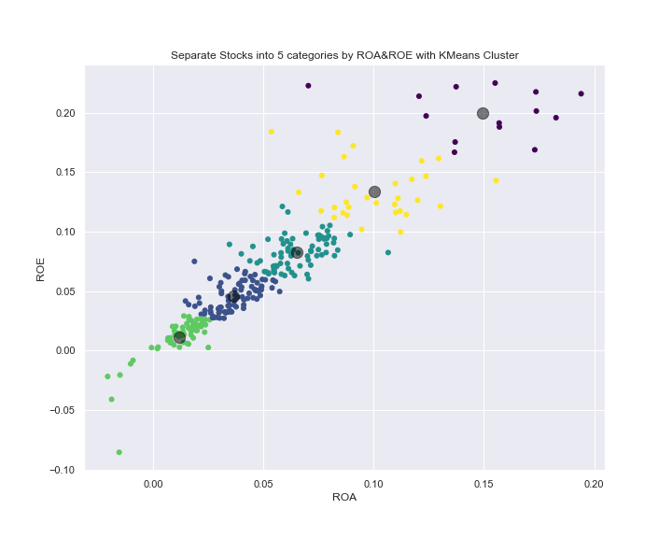  Fig 4. Using KMeans Model Classifying Events with ROA&ROE

