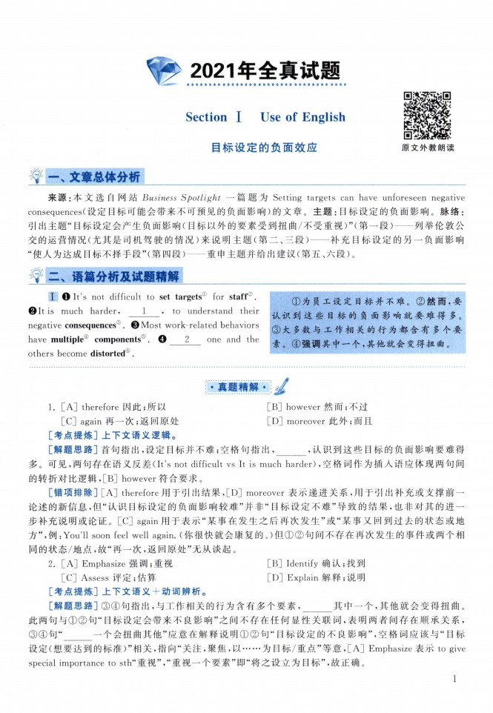
I It's not difficult to set targets' for staff®
It is much harder, 1 , to understand their
negative consequences^. ©Most work-related behaviors
have multiple^ components⑤ 2 one and the
others become distorted 0.
①为员工设定目标并不难。②然而，要 认识到这些目标的负面影响就要难得多。 ③大多数与工作相关的行为都含有多个要 素。④强调其中一个，其他就会变得扭曲。

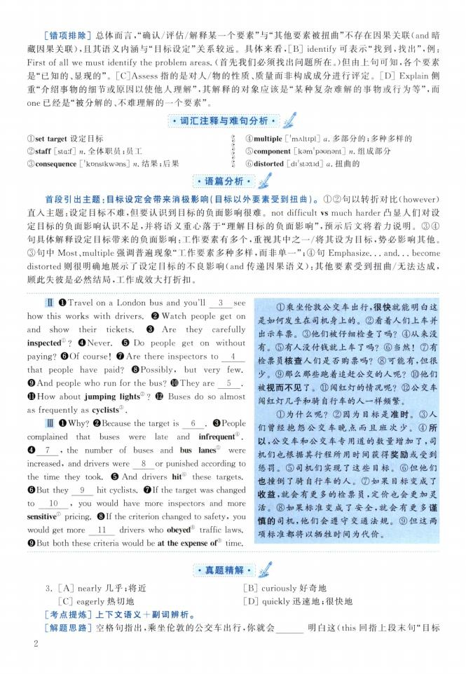
II ❶ Travel on a London bus and you'll 3 see how this works with drivers ❷ Watch people get on and show their tickets. ❸ Are they carefully inspected。？ ❹Never.Θ Do people get on without paying?Θ Of course! OAre there inspectors to 4
that people have paid? ©Possibly, but very few ❾ And people who run for the bus?❿They are 5 . (D How about jumping lights® ? © Buses do so almost as frequently as cyclists3 .
HI ❶ Why?❷ Because the target is 6 .❸ People complained that buses were late and infrequent^. ❹ 7 9 the number of buses and bus lanes were increased, and drivers were 8 or punished according to the time they took Θ And drivers hit® these targets. Θ Eut they 9 hit cyclists.❼ If the target was changed to 10 9 you would have more inspectors and more sensitive pricing. ©If the criterion changed to safety, you would get more 11 drivers who obeyed traffic laws. ❾But both these criteria would be at the expense of time.
①乘坐伦敦公交车出行，很快就能明白这 是如何发生在司机身上的。②看着人们上车并 出示车票。③他们被仔细检查了吗？④从来没 有。⑤有人没付钱就上车了吗？ ⑥当然！⑦有 检票员核查人们是否购票吗？⑧可能有，但很 少。⑨那么那些跑着追赶公交的人呢？⑩他们 被视而不见了。 闯红灯的情况呢？ 公交车 闯红灯几乎和骑自行车的人一样频繁。
①为什么呢？ ②因为目标是准时。③人 们曾经抱怨公交车晚点而且班次少。④所 以，公交车和公交车专用道的数量增加了，司 机们也根据其行程所用时间获得奖励或受到 惩罚。⑤司机们实现了这些目标。⑥但他们 也撞倒了骑自行车的人。⑦如果目标变成了 收益，就会有更多的检票员，定价也会更加灵 活。⑧如果标准变成了安全，就会有更多谨 慎的司机，他们会遵守交通法规。⑨但这两 项标准都将以牺牲时间为代价。

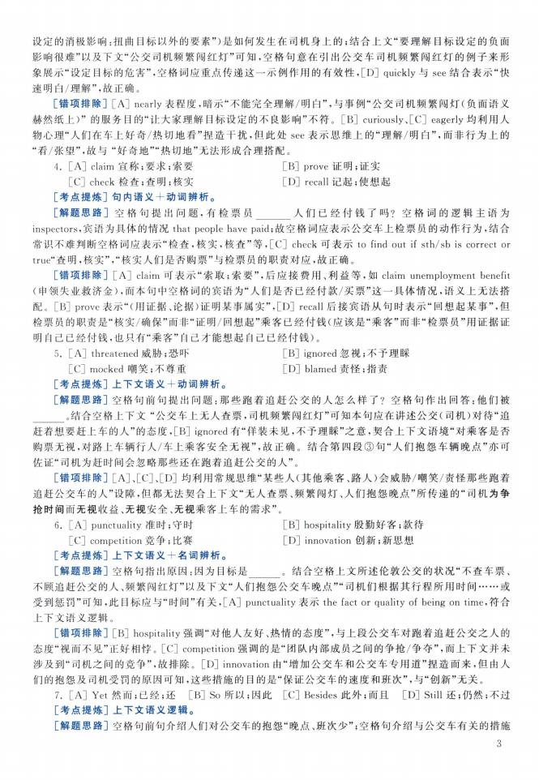

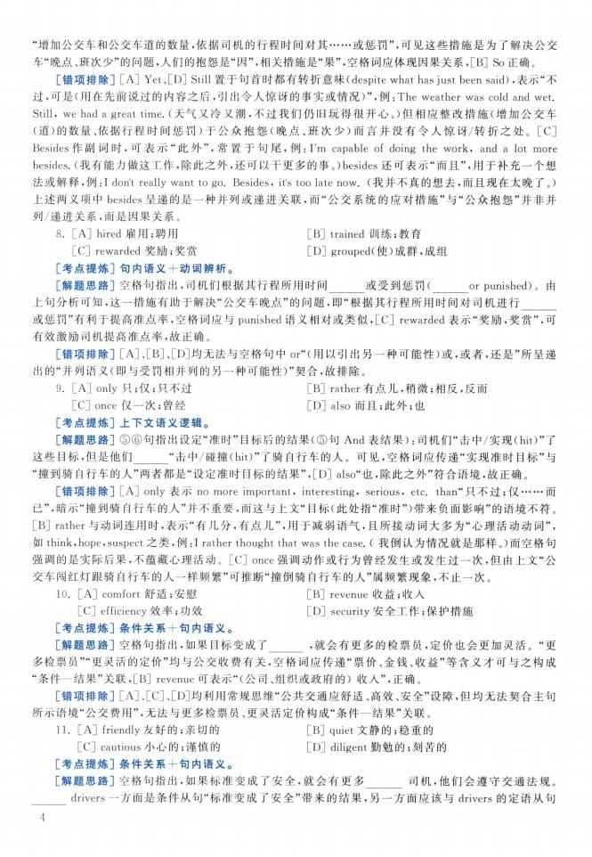

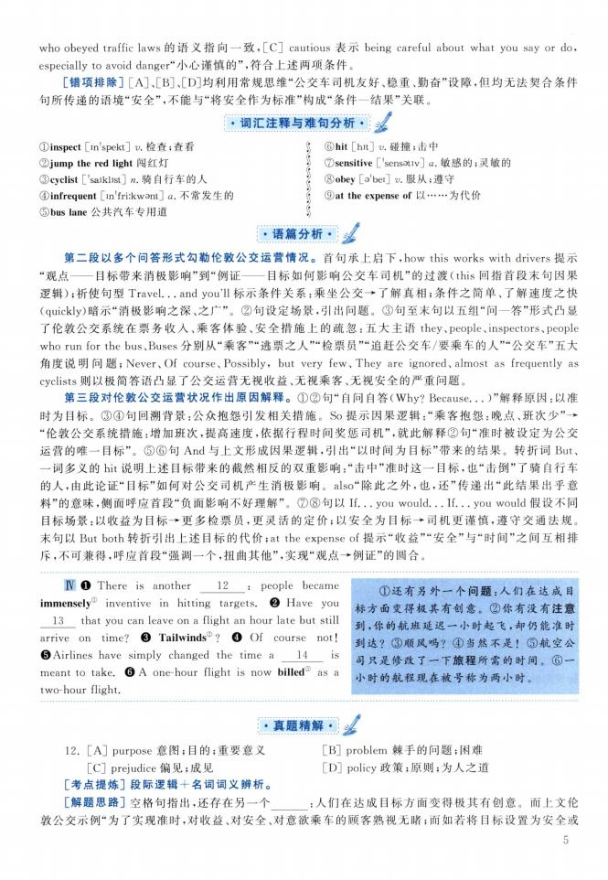
① inspect [in'spekt] v.检查；查看
②jump the red light 闯红灯
③ cyclist ['saiklist] n.骑自行车的人
④ infrequent [in'friikwant] a.不常发生的
⑤ bus lane公共汽车专用道
》 ⑥hit [hit] v.碰撞；击中
》 ⑦sensitive ['sensativ] a 敏感的；灵敏的 J ⑧obey [a'bei] v.服从；遵守
《 ⑨at the expense of以... 为代价
i
IV ❶ There is another 12 : people became
immensely© inventive in hitting targets. ❷ Have you 13 that you can leave on a flight an hour late but still arrive on time? ❸ Tailwinds® ?❹ Of course not!
©Airlines have simply changed the time a 14 is
meant to take. © A one-hour flight is now billed 9 as a two-hour flight.
①还有另外一个问题：人们在达成目 标方面变得极其有创意 。②你有没有注意 到，你的航班延迟一小时起飞，却仍能准时 到达？ ③顺风吗？④当然不是！⑤航空公 司只是修改了一下旅程所需的时间 。⑥一 小时的航程现在被号称为两小时。
12. [A] purpose意图；目的；重要意义 [C] prejudice 偏见；成见
[考点提炼]段际逻辑+名词词义辨析。
[解题思路]空格句指出，还存在另一个
[B] problem棘手的问题；困难 [D] policy政策；原则；为人之道
:人们在达成目标方面变得极其有创意 。而上文伦

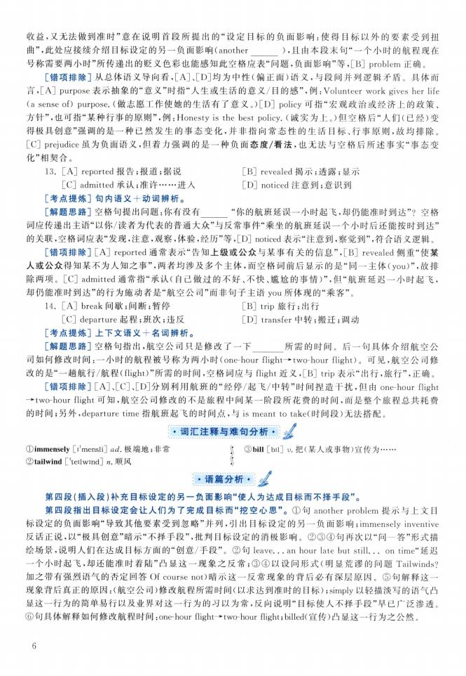

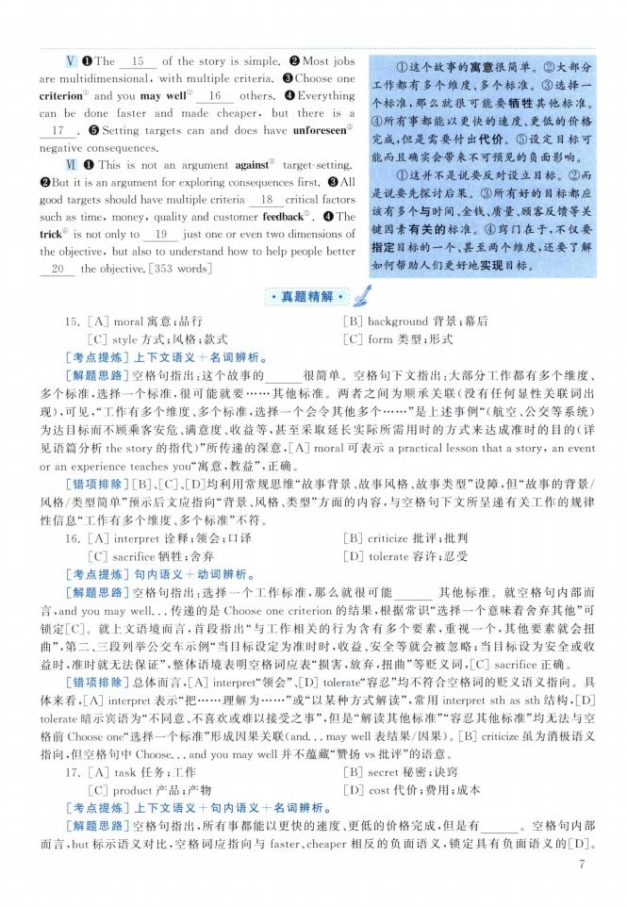
V The 15 of the story is simple. Most jobs are multidimensional, with multiple criteria ©Choose one
criterion and you may well 16 others Everything
can be done faster and made cheaper, but there is a 17 . © Setting targets can and does have unforeseen
negative consequences
VI O This is not an argument against1 target-setting. But it is an argument for exploring consequences first. ©All good targets should have multiple criteria 18 critical factors such as time, money, quality and customer feedback⑤ 0The trick is not only to 19 just one or even two dimensions of the objective9 but also to understand how to help people better 20 the objective [353 words]
①这个故事的寓意很简单。②大部分 工作都有多个维度、多个标准。③选择一 个标准，那么就很可能要牺牲其他标准。
④所有事都能以更快的速度、更低的价格 完成，但是需要付出代价。⑤设定目标可 能而且确实会带来不可预见的负面影响。
①这并不是说要反对设立目标。②而 是说要先探讨后果。③所有好的目标都应 该有多个与时间、金钱、质量、顾客反馈等关 键因素有关的标准。④窍门在于，不仅要 指定目标的一个、甚至两个维度，还要了解 如何帮助人们更好地实现目标。

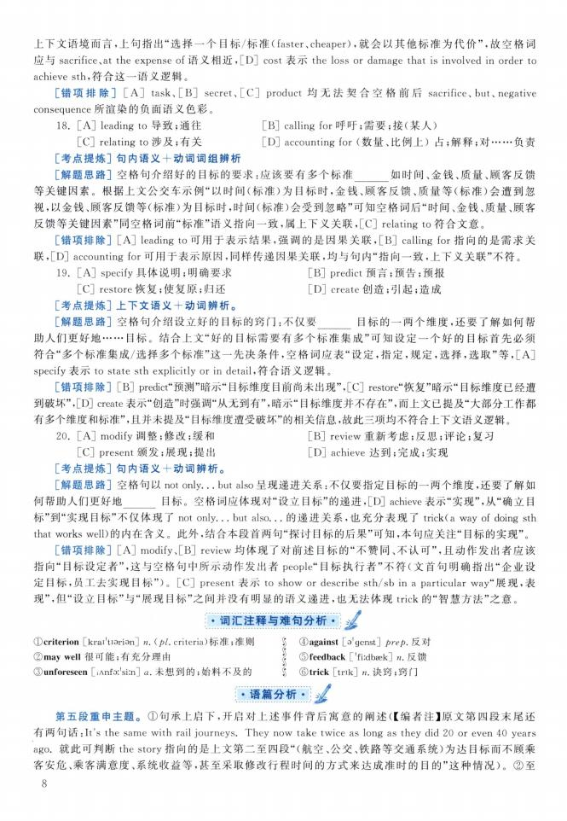

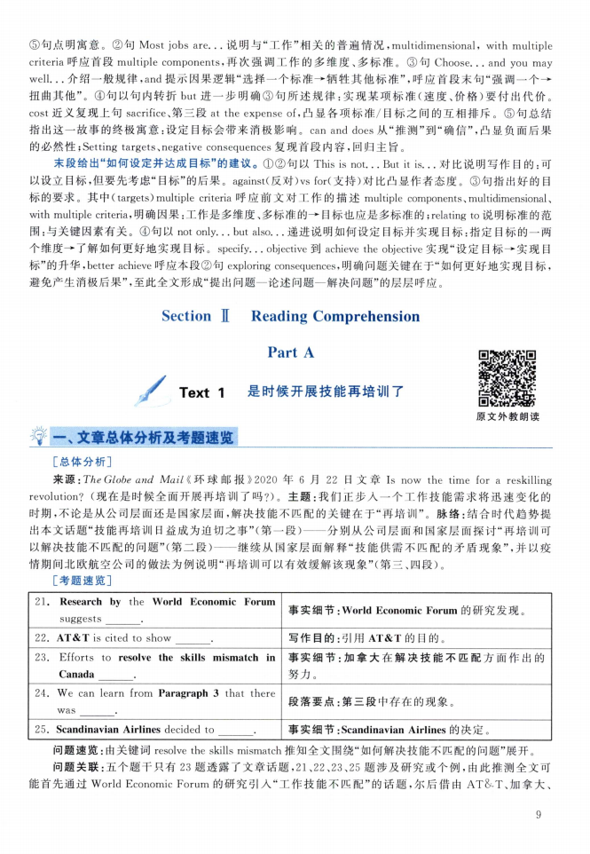
21. Research by the World Economic Forum suggests
22. AT&T is cited to show .
23. Efforts to resolve the skills mismatch in Canada .
24. We can learn from Paragraph 3 that there
was .
25. Scandinavian Airlines decided to .
事实细节:World Economic Forum的研究发现。
写作目的：引用AT&T的目的。
事实细节：加拿大在解决技能不匹配方面作出的 努力。
段落要点：第三段中存在的现象。
事实细节:Scandinavian Airlines 的决定。

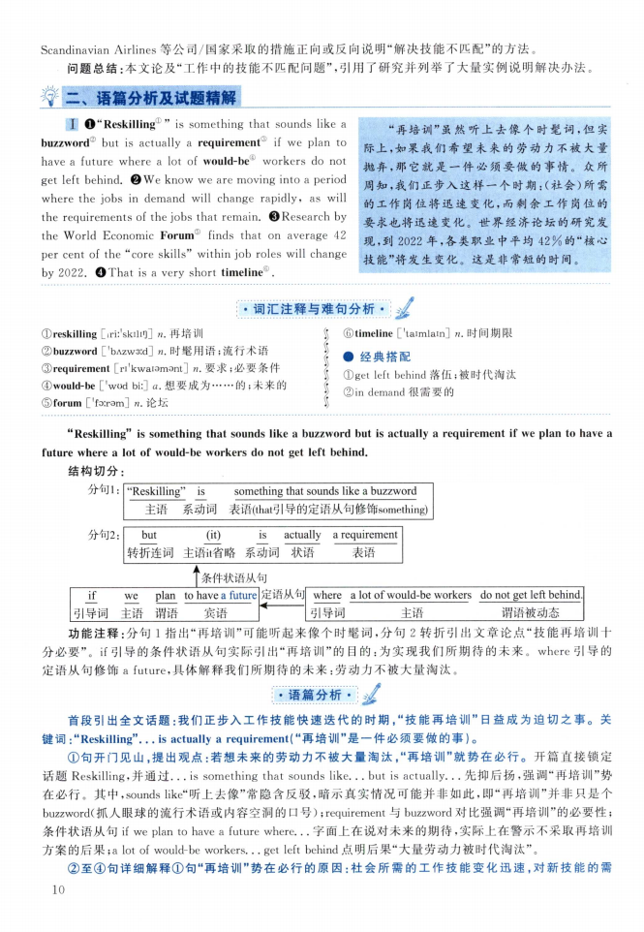
I OuReskillingis something that sounds like a buzzword② but is actually a requirement^ if we plan to have a future where a lot of would-be1 workers do not get left behind @ We know we are moving into a period where the jobs in demand will change rapidly, as will the requirements of the jobs that remain. ©Research by the World Economic Forum finds that on average 42 per cent of the“core skills" within job roles will change by 2022.❹That is a very short timeline® .
“再培训”虽然听上去像个时髦词，但实 际上，如果我们希望未来的劳动力不被大量 抛弃，那它就是一件必须要做的事情。众所 周知，我们正步入这样一个时期：（社会）所需 的工作岗位将迅速变化，而剩余工作岗位的 要求也将迅速变化。世界经济论坛的研究发 现，到2022年，各类职业中平均42%的“核心 技能”将发生变化。这是非常短的时间。
(Dreskilling [irii'skili1]] n.再培训
② buzzword ['bAzw3：d] n.时髦用语；流行术语
③ requirement [ri'kwaiamant] z? 要求；必要条件
④ would-be ['wod bi:] a.想要成为... 的；未来的
⑤ forum ['foirsm] z?•论坛
§ ⑥timeline ['taimlain] n.时间期限 I •经典搭配
j）①get left behind落伍；被时代淘汰 ' ②in demand很需要的

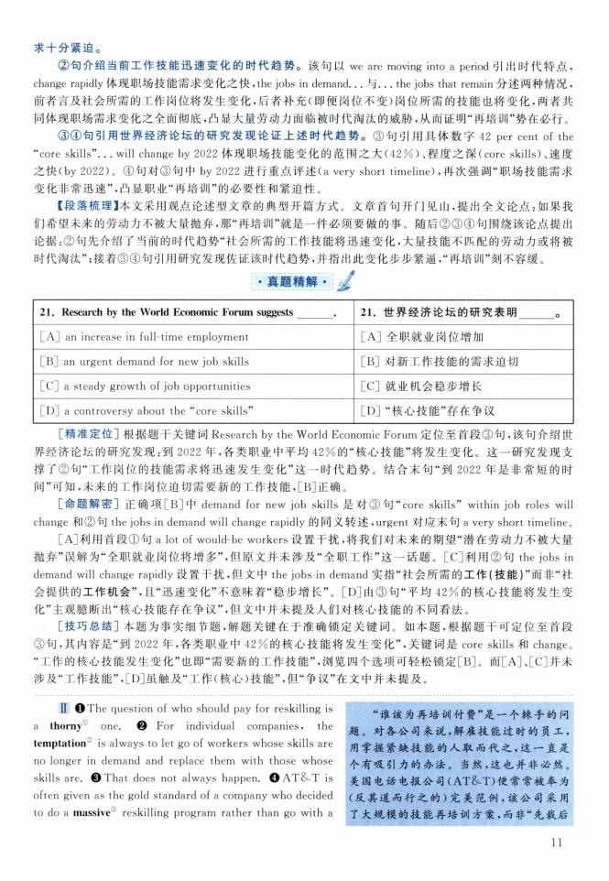
。
21. Research by the World Economic Forum suggests
21.世界经济论坛的研究表明
[A] an increase in full-time employment
［A］全职就业岗位增加
[B] an urgent demand for new job skills
［B］对新工作技能的需求迫切
[C] a steady growth of job opportunities
［C］就业机会稳步增长
[D] a controversy about the 44core skills"
［D］“核心技能”存在争议
U ❶ The question of who should pay for reskilling is a thorny1 one. ❷ For individual companies, the temptation is always to let go of workers whose skills are no longer in demand and replace them with those whose skills are.❸ That does not always happen.❹ AT&T is often given as the gold standard of a company who decided to do a massive" reskilling program rather than go with a
“谁该为再培训付费”是一个棘手的问 题。对各公司来说，解雇技能过时的员工， 用掌握紧缺技能的人取而代之，这一直是 个有吸引力的办法。 当然，这也并非必然。 美国电话电报公司（AT&T）便常常被奉为 （反其道而行之的）完美范例，该公司采用 了大规模的技能再培训方案，而非“先裁后

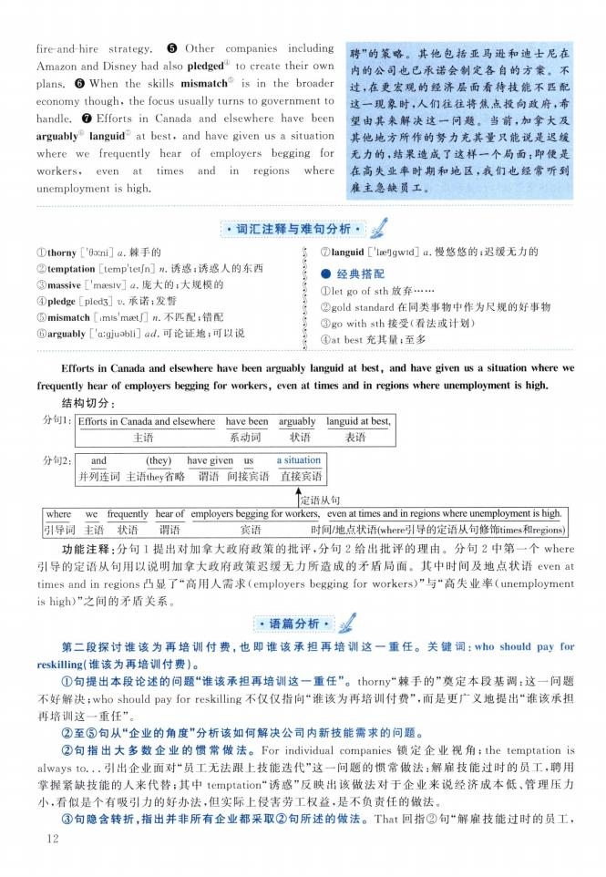
fire-and-hire strategy. Θ Other companies including Amazon and Disney had also pledged0 to create their own plans.Θ When the skills mismatch is in the broader economy though, the focus usually turns to government to handle ❼ Efforts in Canada and elsewhere have been arguably languid2^ at best, and have given us a situation where we frequently hear of employers begging for workers, even at times and in regions where unemployment is high.
聘”的策略。其他包括亚马逊和迪士尼在 内的公司也已承诺会制定各自的方案。不 过，在更宏观的经济层面看待技能不匹配 这一现象时，人们往往将焦点投向政府，希 望由其来解决这一问题。 当前，加拿大及 其他地方所作的努力充其量只能说是迟缓 无力的，结果造成了这样一个局面：即便是 在高失业率时期和地区，我们也经常听到 雇主急缺员工。
①thorny ['6□:ni] q.棘手的
©temptation [temp'teijn]刃•诱惑；诱惑人的东西
③ massive ['maesiv] a.庞大的；大规模的
④ pledge [pled3] v.承诺；发誓
⑤ mismatch [imis'maetf]克•不匹配；错配
©arguably ['aigjuobli] ad,可论证地；可以说
⑦languid ['laeOgwid] a 慢悠悠的；迟缓无力的
•经典搭配
① let go of sth 放弃...
② gold standard在同类事物中作为尺规的好事物
③ go with sth接受（看法或计划）
④ at best充其量；至多

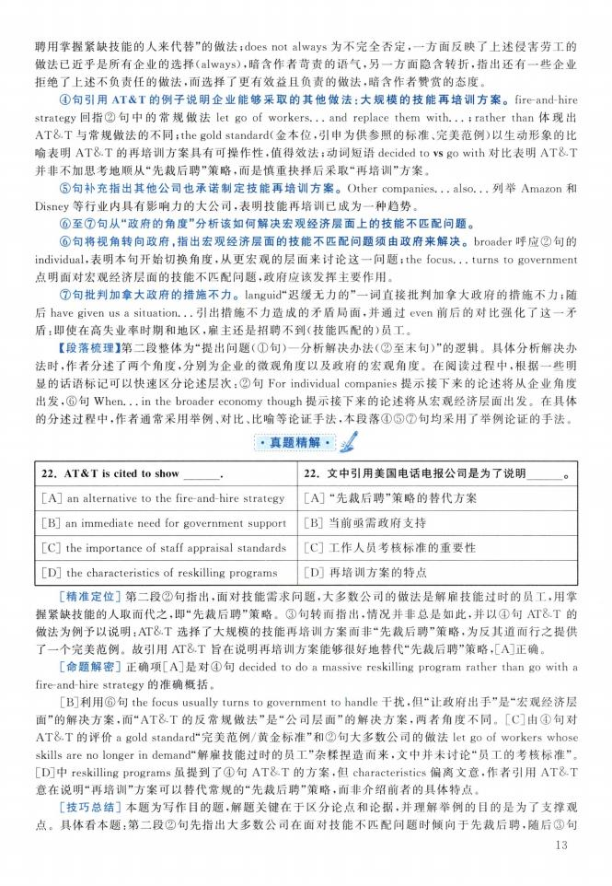

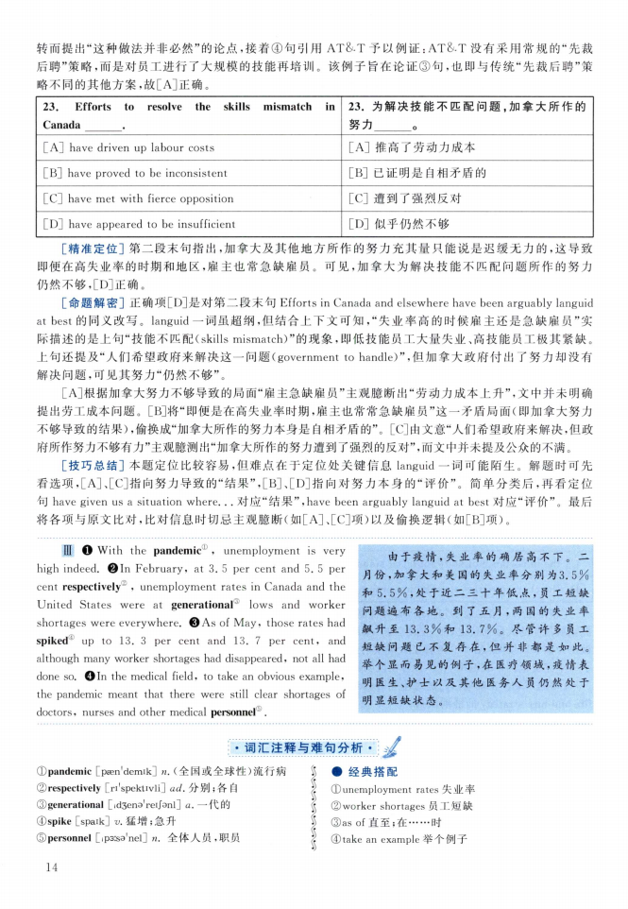

23. Efforts to resolve the skills mismatch in
Canada
[A] have driven up labour costs
[B] have proved to be inconsistent
[C] have met with fierce opposition
[D] have appeared to be insufficient
23.为解决技能不匹配问题，加拿大所作的 努力 。
［A］推高了劳动力成本
:B］已证明是自相矛盾的
［C］遭到了强烈反对
［D］似乎仍然不够
皿 With the pandemic09 , unemployment is very high indeed ❷In February, at 3. 5 per cent and 5. 5 per cent respectively②,unemployment rates in Canada and the United States were at generational lows and worker shortages were everywhere ❸As of May, those rates had spiked1 up to 13. 3 per cent and 13. 7 per cent, and although many worker shortages had disappeared, not all had done so. Oln the medical field, to take an obvious example, the pandemic meant that there were still clear shortages of doctors, nurses and other medical personnel 0
由于疫情，失业率的确居高不下。二 月份，加拿大和美国的失业率分别为3.5% 和5. 5%，处于近二三十年低点，员工短缺 问题遍布各地。到了五月，两国的失业率 飙升至13. 3%和13.7%。尽管许多员工 短缺问题已不复存在，但并非都是如此。 举个显而易见的例子，在医疗领域，疫情表 明医生、护士以及其他医务人员仍然处于 明显短缺状态。
① pandemic [paen'demik] n.（全国或全球性）流行病
② respectively [ri'spektivli] ad.分别；各自 ©generational [idsena^eijonl] q.—*代的
④ spike [spaik] 卩 猛增；急升
⑤ personnel [ip3：sa'nel] n.全体人员，职员
•经典搭配
（Dunemployment rates 失业率
② worker shortages员工短缺
③ as of直至；在... 时
④ take an example举个例子

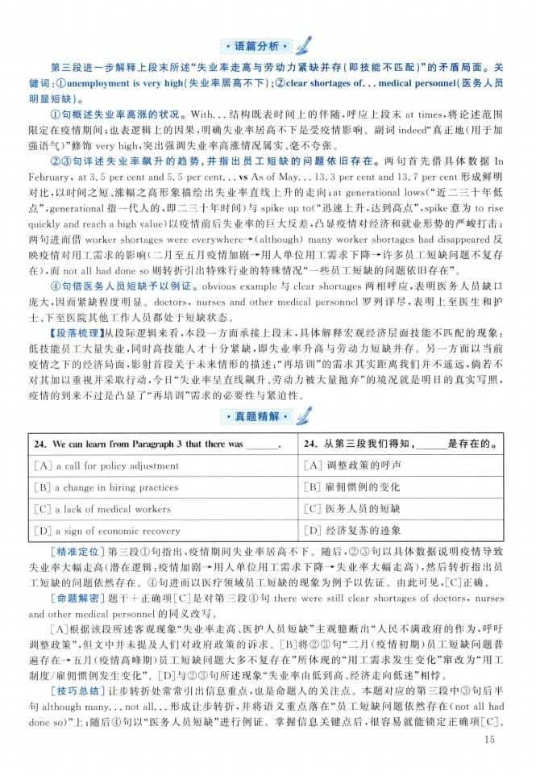

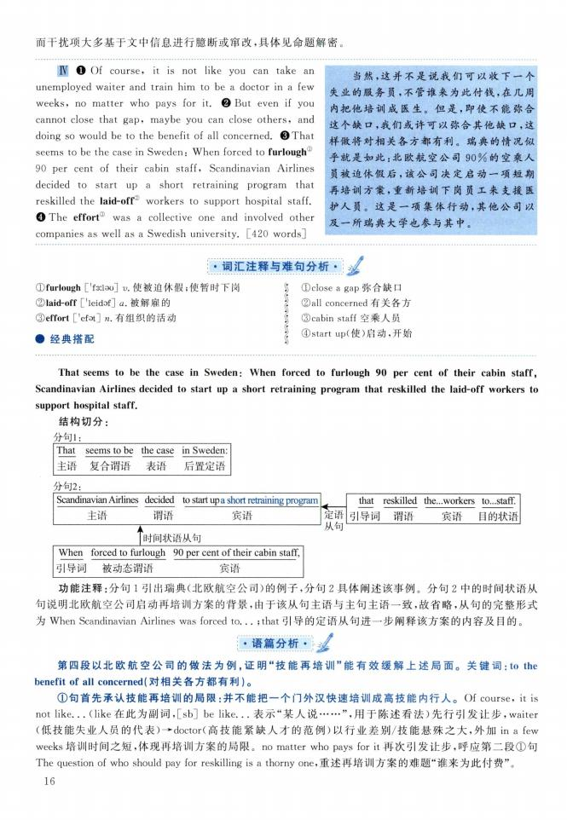
IV O Of course, it is not like you can take an unemployed waiter and train him to be a doctor in a few weeks > no matter who pays for it. ❷ But even if you cannot close that gap, maybe you can close others, and doing so would be to the benefit of all concerned ©That seems to be the case in Sweden：When forced to furlough① 90 per cent of their cabin staff, Scandinavian Airlines decided to start up a short retraining program that reskilled the laid-off® workers to support hospital staff ❹ The effort③ was a collective one and involved other companies as well as a Swedish university. [420 wordsj
当然，这并不是说我们可以收下一个 失业的服务员，不管谁来为此付钱，在几周 内把他培训成医生。但是，即使不能弥合 这个缺口，我们或许可以弥合其他缺口，这 样做将对相关各方都有利。瑞典的情况似 乎就是如此：北欧航空公司90%的空乘人 员被迫休假后，该公司决定启动一项短期 再培训方案，重新培训下岗员工来支援医 护人员。这是一项集体行动，其他公司以 及一所瑞典大学也参与其中。
① furlough ['f3：lau] 使被迫休假；使暂时下岗
② laid-off ['leidof] a.被解雇的
③ effort ['efat] n.有组织的活动
•经典搭配
》 ①close a gap弥合缺口
J ②all concerned有关各方 j ③cabin staff空乘人员
|④start up（使）启动，开始

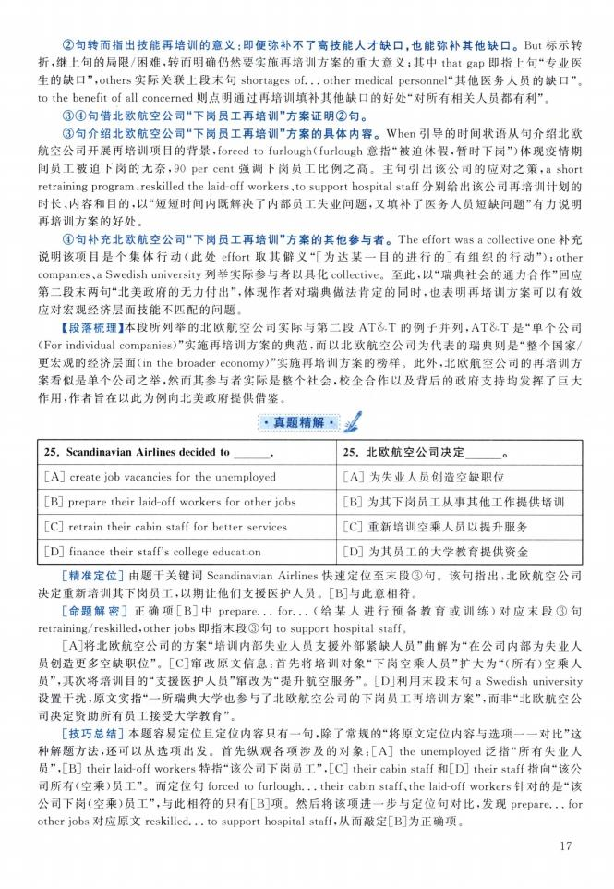
25 Scandinavian Airlines decided to .
[A] create job vacancies for the unemployed
[E] prepare their laid-off workers for other jobs
[C] retrain their cabin staff for better services
[D] finance their staff's college education
25.北欧航空公司决定 。
:A］为失业人员创造空缺职位
［B］为其下岗员工从事其他工作提供培训
［C］重新培训空乘人员以提升服务
:D］为其员工的大学教育提供资金

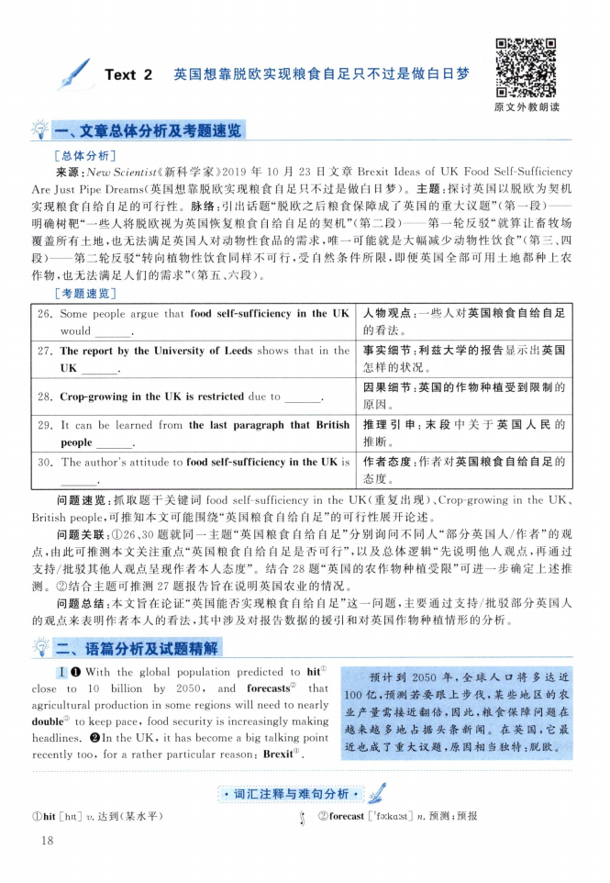
I With the global population predicted to hit1 close to 10 billion by 2050, and forecasts" that agricultural production in some regions will need to nearly double® to keep pace, food security is increasingly making headlines 01n the UK, it has become a big talking point recently too, for a rather particular reason：Brexitu).
预计到2050年，全球人口将多达近 100亿，预测若要跟上步伐，某些地区的农 业产量需接近翻倍，因此，粮食保障问题在 越来越多地占据头条新闻。在英国，它最 近也成了重大议题，原因相当独特：脱欧。

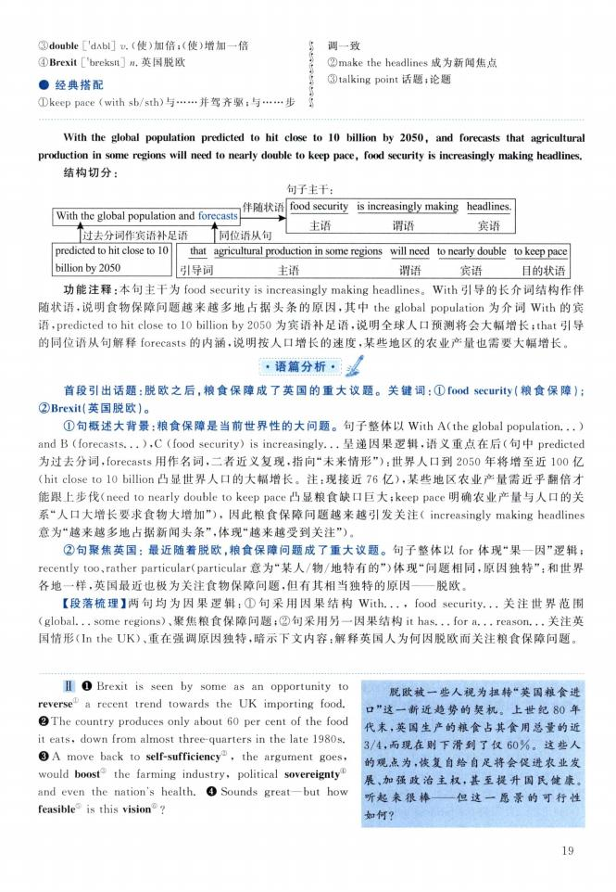
③ double ['dAbi] v.（使）加倍；（使）增加一倍
④ Brexit ['breksit] n.英国脱欧
•经典搭配
①keep pace（with sb/sth）与... 并驾齐驱；与
》 调一致
? ②make the headlines成为新闻焦点
《 ③talking point话题；论题 步S
II O Brexit is seen by some as an opportunity to reverse1 a recent trend towards the UK importing food. ❷The country produces only about 60 per cent of the food it eats, down from almost three-quarters in the late 1980s. © A move back to self-sufficiency©, the argument goes, would boost! the farming industry, political sovereignty® and even the nation's health. ❹ Sounds great一but how feasible is this vision ?
脱欧被一些人视为扭转“英国粮食进 口”这一新近趋势的契机。上世纪80年 代末，英国生产的粮食占其食用总量的近 3/4,而现在则下滑到了仅60%。这些人 的观点为，恢复自给自足将会促进农业发 展、加强政治主权，甚至提升国民健康。 听起来很棒----但这一愿景的可行性 如何？

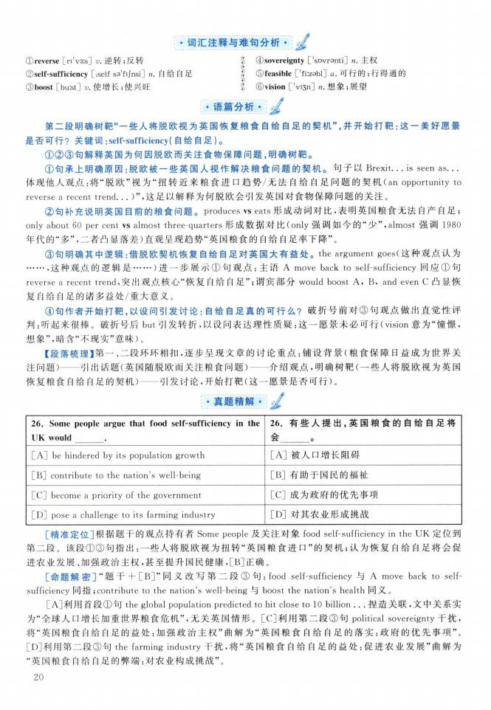

26. Some people argue that food self-sufficiency in the
UK would
[A] be hindered by its population growth
[B] contribute to the nation's well-being
[C] become a priority of the government
[D] pose a challenge to its farming industry
26.有些人提出，英国粮食的自给自足将 会 O
[A]被人口增长阻碍
[B]有助于国民的福祉
[C]成为政府的优先事项
[D]对其农业形成挑战

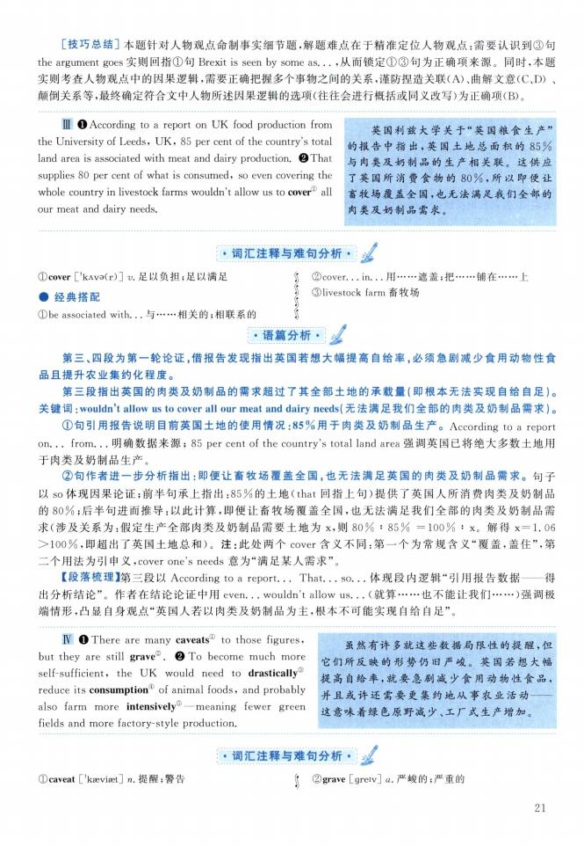
HI O According to a report on UK food production from the University of Leeds, UK, 85 per cent of the country's total land area is associated with meat and dairy production. ❷ That supplies 80 per cent of what is consumed, so even covering the whole country in livestock farms wouldn't allow us to cover" all our meat and dairy needs.
英国利兹大学关于“英国粮食生产” 的报告中指出，英国土地总面积的85% 与肉类及奶制品的生产相关联。这供应 了英国所消费食物的80% ,所以即便让 畜牧场覆盖全国，也无法满足我们全部的 肉类及奶制品需求。
W O There are many caveats① to those figures, but they are still grave3. ❷ To become much more self-sufficient, the UK would need to drastically③ reduce its consumption 1 of animal foods, and probably also farm more intensively^—meaning fewer green fields and more factory-style production.
虽然有许多就这些数据局限性的提醒，但 它们所反映的形势仍旧严峻。英国若想大幅 提高自给率，就要急剧减少食用动物性食品， 并且或许还需要更集约地从事农业活动-
这意味着绿色原野减少、工厂式生产增加。

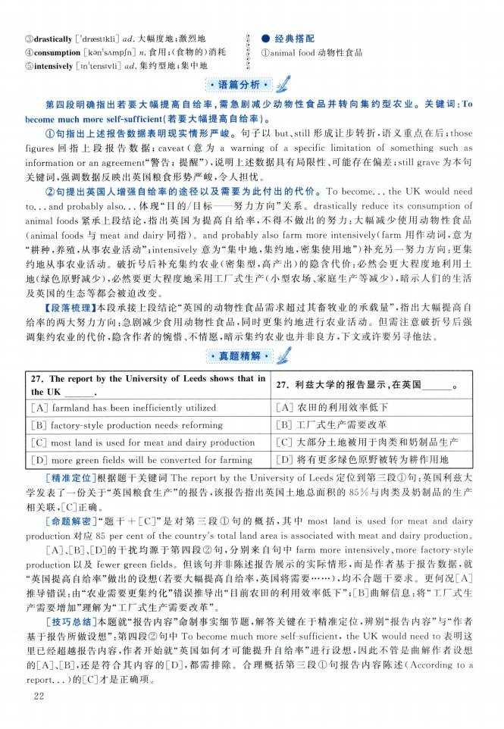

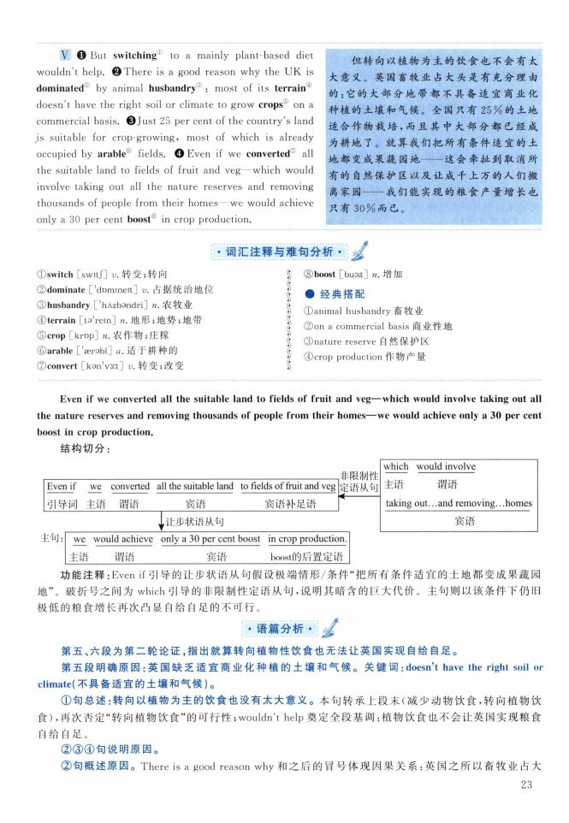
V O But switching1 to a mainly plant-based diet wouldn't help. ©There is a good reason why the UK is dominated by animal husbandry D : most of 让s terrainD doesn't have the right soil or climate to grow crops on a commercial basis ©Just 25 per cent of the country's land .is suitable for crop-growing, most of which is already occupied by arable' fields. ❹ Even if we converted ; all the suitable land to fields of fruit and veg一which would involve taking out all the nature reserves and removing thousands of people from their homes一we would achieve only a 30 per cent boost® in crop production.
但转向以植物为主的饮食也不会有太 大意义。英国畜牧业占大头是有充分理由 的：它的大部分地带都不具备适宜商业化 种植的土壤和气候。全国只有25%的土地 适合作物栽培，而且其中大部分都已经成 为耕地了。就算我们把所有条件适宜的土 地都变成果蔬园地—这会牵扯到取消所 有的自然保护区以及让成千上万的人们搬 离家园—我们能实现的粮食产量增长也 只有30%而已。
① switch [switj] u 转变；转向
② dominate ['domineit] v. 占据统治地位
③ husbandry『hAzbandri] n.农牧业
④ terrain [to1rein] zz.地形；地势；地带
⑤ crop [krop] n.农作物；庄稼 ©arable ['aerobl] a.适于耕种的
⑦convert [kon'v31] v.转变；改变
$ ⑧boost [burst] "•增加 I •经典搭配
? (Danimal husbandry 畜牧业
J ②on a commercial basis 商业性地 j ③nature reserve自然保护区
》 ④crop production作物产量

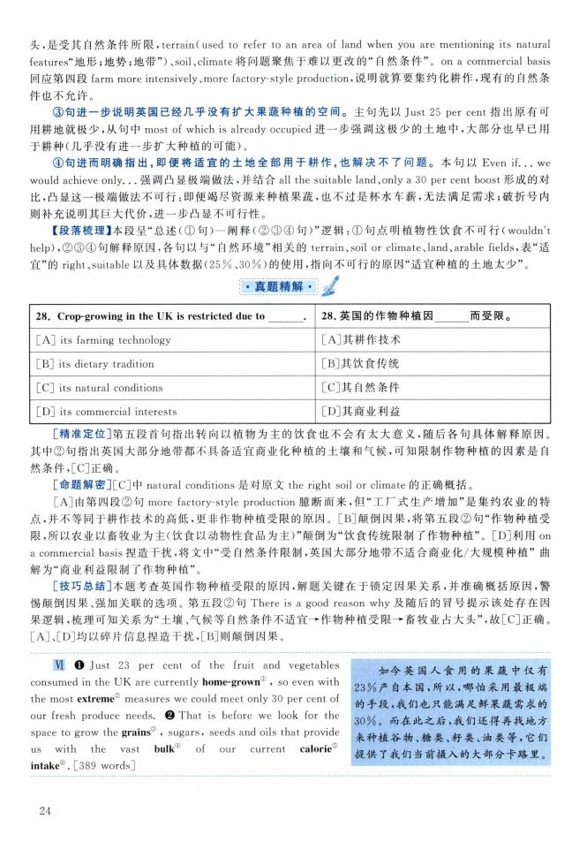
VI O Just 23 per cent of the fruit and vegetables consumed in the UK are currently home-grown11 , so even with the most extreme measures we could meet only 30 per cent of our fresh produce needs. ❷ That is before we look for the space to grow the grains® , sugars, seeds and oils that provide us with the vast bulk® of our current calorie^ intake®. [389 words]
如今英国人食用的果蔬中仅有 23%产自本国，所以，哪怕采用最极端 的手段，我们也只能满足鲜果蔬需求的 30%。而在此之后，我们还得再找地方 来种植谷物、糖类、籽类、油类等，它们 提供了我们当前摄入的大部分卡路里。

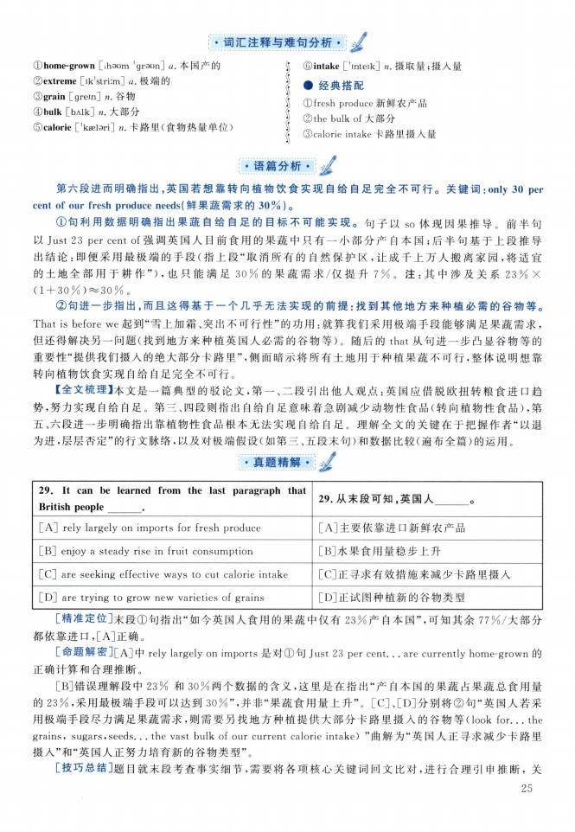
①home-grown [ihsom 'graon] a.本国产的 ©extreme [ik'striim] a.极端的
③ grain [grein]九•谷物
④ bulk [bAlk] n.大部分
⑤ calorie ['kaelari] n.卡路里（食物热量单位）
§ ⑥intake [Unteik] n.摄取量；摄入量 I •经典搭配
$ ①fresh produce新鲜农产品
z ②the bulk of大部分
j ③calorie intake卡路里摄入量

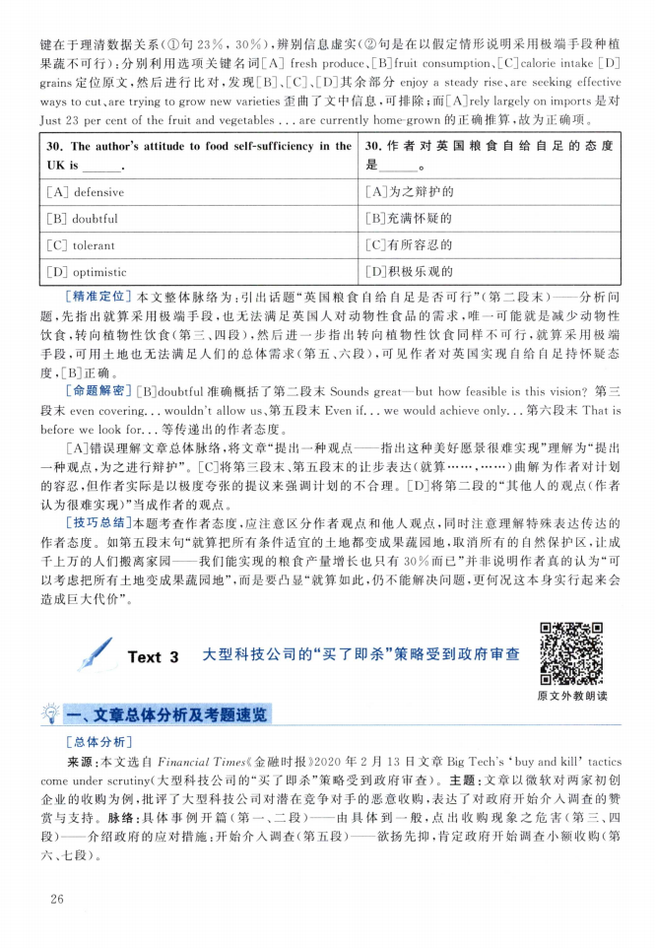

30. The author^s attitude to food self-sufficiency in the
UK is
[A] defensive
[E] doubtful
[C] tolerant
[D] optimistic
30•作者对英国粮食自给自足的态度 是 O
［A］为之辩护的
［B］充满怀疑的
［C］有所容忍的
［D］积极乐观的

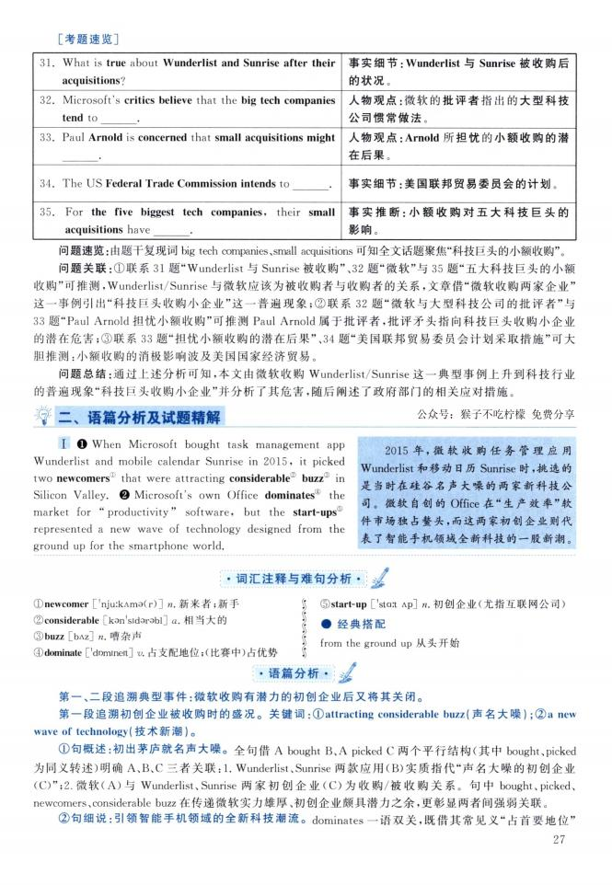
I O When Microsoft bought task management app Wunderlist and mobile calendar Sunrise in 2015 9 it picked two newcomers1 that were attracting considerable2 buzz in Silicon Valley.❷ Microsoft's own Office dominates④ the market for "productivity” software, but the start-ups represented a new wave of technology designed from the ground up for the smartphone world
•词汇注释与难句分析
2015年，微软收购任务管理应用 Wunderlist和移动日历Sunrise时彳挑选的 是当时在硅谷名声大噪的两家新科技公 司。微软自创的Office在“生产效率”软 件市场独占鳌头，而这两家初创企业则代 表了智能手机领域全新科技的一股新潮。

2
① newcomer ['njuikAma(r)] n.新来者；新手
② considerable [kon'sidarobl] a.相 当大的
③ buzz [bAz] n.嘈杂声
④ dominate ['domineit] v. 占支配地位;(比赛中)占优势
》 ⑤start-up ['sta:t Ap] n.初创企业（尤指互联网公司） I •经典搭配
》 from the ground up从头开始

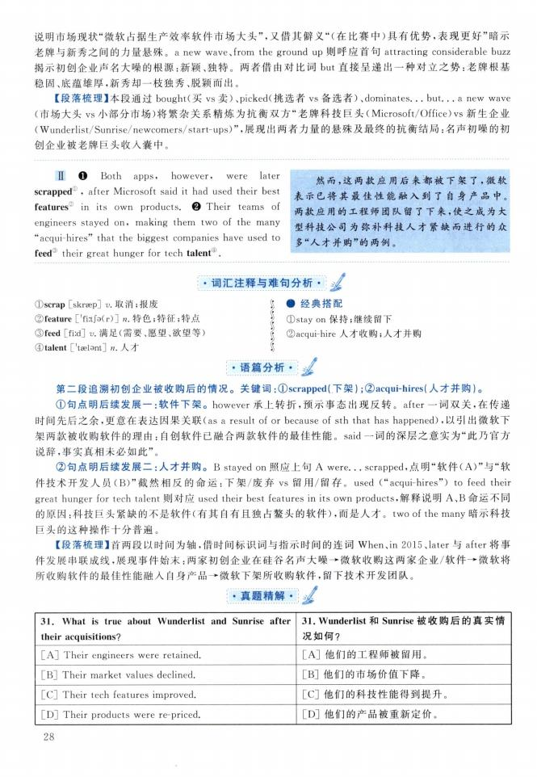
II O Both apps, however, were later scrapped , after Microsoft said it had used their best features in its own products ❷ Their teams of engineers stayed on, making them two of the many "acqui-hires" that the biggest companies have used to feed" their great hunger for tech talentD.
然而，这两款应用后来都被下架了，微软 表示已将其最佳性能融入到了自身产品中。 两款应用的工程师团队留了下来，使之成为大 型科技公司为弥补科技人才紧缺而进行的众 多“人才并购”的两例。

31. What is true about Wunderlist and Sunrise after
their acquisitions?
[A] Their engineers were retained
[B] Their market values declined
[C] Their tech features improved
[D] Their products were re-priced.
31. Wunderlist和Sunrise被收购后的真实情 况如何？
[A]他们的工程师被留用。
[B]他们的市场价值下降。
[C]他们的科技性能得到提升。
[D]他们的产品被重新定价。

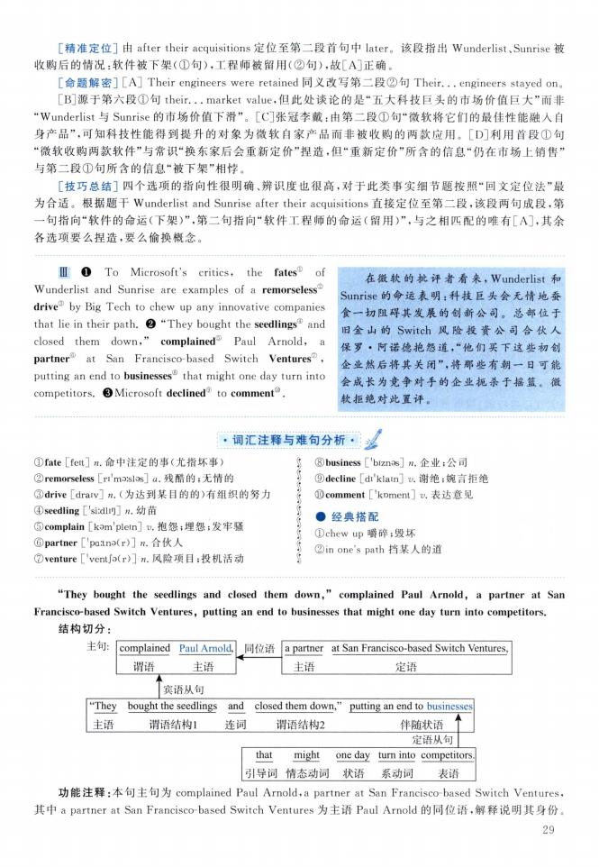
DI ❶ To Microsoft's critics, the fates' of Wunderlist and Sunrise are examples of a remorseless® drive® by Big Tech to chew up any innovative companies that lie in their path. ❷ **They bought the seedlings' and closed them down," complained Paul Arnold, a partner at San Francisco-based Switch Ventures ', putting an end to businesses8, that might one day turn into competitors. ©Microsoft declined ' to comment".
在微软的批评者看来，Wunderlist和 Sunrise的命运表明:科技巨头会无情地蚕 食一切阻碍其发展的创新公司。总部位于 旧金山的Switch风险投 资公司 合伙人 保罗 •阿诺德抱怨道，“他们买下这些初创 企业然后将其关闭”，将那些有朝一日可能 会成长为竞争对手的企业扼杀于摇篮。微 软拒绝对此置评。
① fate [feit] z命中注定的事（尤指坏事）
② remorseless [ri'mDislas] a.残酷的；无情的
③ drive [draiv] n.（为达到某目的的）有组织的努力
④ seedling ['siidlio]九.幼苗
©complain [kam'plein] p•抱怨；埋怨；发牢骚 ©partner ['pa^nsCr）] n.合伙人
⑦venture ['ventfaCr）] n.风险项目；投机活动
$ ⑧business『biznos] n.企业；公司
| ⑨decline [di'klain] v.谢绝；婉言拒绝 《 ⑩comment ['koment] v.表达意见
I •经典搭配
j ①chew up嚼碎；毁坏
$ ②in one's path挡某人的道

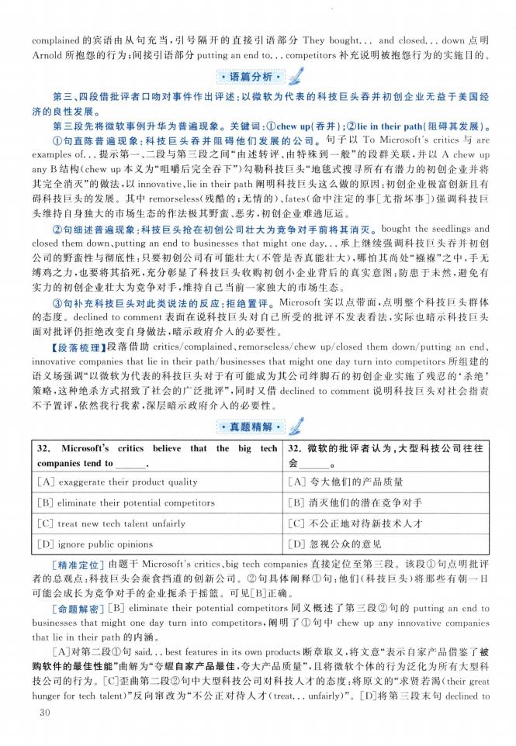

32. Microsoft^ critics believe that the big tech
companies tend to
[A] exaggerate their product quality
[B] eliminate their potential competitors
[C] treat new tech talent unfairly
[D] ignore public opinions
32.微软的批评者认为，大型科技公司往往 会 O
［A］夸大他们的产品质量
:B］消灭他们的潜在竞争对手
［C］不公正地对待新技术人才
［D］忽视公众的意见

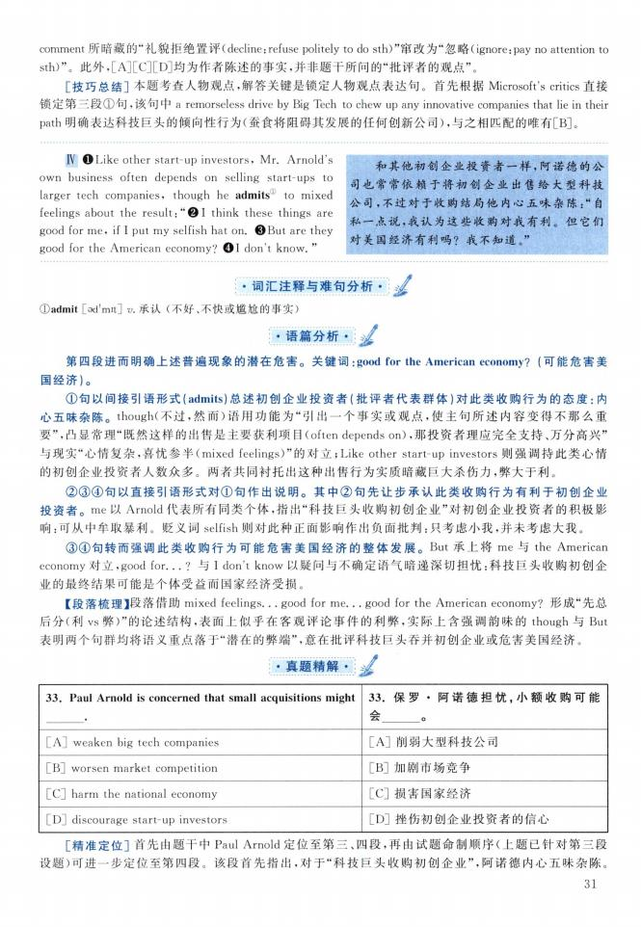
W ❶Like other start-up investors, Mr. Arnold's own business often depends on selling start-ups to larger tech companies, though he admits1 to mixed feelings about the result：u 0 I think these things are good for me, if I put my selfish hat on. ©But are they good for the American economy?❹I don't know ”
和其他初创企业投资者一样，阿诺德的公 司也常常依赖于将初创企业出售给大型科技 公司9不过对于收购结局他内心五味杂陈：“自 私一点说，我认为这些收购对我有利。但它们 对美国经济有利吗？我不知道。”

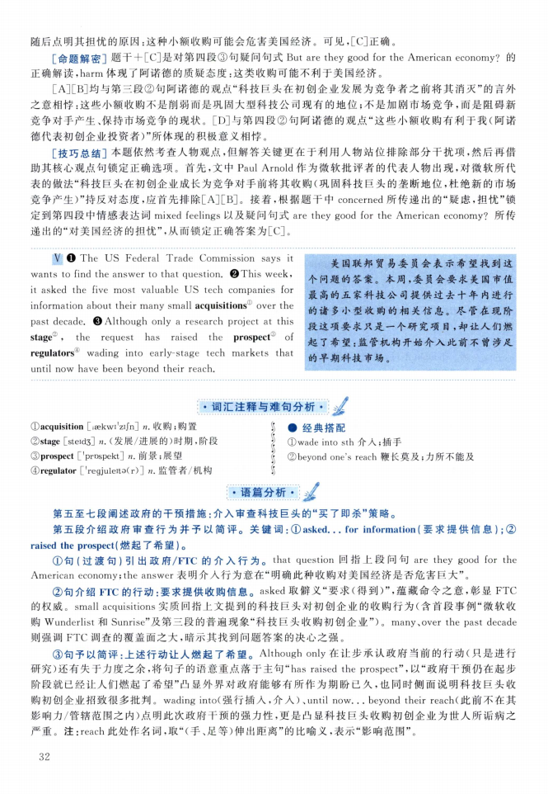
V The US Federal Trade Commission says it wants to find the answer to that question. ❷This week, it asked the five most valuable US tech companies for information about their many small acquisitions 0 over the past decade. © Although only a research project at this stage , the request has raised the prospect of regulators11 wading into early-stage tech markets that until now have been beyond their reach.
美国联邦贸易委员会表示希望找到这 个问题的答案。本周，委员会要求美国市值 最高的五家科技公司提供过去十年内进行 的诸多小型收购的相关信息。尽管在现阶 段这项要求只是一个研究项目，却让人们燃 起了希望：监管机构开始介入此前不曾涉足 的早期科技市场。

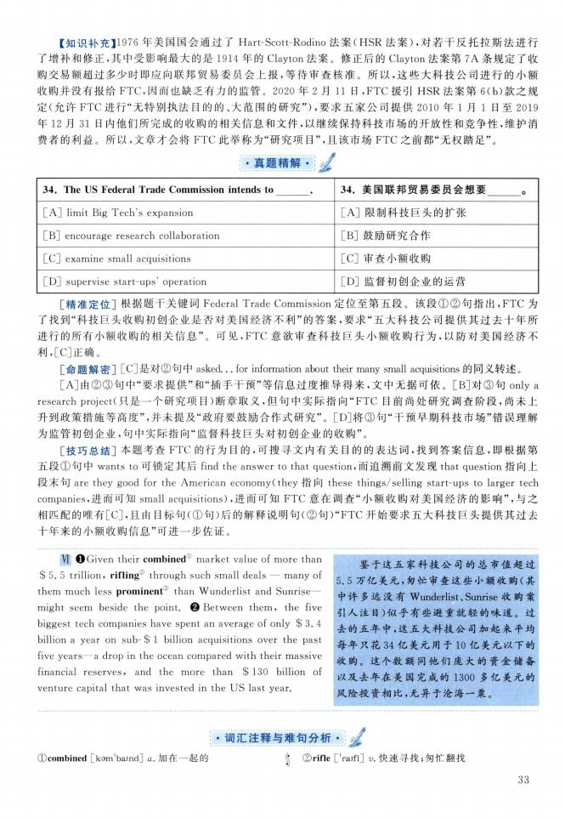
VI OGiven their combined 1! market value of more than $ 5. 5 trillion, riflings through such small deals — many of them much less prominent3 than Wunderlist and Sunrise一 might seem beside the point. ❷ Between them, the five biggest tech companies have spent an average of only $3.4 billion a year on sub- $ 1 billion acquisitions over the past five years一a drop in the ocean compared with their massive financial reserves, and the more than $ 130 billion of venture capital that was invested in the US last year.
鉴于这五家科技公司的总■市值超过 5.5万亿美元，匆忙审查这些小额收购（其 中许多远没有 Wunderlist、Sunrise收购案 引人注目）似乎有些避重就轻的味道。过 去的五年中，这五大科技公司加起来平均 每年只花34亿美元用于10亿美元以下的 收购。这个数额同他们庞大的资金储备 以及去年在美国完成的1300多亿美元的 风险投资相比，无异于沧海一粟。

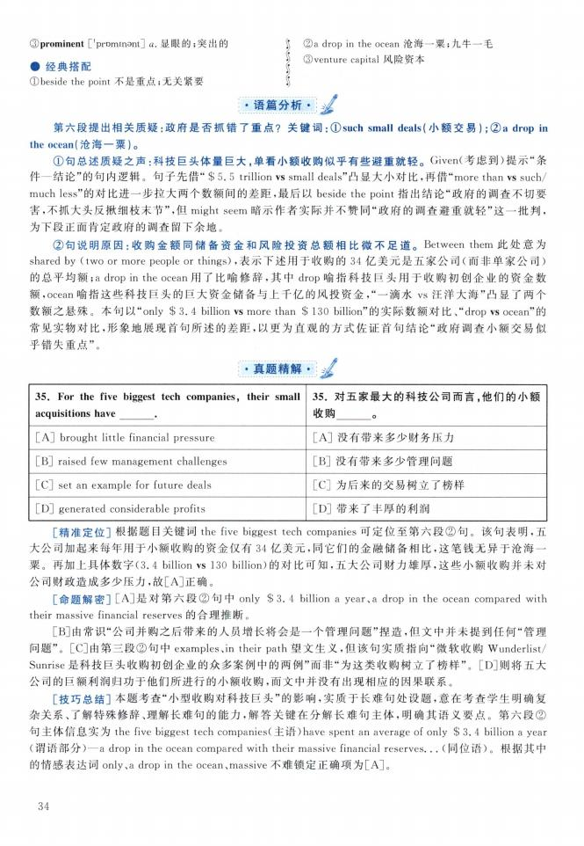

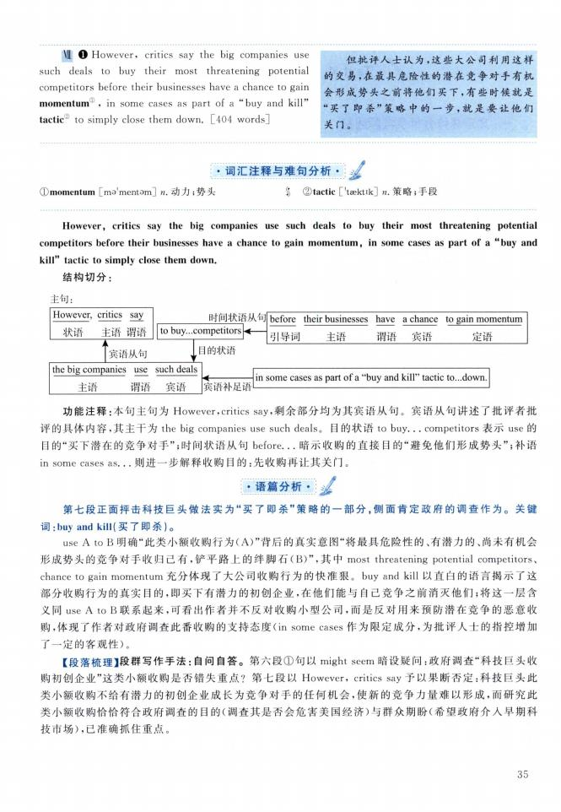
VII O However, critics say the big companies use such deals to buy their most threatening potential competitors before their businesses have a chance to gain momentum^ , in some cases as part of a "buy and kill” tactic② to simply close them down. [404 words]
但批评人士认为，这些大公司利用这样 的交易，在最具危险性的潜在竞争对手有机 会形成势头之前将他们买下，有些时候就是 “买了即杀”策略中的一步，就是要让他们 关门。

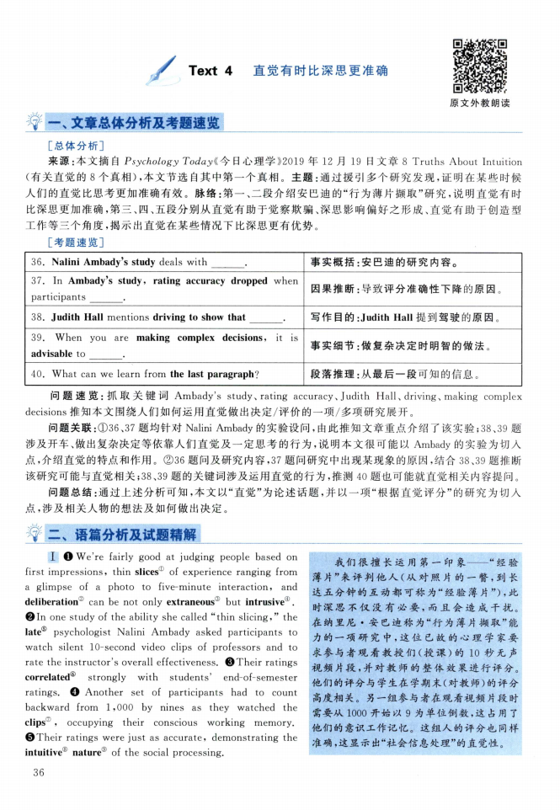

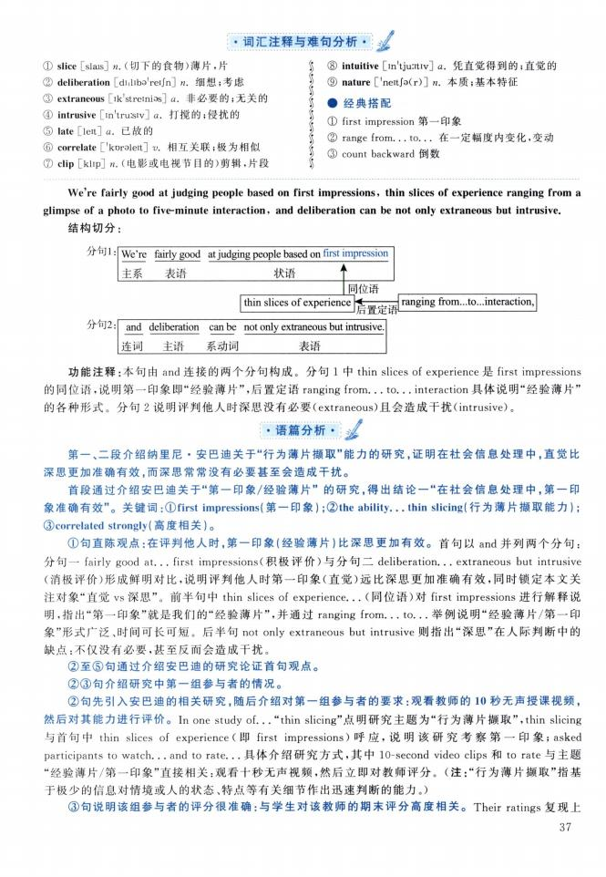
① slice [slais] n.（切下的食物）薄片，片
② deliberation [diiliba'reijn] n.细想；考虑
③ extraneous [ik1 stremiss] a.非必要的；无关的
④ intrusive [in'tru：siv] a.打搅的；侵扰的
⑤ late [leit] a 已故的
⑥ correlate [^oraleit] v.相互关联；极为相似
⑦ clip [klip] n.（电影或电视节目的）剪辑，片段
》 ⑧intuitive [in'tjuiitiv] a.凭直觉得到的；直觉的
| ⑨nature |?ne町a（r）] n.本质；基本特征 I •经典搭配
J ① first impression 第一印象
i ②range from. . . to...在一定幅度内变化，变动 》 ③ count backward 倒数

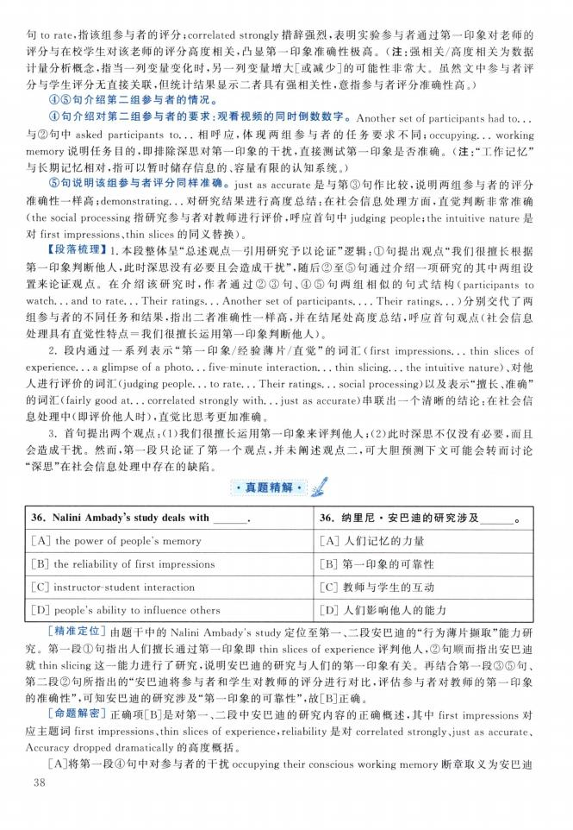

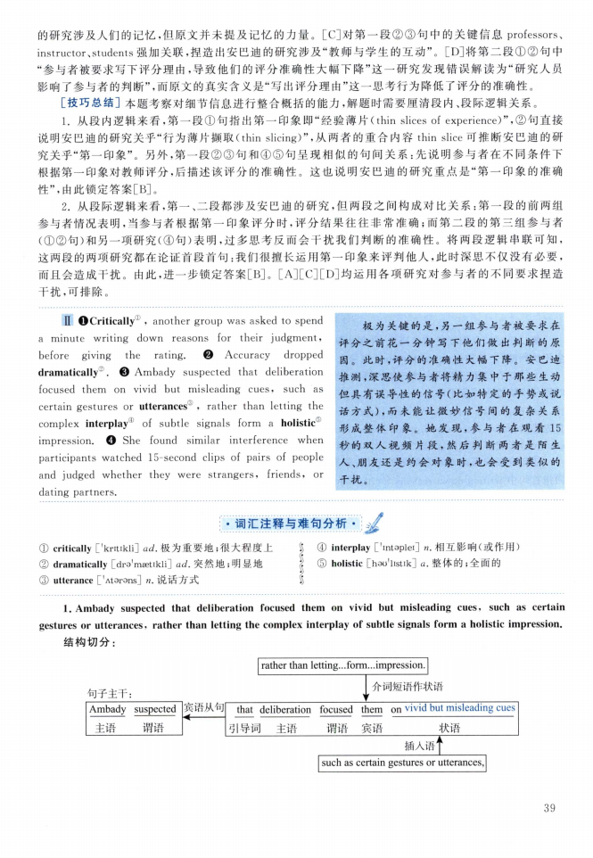
H OCritically1 , another group was asked to spend a minute writing down reasons for their judgment,
before giving the rating. Accuracy dropped
dramatically^ Ambady suspected that deliberation
focused them on vivid but misleading cues, such as certain gestures or utterances③ 9 rather than letting the complex interplay④ of subtle signals form a holistic® impression.❹ She found similar interference when participants watched 15-second clips of pairs of people and judged whether they were strangers, friends, or dating partners
极为关键的是，另一组参与者被要求在 评分之前花一分钟写下他们做出判断的原 因。此时，评分的准确性大幅下降。安巴迪 推测，深思使参与者将精力集中于那些生动 但具有误导性的信号（比如特定的手势或说 话方式），而未能让微妙信号间的复杂关系 形成整体印象。她发现，参与者在观看15 秒的双人视频片段，然后判断两者是陌生 人、朋友还是约会对象时，也会受到类似的 干扰。
① critically ['kritikli] a/ 极为重要地；很大程度上
② dramatically [dra'maetikl订 ad.突然地；明显地
(3) utterance ['Atarans] n.说话方式
》 ④interplay［'intaplei］n.相互影响（或作用） J ⑤ holistic［hao'listik］a.整体的；全面的

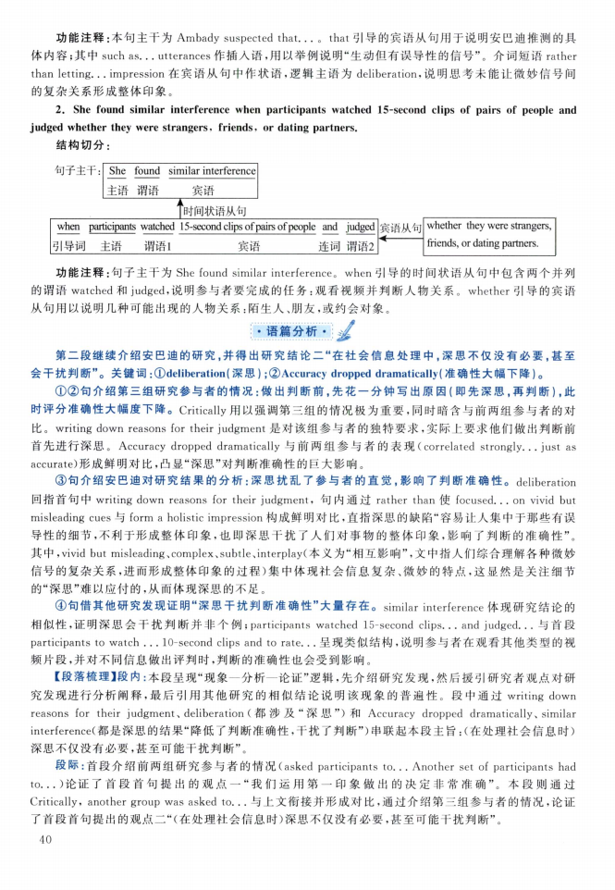

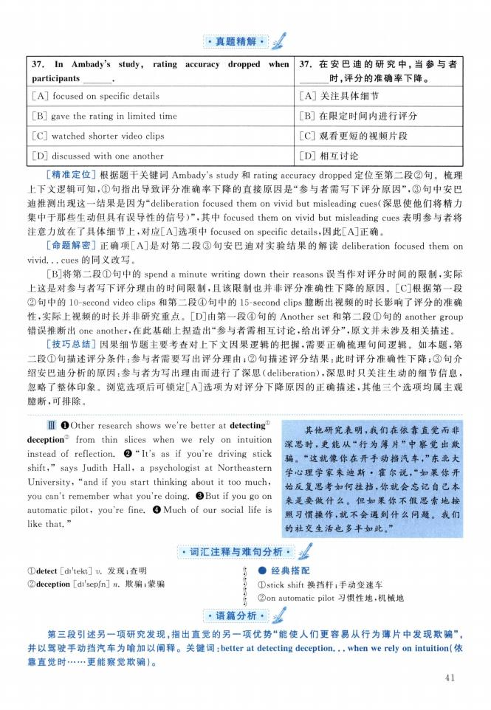
37 In Ambady，s study, rating accuracy
participants
[A] focused on specific details
[B] gave the rating in limited time
[C] watched shorter video clips
[D] discussed with one another
dropped when 37.在安巴迪的研究中，当参与者
时，评分的准确率下降。
［A］关注具体细节
［B］在限定时间内进行评分
［C］观看更短的视频片段
［D］相互讨论
DI OOther research shows we're better at detecting" deception" from thin slices when we rely on intuition instead of reflection. ❷ ** It's as if you're driving stick shift," says Judith Hall, a psychologist at Northeastern University, "and if you start thinking about it too much, you can't remember what you're doing. ©But if you go on automatic pilot, you're fine. 0 Much of our social life is like that."
其他研究表明，我们在依靠直觉而非 深思时，更能从“行为薄片 ”中察觉出欺 骗。“这就像你在开手动挡汽车，”东北大 学心理学家朱迪斯 霍尔说，“如果你开 始反复思考如何挂挡，你就会忘记自己本 来是要做什么。但如果你不假思索地按 照习惯操作，就不会遇到什么问题。我们 的社交生活也多半如此。”

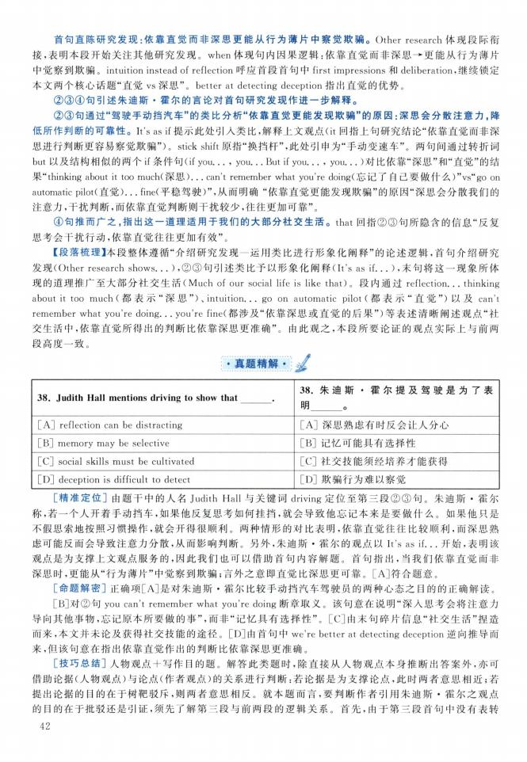
3& Judith Hall mentions driving to show that
[A] reflection can be distracting
[B] memory may be selective
[C] social skills must be cultivated [D] deception is difficult to detect
3&朱迪斯•霍尔提及驾驶是为了表 明 。
:A］深思熟虑有时反会让人分心 :B］记忆可能具有选择性
:C］社交技能须经培养才能获得 ：D］欺骗行为难以察觉

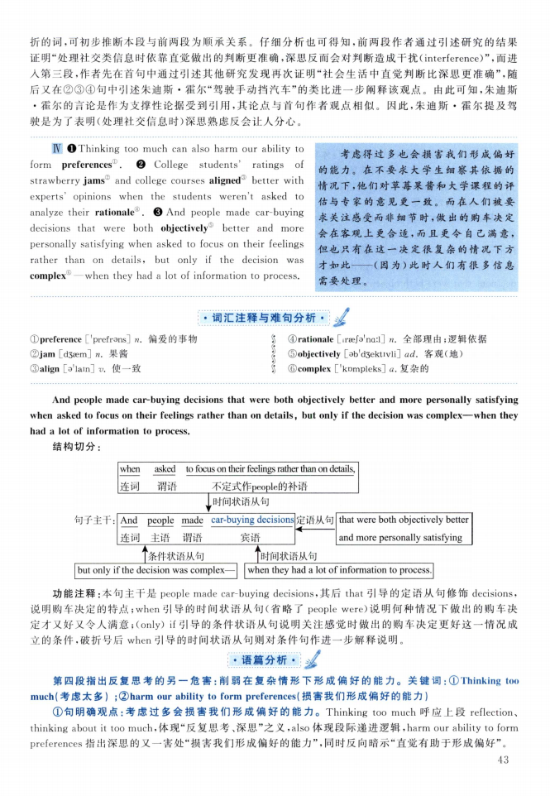
■ ©Thinking too much can also harm our ability to
form preferences① College students' ratings of
strawberry jams② and college courses aligned® better with experts' opinions when the students weren't asked to
analyze their rationale1. And people made car-buying
decisions that were both objectively" better and more personally satisfying when asked to focus on their feelings rather than on details, but only if the decision was complex' —when they had a lot of information to process.
考虑得过多也会损害我们形成偏好 的能力。在不要求大学生细察其依据的 情况下，他们对草莓果酱和大学课程的评 估与专家的意见更一致。而在人们被要 求关注感受而非细节时，做出的购车决定 会在客观上更合适，而且更令自己满意， 但也只有在这一决定很复杂的情况下方 才如此一一（因为）此时人们有很多信息 需要处理。

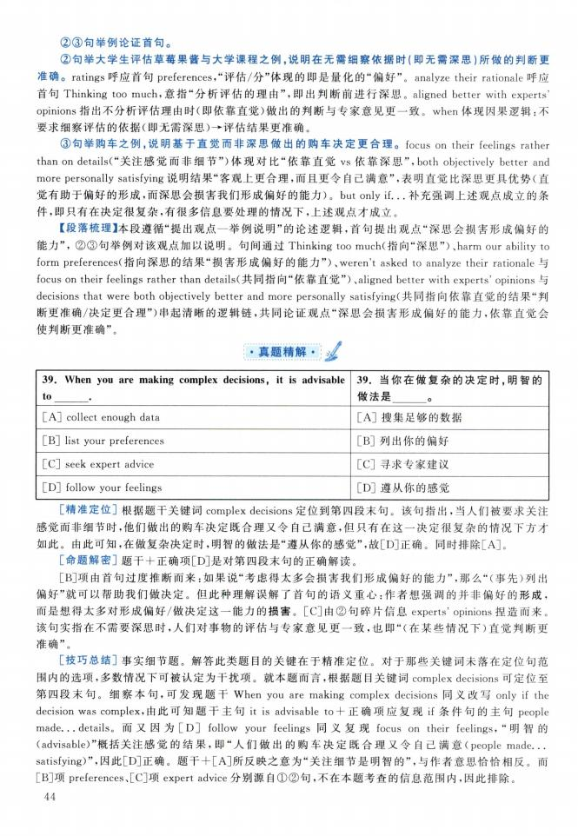

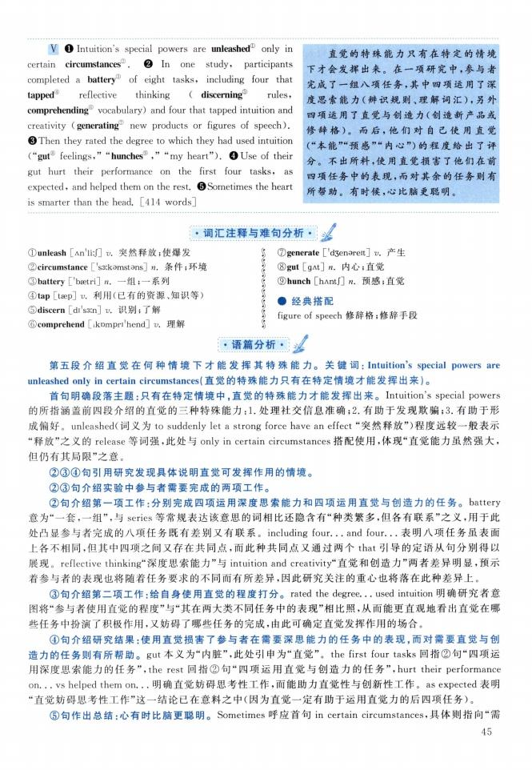
V O Intuition's special powers are unleashed® only in
certain circumstances0. In one study, participants
completed a battery⑶ of eight tasks, including four that tapped1 reflective thinking ( discerning® rules, comprehending vocabulary) and four that tapped intuition and creativity (generating0 new products or figures of speech). ©Then they rated the degree to which they had used intuition C'gut® feelingsuhunches，，‘“my heart?,) .❹ Use of their gut hurt their performance on the first four tasks, as expected9 and helped them on the rest. ©Sometimes the heart is smarter than the head [414 words]
直觉的特殊能力只有在特定的情境 下才会发挥出来。在一项研究中，参与者 完成了 一组八项任务，其中四项运用了深 度思索能力（辨识规则、理解词汇），另外 四项运用了直觉与创造力（创造新产品或 修辞格）。而后，他们对自己使用直觉 （“本能”“预感必内心”）的程度给出了评 分。不出所料，使用直觉损害了他们在前 四项任务中的表现，而对其余的任务则有 所帮助。有时候，心比脑更聪明。
① unleash [An'li:J] v.突然释放；使爆发
② circumstance「s3：komstons] n.条件；环境
③ battery ['bsetri] n. 一组；一系列
④ tap [taep] u.利用（已有的资源、知识等） ©discern [di's3in] v.识别；了解
©comprehend [ikompri'hend]仇 理解
$ ⑦generate ['d3enareit] u.产生 ?⑧gut [gAt] n. 内心；直觉
j ⑨hunch [hAntJ] n.预感；直觉 I •经典搭配
j figure of speech修辞格；修辞手段

语篇分析 • J:

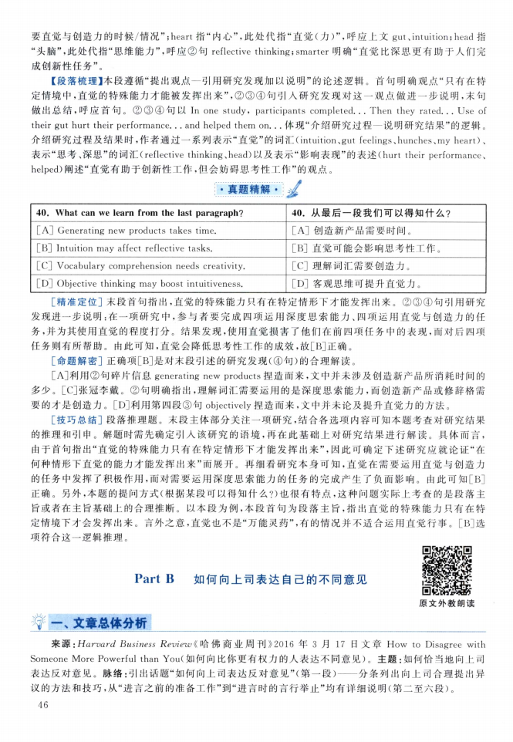

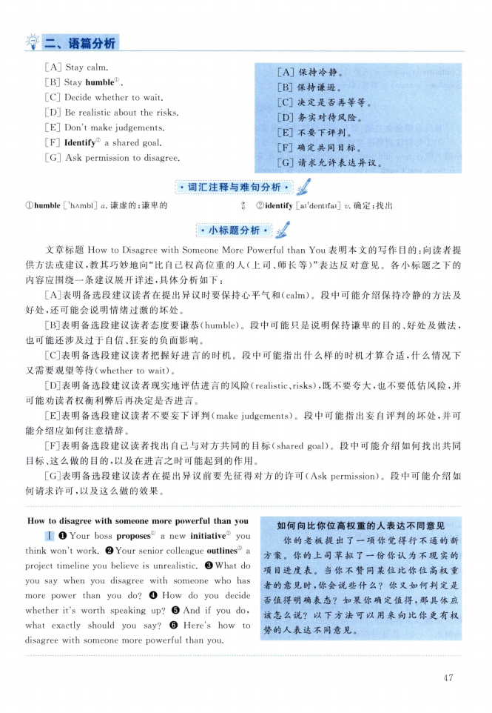
[A] Stay calm.
[B] Stay humble1 .
[C] Decide whether to wait.
[D] Be realistic about the risks [E] Don't make judgements
[F] Identify② a shared goal.
[G] Ask permission to disagree.
［A］保持冷静。 ［B］保持谦逊。
［C］决定是否再等等。 CD］务实对待风险。
［E］不要下评判。
［F］确定共同目标。
［G］请求允许表达异议。
How to disagree with someone more powerful than you
I O Your boss proposes1 a new initiative2 you think won't work. ❷ Your senior colleague outlines 1 a project timeline you believe is unrealistic. ❸ What do you say when you disagree with someone who has more power than you do?❹ How do you decide whether it's worth speaking up?Θ And if you do, what exactly should you say?Θ Here s how to disagree with someone more powerful than you.
如何向比你位高权重的人表达不同意见
你的老板提出了一项你觉得行不通的新 方案。你的上司草拟了一份你认为不现实的 项目进度表。 当你不赞同某位比你位高权重 者的意见时，你会说些什么？你又如何判定是 否值得明确表态？如果你确定值得，那具体应 该怎么说？ 以下方法可以用来向比你更有权 势的人表达不同意见。

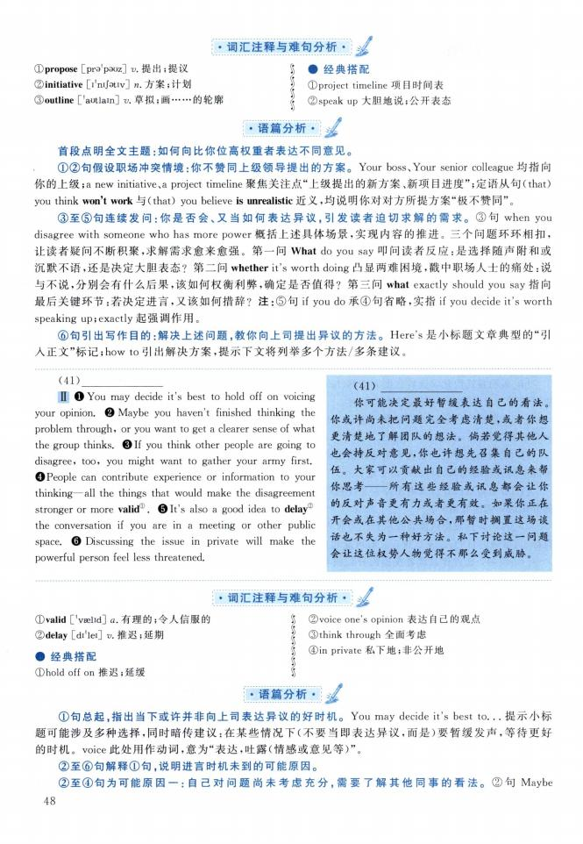
©propose Lpra'pauz] v.提出；提议
② initiative [I’nijativ]".方案；计划
③ outline ['aotlain] v.草拟；画... 的轮廓
》 •经典搭配
f ①project timeline 项目时间表 j ②speak up大胆地说；公开表态
(41)
H O You may decide it's best to hold off on voicing your opinion. ❷ Maybe you haven't finished thinking the problem through, or you want to get a clearer sense of what the group thinks. ❸ If you think other people are going to disagree, too, you might want to gather your army first. ©People can contribute experience or information to your thinking一all the things that would make the disagreement stronger or more valid®. 0 It's also a good idea to delay® the conversation if you are in a meeting or other public space. Θ Discussing the issue in private will make the powerful person feel less threatened.
（41）
你可能决定最好暂缓表达自己的看法。 你或许尚未把问题完全考虑清楚，或者你想 更清楚地了解团队的想法。倘若觉得其他人 也会持反对意见，你也许想先召集自己的队 伍。大家可以贡献出自己的经验或讯息来帮 你思考— 所有这些经验或讯息都会让你 的反对声音更有力或者更有效。如果你正在 开会或在其他公共场合，那暂时搁置这场谈 话也不失为一种好方法。私下讨论这一问题 会让这位权势人物觉得不那么受到威胁。
©valid E'vselid] a.有理的；令人信服的
②delay [di'leij v.推迟；延期
•经典搭配
①hold off on推迟；延缓
§ ②voice one's opinion表达自己的观点
j ③think through全面考虑
j ④in private私下地；非公开地

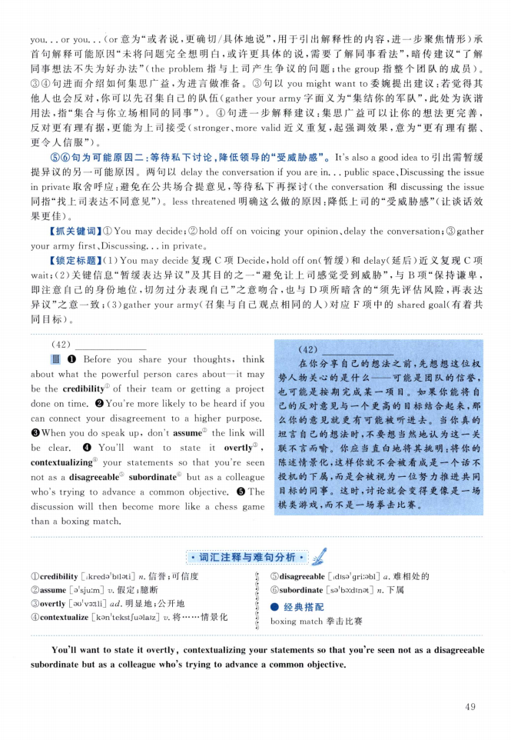
(42)
DI O Before you share your thoughts, think about what the powerful person cares about—-it may be the credibility1 of their team or getting a project done on time. ©You're more likely to be heard if you can connect your disagreement to a higher purpose. ©When you do speak up, don't assume2 the link will be clear.❹ You'll want to state it overtly® , contextualizing* your statements so that you're seen not as a disagreeable ! subordinate' but as a colleague who's trying to advance a common objective. Θ The discussion will then become more like a chess game than a boxing match.
（42）
在你分享自己的想法之前，先想想这位权 势人物关心的是什么—可能是团队的信誉， 也可能是按期完成某一项目。如果你能将自 己的反对意见与一个更高的目标结合起来，那 么你的意见就更有可能被听进去。 当你真的 坦言自己的想法时，不要想当然地认为这一关 联不言而喻。你应当直白地将其挑明：将你的 陈述情景化，这样你就不会被看成是一个话不 投机的下属，而是会被视为一位努力推进共同 目标的同事。这时，讨论就会变得更像是一场 棋类游戏，而不是一场拳击比赛。
① credibility [ikredo'bilsti]舁•信誉；可信度
② assume [a'sjuim] v.假定；臆断
③ overtly [0o'v3：tl订ad.明显地；公开地
④ contextualize [kan11ekstfualaiz] u.将... 情景化
》 ⑤disagreeable [idiss'griiabl] a,难相处的 / ©subordinate [sa'boidinat] x•下属
I •经典搭配
J boxing match 拳击 比赛

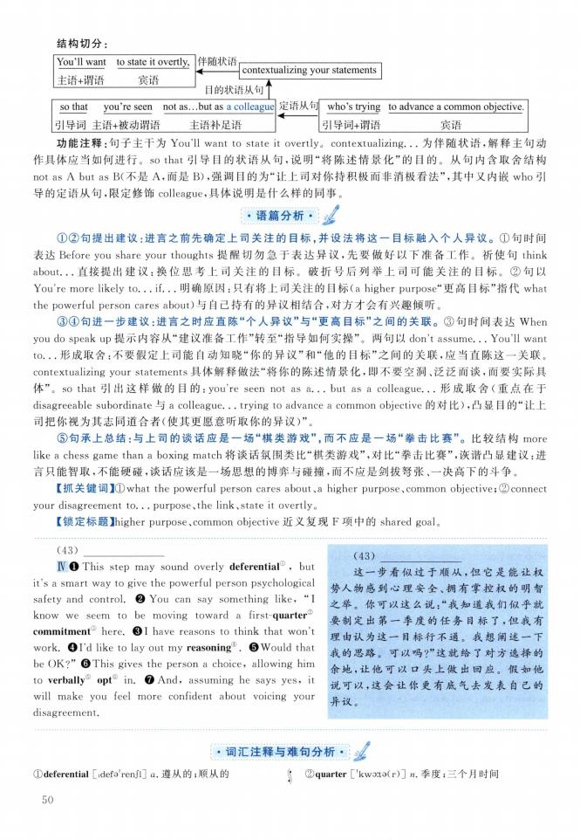
伴随状语
结构切分: You911 want 主语+谓语
to state it overtly, 宾语
<------ contextualizing your statements 目的状语从句八
(43)
IV ❶ This step may sound overly deferential 0 , but it's a smart way to give the powerful person psychological safety and control. ❷ You can say something like, "I know we seem to be moving toward a first-quarter" commitment here ❸ I have reasons to think that won't work.❹I'd like to lay out my reasoning®.Θ Would that be ()K?" ©This gives the person a choice? allowing him to verbally" optp in.❼ And, assuming he says yes, it will make you feel more confident about voicing your disagreement.
(43)
这一步看似过于顺从，但它是能让权 势人物感到心理安全、拥有掌控权的明智 之举。你可以这么说：“我知道我们似乎就 要制定出第一季度的任务目标了，但我有 理由认为这一目标行不通。我想阐述一下 我的思路。可以吗？”这就给了对方选择的 余地，让他可以口头上做出回应。假如他 说可以，这会让你更有底气去发表自己的 异议。

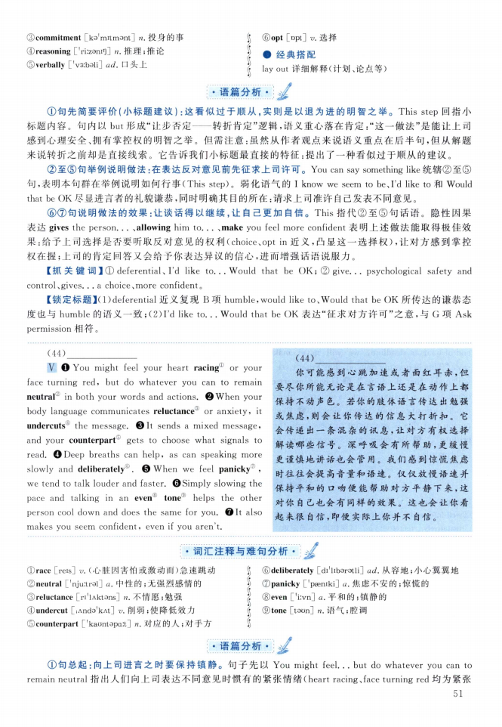
③ commitment [ko'mitmant] n.投身的事
④ reasoning ['riizam1]] n.推理；推论
⑤ verbally ['v3：bali] ad. 口头上
》 ®opt [opt] V.选择 I •经典搭配
j lay out详细解释（计划、论点等）
(44)
V O You might feel your heart racing① or your face turning red, but do whatever you can to remain neutral② in both your words and actions ©When your body language communicates reluctance® or anxiety, it undercuts① the message © It sends a mixed message» and your counterpart gets to choose what signals to read 0Deep breaths can help, as can speaking more
slowly and deliberately® When we feel panicky ,
we tend to talk louder and faster. Θ Simply slowing the pace and talking in an even tone11 helps the other person cool down and does the same for you. ❼ It also makes you seem confident, even if you aren't.
（44）
你可能感到心跳加速或者面红耳赤，但 要尽你所能无论是在言语上还是在动作上都 保持不动声色。若你的肢体语言传达出勉强 或焦虑，则会让你传达的信息大打折扣。它 会传递出一条混杂的讯息，让对方有权选择 解读哪些信号。深呼吸会有所帮助，更缓慢 更谨慎地讲话也会管用。我们感到惊慌焦虑 时往往会提高音量和语速。仅仅放慢语速并 保持平和的口吻便能帮助对方平静下来，这 对你自己也会有同样的效果。这也会让你看 起来很自信，即便实际上你并不自信。
① race [reis] v.（心脏因害怕或激动而）急速跳动
② neutral ['nju^ral] a. 中性的；无强烈感情的
③ reluctance [ri'lAktons] n.不情愿；勉强
④ undercut [lAnda'kAt] v, 削弱；使降低效力
⑤ counterpart ['kaontapart] n.对应的人；对手方
》 (©deliberately [di'libaratli] ad.从容地；小心翼翼地 $ ⑦panicky ['paemki] a.焦虑不安的；惊慌的
J ⑧even [?i：vn] a.平和的；镇静的 补 ⑨tone [toon] n.语气；腔调

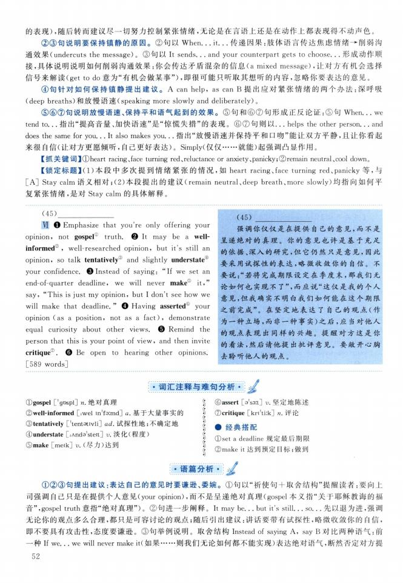
(45)
V[❶ Emphasize that you're only offering your opinion, not gospel1 truth. ❷ It may be a well- informed②, well-researched opinion, but it's still an opinion, so talk tentatively® and slightly understate® your confidence. © Instead of saying："If we set an end-of-quarter deadline, we will never make' it," say, "This is just my opinion, but I don't see how we will make that deadline. "❹ Having asserted "J your opinion (as a position, not as a fact) , demonstrate equal curiosity about other views. Θ Remind the person that this is your point of view, and then invite critique⑦. Θ Be open to hearing other opinions. [589 words]
（45）
强调你仅仅是在提供自己的意见，而不是 呈递绝对的真理。你的意见也许是基于充足 的依据、深入的研究，但它仍然只是意见，因此 要采用试探性的表达，略微收敛你的自信。不 要说：“若将完成期限设定在季度末，那我们无 论如何也实现不了”，而应说“这仅是我的个人 意见，但我确实不明白我们如何能在这个期限 之前完成”。在坚定地表达了自己的观点（作 为一种立场，而非一种事实）之后，应当对他人 的观点表现出同样的兴趣。提醒对方这是你 的看法，然后请他提出批评意见。要敞开心胸 去聆听他人的观点。
① gospel ['gospl]仇•绝对真理
② well-informed [iwel in'foimd] a.基于大量事实的
③ tentatively『tentativli] ad.试探性地；不确定地
④ understate [lAndo'steit] 卩 淡化(程度)
⑤ make [meikj v. (尽力)达到
⑥ assert [Rs3：t] v.坚定地陈述
⑦ critique [kri'tiik] n.评论
•经典搭配
① set a deadline规定最后期限
② make让达到预定目标；做到

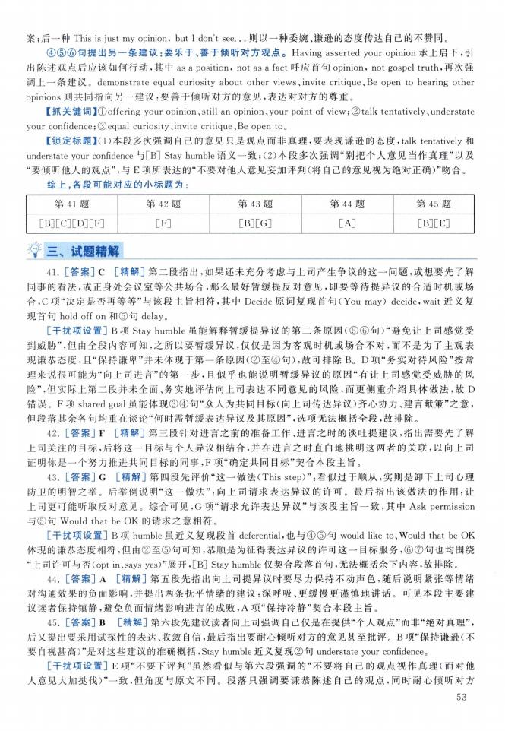

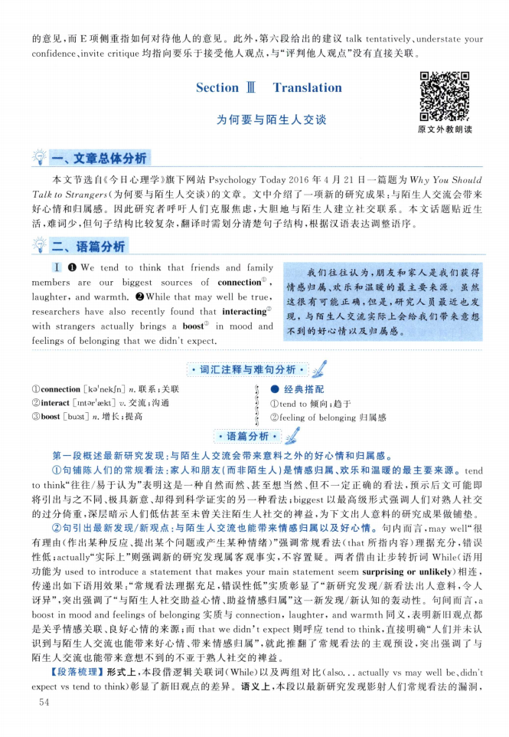
I ❶ We tend to think that friends and family members are our biggest sources of connection1 , laughter, and warmth. ❷While that may well be true, researchers have also recently found that interacting" with strangers actually brings a boost in mood and feelings of belonging that we didn't expect.
我们往往认为，朋友和家人是我们获得 情感归属、欢乐和温暖的最主要来源。虽然 这很有可能正确，但是，研究人员最近也发 现，与陌生人交流实际上会给我们带来意想 不到的好心情以及归属感。

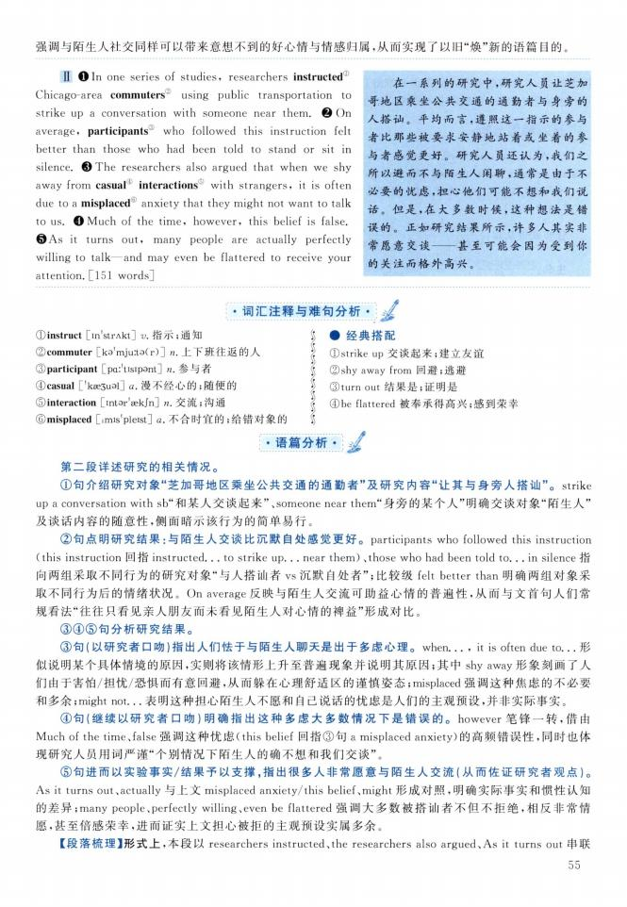
II O In one series of studies, researchers instructed 1 Chicago-area commuters' using public transportation to strike up a conversation with someone near them. ❷ On average, participants③ who followed this instruction felt better than those who had been told to stand or sit in silence ❸ The researchers also argued that when we shy away from casual1 interactions with strangers, it is often due to a misplaced anxiety that they might not want to talk to us. 0 Much of the time, however, this belief is false ©As it turns out, many people are actually perfectly willing to talk一and may even be flattered to receive your attention. [151 words]
在一系列的研究中，研究人员让芝加 哥地区乘坐公共交通的通勤者与身旁的 人搭讪。平均而言，遵照这一指示的参与 者比那些被要求安静地站着或坐着的参 与者感觉更好。研究人员还认为，我们之 所以避而不与陌生人闲聊，通常是由于不 必要的忧虑，担心他们可能不想和我们说 话。但是，在大多数时候，这种想法是错 误的。正如研究结果所示，许多人其实非 常愿意交谈—甚至可能会因为受到你 的关注而格外高兴。
©instruct [in'strAkt] v.指示；通知
② commuter [ka'mju：ta（r）] n.上下班往返的人
③ participant [pa：'tisipant] n.参与者
④ casual ['k0e3ual] a.漫不经心的；随便的
⑤ interaction [intar'sek/n] n.交流；沟通
©misplaced [imis'pleist] a.不合时宜的；给错对象的
》 •经典搭配
| ①strike up交谈起来；建立友谊
« ②shy away from 回避；逃避 I ③turn out结果是；证明是
j ④be flattered被奉承得高兴；感到荣幸 《

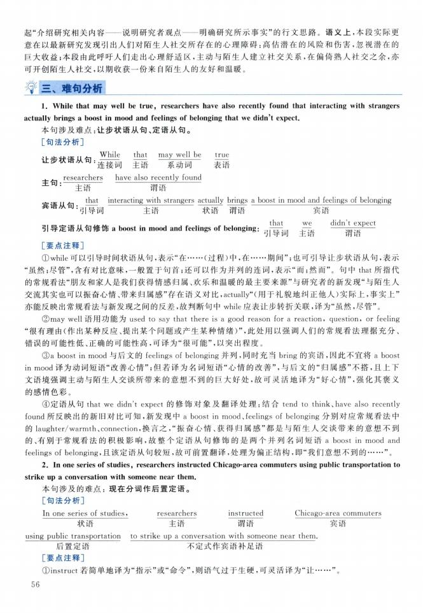

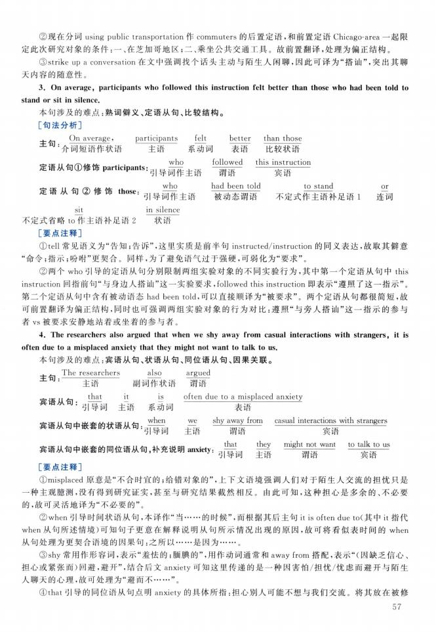

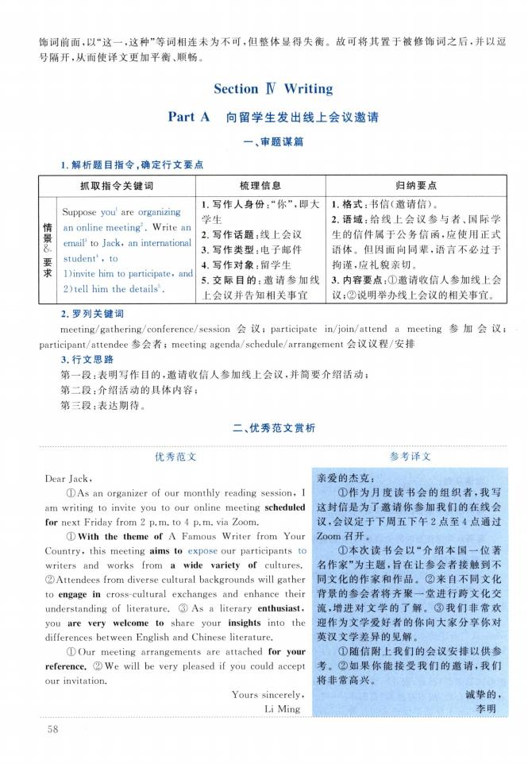
情景
要求
&
Suppose you1 are organizing
an online meeting2. Write an email3 to Jack, an international student4 , to
1) invite him to participate and
2) tell him the details5.
1. 写作人身份：“你”，即大 学生
2. 写作话题：线上会议
3. 写作类型：电子邮件
4. 写作对象：留学生
5. 交际目的：邀请参加线 上会议并告知相关事宜
1. 格式：书信（邀请信）。
2. 语域：给线上会议参与者、国际学 生的信件属于公务信函，应使用正式 语体。但因面向同辈，语言不必过于 拘谨,应礼貌亲切。
3. 内容要点:①邀请收信人参加线上会 议;②说明举办线上会议的相关事宜。
Dear Jack,
①As an organizer of our monthly reading session, I am writing to invite you to our online meeting scheduled for next Friday from 2 p.m. to 4 p. m. via Zoom.
① With the theme of A Famous Writer from Your Country, this meeting aims to expose our participants to writers and works from a wide variety of cultures
(2)Attendees from diverse cultural backgrounds will gather to engage in cross-cultural exchanges and enhance their understanding of literature ③ As a literary enthusiasts you are very welcome to share your insights into the differences between English and Chinese literature
① Our meeting arrangements are attached for your reference ② We will be very pleased if you could accept our invitation.
Yours sincerely, Li Ming
亲爱的杰克：
①作为月度读书会的组织者，我写 这封信是为了邀请你参加我们的在线会 议，会议定于下周五下午2点至4点通过 Zoom召开。
①本次读书会以“介绍本国一位著 名作家”为主题，旨在让参会者接触到不 同文化的作家和作品。②来自不同文化 背景的参会者将齐聚一堂进行跨文化交 流,增进对文学的了解。③我们非常欢 迎作为文学爱好者的你向大家分享你对 英汉文学差异的见解。
①随信附上我们的会议安排以供参 考。②如果你能接受我们的邀请，我们 将非常高兴。
诚挚的, 李明

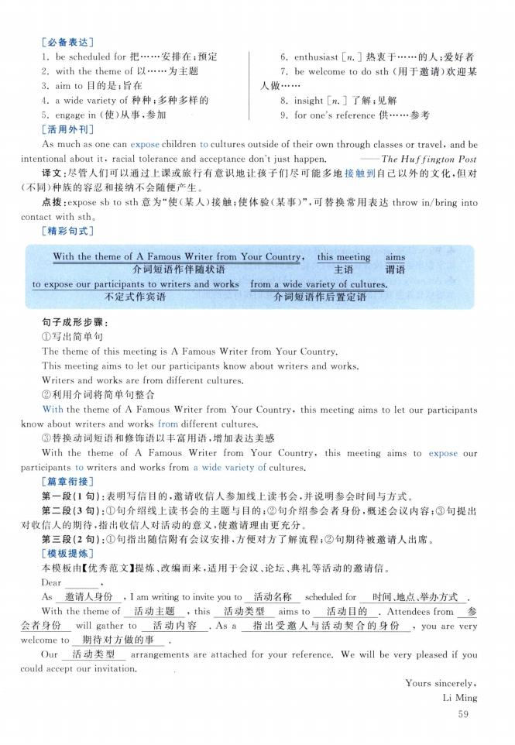

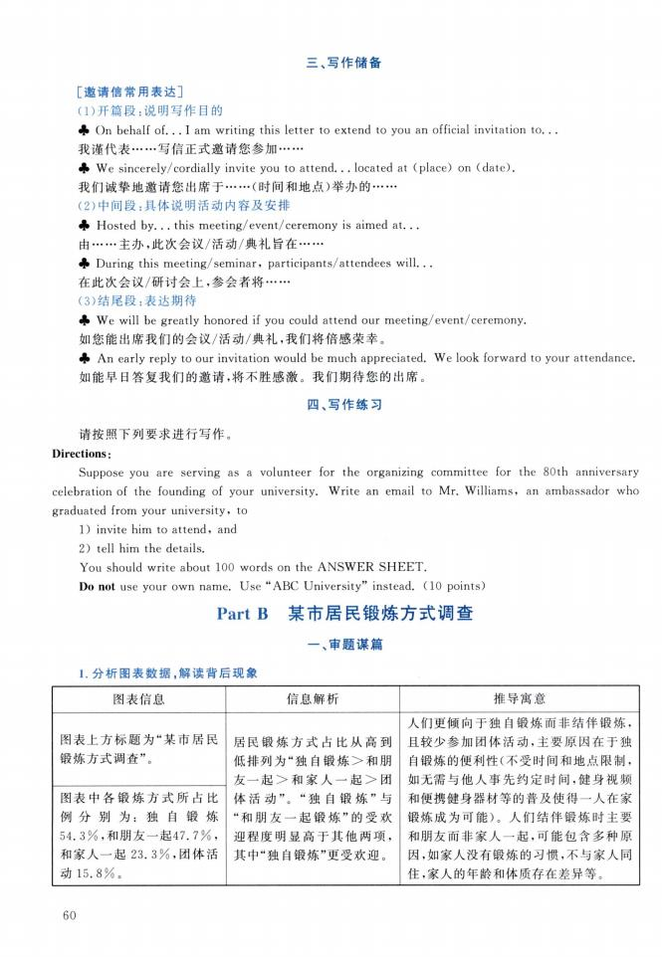

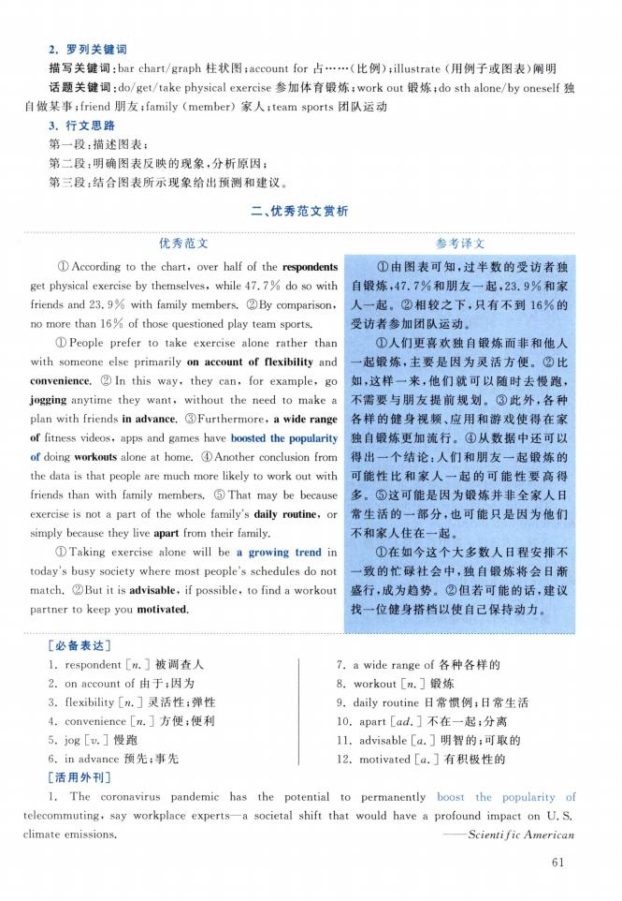

二、优秀范文赏析
优秀范文
(D According to the chart, over half of the respondents get physical exercise by themselves, while 47. 7 % do so with friends and 23. 9% with family members (2)By comparison, no more than 16% of those questioned play team sports.
① People prefer to take exercise alone rather than with someone else primarily on account of flexibility and convenience .② In this way, they can, for example, go jogging anytime they want, without the need to make a plan with friends in advance. (3)Furthermore» a wide range of fitness videos, apps and games have boosted the popularity of doing workouts alone at home. ® Another conclusion from the data is that people are much more likely to work out with friends than with family members. (5) That may be because exercise is not a part of the whole family's daily routine, or simply because they live apart from their family.
① Taking exercise alone will be a growing trend in today's busy society where most people's schedules do not match. ②Eut it is advisable, if possible, to find a workout partner to keep you motivated.
参考译文
①由图表可知，过半数的受访者独 自锻炼，47. 7%和朋友一起，23. 9%和家 人一起。②相较之下，只有不到16%的 受访者参加团队运动。
①人们更喜欢独自锻炼而非和他人 一起锻炼，主要是因为灵活方便。②比 如，这样一来，他们就可以随时去慢跑， 不需要与朋友提前规划。③此外，各种 各样的健身视频、应用和游戏使得在家 独自锻炼更加流行。④从数据中还可以 得出一个结论：人们和朋友一起锻炼的 可能性比和家人一起的可能性要高得 多。⑤这可能是因为锻炼并非全家人日 常生活的一部分，也可能只是因为他们 不和家人住在一起。
①在如今这个大多数人日程安排不 一致的忙碌社会中，独自锻炼将会日渐 盛行，成为趋势。②但若可能的话，建议 找一位健身搭档以使自己保持动力。

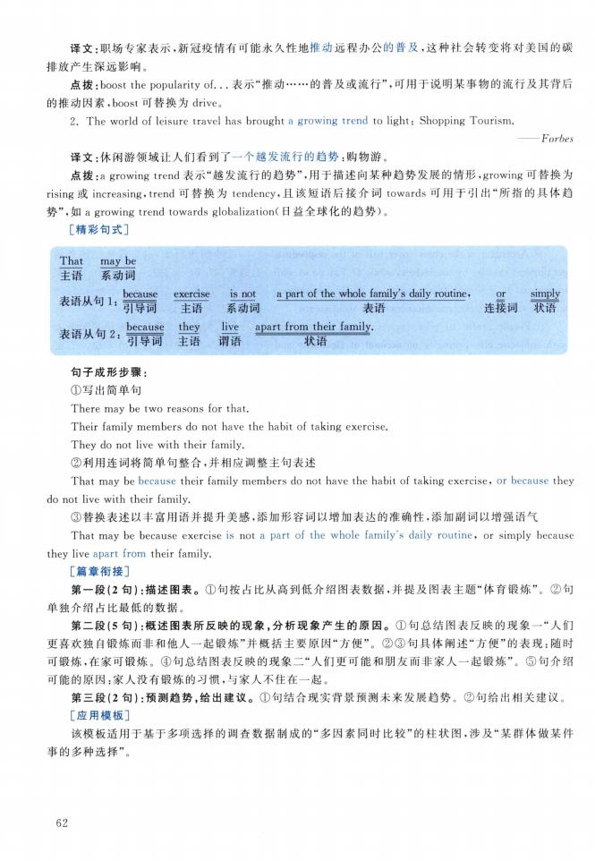

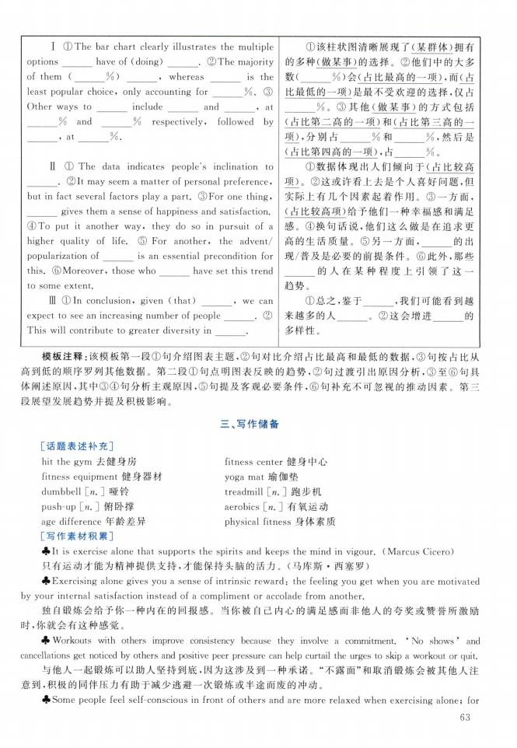
I ① The bar chart clearly illustrates the multiple
options have of (doing) . ②The majority
of them ( %) , whereas is the
least popular choice, only accounting for %. ③
Other ways to include and , at
% and % respectively, followed by
, at %.

II ① The data indicates people's inclination to
②It may seem a matter of personal preference,
but in fact several factors play a part. ③For one thing,
gives them a sense of happiness and satisfaction.
④To put it another way, they do so in pursuit of a higher quality of life.⑤ For another, the advent/
popularization of is an essential precondition for
this. ©Moreover, those who have set this trend
to some extent.
ID ® In conclusion, given (that) 9 we can
expect to see an increasing number of people . (2)
This will contribute to greater diversity in .
①该柱状图清晰展现了单处2拥有 的多种（做某事）的选择。②他们中的大多 数（ %）会（占比最高的一项）,而（占 比最低的一项）是最不受欢迎的选择，订
%。③其他（做某事）的方式包括 （占比第二高的一项）和（占比第三高 的一 项），分别占 ％和 ％，然后是 （占比第四高的一项）9占 % o
①数据体现出人们倾向于（占比较高 Wo②这或许看上去是个人喜好问题，但 实际上有几个因素起着作用。③一方面， （占比较高项）给予他们一种幸福感和满足 感。④换句话说，他们这么做是在追求更 高的生活质量。 ⑤另一方面，______ 的出 现/普及是必要的前提条件。⑥此外，那些 ______ 的人在某种程度上引领了这一 趋势。
①总之，鉴于______ ，我们可能看到越 来越多的人______ o②这会增进______ 的 多样性。
［话题表述补充］
hit the gym去健身房
fitness equipment 健身器材

三、写作储备

fitness center 健身中心 yoga mat瑜伽垫
push-up \_n.］俯卧撑
age difference 年龄差异
［写作素材积累］
aerobics [_n.] 有氧运动 physical fitness 身体素质



