

Expenses tracker with banking API integration and AI-powered Chatbot

  - Bachelor of Science (Honors) in Computing with Games Development
  - Student: Anna Kovalenko
  - T-Number: T00243622
  - Module: Final Year Project

Abstract
The manual tracking of personal expenses is time-consuming, error-prone, and rarely produces actionable insight. This project presents Bloom, a full-stack AI-powered personal finance application that automates the ingestion and analysis of real banking transaction data from AIB, Revolut, and the Plaid API. Machine learning pipeline processes transactions through feature engineering, anomaly detection, forecasting, and a recommendation engine, with results delivered through a natural language chat interface.
A key design concern is data privacy. Bloom's dual-configuration architecture supports either a locally hosted LLM, Qwen3 1.7B via Ollama, or the cloud-hosted Gemini 2.5 Flash Lite API, enabling direct empirical comparison of both approaches. Evaluation across 27 query–model pairs and two hardware environments found the models near-equivalent in quality, supporting the conclusion that local inference is a practical, privacy-preserving alternative to cloud-hosted LLMs and that the choice between them is one of values rather than capability.

Contents
Abstract 2
Glossary 6
1. Introduction 8
2. Literature Review: Machine Learning and Artificial Intelligence Development 9
2.1. Overview of Machine Learning Concepts 9
2.1.1. Definitions and Scope of Machine Learning 9
2.1.2. Categories of Machine Learning: Supervised, Unsupervised, Semi-Supervised, and Reinforcement Learning 9
2.1.3. Comparison of Machine Learning Models 16
2.2. Transaction Categorization Techniques 17
2.2.1. Rule-based approaches 18
2.2.2. AI-Driven Categorization Using Gemini AI 18
2.2.3. Machine Learning Approaches 18
2.2.4. Comparative Analysis of Categorization Techniques 19
2.3. AI Model Creation and Training 20
2.3.1. Model Development Processes 20
2.3.2. Training Algorithms and Platforms 21
2.3.3. AI Model Pipeline and Deployment 23
2.4. AI Model Hosting Platforms 23
2.4.1. Overview of Hugging Face Hosting 23
2.4.2. Local Hosting of Large Language Models via Ollama 24
2.4.3. Comparative Review of Hosting Platforms 25
2.4.4. Application of Gemini AI for Response Comparison 26
3. Literature Review: API Integration 27
3.1. Banking API Integration 27
3.1.1. Overview of Plaid API 27
3.1.2. Sandbox Testing: Integration of Login and Card Connection Functionalities 28
3.1.3. Sandbox Test Users and Custom Test Users 29
3.2. Transactions Analysis and Recommendations 37
3.2.1. Core Financial Principles for Transaction Analysis 37
3.2.2. Rule-Based Transaction Evaluation Framework 38
3.2.3. The 10 Essential Personal Finance Rules for System Implementation 39
4. Project Plan 42
5. Design Phase 47
System Architecture Diagram 47
Integration Sequence Diagram 49
Database Schema (ERD) 54
AI/ML Training and Deployment Pipeline 57
Activity Diagram 59
Chatbot Interaction Flowchart 63
Data Flow Diagrams (DFDs) 66
Wireframes 68
Plaid API Interface 71
User Interface 73
6. Justification 76
7. Methodology Overview 78
Data Collection Methodologies 79
Agile Development & Jira 85
User Stories 86
8. Implementation 108
System Overview 108
Technology Stack 108
Application realisation steps 109
Key Design Decisions and Lessons Learned 120
9. Project Rationale and Motivation 122
10. The Case Against General Purpose AI Agents 122
10.1. Data Privacy 123
10.2. Context and Risks 123
10.3. Cost, Latency, and Offline Operation 124
10.4. Structured Intelligence Beyond Language 124
11. Deployment Contexts and Use Cases 124
12. Hardware Context and Latency Analysis 125
12.1. Hardware Specifications 125
12.2. Evaluation 1: Dell Latitude 5520 (CPU-Only) 126
12.3. Evaluation 2: Dell OptiPlex 5090 (GPU-Accelerated) 128
12.4. Cross-Environment Latency Summary 130
13. Comparative LLM Evaluation: Quality Analysis 130
13.1. Instructions Following 130
13.2. Naturalness 131
13.3. Specificity 131
13.4. Conciseness 132
13.5. Tone and Warmth 132
13.6. Readability 132
14. Quality Equivalence Findings 132
15. Future Extensions and Scalability 133
16. Challenges and Technical Difficulties 134
17. Learning Outcomes and Skills Development 137
18. Conclusion 138
Appendix 140
References 141

Glossary
AI (Artificial Intelligence)
ACH (Automated Clearing House)
AUC (Area Under the Curve)
ARIMA (Autoregressive Integrated Moving Average)
API (Application Programming Interface)
CNN (Convolutional Neural Network)
CI/CD (Continuous Integration and Continuous Delivery)
DAG (Directed Acyclic Graph)
DRL (Deep Reinforcement Learning)
DNN (Deep Neural Network)
DFD (Data Flow Diagram)
IT (Information Technology)
GPU (Graphics Processing Unit)
GMM (Gaussian Mixture Model)
GDPR (General Data Protection Regulation)
HTTP (Hypertext Transfer Protocol)
JSON (JavaScript Object Notation)
LLM (Large Language Models)
LSTM (Long Short-Term Memory)
MAE (Mean Absolute Error)
MARL (Multi-Agent Reinforcement Learning)
MDP (Markov Decision Process)
ML (Machine Learning)
MSE (Mean Squares Error)
NLP (Natural Language Processing)
NMT (Neural Machine Translation)
NAS (Neural Architecture Search)
RL (Reinforcement Learning)
RMSE (Root Mean Squares Error)
UI (User Interface)
URL (Uniform Resource Locator)
UML (Unified Modeling Language)
VPN (Virtual Private Network)
SSC (Semi-Supervised Classification)
SSL (Semi-Supervised Learning)
SVM (Support Vector Machines)
TPU (Tensor Processing Unit)

Introduction
The Automated AI-Driven Expense Tracker project is designed to transform how people manage their money by using the combination of machine learning and banking API integration to provide fast, precise, and relevant insights to users about their spending habits. “Effective expense tracking is vital for personal and business financial management, helping monitor spending, budget efficiently, and uncover cost- saving opportunities. Traditional methods, often manual and rule-based, are time-consuming, error-prone, and lack scalability.”, was mentioned in the EXPENSE TRACKER USING MACHINE LEARNING (Gayathri, 2025). The shortcomings of the traditional expense tracking methods present obstacles to individuals being able to understand their spending habits or make informed financial decisions.
Bloom was developed to address the shortcomings identified above. Specifically, it is a full stack application that combines secure banking APIs with machine learning and conversational natural language processing in order to deliver fast, precise and customised insights regarding a user's financial situation. Unlike other applications, the entire process of data collection through delivery of financial analysis is automated by Bloom. Therefore, the sophisticated financial analysis delivered by Bloom can be utilized by anyone regardless of technical expertise.
The project was organised around three main goals. First, automatic transaction synchronization: Bloom retrieves all of a user's bank transactions via the Plaid API or native CSV exports from AIB and Revolut. Once retrieved, each transaction will be normalised and classified without any manual input. Second, machine learning driven analysis: a pipeline consisting of feature engineering, anomaly detection, time series forecasting and a recommendation engine analyzes each user's transactional patterns in order to surface meaningful data grounded insights. Third, intelligent interface: a clean dashboard alongside an ai-powered chat interface provides users with the ability to explore their financial data and receive personalized, conversational guidance on key spends which can be reached in less than three clicks.
All together these components form a system that goes beyond simply logging expenses in order to provide the kind of intelligent, personalized financial commentary previously only available through professional advice.

Literature Review: Machine Learning and Artificial Intelligence Development

Overview of Machine Learning Concepts

Definitions and Scope of Machine Learning
“[Machine Learning is the] field of study that gives computers the ability to learn without being explicitly programmed – Arthur Samuel, 1959” (Aurelien Geron, 2019, p. 30)
Arthur Samuel’s definition highlights the main goal of machine learning. The goal is to enable systems to improve performance through experience instead of fixing programming. This idea laid the foundation for many modern applications, from speech recognition to medical diagnosis. It shows how learning algorithms adapts to new data, making them useful for solving complex problems.
In another source, Mohammed, Khan and Bashier, pp. (2017, pp. 22–23) described machine learning as a branch of artificial intelligence that enables machines to perform tasks skillfully through intelligent software. Statistical learning methods from the foundation of such systems, allowing them to learn patterns and improve performance over time.
In my project, which focuses on an AI-powered expenses tracker with API integration, machine learning helps analyze user spending behavior and predict future expenses. This allows the system to provide personalized financial insights and improve decision-making for users.

Categories of Machine Learning: Supervised, Unsupervised, Semi-Supervised, and Reinforcement Learning
Supervised Learning in Financial Applications
According to Aurelien Geron (2019, p. 34), supervised learning is a category of Machine Learning (ML) systems classified by the provision of human supervision during training. Specifically, the training data provided to the algorithm explicitly includes the desired solutions, called labels.
“In supervised learning, the training data you feed to the algorithm includes the desired solutions, called labels.”(Aurelien Geron, 2019, p. 34)
In my project, supervised learning helps the expense tracker model identify and categorize transactions based on labeled data from past patterns. By training on examples such as “food”, “transport”, or “entertainment”, the model learns to classify new transactions automatically.
In supervised learning, different approaches address different types of prediction tasks. Each approach plays a key role in building an effective learning environment.
Classification
Classification is done for expense categorization, where the algorithms such as Decision Trees, Random Forest, and Deep Neural Networks classify transactions automatically into categories such as groceries, travel or utilities Gayathri (2025, pp. 1–2). These models use Natural Language Processing (NLP) to process the transaction description and reach high performance in categorization, thereby reducing the input.
Another common classification method is Naïve Bayesian classifier. The classifier uses probabilities to determine the most probable category for a given transaction relying on some formerly labeled data. The algorithm assumes that features, such as transaction descriptions or amounts, are independent of one another. Regardless of this assumption, classifiers of this type are usually effective at classifying text-based data and can be quite effective in the treatment of the descriptions of transaction and of transaction notes for expense tracking systems.
“Naïve Bayesian classifiers are simple probabilistic classifiers with their foundation on application of Bayes’ theorem with the assumption of strong (naive) independence among the features. The following equation states Bayes’ theorem in mathematical terms:
$$P\left(A | B\right)=P(A)P(B|A)P(B)$$
where:
A and B are events:
P(A) and P(B) are the prior probabilities of A and B without regard to each other.
P(A|B), also called posterior probability, is the probability of observing event A given that B is true.
P(B|A), also called likelihood, is the probability of observing event B given that A is true.”(Mohammed, Khan and Bashier, 2017, p. 60)
In the context of the AI-powered expense tracker with banking API integration, the Naïve Bayesian classifier can play a central role in automating expense categorization. Once transaction data is collected through the banking API, the classifier can use features such as transaction descriptions, merchant names, and amounts to predict the most suitable category for each expense. This helps reduce manual labeling and improved user experience through accurate, real-time classification.
The model can be trained using historical transaction data labeled by users or financial institutions. Over time, as more data is gathered, the classifier can update its probabilities and improve accuracy. This makes it adaptive to changes in user spending behavior and new transaction patterns.
In addition, combining the Naïve Bayesian classifier with Natural Language Processing (NLP) techniques enhances its performance when handling unstructured text, such as transaction notes. Tokenization and preprocessing help extract relevant keywords that improve classification accuracy.
For research purposes, this integration also provides opportunities to measure model performance using metrics like precision, recall, and F1-score. These evaluations can help compare the Naïve Bayesian classifier against other algorithms, such as Decision Trees or Deep Neural Networks, to determine which method delivers the best balance of accuracy and computational efficiency for expense categorization.
Regression
According to Braga-Neto (2024, p. 270), the objective of regression is to predict the value of a continuous target variable Y ∈ R based on a feature vector X ∈Rd, using sample data or knowledge of the distribution of the random vector (X, Y). Unlike classification, regression focuses on numerical prediction. This difference changes both the theory and practical applications, as regression relies on performance measures such as Mean Squares Error (MSE) or Root Mean Squares Error (RMSE) instead of classification accuracy.
In my project, regression techniques can be used to predict user spending trends and forecast future expenses. By analysing historical transaction data, the model can estimate how spending might change over time or under specific conditions. For instance, linear regression can help determine the relationship between income and spending, while nonparametric methods like Gaussian Process Regression can capture complex patterns in user behaviour. These predictions support better financial planning by alerting users to potential overspending or helping them set realistic budget goals.
Model Evaluation
According to Aurelien Geron (2019, p. 57-59), model evaluation and validation constitute the fundamental process of assessing the efficiency and robustness of a Machine Learning (ML) model, primarily by estimating its ability to generalize to unseen data. The performance measure used to quantify this ability is known as the generalization error or out-of-sample error. If the model demonstrates low error on the training data but high generalization error, it is typically an indication of overfitting.
Model evaluation involves dividing data into training, validation, and test sets. The training set builds the model, the validation set helps tune its parameters, and the test set provides an unbiased estimate of performance. Cross-validation can also be used, especially when data is limited. In K-fold cross-validation, the dataset is divided into several folds to ensure a more reliable performance estimate.
The main goal is to measure how well the model predicts new data. For regression tasks, metrics such as Root Mean Squared Error (RMSE) and Mean Absolute Error (MAE) are common, while for classification, Precision, Recall, F1-score, and AUC are often used. These measures help detect issues like underfitting and guide model improvements.
In my project, model evaluation can be used to ensure that the algorithms predicting spending patterns and categorizing expenses perform accurately across different users and data sources. Using proper validation methods helps maintain consistent and reliable prediction, which is essential for providing trustworthy financial insights.
Data Preparation
Data preparation or processing is a crucial stage in any Machine Learning (ML) project workflow, designed to condition the raw data for algorithmic processing and enhance model performance. It is often a long process where data scientists dedicate a significant amount of time.
“Obviously, if your training data is full of errors, outliers, and noises (e.g., due to poor quality measurements), it will make it harder for the system to detect the underlying patterns, so your system is less likely to perform well. It is often well worth the effort to spend time cleaning up your training data. The truth is that most data scientists spend a significant part of their time doing just that.” Aurelien Geron (2019, p. 53)
Unsupervised Learning in Financial Applications
According to Mohammed, Khan and Bashier (2017, pp. 26–27), unsupervised learning systems are characterised using unable training data, which means the systems learns without a provided supervisor or teacher. The main goal is to discover hidden structures and patterns within the data. This approach is useful when labelling is costly.
Clustering groups transactions or users based on similarity, enabling the discovery of spending behaviors, user segmentation, and the identification of less visible consumption patterns. Common algorithms include K-Means, hierarchical clustering, and spectral clustering, which help categorize expenditures and reveal financial trends.
Anomaly detection controls unsupervised methods to identify irregular or suspicious transactions that deviate from normal behavior. This is important for detecting fraud, auditing spending activity, and enhancing financial security. Techniques such as clustering, autoencoders, and deep learning models have been used effectively to flag anomalies without requiring predefined fraud models.
“Semi-Supervised Learning. In this type of learning, the given data are a mixture of classified and unclassified data. This combination of labeled and unlabeled data is used to generate an appropriate model for the classification of data. In most of the situations, labeled data is scarce and unlabeled data is in abundance (as discussed previously in unsupervised learning description). The target of semi-supervised classification is to learn a model that will predict classes of future test data better than that from the model generated by using the labeled data alone.”- (Mohammed, Khan and Bashier, 2017, pp. 26–27)
Advantages of Semi-Supervised Learning are:
- Semi-Supervised Learning solves the problem that the cost of getting labeled data is high and it is difficult to get enough labeled data due to the need for trained, domain-specific professionals.
- It overcomes the drawbacks associated with the high costs and time needed for obtaining sufficient amounts of training data to use supervised learning.
- Classification and Clustering typically provides "better accuracy" than supervised and unsupervised machine learning methods.
- Use of Unlabeled Data Patterns plus Labeled Data yields "better accuracy" than both Supervised and Unsupervised machine learning methods.
- Semi-Supervised Classification (SSC) uses "less train data to classify the large amount of test data", thus, less training data is used.
Disadvantages of Semi-Supervised Learning (SSL) are:
- SSL does not work well on large amounts of data.
- Graph-based semi-supervised learning has scalability problems that have cubic time complexity O(n3)
- Working with huge amounts of unlabeled data is an important challenge.
- Generative semi-supervised learning can be totally unsuccessful when the unlabeled data does not match the classification task.
- Discriminative semi-supervised learning can be unsuccessful when the classes are interlaced.
- A good structure for the problem is very important in order to improve the performance of SSL.
Padmanabha Reddy, Viswanath and Eswara Reddy (2018) identified many benefits of semi-supervised learning including that it reduces the cost associated with obtaining labels for a large dataset, increases accuracy in classification and clustering tasks when compared to traditional supervised and unsupervised learning approaches, and uses fewer labeled examples to do so. The authors also discussed potential drawbacks of semi-supervised learning including limitations in scalability for certain graph-based models, poor performance on larger datasets or noisier datasets, and the need for a well-defined task/problem to obtain a good result from semi-supervised learning. These findings will be useful to the AI expense tracking project since the projects typically have limited labeled transactions and an abundance of unlabeled transaction data.
“The reinforcement learning method aims at using observations gathered from the interaction with the environment to take actions that would maximize the reward or minimize the risk. In order to produce intelligent programs (also called agents), reinforcement learning goes through the following steps: Input state is observed by the agent. Decision making function is used to make the agent perform an action. After the action is performed, the agent receives reward or reinforcement from the environment. The state-action pair information about the reward is stored. Using the stored information, policy for particular state in terms of action can be fine-tuned, thus helping in optimal decision making for our agent.”(Mohammed, Khan and Bashier, 2017, pp. 27–28)
Reinforcement learning can be used for the development of the AI expense tracking app for personalizing financial recommendations for each user. In this way, the AI expense tracking app functions like an agent that tracks the users' spending behaviour. Their income and how much they save. Afterward, the AI expense tracking app provides suggestions to the user such as limiting budgets, limiting daily spending, or how much money they should save. Every time a user decides to follow or ignore one of these recommendations, the AI expense tracking app receives feedback from the user. This feedback enables the AI expense tracking app to adjust its strategy to give better advice to the user in the future.
Advantages of Reinforcement are:
- RL is now an emerging area of ML, with increasing applications extending well beyond gaming.
- RL's flexibility makes it highly relevant to the field of Game Theory, Control Systems, Robotic Control, Multi-Agent Systems, Statistics etc.
- RL is capable of resolving problems involving control systems in the most optimal route.
- RL is a contemporary approach to constructing a human level agent.
- Deep Reinforcement Learning (DRL) has greatly contributed to significant technological advancements in areas such as the use of self-driving autonomous vehicles.
- Multi-Agent Reinforcement Learning (MARL) enables multiple agents to share their experiences to improve learning speed and is robust since other agents can assist in case of failure.
- MARL also exhibits scalability and allows for easy insertion of new agents into the system.
- In the Finance world, RL does not make any of the same assumptions that are typically found in Classical approaches because RL learns to maximize gain regardless of the Cost Function.
- RL has significantly improved the solutions to many of these challenges in an optimized and efficient way.
Disadvantages of Reinforcement are:
- RL's primary objective is to find the optimal balance between exploring new actions and exploiting existing knowledge
- Too much exploration in MARL can negatively affect how well other agents perform; this creates more complexity in learning
- MARL systems are hampered by several limitations: the curse of dimensionality, lack of stability, the need to find the right balance between exploration and exploitation, and non-stationarity
- Many RL models have difficulty generalizing what they've learned about a particular policy to new unseen environments or tasks (Generalization and Transfer Learning Challenges)
- Some RL algorithms will learn behaviors that could potentially cause harm or are not desirable; therefore, there is a strong need to develop techniques to ensure safe behavior and ethical behavior while using RL.
- It is difficult for many RL algorithms to converge to optimal policies; thus, they can produce erratic results and/or be unstable.
- It is also difficult to understand how RL models make decisions based on the lack of interpretability within these models. This makes it difficult to explain decision-making processes and raises significant ethical concerns.
- Dynamic Programming is only applicable if you fully understand your model, and its use is further restricted by computational cost.
- As the size of the State Space grows with standard Q-learning, defining a Q-table becomes increasingly burdensome.
- Monte Carlo methods can only be used to solve episodic problems and are only applicable to very small, finite Markov Decision Processes (MDPs).
- Meta-RL Cost Functions can fail to capture the internal mechanisms of a robot system (such as transmission loss and power usage); this can result in poor cost function design.
- MARL is typically only applied to small problems due to scalability concerns.
- Many RL agents require a large number of interactions with their environment to learn optimal policies; this is costly from a computational standpoint and prevents applicability in cases where data is limited (Sample Efficiency Challenges)
- RL agents experience significant difficulty when working in high dimensional state or action spaces, particularly when exploration becomes problematic and learning is unsuccessful due to the Curse of Dimensionality
Kommey et al. (2024) provided a detailed outline of the benefits and drawbacks of Reinforcement Learning. Reinforcement Learning (RL) is a developing field of machine learning that has widespread applications in areas such as game theory, control systems, robotics and finance. This form of learning allows the development of intelligent agents that will make optimal decisions based on continual interactions with the environment, thus, providing flexibility in terms of decision making and problem solving.

Comparison of Machine Learning Models
The selection of suitable Machine Learning (ML) models depends greatly on the specific needs of each application. Application domains use different ML models that are optimized to meet the needs of their unique data sets and objectives.
Conversational Artificial Intelligence (AI)
Natural Language Processing (NLP) techniques are central to conversational AI systems and primarily depend on deep neural network (DNN) techniques for the processing of complex, sequential linguistic information. As early examples of NLP-based conversational models, RNNs (Recurrent Neural Network) were developed to create conversational models using large-scale training datasets including IT helpdesk logs and movie dialogue scripts. In addition to enabling conversational chatbots to respond appropriately based on the context of a conversation and to interact naturally, conversational models can now leverage DNN techniques that include Long Short-Term Memory (LSTM) networks that utilize LSTM to handle longer distance dependencies in text, and attention mechanisms, which has given rise to the development of the Transformer architecture that uses only self-attention to perform tasks such as Neural Machine Translation (NMT) with higher levels of accuracy and efficiency than prior models. While relatively less popular than RNNs and Transformers, Convolutional Neural Networks (CNNs) have been applied successfully in various specific NLP-related applications, including voice and speech recognition, and demonstrate the flexibility of applying neural technologies to conversational AI, according to (Mohammed, Khan and Bashier, 2017, pp. 36–50).
Transaction Patterns Recognition and Financial Analysis
Gayathri (2025) mentioned that Machine Learning (ML) techniques are applied in finance for a variety of purposes, including classification of expenditures, prediction of future financial trends and identification of unusual or abnormal expenditure patterns within financial transactional datasets. The tasks described above generally involve the use of a combination of supervised learning for classification, time-series forecasting models for predictive analytics, and unsupervised learning for anomaly detection.
Expense Classification (Supervised Learning)
Expense classification is focused on accurate classification of unstructured transaction data into previously defined categories. Random Forest classifiers are popularly used for expense classification due to their ability to provide strong results when dealing with noisy descriptive text and to automatically classify expenses reliably. Naïve Bayes is another algorithmically simple supervised learning technique that is useful for classification of unstructured transaction text and improves expense classification by providing probabilistic modelling.
Predictive Financial Analysis (Predictive Analytics)
Predictive financial analysis generally employs time-series models to predict future spending patterns. A prominent example of a time-series model in this area is ARIMA, which enables the use of past expense data to predict future financial trends. ARIMA can be integrated into budgeting tools, so users can receive meaningful predictive insights to assist them in making more proactive decisions about their finances.
Pattern and Anomaly Detection (Unsupervised Learning)
Unsupervised learning techniques are essential to the identification of hidden patterns in and to the detection of anomalies within financial transactional datasets. For instance, clustering techniques enable segmentation of expense behaviours and identification of irregular transactions that could represent unusual activity or possible fraud. Furthermore, Gaussian Mixture Models (GMMs) are probabilistically useful for anomaly detection and identify transactions that deviate from typical behaviour, therefore providing enhanced fraud detection systems.

Transaction Categorization Techniques
Transaction categorization is an important process used in managing bank account information for automatic categorizing of bank account activity so that individual consumers and businesses can better understand their spending habits and make more informed decisions when it comes to budgeting and other financial planning. However, one of the biggest challenges associated with transaction categorization is accurately identifying what a consumer has purchased based on ambiguous, often vague, and sometimes missing information in both the merchant’s name and the description of the transaction.

Rule-based approaches
Traditional rule-based methods are used for Transaction Categorization. Rule based methods use pre-defined patterns and match keywords in order to determine which category a transaction fall into. Regular Expressions, Keyword Dictionaries, Conditional Logic are all tools that can be used to determine how a transaction description relates to one of several categories. For example, if a transaction contains the keywords "Tesco", "Sainsbury's" it may fall into the grocery category, while if a transaction contained "Shell", "BP" then it may fall into the category of fuel expense. The main benefit of Rule Based Methods is the level of transparency and interpretability they provide to users. They are time consuming to create and maintain manually, cannot handle changes in a merchant’s name and cannot learn from new patterns, according to Kocielnik, Amershi and Bennett (2019). Also noted that to keep the accuracy of a rule-based categorization system up to date as new merchants emerge and an existing merchant alters their transaction descriptor(s) is extremely laborious and therefore impractical for today’s finance industry.

AI-Driven Categorization Using Gemini AI
GeminiAI's use of Large Language Models (LLM) provides a way of categorizing transactions using large amounts of pre-trained knowledge and its contextual aware abilities. LLMs are capable of interpreting transaction descriptions in a manner similar to humans. Models have an ability to recognize semantic relationships and understand the nuance of context in the same way a human does. LLMs provide flexibility for prompting them to categorize transactions via either Zero-Shot Learning or Few-Shot Learning, which allows the model to learn from very small example sets and understand what the categorization task entails. A few of the benefits include having little to no set up required, ability to understand ambiguous descriptions of transactions, and the ability to adapt to new merchants’ names without requiring additional training. However, there are also many disadvantages including high computational cost, potential latency issues associated with real-time categorization, dependence upon external APIs, and potential risks of data breach when processing sensitive financial information using third party models.

Machine Learning Approaches
Machine learning techniques, especially methods of supervised learning, have come to be powerful solutions for transaction categorization. Generally, these methods consist of training classification models upon the labeled transaction data, with the aim of discovering the relevant patterns which separate various categories of spending. Typical algorithms in this field include Support Vector Machines (SVM), Random Forests, Gradient Boosting and Neural Networks. The phenomenon of feature engineering plays an important role in this field which allows features to be extracted from the transaction description including n-grams, TF-IDF vectors and merchant name embeddings, as well as transaction meta-data such as amounts transacted, and timestamps.
Deep learning approaches, in particular recurrent neural networks on Transformer architecture-based models can represent learned rich text representations from raw text, with less extensive manual feature engineering organizations. Zheng et al. (2016) demonstrate that ensemble machine learning methods where multiple classification algorithms are evaluated together give better classification results in financial transaction categorization, and their proposed method achieves greater than 90% classification accuracy applied to various categories of transactions by successful joint representation of lexical patterns, and context in the transaction descriptions.

Comparative Analysis of Categorization Techniques
There are different advantages and disadvantages when it comes to how you classify your transactions. Each will have its own trade-off based upon how accurate they are, how easy they are to maintain, how easy they are to implement, and the ease of use of the system. The first category is using rule-based systems. Rule-based systems have the advantage of being interpretable and preserve privacy because all of the transaction processing takes place on your local machine. On the another side, rule-based systems require you to manually program rules which leads to an increase in development time and can be more difficult to handle edge cases that don't fall into one of your predefined categories.
The second category is using machine learning models to classify your transactions. Once you've developed a model with enough labeled data, machine learning models tend to produce higher accuracy classifications than any of the other two options and can periodically learn from new classification patterns by retraining. However, developing a high-quality machine learning model requires a large amount of labeled data, and models produced using machine learning are often considered to be black box systems where there is little ability to provide explanations for why a particular classification was made.
Gemini AI and other Large Language Models (LLMs) are a middle option. While LLMs are very capable of producing high-quality classifications with relatively small amounts of labeled data, and offer good generalization capabilities, their primary drawback is the recurring costs associated with using them, and possible latency issues related to communication between your application and the cloud-based LLM service. Another concern is the fact that many LLM services operate as third-party services and therefore may raise some concerns regarding your organization's ability to protect customer data in compliance with data protection regulations such as General Data Protection Regulation (GDPR).

AI Model Creation and Training
The development of models for Artificial Intelligence represents a systematic process transforming raw data and domain knowledge into intelligent systems able to make predictive, classification or decision-making actions. This process consists of two basic phases: model creation, consisting of the architecture and arrangement of the AI system, and model training, where with respect to the data, the model can be optimized to learn patterns from it.

Model Development Processes
Identifying the problem that you are going to be solving for the goal of your business, if you will, and then translating this into a machine learning problem is the first stage of the process of building an AI model. To convert the goal into something like a machine learning problem, you will need to decide if this is a classification problem, regression, clustering or generation and how you decide if the model is a success. The creation stage involves making several important decisions including:
- Choosing the correct model architecture based upon the type of data being processed and/or the task that needs to be accomplished.
- Determining the correct complexity level to allow the model to identify the underlying relationships in the data but not so complex that it fits the noise in the data instead of the signal.
- Designing a data preprocessing pipeline to ensure the quality of the data before it is used by the model.
The various models of architecture can be very different depending on the type of data that is being used and the kind of problem to be solved. Convolutional Neural Networks (CNN's) are probably best suited to image problems, while Recurrent Neural Networks (RNN's) and Transformers tend to do better on problems where there is a sequential problem, while the classical machine learning algorithms of decision trees or Support Vector Machines (SVM's) are adequate in dealing with structured tabular data.
Heaton (2018) state that at the model creation stage the trade-off of the expressive power of the model and the computational resource expenditure to train the model must be weighed. A model that is too complex and requires too many parameters may fit the noise in the training data more than the underlying relationships in the data. A model that is too simple may fail to capture the underlying relationship in the data.
Modern AI models can be created using a range of approaches depending on expertise and required performance. In a code first approach libraries such as Tensorflow or PyTorch are made available which give the developer the maximum opportunity to develop. In this case the developer has to code the model architecture, loss function, data pre-processing and training code. This approach requires a certain skill set from the programmer but grants the developer complete control over all aspects of the code.
Low and no code AI no-code applications such as Google AutoML, Microsoft Azure Machine Learning Studio, AWS SageMaker Autopilot enable the democratization of Artificial Intelligence (AI) model building. They provide visual interfacing on which models can be developed without a requirement of deep understanding of the models and automatically take care of the automatic model architecture and automatic selection of the hyper-parameters. These are aimed at domain experts or employees in company departments who possess limited modelling skills.
Pre-trained model stores such as HuggingFace Model Hub, Tensor-flow Hub, PyTorch Hub provide possibilities for transfer learning baking which ensures the user can download models which have taken on huge amounts of data sets. This is useful for users as there are lower training times and lesser data required for users to train models for a specific task.
Model zoos or Neural Architecture Search (NAS) provides an automatic production of model architecture. They carry out the automatic searching of huge areas of model possibilities and dynamically produce model architectures which have been found which yield good results with respect to a given task. Cloud based AI following this approach provides such applications as Google Cloud AI Pillar, Azure Machine Learning and AWS SageMaker. Cloud based solutions provide end-to-end environments for the whole process of data storage, model development, training infrastructure and deployment pipelines. Zoph and Le find that these produced architectures generated by automated neural architecture search can yield model architectures that yield models that yield model accuracies comparable to the human designed model architectures. It serves to lessen the access-based knowledge barrier to AI development for others, although at great cost of computational effort required during the automated searching phase.

Training Algorithms and Platforms
During model training, the optimization process, the AI system learns patterns from the data by updating its parameters iteratively to minimize the prediction error. The model learns as follows: the model takes as input the input data, produces predictions, uses a loss function to evaluate these predictions against their true labels, and then modifies the model parameters through either the backpropagation or gradient descent algorithms. During training, care must be paid to several important parameters, including the quality and size of the training data, the choices of batch size and learning rate, regularization techniques to avoid overfitting, and validation techniques to ascertain the generalization performance. Training is generally done in several epochs until performance of the model has reached a satisfactory point or certain stopping criteria have occurred. Major difficulties during training include the problem of class imbalances, handling missing and noisy data, preventing overfitting through dropout and other data augmentation strategies, and proper management of all required computational resources. The training stage also involves hyperparameter tuning, external parameters such as learning rates, the depth of the network, regularization strengths, etc. that are optimized by means of systematic search or Bayesian optimization. As noted by Bottou, Curtis and Nocedal (2018), proper training requires familiarity with the optimization landscape, and appropriate algorithms must be chosen that give a balance between convergence speed and stability, especially since the models are often increased to the billions in parameters in current deep learning neural networks.
There are several different ways to train an artificial intelligence (AI) model based on a number of variables. The first variable is computational resources along with the second variable which is your amount of data. The third variable is how much time you have available to complete the project.
Training on a local workstation or on-premises server is ideal for smaller-scale projects or prototyping since it provides optimal data control and privacy but is not scalable. Training in the cloud enables scalable computing power and access to specialized hardware, GPUs and TPU. They allow for distributed training across numerous machines for larger models and datasets and they offer a fully managed service that handles all aspects of the resource management, experimentation tracking and hyperparameter optimization for you.
Distributed training frameworks are used to distribute the training process across multiple GPUs or machines. This allows for much faster training times for large models compared to using only one machine. Federated learning frameworks provide an alternative way to train models across decentralized datasets while keeping each individual’s data private. This is especially beneficial for use cases where privacy is paramount, such as health care and finance.
Transfer learning and fine-tuning are examples of efficient training methods that utilize a model that was trained on a very large, general dataset and then apply that model to a smaller dataset to complete a specific task. The amounts of computational resources needed for these methods are drastically less compared to training from scratch.
AutoML platforms provide an automated version of the entire training process from preprocessing data and creating features to selecting the best model and hyperparameters to produce the best results. This is beneficial because it makes AI more accessible to those who do not have extensive experience in developing AI models.
In addition to providing platforms to train AI models, modern platforms include tools to track experiments so that training metrics can be monitored, model versions can be compared and reproducibility can be ensured. Ultimately, the type of training platform used will depend on the specific needs of the project including size of the dataset, size of the model, computational budget available, the level of privacy required and the time constraint. Many developers take a hybrid approach and use a combination of different platforms and strategies during their model development lifecycle.

AI Model Pipeline and Deployment
A custom AI Model Pipeline and its Deployment have an organized, modular process that automatically performs the main tasks from raw data through to production-ready AI services. Most of the time, the pipeline begins with data ingestion and data preparation. The data may be ingested directly into a database or other data repository, or from one or more APIs, and then cleaned to remove erroneous information and prepare the data in such a way that it will be compatible with training. Next is the feature engineering step where features are extracted or created in order to enhance the ability of the model to learn. After the data has been prepared, the model training and evaluation phase uses machine learning algorithms to train models and perform hyperparameter tuning to select the model that is likely to perform best on unseen data. When the model is ready for deployment, the model is typically packaged, often in the form of a container such as Docker, and deployed onto the production infrastructure. The model exposes predictive services through APIs or batch processes. One of the most important aspects of deploying an AI model is to monitor it, so that the model's performance and how much the data is drifting can be tracked to ensure that the model continues to make accurate predictions, and to trigger retraining when necessary, according to Henrique Pett (2025).
This workflow is commonly depicted as a Directed Acyclic Graph (DAG), so that the modular, reusable components of the pipeline can evolve over time, and can grow with the data and needs of the organization. Many advanced pipelines also use event-driven architectures to provide resiliency and scalability of computations. Tools such as Kubeflow and Airflow automate many of the stages of the pipeline and enable the creation of CI/CD pipelines for MLOps best practices, noted Richmond Alake (2023).

AI Model Hosting Platforms

Overview of Hugging Face Hosting
The Hugging Face Platform is one of the most used platforms when it comes to Natural Language Processing (NLP) to develop, share, and deploy machine learning models. One of the primary reasons that Hugging Face is so widely used is because of its large collection of pre-trained NLP models like BERT, GPT, and RoBERTa, that can be easily fine-tuned for a wide range of NLP based tasks including but not limited to Text Classification, Machine Translation, Question Answering, etc. Another reason why Hugging Face is widely used is due to its Model Hub feature, where users can upload their own pre-trained models, datasets, or even web-based apps, to foster collaboration and speed up AI innovation. The transformers library available at Hugging Face, makes it easy for developers to utilize the models they have built using PyTorch, TensorFlow, to deploy them quickly and efficiently. Due to its open-source nature, and its easy-to-use interface, Hugging Face provides a great way for both experts and non-experts to start working with AI, and create an environment that will allow anyone to successfully work with your custom AI Expense Tracker Project, said Miguel Rebelo (2025).
Models hosted on Hugging Face Hub use Git-based repository systems which provide a number of functions including versioning, collaborative work, and seamless integration with other widely used AI/ML libraries.
To upload a model to the Hugging Face Hub you will signing into your new or existing account, you will need a User Access Token with write permissions to perform either a programmatic or CLI upload of your model, according to Hugging Face.
There are three common ways to upload a model:
- Web Interface
- Programmatic Upload using Hugging Face Libraries
- Hugging Face CLI or Git
Benefits of Publishing Your Model to the Hugging Face Hub
- Built-in versioning and collaboration
- Automated creation of inference API and widgets
- Integration with Spaces, Gradio, and many other third-party platforms
- Model cards help with promoting transparency and responsible AI
- Prominent placement of your model within the global machine learning community
- Support for private models and enterprise features (Hugging Face)

Local Hosting of Large Language Models via Ollama
The Ollama is a platform that enables users to easily host large language models (LLMs), and other AI services, locally on their hardware, whether a personal computer or a server. Users have complete control over how they use the model as all data stays on their local machine, no need to rely on cloud providers. The Ollama has a number of features that include supporting many open source models, having an API that enables users to query their models locally via a lightweight command line interface, and many others. Due to these features, the Ollama is a great option for users who need to protect sensitive information and/or do not want to be dependent upon internet connections for their applications, mentioned Oliver Kingsley (2025) an Ollama’s documentation.
Benefits of Using Ollama for Local Hosting of Large Language Models and Other AI Services:
- Data Protection and Control
- Offline Usage
- Flexibility
- Cost Savings
- Reduced Response Time
- Compatibility with Open Source Models (Alain Airom, 2025)
Disadvantages of Using Ollama for Local Hosting of Large Language Models and Other AI Services:
- Hardware Needs: In order to successfully host models that contain the most up-to-date technology, users will typically require very powerful processors, graphics cards and memory.
- Responsibilities: Users are responsible for updating software, protecting against potential threats to security, and managing their hardware as there is no assistance provided by cloud providers.
- Scalability Issues: Increasing the number of requests to process requires creating complex hardware configurations.
- Limitations on Access: local hosted solutions are limited to being accessed within local networks unless properly secured to enable remote access.
- Complexity of Setup: While installing and configuring the Ollama itself does not require a lot of technical expertise, doing so often involves installing and setting up additional drivers and dependencies, which can be moderately complicated to accomplish.(Alain Airom, 2025)

Comparative Review of Hosting Platforms
Feature | Hugging Face | Ollama Local Hosting
Setup and Maintenance | Minimal setup, managed infrastructure. | Requires hardware setup and software installation.
Scalability | Automatically scalable via cloud. | Limited by local hardware capabilities.
Cost | Pay-as-you-go, no upfront hardware costs. | Upfront hardware cost, potentially cheaper long-term.
Accessibility | Easy API access from anywhere. | Limited to local network or via VPN/configuration.
Speed and Latency | It depends on internet and cloud load. | Potentially lower latency if local network is fast.
Control and Privacy | Limited control, data stored on cloud. | Full control over data and environment.
Model Versioning and Sharing | Integrated versioning and community sharing. | Manual versioning, less seamless sharing.
Integration | Out-of-the-box libraries and tools. | Requires manual integration and management.
Support and Updates | Regular updates, active community. | Self-maintained, updates depend on user effort.
Use Cases | Research, rapid prototyping, production. | Edge deployment, privacy-sensitive, offline use.
(Hugging Face vs Ollama: Local AI Development Guide, 2025)

Application of Gemini AI for Response Comparison
Google's multi-modal AI, first introduced as Bard and now available as Gemini AI, is a powerful LLM (Large Language Model), which is able to take in multiple types of media. It is specifically designed to handle both simple and complex reasoning, coding and advanced data analysis and it integrates perfectly with other Google products and services, mentioned James Manyika and Sissie Hsiao (2024).
​The ability to utilize my own AI model with Gemini AI gives me a way to test and evaluate how your personal AI expense tracker model or custom AI application performs in comparison to one of the top performing models in the field today. Gemini's free version allows you to input real world examples, receive high quality answers and then compare those answers directly to what your custom model produced. Using this type of comparison will give me the opportunity to continually improve your model's accuracy, reliability and overall completeness of features while also utilizing Google's ongoing updates and improvements to Gemini, according to Google AI for Developers (2025).

Literature Review: API Integration

Banking API Integration

Overview of Plaid API
Plaid is a company that develops APIs for financial technologies. These APIs allow developers to link their applications to users’ bank accounts and other financial information. Since its founding in 2013, Plaid has grown into a major player in the fintech space, connecting users and their bank accounts with third-party apps.
The way the Plaid API functions is based on securely collecting data from user bank accounts. When a user links his/her bank account(s), he/she authenticates directly with his/her financial institution, then Plaid collects the permitted data, at the behest of the app. By doing this, Plaid satisfies two big needs for developing financial applications: security and standardization. Prior to Plaid, developers had to write multiple integration codes with the thousands of banks that exist worldwide, each with their own methods for providing and accessing account data. With the Plaid API, there is only one code base to develop against, and it will access more than 12,000 banks across North America and Europe, according to Plaid (2025).
In addition to these core products, the Plaid API also provides several other product lines that support specific use cases. For example, Plaid Auth confirms whether a user owns a bank account and collects the user's routing and account number so he/she may send money via ACH transfer. The Plaid Transactions product line provides access to historical transactions for an account. Developers using Plaid Transaction can track expenses, budgets, etc., and use this history to build a model to predict future spending. The Plaid Balance product line provides a method for developers to check a user's current balance and ensure that the user does not attempt to make a payment with an account that has insufficient funds. Recently, Plaid added additional products to their suite of services including Plaid Identity for identity verification and Plaid Assets for income/asset verification, mentioned Plaid (2025).
As far as technical specifications go, Plaid utilizes RESTful API architecture with JSON requests and responses, allowing developers to write applications in a variety of languages and run them on any platform. Plaid also utilizes OAuth 2.0 authentication to guarantee that no sensitive user credentials are ever exchanged by third-party applications. Users enter their banking login information into a Plaid hosted login system, called Plaid Link. Plaid Link returns an access token to the developer who can then use that token to call the Plaid API, says on Plaid API Reference (2025).

Sandbox Testing: Integration of Login and Card Connection Functionalities
Prior to moving Plaid into any live setting, a developer must operate in Plaid’s sandbox environment, a simulation of real bank connections with no access to any real data. This testing environment is critical for development and quality-assurance purposes.
The sandbox environment has a number of credentials that represent various banking scenarios within its environment. For example, the credentials of usergood with passgood enable successful flow through the authentication process, while userbad with passbad represent unsuccessful authentication processes. Plaid has credentials for multi-factor authentication scenarios, so that developers can test out applications which must verify additional validation steps required by some banks, according to Plaid Sandbox (2025).
When configuring the sandbox, the environment variable in the application code must be properly set. Most of the Plaid client libraries have an environment variable where the developer indicates that he or she is working in sandbox during the development process.
The sandbox environment provides the same functionality as a live system, but usually faster and with a more deterministic behavior. Sample data is placed in the transaction history, and balance updates are instantaneous instead of having access to real banking schedules. This means that one can test the system automatically with great efficiency, but that developers will also need to test in Plaid’s development environment before deploying full production, mentioned on Plaid Quickstart (2025).
The login integration works through a client-side module called Plaid Link, which manages the entire authentication process. Plaid Link is a ready-made, customizable interface that walks users through selecting their bank, providing credentials, and authorizing access to their data. This approach safely isolates sensitive credentials from the application’s servers, granting increased security and lower costs of compliance.
Integration is performed by creating a Link token server-side. The Link token is a short-lived, one-time-use key which configures a Link session with parameters such as what products to enable, the user identifier, and webhook URLs for notifications. A typical request to create a Link token would include values such as the client name, supported products, country codes for the supported institutions, and the user’s language preference, mentioned on Plaid Link (2025).
Upon successful completion of the Link flow by users, Plaid returns the public token, which is a temporary token which must be exchanged at the /item/publictoken/exchange/ endpoint for a permanent access token. The access token generated in this process is stored by the application and is used for all future API calls regarding the financial data for that specific user. It is relevant to note that this access token is never invalidated unless it is explicitly revoked, thereby security.
Although Plaid is best known for connecting users to their bank accounts, it can be used to connect users to their bank cards by way of its products including Plaid Identity Verification and/or by forming partnerships with bank card networks. However, most commonly the application will connect a payment processor to Plaid in order to provide users a way to make bank-to-bank transfers versus making a credit or debit card transaction.
Most applications that store both card on file information and utilize Plaid to connect users to their bank accounts store bank account information provided from Plaid Auth so when the user selects the bank account for the transaction, the bank account information is used instead of the card number to complete the ACH transaction, according to Plaid Auth Guide (2025).

Sandbox Test Users and Custom Test Users
“The Sandbox Environment includes a set of pre-defined test users to help simulate common banking use-cases for Developers. The "test users" are useful for allowing Developers to test their product integrations using the Plaid Product Suite without having to connect to Live Financial Institutions, or process Live Data. The test users are provided with fixed usernames and passwords which will give them access to sample bank accounts and transactions that represent typical Live Accounts.” - Sandbox - Test credentials | Plaid Docs
Beyond the predefined Test Users, Plaid also offers the ability to develop your own Custom User accounts within the Sandbox. Plaid’s Custom Users are JSON configurations that represent specific information about a user including their account type(s), balance(s) and/or transaction data that you want to tailor to meet your testing requirements.
Plaid offers two methods to create a custom user. First is to use the Sandbox Users feature of the Plaid Dashboard, which is an interactive interface where you can set a username and several configuration options and then test Plaid Link Flows in the Sandbox with that customized data. Second, you can create a custom user programmatically via the /sandbox/public_token/create API endpoint and include an array of overrides, such as override_username and override_password, according to Sandbox - Customize test data | Plaid Docs.
Template to Create Custom Test User
JSON files specifying custom users suitable for testing Plaid integrations on Sandbox
{
"version": null,
"seed": null,
"override_accounts": [
{
"type": null,
"subtype": null,
"starting_balance": null,
"force_available_balance": null,
"currency": null,
"meta": {
"name": null,
"official_name": null,
"limit": null
},
"numbers": {
"account": null,
"ach_routing": null,
"ach_wire_routing": null,
"eft_institution": null,
"eft_branch": null,
"international_bic": null,
"international_iban": null,
"bacs_sort_code": null
},
"transactions": [
{
"date_transacted": null,
"date_posted": null,
"amount": null,
"description": null,
"currency": null
}
],
"identity": {
"names": [
null
],
"phone_numbers": [
{
"data": null,
"primary": null,
"type": null
}
],
"emails": [
{
"data": null,
"primary": null,
"type": null
}
],
"addresses": [
{
"data": {
"city": null,
"region": null,
"street": null,
"postal_code": null,
"country": null
},
"primary": null
}
]
},
"liability": {
"type": null,
"purchase_apr": null,
"cash_apr": null,
"balance_transfer_apr": null,
"special_apr": null,
"last_payment_amount": null,
"minimum_payment_amount": null,
"is_overdue": null,
"origination_date": null,
"principal": null,
"nominal_apr": null,
"interest_capitalization_grace_period_months": null,
"repayment_model": {
"type": null,
"non_repayment_months": null,
"repayment_months": null
},
"expected_payoff_date": null,
"guarantor": null,
"is_federal": null,
"loan_name": null,
"loan_status": {
"end_date": null,
"type": null
},
"payment_reference_number": null,
"pslf_status": {
"estimated_eligibility_date": null,
"payments_made": null,
"payments_remaining": null
},
"repayment_plan_type": null,
"sequence_number": null,
"servicer_address": {
"data": {
"city": null,
"region": null,
"street": null,
"postal_code": null,
"country": null
},
"primary": null
}
},
"inflow_model": {
"type": null,
"income_amount": null,
"payment_day_of_month": null,
"transaction_name": null,
"statement_day_of_month": null
}
}
],
"mfa": {
"type": null,
"question_rounds": null,
"questions_per_round": null,
"selection_rounds": null,
"selections_per_question": null
},
"recaptcha": null,
"force_error": null
}
For the project these fields are going to be in use:
- Version
- Seed
“A seed, in the form of a string, that will be used to randomly generate account and transaction data, if this data is not specified using the override_accounts argument. If no seed is specified, the randomly generated data will be different each time.” - Sandbox - Customize test data | Plaid Docs
- Override_accounts
  - Type
  - Subtype
  - Starting_balance
  - Currency
“The ability to use the override_accounts function provides developers with an opportunity to define how the test accounts will be defined based on the needs of their application. If a developer chooses not to utilize the override_accounts option, Plaid will create the account and transaction information based on the account type and sub-type selected by the developer, however, the developers have no control over the other product types' data that may be generated in conjunction with the testing data.
Plaid has different override_Accounts types such as:
investment: Investment account.
credit: Credit card
depository: Depository account
loan: Loan account
payroll: Payroll account
other: Non-specified account type” - Sandbox - Customize test data | Plaid Docs
The starting_balance function is utilized by developers to provide the starting balance of the account which is represented as a double, and the currency field is used to define the ISO-4217 currency code that will represent all of the account and transaction information.
- Meta
  - Name
  - Official Name
“Meta allows specifying the metadata of the test account such as account's name and the account's official name” - Sandbox - Customize test data | Plaid Docs.
- Numbers
  - Account
  - Ach_routing
“Account and bank identifier number data used to configure the test account. All values are optional. Account will be used for the account number. Ach routing must be a valid ACH routing number. To test /transfer/capabilities/get, set this to 322271627 to force a true result.” - Sandbox - Customize test data | Plaid Docs.
- Transactions
  - Data transacted
  - Date posted
  - Amount
  - Description
  - Currency
Specify the list of transactions on the account.
“Transactions for a date in the future will show up as "pending" whereas transactions for a past or today's date will show up as "posted." A double is supported in the amount field for either a positive or negative value. Currency of the transaction should also be passed in using a currency code that is either an official ISO-4217 or an unofficial one.” - Sandbox - Customize test data | Plaid Docs.
- Identity
  - Names
  - Phone Numbers
    - Data
    - Primary
    - Type
  - Emails
    - Data
    - Primary
    - Type
  - Adresses
    - Data
      - City
      - Region
      - Street
      - Postal code
      - Country
    - Primary
“Identity is a data about the owner or owners of an account. Any fields not specified will be filled in with default Sandbox information. Names are a list of names associated with the account by the financial institution. These should always be the names of individuals, even for business accounts. Phone Numbers are a list of phone numbers associated with the account. Data is the phone number. Primary is when true, identifies the phone number as the primary number on an account. Type is the type of phone number.” - Sandbox - Customize test data | Plaid Docs.
Differences Between Test Users and Custom Users
Feature | Test Users | Custom Users
Setup | Pre-built, out-of-the-box users | User-defined JSON configuration
Flexibility | Limited to predefined scenarios | Highly customizable for specific test cases
Use Case | Quick testing and common scenarios | Complex edge cases, detailed product testing
Creation | No setup required | Created via Dashboard or API with JSON
Data Updates | Static, or refreshed periodically by Plaid | User managed, editable JSON files
Example | user_good with pass_good | Custom user with specific transactions or categories
What a Plaid Handles Institution Selection with Custom Sandbox Users
It is important to recognize that there is a difference between custom user configuration and the selection of an institution in the Plaid's Sandbox environment, because they work separately in the overall system. When creating a custom test user, developers provide a JSON file that includes the account information. An important point about this JSON configuration is that it will never ask the developer to specify what financial institution the user belongs to. A custom sandbox user is just an example of a simulated financial profile and Plaid has no way to tie those users to a particular institution in the custom user JSON file. Instead, the selection of an institution is done later in the workflow, at the time the developer creates a Link token, or when they initiate the Plaid Link or Fast Link flow.
The primary control over institution selection comes from the /link/token/create API call. At this time the developer can provide an optional institution_id parameter. When this field is provided, the developer is able to pre-choose a specific institution in the Plaid Link interface, so when the user connects, they are limited to connecting to that single institution, and the Link UI will skip the entire institution search and selection steps. Conversely, if the developer omits the institution_id, Plaid will present the complete, searchable list of all institutions available to the user, and the user will have the ability to select from any one of those.
Institution IDs
Institution name | ID
First Platypus Bank (non-OAuth bank) | ins_109508
First Gingham Credit Union (non-OAuth bank) | ins_109509
Tattersall Federal Credit Union (non-OAuth bank) | ins_109510
Tartan Bank (non-OAuth bank) | ins_109511
Houndstooth Bank (for Instant Match and Automated Micro-deposit testing) | ins_109512
Tartan-Dominion Bank of Canada (Canadian bank) | ins_43
Flexible Platypus Open Banking (UK Bank) | ins_116834
Royal Bank of Plaid (UK Bank) | ins_117650
Platypus OAuth Bank (for OAuth testing) | ins_127287
First Platypus OAuth App2App Bank (for App-to-App OAuth testing) | ins_132241
Flexible Platypus Open Banking (for OAuth QR code authentication testing) | ins_117181
Windowpane Bank (for Instant Micro-deposit testing) | ins_135858
Unhealthy Platypus Bank - Degraded | ins_132363
Unhealthy Platypus Bank – Down | ins_132361
Unsupported Platypus Bank - Institution Not Supported | ins_133402
Platypus Bank RUX Auth (formerly for testing legacy RUX flows) | ins_133502
Platypus Bank RUX Match (formerly for testing legacy RUX flows) | ins_133503
(Sandbox - Sandbox institutions | Plaid Docs)

Transactions Analysis and Recommendations
An intelligent personal financial management system should be capable of analyzing a user's transaction history and providing them with information about their spending habits. A fundamental task of any transaction analysis is identifying potential problems or opportunities for change in the user's financial behavior.
The primary challenge associated with developing an intelligent financial system is creating the logic to create and evaluate relevant financial recommendations. Financial recommendations may include generic statements, however, the ideal recommendation would be one that provides timely and relevant guidance based on the user's specific financial situation.

Core Financial Principles for Transaction Analysis
Financial management advisors are generally in agreement over basic principles that undergird good management of finances. The 50-30-20 rule of budgeting, popularized by Senator Elizabeth Warren, recommends using 50% of after-tax incomes for needs such as living expenses for housing, utilities, food, transportation, 30% of the budget for wants such as entertainment, dining out, subscriptions, 20% of the budget for saving and paying debts. An AI application can analyze transactions considering these benchmarks and can notify users when their discretionary spending patterns suggest habitual over-expenditure in categories where spending should remain within recommended ratios. The principle of having an emergency fund provides for the holding of 3-6 months of on-going needs in liquid savings in a readily available source. This gives a buffer against unexpected financial shocks. Applications should monitor certain liquid savings balances and give appropriate warnings to users when emergency funds go lower than target levels and when unnecessary spending threatens the existence of such an emergency buffer fund. The strategies of debt avalanche versus debt snowball supply structured methods for effecting payment of debts. The avalanche approach recommends paying those debts of highest interest first, in order to minimize total interest costs.
The snowball method recommends paying the smallest debts first, in order to achieve psychological victories, which, in turn, are the building blocks for strength of will pay growing minimum debts. Transaction programs can find repeated debt obligations that signal needs for these strategies and can calculate interest costs of these obligations so as to recommend best efforts at payment of obligations for users over their debt portfolios. According to (Garbinsky, Mead and Gregg, 2021), by giving concrete and usable financial advice with reasons given plainly, compliance can be increased due to users' better understanding of the “why” that lies behind financial advice, necessary to succeed in implementing and gaining needed support and stimulation for following through on financial improvement suggestions.

Rule-Based Transaction Evaluation Framework
To create a truly successful recommendation system developer must develop well-defined rules for measuring how well your customers spend money. The three primary types of rules that can be used are:
Frequency-based rules - this type of rule identifies abnormal behavior and would be triggered if you purchased something from a store or an app more frequently than any other customer.
Threshold-based rules - this type of rule will alert you when you reach a specific percentage of spending in a particular area.
Comparative Analysis Rules - these rules compare your spending in each category to the average number of people who earn the same amount as you do in those categories. This will give a general idea of whether users following good financial habits and possibly even give ideas of areas where they can cut back.
Recommendations based on time are also very valuable. A system could identify "Subscription Creep" by identifying recurring charges for services that are probably not giving you much value and then remind you to periodically review them. Before making a big purchase, a system could give you 2 days before buying non-essential things over a certain price to see if you really want it. A system could analyze seasonal spending and offer you suggestions for seasonal behaviors that may cause you to overspend. For example, maybe you always go overboard during holidays and the system gives you a suggestion to set up a yearly gift budget instead of trying to budget gifts every month or maybe you know you use more electricity during the summer months and the system offers you some tips for reducing your usage.
In addition to the above criteria, a quality indicator can be applied to recommendations to measure how beneficial they are to the end-user. Recommendations need to be:
Specific vs. General: Instead of simply telling to "cut back on unnecessary spending", tell what specifically they wasted their money on. For instance, "You spent $450 at Starbucks last month...if you brewed at home, you could save $360 per month."
Actionable: Provide clear next steps for what they need to do to implement the recommendation.
Contextual: Take into account their current financial status - i.e., don't recommend cutting back on food expenses if they just lost their job.
Measurable: Have specific criteria for measuring how well the recommendation worked - i.e., did they save 20% off their grocery bill? Did they cut down on 5 subscriptions?
Timely: Try to send they recommendations when they are in a state of mind to act on them.
According to Sussman and O’Brien (2016), recommendation systems will perform much better if they frame their recommendations as positive opportunities. For instance, "Saving money by doing X" vs. negative losses "Don't waste your money on Y". This is especially true for discretionary spending categories because these tend to be areas where the user has complete control over their spending.

The 10 Essential Personal Finance Rules for System Implementation
According to Choi (2022), here are 10 Essential Personal Finance Rules.
- Pay yourself first (Savings Rate ≥ 10%)
Automatically setting aside savings (at least 10% of net income) from income as soon as possible after earning income is one of the most common recommendations of financial advisors. This habit will help to establish a consistent savings routine and improve your financial security.
- Do not let housing costs go beyond 30% of Gross Income
The rule of thumb among personal finance professionals is that the combined cost of renting/mortgage, utilities, insurance and property taxes/leasehold costs and maintenance should not exceed 30% of your gross income, because spending at higher levels could compromise your ability to maintain other financial goals and/or respond to financial crises.
- Getting rid of high-interest debt
Debt which carries interest rates above 15% should be given priority for repayment by financial advisors, since excessive interest charges can deplete your financial health and add to your long-term costs. Experts have developed techniques to pay off debt such as the "avalanche method", where you prioritize paying off debts with the highest interest rates first, in order to minimize the amount of money you spend on interest and get out of debt faster.
- Develop an emergency fund (3–6 Months)
Creating and maintaining a savings fund sufficient to cover three to six months of your living expenses is a central recommendation made by financial planners, as it provides a safety net in case you lose your job or need to spend money for some unexpected reason. Providing feedback about whether you are successfully building this savings fund will help to keep you motivated to continue saving.
- Protect your savings from lifestyle inflation
Many people experience "lifestyle inflation" such as increasing their spending following an increase in income, which can undermine the benefits of the increase in income and result in ongoing financial instability. Therefore, you must regularly review your spending and make sure that your savings increase correspond to your increase in income in order to achieve financial success and avoid a "paycheck-to-paycheck" lifestyle.
- Cancellation of unused subscriptions every quarter
Regularly identifying and canceling unused subscription services can help to eliminate unnecessary waste and provide additional funds for essential items and/or potential investments. Many financial coaches suggest conducting a periodic review of recurring expenses to optimize performance and efficiency.
- Waiting 24 hours before making large purchases
A 24-hour "cool-down" period prior to finalizing discretionary expenditures exceeding a certain dollar value, for example, $100, has been shown through behavioral research to be effective in reducing impulsive buying behavior and encouraging financial self-control.
- Spend money on experiences rather than goods
There is a substantial body of evidence in behavioral economics that demonstrates that consumers derive greater long-term satisfaction from spending money on experiences including travel and education than they do from acquiring physical possessions. As a result, many financial experts recommend shifting discretionary funds away from material acquisitions toward experiences.
- Set up automatic payments for all recurring financial obligations
Setting up automatic payments for all of your recurring financial obligations including bills, savings contributions and debt payments can assist in preventing missed deadlines, ensuring timely payments, and promoting adherence to a disciplined approach to managing your finances. Several financial institutions now offer tools to alert users of accounts that repeatedly incur late fees and enable automatic payments to be established for those accounts.
- Monitor your Net Worth each month
Monitoring your net worth monthly can give you a more accurate picture of your overall financial situation than just tracking your income. By doing so, you will have the information you need to make informed decisions about how to build wealth and celebrate your successes, no matter what happens to your income.

Project Plan
Week | Activities & Estimate | Output
1 | Project Vision Statement | One paragraph on the vision of my project.
2-3 | Project Proposal Document | Title, objectives, research areas, references,
4 | Presentation | 4 slides presentation about the project
5-6 | Project Plan | Table of Content, Literature Review in Progress, Project Plan and Rick Analysis
7-8 | Project Specification | Prepare Jira with backlogs, epics, etc.
9-10 | Formal Design | Design Phase Document, Sprints, Key Class Diagrams
11-12 | Prototype | FYP Doc in progress (Research Chapters, Methodology & Design Chapter)  Implementations and Testing  //KDD or CRISP-DM  //Test responses between rule-based system, my model and AI Chats like Gemini. (prototype)
12 | Design Presentation | Present the project

Rick Analysis
Rick Description | Impact  (High, Medium, Low) | Likelihood  (High, Medium, Low) | Prevention activity | Action plan
Bank API Access (Demo) | High | Medium | Use secure test environment and verify API compliance with bank standards. | Validate authentication flows with simulated data. Conduct security review using demo credentials and mock responses.
AI Chatbot | Medium | High | Use domain-specific demo data and review outputs for accuracy and consistency. | Add human review for complex or unclear responses. Retrain model with refined demo interactions.
Synthetic Data Use | Medium | Medium | Generate diverse synthetic datasets that mimic realistic patterns. | Test model behavior against a range of simulated scenarios. Adjust data generation rules as needed.
Expense Categorization | Medium | High | Expand synthetic dataset with varied transaction types. | Monitor classification accuracy on test scenarios. Refine model using error analysis results.
Visualization and Frontend | Low | Medium | Design dashboard with clear financial summaries and data checks for accuracy. | Test UI for usability and data clarity. Fix layout or data display issues from mentors feedback.
Output
Output | Date
Research Question | 14/09/25
Research Areas | 21/09/25
Literature Review Write up started | 28/09/25
Literature Review Write up continue | 12/10/25
Project Plan | 19/10/25
Rick Analysis | 19/10/25
Project Specification Draft | 02/11/25
Formal Design Document | 16/11/25
Prototype Development | 30/11/25
Design Presentation | 05/12/25
Final Report Submission | 05/12/25

Design Phase

System Architecture Diagram
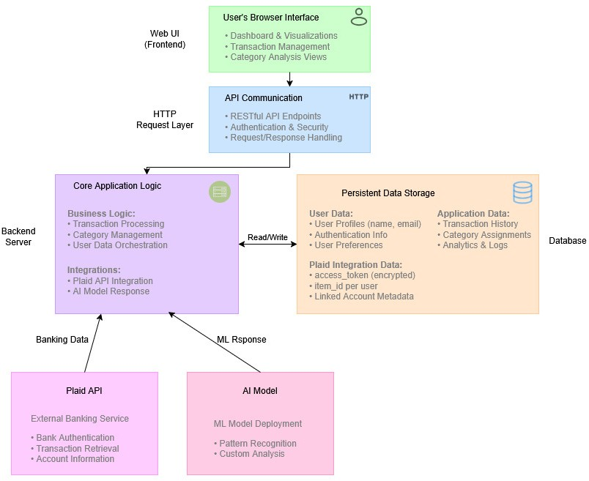
The financial system is comprised of three layers in this system architecture diagram, including a Web-based User Interface (UI) Front-end, a Backend server that hosts the business logic for the application and communicates with several outside services, and several outside services that the Backend server uses to execute its tasks.
The Front-end of the application provides the user experience and is used by the users' browsers for displaying the dashboard or transaction views. The Front-end communicates with the Backend using HTTP communications through an API Layer that performs all of the security checks and requests for the Front-end.
The Backend Server has the Core Business Logic for the application, which includes performing transactions on behalf of the user and managing the data associated with the user (e.g., user profile information, the history of application transactions). The Core Logic reads and writes data to the Persistent Data Store for both user profiles and the applications' history. A critical feature of the Core Logic is that it calls upon two external services: one is the Plaid API service that retrieves banking data and the other is an AI Model service that performs machine learning operations such as pattern recognition. As a result of these features, the application serves as a connected tool for both financial management and analysis.

Integration Sequence Diagram
Log in
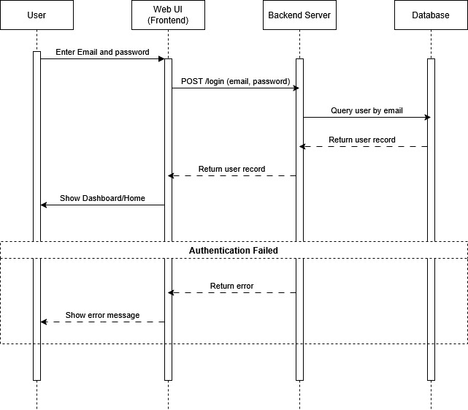
A typical user login process is shown in this diagram. First, the User enters his/her username & password (credentials) into the Web UI Frontend and submits them by sending a POST request to the Backend Server. After receiving the POST request from the Frontend, the Backend Server searches for the user’s records in the Database using the email entered by the User. Once the backend confirms that the user has successfully logged in, it returns the user’s records to the Frontend and the User can view the Dashboard. If the User cannot be authenticated, the Backend will send an error message to the Frontend and the User will receive an error message instead of being able to view the Dashboard.

Get Transactions
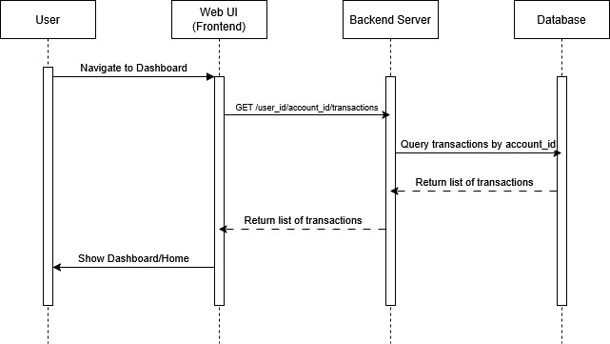
The diagram demonstrates how a user logs into his/her account and views the user's transaction history from the dashboard/home page. The user logs into the site via the web UI frontend sends a get request (get /user_id/account_id/transaction) to the backend server. The backend server will use the user's account id to query the database for the appropriate records. Once the backend server has received all of the relevant data back from the database, it is sent to the frontend by the backend server. The frontend then takes the received data and displays it as the full dashboard/home view to the user.

Plaid Link Initialization and Authentication
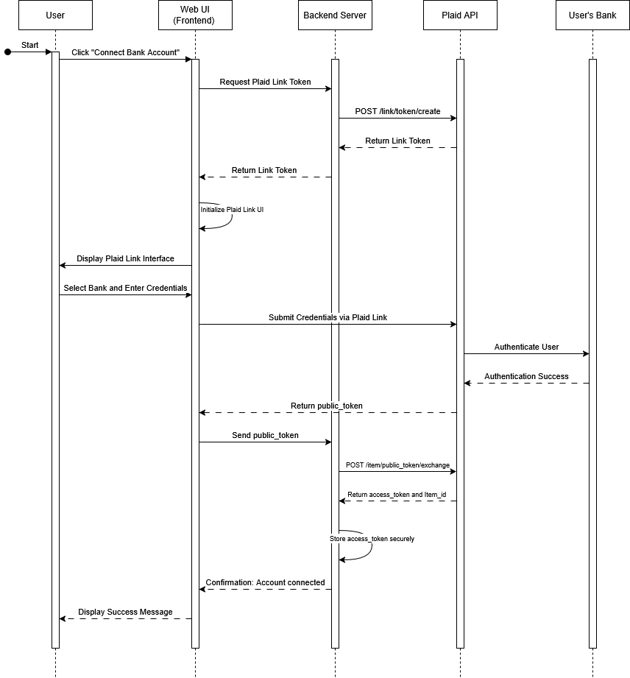
The diagram represents the safe way a user connects a bank account via the Plaid service, called the Plaid link flow.
The user begins the process by clicking on "connect bank account", in the web ui frontend, the frontend will make a request for a plaid link token to be created. The backend server is making a call to the Plaid API ( POST /link/token/create), for the creation of the link token and will return that to the frontend. The frontend will take the link token and use it to start up the plaid link interface to the user.
Next, the user will interact with the plaid link interface to select their bank and enter their login information. The user will input login credentials into the plaid link interface. The plaid link interface will submit the users login credentials and authenticate the user through the user’s banking system. Once authenticated successfully, the plaid link interface will return a public_token to the frontend.
Lastly, the frontend will send the public_token to the backend server. The backend server will exchange the public_token for a secure access_token and an item_id through a call to the Plaid API (POST /item/public_token/exchange). The backend will store the access_token safely. Then the backend will confirm "account connected" to the frontend, which will show the user a success message, finishing the process of connecting the users bank account.

Fetch Transactions
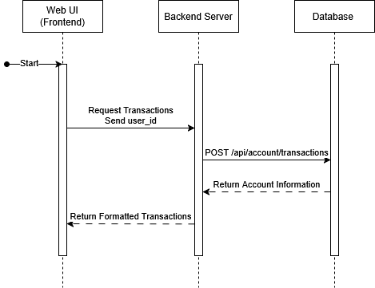
Above is a representation of how you would fetch, and then present to the end-user, their bank transaction history.
As such, this is the flow of events that occur when an End-User attempts to view their transactions through the Web UI Frontend. As the End-User loges in the system the frontend sends request to the Backend Server.
The Backend Server will then make two separate API calls to the database. The first call to the database is made using POST /api/accounts/transactions and will be used to fetch the user’s bank account details from the users’ bank. The Backend Server processes the transactions received from database and then formats the stored transactions into a format that can be easily displayed to the end-user.

Database Schema (ERD)


Accounts table is the root entity with account_id as its primary key, holding name, type, mask, balances_current, balances_available, and currency_code.
Users table sits just below it, with user_id as PK and fields for email, password, full_name, phone_number, plaid_access_token, plaid_item_id, is_active, and account_id as a foreign key back to accounts. So, the relationship is users to accounts (one-to-one).
Transactions table links to accounts via account_id. It holds transaction_id (PK), category_id, date, merchant_name, description, amount, currency_code, payment_channel, pending, and transaction_class. The crow's foot on the accounts side shows many transactions belong to one account.
Fm_encoded table is the feature engineering output. Has user_id and account_id as keys, then a large number of featuretools-generated columns like accounts.balances_current, accounts.COUNT(transactions),accounts.MEAN(transactions.amount),accounts.TIME_SINCE_LAST(transactions.date), plus custom metrics like vel_1d, vel_7d, vel_30d, days_since_last, merchant_diversity, new_merchant_count, task_segment, top_category, top_merchant, primary_spending_trend, avg_amt_30d, count_30d, account_ids, primary_account_id, and account_count.
Anomaly_scores table links to users via user_id. Stores iso_flag, lof_flag, is_anomaly, iso_score, lof_score, anomaly_score, severity, plus the velocity/behaviour features copied over (vel_1d, vel_7d, vel_30d, count_30d, avg_amt_30d, days_since_last, merchant_diversity, new_merchant_count), and anomaly_drivers, account_ids, primary_account_id, account_count, anomaly_drivers_json.
Forecasts table links to users via user_id. Contains forecast_month, n_months_history, segment, spend_forecast, spend_lower, spend_upper, spend_method, count_forecast, count_lower, count_upper, count_method, avg_amount_forecast, hist_avg_spend, hist_avg_count, last_month_spend, last_month_count, spend_pct_change_vs_hist, spend_direction, spend_vs_last_month_pct, top_category_forecasts, trend_summary, confidence_note, account_ids, primary_account_id, account_count, per_account_forecasts.
Recommendations table links to users via user_id. Stores primary_account_id, account_ids, account_count, segment, total_recommendations, high_priority_count, top_rec_type, top_rec_priority, top_rec_message, top_rec_action, all_recommendations, is_anomaly, anomaly_score.
Transactions_enriched table links to users via user_id and has account_id. Mirrors the transactions table but adds is_new_merchant, user_avg_amount, spend_anomaly_type, and deviation_ratio.
User_monthly_stats table links to both users and accounts. Has stats_id (PK), month_start_date, total_amount, total_transactions, total_spent, total_received, avg_transaction, largest, largest_abs, spending_by_category.
User_all_time_stats table links to users via user_id and account_id. Stores total_transactions, avg_transactions_value, and largest_transaction.

AI/ML Training and Deployment Pipeline
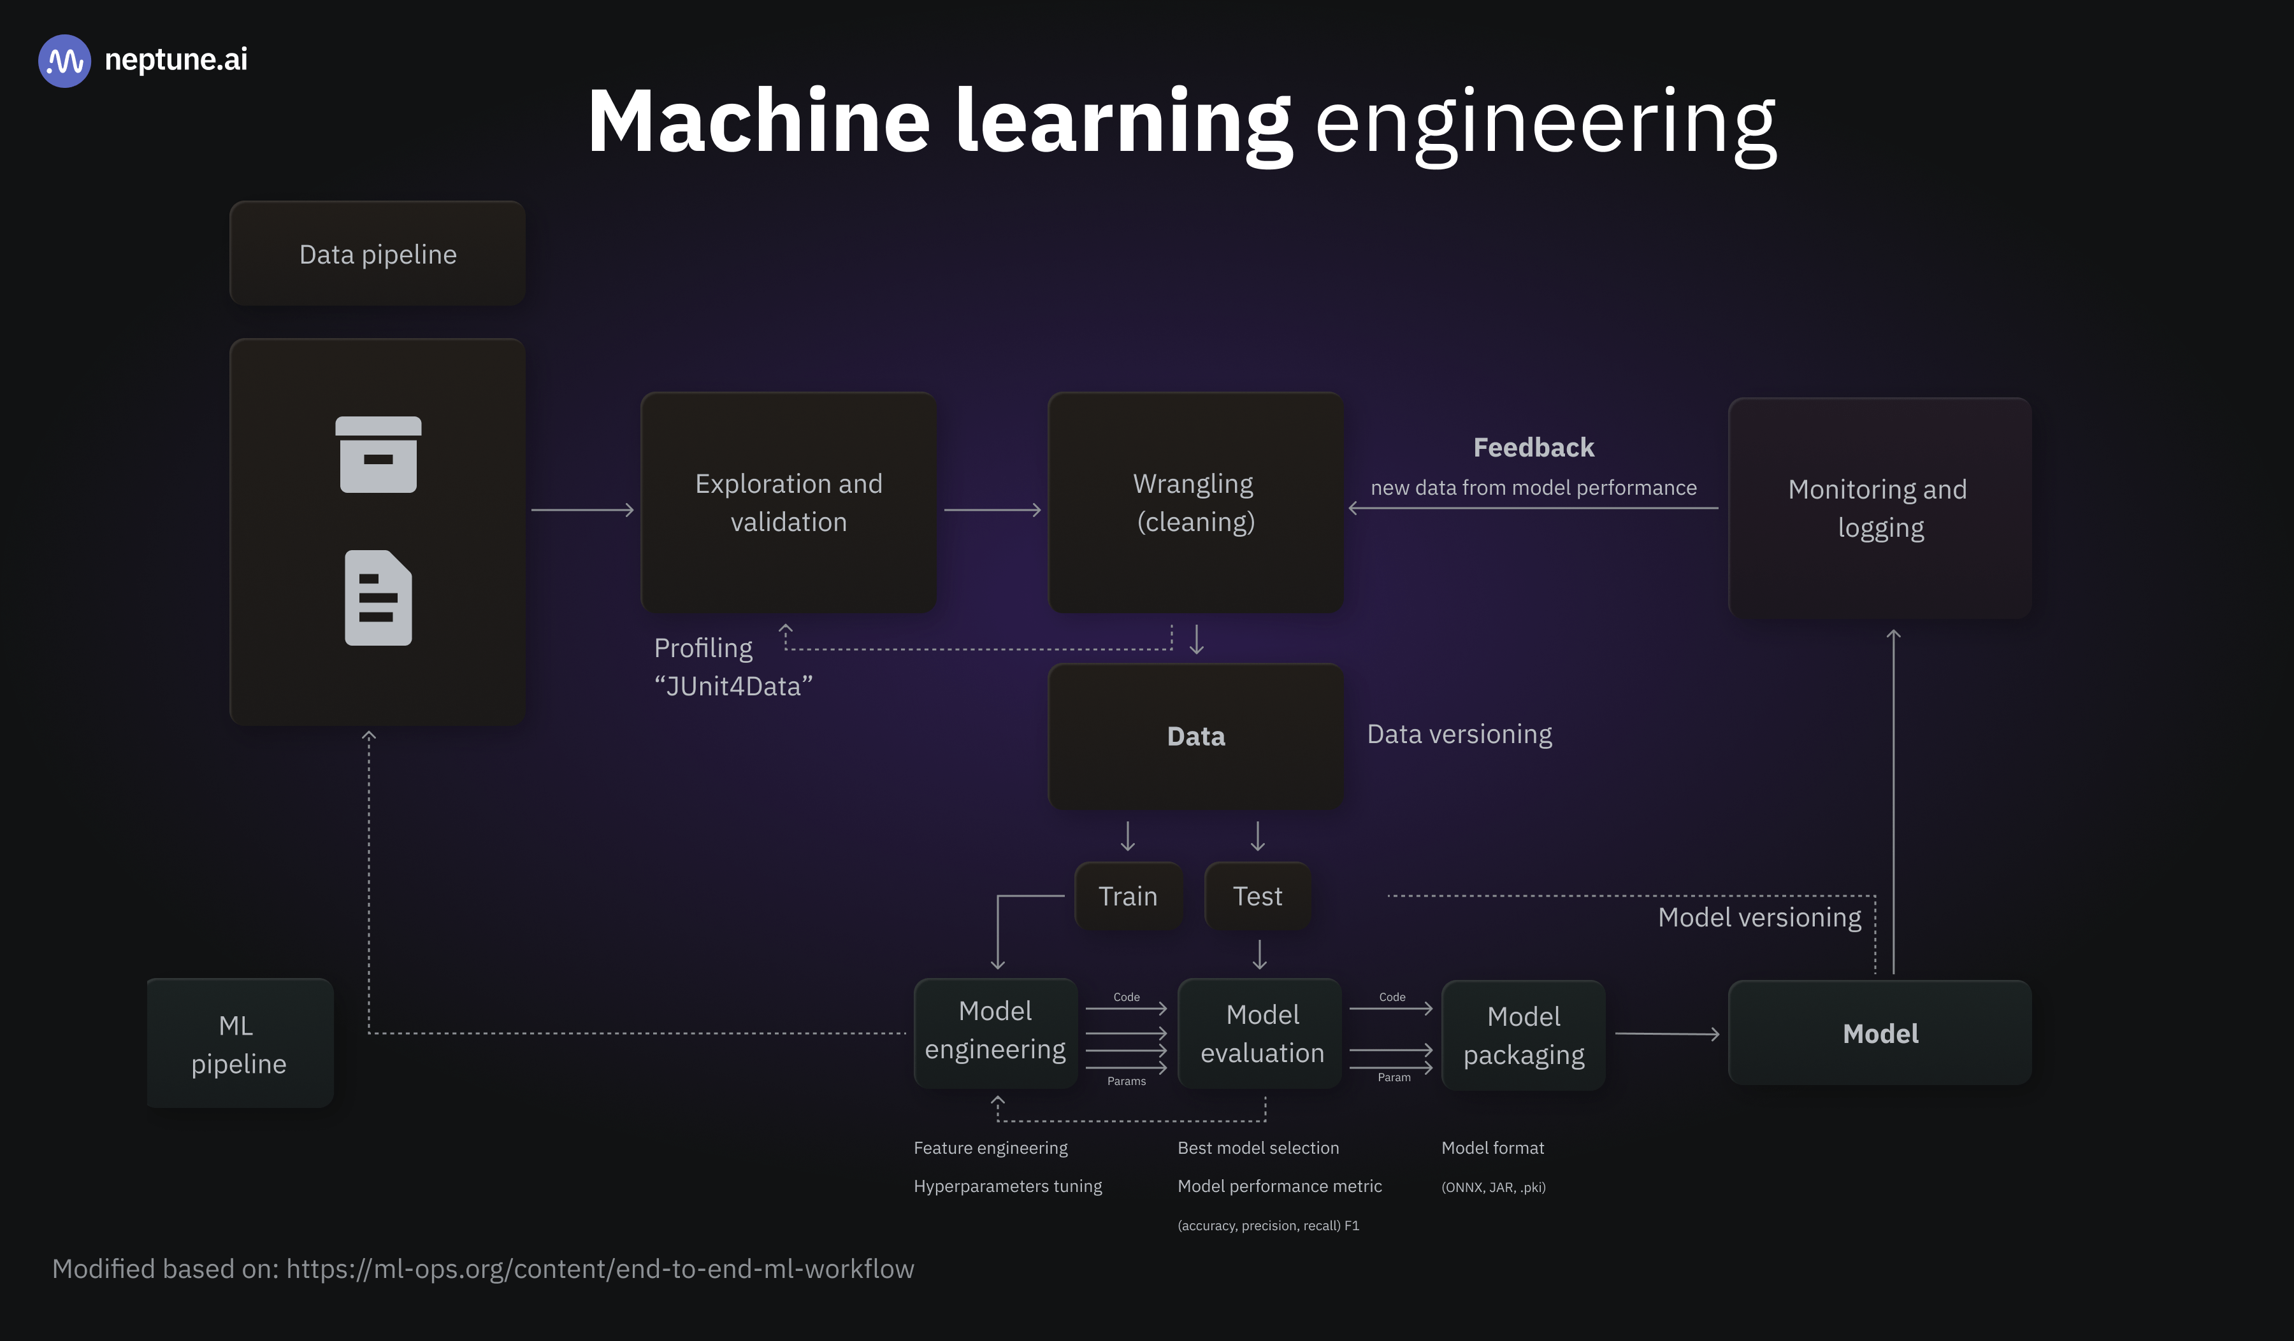
(Henrique Pett, 2025)
This Workflow ties together numerous steps through a looped system to show the Data processing steps and the development of Models and their Evaluation and Maintenance processes.
The first part of the Workflow is the Data pipeline, which takes raw data and sends it to three other parts of the workflow:
- Exploration/Validation (Data profiling).
- Cleaning (Wrangling), preparing the Data for use by a Model.
- Final Data (The final dataset): This last part of the Data pipeline uses Data Versioning to track all versions of the final dataset.
Once the Data has been cleaned by the Data pipeline, it is split into two groups:
- A Train group to feed into Model Engineering (steps include feature engineering and hyperparameter tuning).
- A Test group to test the best performing Model from Model Engineering (best Model is determined by comparing Model performance metrics (accuracy, precision, recall, F1)).
Both the output of Model Engineering and the Test Group go to Model Evaluation.
The best Model, as determined by Model Evaluation, goes to Model Packaging (Model is saved in Model Format (ONNX, JAR, PKL)) and is assigned a Model version number.
The output of the entire Workflow is the Model. After being deployed, the Model is monitored and logged. Metrics gathered during Monitoring provide Feedback about the Model's performance that can be used to send new Data from the Model's performance to the cleaning (wrangling) portion of the Data pipeline, and therefore create an ongoing cycle of improvements.

Activity Diagram
Plaid Login
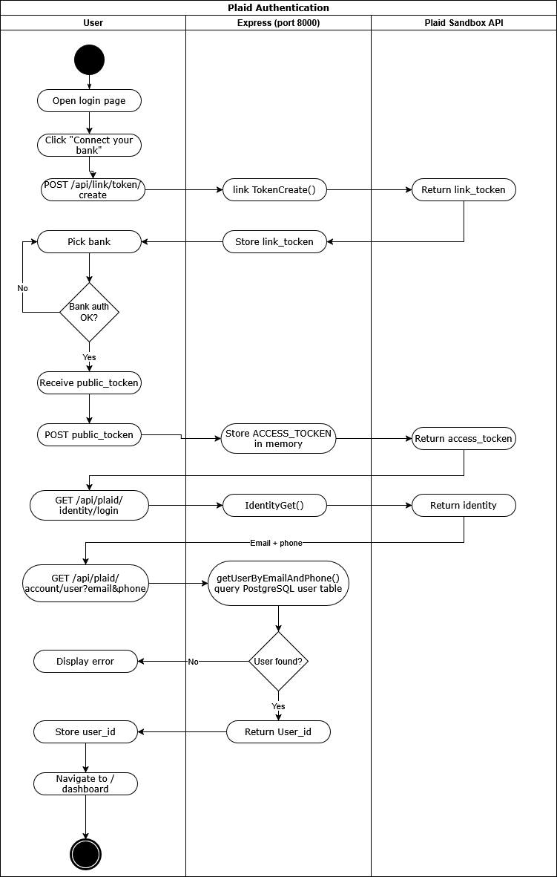
CSV Upload and Onboarding
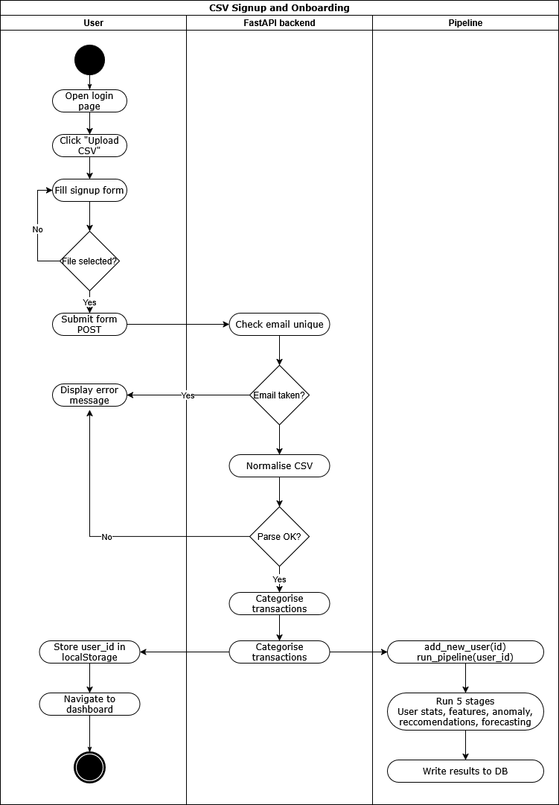

Dashboard Data Load
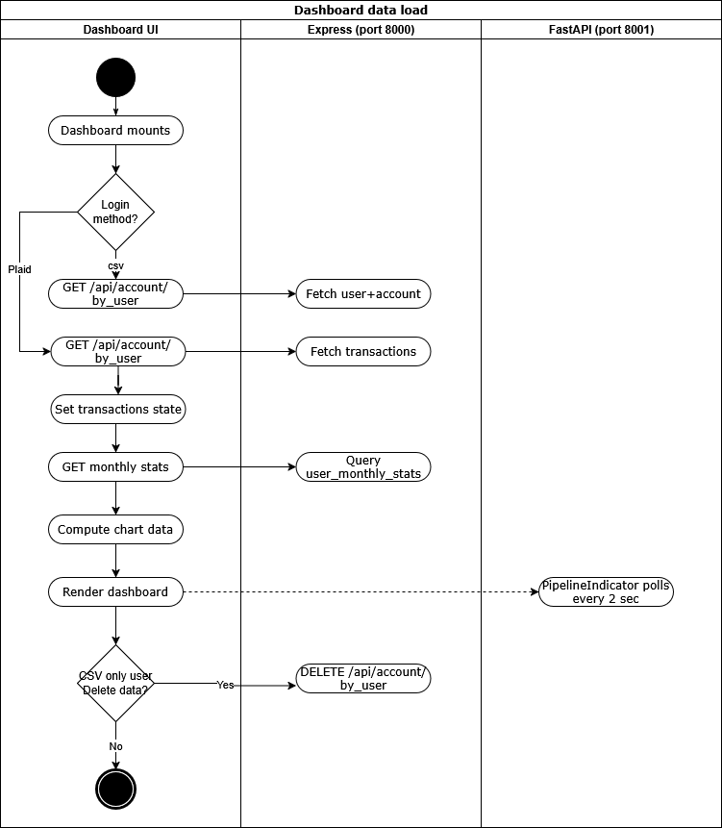
AI Chat Query
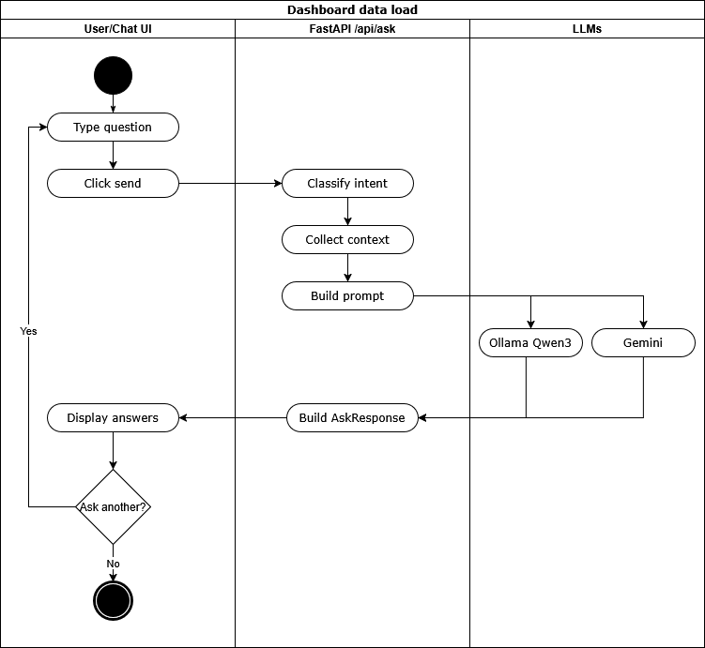

Chatbot Interaction Flowchart
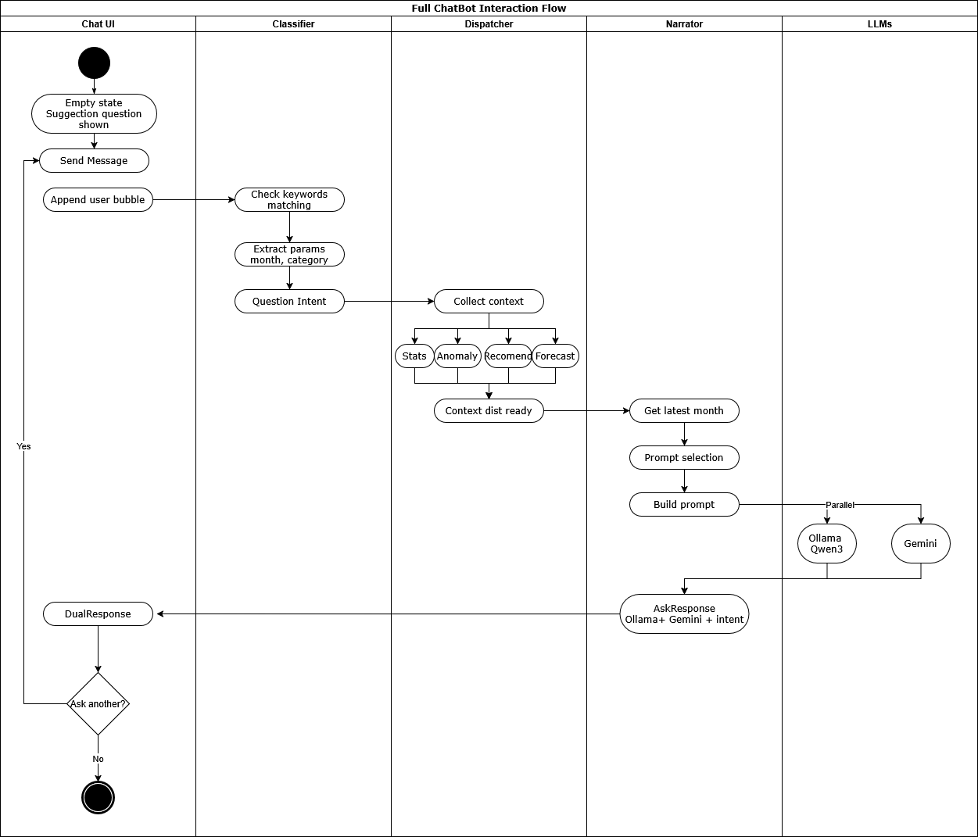
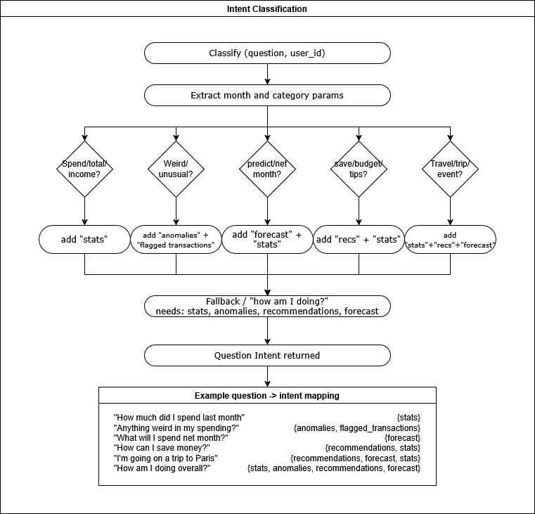
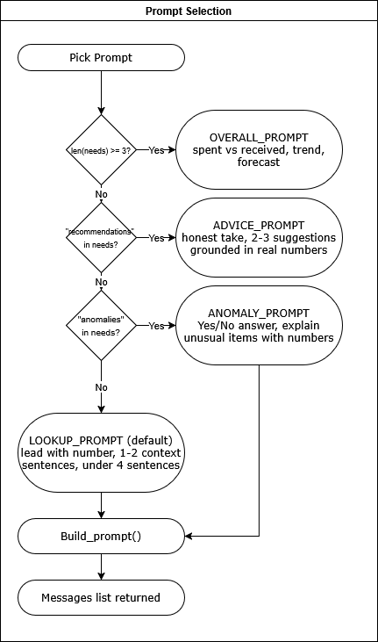

Data Flow Diagrams (DFDs)
Level 0
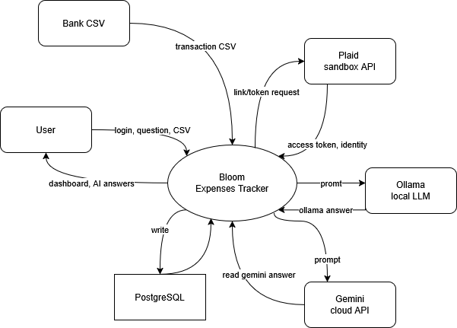

Level 1
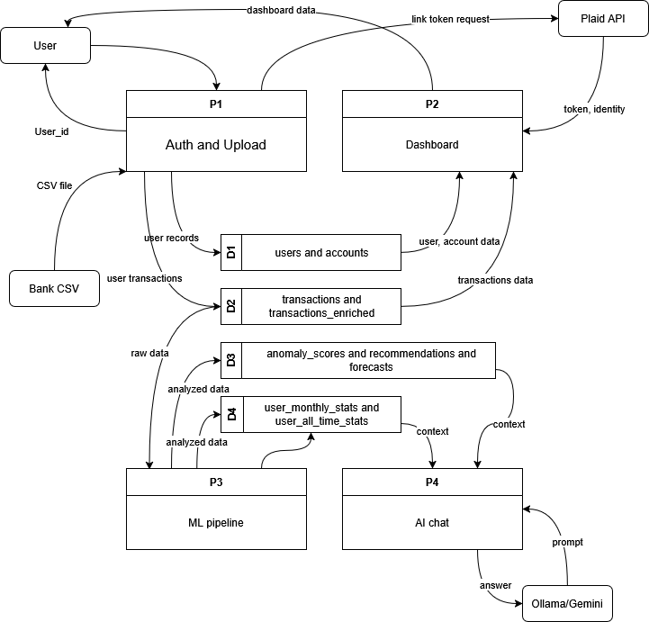

Wireframes
Log in
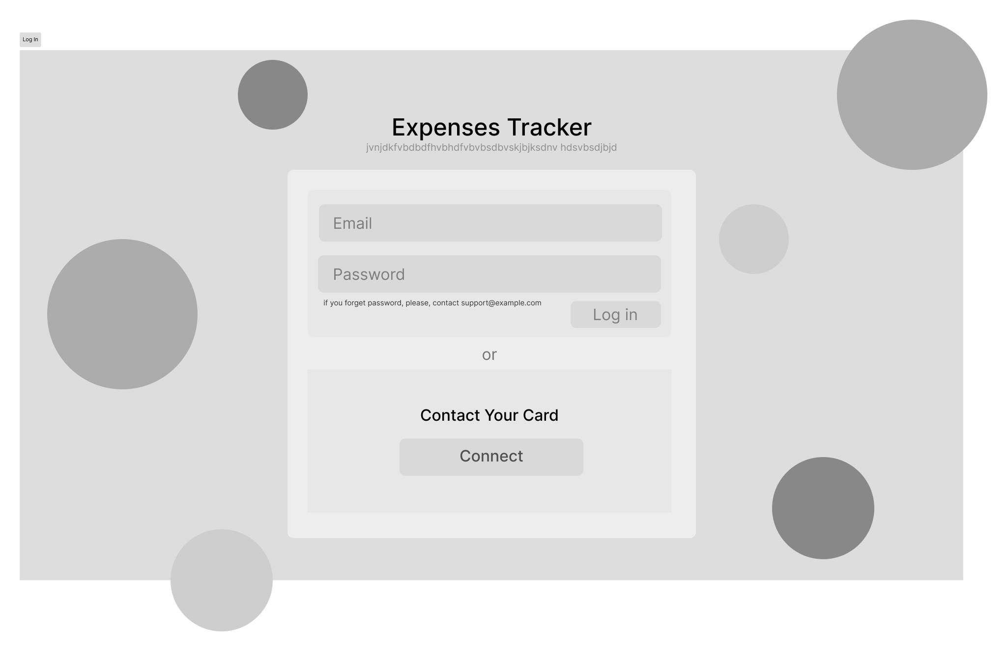

Dashboard/Home Page
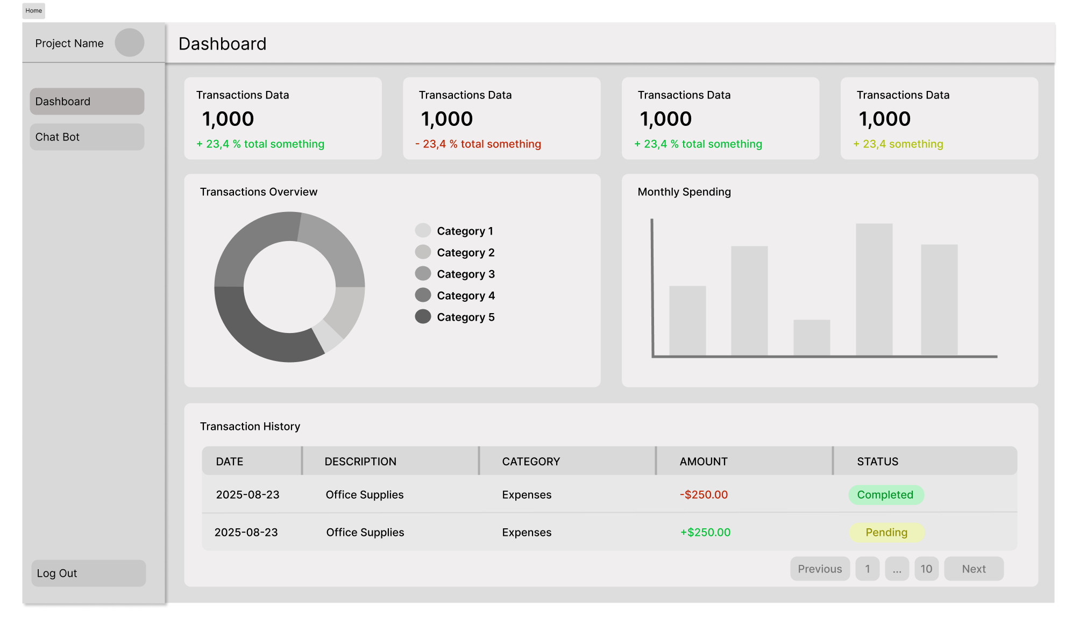

Chat Bot Page
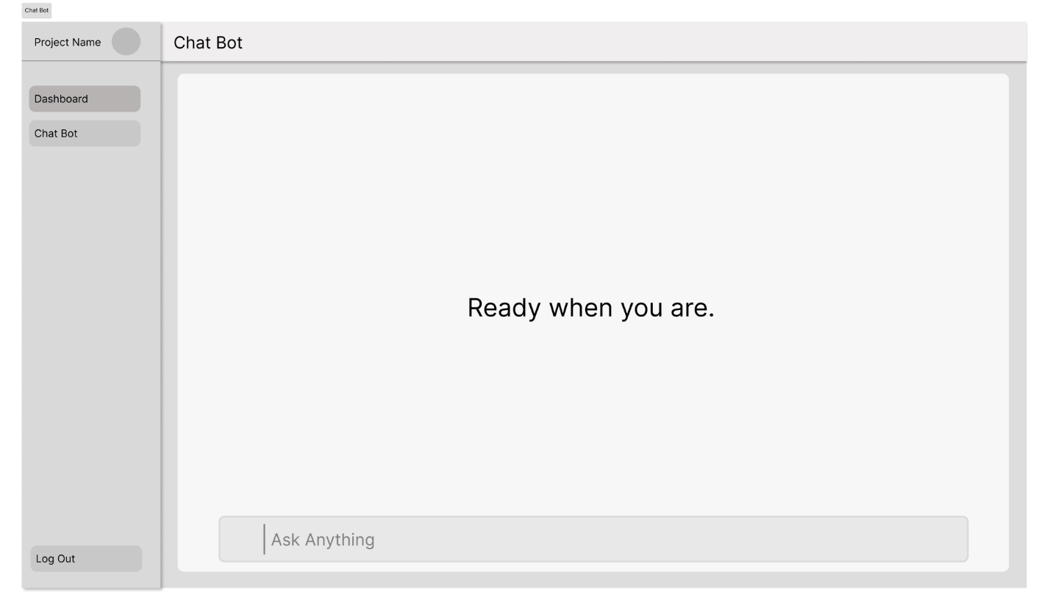
Chat Bot in Action
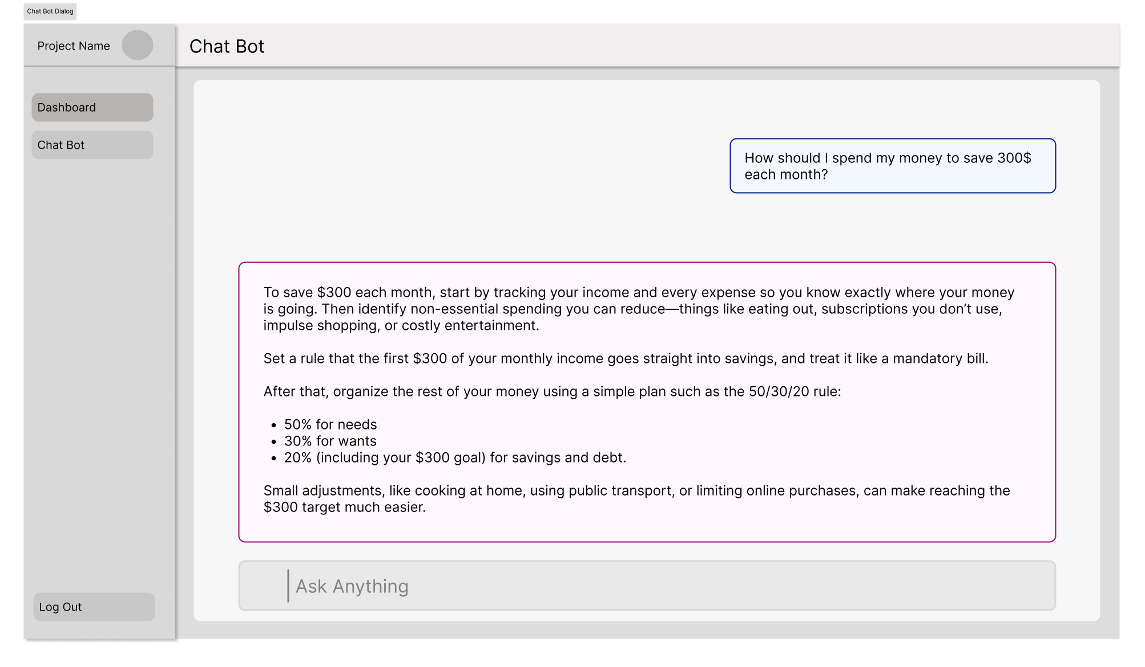

Plaid API Interface
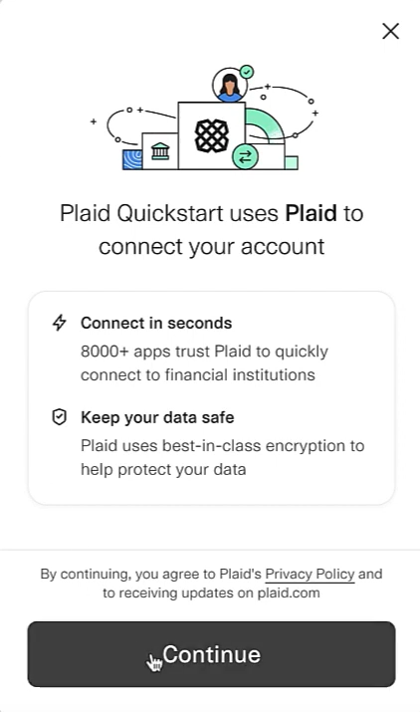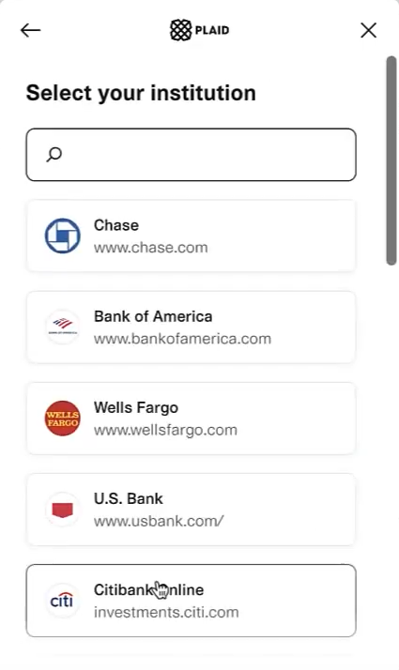
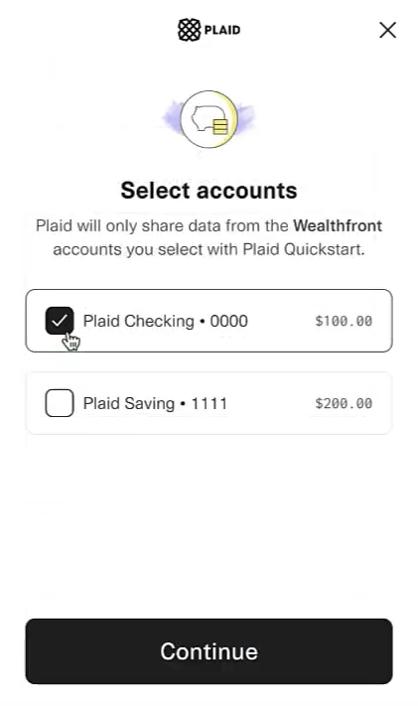


User Interface
Login Page
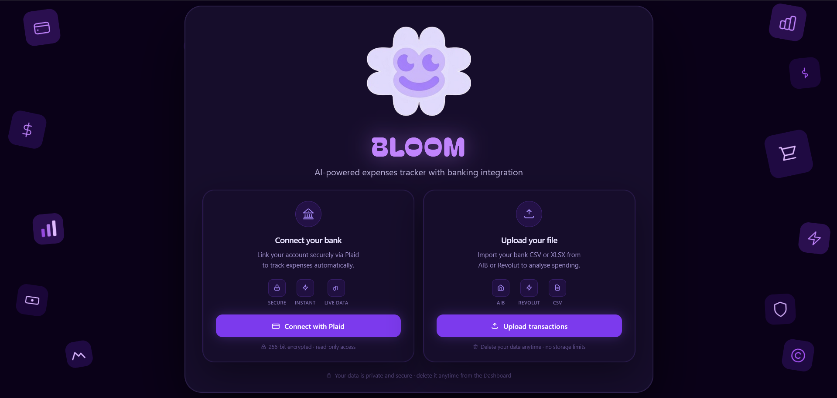
Registration Page
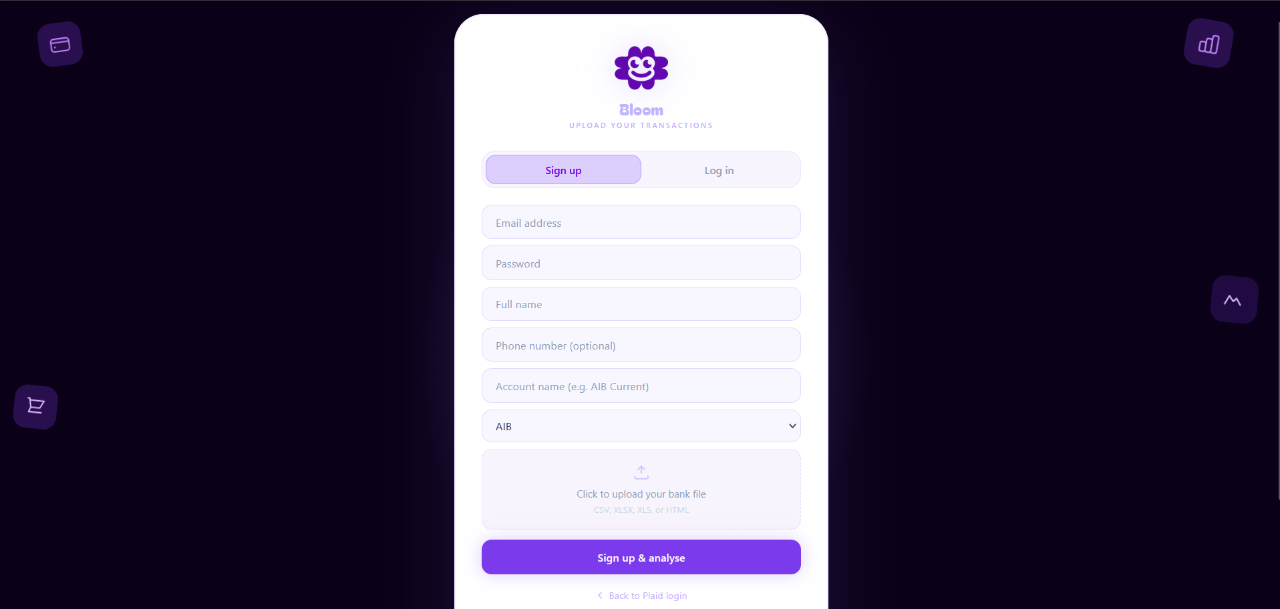
Login Upload Page
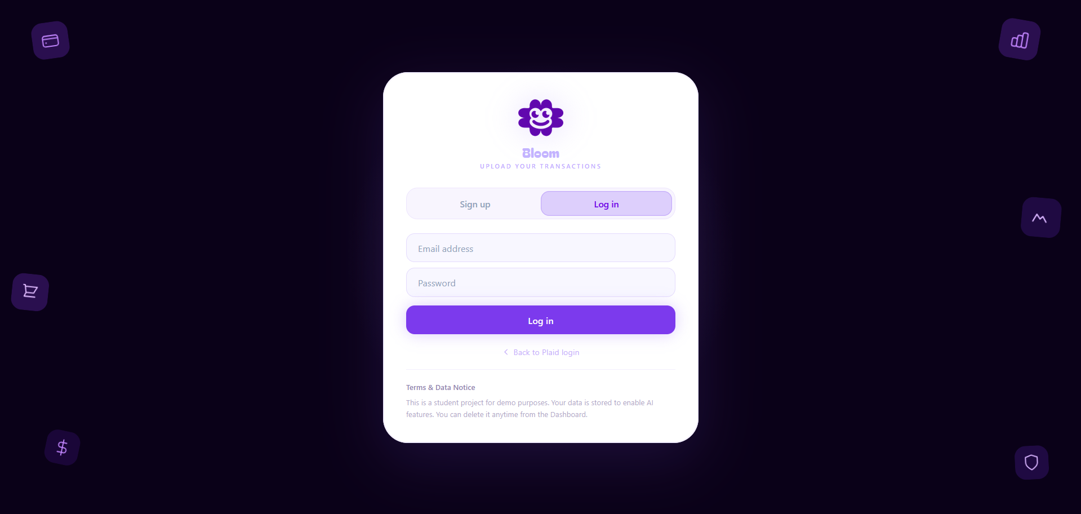
Dashboard Page
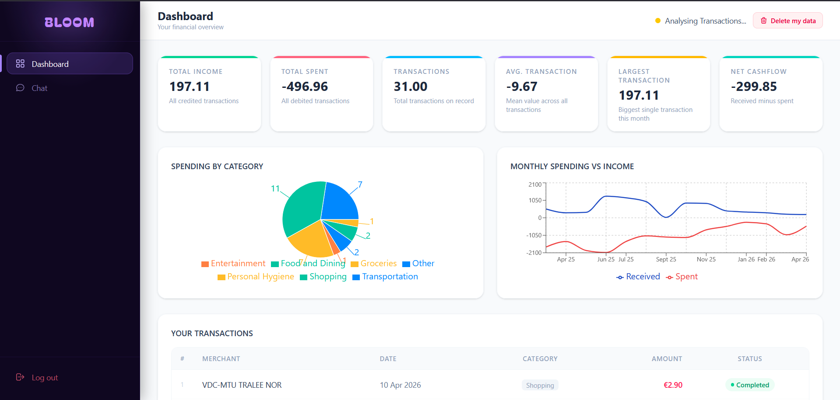
Chat Bot Page
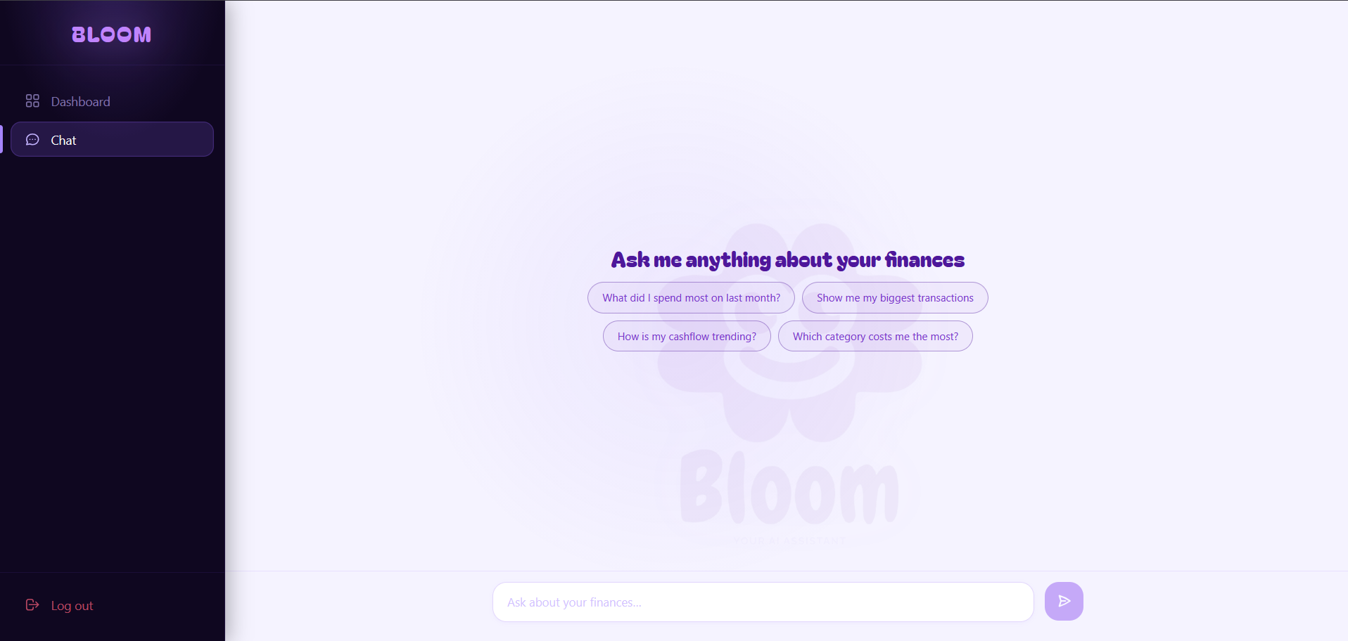
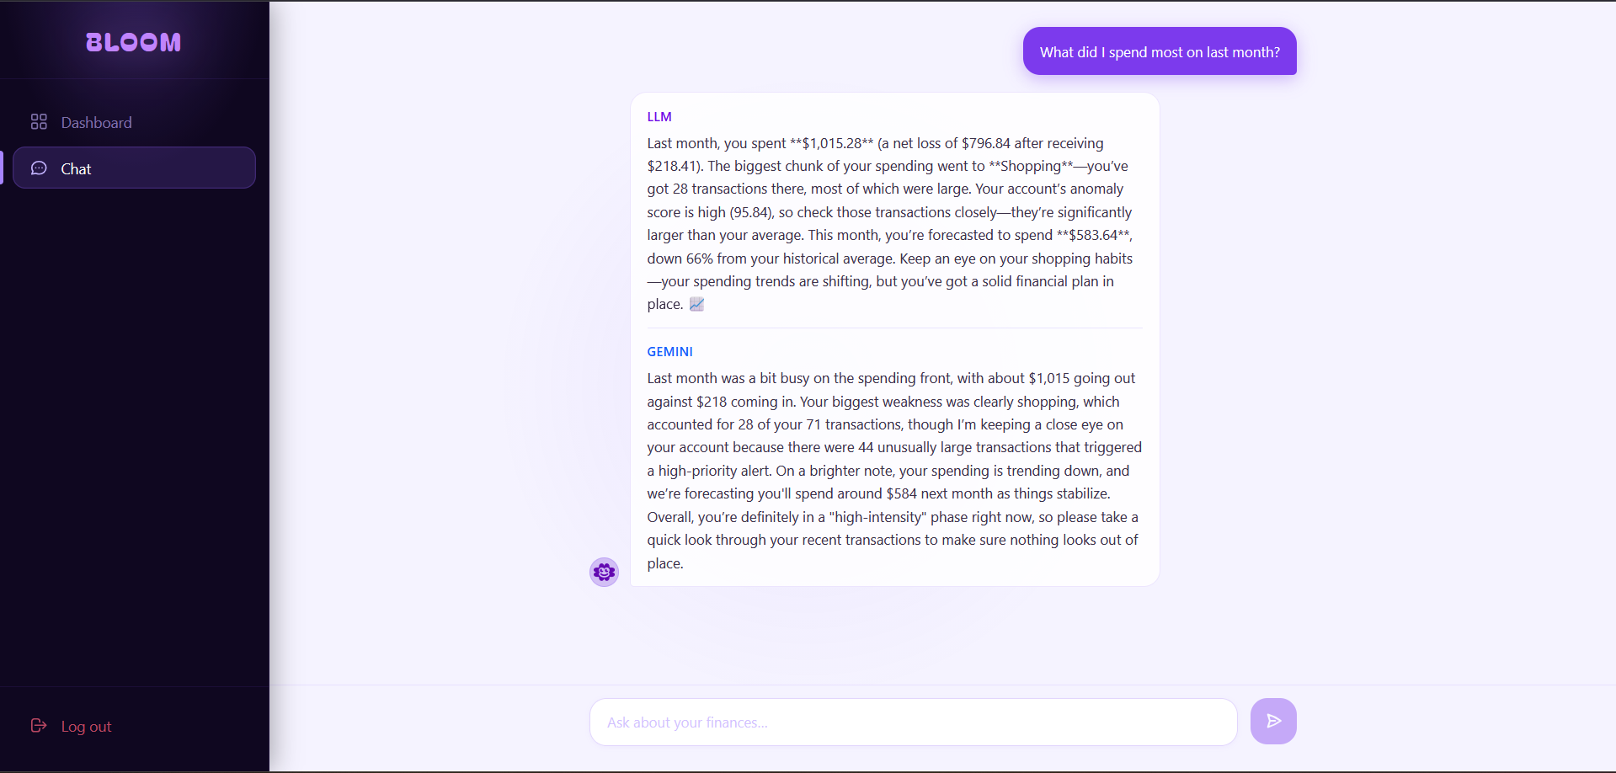

Justification

Research Question
How can an AI-driven conversational interface, powered by both local and cloud-hosted large language models, improve personal expense tracking and deliver actionable financial insight to users?
How can a privacy-preserving, locally-hosted large language model be effectively integrated into a personal finance application to deliver conversational financial insight without transmitting sensitive data to third-party services?

Project Specification
This project will create a fully functional end-to-end demo application. In addition to the web-based application with a responsive interface for user access, the demo will include the banking simulation application that connects via Plaid link to mimic connecting a user's card/account using the sandbox environment. Once connected the demo application will pull down transactions from the sandbox and display the data in a dashboard view of the user's spending patterns. The other key deliverable will be the AI chatbot application which allows users to have a conversation with the application to ask questions about how they are spending money. The AI will take into consideration the user's historical spending patterns, evaluate those patterns against previously established rules for spending money and generate responses based upon a set of previously defined rules. The demo will not attempt to retrieve information from real-time banking accounts or cards due to limitations of Plaid Sandbox, and due to the complexity of providing certified security standards required to connect to real time banking cards/accounts, these aspects are also outside the scope of this project.

Objectives
The goal for this project is to show how you can apply machine learning to real-world problems such as financial management through a practical example, so users have automated, actionable insights into their spending patterns. By the end of the second semester,
- Develop a functional web application that securely accesses user’s bank accounts, processes them and categorizes each transaction by category.
- Design an AI model that will achieve a minimum transaction analyze response accuracy rate of 85% using the project’s test dataset.
- Develop a clean and easy-to-use user interface so users can easily connect to a bank account and see their key expense report in 3 clicks or less from the main dashboard.
- All sensitive information (User credentials, Access tokens) should be secured, encrypted and stored according to industry best practice and API requirements (i.e. Plaid Token Exchange Process).

Requirements
Epic | Description | Complexity | Duration | Priority
Semester 1
Epic 1 | Literature Review/Doc | Low | 300 | Low
Epic 2 | Design Document | Medium | Weeks 2 | High
Epic 3 | Implementation/Setup | Low | Weeks 1 | Medium
Epic 4 | Research | Medium | 300 | High
Epic 5 | Data Collection | High | Weeks 7 | High
Epic 6 | Data Analysis | High | Weeks 2 | High
Epic 7 | Prototype | Medium | Weeks 3 | High
Semester 2
Epic 1 | Plaid User Authentication & Authorization | High | Weeks 2 | High
Epic 2 | Banking API Integration & Data Sync | Medium | Weeks 1 | Medium
Epic 3 | AI Model Development | High | 420 | High
Epic 4 | Model Testing | Medium | Weeks 3 | High
Epic 5 | AI Chatbot Comparison | Low | Week 1 | High
Epic 6 | Frontend Interface | Low | Weeks 2 | Low
Epic 7 | Finalizing Report | Low | Weeks 1 | Low

Methodology Overview
The development of the Personal Expenses Tracker with an AI-Powered Financial Advisor followed a structured, iterative, and methodical process aligned with standard software engineering practices.
The first phase focused on requirement analysis and planning. I began by examining existing personal finance applications to understand their strengths and limitations. This investigation highlighted a significant gap in the market: although these tools provide tracking and categorisation, they lack the type of personalised, conversational financial guidance that modern users increasingly expect. Based on this analysis, I defined the functional requirements for the system, which included secure banking integration through Plaid, persistent transaction storage, an interactive visual dashboard, and an AI component capable of giving tailored spending and saving advice. At the same time, I identified several non-functional requirements such as ensuring rapid system performance, data privacy and friendly user interface.
The second phase involved detailed system design. During this stage, a high-level architectural blueprint was created describing how the frontend, backend, database, and external services would interact with one another. This was followed by the development of several UML diagrams, including use case diagrams, activity diagrams, sequence diagrams for both Plaid and AI workflows, and multi-level data flow diagrams, to ensure that the behaviour of each system component was clearly defined. I also designed the database schema, establishing the structure for tables responsible for users, tokens, transactions, categories, and chat history. In parallel, I developed the prompt-engineering strategy for the AI advisor, constructing templates and context-generation logic that would allow the model to deliver consistent and accurate financial recommendations.
With the design in place, the third phase adopted an iterative prototyping methodology for second semester. The first is authentication and Plaid integration. During this period, I will implemented Plaid Fast Link authentication and connected the application to the Plaid Sandbox, enabling users to securely link financial accounts. The second step focused on transaction handling and the dashboard interface. This involved normalising the transaction data structure, implementing a hybrid categorisation system using both Plaid labels and custom rules, and constructing a responsive dashboard. The third step centred on developing the first version of the AI chatbot. For this, I will create my own pipeline, which will prepare data for local LLM to process for generating personalised financial context summaries, and implemented real-time messages.
The fourth phase covers testing, which will be integrate throughout development but also conducted more comprehensively toward the end. Unit testing will apply to backend routes. Integration testing will perform using Plaid’s Sandbox accounts to simulate realistic user interactions, such as onboarding, transaction retrieval, and dashboard loading. Performance tests will confirm that the AI response time average and the dashboard loading.
(???
Deployment and documentation will form the fifth phase. The frontend will be deployed. Continuous integration and deployment pipelines will configure through GitHub Actions to automate testing and deployment stages.
The final phase considers ethical and legal aspects. Throughout the project, only Plaid Sandbox data will used to avoid handling real financial information during development. Data encryption will implement both at rest and in transit to uphold security standards. The application clearly informs users that the AI produces general financial suggestions rather than professional financial advice.
???)

Data Collection Methodologies
The main issue that arose during this project was getting the appropriate data. For the study, the researchers needed a dataset consisting of actual or simulated credit card transactions that would resemble how consumers spend their money in real life. More specifically, the dataset needed to have multiple credit cards with many transactions on each card, and include important attributes (e.g., merchant ID, date/time, and amount) that would be necessary to fulfil the goals of the project. Collecting data at a detailed level was necessary for the research but publicly available databases rarely contain this type of detail.
A preliminary review of existing data sets was completed through several online repositories, including Kaggle and other public open data sites, using search terms such as “credit card transactions,” “fraud detection in credit card transactions,” and “simulating user spending.” Most of the retrieved data sets included random numbers or basic examples of transactions that did not adequately represent how people use their credit cards in real life. In particular, most of the data sets lacked realistic relationships between the consumers who owned the cards, the cards themselves, and the way they used the cards in real life.
When searching again, educational resources about the Plaid API were explored. Plaid is a company that offers financial technologies to help companies develop applications that connect to bank data and therefore could be relevant to the project. A tutorial presented by Plaid in its YouTube channel showed that the .transactions feature in the Plaid API can generate transaction data that appears to have been generated organically rather than manually created. The fact that this data seemed organic motivated me to explore the data source.(Plaid, 2022)
Further research showed that Plaid’s Sandbox environment generates simulated banking data, which includes synthetic, yet realistic cards, accounts, and transactions. These synthetic records are specifically intended to support developers’ ability to test applications that interact with financial data in a controlled environment. Since the project’s needs matched exactly the capabilities described, a method was developed to extract the simulated data from the sandbox into a format that was suitable for analysis via CSV files. Using ChatGPT and the previously referenced tutorial, the script was developed written in JavaScript that connected to the API, authenticated with the sandbox environment, and then retrieved the transaction data. The rapid completion of the script using AI-assisted coding made the process faster and more efficient, especially since experience with developing scripts for interacting with Plaid’s sandbox environment had limited.
According to Plaid’s documentation, the sandbox environment represents multiple simulated banks (institutions), where each institution has a unique identifier, simulates a banking entity, and includes accounts with various balances, historical transaction activity, and user information. Therefore, the simulated data within the sandbox is diverse enough to support thorough analysis. However, there were additional issues when collecting the data: some institutions listed in the official documentation no longer operated and/or lacked full identity information for cardholders. Important to verify each institution's functionality manually due to inconsistencies in the accuracy of the documentation.
Using repeated testing cycles, the cards were successfully extracted, transactions, and limited identity information including username and account details. Although the collected dataset was substantial, but not sufficient to train a fully functional artificial intelligence model.
To expand the dataset and make it usable for developing an artificial intelligence model, the same process was replicated using similar platforms that provide financial APIs with sandbox or demo environments. Additionally, the Plaid’s terms of service were reviewed to ensure that the use of the sandbox data complies with all applicable policies. Review of the documentation confirms that the use of sandbox data for research purposes is allowed, provided that the data is not used for commercial purposes or to generate income.
This experience demonstrates that often, creating accurate financial datasets for complex analyses involves combining data from multiple data sources. While publicly available datasets may have limitations, simulated environments such as Plaid’s sandbox environment can provide alternatives for creating data that more closely mimics the real world nature of transaction patterns.
Primary focus during this phase was the review of the data collection script export_paid_sandbox.js, which was designed to efficiently interact with the Plaid Sandbox environment. This script is getting the necessary financial data, such as accounts, transactions, and identity information that will form the basis of the project’s analysis.
//export_plaid_sandbox.js
1. require('dotenv').config();
2. const fs = require('fs');
3. const { PlaidApi, Configuration, PlaidEnvironments } = require('plaid');
4. const createCsvWriter = require('csv-writer').createObjectCsvWriter;
5.
6. const clientConfig = new Configuration({
7. basePath: PlaidEnvironments[process.env.PLAID_ENV || 'sandbox'],
8. baseOptions: {
9. headers: {
10. 'PLAID-CLIENT-ID': “PLAID-CLIENT-ID",
11. 'PLAID-SECRET': "PLAID-SECRET"
12. },
13. },
14. });
15.
16. const client = new PlaidApi(clientConfig);
17.
18. const sleep = (ms) => new Promise(resolve => setTimeout(resolve, ms));
19.
20. const SANDBOX_INSTITUTIONS = [
21. 'ins_109508',
22. 'ins_109509',
23. 'ins_109512',
24. 'ins_109510',
25. 'ins_109511',
26. 'ins_43',
27. ‘ins_116834',
28. 'ins_117650',
29. 'ins_127287',
30. 'ins_132241',
31. 'ins_117181',
32. 'ins_135858',
33. 'ins_132363',
34. 'ins_132361',
35. 'ins_133402',
36. 'ins_133502',
37. 'ins_133503'
38. ];
39.
40. const PRODUCTS = ['transactions', 'identity'];
41.
42. const PAGE_SIZE = 100;
43.
44. const ACCOUNTS_CSV = 'accounts.csv';
45. const TRANSACTIONS_CSV = 'transactions.csv';
46. const IDENTITY_CSV = 'identity.csv';
47.
48. (async function main() {
49. try {
50. const allAccounts = [];
51. const allTransactions = [];
52. const allIdentityRows = [];
53.
54. for (const institution_id of SANDBOX_INSTITUTIONS) {
55. console.log(`\n--- Creating sandbox public_token for ${institution_id} ---`);
56.
57. const createResp = await client.sandboxPublicTokenCreate({
58. institution_id,
59. initial_products: PRODUCTS,
60. options: {
61. webhook: 'https://example.com/fake-webhook',
62. },
63. });
64.
65. const public_token = createResp.data.public_token;
66. console.log('public_token created');
67.
68. const exchangeResp = await client.itemPublicTokenExchange({ public_token });
69. const access_token = exchangeResp.data.access_token;
70. console.log('access_token received');
71.
72. await client.sandboxItemFireWebhook({
73. access_token,
74. webhook_code: 'DEFAULT_UPDATE',
75. webhook_type: 'TRANSACTIONS',
76. });
77.
78. console.log('Waiting 5 seconds for Transactions data to become ready...');
79. await sleep(5000);
80.
81. // ==== Accounts ====
82. try {
83. const accountsResp = await client.accountsGet({ access_token });
84. const accounts = accountsResp.data.accounts || [];
85. for (const a of accounts) {
86. allAccounts.push({
87. institution_id,
88. account_id: a.account_id,
89. name: a.name,
90. official_name: a.official_name,
91. subtype: a.subtype,
92. type: a.type,
93. mask: a.mask,
94. balances_current: a.balances?.current,
95. balances_available: a.balances?.available,
96. balances_limit: a.balances?.limit,
97. iso_currency_code: a.balances?.iso_currency_code,
98. });
99. }
100. console.log(` accounts: ${accounts.length}`);
101. } catch (err) {
102. console.error(' accounts/get error:', err?.response?.data || err.toString());
103. }
104.
105. // ==== Auth (with product support validation) ====
106. try {
107. if (PRODUCTS.includes('auth')) {
108. const authResp = await client.authGet({ access_token });
109. const numbers = authResp.data.numbers || {};
110. const authAccounts = authResp.data.accounts || [];
111.
112. console.log(` auth accounts: ${authAccounts.length} (ACH/EFT/International numbers available)`);
113.
114. } else {
115. console.log(' auth: Skipped (not in PRODUCTS list).');
116. }
117. } catch (err) {
118. const isProductUnsupported = err?.response?.data?.error_code === 'PRODUCT_NOT_SUPPORTED';
119.
120. if (isProductUnsupported) {
121. console.log(' auth/get: Product not supported by this institution. Skipping auth.');
122. } else {
123. console.error(' auth/get unexpected error:', err?.response?.data || err.toString());
124. }
125. }
126.
127. // ==== Transactions ====
128. const endDate = new Date();
129. const startDate = new Date();
130. startDate.setFullYear(startDate.getFullYear() - 2);
131.
132. let offset = 0;
133. while (true) {
134. try {
135. const txResp = await client.transactionsGet({
136. access_token,
137. start_date: startDate.toISOString().slice(0, 10),
138. end_date: endDate.toISOString().slice(0, 10),
139. options: { count: PAGE_SIZE, offset }
140. });
141. const txs = txResp.data.transactions || [];
142. console.log(` fetched transactions: ${txs.length} (offset ${offset})`);
143. for (const t of txs) {
144. allTransactions.push({
145. institution_id,
146. account_id: t.account_id,
147. transaction_id: t.transaction_id,
148. amount: t.amount,
149. date: t.date,
150. pending: t.pending,
151. merchant_name: t.merchant_name,
152. name: t.name,
153. category: (t.category || []).join('|'),
154. transaction_type: t.transaction_type,
155. payment_channel: t.payment_channel,
156. pending_transaction_id: t.pending_transaction_id || ''
157. });
158. }
159. if (txs.length < PAGE_SIZE) break;
160. offset += txs.length;
161. } catch (err) {
162. console.error(' transactions/get error:', err?.response?.data || err.toString());
163. break;
164. }
165. }
166.
167. // ==== Identity ====
168. try {
169. const idResp = await client.identityGet({ access_token });
170. const identityAccounts = idResp.data.accounts || [];
171. for (const ia of identityAccounts) {
172. allIdentityRows.push({
173. institution_id,
174. account_id: ia.account_id,
175. owners: JSON.stringify(ia.owners || []),
176. names: JSON.stringify(ia.names || []),
177. emails: JSON.stringify((ia.owners || []).map(o => o.email || null)),
178. phones: JSON.stringify((ia.owners || []).map(o => o.phones || null)),
179. });
180. }
181. console.log(` identity accounts: ${identityAccounts.length}`);
182. } catch (err) {
183. console.error(' identity/get error:', err?.response?.data || err.toString());
184. }
185. }
186.
187. // === Write CSVs ===
188. // accounts.csv
189. if (allAccounts.length) {
190. const accountsCsvWriter = createCsvWriter({
191. path: ACCOUNTS_CSV,
192. header: Object.keys(allAccounts[0]).map(k => ({ id: k, title: k })),
193. });
194. await accountsCsvWriter.writeRecords(allAccounts);
195. console.log(`\nWrote ${ACCOUNTS_CSV} (${allAccounts.length} rows)`);
196. } else console.log('\nNo accounts to write.');
197.
198. // transactions.csv
199. if (allTransactions.length) {
200. const txCsvWriter = createCsvWriter({
201. path: TRANSACTIONS_CSV,
202. header: Object.keys(allTransactions[0]).map(k => ({ id: k, title: k })),
203. });
204. await txCsvWriter.writeRecords(allTransactions);
205. console.log(`Wrote ${TRANSACTIONS_CSV} (${allTransactions.length} rows)`);
206. } else console.log('No transactions to write.');
207.
208. // identity.csv
209. if (allIdentityRows.length) {
210. const idCsvWriter = createCsvWriter({
211. path: IDENTITY_CSV,
212. header: Object.keys(allIdentityRows[0]).map(k => ({ id: k, title: k })),
213. });
214. await idCsvWriter.writeRecords(allIdentityRows);
215. console.log(`Wrote ${IDENTITY_CSV} (${allIdentityRows.length} rows)`);
216. } else console.log('No identity rows to write.');
217. console.log('\nDone.');
218. } catch (err) {
219. console.error('Fatal error:', err?.response?.data || err.toString());
220. }
221. })();
222.
After collecting the first set of data using Plaid’s sandbox environment, an attempt to collect additional data sets from alternative financial API platforms such as MasterCard sandbox, TrueLayer and a number of other similar services, was undertaken to increase the size and diversity of the dataset collected. This multi- source integration of data collections was intended to increase the overall amount of data collected for analysis. However, this endeavor was hampered by numerous technical problems that occurred with the sandbox environments of many of the other platforms. These technical issues included authentication failure, poor documentation on the API’s capabilities, and restricted access to the API’s functionality. As a result, the transactional data collected from these platforms, although technically possible to collect, failed to contribute in terms of volume to add sufficient value to the dataset collected to be useful for the purposes of this study.
Although there were some technical challenges, data was successfully extracted from the Tink platform.(Tink, 2025) However, the process of extracting data from the Tink platform required a significant amount of time because of the nature of its authentication mechanism. In order to obtain a sandbox environment with the Tink platform, a user must generate a unique access token for each user account via a specific authentication link, along with the user’s account credentials. Although this token-based approach may provide enhanced security, created a considerable amount of procedural complexity for me since each user account would require manual authentication and creation of a unique access token. The effort did produce positive results. Tink’s platform produced transactions generated from multiple countries within Europe, providing geographic diversity and various use cases that are necessary for the comprehensive analysis of the research project.
In addition to the success of collecting data from the Tink platform, project supervisor, contributed to the quality and quantity of the dataset by identifying a publicly available dataset that could be used to augment the dataset being developed by me. The addition of this new dataset further enhanced the robustness and analytical potential of the dataset developed for the research project.
As part of the process of developing the dataset, my personal transaction history was collected from AIB Bank and also collected anonymous transaction history from students in the program, including one dataset from a Revolut account. Because of the requirements to protect data subject rights and to comply with data protection laws, all identifiable information from these “real world” datasets were systematically removed or altered. Important to note that the actual “real world” transaction histories were not added to the GitHub repository used for the research project to ensure compliance with data protection regulations and to adhere to good research ethics.
The total amount of data collected, which includes simulated and actual “real world” transaction data, comprised over 20,000 transaction records and more than 100 different accounts. The large amount of data collected provided a solid foundation for the subsequent analytical procedures and models to be developed in the research project.

Agile Development & Jira
Agile development is a flexible and iterative approach to software development that prioritizes collaboration, customer feedback, and the rapid delivery of valuable software. Rather than following a rigid, linear plan, Agile teams work in short cycles, often called sprints, to build, test, and improve their products continuously based on real-world needs. This allows the software to evolve and adapt quickly to changing requirements, ensuring that the result aligns closely with customer expectations. (Sarah Laoyan, 2025)
I use Jira to manage my Personal Expenses Tracker project by setting up a Scrum board with sprints. All features capture as user stories and group under epics. Tasks assign prioritized in the backlog, and moved across To Do, In Progress, Done columns, with sub-tasks for frontend, backend, and testing.
Jira User Stories
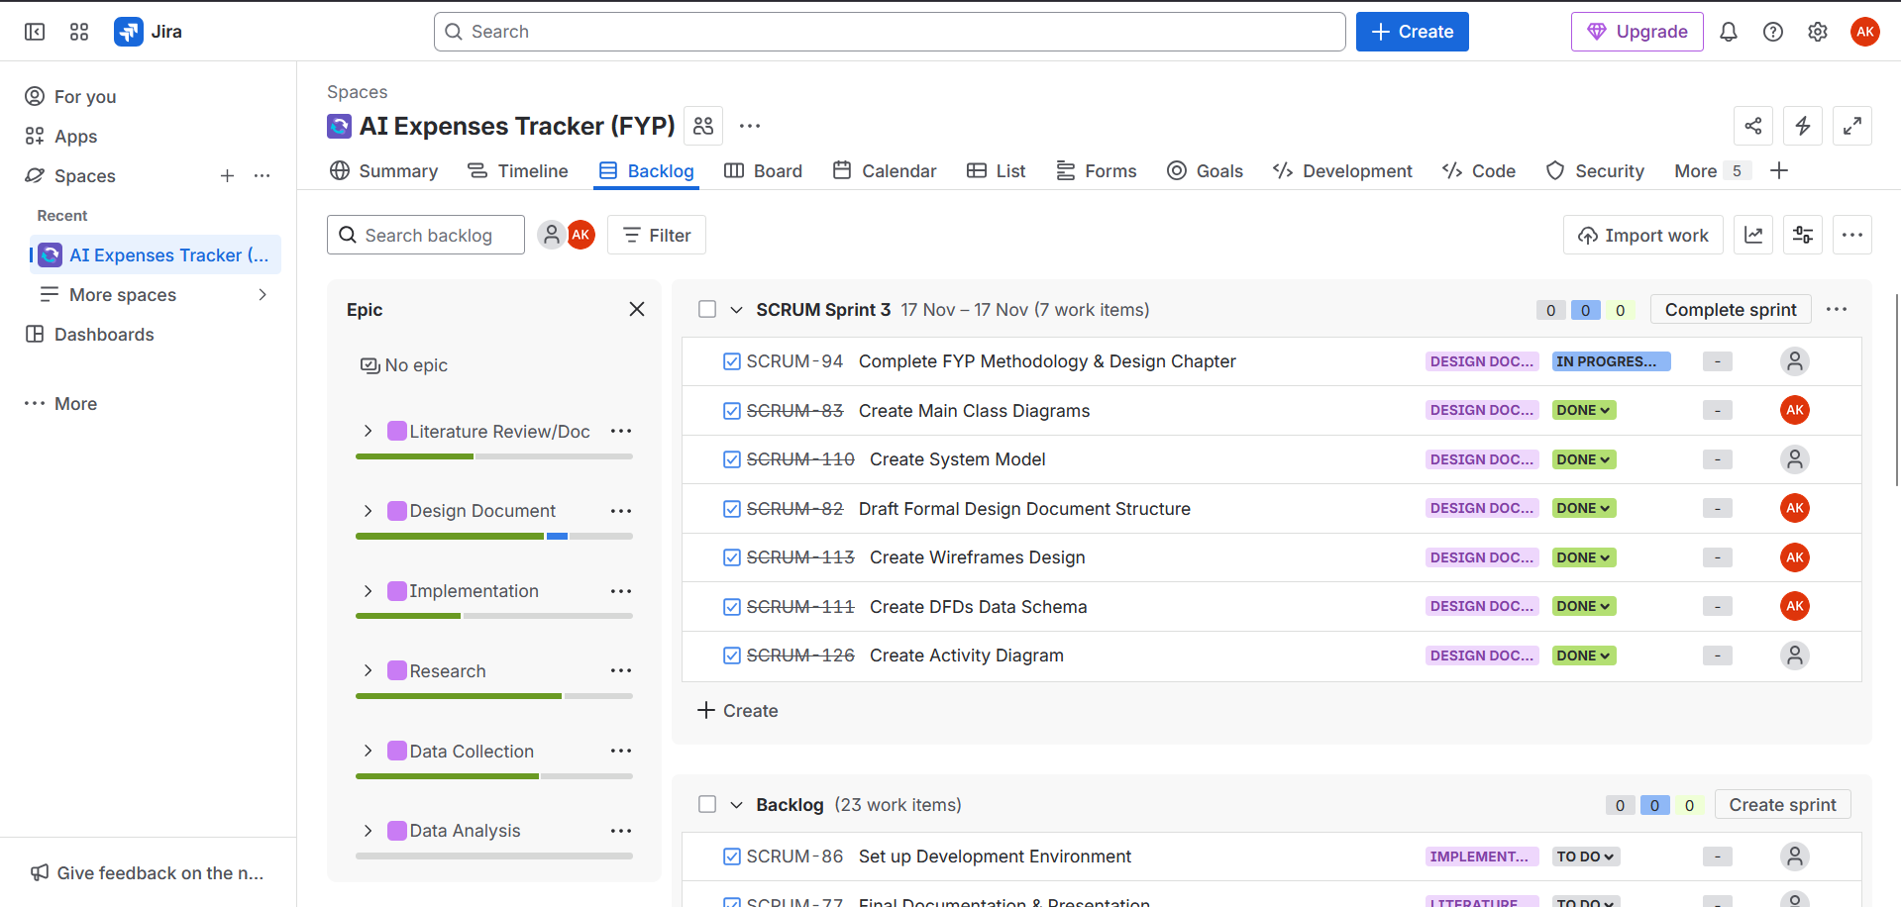

User Stories

Semester 1: Research, Documentation, and Data Preparation
Unique No. | SCRUM-114
Title | Complete Literature Review Chapter
Priority | Low
Owner | Student
Stakeholders | Supervisor
Dependency | None
Estimate Time | 300 hours
Description | As a student,  I want to create literature reviews and write the corresponding chapter,  So that I can build the theoretical foundation and contextualize the project's work.
Acceptance Criteria | 1. Chapter includes review of ML types.  2. Chapter includes review of Banking APIs.  3. Minimum of 20 high-quality sources are cited correctly.  4. The Review continues during research and development.
Success | The Literature Review chapter is complete, well-referenced, and approved by the supervisor.
Failure | The chapter is incomplete, lacks external sources, or contains referencing errors.

Unique No. | SCRUM-115
Title | Technical Design Document
Priority | High
Owner | Student
Stakeholders | Supervisor
Dependency | S004
Estimate Time | 2 Weeks
Description | As a student,  I want to create a Technical Design document outlining the system architecture,  so I have a clear structure for the implementation phase.
Acceptance Criteria | 1. Document specifies frontend, backend, and database technologies.  2. Document details the AI model choice and justification.  3. Document includes a high-level system diagram.  4. Document has all required diagrams, schemas, etc.
Success | The Design Document is complete and approved, providing a clear path to implementation.
Failure | The document is missing architectural diagrams, or lacks justification for key technology choices.

Unique No. | SCRUM-116
Title | Initial Development Environment Setup
Priority | Medium
Owner | Student
Stakeholders | None
Dependency | S002
Estimate Time | 1 Weeks
Description | As a student,  I want to set up the chosen development environment and perform initial configuration,  so I can immediately begin implementation in Semester 2.
Acceptance Criteria | 1. Jira needs to be setup and connect to GitHub.  2. Basic web application skeleton (HTML/React/Angular) is initialized.  3. Plaid Sandbox account credentials are set up and verified.
Success | Running a application verifies all core technologies are communicating successfully.
Failure | Cannot run a basic application or cannot connect to the necessary API services.

Unique No. | SCRUM-117
Title | AI Model and Best Practices Research
Priority | High
Owner | Student
Stakeholders | Supervisor
Dependency | None
Estimate Time | 300 hours
Description | As a student,  I want to research various machine learning and NLP techniques for text classification,  so I can select the most appropriate model for transaction categorization and ai chatbot.
Acceptance Criteria | 1. Analysis of at least three model types (e.g., Rule-Based, Traditional ML, Deep Learning).  2. Final model choice is justified based on performance expectations and complexity.
Success | A clear decision is made on the AI model architecture with strong supporting evidence from the research.
Failure | Research is inconclusive, or the chosen model is not suitable for the task.

Unique No. | SCRUM-118
Title | Transaction Data Collection
Priority | High
Owner | Student
Stakeholders | None
Dependency | S004
Estimate Time | 7 Weeks
Description | As a student,  I want to collect and clean a substantial dataset of transaction descriptions,  so I have high-quality training data for the AI model.
Acceptance Criteria | 1. Dataset contains at least 15,000 unique transactions.  2. Data is uniformly categorized into 10 predefined categories.  3. Data is split into Training, Validation, and Test sets.
Success | A clean and balanced dataset is created and ready for model training.
Failure | Dataset is too small, contains noise/errors, or labels are inconsistent.

Unique No. | SCRUM-121
Title | Exploratory Data Analysis (EDA)
Priority | High
Owner | Student
Stakeholders | None
Dependency | S005
Estimate Time | 2 Weeks
Description | As a student,  I want to perform data analysis on the collected transaction data,  so I can understand data distribution, identify features, and inform the model training process.
Acceptance Criteria | 1. Analysis includes visualization of category distribution (charts).  2. Key text features (average length, common stop words) are identified.  3. Final report summarizes data cleaning steps and feature engineering plan.
Success | Data analysis is complete, providing clear insights into the dataset's characteristics.
Failure | Data analysis is superficial, failing to uncover key issues or patterns needed for training.

Unique No. | SCRUM-122
Title | Concept Prototype
Priority | High
Owner | Student
Stakeholders | Supervisor
Dependency | S003, S006
Estimate Time | 3 Weeks
Description | As a student,  I want to build a simple web prototype linking the UI to a mock data endpoint,  so I can demonstrate the overall system flow and prove technical feasibility before core implementation.
Acceptance Criteria | 1. Prototype displays a static list of transactions.  2. A placeholder chat window simulates interaction.  3. Core navigation between screens is functional.  4. The Transactions overview is displayed.
Success | The supervisor confirms the prototype successfully demonstrates the project's visual and functional goals.
Failure | Prototype fails to link the user interface to the backend or mock data source.

Unique No. | SCRUM-123
Title | Develop Dashboard
Priority | High
Owner | Student
Stakeholders | User
Dependency | S005
Estimate Time | 1 Weeks
Description | As a student,  I want to write the final conclusions, review the entire report for consistency, and format all chapters,  so the report is ready for final submission.
Acceptance Criteria | 1. The conclusion summarizes key findings and success against objectives.  2. The entire document meets all submission guidelines (formatting, structure).  3. No outstanding report sections remain incomplete.
Success | The final project report is submitted on time and meets all academic requirements.
Failure | The report is submitted late or contains significant structural/formatting errors.

Semester 2: Core Implementation and Finalization
Unique No. | S009
Title | Implement User Authentication & Secure Session
Priority | High
Owner | Student
Stakeholders | User
Dependency | S003
Estimate Time | 2 Weeks
Description | As a new user,  I want to securely sign up and log in, and as a returning user,  I want to remain authenticated across sessions, so I can reliably access the system.
Acceptance Criteria | 1. The sign-up form validates email and password complexity.  2. Authentication uses secure service.  3. A logged-in user can visit different pages without re-authenticating.
Success | Users can successfully register, log in, and maintain a persistent, secure session.
Failure | Authentication fails or credentials are stored insecurely.

Unique No. | S010
Title | Plaid Sandbox Integration and Data Sync
Priority | Medium
Owner | Student
Stakeholders | User
Dependency | S008
Estimate Time | 1 Weeks
Description | As a user,  I want to initiate the Plaid Link flow in the Sandbox environment to connect a dummy account,  so the application can retrieve sample transaction data.
Acceptance Criteria | 1. The Plaid Link module launches successfully in the browser.  2. The system successfully calls the Plaid Transactions API to retrieve and store sample data.
Success | The application receives transaction data from the Plaid Sandbox and stores it in the database.
Failure | The Plaid Link module fails to load, or the system cannot exchange tokens or retrieve data.

Unique No. | S011
Title | Train and Deploy Core AI Model
Priority | High
Owner | Student
Stakeholders | User
Dependency | S005, S006
Estimate Time | 300 hours
Description | As the system,  I want to use the trained machine learning model to automatically response to a user with analysis user’s transactions patterns,  so response is accurate.
Acceptance Criteria | 1. The model is trained using the collected dataset and deployed as a callable service.  2. The model achieves an overall accuracy rate of at least 85%.  2. The Chatbot accepts natural language questions (e.g., "Where did I spend most last month?").  3. The Chatbot responds using pre-analyzed spending patterns and rules.
Success | The deployed model automatically and correctly categorizes over 85% of transactions on the test set.
Failure | The model accuracy falls significantly below the 85% target or fails to deploy correctly.

Unique No. | S012
Title | Final AI Model Testing and Validation
Priority | High
Owner | Student
Stakeholders | Supervisor
Dependency | S010
Estimate Time | 3 Weeks
Description | As a student,  I want to conduct thorough testing and gather performance metrics (accuracy, precision, recall) on the final deployed AI model,  so I can validate its performance against the project objective.
Acceptance Criteria | 1. Test results are documented and compared against the 85% accuracy objective.  2. A clear confusion matrix is generated and analyzed.  3. Any systematic errors or biases are noted.
Success | Model performance is fully documented, and the objective is either met, or the results are fully analysed.
Failure | Testing is incomplete, or results are not formally documented and analysed.

Unique No. | S013
Title | Custom AI vs. Gemini Responses
Priority | High
Owner | Student Developer
Stakeholders | Supervisor
Dependency | S011, S012
Estimate Time | 1 Weeks
Description | As a developer,  I want to compare the quality and relevance of the custom AI's financial advice/analysis responses against responses from the Gemini model,  so I can formally document the performance differences.
Acceptance Criteria | 1. A test set of 50 unique financial analysis questions is generated.  2. Both the custom AI and Gemini models process these 50 questions.  3. A quantitative scoring rubric is defined (e.g., Relevance, Clarity, Actionability).  4. A report table summarizes the comparative scores and the overall findings.
Success | All 50 test cases are executed, scored against the rubric, and comparative results are documented for the final report.
Failure | The testing framework fails, or fewer than 75% of the responses can be generated and scored.

Unique No. | S013
Title | Finalizing Report and Conclusion
Priority | Low
Owner | Student
Stakeholders | Supervisor
Dependency | S009
Estimate Time | 240 hours
Description | As a user,  I want a functional dashboard displaying spending reports,  so I can visualize my finances.
Acceptance Criteria | 1. The dashboard displays a spending chart grouped by categorized data.
Success | The user interface provides clear financial visualization as intended.
Failure | The dashboard fails to load data.

Sprints in Jira
Sprint 1 (27/10/2025 - 09/11/2025)
The Sprint 1 helped organize the Literature Review, find more data, and set up some environments.
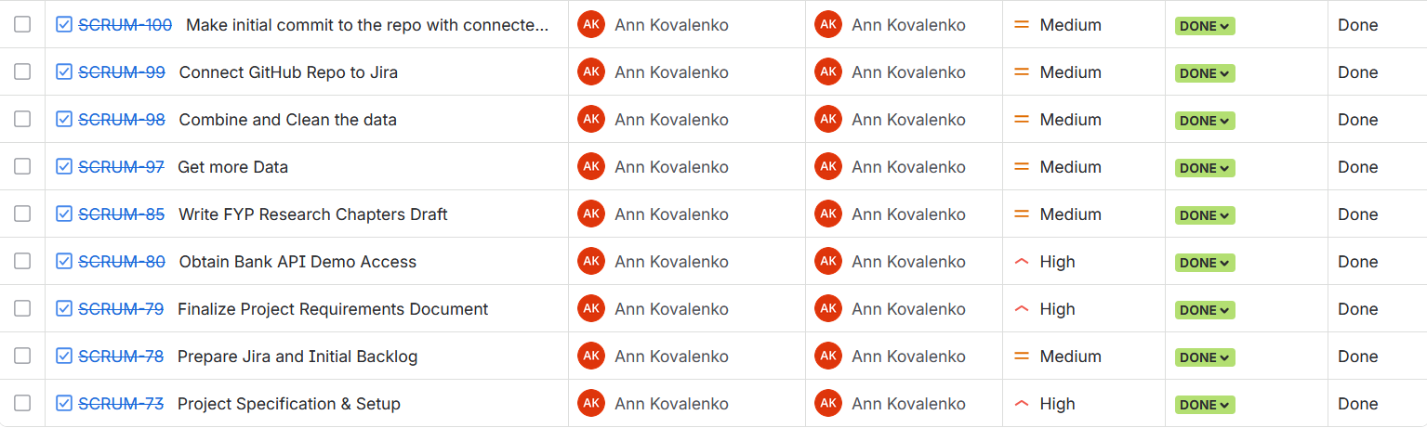
Sprint 2 (10/11/2025 - 16/11/2025)
Sprint 2 helped organize the literature review and research about Plaid.
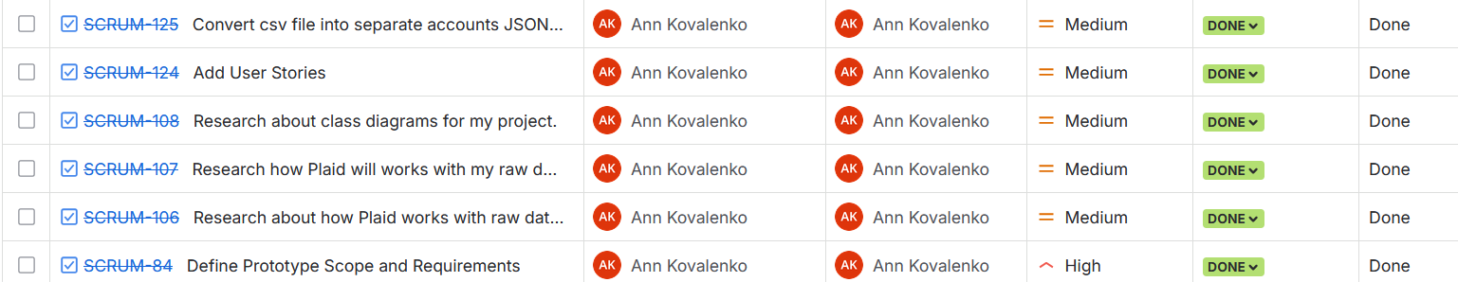
Sprint 3 (17/11/2025 - 17/11/2025)
The Sprint 3 was focused on the design document and creating different diagrams.
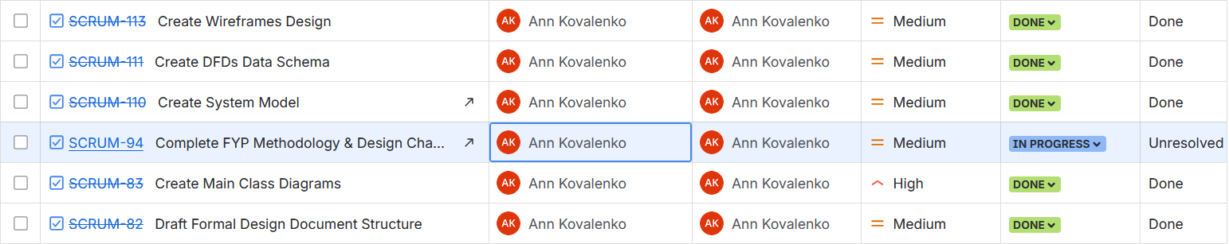
Sprint 4 (18/11/2025 – 25/11/2025)
The Sprint 4 is focused on finishing the document and preparing for the presentation.
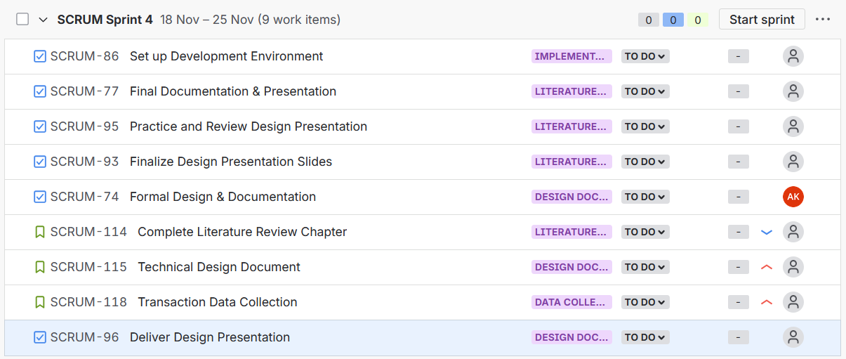
Sprint 5 (30/11/25 – 05/12/25)
The Sprint 5 focused on Making prototype and preparing for submission and presentation.
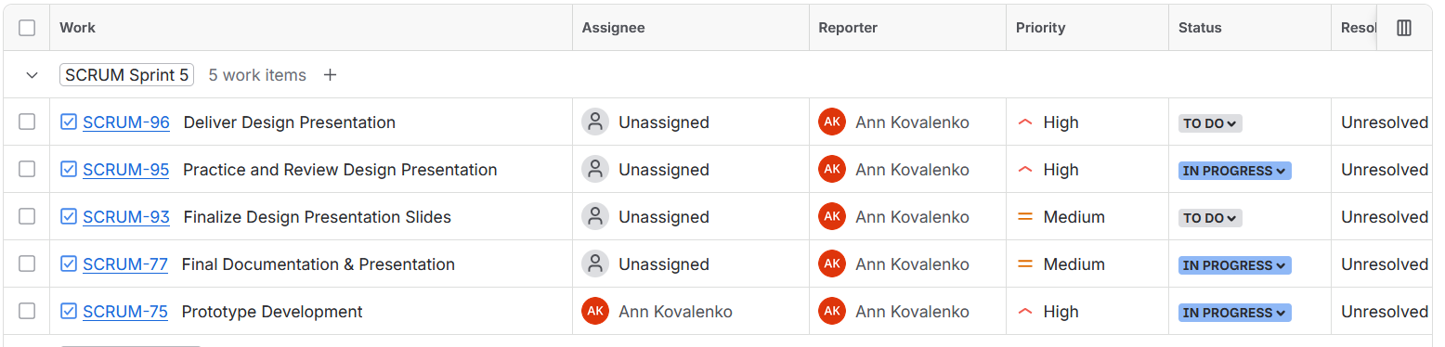
Sprint 6 (26/01/26 – 05/02/26)
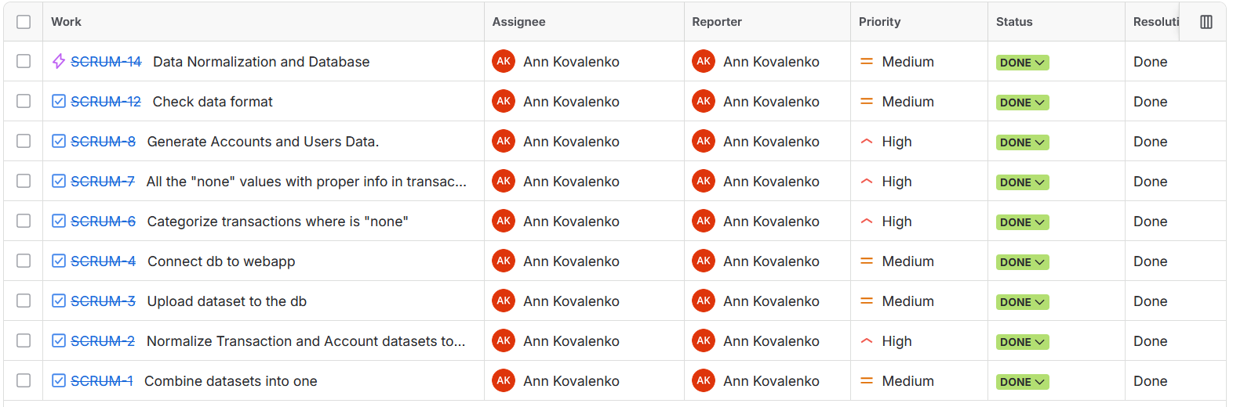
This sprint was focused on the early foundational work of building the expenses tracker, getting the data layer solid before any features could be built on top of it. Raw datasets were combined at the start into a single unified source (SCRUM-1), then normalised transaction and account data to ensure consistency (SCRUM-2). From there, the work moved to uploading the cleaned dataset to the database (SCRUM-3) and connecting it to the web application (SCRUM-4). A significant chunk of effort went into data quality: categorising transactions that had missing or "none" values (SCRUM-6 and SCRUM-7), and then generating the accounts and users data needed to populate the system (SCRUM-8). The sprint wrapped up with a data format check (SCRUM-12) and a broader data normalisation and database task (SCRUM-14).
Sprint 7 (05/02/26 – 14/02/26)
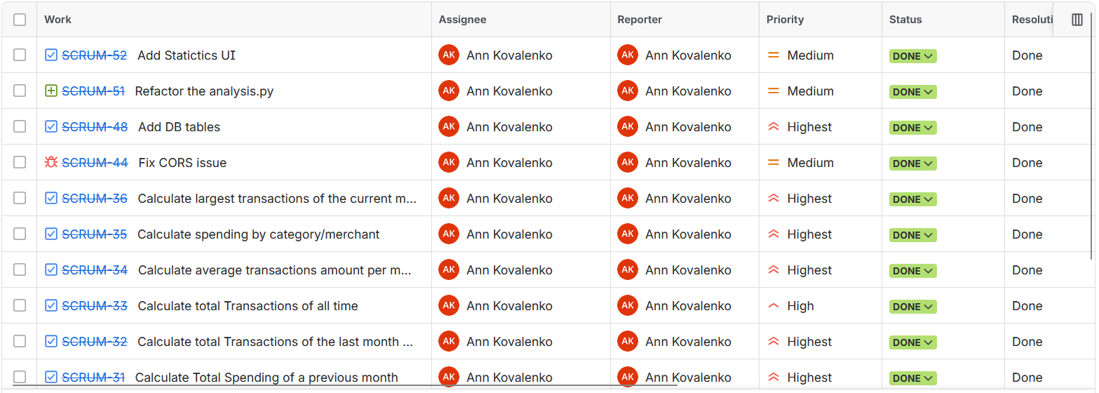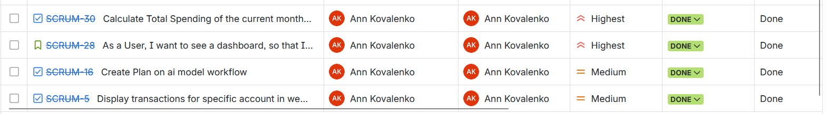
This sprint was all about bringing the application to life analytically and visually, transforming the raw data foundation from the previous sprint into meaningful insights and a working UI. The bulk of the tickets were high-priority statistical calculations: total spending for the current and previous months (SCRUM-30, SCRUM-31), total transactions of the last month and all time (SCRUM-32, SCRUM-33), average transaction amounts per month (SCRUM-34), spending broken down by category and merchant (SCRUM-35), and the largest transactions of the current month (SCRUM-36). These formed the core analytics engine powering the dashboard. Alongside the stats work, the team built out the first real user-facing features, displaying transactions for a specific account (SCRUM-5), creating a plan for the AI model workflow (SCRUM-16), and implementing the dashboard view itself so users could actually see their financial data (SCRUM-28). Infrastructure work also got attention, with new database tables added (SCRUM-48), a CORS issue fixed to unblock frontend-backend communication (SCRUM-44), and `analysis.py` refactored for cleaner structure (SCRUM-51). The sprint closed out with a Statistics UI ticket (SCRUM-52) to surface all those calculated metrics visually.
Sprint 8 (19/02/26 – 27/02/26)
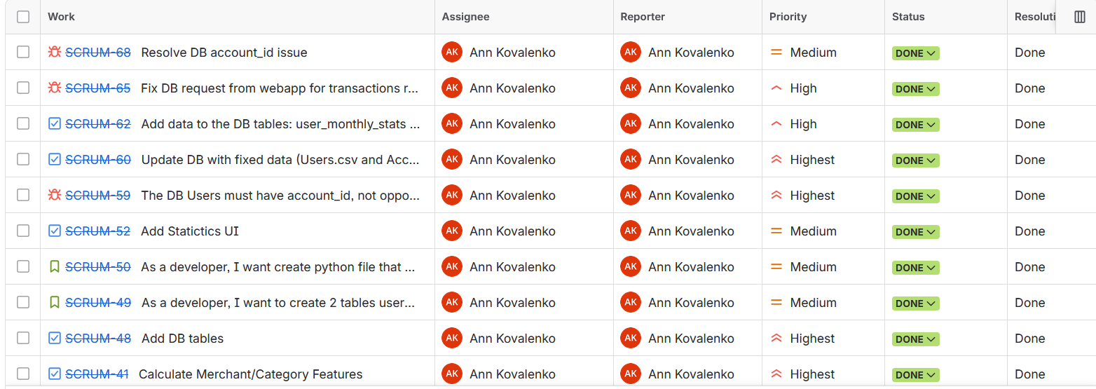
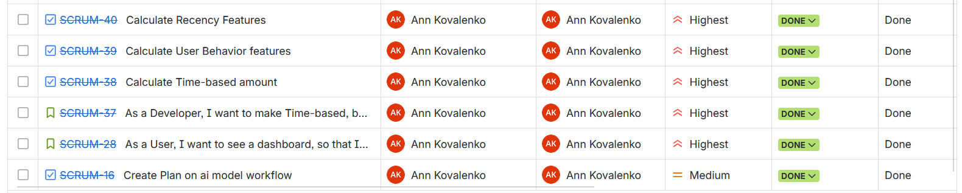
This Sprint was largely about developing and testing Feature Engineering and Data Integrity, the foundation for the AI/ML components of the application. Many of the high priority tickets in this Sprint were related to creating the features used by the machine learning models; e.g., merchant & category features (SCRUM-41), recency features (SCRUM-40), user behavior features (SCRUM-39), and time-based amount features (SCRUM-38). Additionally, the overall design of the time-based feature architecture was done as a developer story first (SCRUM-37).
One of the important thing were to ensure the correctness of data in the database during this Sprint. While this is an ongoing effort to correctly place the actual bank data in a relational schema, several issues were addressed. These included resolving the "account_id" issue (SCRUM-68), fixing a broken transaction request from the web app (SCRUM-65), correcting and uploading again the Users/Accounts CSV data (SCRUM-60), enforcing a critical schema constraint such that users are required to have an account_id, but accounts do not need a user_id (SCRUM-59). Monthly statistics were also entered into the database (SCRUM-62) and additional support tables were created using python scripts (SCRUM-49, SCRUM-50) along with continuing work on the existing DB table created in a prior sprint (SCRUM-48). In addition, completing the dashboard (SCRUM-28) and planning for AI Model Workflow (SCRUM-16) suggest both items may have been finalized after having been brought forward from the previous sprint.
Sprint 9 (01/03/26 – 07/03/26)
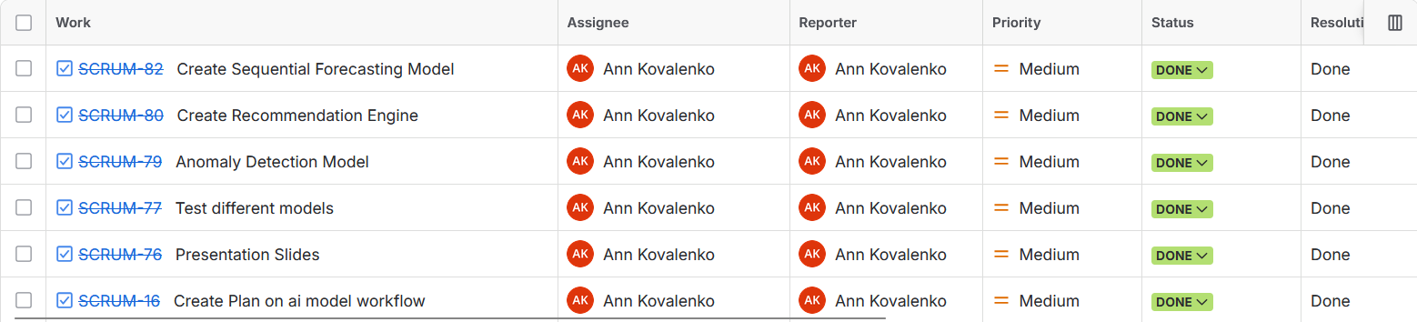
This Sprint was an important achievement, the complete build-out of the main AI/ML Pipeline. After completing sprints developing Data Foundations and Feature Engineering, it was time to put some "Intelligent" into those models. This is when the three Key Models were developed, the Anomaly Detection Model (SCRUM-79) to identify abnormal usage patterns, the Recommendation Engine (SCRUM-80) to provide users with personalized financial recommendations and the Sequential Forecasting Model (SCRUM-82) to forecast future spending behavior. Various modeling techniques were explored during this sprint prior to implementing the final versions of each (SCRUM-77). While this represented a Research-based approach as opposed to simply implementing the First Solution that worked.
Sprint 10 (20/03/2026 – 03/04/26)
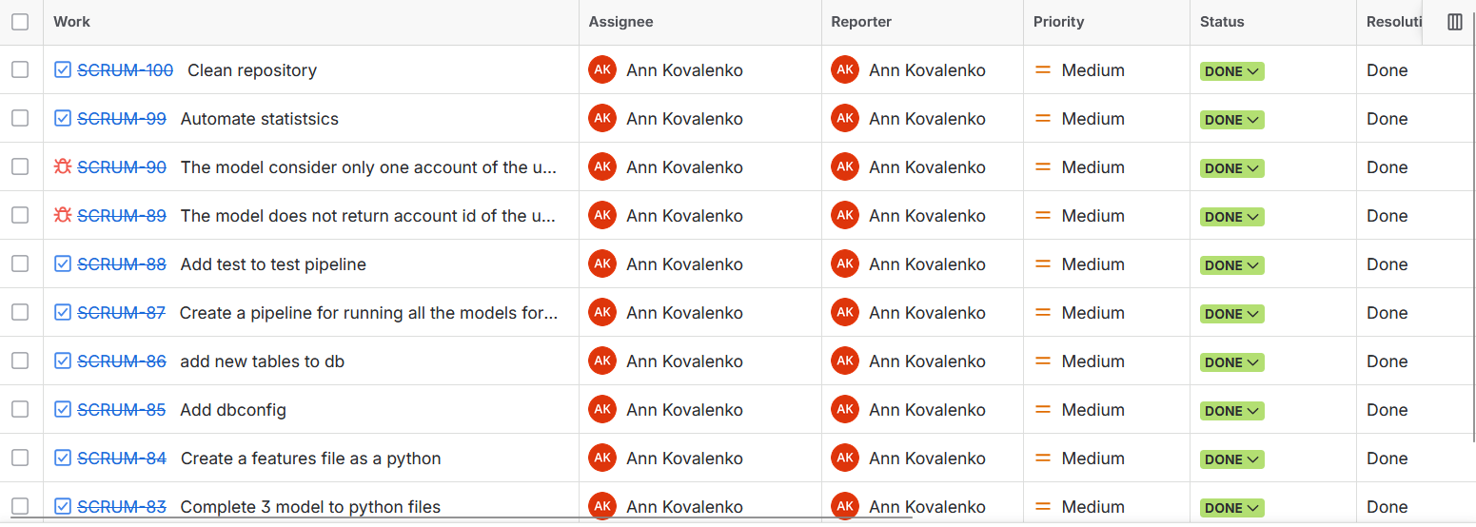
This Sprint was centered around hardening, integration and polish. With the individual Models from the prior Sprint integrated into a single system. Three Models were moved out of the main program into their own Python Files (SCRUM-83), a new Features File was created to centralize Feature Engineering (SCRUM-84), and a Database Config Module was added to streamline Connection Management (SCRUM-85). New database Tables were added to Support the Expanded System (SCRUM-86), and most importantly, a unified pipeline was created to run all of the models together in sequence (SCRUM-87). When the separate pieces became one cohesive AI system. Tests were written for the pipeline (SCRUM-88) to ensure reliability, reflecting a maturing codebase that needed confidence before presentation.

Additionally, 2 bugs were caught and fixed at this stage: the model was only considering one account per user instead of all of them (SCRUM-90), and it wasn’t correctly returning the account id (SCRUM-89). Both issues would have caused silent errors on the dashboard. Statistics calculation was automated so no longer had to be triggered manually (SCRUM-99), and the repository was cleaned up (SCRUM-100).

Sprint 11(09/04/26 – 19/04/26)
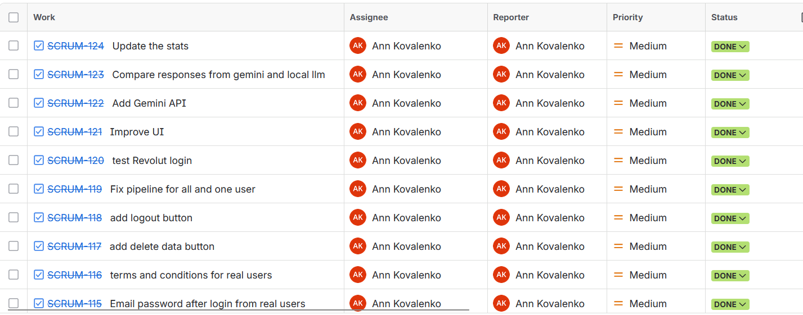
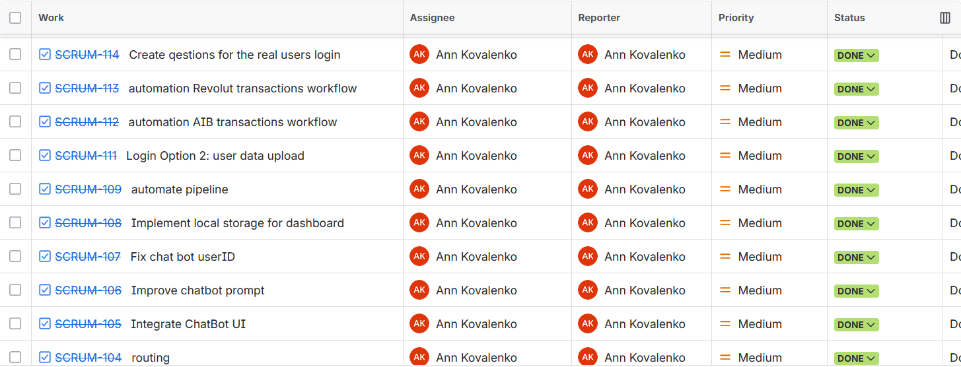
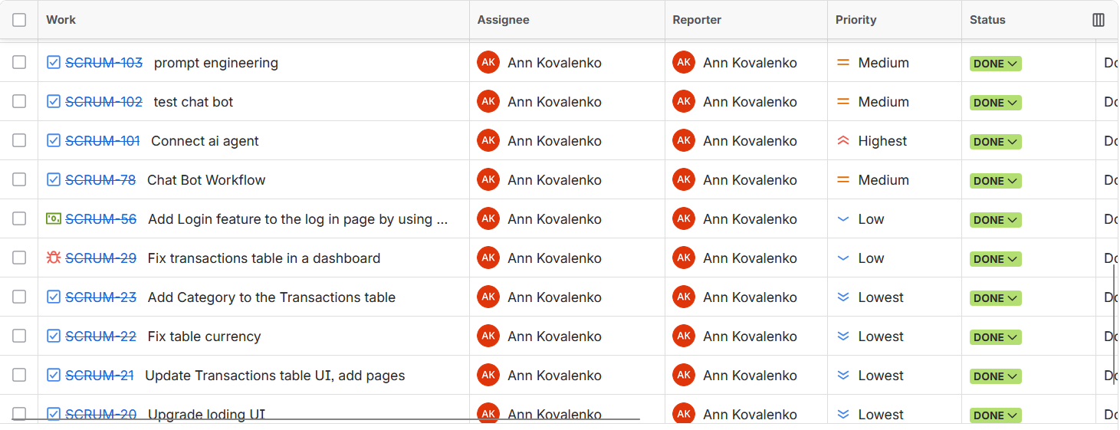

The focus in the last push was to finish all the functionality for the complete product, including the chat AI layer and get live users onboarded. Main items that were delivered include integration with the AI Agent; Chatbot Integration (Prompt Engineering/UI/ User ID Fix); Implementation of Gemini API Support; Testing Local VS Hosted LLM Responses; Automation of both AIB and Revolut Transaction Workflows; Development of CSV Upload Login Functionality; Development of Logout/Delete Data Button Functionality; Terms & Conditions Functionality; and various additional UI Improvements.

Implementation
Bloom is an online tool to track your personal finances, which links directly to banks through Plaid API, enabling better understand and control of money. As part of this Final Year Project, a particular configuration system was developed for the purpose of building and testing Bloom. There are two configurations, as follows:
Configuration 1 will link to actual bank accounts via the Plaid sandbox API and run an LLM using a service called Ollama locally.
Configuration 2 enables users to import CSV files created by uploading data from either AIB or Revolut into Bloom, and enable natural language responses via the Ollama locally and compared to Gemini response. These two different approaches enable me to test the difference between running AI applications locally vs. hosting them in the cloud when presenting my work at the end of the year.

System Overview
There are 5 distinct "layers" of the system and they all interact using clear interface definitions:
- Frontend – a React application built with Vite, styled with tailwind CSS and DaisyUI for styling.
- Express.js backend (port 8000) - handles plaid bank-link flow logic, user authentication, account/transaction queries.
- Fastapi backend (port 8001) - receives natural language questions from the frontend, runs intent classification and context collection pipeline to generate answers using artificial intelligence.
- Machine learning pipeline (python) - five sequential steps: user statistics, feature engineering, anomaly detection, recommendation generation, forecasting, run after a user uploads data.
- PostgreSQL database - stores all user, account, transaction and model output data relationally.
Vite's development server is configured with a proxy that automatically forwards calls to /api/* to the correct backend so that the frontend only ever communicates with one origin.

Technology Stack
Category | Technology | Purpose
Frontend | React 18 + Javascript + Vite | UI and building tooling
 | Tailwind CSS + Daisy UI | Styling and components
 | Recharts | Charts and data visualisation
Backend 1 | Node.js + Express.js | REST API for Plaid and auth
 | Plaid Node SDK | Bank-link integration
Backend 2 | Python + FastAPI | AI chat pipeline endpoints
 | Pydantic | Request/response validation
ML/AI | Scikit-learn (Isolation Forest) | Anomaly detection
 | Featuretools | Automated feature engineering
 | Prophet | Spending forecast
 | Ollama/Gemini API | Natural-language generation
Database | PostgreSQL | Persistent relational store
 | SQLArchemy + psycopg2 | Python ORM and drivers
Version Control | GitHub | Version control

Application realisation steps
The following sections describe the complete build process.

Step 1: Establishing the Development Environment
The initial step prior to developing any code was creating a reliable development environment. Git was utilized for version control, the GitHub repository was created to act as the remote origin to enable commit to this repository after every significant point of progress. This approach allowed for tracking all modifications to the source code, while preserving the history of these modifications.
Version 20 or greater of Node.js was installed to provide both the frontend build tooling and the Express.js backend. Conda was utilized to create a separate virtual environment called featuretools-env which included python 3.9. Python 3.9 was selected due to compatibility restrictions imposed upon the FeatureTools library that prevented proper execution on any versions of python greater than version 3.9. The use of an identified Conda environment ensured that regardless of the Python version present in the system environment, this environment could reproduce the project successfully. Once activated, all python dependencies were installed from the requirements.txt file located within the project. All Node dependencies were installed via npm install and read the dependency information contained within the package.json manifest and populated the local node_modules directory.
Next, a PostgreSQL database was established. The connection string (host, port, database name, user-name, password) for the database was recorded. All sensitive data including credentials such as Plaid Client Id and Secret, Gemini Api Key, and Database Url were placed into a .env file at the root of the project.
The .env file was placed into .gitignore so sensitive data would never be pushed to the remote repository.

Step 2: Designing the Database Schema
The relational schema was defined completely prior to writing backend code because the design of the database defines how all layers of the application communicate with each other. There is just one PostgreSQL database containing all the data. There are 8 tables:
The Users Table contains information about each account holder, Database Schema (ERD).
The Accounts Table has a row for each bank account and contains account_id which can be used to hold the 15 digit numeric ID created for csv users. It also contains a mask to hold the last 4 characters of an account id for display.
The Transactions Table is the central fact table of the schema. Each row in this table represents a single financial transaction and contains columns for the amount, date, description and a category determined by the transaction classifier. From this table, the User Stats Table stores monthly summary statistics per user including the total amount spent, total amount received, most frequently spending category and number of transactions.
In addition to these three tables, there are three additional tables which are used solely to populate data from the machine learning pipeline. The Anomaly Scores Table stores an anomaly score and a flag indicating whether a transaction is an anomaly for each transaction. The Recommendations Table stores personalized budget tips based upon cosine similarity matching. The fm_encoded Table stores the one-hot encoded feature matrix produced by feature tools. Due to the fact that, all three tables are repopulated fully after every pipeline run, all three tables are created with if_exists = 'replace' instead of 'append', so that no column count mismatch occurs and no duplicate index errors occur when the feature schema is changed during subsequent runs. Lastly, the Forecasts Table stores the forecasted spending amounts produced by Facebook Prophet.

Step 3: Building the Express.js Backend
The express.js server handles all of the plaid node sdk and node.js library specific functions. The server is listening on port 8000. The server has a series of rest endpoints to serve two main concerns: linking banks and authenticating users.
Plaid Integration:
Firstly, POST /api/link/token/create generates a one-time use link token for Plaid to open their link modal.
Secondly, once the user closes Plaid’s link modal, they receive a one-time public token. They then send that token in a POST request to /api/item/public_token/exchange. That call will return a long-lived access token. The token stored in memory. Any future requests will be made with that token to pull account data from the Plaid Sandbox.
CSV Authentication Path:
Firstly, POST /api/auth/register accepts a username, password, and csv upload. After receiving these three items the password hashes with bcrypt and then stores in database.
Secondly, POST /api/auth/login verifies the user’s credentials and sends back the user’s id to the frontend.
Thirdly, there is a delete /api/user/data endpoint which will delete all of the users rows from every table when triggered. However, the delete /api/user/data endpoint is protected by a server-side check of the login_method field. So, if the authentication was made via Plaid, the user will not be able to delete user data.
Every SQL statement in backend executes against the db_utils.js helper module and is executing off of connection pool. All of the SQL statements in our backend execute using parameterized placeholders. Not string interpolation, therefore there is no way to inject sql in our app.

Step 4: Building the FastAPI Backend and AI Chat Pipeline
The FastAPI backend of the application, which has been built into main.py is running at localhost port 8001 and provides the application's artificial intelligence powered conversational capabilities. The primary endpoint of the FastAPI backend, POST /api/ask, takes as input a user's question and their user ID and will then provide back to them an appropriate natural language financial answer based on that question. Internally, the POST /api/ask endpoint works by coordinating the results from a three-stage pipeline with each stage being completed within one of three different components.

Step 4.1: Intent Classification
Beginning with the classifier defined in "classifier.py," this application utilizes the classifier to match keywords contained within the unprocessed question text to generate a QuestionIntent class that identifies the subject of the question. A variety of keywords are used by the classifier to assign intents including: stats (i.e., how much did you spend on) which includes 'spent,' 'income,' etc.; anomalies (i.e., weird, unusual, flagged); forecast (i.e., predict, next month, forecasted); recommendations (i.e., save, should i, recommend). Recommendations include both a stat and recommendation intent because they represent questions that seek contextual information for a particular decision. Additionally, to the identification of intent, the classifiers utilize helper functions located in extractors.py to identify references to months and categories of spending.

Step 4.2: Context Collection
The Dispatcher (Dispatcher.py), gets a QuestionIntent object and asks the PostgreSQL Database for just enough information to provide an answer to the user. This limited retrieval is very important for token efficiency. For example, if an Intent wants to know how much was spent on something, it does not want to receive anomaly scores or recommendations. Thus, the context, which is then given to the language model, has been kept as short and concise as possible. When there are anomalies included in an Intent, the dispatcher joins the anomaly_scores table with the transactions table so that the full details of each flagged row can be returned. Filters that were identified through classification are applied at the query level vs. through application code. This reduces the amount of data transferred from the database.

Step 4.3: Narration and Language Model Integration
The "narrator" class receives the question asked originally by the end-user and the dictionary created by the dispatcher of all available contextual information. Next, the narrator randomly picks from among four predefined prompts based on the type of query made. For example, if a factual query was asked, the narrator will select the “lookup” template. If an anomalous transaction occurred, then the “anomaly” template would be used. If budget advice or guidance was needed, the “advice” template would be chosen. And finally, if the end-user simply wanted some overall financial guidance, the “overall” template would be used. After selecting a prompt, the narrator completes the selected template with data provided by the end-user. Once complete, this formatted prompt is sent to client.py. Client.py has one method called chat(). Regardless of how the reply is produced, it is returned to the front-end as a JSON object that includes three main elements: (a) the generated answer; (b) the detected intent; and (c), a list of all context keys that were populated during the production process.

Step 5: Building the Machine Learning Pipeline
The machine learning pipeline is the analytical engine for this application. This can be triggered programmatically by the fast api endpoint POST /api/pipeline/run when a user has completed a CSV upload, as well as manually from the command line to facilitate development and testing purposes. The five stages are executed in sequence with each stage reading from PostgreSQL and writing its results back into an exclusive table.

Step 5.1: User Statistics
The initial phase of the process was designed to be located in "user_stats.py" and has been developed to read all transaction information, compute average monthly financial totals for each consumer and categorize transactions using the category attribute of each transaction. In terms of computation, both the amount spent on spending items such as direct debit and credit card payments and the received amounts will be computed based upon an individual's transactions. With regards to AIB CSV exports, the classification of each transaction into either a spending class or an income class depends on whether the transaction has a negative value and if its description begins with one of four possible strings that indicate it is a spending item ("VDP-", "VDC-", "VDA-", or "ATM"). If an AIB export contains a transaction whose description starts with none of these strings but still contains a positive value then that transaction is treated as income. If this were not the case then every salary payment credited to the account would be misclassified as being generated by a card payment.

Step 5.2: Feature Engineering
The second phase is in the features.py file. It uses the Featuretools python package that performs Deep Feature Synthesis (DFS). In DFS three entities were created: users, accounts, and transactions. Featuretools then produces an enormous number of features from these three entities. These include but are not limited to sums of transaction values based on categories, standard deviations of each day’s spending amount, counts of transactions above certain limits. feature matrix were created and One-Hot-Encoding used on it. We store the encoded feature matrix into the fm_encoded table. The second phase will process all of the users contained within the database whether or not they have been a trigger for running the pipeline. This was an intentional design choice for the sake of Cold-Start Protection. A brand-new registered user will receive feature rows immediately upon registration without needing to manually initiate the pipeline for each individual user.

Step 5.3: Anomaly Detection
In anomaly_detection_model.py the third and final phase is training an Isolation Forest Model against the fm_encoded feature matrix. An Isolation Forest is an unsupervised ensemble algorithm that finds outliers/anomalies by randomly splitting the featurespace into subspaces until it has "isolated" each data point. It assigns an anomaly score based on how many subspaces were needed for isolation. Based on this score, an is_anomaly flag (0 or 1), as well as the raw anomaly score, are added to the anomaly_scores table and will then be retrievable from there by the dispatcher and displayed to the end-user via the chat window.

Step 5.4: Personalised Recommendations
The fourth stage of our model, that was placed into the code file "recommendation_model.py," calculates personalized financial recommendations based on how close a current user's spending-feature vector is to all pre-defined budget-persona vectors. Each persona has its own unique spending-pattern, for example, an individual who spends heavily at restaurants vs. one who frequently withdraws cash from ATMs, and each is also linked to specific saving tips. The users' tip lists are populated with those from the personas whose feature vectors are closest to the user's feature vector. This method enables us to provide the appropriate financial assistance, based on where the customer fits within our system of personas, regardless of whether we are using labelled data to train our models.

Step 5.5: Expenditure Forecasting
The fifth step of this process trains an individual Prophet model on each user’s monthly spending data. It uses a decompositional additive model called Prophet to estimate three separate components from the time series. This allows for the estimation of both the overall trend as well as both seasonal patterns, specifically weekly and yearly patterns. A point forecast for the user's total monthly expenditures will be generated using the trained model. This generated point forecast will then be placed into the forecasts table so that it can be referenced when generating responses based on forward looking questions about the user’s financial situation.

Step 6: Building the React Frontend
The frontend is a single-page application written in React and JavaScript, bundled by Vite, and styled with Tailwind CSS and DaisyUI. React Router handles client-side navigation between four main views: the login screen, the upload and registration screen, the dashboard, and the chat interface.

Step 6.1: Authentication Screens
Login offers the user a choice of one of two methods for access to the application on the left side of the page, with each of these being represented on the right side of the page. When you click "Connect a bank," the application will initiate the Plaid banking link process. If you select "Upload a CSV," the application will navigate directly to the Upload Registration Screen. Regardless of which method the user has selected, upon selection, that method is saved to browser local storage as the value for the login_method flag. Each subsequent decision point in the application reads from this single flag.
Upload Authentication Login manages the csv-based registration process. The user enters a display name and password and chooses either an AIB or Revolut cvs file from computer. Upon submitting the form, the frontend encodes the file as multipart/formdata and makes a post request to express server to parse the csv, create a new user account, store the transactions in PostgresQL, and trigger the ml pipeline. After creating a poller called PipelineIndicator that continuously requests GET /api/pipeline/status at 2 second intervals, it displays a "running" or "ready" status badge to indicate when the user's analysis has completed.

Step 6.2: Dashboard
Dashboard is the primary view displayed after authentication. On mount, it reads login_method and directs its data requests to the appropriate backend. For Plaid users, it calls the Express transaction endpoint, for CSV users, it calls the FastAPI statistics endpoint. The retrieved data is distributed across four reusable components. Stat.tsx renders three summary cards showing total spending, total income received, and transaction count. CategoryPie.tsx renders a Recharts donut chart of expenditure broken down by category. MonthlyTrend.tsx renders a Recharts line chart showing total monthly spending over the available date range. Table.tsx renders a paginated transaction table, with five rows per page, coloured status pills for each transaction category, and right-aligned currency values.

Step 6.3: Chat Interface
This chat module represents the frontend portion of the conversation. A user can type in their own free-form question in an input area. That data will then be sent via POST /api/ask to the fastapi backend with the current users id as part of the request payload. The backend responds back with a natural language response which is then displayed in a scrolling message log. For the duration of this session, both the user's previous questions and responses are stored as state within the React components used in rendering the messages so that there is no need for a separate webpage or navigation away from this page to view previously asked questions and their respective responses.

Step 6.4: Visual Design
The Application uses a consistent dark purple color scheme for its design. Backgrounds of pages are using a dark purple black (#0a0118). Card surface backgrounds are using an even light purple tone (#160d2b) so there will be some visual depth. A violet (#7c3aed) is being used for all primary click-able objects. A softer purple (#c084fc) is used for secondary accent objects. The "Bloom" logo mark is made up of the Google font "Bagel Fat One". This font is being imported into html header via a link tag, because importing fonts via css failed silently when we were developing the app in vite. The left side bar (sidebar) of the application is created by making this sidebar a fixed width. Then, a right-side content pane has been positioned so that it does not overlap with the sidebar.

Step 7: Configuring Unified Server Start-up
The normal approach when developing would be to have three separate servers running, the Vite frontend on port 5173, Express on port 8000 and FastAPI on port 8001, which would normally need to be running from three different open terminal windows. The concurrently npm package has been installed as a development dependency and is referenced in the script portion of package.json. Using the npm run dev will start up both the frontend and backends at the same time using one terminal window. Color coded prefixes are used to identify the log streams for each of the servers.
In addition to starting up the servers concurrently, the vite_config.ts file provides a proxy definition. This proxy identifies all incoming HTTP requests with path names that include “/api” and forwards those requests to the correct backend. The /api/link, /api/auth, and /api/transaction routes are routed to express server at port 8000. The /api/ask and /api/pipeline routes are routed to fast-api server at port 8001.

Step 8: Testing and Validation
Each layer of the application was tested incrementally as it was built, using a combination of dedicated test scripts and interactive endpoint inspection. This approach allowed individual components to be verified in isolation before they were integrated with the layers above and below them.

Step 8.1: Database Connectivity
Two scripts were created to test the database connection prior to the application depending upon it. test_db_connection.js establishes a new connection pool and then runs a trivial SELECT 1 SQL query against postgresql. It is designed to verify that the node.js backend can connect to postgresql as defined within the .env file.

test_dbconnection.py creates an equivalent validation with psycopg2 for both the sqlalchemy connection url utilized by the ml pipeline and verifies the ability of python to successfully establish a connection. Both of these scripts MUST run without errors before proceeding with additional work.

Step 8.2: Pipeline Validation
The validation of the ML pipeline used two test scripts. test_pipeline.py is a complete five stage pipeline run on a known test user. It makes assertions about all output tables (user_stats, fm_encoded, anomaly_scores, recommendations, and forecasts) existent within PostgreSQL with at least one row after successful execution. Test_user_stats.py verifies the logic for classifying incomes and expenses via synthetic constructed rows for each transaction, making assertions for appropriate label categories, including positive amount AIB transactions to be labelled as income, and excluding Revolut vault-to-vault transfer amounts from total income/spending classifications.

Step 8.3: API Endpoint Testing
The backend for the FastAPI application was used in interactive testing through the Swagger User Interface (http://localhost:8001/docs) which is automatically generated when FastAPI application starts. Endpoints were tested for all types of payload representative of their respective intended use. The /api/ask endpoint was tested with five different types of representative questions: a spending-lookup question, an anomaly question, a recommendation question, a forecast question, and a general overview question. All the Natural Language Responses returned by the /api/ask endpoint were checked for factual correctness relative to the contents of the test database.
Component tested | Test description | Method | Expected Output
PostgreSQL – node.js connection | Test_db_connection.js executes SELECT 1 via pd Pool using .env credentials | Automated scrit | Script exits 0  No connection error
PostgreSQL – Python connection | Test_dbconnection.py connects via psycopg2 and validates the SQLAlchemy URL | Automated script | Script exits 0  Connection confirmed
Classifier.py – intent detection | 10 representative questions passed  Correct QuestionIntent label asserted for each | Unit test | All 10 intent assertions pass
Classifier.py – default fallback | Ambiguous question with no recognisable keywords passed to classifier | Unit test | Intent defaults to Overall  All 4 need flags set
User_stats.py – AIB income | Synthetic AIB rows with positive amounts and no spend prefix passed to classifier | Unit test | Rows labelled 'topup'  total_received > 0
user_stats.py – AIB spend | Synthetic AIB rows with VDP- and ATM description prefixes passed to classifier | Unit test | Rows labelled 'card_payment';  contribute to total_spent
user_stats.py – Revolut vault transfer | Revolut CSV rows with Type='transfer' passed to classifier | Unit test | Rows excluded from both total_spent and total_received
ML pipeline – full run | test_pipeline.py runs all five stages against a seeded test user | Integration test | All five output tables exist and contain >= 1 row
ML pipeline – schema drift guard | Pipeline run twice; fm_encoded schema changed between runs | Integration test | Second run completes without duplicate-index error; new schema applied
Anomaly detection – flag assignment | Synthetic outlying transaction injected into fm_encoded before pipeline run | Integration test | Outlying transaction receives is_anomaly = true
POST /api/ask – spending lookup | 'How much did I spend last month?' submitted via Swagger UI | Interactive test | Response contains correct monthly total from user_stats
POST /api/ask – anomaly intent | 'Are there any unusual transactions?' submitted via Swagger UI | Interactive test | Response lists flagged transactions by date and amount
POST /api/ask – forecast intent | 'What will I spend next month?' submitted via Swagger UI | Interactive test | Response includes Prophet-generated estimate from forecasts table
POST /api/ask – advice intent | 'How can I save more money?' submitted via Swagger UI | Interactive test | Response includes ≥ 1 personalised tip from recommendations table
POST /api/auth/login – wrong password | Login attempted with correct username and incorrect password | Manual test | 401 Unauthorised returned;  no session created
DELETE /api/user/data – Plaid guard | Delete endpoint called while login_method = 'plaid' | Manual test | Request rejected;  no data deleted
End-to-end – CSV upload flow | Real AIB CSV uploaded; dashboard and chat verified after pipeline completes | Manual end-to-end test | Dashboard stats match CSV data;  chat answers factually consistent
End-to-end – Plaid sandbox flow | Plaid Link modal completed with sandbox credentials; dashboard populated | Manual end-to-end test | Sandbox transactions appear correctly in dashboard and transaction table
Table 1. Test case summary

Key Design Decisions and Lessons Learned
- Parameterised queries
Early versions of the Express backend constructed SQL strings by concatenating user input directly into query text. This is a critical security vulnerability, SQL injection. All queries were refactored to use the pg library's parameterised placeholder syntax ($1, $2, …) before any user-facing testing began.
- account_id as BIGINT not UUID
Plaid account Ids are hexadecimal strings, however, the Bloom generate_account_id() helper function for CSV users will need to create a 15-character numeric string due to the fact that the accounts table has declared the account_id as BIGINT. In order to avoid the type mismatch errors encountered during inserts when you store a hex string in a BIGINT field, you can randomly select a number with 15 digits and then format it as a zero padded string.
- if_exists='replace' for pipeline tables
Pipeline-derived tables (fm_encoded, anomaly_scores, recommendations) are generated fresh on each run. If the schema of the feature matrix changes between runs (for example, Featuretools adds a new column), using if_exists='append' will produce a duplicate-index error. Using if_exists='replace' drops and recreates the table each time, preventing schema drift entirely.
- Income classification for AIB vs Revolut
AIB csv exports do not include a transaction type column, classification must be inferred from the description text and the sign of the amount. Any positive-amount row that does not start with a known spend prefix (VDP-, VDC-, VDA-, ATM) is classified as 'topup' (income). Revolut exports include a Type column, making classification more straightforward, but vault-to-vault transfers must be excluded from both income and spending totals to avoid double-counting.
- Vite proxy for cross-port development
There are three servers running during development on three separate ports. There is a blockage by the browsers Same-Origin Policy against cross-domain fetch calls. The answer to this problem is to have Vites Proxy function forward any call made to an api on the client-side of the react application to the correct backend as if it was called directly with the proxy forwarding each call to port 5173 (the Vite Dev Server). This allows to remove CORS issues when developing without changing any of your frontend code.

Project Rationale and Motivation
Managing personal finances is probably one of the most important things that people do today, and yet, it is frequently overlooked. Although people are able to use smartphone apps to manage their money, and make payments using digital methods, they still don't know enough about where their money goes, when bills will be due, etc., nor do they take advantage of objective recommendations based on evidence. Studies show again and again that poor financial knowledge has clear effects. According to an OECD (2023) report released in March 2023, less than 50 percent of adult respondents across all countries included in the survey reported being able to interpret a simple bank statement within the context of other information related to their overall financial situation. Most traditional personal finance software tools only partially fill the need by providing an itemized list of your transactions and what categories you have put them into.
This gap in existing personal finance tools is exactly what Bloom was designed to close. It is a fully functional web-based application that takes actual banking file exports, which include both AIB and Revolut formats since these are two of the most popular consumer banks in Ireland and Europe, and converts the raw transactional data into a comprehensive, logical story regarding your financial condition. Unlike many other personal finance programs, Bloom does not require you to assign specific labels to individual transactions, nor must you search through often difficult-to-use menus. Instead, Bloom uses a multi-level machine learning process and a natural language chat interface that utilizes large language models to provide insightful responses to questions like "did I spend more on food this month compared to last month?," "are there any unusual charges on my account?," or "how much am I likely going to spend next month?", all without needing to be financially literate or having technical expertise.
There are several reasons why Bloom was created. There is a valid and unmet demand among people who would greatly benefit from automated, customized financial guidance that cannot afford professional financial services. In addition, the rapid development of open source and hosted LLM technologies now allow me to create intelligent conversational analysis similar to this type at minimal or no incremental costs. Finally, and most importantly for the academic perspective of this project, the way to deploy these models in a respectful of privacy, dependable and cost effective manner is still unclear and presents a compelling problem in terms of engineering and design that this project specifically seeks to solve.

The Case Against General Purpose AI Agents
A very common question about using the many capabilities of current large language models (GPT-4o, Gemini Ultra, Claude Opus) that can generate good financial reasoning as long as you prompt them correctly, is the following: "Why not just give one of these systems access to your bank account information and let it do the analysis for you? That would be so much easier than building a custom application." The reason this is such a great question is that it gets right down to the fundamental questions regarding how Bloom could be a worthwhile engineering project.

Data Privacy
The major argument against using a general-purpose AI agent as the main tool to perform financial analysis relates to privacy. Financial data is probably one of the private data types that is most personal in nature. Transactional banking records indicate not only what money spent on but also many other things about person, such as where they work, their health condition (from pharmacy/clinic transactions) and how they are likely to be politically affiliated (from charity donations), who they have relationships with, etc. So, sending this type of raw transaction data to another company's cloud service, whether it claims to protect customer's data or not, generates a real potential for the data to be exposed, retained or misused by someone.
The above issue is not theoretical. The EU has adopted the General Data Protection Regulation (GDPR) and these regulations apply to anyone living or working in Ireland and within the European Union. GDPR imposes very specific obligations regarding the treatment of individualized and detailed financial transaction records when they are used to create aggregated datasets to identify individuals. Thus, transmitting a full record of a customer's transactions to an outside API can generate serious compliance issues that need to be addressed in a responsible way as part of system design.
Bloom addresses this problem through its multi-mode operation. Bloom is configured primarily to operate on Ollama. Ollama is an open-source operating environment for running quantized versions of Large Language Models (LLMs) on a developer's own hardware. When Bloom operates in this mode, the transaction data will never leave the end-user's machine. The inference performed by the LLM will occur entirely on-device, so no financial information will ever reach an outside server.

Context and Risks
One other major disadvantage of general purpose AI agents to perform financial analysis is hallucination, which is the documented propensity for large language models to produce believable yet factually inaccurate responses whenever they are forced to operate without being grounded by verifiable data (Ji et al., 2023) .If general purpose assistant is asked "how much money did I spend on grocery's last month" and do not provide person actual transaction records, the model will have no option but to either create a false response or refuse to answer at all.
In addressing this issue, bloom uses a specifically engineered retrieval augmented generation (RAG) architecture. Prior to passing any query to the LLM, the systems intent classification layer identifies what type of user intents were involved with the user’s question/query. There are five (5) types of user intents that can be identified with the classifier. These are:
- Lookup (identify a specific number)
- Anomaly (review unusual transactions)
- Advice (provide actionable recommendations)
- Scenario (plan hypothetically)
- Overview (provide overall summary)
The dispatcher then pulls exactly the data needed from the database based upon the user's intent type and inserts it as structured context into the database. Therefore, the LLM is simply acting as narrator translating verified user-specific data into natural language, thereby greatly minimizing the risk of hallucinations.

Cost, Latency, and Offline Operation
Commercial AI APIs cost based on the number of tokens used. The amount of money that a consumer would pay will add up quickly over time due to the number of queries they are making each day if all those queries go through a remote hosted model like GPT-4o or Gemini Ultra. Systems built using API's can be subject to network latency and outage at any time. The local Ollama implementation of Bloom’s removes both issues: Inference is executed locally, and the entire system continues to function regardless of whether there is a connection to the Internet, which has real-world value to consumers in low connectivity areas.

Structured Intelligence Beyond Language
Bloom's type of financial knowledge cannot be replaced with the capabilities of language models even if they are incredibly capable. The system's ML pipeline uses feature tools in order to automate feature engineering, scikit learn isolation forest to perform unsupervised anomaly detection, prophet to perform time series forecasting as well as a custom recommendation engine. All of these models use structured table-based data as input and will provide output that is completely different from any output generated by a language model via text reasoning. The LLM makes the outputs provided by these other models readable and understandable to users who do not have technical skills. Therefore this is an example of a hybrid architecture which provides a much better way to obtain results then relying solely on a single general-purpose agent.

Deployment Contexts and Use Cases
The design of bloom was done so that it could be a flexible platform, as opposed to a one purpose solution, with two primary ways (deployment modes) to utilize the platform by two distinct user communities. Therefore, it has been able to accommodate many environments, ranging from an individual who places a high emphasis on their privacy, to an organization requiring large-scale financial analysis capabilities.
As far as individual users are concerned, bloom can operate entirely locally utilizing Ollama. The advantages of this operation mode include that all components are stored on the users’ machines (including the database and LLM). Therefore, when utilizing the local operating mode, no financial data will leave the system. Given that we now exist in a post-GDPR world, where companies are required to adhere to new strict privacy regulations, this advantage provides great value to local users. Although running bloom locally does result in some minor compromises regarding latency relative to cloud-based models, performance results demonstrate that the difference is minimal.
Although the use of cloud inference may be impractical for local users, organizations such as small businesses and accountants have access to bulk financial analysis capabilities via CSV uploads and cloud-based models (Gemini). By providing fast insight into financial analysis, clear summaries of financials, and polished outputs suitable for client reports, these organizations can effectively utilize cloud inference as a practical business decision.
Additionally, for development teams and research teams, bloom provides a unique opportunity to easily compare local models to cloud models using a structure evaluation framework provided by the dual-LLM architecture. As well, at a larger scale, bloom can provide a means for enterprises to securely analyze internal financial data without risking the exposure of sensitive information to external service providers.

Hardware Context and Latency Analysis
One of the major recurring themes within Local LLM is that performance metrics cannot be taken seriously unless it can be understood where the metric was generated. The evaluation portion of this study was completed with two different hardware configurations. Thus, the results demonstrate an empirically relevant issue: How much does hardware contributes to local LLM inference, and at what point would a local model be usable in the real world.

12.1. Hardware Specifications
Specification | Dell Latitude 5520 | Dell OptiPlex 5090
CPU | Intel Core i5-1135G7 ∼1,690 MHz | Intel Core i7-11700 ∼2,496 MHz
RAM | 16 GB | 16 GB
GPU | Intel Iris Xe + AMD Radeon RX 640 — no CUDA/ROCm; CPU-only inference | Dedicated GPU present (older generation, CUDA-capable)
LLM Interface Mode | CPU only via Ollama | GPU-accelerated via Ollama
Evaluation Scope | 12 questions and 4 intent types | 15 questions and 5 intent types and scenario
Table 2. Hardware specifications for the two evaluation environment

12.2. Evaluation 1: Dell Latitude 5520 (CPU-Only)
The first analysis took place on Dell Latitude 5520 Laptop using the application within a VS Code docker environment. Ollama was run natively on the host machine, outside the container, enabling it to use the laptop’s CPU-based resources. Nonetheless, the hardware specifications described in Table 2 show that the Latitude 5520 contains an AMD Radeon RX 640 & Intel Iris XE Integrated graphics card, neither of which is supported by the two acceleration backends Ollama provides (CUDA for NVIDIA hardware or ROCm for AMD compliant hardware) and thus inference occurred exclusively via the CPU. This represents a constrained worst case for deploying an LLM locally on a mid-range user laptop. However, as we will see in Evaluation 2, when a compatible GPU is present, the hardware constraint has little bearing upon the overall performance of the models.
Qwen3 1.7 B latency varied between 26.9 and 93 seconds over twelve different queries with a steep increase in latency for all advice type queries due to long chains of thought occurring during query processing. Conversely, Gemini 2.5 Flash Lite had latencies ranging between 0.8 and 3.2 seconds for all queries. As such, there is a latency difference of approximately thirty times between the two applications. Although this represents a prohibitively large latency in an operational setting, it is crucial to recognize that this difference is solely due to hardware compatibility issues, and not issues related to the architectures of either model. As shown in Evaluation 2, both the Iris XE and Radeon RX 640 are perfectly suitable graphics cards for most users’ workload requirements. The hardware constraints can be eliminated when utilizing a compatible NVIDIA or ROCM compatible GPU.
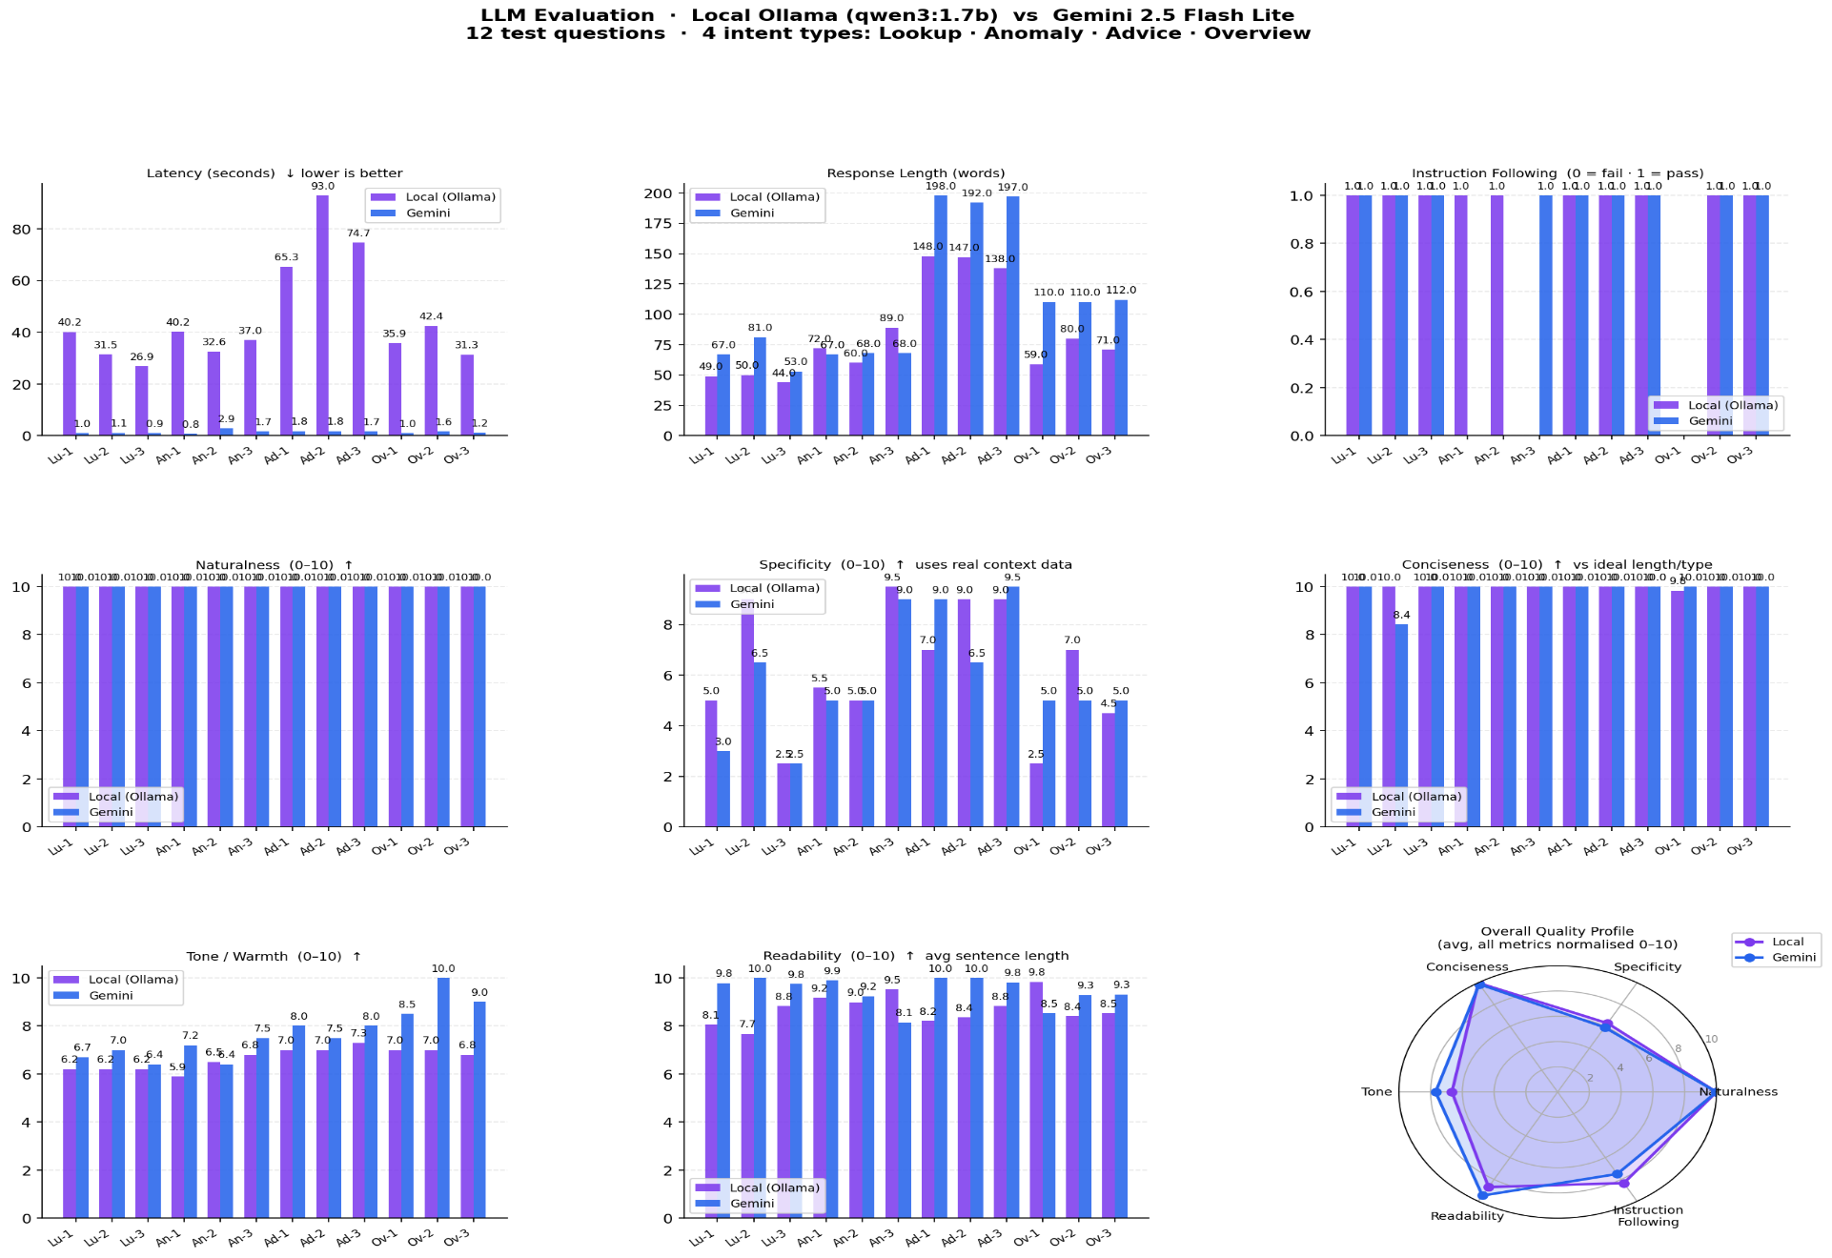
Figure 1. Evaluation 1: Dell Latitude 5520 (CPU-Only)

Evaluation 2: Dell OptiPlex 5090 (GPU-Accelerated)
The test was performed using a Dell Optiplex 5090 Desktop computer. The computer has an Intel Core i7-11700 processor. Additionally, it contains a dedicated, though older generation, CUDA capable graphics card. Therefore, Ollama can send parts of its models to the GPU for processing as part of each token processed. As such, the processing time per token is greatly decreased by offloading portions of the model to the GPU.
The results indicate improved performance as had been anticipated. Qwen3 1.7b latency dropped to 7-66 seconds, with 70% of all queries taking between 18-30 seconds to complete. This represents a 3x decrease in the amount of time required to process queries versus the cpu only test. Also, Gemini 2.5 Flash Lite latency increased on this machine to take between 4-25 seconds. These latencies were much greater than those taken during Evaluation 1.
Therefore, there is significantly less difference in latency when comparing local inference to remote inference on the college pc. Specifically, Gemini's advantages have diminished from approximately thirty-fold to around 1.5-3 fold for nearly every query. While these differences may be problematic for applications requiring subsecond response times, they appear reasonable for a personal finance application, especially since local inference provides additional privacy.

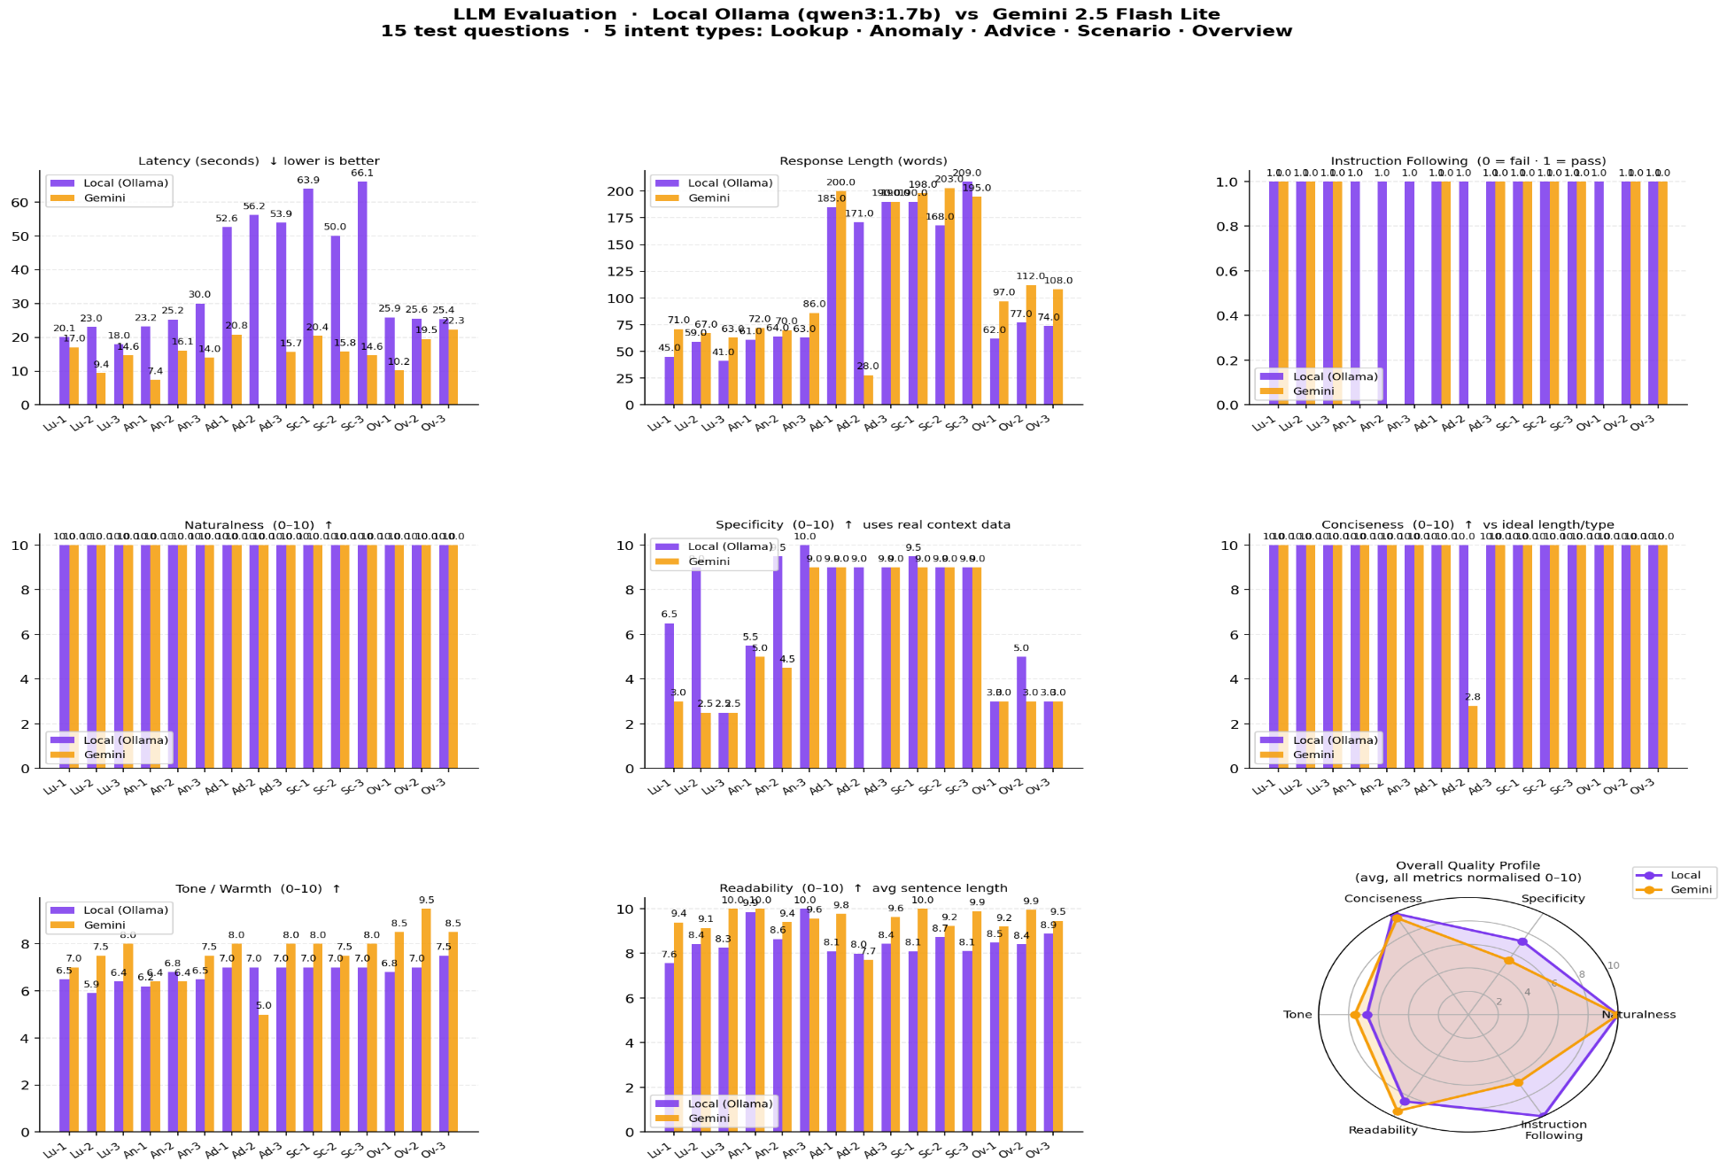
Figure 2. Evaluation 2: Dell OptiPlex 5090 (GPU-Accelerated)

Cross-Environment Latency Summary
Metric | Dell Latitude 5520 | Dell OptiPlex 5090 | Improvement
Ollama avg. latency | ~55 sec | ~28 sec | ~3x faster
Ollama worst case | 93 sec | 66 sec | ~1.4x faster
Gemini avg. latency | ~1.8 sec | ~1.5 sec | Network variance
Local vs Cloud gap | ~30x | ~1.5-3x | Dramaticallynarrowed
Table 3. Latency comparison across hardware environments.
These results provide a direct use case implication: Local LLMs can be deployed by anyone that has a machine with a single-dedicated (older) gpu for personal financial apps. With consumer gpu prices continuing to decrease as well as small models becoming increasingly efficient, it's anticipated that the amount of hardware needed to deploy an AI assistant like Bloom will continue to grow.

Comparative LLM Evaluation: Quality Analysis
The assessment of the performance was done with respect to seven further quality dimensions at both hardware levels for all 27 possible combinations of queries and models (12 in Assessment 1 and 15 in Assessment 2 where five additional intents were tested including a new intent type, scenario, that relates to fictitious planning scenarios as well as e.g. "what happens to my budget when my monthly rent increases by 200 euros?")

13.1. Instructions Following
In total across both evaluation runs with each of the 27 query-model pairs, there was a perfect "instruction-following" result of 1.0 for both Qwen3 1.7B and Gemini 2.5 Flash Lite. The binary "instruction-following" results indicated that each model strictly followed the specific formatting and scope limitations as outlined within the original system prompts (e.g., providing responses within the proper language register, not including fictional/hallucinated content, and utilizing the exact same four-part response format as originally presented in the prompt template examples provided).
In my opinion, this is one of the most significant individual findings from the entirety of the evaluation. It clearly shows that a relatively small, freely deployable 1.7B parameters LLM model can perform identically to a large proprietary cloud-based model when evaluating structural compliance, which is the most critical aspect for a commercial product that requires consistent, reliable output formats. Thus far, the difference in performance between these two models has been based upon richness and depth of knowledge, but not upon structural dependability. As such, the differentiation of reliability in terms of structural dependability will be important for developers who are creating their own software applications that use LLMs.

13.2. Naturalness
The two systems scored perfectly, a full 10/10 on Naturalness for each question for all queries for both evaluations. The evaluation of how "natural" a system's response reads was done through evaluating how much its responses were written like "normal", idiomatic English instead of sounding like they had been written by a robot. These findings support the common view of researchers about language models generally, especially now when models can be produced at smaller sizes, that problems related to "surface fluency" have largely been resolved. Therefore, the primary distinguishing characteristics between systems would include the extent to which a system is able to provide deep answers, accurate answers, and answers that are appropriate within the context being asked about, this is measured using Specificity and Tone metrics below.

Specificity
A key difference in the model's ability to provide specific answers using a users' actual transaction data instead of general comments about money was found in specificity. Specificity is the most directly related metric to Bloom's goal of being a personalized financial assistant.
Gemini had a significant advantage over Ollama when comparing their performance in lookup and anomaly queries during evaluation one. Specifically, Gemini achieved a specificity score of 9.0 for lookups and 6.5 for anomalies while Ollama achieved scores of 5.0 and 2.5 respectively. Similar results were also seen during evaluation two where Gemini again showed an advantage for lookup queries. However, on more complex query types, including scenario based queries the specificity scores were very close with each model receiving a score of approximately 9.0 – 10.0. It appears that the scenario-based queries, as they are generally more open ended and rely less on a users exact numeric recollection, play more evenly into the strengths of each model.
The large gap in specificity scores between Gemini and Ollama on lookup queries can be attributed to the fact that gemini has a larger context window and has been trained to retrieve exact numbers from a wider range of user data. However, it is important to note that even though Ollama may have scored lower on many of its lookup queries, those low scores do represent responses to user transactions. They just weren’t as accurate in citing the correct number. Most importantly, they did not make up information.

Conciseness
Both models scored 10/10 on the overwhelming number of queries for virtually every query in both evaluations as it pertains to conciseness, defined by how well they aligned with the intended optimal response length for each of the respective intents types. The only time there were not 10s from both models for this particular metric was one instance when the local model created an extremely long response compared to what would be considered typical for an overview. Otherwise, each model successfully calibrates the response length appropriately so as to demonstrate that compact models do not inherently produce verbose responses.

Tone and Warmth
The tone and warmth are how closely did the responses reflect an optimistic, encouraging and supportive style suitable for a financial aid assistant. Across both evaluations there were no large differences, however, Gemini 2.5 had slightly better performance than Ollama as it scored 7.5-10.0 vs. Ollama's 5.9-8.5. The largest difference was seen in Evaluation 2 with respect to overview questions. Thus, my findings suggest that Gemini has been trained much more extensively for consumer-facing empathetic communications. I believe this is due to Google's extensive use of its RLHF (Reinforcement Learning from Human Feedback) pipeline to optimize their model for friendly conversation tone over many varied contexts.
In contrast, although Ollama's tone scores are still well within acceptable ranges for all question types and overall improved substantially when comparing evaluation 1 to evaluation 2. This could be indicative of the fact that the GPU environment produces either qualitatively different or qualitatively warmer outputs.

Readability
Both models were very strong on readability metrics for each of the three question types and two evaluation sets with most scores falling in the 8.0-10.0 score range. The Readability metric is a measure of how good an average sentence length is compared to optimal benchmark sentence lengths based upon the question type. Regardless of how complex the question was, both models generated clearly written and readable text which confirmed that even small LLM's can internally process what are considered conventional writing registers and structures for conversation.

Quality Equivalence Findings
In summary, as demonstrated by the charts shown in Evaluation 1: Dell Latitude 5520 (CPU-Only)Figure 1Figure 1. Evaluation 1: Dell Latitude 5520 (CPU-Only) and Figure 2, the quality profiles of Qwen3 1.7 B and Gemini 2.5 Flash Lite demonstrate similar quality characteristics across almost all of the features measured. These findings have very significant practical implications that can best be understood in terms of how actual users of Bloom experience their interactions with Bloom.
- A user asking, “How much did I spend on food last month?” would likely receive a clear, fluent, well-structured answer from both models. While Gemini may provide a more precise citation of the exact amount spent, Ollama may frame it in slightly more general terms. Both responses would be informative.
- A user asking “Were there any unusual transactions on my account?” would likely receive a coherent listing of anomalous items from both models, based upon the same Isolation Forest outputs used by both. Although the ML-based detection process behind these anomalous items is identical, the LLM simply provides narrative explanation of the results.
- A user asking “What can I do differently to save money next month?” would likely receive personalized, action-oriented recommendations from both models, each of which is based upon the same recommendation engine outputs. While Gemini may provide warmer phrasing in its response, Ollama may provide slightly terser language. Ultimately, both responses would be valuable and actionable.
Therefore, the ultimate conclusion is not that Gemini is better and Ollama is inferior. Rather, the conclusion is that both models are suitable for use as tools to assist users with their personal financial affairs and that the primary distinction between the two is not one of quality. Instead, the primary distinctions between the two models relate to different values and different infrastructural requirements. Thus, a user who places high value on privacy and is willing to accept slightly less warmth in the response tone could choose Ollama. Alternatively, a user who desires greater fluency and is comfortable with cloud processing could select Gemini. Bloom offers both choices to users and allows them to make this trade-off explicitly and transparently, which constitutes a meaningful design feature.

Future Extensions and Scalability
Bloom, as it stands now, represents a working version of an idea that was designed to be constrained to fit the timeframe of a final year project. Nonetheless, the architecture has been built in a way that will allow for substantial increases in terms of utility and commercial viability of the system through various future extensions.
An obvious example of one possible extension would be to implement a “household finance” mode. This would involve creating a common dashboard where each user may link their individual account(s) to create a single view for managing expenses jointly, dividing bills equally, and establishing combined savings goals. Since the pipeline architecture currently operates at the user level, adding functionality to collect data across multiple users would likely need minor changes to the pipeline architecture to aggregate user-level data.
As demonstrated by the hardware comparison done here in this project, even an old graphics card can produce a 3x reduction in latency over performing local LLM inference compared to using a Cloud service. Adding either a modern consumer-grade graphics processing unit (GPU; e.g., NVIDIA RTX 4060 or newer), or an Apple Silicon M-series chip (which includes hardware acceleration for matrix multiplication) would drop the average inference time for a Qwen3 1.7B model down to approximately 2-5 seconds per response. At this point, the local version of Bloom would essentially have identical user-experience characteristics to cloud hosted services.
In addition to allowing users to upload their transaction history via a CSV file, future versions of Bloom could be integrated with open banking APIs. This integration would enable Bloom to automate the collection of all financial transactions from participating banks using explicit user permission. As a result, Bloom would transition from being used for periodic analyses to providing continuous insights about a user's finances. The pipeline would then run continuously once new transactions are detected.
There are also some very academically interesting areas that are worth pursuing as future work. One area involves training compact language models on personal finance specific data. As stated previously, the evaluation methodology created for this project provides everything needed to evaluate whether or not these types of optimizations improve performance

Challenges and Technical Difficulties
The implementation of the Bloom project did not follow an orderly process. During the course of five Scrum sprints, the project encountered a number of technological issues that needed meaningful troubleshooting and debug work.
CSV Files Used for Normalization
Revolut and AIB generate CSV files that have very different architectures. For example, AIB includes a Signed Debit/Credit Amount column, whereas Revolut generates a Transaction Type column based upon prefixes (VDP-, VDC-, ATM) in its Debit/Credit Description column. Building normalizers.py to accommodate these differences needed many iterations of testing and coding. In particular, identifying actual purchases versus internal account movements represented by Revolut's TOPUP and SAVINGS transactions posed an additional challenge. Although these were not true expenses, they were appearing in the same list as genuine card payments, thus artificially increasing reported expenditures and affecting the inputs to the machine learning pipeline. To resolve this issue, a Transaction Class field was encoded and class-based filtering was applied prior to performing any statistical operations.
SQL Injection Vulnerability
The initial version of the application created SQL queries using Python f-string formatting. The variable user_id was being directly substituted into the query string. Although this is a common method of creating dynamic queries, it also presents a well-documented SQL injection risk. This security hole was identified during a peer-review session and corrected by converting all queries to use SQLAlchemy's named parameter binding syntax, where parameters are sanitized at the database driver level before reaching the database.
PostgreSQL Data Type Errors
Another bug that presented itself during the implementation of the application involved the account_id column being defined as a PostgreSQL BIGINT type. However, because the application generated ids as hexadecimal UUIDs, when they were written to the PostgreSQL database, PostgreSQL would reject them due to type coercion errors. An associated issue presented by the mask column was that it was defined as CHARACTER(4), when non-formatted id values were inserted, they would be truncated. These two bugs required tracking data flows from csv normalization through the Fast API endpoint to db writes to understand where type coercion was occurring.
Derived Tables Written by Pipeline
The final piece of the puzzle involved writing results of the ML pipeline to four derived tables: fm_encoded, anomaly_scores, recommendations, and user_monthly_stats. Initially, if_exists="append" was used when writing these tables, however, this allowed the original schema to persist. When updates were made to the ML pipeline feature set and/or removed columns, this resulted in silent data corruption or write failure. Switching all pipeline-derived tables to if_exists="replace", dropping/recreating each table on every run ensured that schema consistency was maintained.
Pipeline Run Logic
One other issue surfaced when a new user activated their registration and triggered a pipeline run. Due to the fact that multiple pipeline steps, particularly features.py which constructs a featuretools Entity Set, require data from all users to create meaningful aggregate statistics, running in isolation without first loading pipeline tables would result in either failing to execute or generating meaningless output. To address this issue, a check called all_pipeline_tables_exist() was added to pipeline.py which promoted single-user runs to full pipeline runs when necessary tables were missing. Additionally, features.py was modified to always load all users regardless of who initiated the pipeline.
Proxy Route Configuration Issues
Finally, one last "simple yet confusing" bug was discovered with respect to Vite proxy configurations matching routes in declaration order. The catch-all /api route (which points to Express running on port 8000) was declared before the more-specific FastAPI routes (/api/ask,/api/pipeline,/api/upload,/api/health). Thus, even though requests for FastAPI routes were being sent correctly according to client-side routing rules, requests for FastAPI routes were instead being forwarded incorrectly to Express by virtue of having been received by the earlier-catchall route. The symptoms were FastAPI endpoints returning Express 404 error messages. This was misleading since there was no apparent reason for this behavior. However, simply re-ordering the proxy declarations such that more-specific routes appear before the catch-all resolved this issue quickly.
Loading Wordmarks with Google Fonts
As described above, the Bagel Fat One font family used for rendering the Bloom logo wordmark was originally loaded with a CSS @import directive contained within index.css. Unfortunately, this method of loading fonts has historically proven to be problematic, on certain network conditions it can fail quietly resulting in the wordmark falling-back to whatever system font is available. Therefore, moving the element containing the declaration for Google Fonts into index.html's, the recommended location for importing Google Fonts in Vite projects, eliminated this issue completely.
Inaccurate Income Reporting for Revolut Users
There was another issue related to user_stats.py that resulted in systematic underreporting of income figures for Revolut users. Prior to executing any logic designed to detect income, a filter had been globally applied excluding all rows with transaction_class = 'topup'. Since Revolut encodes bank transfers received from banks as TOPUP rows, this effectively prevented legitimate incoming bank transfers from being detected and therefore included in total income figures. Instead of globally excluding classes at the beginning of a function, and thereby impacting multiple computations, this global filter should have been selectively applied per computation rather than globally at the start of functions.
Concurrent LLM Execution and Thread Safety
Both running LLM Inference calls concurrently using the concurrent.futures.Threading.ThreadPoolExecutor caused a Race Condition that allowed for another concurrent call to also run a duplicate pipeline while it is still running in memory pipeline status dictionary can be checked for “idle” during a concurrent call’s pipeline execution. To resolve the issue, I wrapped all Status Updates within a Threading.Lock()
LLM Temporal Hallucination
Early Testing revealed both models on occasion would refer to the lastest transactions as outdated and were confused between their training time version of “now”, and what actually existed in terms of Data. This was resolved by creating get_latest_transaction_date() in collectors.py. It will query max(date) from transactions_enriched and then insert that value into each prompt, thus instructing the model to use that date as its current day."

Learning Outcomes and Skills Development
The experience gained in developing Bloom enabled a very diverse and interactive learning environment that spans all aspects of both Computer Science and Software Engineering. To enable the development of a complete end-to-end front/back stack application, Bloom necessitated building expertise in all aspects of a full stack application from first principles. In the case of the front end, the application provided an opportunity to develop proficiency in working with React 18 with TypeScript. This included building custom hooks, conditionally rendering based on what is stored in localStorage using the item ‘login_method’ as a branch point to navigate between Plaid and CSV API endpoints and compose components. Working with Tailwind CSS and DaisyUI allowed me to gain practical experience in how to utilize utility-based styles and follow a design system approach when creating large-scale applications. For the back end, I utilized Express.js to create REST APIs and FastAPI to create native Python API designs, which included configuring CORS for multi-origin communication.
Implementing the entire workflow from raw CSV ingestion to feature engineering to anomaly detection, using scikit-learn's Isolation Forest, to time series forecasting, using Facebook Prophet and finally to generating recommendations required a high degree of engagement with the problems associated with implementing machine learning in a production setting: schema drift preventing "cold start" for users who do not have enough data to produce reliable results, and maintaining thread-safe status for each stage of a multi-stage pipeline. These are types of engineering problems you typically encounter in production ML environments, however they are rarely discussed or explored in academic course work.
Additionally, Bloom provided the ability to develop real-world experience with developing an LLM-enabled application: designing prompts, classifying intents, injecting context into an LLM model and concurrently invoking two LLM models using Python. Furthermore, designing and evaluating the formal evaluation framework using standardized queries, controlled context injection and multi-dimensionality score calculations provided me with the opportunity to develop empirical research methodologies that can be used in both academia and industry research settings.
The data layer of Bloom required designing a PostgreSQL schema that supported both multiple user accounts and multiple output tables from ML pipelines, utilizing SQLAlchemy and psycopg2 for connecting to PostgreSQL, writing parameterized queries to prevent SQL injection attacks and defining cascade delete relationships for complying with GDPR regulations related to removing personal identifiable information. To provide security at the architectural level: I employed bcrypt/argon2 for storing passwords securely, wrote parameterized SQL statements to prevent SQL injection attacks, and defined separate paths for performing local versus cloud-based inference operations to allow for private-by-design deployment configurations.

Conclusion
In contrast to previous implementations of LLM-based personal finance applications, which have either been completely cloud hosted and therefore prohibitively expensive, required advanced technical knowledge from end-users, compromised user privacy through data transmission requirements, etc., Bloom is unique in its ability to provide personalized, high-quality, private financial intelligence to non-expert users at no cost. This capability is achieved by creating a structured pipeline of machine learning techniques combined with a natural language interface using both local and cloud hosted LLMs. Therefore, Bloom occupies a previously unexploited niche in the field of personal finance technologies: it is both technically innovative and practically applicable.
A key result of comparative assessment of Qwen3 1.7B and Gemini 2.5 Flash Lite, specifically across the space of all possible query-model pairings, across all available hardware configurations, and across all measured quality metrics, was a highly counter-intuitive yet significant finding. The two models produce output that is nearly equivalent in terms of quality. Specifically, they were indistinguishable in terms of instruction-following capabilities and naturalness. They were almost indistinguishable in terms of concision and readability and were within 1-2 quality units of one another in terms of specificity for most query types. However, where Gemini did possess advantages relative to Qwen3 1.7B, those advantages were relatively small, and the primary qualitative difference between the models, their latency, appears to be largely an artifact of differences in the hardware platforms upon which they are deployed rather than inherent differences in how the models themselves operate. This conclusion strongly supports Bloom's central hypothesis about the trade-offs involved in deploying dual-configuration architecture for accessing LLMs: whether or not to deploy the local LLM versus the cloud-hosted version is fundamentally a value-based decision. Alternatively, organizations or individual users seeking to maximize the quality of responses produced by the LLM can elect to configure Bloom as a cloud-hosted service. Moreover, because Bloom explicitly represents this trade-off as a user-configurable parameter, while simultaneously providing objective, empirically-derived measures of the quality differential associated with different configurations, I believe that this work contributes significantly to a broader literature focused on developing systems that are both technically feasible and ethically responsible.
Additionally, the development of Bloom provided an opportunity for skills development across the complete range of full-stack web engineering disciplines: front-end UI/UX, back-end server-side programming, middleware services, ML pipeline design, NLP and LLM integration, database engineering practices, security best-practices and methodologies for conducting empirical research. Finally, there exist several clear paths forward for extending the functionality of Bloom to include multi-household modes of operation, optimized local-inference support via GPUs, direct Open Banking API access, domain-specific model fine-tunability and multimodal receipt analysis. Thus, in addition to being a working prototype, Bloom constitutes a foundational platform onto which far more ambitious capabilities for delivering financial intelligence can be developed.

Appendix
The link directs to the GitHub repository “FYP”:
https://github.com/Yunnna005/FYP

References
Alain Airom (2025) Pros and Cons using containerized Ollama vs. local setup for Generative AI Applications - DEV Community. Available at: https://dev.to/aairom/pros-and-cons-using-containerized-ollama-vs-local-setup-3he3 (Accessed: November 26, 2025).
Aurelien Geron (2019) Hands-on Machine Learning with Scikit-Learn, Keras, and TensorFlow Concepts, Tools, and Techniques to Build Intelligent Systems SECOND EDITION.
Bottou, L., Curtis, F.E. and Nocedal, J. (2018) “Optimization Methods for Large-Scale Machine Learning.” Available at: http://arxiv.org/abs/1606.04838 (Accessed: October 22, 2025).
Braga-Neto, U. (2024) Fundamentals of Pattern Recognition and Machine Learning, Fundamentals of Pattern Recognition and Machine Learning. Springer International Publishing. Available at: https://doi.org/10.1007/978-3-031-60950-3.
C A Padmanabha Reddy, Y., Viswanath, P. and Eswara Reddy, B. (2018) “Semi-supervised learning: a brief review,” International Journal of Engineering & Technology, 7(1.8), p. 81. Available at: https://doi.org/10.14419/ijet.v7i1.8.9977.
Choi, J.J. (2022) “Popular Personal Financial Advice versus the Professors,” The Journal of economic perspectives, 36(4), pp. 167–192. Available at: https://doi.org/10.1257%2Fjep.36.4.167.
Garbinsky, E.N., Mead, N.L. and Gregg, D. (2021) “Popping the Positive Illusion of Financial Responsibility Can Increase Personal Savings: Applications in Emerging and Western Markets,” Journal of marketing. SAGE Publications Ltd, pp. 97–112. Available at: https://doi.org/10.1177%2F0022242920979647.
Gayathri, Mrs.K. (2025) “EXPENSE TRACKER USING MACHINE LEARNING,” International Scientific Journal of Engineering and Management, 04, pp. 1–9. Available at: https://doi.org/10.55041/isjem03764.
Google AI for Developers (2025) Gemini models and Gemini API. Available at: https://ai.google.dev/gemini-api/docs/models (Accessed: November 26, 2025).
Heaton, J. (2018) “Ian Goodfellow, Yoshua Bengio, and Aaron Courville: Deep learning,” Genetic Programming and Evolvable Machines, 19(1–2), pp. 305–307. Available at: https://doi.org/10.1007/S10710-017-9314-Z.
Henrique Pett (2025) How to Build ML Model Training Pipeline. Available at: https://neptune.ai/blog/building-ml-model-training-pipeline (Accessed: November 26, 2025).
Hugging Face (no date a) Features & benefits. Available at: https://huggingface.co/docs/google-cloud/en/features (Accessed: November 26, 2025).
Hugging Face (no date b) Uploading models. Available at: https://huggingface.co/docs/hub/en/models-uploading (Accessed: November 26, 2025).
Hugging Face vs Ollama: Local AI Development Guide (2025). Available at: https://collabnix.com/hugging-face-vs-ollama-the-complete-technical-deep-dive-guide-for-local-ai-development-in-2025/#What_is_Ollama (Accessed: November 26, 2025).
James Manyika and Sissie Hsiao (2024) What is Gemini and how it works. Available at: https://gemini.google/overview/ (Accessed: November 26, 2025).
Ji, Z. et al. (2023) “Survey of Hallucination in Natural Language Generation,” ACM Computing Surveys, 55(12). Available at: https://doi.org/10.1145/3571730/ASSET/0F025751-E0A6-435C-B06C-2914C0F1165E/ASSETS/IMAGES/LARGE/CSUR-2022-0173-F01.JPG.
Kocielnik, R., Amershi, S. and Bennett, P.N. (2019) “Will you accept an imperfect AI? Exploring Designs for Adjusting End-user Expectations of AI Systems,” Conference on Human Factors in Computing Systems - Proceedings [Preprint]. Available at: https://doi.org/10.1145/3290605.3300641.
Kommey, B. et al. (2024) “A Reinforcement Learning Review: Past Acts, Present Facts and Future Prospects,” Journal Research and Development (ITJRD), 8(2). Available at: https://doi.org/10.25299/itjrd.2024.13474.
Miguel Rebelo (2025) What is Hugging Face? | Zapier. Available at: https://zapier.com/blog/hugging-face/ (Accessed: November 26, 2025).
Mohammed, M., Khan, M.B. and Bashier, M. (2017) Machine learning : algorithms and applications. Crc Press. Available at: https://ebookcentral.proquest.com/lib/munster/detail.action?docID=4683300.
OECD (2023) “OECD/INFE 2023 International Survey of Adult Financial Literacy,” OECD Business and Finance Policy Papers, 39. Available at: https://doi.org/10.1787/56003A32-EN.
Oliver Kingsley (2025) Deploy LLMs Locally Using Ollama: The Ultimate Guide to Local AI Development. Available at: https://apidog.com/blog/deploy-local-ai-llms/ (Accessed: November 26, 2025).
Ollama’s documentation - Ollama (no date). Available at: https://docs.ollama.com/ (Accessed: November 26, 2025).
Plaid (2022) Getting started with the Plaid API -- Plaid Academy. Available at: https://www.youtube.com/watch?v=sGBvKDGgPjc&t=620s (Accessed: December 4, 2025).
Plaid (2025) Plaid: Enabling all companies to build fintech solutions, Plaid. Available at: https://plaid.com/home/ (Accessed: October 22, 2025).
Plaid API Reference (2025) Home | Plaid Docs. Available at: https://plaid.com/docs/ (Accessed: October 22, 2025).
Plaid Auth Guide (2025) Auth - Introduction to Auth | Plaid Docs. Available at: https://plaid.com/docs/auth/ (Accessed: October 22, 2025).
Plaid Link (2025) Link - Overview | Plaid Docs. Available at: https://plaid.com/docs/link/ (Accessed: October 22, 2025).
Plaid Quickstart (2025) Quickstart | Plaid Docs. Available at: https://plaid.com/docs/quickstart/ (Accessed: October 22, 2025).
Plaid Sandbox (2025) Sandbox - Overview | Plaid Docs. Available at: https://plaid.com/docs/sandbox/ (Accessed: October 22, 2025).
plaid/sandbox-custom-users: JSON files specifying custom users suitable for testing Plaid integrations on Sandbox (no date). Available at: https://github.com/plaid/sandbox-custom-users (Accessed: November 25, 2025).
Richmond Alake (2023) ML Pipeline Architecture Design Patterns (With Examples). Available at: https://neptune.ai/blog/ml-pipeline-architecture-design-patterns (Accessed: November 26, 2025).
Sandbox - Customize test data | Plaid Docs (no date). Available at: https://plaid.com/docs/sandbox/user-custom/ (Accessed: November 25, 2025).
Sandbox - Sandbox institutions | Plaid Docs (no date). Available at: https://plaid.com/docs/sandbox/institutions/ (Accessed: November 25, 2025).
Sandbox - Test credentials | Plaid Docs (no date). Available at: https://plaid.com/docs/sandbox/test-credentials/#sandbox-simple-test-credentials (Accessed: November 25, 2025).
Sarah Laoyan (2025) Agile Methodology. Available at: https://asana.com/resources/agile-methodology (Accessed: November 30, 2025).
Sussman, A.B. and O’Brien, R.L. (2016) “Knowing when to spend: Unintended financial consequences of earmarking to encourage savings,” Journal of marketing research. American Marketing Association, pp. 790–803. Available at: https://doi.org/10.1509%2Fjmr.14.0455.
Tink (2025). Available at: https://tink.com/ (Accessed: November 26, 2025).
Zheng, Y. et al. (2016) “Exploiting multi-channels deep convolutional neural networks for multivariate time series classification,” Frontiers of Computer Science, 10(1), pp. 96–112. Available at: https://doi.org/10.1007/S11704-015-4478-2.
Zoph, B. and Le, Q. (no date) “Neural Architecture Search with Reinforcement Learning Motivation for Architecture Search.”

