Distributed Computing Assessment (2026)
Short Message Protocol Project Report
Anna Kovalenko
Munster Technological University, Tralee, Co.Kerry

Date submitted: 17/04/2026

Summary
This report documents the design and implementation of SMP (Short Message Protocol), a secure client-server application built using the Java stream socket API with SSL/TLS encryption. The system allows multiple client users to connect to central server, log in with credentials, and upload short text message, download stored messages, and log off. The server handles multiple clients at the same time using threads. The security requirements were meet by encrypting all communications using SSL. The protocol uses a simple code system inspired by established protocols such as HTTP and FTP. The application was built incrementally, starting from EchoServer3 framework provided in class, and gradually adding the SMP protocol logic, message storage, and finally SSL security. This report covers the protocol design, the software architecture, implementation details, and instructions for running the application.
Table of Contents
Summary 2
1. Introduction 1
1.1 Protocols and Security 1
2. Protocol Design 2
2.1 Message Format 2
2.3 Functional Requirements Implementation 3
2.4 Inter-Process Communication 5
2.5 Sequence Diagram 5
3. Software Architecture and Implementation 7
3.1 SSL Implementation 8
3.2 Error Handling 9
3.3 Instructions to Run the Application 10
4. Example of Server and Client Outputs 12
5. Conclusions 14
References 15
Bibliography 16
Appendix 17

Introduction
The project's goal is to design and implement a secure, client-server system using Java stream sockets. The system implements an application-layer protocol called SMP (Short Message Protocol) that allows users to exchange short text messages through a central server.
The project has log on, upload a short message, download messages, and log off. The server must handle multiple clients concurrently using threads, and all communication must be secured using SSL/TLS. The command-line was chosen for user interface.
The project was started with the existing code framework given in class, specifically the EchoServer3 and EchoClientHelper2 examples. The project designed the SMP protocol, implemented the message handling logic, and added SSL encryption as the final step. This incremental approach is recommended in the project specification and helped me test each piece before adding more complexity.

Protocols and Security
There were three primary reasons why TCP stream sockets were chosen over UDP datagram sockets in SMP. First, SMP relies upon reliable message transmission. Therefore, when a client posts an item or makes a file transfer request, all transmitted items must be delivered fully and accurately. TCP guarantees that this is true, whereas UDP may lose, duplicate or receive them in any other sequence than they were sent. Second, the SMP utilizes the request-reply method. Thus, after each of these commands has been issued by the client, it waits for a reply from the server. This sequential back and forth communication model fits perfectly into the structure of a TCP connection. Third, since the use of SSL encryption was required in the project, which only operates with TCP, there were no alternatives but to use TCP. The Java SSL library classes (SSL Server Socket and SSLSocket) are built to operate with TCP streams.
SSL provides security on communications by way of encryption, authentication, and data validation of connection networks. In the context of this project, I have chosen to use the latest version of the protocol TLS. Since TLS is currently the industry standard; Java also natively has support for it via the javax.net.ssl package. All the information that is transmitted from the client to the server will be encrypted. Therefore, no matter how an individual may choose to capture the clients and servers communications, he/she will never see the actual content of any message, password, etc. In addition to providing an environment where all communications are encrypted, the Server establishes its identity to the Client using a certificate which is stored within the Servers keystore.(Java Secure Socket Extension (JSSE) Reference Guide)

Protocol Design
The SMP protocol lays out the guidelines on how to communicate between the client and the server while the client is logged into a session. The protocol states which messages may be exchanged, how these messages should appear in terms of formatting, and what responses the client should expect from the server. The SMP protocol is a text-based protocol, where all messages will be passed through the TCP connection as human readable string. I decided to use a text-based protocol due to ease of debugging and this method has been employed within the example classes we have reviewed in class.
All messages sent via SMP begin with an integer representing the specific message being sent. The integer is followed by optional space-separated parameter fields. The server responds with its own integer indicating a response back to the client, along with optional data. The design for numeric codes for both SMP and HTTP/FTP was established using HTTP's Status Codes (e.g., "200 OK" or "404 Not Found") and FTP's three digit reply codes. Numeric codes make it very simple for clients to decode responses, simply check the first three digits of each response.

2.1 Message Format
All SMP messages follow this general format CODE [parameters]. Where CODE is a three digit number and parameters are optional text separated by spaces. The message is terminated by a newline character, which is handled by the sendMessage() and receiveMessage() methods in MyStreamSocket. I grouped the codes by function t keep them organised.(Client Server AY25/26 Spring - Distributed Computing-43992 (DTEC81000))
Code | Name | Parameters | Description
100 | LOGIN | Username, password | Client sends username and password to log in.
101 | LOGIN_OK | None | Server confirms login was successful.
102 | LOGIN_FAIL | Reason text | Server reports login failure with reason.
200 | UPLOAD | Message text | Client uploads a message to the server.
201 | UPLOAD_OK | None | Server confirms message was stored.
202 | UPLOAD_FAIL | Reason text | Server reports upload failure with reason.
300 | DOWNLOAD_ALL | None | Client requests all stored messages.
301 | DOWNLOAD_ALL_OK | Count | Server sends count, then each message, then END.
302 | DOWNLOAD_ALL_EMPTY | None | Server reports no messages are available.
350 | DOWNLOAD_ONE | Index | Client requests message at specific index.
351 | DOWNLOAD_ONE_OK | Message text | Server sends the requested message.
352 | DOWNLOAD_ONE_FAIL | Reason text | Server reports invalid index.
400 | LOGOFF | None | Client requests to end the session
401 | LOGOFF_OK | None | Server confirms session ended.
500 | ERROR | Reason text | Server received an unknown command.
Table 1. SMP Protocol Message Codes

2.2 Functional Requirements Implementation

2.2.1 Login
When the user decides they want to log into an account, the client will create a request in the form of “100 username password” to send to the server. The server thread will receive this request from the client and split it by spaces. After, the server thread will verify username and password. According to the project specification, the server does not have to verify if the login credentials match the credentials stored within a database. The server only has to accept any non-empty value as a valid username and password combination. After verifying the username and password combination is acceptable for logging into an account, the server will store the provided username for use during this session and respond with “101 Login Successful”. In all other cases where either a username or password is empty or missing entirely, the server will respond with “102 Login Failed” along with a description of why.
Pseudo Code, the server side login. Please see the full code in Figure 1:
Function handleLogin(message):
Split message to get username and password
If username and password are empty:
Send error: Login fail
Save username for this session
Set loggedIn = true
Send Login successful

2.2.2 Upload
Once user logged into your account, user may send a new message to the server by sending “200 message_text”.
The server will check two things:
- Whether you are currently logged in to an account.
- Check if a message was provided to be sent.
If both checks pass then the server will save the message to the shared ArrayList which includes the username as part of the message (i.e. username: message).
User receive either “201 Message uploaded successfully” back from the server or “202 Upload failed” followed by one of three reasons why it was unsuccessful.
Pseudo code, please see the full code in Figure 2:
Function handleUpload(message):
If client is not loggd in:
Send error: Upload failed
Extract message text from the message
If message is empty:
Send error: Upload failed
Store “username: message” in message list
Send Uploaded successfully

2.2.3 Download All
The customer enters "300" to get all of their messages. The server first verifies if the user is connected to the system. Once it confirms this, the server will look up all of the messages the user has stored. If the server locates any messages for the user, it will send a "301 count", where the "count" is the amount of messages located. Then the server will send one message at a time with an index in square brackets and lastly it will send "END" after sending all of the customers messages.
Pseudo code, please see the full code in Figure 3:

Function handleDownloadAll():
If not logged in:
Send error: Download Failed
Messages = get all messages from server
If messages is empty:
Send error: No messages available
Send message count
For each massage:
Send “[index] message”
Send END

2.2.4 Download One
The client will send “350 index” where index is the location of the desired message. Index is zero based. The server checks the validity of the index. If it’s a valid index in the messages database then the server will send “351 message_text” containing the message, otherwise “352 Invalid Message Index”.
Pseudo code, please see the full code in Figure 4:
Function handleDownloadOne(parts):
If not logged in:
Send error: Download Failed
If no provided in parts:
Send error: no index provided
Try:
Index = parse part[1] as integer
Catch invalid number:
Send error: index not a number
Message = get message at index from server
If message is not found:
Send error: index out of range
Send message

2.2.5 Logoff
If the client sends “400”, this indicates that they want to disconnect. The server will respond with “401 LogOff Successful” and delete all information associated with the session and close the socket connection. Upon disconnection the server thread will terminate and all resources for the socket will be deleted.
Pseudo code, please see the full code in Figure 5:

Function handleLoggOff():
Send Logoff successful
Set loggedIn = false
Clear clientUsername

2.3 Inter-Process Communication
SMP Protocol utilizes TCP Stream Sockets for Inter-Process Communication. The communication pattern is the Client initiating a connection to the Server, subsequently both communicate using a Request/Response standard. The server will listen at a predefined Port, and upon establishing a connection with a client, accept further incoming requests. Each incoming request to the server establishes a new TCP Connection that is encapsulated in a SSL/TLS Layer which encrypts all Data communicated over the established Connection.
MyStreamSocket Wrapper Class handles the transmission and receipt of Messages through utilizing BufferedReader to read Lines and PrintWriter to write Lines and appending a newline Character after each Message transmitted and flushing the OutputStream Buffer to send the data as soon as possible.
The communications are Synchronous. In other words, the client transmits a request and waits until the server has returned a response. This methodology is similar to what was demonstrated within the EchoClient/EchoServer Examples presented in-class. Due to the nature of the SMP Protocol, this method of communication fits well with this type of simple Protocol.

2.4 Sequence Diagram
The following diagram describes a SMP session. Client connects through SSL, logs in, uploads a message, downloads all messages available, downloads a specific message, and then logs off.
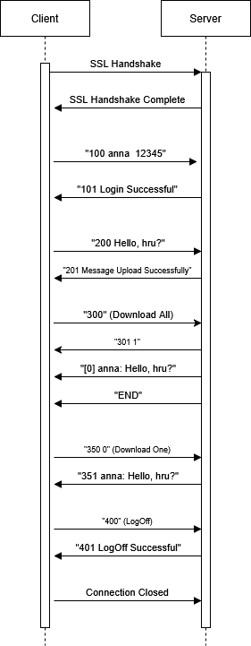
Figure 1. SMP Protocol Sequence Diagram

Software Architecture and Implementation
The client application was developed on top of three layers: User Interface (UI) Layer, Application Layer, and Session Layer. In terms of design patterns, Client.java provides user interface, while ClientHelper.java contains the core logic for the client and MyStreamSocket.java manages the underlying socket and the data transmission from/to server. Because each layer operates independently of all others, when you make a change to any single layer, you don't have to go back into any of the other layers.(Lab 2 SSL 2023.Docx: AY25/26 Spring - Distributed Computing-43992 (DTEC81000))
The project has 5 Java files:
- Client.java: Client user interface. Displays menu, reads user input, calls helper methods.
- ClientHelper.java: Client application logic. Builds protocol messages, sends to server, parses responses.
- Server.java: Server main class. Sets up SSL, accepts connections, starts threads, stores messages.
- ServerThread.java: Server session handler. Processes protocol commands for one client session.
- MyStreamSocket.java: Socket wrapper. Provides sendMessage() and receiveMessage() methods over TCP.

3.1 Presentation Tier
The Presentation Tier contains every interaction the end-user has with their application. for Client.java, this would include: displaying the welcome message, asking for server hostname and port number, showing login prompts, displaying main menu with numbered options, printing responses from server. The layer does not know anything about network communication and simply calls methods such as helper.login(username, password) and helper.uploadmessage(text). Then displays whatever string comes back.
A command-line interface was used because it is easier to implement than a GUI interface. It also keeps focus on protocol and networking aspects of project. The user input uses inputStreamReader and BufferedReader. The menu uses simple numbered options: 1 - upload message, 2 - download all messages, 3 - download one message, 4 - log off, and validates user input before sending any data to the server.

3.2 Application Tier
The Application Tier, the core logic, is located on the Client-side as well. On the client side ClientHelper.java puts together protocol messages, and on the server side Server.java parses the responses for the Client. Server is the main entry point into the Server Application. It establishes an SSL Server Socket and executes a forever-loop to accept new Client Connections. For every new connection accepted, it will create a new instance of ServerThread.java and start that in its own Thread. This allows for multi-threaded access to the Server, as each connected Client will have their own thread running concurrently.
Server also uses Synchronized Methods to manage the Shared Message Store. The Synchronized Methods are used so no matter what order the Threads execute their messages in, there is still integrity of the Data.
In the run() Method of ServerThread.java is where all the Protocol Processing occurs. In this Method is another Loop that Reads Messages from Clients, determines which command was sent based upon code number, calls the appropriate handler method, validates input to the handler method, executes requested action, sends back the proper response code.

3.3 Session Tier
The Session Tier manages all communications over the network. MyStreamSocket.java wraps a Java Socket, and has two very simple methods:
- sendMessage(String) that simply writes a line of text out to the socket's OutputStream followed by a newline terminator and flush.
- receiveMessage() that reads a single line of text from the socket's InputStream.
The following class diagram shows the relationships between the classes. Client uses ClientHelper, ClientHelper uses MyStreamSocket, Server creates ServerThread object, and ServerThread uses MySteamSocket. All Classes are described in a Figure 2.
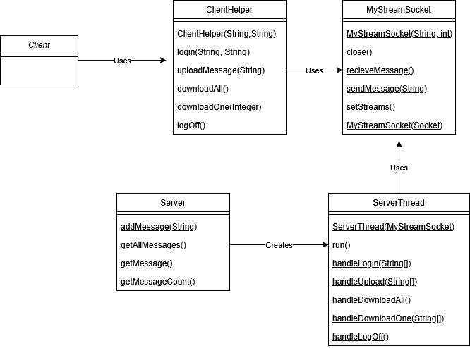
Figure 2. Class Diagram
The server enables the use of many clients accessing the server at once through Java threading. Once a client makes contact, the server invokes serverSocket.accept(), creating a new Socket for each client. Each new Socket is wrapped in an instance of MyStreamSocket and passed into a new ServerThread object. An additional Thread is created with the ServerThread and invoked. Therefore, the main server loop will immediately go back to accepting connections from other clients. So, there is no need to wait until after serving one client before accepting connections from another.
A number of methods within Server, which access the shared message storage, are declared as synchronized. Synchronization is a mechanism available within the Java language, where only one thread may invoke a synchronized method at a given moment upon a single object. If not synchronized, simultaneous execution of two threads attempting to add a message to the shared list would result in potential corruption of the data structure.

3.4 SSL Implementation
SSL configuration includes three basic actions:
Step 1: Create a server keystore by executing the keytool command. The keytool command is located within the Java Development Kit. The keystore will be comprised of a 2048 bit RSA key-pair and a self signed certificate. (Keytool)
Step 2: Export the server certificate from the keystore into a certificate file. The certificate file has only the public key and does not have the private key, therefore, it can safely be distributed.
Step 3: On the client side, import the server's certificate into a client truststore. The client uses this truststore to validate the server's identity through an SSL Handshake.
At startup on the server-side, the keystore is loaded. A KeyManagerFactory is initialized with the keystore. An SSLContext is then created using TLS. The SSLContext provides an SSLServerSocketFactory that is used to create an SSLServerSocket. Once a connection has been made to the server, the accepted socket will be an SSLSocket that will have encryption enabled.(Java Secure Socket Extension (JSSE) Reference Guide SSLSocketFactory)
At startup on the client side, the path to the client truststore is provided as two command line system property entries. The default SSLSocketFactory uses these two properties to locate the truststore. After creating an SSLSocket, when the client invokes startHandshake(), the SSL/TLS Handshake occurs automatically. In addition to establishing a secure communication channel, during this handshake, the server sends its certificate and the client validates it against all certificates found in the trust store.(SSLSocketFactory (Java Platform SE 8 ))

3.5 Error Handling
The application error handling is multi-layered. At protocol level, the server validates all client input before processing it. If client sends login command without username or password, server returns code 102 with descriptive reason. If client tries to upload while not logged in, server returns code 202. If client requests message with invalid index, server returns code 352. If client sends unrecognized command code, server returns code 500.
At network level, all socket operations are wrapped in try-catch blocks. When client disconnects unexpectedly server thread exits cleanly and closes socket in finally block.
At user input level, client validates menu choices and displays an error message for invalid input without sending anything to the server.
For example, when user enters “5” at main menu, client prints error and shows the menu again:
vscode ➜
/workspaces/java/mtu_distributed_computing/project (project) $
java -Djavax.net.ssl.trustStore=client_truststore.jks -Djavax.net.ssl.trustStorePassword=password Client
Welcome to Client.
"What is the name of the server host?
localhost
What is the port number of the server host?
7
SSL connection established.
Connected to server at localhost:7
LOGIN
Please enter your username:
anna
Please enter your password:
12345
Server response: 101 Login successful
Welcome, anna!

MENU
1. Upload a message
2. Download all messages
3. Download a specific message
4. Log off
Enter your choice (1-4):
5
Invalid choice. Please enter a number between 1 and 4.
MENU
1. Upload a message
2. Download all messages
3. Download a specific message
4. Log off
Enter your choice (1-4):

3.6 Instructions to Run the Application
Java Development Kit (JDK) version 8 or above is required for this program.
Step 1: Put all Java source files in one directory or Open the Project folder inside the Too243622_AnnaKOvalenko_project folder.
Step 2: Generate the server keystore and certificate, please see the executed code in Figure 8:
Keytool -genkeypair -alias serverkey -keyalg RSA -keysize 2048 -keystore server_keystore.jks -storepass password -dname "CN=localhost" -validity 365
Step 3: Export the certificate, please see the executed code in Figure 9:
keytool -exportcert -alias serverkey -keystore server_keystore.jks -storepass password -file server.crt
Step 4: Import the certificate into the client truststore, please see the executed code in Figure 10:
keytool -importcert -alias serverkey -file server.crt -keystore client_truststore.jks -storepass password -noprompt
Step 5: Compile all Java source files by typing:
javac *.java
Step 4: Start the server in another terminal window. By default, it will be listening on port 7. If you want to use a different port enter the number after the Server class name. For example:
java Server 1234
Step 5: Run a new instance of the SMP Client from yet another terminal window. Enter the server hostname and port as prompted. When asked for a login, enter your chosen username and password. After logging in you will see a menu that allows you to send messages, retrieve messages, logout and so on. If you wish to connect with multiple Clients at once, open an additional terminal window and type the command bellow and follow the prompts again.
The command to run in VS Code:
java -Djavax.net.ssl.trustStore=client_truststore.jks -Djavax.net.ssl.trustStorePassword=password Client

The command to run in a terminal:
java “-Djavax.net.ssl.trustStore=client_truststore.jks -Djavax.net.ssl.trustStorePassword=password” Client

Example of Server and Client Outputs
The following shows the actual output from a session. The server and 2 clients were run on the same machine using localhost, see .
Server:
vscode ➜ /workspaces/java/mtu_distributed_computing/project (main) $ java Server 1234
Server ready on port 1234. PLease wait for connections...
Client connected: 127.0.0.1
Received from client: 100 Anna 123
User logged in: Anna
Client connected: 127.0.0.1
Received from client: 100 Kate 123
User logged in: Kate
Received from client: 200 Hello, Kate
Message uploaded by Anna
Received from client: 200 Hello, Anna, hru?
Message uploaded by Kate
Received from client: 300
Sent 2 messages to Anna
Received from client: 350 0
Sent message 0 to Kate
Received from client: 400
User logged off: Anna
Received from client: 400
User logged off: Kate
Client 1(Anna):
vscode ➜ /workspaces/java/mtu_distributed_computing/project (main) $ java -Djavax.net.ssl.trustStore=client_truststore.jks -Djavax.net.ssl.trustStorePassword=passwor
d Client
Welcome to Client.
What is the name of the server host?
localhost
What is the port number of the server host?
1234
SSL connection established.
Connected to server at localhost:1234
LOGIN
Please enter your username:
Anna
Please enter your password:
123
Server response: 101 Login successful
Welcome, Anna!

MENU
1. Upload a message
2. Download all messages
3. Download a specific message
4. Log off
Enter your choice (1-4):
1
Enter the message to upload:
Hello, Kate
Server response: 201 Message uploaded successfully
MENU
1. Upload a message
2. Download all messages
3. Download a specific message
4. Log off
Enter your choice (1-4):
2
Server response:
301 2
[0] Anna: Hello, Kate
[1] Kate: Hello, Anna, hru?

MENU
1. Upload a message
2. Download all messages
3. Download a specific message
4. Log off
Enter your choice (1-4):
4
Server response: 401 Logoff successful
Goodbye.
Client 2 (Kate):
vscode ➜ /workspaces/java/mtu_distributed_computing/project (main) $ j.ssl.trustStore=client_truststore.jks -
ava -Djavax.net.ssl.trustStore=client_truststore.jks -D
javax.net.ssl.trustStorePassword=password Client
Welcome to Client.
What is the name of the server host?
localhost
What is the port number of the server host?
1234
SSL connection established.
Connected to server at localhost:1234
LOGIN
Please enter your username:
Kate
Please enter your password:
123
Server response: 101 Login successful
Welcome, Kate!

MENU
1. Upload a message
2. Download all messages
3. Download a specific message
4. Log off
Enter your choice (1-4):
1
Enter the message to upload:
Hello, Anna, hru?
Server response: 201 Message uploaded successfully
MENU
1. Upload a message
2. Download all messages
3. Download a specific message
4. Log off
Enter your choice (1-4):
3
Enter the message index number:
0
Server response: 351 Anna: Hello, Kate
MENU
1. Upload a message
2. Download all messages
3. Download a specific message
4. Log off
Enter your choice (1-4):
4
Server response: 401 Logoff successful
Goodbye.

Conclusions
This project has successfully implemented a fully functional secure client-server application with the Java Stream Socket API. The SMP protocol has provided a full suite of operations with regard to logging into the service, uploading messages of limited size, downloading messages from the service, and logging out. Each client connection was handled concurrently by the server using separate threads. All communication was performed over an encrypted channel utilizing SSL/TLS.
As far as protocol design, the SMP Protocol utilizes a very straight forward numeric coding scheme for ease of parsing and understanding. To keep things organized and allow for future extensions of the protocol, the three digit codes have been grouped based on their functions (1xx = Login Operations; 2xx = Upload Message Operations; 3xx = Download Message Operations; 4xx = Logout Operation; 5xx = Error Messages). As such if additional functionality was required in the future, new codes may be defined within a different range than those currently used without affecting the existing functionality.

Two limitations exist within this implementation: messages are held in memory and thus will disappear once the server is started again. Although this is clearly stated within the project specification as acceptable for simplification purposes. The second limitation exists due to the fact that usernames and passwords do not contain valid credentials previously entered into the database. Again, as noted in the project specifications, this is acceptable. However, both of these items would require correction in order to implement a working production level solution.

References
ArrayList (Java Platform SE 8 ). (n.d.). Retrieved April 4, 2026, from https://docs.oracle.com/javase/8/docs/api/java/util/ArrayList.html
ServerSocket (Java Platform SE 8 ). (n.d.). Retrieved April 4, 2026, from https://docs.oracle.com/javase/8/docs/api/java/net/ServerSocket.html
SSLSocketFactory (Java Platform SE 8 ). (n.d.). Retrieved April 4, 2026, from https://docs.oracle.com/javase/8/docs/api/javax/net/ssl/SSLSocketFactory.html
keytool. (n.d.). Retrieved April 4, 2026, from https://docs.oracle.com/javase/8/docs/technotes/tools/unix/keytool.html
Java Secure Socket Extension (JSSE) Reference Guide. (n.d.). Retrieved April 4, 2026, from https://docs.oracle.com/javase/8/docs/technotes/guides/security/jsse/JSSERefGuide.html

Bibliography
Client Server code.rar: AY25/26 Spring - Distributed Computing-43992 (DTEC81000). (n.d.). Retrieved April 4, 2026, from https://mtukerry.instructure.com/courses/6691/files/876646?module_item_id=275128
Lab 2 SSL 2023.docx: AY25/26 Spring - Distributed Computing-43992 (DTEC81000). (n.d.). Retrieved April 4, 2026, from https://mtukerry.instructure.com/courses/6691/files/876621?module_item_id=275112
Library: OpenSSL Cookbook 3ed | Feisty Duck. (n.d.). Retrieved April 4, 2026, from https://www.feistyduck.com/library/openssl-cookbook/

Appendix
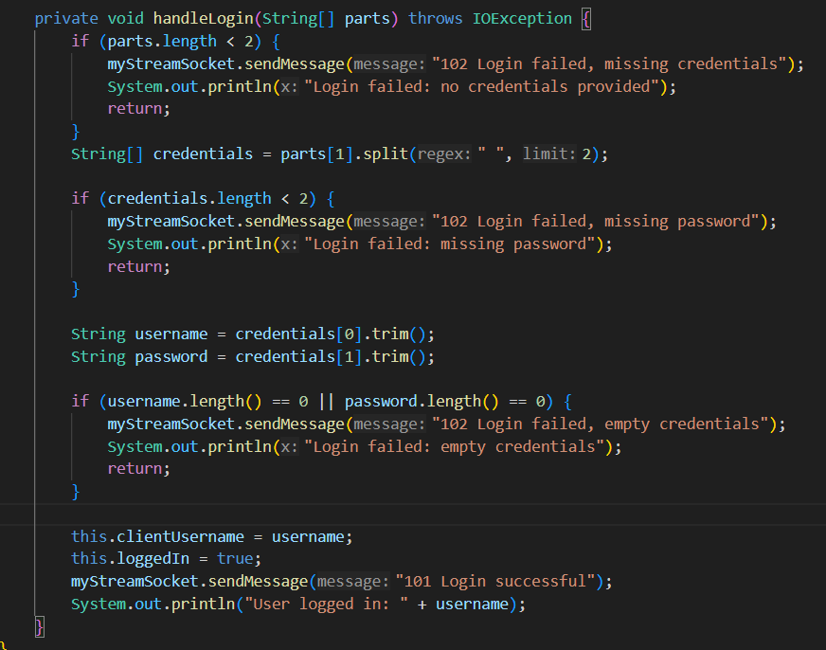
Figure 3. Handle Login function from ServerThread
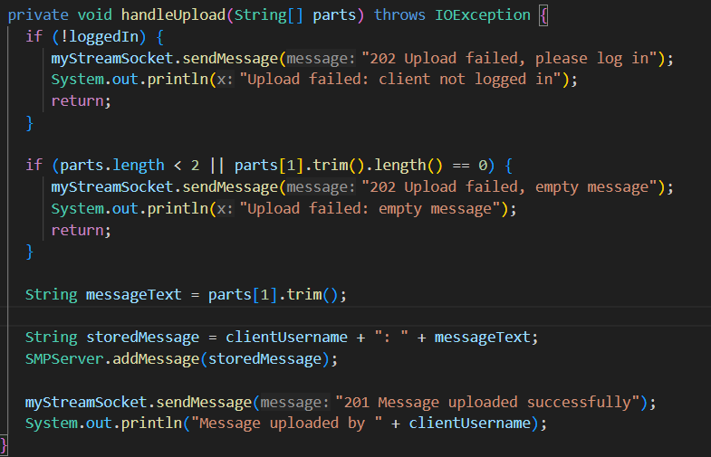
Figure 4. Handle Upload function from ServerThread
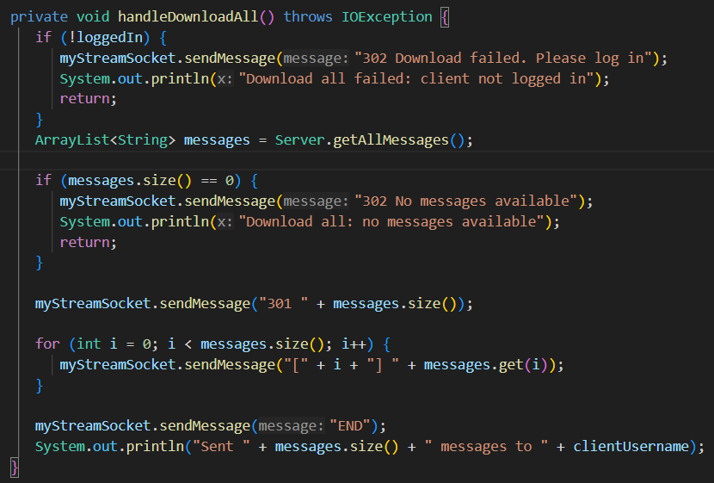
Figure 5. Handle Download All from ServerThread
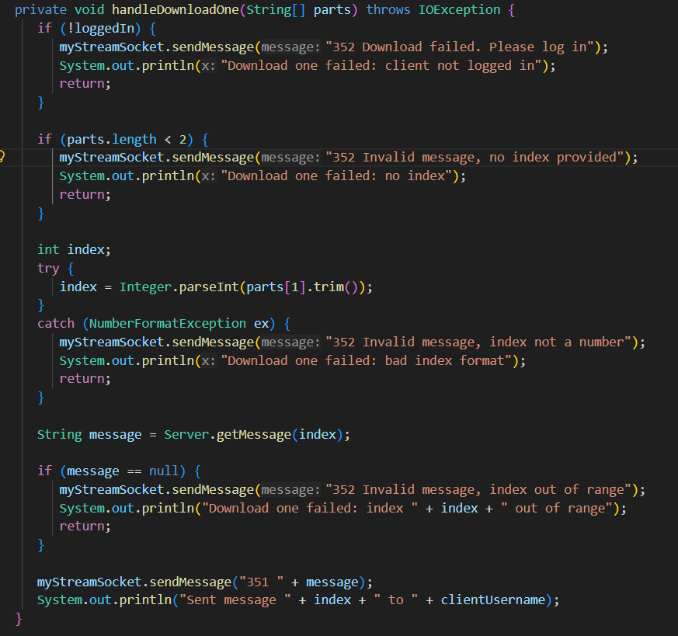
Figure 6. Handle Download One from ServerThread
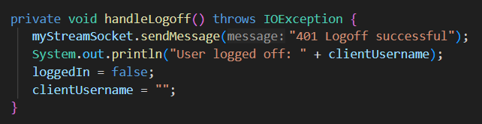
Figure 7. Handle Log Off from ServerThread
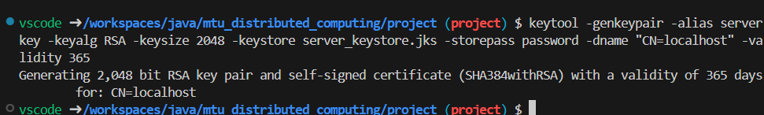
Figure 8. Generate the server keystore and certificate
Figure 9. Export the certificate
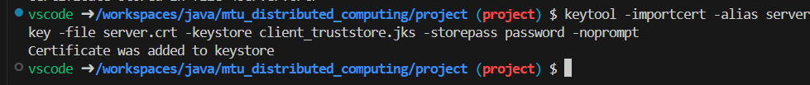
Figure 10. Import the certificate into the client truststore
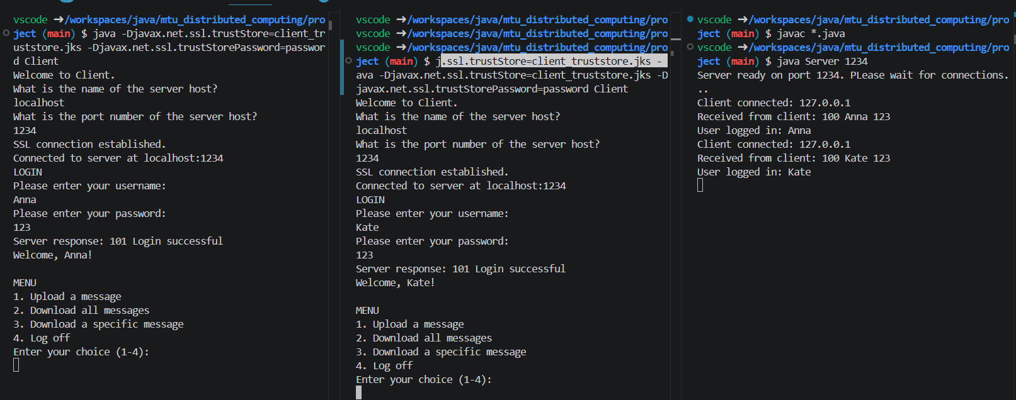
Figure 11. Start of the session 1 server 2 clients
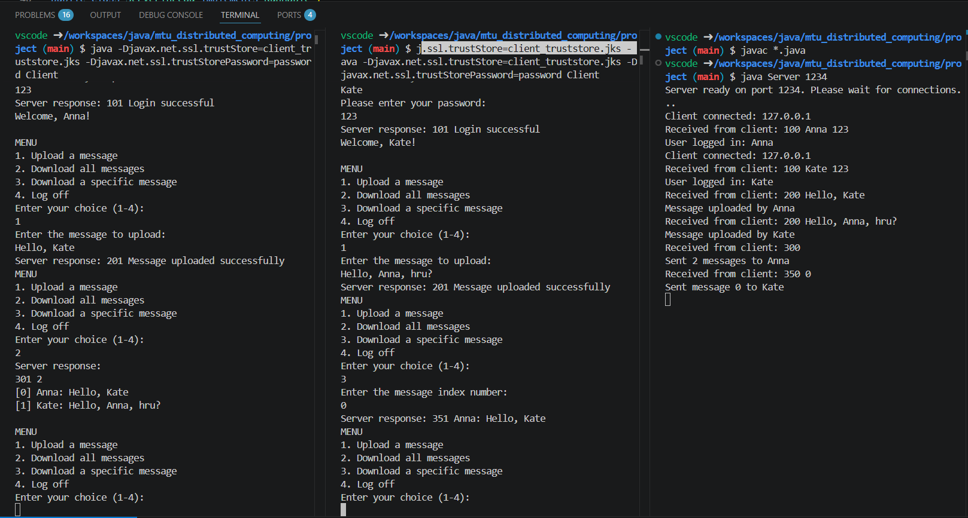
Figure 12. Upload message, download all and 1 specific message.
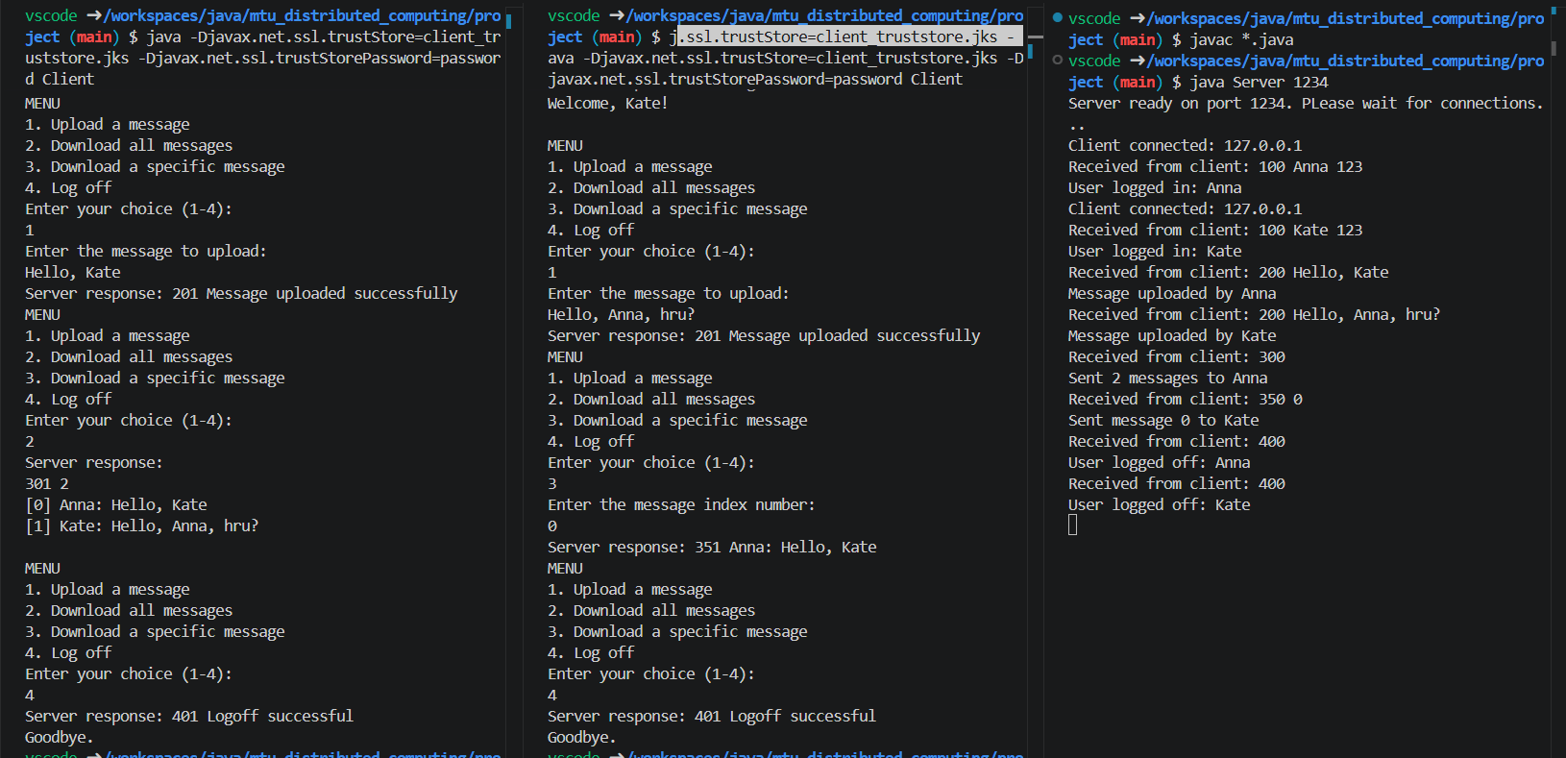
Figure 13. End of the session, logout of 2 clients

