Korean Culture Festival
Dublin
Student Anna Kovalenko (TL_KCOMP_B_Y4)
Table of Contents
1. Background to Project 3
1.1. Justification 3
1.2. Sponsor 3
1.3. Objectives 3
1.4. Project Life Cycle 3
2. Scope Statement 4
2.1. Project Scope 4
2.2. Project Exclusions 4
2.3. Success Criteria 5
3. Work Breakdown Structure (WBS) 6
3.1. Work Breakdown Structure Overview 7
4. Organization Chart 10
4.1. Organization Chart Overview 11
4.2. Organization Structure 12
5. Gantt Chart 13
6. Budget 13
6.1. Project Cost Estimate 15
6.2. Contract Types 17
6.3. Contract Types Justifications 18
7. Communications Plan 22
7.1. Communication Objectives 22
7.2. Stakeholders and Responsibilities 22
7.3. Communication Methods 23
7.4. Meetings 23
7.5. Reports 24
8. Risk Analysis 26
9. Project Chapter 29
10. Event Day Schedule 35
Appendix 37
Appendix 2 42
Appendix 3 45

Background to Project

Justification
My project is to create a Korean Culture Festival based on the growth of interest in Korean Pop (K-pop) and Korean dance and other areas of Korean culture in Ireland. There has been a significant increase in the interest in Korean culture, music and dance as well as traditional art forms, food and cultural practices. However, despite this demand for a Korean Culture Festival, there does not exist at present a recognized festival or professionally run competition to promote K-pop dance and other Korean cultural events in Dublin. The goal of this project is to fill that void with the establishment of an annual event which will promote and celebrate Korea's diverse cultures exchanges between Ireland and Korea. It will provide a platform for both Irish and International performers to showcase their talents and deliver an entertaining and culturally experience to attendees.

Sponsor
The Korean Embassy in Dublin is the primary sponsor of the project. The festival directly supports the Embassy’s goals of promoting Korean culture, fostering community engagement, and strengthening Ireland–Korea relations through soft-power cultural initiatives.

Objectives
- A successful hosting event that promotes the Korean Culture and its music in a formal atmosphere.
- Securing a minimum of 30 entries for the competition and achieving 80% of ticket sale capacity.
- High technical quality of production in respect to technical issues and equalness of the judging officers.

Project Life Cycle
The Korean Culture Festival uses the Predictive life cycle due to having a defined scope, a set date for the event, a fixed list of what will be delivered, and distinct phases that include planning, marketing, logistics, setting up the competition, running the event, and reviewing after the event. A predictive project can plan the timing, cost, and resource needs of the project with a high degree of confidence since the key requirements of the project (location, entertainers, judges, ticketing, safety policies, schedule, etc.) are known and don't often change.
A project using an Adaptive (ASD) life cycle is used for technology or software development when the requirements of the project are changing, the components of the product are being built in an iterative fashion, and the team is learning as it develops the product. Due to the lack of iterative design and changing requirements for this festival, the use of an adaptive process would increase both the complexity and the risk of the project, which are not suit for the project.

Scope Statement

Project Scope
The scope of this project includes planning, coordination, execution, and post-event management of the first-ever annual Korean Culture Festival and includes all logistical and venue responsibilities. The project also includes development of rules and categories for the competitions, management of the on-line registration portal, engagement and coordination of judges, organization of cultural programs to be performed, demonstrated and/or offered at the festival. In addition, marketing and sales functions are part of the project scope, as well as volunteer recruitment, training and management and management of event day personnel. All aspects of vendor procurement, contract administration, resources allocation, budgeting and financial reporting are included, as well as coordination with the Korean Embassy in Dublin as the project's sponsor.
Key areas that are within the scope of this project include:
- Venue management, logistics, and technical setup
- Planning of competitions, coordination of judges, and award of prizes
- Public marketing, ticket sales, and communication
- Recruitment, training and management of volunteers and vendors
- Financial oversight, reporting and coordination with the Korean Embassy in Dublin
All other events and or travel arrangements beyond the first annual event are excluded from the scope of this project.

Project Exclusions
- All Festival Management Activities that occur prior to, during and after the festival date.
- All activities related to the booking/management of local K-pop cover bands for all non-registered competitor and/or contracted performer/workshop host general performances at the festival.
- The full scope of managing outside vendors in food and/or merchandise kiosks. However, only includes providing a specific area for the vendor and does NOT include procuring/sourcing, hiring and supervising those vendors.
- Provisioning or sales of merchandise to be sold after the festival date.

Success Criteria
- The competition and festival program will be completed in accordance with the established time schedule and without significant delays.
- Participant and audience surveys after the event have a 4.0 average rating or above on a scale of 1-5.
- Legal, health, and safety regulations are all fulfilled, with no serious incident(s) occurring.
- This project has been implemented within a 10% variance of the final approved budget.

Work Breakdown Structure (WBS)

Work Breakdown Structure Overview
Korean Culture Festival
1. Project Planning
1.1 Project Foundations
1.1.1 Project goals
1.1.2 Project scope
1.1.3 Set Project Manager
1.1.4 Set Team Leads
1.1.5 Secure sponsor
1.1.6 Establish Project Committee
1.2 Project Design
1.2.1 Set preliminary budget
1.2.2 Develop high-level timeline
1.2.3 Identify required resources
1.2.4 Risk analysis and mitigation planning
2. Venue and Logistics Planning
2.1 Find Venue
2.2 Venue contract
2.3 Design stage layout
2.4 Design technical specifications
2.5 Security and safety planning
2.6 Accessibility and audience flow planning
3. Competition and Cultural Programming
3.1 Competition Planning
3.1.1 Rules and categories
3.1.2 Professional judges
3.1.3 Register Event in events portal
3.2 Cultural Programming
3.2.1 Invite performers
3.2.2 Confirm workshop hosts and activities
3.2.3 Collect technical requirements from performers
3.2.4 Schedule workshops and stage performances
4. Marketing and Sales
4.1 Ticket sales campaign
4.2 Participant registration campaign
4.3 Social media strategy and content calendar
4.4 Press and media coordination
4.5 Advertising materials
5. Staffing and Vendor Management
5.1 Vendor Coordination
5.1.1 Vendor selection
5.1.2 Vendor contracts
5.1.3 Vendor logistics
5.1.4 Prizes and awards procurement
5.2 Volunteer and Staff Management
5.2.1 Recruit volunteers
5.2.2 Assign volunteer roles
5.2.3 Conduct volunteer training
5.2.4 Create event-day staffing schedule
6. Pre-Event Operations
6.1 Judge briefing
6.2 Technical system check
6.3 Stage rehearsals and run-throughs
6.4 Venue setup
6.5 Vendor setup supervision
7. Event Day
7.1 Audience flow and ticket scanning
7.2 Stage management
7.3 Performance managing
7.4 Competition judging process
7.5 Award ceremony
7.6 Coordination of workshops and cultural booths
7.7 Safety and security supervision
7.8 Sponsor liaison
8. Post-Event Activities
8.1 Venue cleanup and vendor load-out
8.2 Financial closing and expense tracking
8.3 Sponsor reporting and thank-you communication
8.4 Event performance evaluation
8.5 Event Review

Organization Chart

Organization Chart Overview
Sponsor: Korean Embassy in Dublin
Provides financial support, cultural guidance, and high-level oversight for the event.
Project Steering Committee
Makes strategic decisions, approves major changes, and manages escalated risks.
Project Manager (PM)
Oversees the entire project, ensuring timelines, budget, quality, and coordination across all teams.
Volunteer Coordinator
Recruits, trains, schedules, and supervises volunteers across all event areas.
Team Lead: Logistics and Venue
Manages venue setup, technical systems, safety arrangements, and all onsite operational requirements.
Team Lead: Marketing and Sales
Handles promotional campaigns, media outreach, branding, and ticket sales strategy.
Team Lead: Finance and Admin
Manages budgeting, payments, contracts, and financial reporting throughout the project.
Team Lead: Culture Programming
Develops competition rules, oversees registrations, recruits judges, and ensures fair scoring.
Event Day Volunteers
Support event operations through tasks like guest assistance, backstage coordination, and general event support.
Performers / Workshop Hosts (External)
Deliver cultural performances and interactive demonstrations such as dance, hanbok, taekwondo, and calligraphy.
Judes (External)
Submit results to the Culture Programming Lead for awards.

Organization Structure
The event will utilize a strong Matrix Organizational Structure in order to support both the ability to collaborate across teams and deliver a unified product. The Project Manager has ultimate authority over the entire event, however, each functional area (Logistics, Marketing, Finance, Programming) will have their own Team Leads who can assist the Project Manager by providing their respective area’s expertise and necessary resources to successfully plan and execute the event.
A functional organizational structure is not suitable for this type of project because within a functional structure all authority is given to Department Managers and the Project Manager typically has very little authority, and therefore the communication is slow, decision making is fractured and there are numerous moving parts that need to be coordinated (performers, judges, vendors, venue logistics, etc.) for the success of the event.
Similarly, a pure Project Organizational Structure is also not suitable for this type of project, as a pure project structure would assign all employees directly to the project under the Project Manager and eliminate all functional departments. A pure project structure may work well for large, stand-alone projects, however, it would be too resource intensive for a temporary cultural event.
Hiring or reassigning permanent employees to roles that will only exist temporarily would be impractical and costly. Additionally, events like the one described often involve volunteers, part-time contributors, external performers, and contractors, which further limits the use of a pure project structure.

Gantt Chart
Level - 3
Please find full WBS in Appendix and Appendix 2.
To access Microsoft Project Gantt Chart and the Gantt Chart PDF, please use the links in Appendix 3.

Budget
The following table outlines the estimated budget required to deliver the Korean Culture Festival, including venue, technical setup, marketing, staffing, awards, and operational costs. All amounts are indicative and will be refined once vendor quotations and contracts are confirmed.

Project Cost Estimate
WBS Item | Units/Hrs. | Cost/Unit/Hr. | Subtotal (€) | WBS level 1 Total (€) | % of Total
- Project Planning |  |  |  | 500 | 4.29%
1.1 Project Foundations | 25 hrs. | 12.00 | 300
1.2 Project Design | 20 hrs. | 10.00 | 200
- Venue and Logistics planning |  |  |  | 3000 | 25.76%
2.2 Venue Contract | 1 contract | 2200.00 | 2,200
2.5 Security and safety planning | 1 service | 500.00 | 500
2.6 Accessibility and audience flow planning | 10 hrs. | 30.00 | 300
- Competition and Cultural Programming |  |  |  | 2000 | 17.17%
3.1.2 Professional judges | 4 judges | 200.00 | 800
3.1.3 Register Event in event portal | 1 registration | 50.00 | 50
3.2.3 Confirm workshop hosts and activities | 6 workshops | 100.00 | 600
3.1 Competition awards and trophies | 3 lot | 116.00 | 350
- Marketing and Sales |  |  |  | 1000 | 8.58%
4.1 Ticket sales campaign | 1 campaign | 150.00 | 150
4.2 Participant registration campaign | 1 campaign | 100.00 | 100
4.3 Social media strategy | 20 hrs. | 15.00 | 300
4.4 Press and media coordination | 10 hrs. | 20.00 | 200
4.5 Advertising materials | 1 lot | 250.00 | 250
- Staffing and Vendor management |  |  |  | 850 | 7.29%
5.1.2 Vendor contracts | 1 lot | 250.00 | 250
5.2.3 Conduct volunteer training | 3 sessions | 200.00 | 600
- Pre-event Operations |  |  |  | 2650 | 22.75%
6.1 Judge briefing and orientation | 4hrs. | 25.00 | 100
6.2 Technical System check | 8 hrs. | 75.00 | 600
6.3 Stage rehearsal and run-throughs | 10 hrs. | 80.00 | 800
6.4 Venue setup | 1 day | 1150.00 | 1150
8.Post-Event Activities |  |  |  | 480 | 4.1%
8.1 Venue cleanup and load-out | 12 hrs. | 40.00 | 480
Subtotal (Before Contingency) |  |  |  | 10480 | 90%
Contingency (10%) |  |  |  | 1048 | 10%
Total Project Cost |  |  |  | 11528 | 100%

Contract Types
Project Item | Cost | Firm Fixed Price | Unit Price
1.1 Project Management
1.2 Cultural Program Development
1.3 Venue
Main Hall
Backstage Rooms
Equipment Rentals
1.4 Technical Services
Stage and AV Setup
Technical Crew
(Event Day)
1.5 Marketing
Brochures and Printed Materials
Digital Promotion
Ticketing System
1.6 Competition Management
Judges
Competition Rules and Scoring System
1.7 Performers / Workshop Hosts
Performer Support
1.8 Volunteers and Staff
1.9 Vendors
Food
Merchandise
1.10 Awards and Trophies
1.11 Safety and Security Services
1.12 Event Documentation
1.13 Event Close-Out
Financial Report
Post-Event Evaluation Report

Contract Types Justifications
  - Project Management – Cost
Description: It encompasses the provision of administrative support, the organization and control of the schedule, reporting, and liaison with stakeholders, including the Embassy.
Hours worked by the PM will usually be variable based on the project's evolving requirements. Therefore, paying for actual effort rather than using a fixed price is generally a better approach when hours will fluctuate, particularly during peak periods.
  - Cultural Program Development - Unit Price
Description: This includes costs related to hosting workshops for activities such as a traditional Japanese Tea Ceremony, Chinese Calligraphy, a Taekwondo demonstration, etc.
Because each host/workshop/session is paid separately, costs depend on how many workshops/sessions are booked. Therefore, Unit Price is the best method to utilize for billing purposes.
    - Venue – Main Hall - Firm Fixed Price
Description: Renting the primary venue for the entire day.
The rent for the main event space is negotiated ahead of time as a flat rate per day regardless of how much of that time is utilized or how many attendees there are.
    - Venue – Backstage Rooms - Firm Fixed Price
Description: Additional areas for performers, judges, warm-ups, and storage.
Backstage areas are also rented on a flat rate basis, and this rate remains unchanged after the contract has been finalized.
    - Venue – Equipment Rentals - Firm Fixed Price
Description: Tables, chairs, barrier systems, queuing structures, etc.
Equipment rentals are also offered as packages (i.e. "100 chairs for X Euro"), so the rental rate is established prior to delivery of the equipment.
1.4.1 Technical Services – Stage and AV Setup - Firm Fixed Price
Description: Setting up stage and audio/video equipment for events.
Technical services are contracted as complete packages. The technical setup and equipment provided under these contracts remain constant once the scope of the contract is mutually agreed upon.
1.4.2 Technical Services – Technical Crew (Event Day) - Unit Price (Hourly/Day Rate)
Description: Engineers who manage and coordinate technical aspects of events (i.e. lighting, sound, stage management), on site.
Technical staff are billed on a per hour/day basis since the amount of time they spend working at an event can vary due to rehearsal times, delays, etc.
1.5.1 Marketing – Brochures and Printed Materials – Cost
Description: Creating and distributing printed materials (posters, flyers, banners, etc.), printing, and distribution.
The costs associated with printed materials will depend on the volume of materials produced, the type of paper used, last minute reprinting of materials, and other marketing-related expenses incurred. The actual costs incurred are reimbursable.
1.5.2 Marketing – Digital Promotion - Firm Fixed Price
Description: Advertising on social media, influencer packages, and promotional content.
Digital marketing campaign packages are often packaged together into a bundle with a predetermined fixed price (e.g. a €300 Instagram ad package).
1.5.3 Marketing – Ticketing System - Firm Fixed Price
Description: Fees charged by ticketing platforms for providing the ticketing portal and/or access to the ticketing system.
Platform providers have fixed fees/packaged pricing or percentages; therefore, these are both considered fixed price options.
1.6.1 Competition Management – Judges - Unit Price (Per Judge)
Description: Honoring professional judges for their participation in the dance competitions.
Each judge receives a separate honorarium, along with any possible travel reimbursement. Therefore, payment is made per judge.
1.6.2 Competition Management – Competition Rules and Scoring System - Firm Fixed Price
Description: Developing scoring sheets, judging criteria, and an online registration framework.
This is a predefined deliverable that has a well-defined scope.
1.7 Performers and Workshop Hosts - Unit Price (Per Performer)
Description: Paying honoraria to performing artists, K-pop cover bands, and workshop hosts/demonstrators.
Each artist/group has a unique fee; therefore, payment is made on a per-unit basis, which is the standard practice in the entertainment industry.
1.7.1 Performers and Workshop Hosts - Performer Support – Cost
Description: Providing snacks/water/backstage necessities to performing artists.
The costs will depend on the number of performing artists and what is purchased.
1.8 Volunteers and Staff Supplies - Unit Price
Description: Purchasing volunteer identification tags/badges, volunteer shirts, and conducting training programs for volunteers.
All these items are purchased individually (by the piece/unit); therefore, the cost will depend on the number of volunteers.
1.9 Vendors – Food and Merchandise - Firm Fixed Price
Description: Each vendor pays a flat rate for booth space.
The vendor fee for renting a booth is a flat rate based on the size of the booth rented.
1.10 Awards and Trophies - Firm Fixed Price
Description: Trophy/medal/certificate awards to winning participants.
Trophies/medals/certificates are typically ordered from suppliers in quantities (flat rates) that meet the expectations of the event organizers.
1.11 Security and Safety Services - Firm Fixed Price
Description: Hiring event security personnel, managing crowds, providing medical assistance at events.
Security companies provide standardized packages for a specified number of security personnel, and the total cost is fixed.
1.12 Event Documentation (Photo and Video) - Firm Fixed Price
Description: Recording video of event highlights, award ceremonies, and workshops.
Photographers and videographers charge fixed packages (i.e. half-day, full-day).
1.13.1 Financial Close-Out – Report – Cost
Description: Producing a final report detailing financial information and expenses for the sponsors, a post-event expense audit.
The timeframe and resources required for preparing the final report may vary, depending on the project's complexity. Therefore, the actual hours/costs are reimbursed.
1.13.2 Financial Close-Out – Post-Event Evaluation Report – Cost
Description: Analysing surveys, reviewing event performance, developing recommendations for future events.
Depending on the scope of analysis requested, the scope of the analysis may expand.

Communications Plan
A communications plan provides a method to communicate in an efficient, timely and consistent manner with all parties associated with the event. The plan determines which communications (what), by whom (who) and through which medium (how). How often to update stakeholders also should be determined in this process. The communications plan allows event organizers to effectively coordinate with all parties, i.e., performers, vendors, judges, volunteers, etc., as well as provide a way for each party to understand how their role fits into the event's overall concept based on its cultural theme, Korea.

Communication Objectives
- Provide all parties with appropriate information as needed and when possible.
- Ensure that there are continuous communication and coordination among departments.
- Assist with rapid decision making and solving problems both leading up to the event and during the event itself.
- Create an atmosphere of openness, professionalism, and respect for others.
- Develop a way to ensure that the cultural theme (Korea) is represented in a consistent manner throughout all communication directed toward the public.

Stakeholders and Responsibilities
Stakeholder | Role in Communication
Project Manager | Oversees communication flow; approves key updates.
Volunteer Coordinator | Communicates schedules, guidelines, and training details.
Marketing and Media Team | Handles public announcements and social media promotion.
Performers and Judges Liaison | Communicates expectations, schedules, and requirements.
Vendors Coordinator | Manages communication with vendors and marketplace partners.
Technical Team Lead | Shares technical requirements, rehearsals, and live updates.
Safety Officer | Communicates emergency procedures and incident reports.

Communication Methods
Communication Method | Purpose
Email | Formal updates, schedules, contracts, key decisions.
WhatsApp | Fast updates, last-minute changes, on-day coordination.
Zoom / Google Meet | Planning meetings and performer/judge briefings.
In-Person Meetings | Weekly organizer syncs, final rehearsal coordination.
Shared Drive (Google Drive/OneDrive) | Document sharing, schedules, maps, guides.
Social media | Public promotion is themed around Korean culture.

Meetings
Meeting Type | Scope Outline | Attendance | Frequency
Project Planning Meeting | Review project progress, update schedules, assign tasks, address risks, confirm deliverables. | Project Manager, Organizing Committee Leads (Logistics, Marketing, Technical). | Weekly (increases to twice weekly pre-event)
Volunteer Briefing | Provide training, review duties, communicate expectations, distribute event-day schedules. | Volunteer Coordinator, All Volunteers. | Two weeks before event + final rehearsal
Performer & Judges Meeting | Share competition rules, event flow, rehearsal times, stage directions, and judging guidelines. | Performers, Judges, Performer/Judge Liaison, Technical Lead. | As required + final briefing before event
Vendor Coordination Meeting | Confirm vendor setup, space allocation, arrival times, safety guidelines, and teardown process. | Vendor Coordinator, All Registered Vendors. | Weekly closer to event
Technical & Production Sync | Discuss stage setup, sound checks, lighting, equipment needs, run-throughs, and troubleshooting. | Technical Team Lead, Stage Crew, Project Manager. | Weekly.  Daily during final week
Marketing & Media Meeting | Review campaign progress, social media schedule, promotional materials, cultural branding details. | Marketing Team, Social Media Manager, Project Manager. | Weekly
Event-Day Command Meeting | Final coordination, safety briefing, communication protocol, escalation procedures, station checks. | All Team Leads, Safety Officer, Project Manager. | Once (morning of the event)
Post-Event Review Meeting | Review successes, challenges, feedback scores, financial summary, and recommendations. | Project Manager, All Committee Leads. | One week after the event.

Reports
Report Name | Content Outline | Distribution List | Frequency
Project Kick-off Report | Project goals, scope overview, roles, deliverables, initial schedule, communication rules. | Sponsor (Korean Embassy), Project Steering Committee, PM, Team Leads. | Once at project initiation
Project Status Report | Progress summary, completed tasks, upcoming milestones, risks/issues, action points. | Project Steering Committee, Sponsor, PM, All Team Leads. | Weekly
Budget Status Report | Current spending vs. budget, cost variances, forecasted expenses, financial risks. | PM, Finance & Admin Lead, Sponsor (as required). | Monthly  Weekly near event
Risk and Issues Report | Newly identified risks, severity, mitigation actions, responsible owners, status updates. | PM, Steering Committee, Relevant Team Leads. | Weekly
Marketing Performance Report | Ticket sales updates, social media analytics, campaign effectiveness, and audience reach. | Marketing Lead, PM, Sponsor (as needed). | Weekly
Technical & Logistics Report | Venue readiness, equipment updates, vendor coordination, technical needs and risks. | Logistics Lead, Technical Team Lead, PM. | Weekly before event
Volunteer Coordination Report | Recruitment numbers, training progress, role assignments, availability issues. | Volunteer Coordinator, PM, Logistics Lead. | Weekly in final month
Project Close-Out Report | Final outcomes, attendance metrics, financial summary, lessons learned, recommendations. | Sponsor, Steering Committee, PM, Team Leads. | Once after event completion

Risk Analysis
No. | Risk Source | Probability |  |  | Impact |  |  | Result | Impact Areas |  |  |  | Risk Response
 |  | Low (1-3) | Med (4-7) | High (8-10) | Low (1-3) | Med (4-7) | High (8-10) | Prob. X Impact | Cost | Sch. |  | Perf.
1 | Venue becomes unavailable last minute | 3 |  |  |  |  | 10 | 30 |  | X | X |  | Secure backup venue.  Include cancellation clause in contract.
2 | Technical equipment failure (sound, lighting, A/V) |  | 5 |  |  |  | 9 | 45 |  | X |  |  | Conduct full tech rehearsal. Hire on-site technicians. Keep backup equipment.
3 | Low ticket sales |  | 4 |  |  |  | 8 | 32 | X | X |  |  | Increase marketing push  Early-bird discounts  Influence partnerships.
4 | Not enough volunteers |  | 5 |  |  | 7 |  | 35 |  | X | X |  | Recruit early; create waitlist  Coordinate with universities/youth groups.
5 | Judges cancel last minute | 3 |  |  |  |  | 9 | 27 |  |  | X |  | Have two backup judges.  Sign commitment contracts.
No. | Risk Source | Probability |  |  | Impact |  |  | Result | Impact Areas |  |  |  | Risk Response
 |  | Low (1-3) | Med (4-7) | High (8-10) | Low (1-3) | Med (4-7) | High (8-10) | Prob. X Impact | Cost | Sch. |  | Perf.
6 | Performers/workshop hosts not following schedule |  | 6 |  |  | 6 |  | 36 |  | X | X |  | Strict schedule briefings.  Attach penalties in agreement.  On-site coordinator.
7 | Budget overrun |  | 4 |  |  |  | 8 | 32 | X |  |  |  | Maintain contingency reserve (10%).  Weekly budget reviews.
8 | Safety incident or medical emergency | 2 |  |  |  |  | 10 | 20 | X |  | X |  | Hire trained security.  First-aid team. Emergency protocol briefing.
9 | Weather-related discomfort for attendees |  | 5 |  |  | 5 |  | 25 |  |  | X |  | Provide covered waiting area.  Manage crowd flow efficiently.
10 | Registration portal failure / technical crash |  | 4 |  |  | 7 |  | 28 |  | X | X |  | Test stability.  Set up manual fallback registration.
11 | Vendor no-show (food, merch, rentals) | 3 |  |  |  | 6 |  | 18 |  |  | X |  | Maintain backup vendor list.  Confirm 48 hours before event.
No. | Risk Source | Probability |  |  | Impact |  |  | Result | Impact Areas |  |  |  | Risk Response
 |  | Low (1-3) | Med (4-7) | High (8-10) | Low (1-3) | Med (4-7) | High (8-10) | Prob. X Impact | Cost | Sch. |  | Perf.
12 | Miscommunication among teams |  | 5 |  |  | 5 |  | 25 |  | X | X |  | Weekly coordination meetings.  Clear reporting lines.  Communication plan.
13 | Project goes over schedule |  | 4 |  |  |  | 9 | 36 | X | X |  |  | Establish detailed timeline  Milestone tracking.  Escalate delays early. Add buffer time.

Project Chapter
Project Title: | Korean Culture Festival
Project Start Date: | April 4, 2026 | Project Finish Date: |  |  | August 23, 2026
Project Manager: | Anna Kovalenko
Project Objectives
A successful hosting event that promotes the K-pop genre and its parent music culture in a formal atmosphere. Securing a minimum of 30 entries for the competition and achieving 80% of ticket sale capacity. High technical quality of production in respect to technical issues and equalness of the judging officers.
Approach
- Identify and assess a potential venue that will be best for your event, and secure the venue.
- Determine how the dance competition events will take place and develop a way to communicate this information to people who are interested in participating through social media.
- Set up a system for managing tickets as well as the price for tickets, where they can be purchased (ticket distribution), and monitor the sale of tickets.
- Find and work with vendors.
- Prepare and supervise all aspects of the event, ensuring that all necessary safety and security protocols are followed on the day of the event.
- Monitor all activities after the event to ensure the venue is cleaned up and an assessment of the event has been completed.
Roles and Responsibilities
Name | Role |  |  | Responsibility
Korean Embassy Dublin  Representative:  Minister Counsellor Jihoon Park | Sponsor |  |  | - Provides financial support and cultural oversight.  - Ensure the festival aligns with Korean cultural standards.  - Approves major program elements and partnerships.  - Acts as the official diplomatic partner for the event.
Dr. Sarah Lee  (Cultural Advisor)  Brendan Murphy  (Operations Advisor)  Aisha Rahman  (Community Engagement Advisor) | Project Committee |  |  | - Provides the Project Manager with a general oversight role in managing an event from planning through to post-event.  - Ensures cultural accuracy, safety, and quality across all event components.  - Reviews proposals, budgets, and contracts.  - Acts as a decision-making board for major changes.
Anna Kovalenko | Project Manager |  |  | - Manages aspects of event management including Planning, Coordination, Execution and Evaluation.  - Manages communication among all teams involved in the event and the Korean Embassy.  - Manages the Event Managers met deadlines, safety protocols and quality standards.  - Manages Risks, Escalation and Event Day Supervision.
Daniel Park | Team Lead: Logistics and Venue |  |  | - Manages the securing of venues, finalization of layouts and management of contracts.  - Manages the technical aspect of the event, including Sound, Light and Stage.  - Manages Vendors (Food Stalls, Cultural Booths and Equipment Providers)  - Manages the Event Day Setup, Crowd Flow, Safety and Emergency Procedures.
Emily Byrne  Jacob Martinez | Logistics Team Members |  |  | - Assist with venue preparation, booth setup, and equipment distribution.  - Coordinate signage, seating, and backstage areas.  - Assists Vendors with Arrival and Troubleshooting.
4 Volunteers | Event Day Volunteers for Logistics team |  |  | - Assists with registration desks, crowd management, room guidance.  - Support stage transitions and manage queue lines.  - Assists with the Clean-up and Closing Procedures of the event.
Hana Kim | Team Lead: Marketing and Sales |  |  | - Developed and implemented the Marketing Strategy for the event.  - Manages Posters, Social Media Campaigns, Partnerships and Press Releases.  - Manages Ticket Sales, Pricing Structure and Promotional Discounts.  - Manages Photography/Videography and Event Branding.
Liam O’Donnell  Sofia Nguyen | Marketing Team Members |  |  | - Produce digital content and manage social media accounts.  - Design promotional materials and coordinate distribution.  - Track ticket sales and maintain communication with attendees.
2 Volunteers | Event Day Volunteers for Marketing Team |  |  | - Manage ticket scanning, program distribution.  - Assist photographers and record social media content.  - Support attendee engagement and information desks.
Rachel Connors | Team Lead: Finance and Admin |  |  | - Manage overall event budget and financial documentation.  - Handles vendor payments, invoices, and sponsorship funds.  - Oversee volunteer registrations, schedules, and documentation.  - Guarantees that All Contracts, Insurance Forms and Policies have been Completed.
Omar Hassan | Finance Team Member |  |  | - Assists with Tracking Budget and Receipt Collection.  - Prepares financial reports and administrative paperwork.  - Manages volunteer sign-in and event records.
Jisoo Choi | Team Lead: Programming |  |  | - Designs the cultural program schedule (K-pop performances, Hanbok booth, tea ceremony, workshops).  - Manages Performer/Instructor/Cultural Partner Registration.  - Guarantees Cultural Accuracy and Smooth Stage Flow.  - Manages Backstage Operations and Performance Timing.
Lucas Tan  Nari Song | Programming Team Members |  |  | - Assist performers with preparation, call times, and backstage setup.  - Manage props, costumes, and booth materials.  - Support time management between performances.
Maeve Gallagher | Volunteer Coordinator |  |  | - Manages volunteer assignments, schedules, and communication.  - Ensures volunteers know their roles on event day.  - Manages Breaks, Replacements and Emergency Assistance.
Performers and Workshop Hosts | External Participants |  |  | - Registers via the Performer Portal and submits necessary details (Performance Type, Duration, Technical Requirements).  - Follow the event schedule and arrive at the designated check-in time.  - Comply with venue rules, safety policies, and backstage guidelines.  - Coordinate with the Programming Team for rehearsal time, stage cues, and setup requirements.
Judges | External Contractors |  |  | - Evaluate performances based on established scoring criteria.  - Guarantees Fairness, Professionalism and Cultural Integrity.  - Submit results to the Programming Team for award announcements.  - Must Attend Mandatory Briefing Sessions Prior to the Event.
Sign-off
Minister Counsellor Jihoon Park  Dr. Sarah Lee  Brendan Murphy  Aisha Rahman  Anna Kovalenko  Daniel Park  Emily Byrne  Jacob Martinez  Hana Kim |  |  | Liam O’Donnell  Sofia Nguyen  Rachel Connors  Omar Hassan  Jisoo Choi  Lucas Tan  Nari Song  Maeve Gallagher
Comments
- All Volunteers, Performers and Judges are required to complete a Participation Agreement prior to attending the festival.
- All Staff and Volunteers will be required to review the festival’s Health & Safety policies prior to the festival commencing.
- A full technical rehearsal will take place prior to the commencement of the festival to ensure that all Audio, Lighting and Stage Flow requirements meet the festival's Technical Standards.
- All promotional materials produced for the festival must be submitted to the Korean Embassy in Dublin for approval prior to their release to maintain Cultural Integrity.
- Risk Assessments must be carried out on the layout of the Venue, Crowd Control and Technical Equipment used at the festival.
- The festival is required to adhere to Data Protection Guidelines in respect of the collection of Participant and Ticket Holder data.
- The final program schedule must be shared with all teams at least one week before the event.
- All vendors should provide proof of insurance or compliance certificates where required.
- A contingency plan should be prepared for technical failures, performer cancellations, or delays.
- A feedback form should be distributed to participants, volunteers, and attendees to support future improvements.

Event Day Schedule
K-Pop Dance Competition and Korean Culture Festival
Time | Action | Description
08:00 – 09:00 | Venue Opening and Technical Setup | - Technical crew arrives, sound & lighting checks begin  - Stage layout finalized  - Vendor stalls (food & Korean cultural booths) set up  - Volunteer coordinator briefs volunteers
09:00 – 10:00 | Performer and Judge Check-In | - Registration desk opens  - Competing teams check in, receive badges & schedules  - Judges welcomed and briefed  - Backstage orientation for performers  - Dressing rooms assigned
10:00 – 10:30 | Opening Ceremony | - Host welcome speech  - Introduction of judges  - Overview of event rules  - Short traditional Korean performance or cultural showcase
10:30 – 12:30 | Competition Round 1 | - Beginner & intermediate categories  - 3–5 min per performance  - Real-time scoring by judges  - Volunteers manage stage transitions & timing
12:30 – 13:30 | Lunch Break and Korean Culture Hour | - Food stalls open (Korean street food)  - Open K-pop Random Dance Play  - Cultural booths (Hangul writing, Korean snacks, K-beauty showcase)
13:30 – 15:00 | Competition Round 2 – Advanced Category | - Advanced and group performances  - Judges provide brief comments  - Tech crew manages music transitions
15:00 – 15:30 | Guest Performances and Workshop | - K-pop cover group performance  - Dance workshop hosted by invited performers or choreographers  - Audience participation encouraged
15:30 – 16:00 | Judges' Deliberation | - Judges finalize scores  - Staff prepares trophies, certificates, and stage for the awards ceremony
16:00 – 16:30 | Awards Ceremony | - Announcement of winners (all categories)  - Presentation of trophies, medals, certificates  - Group photos with judges & performers
16:30 – 17:00 | Closing Remarks | - Thank-you speech from the event team  - Acknowledgement of sponsors, participants & volunteers  - Announcement about next year’s festival

Appendix
Gantt Chart Level 4 – 1. Project Planning

Gantt Chart Level 4 – 2. Venue and Logistic Planning
Gantt Chart Level 4 – 3. Competition and Culture

Gantt Chart Level 4 – 4. Marketing and Sales
Gantt Chart Level 4 – 5. Staffing and Vendor

Gantt Chart Level 4 – 6. Pre-event Operations and 7. Event Day

Gantt Chart Level 4 – 8. Post-event Activities

Appendix 2
Full Gantt Chart View
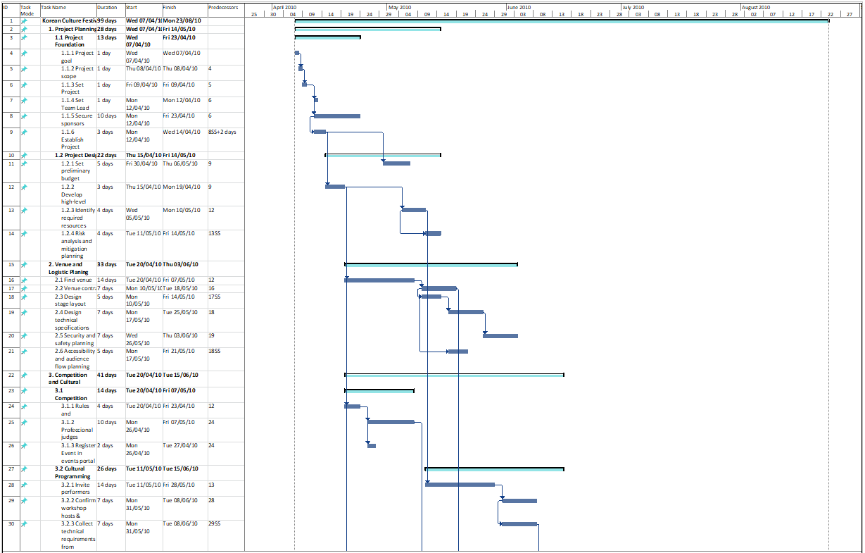
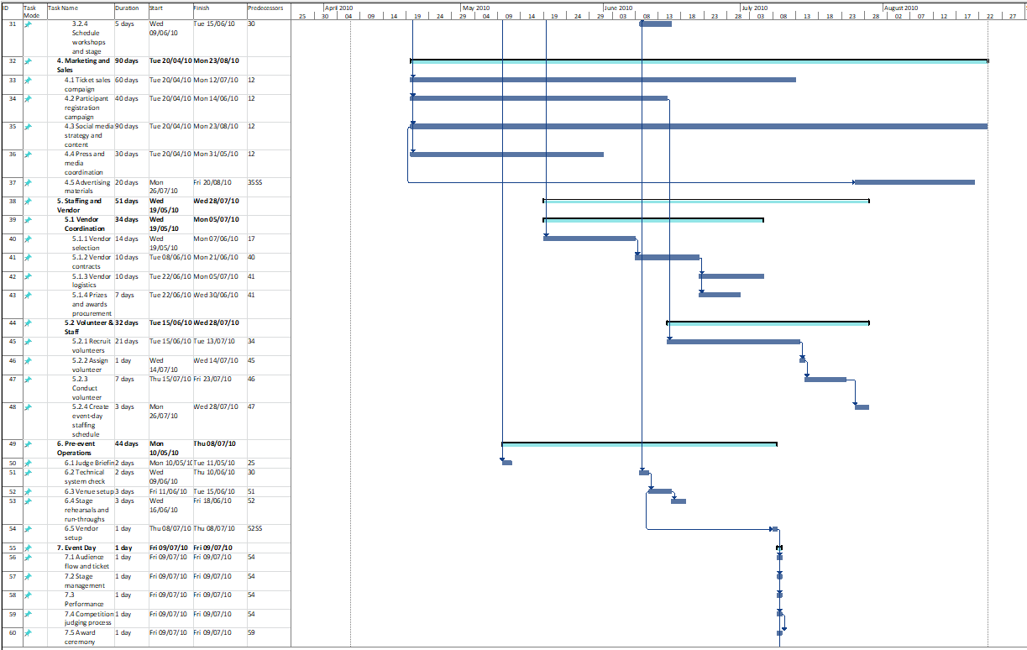
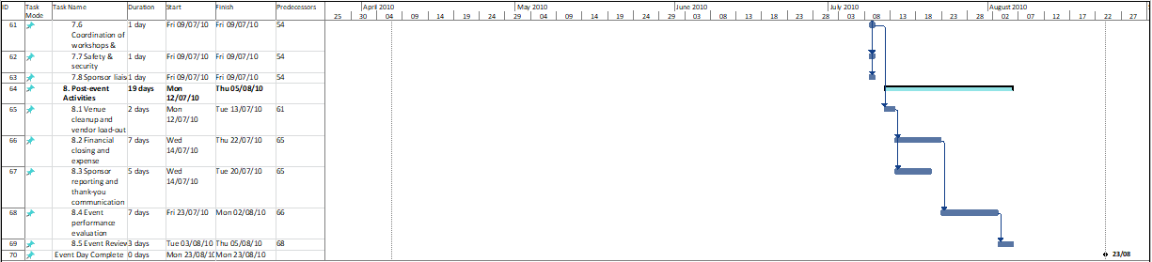

Appendix 3
Link to the Microsoft Project Gantt Chart:
https://mtuireland-my.sharepoint.com/:u:/g/personal/t00243622_mymtu_ie/IQBa4LQDB_xnSbclLC7bnJY4ASD3P60QePTOjsReR8tFRUc?email=Mairead.OSullivan%40mtu.ie&e=c0kBgf
Link to the Gantt Chart PDF:
https://mtuireland-my.sharepoint.com/:b:/g/personal/t00243622_mymtu_ie/IQDch1jy-c7HTb8_6wGuzhD2AZJyfq2L5o18w7YGJNlQm7Y?email=Mairead.OSullivan%40mtu.ie&e=feOtvZ

