Gesture AR Project: Concise Current Report
C4 task-aware, webcam-capable AR interaction snapshot
Project | Hand-gesture control for an augmented-reality web interface.
Snapshot date | 26 May 2026
Current emphasis | Gesture recognition plus action-safe control inside full AR task scenarios.
Demo status | The system can be launched locally and interacted with through a webcam; screenshot slots are marked below.

1. Project Essence
The project develops a gesture-driven augmented-reality interaction system. A live camera stream is processed into hand landmarks, a temporal model recognizes command gestures, and a web AR interface converts those commands into actions such as pointing, confirming, navigation and zooming. The practical goal is a hands-free control loop for AR tasks, where the user can manipulate virtual objects without touching the keyboard, mouse or screen.
The current stage is no longer limited to measuring a classifier in isolation. The new C4 layer evaluates whether recognized gestures should become interface actions in the current task context. This is important because false actions in AR can be more harmful than a wrong label: an accidental confirmation, navigation step or zoom may move the scenario into an incorrect state.
Main contribution in the current snapshot
A temporal gesture recognizer is combined with a task-aware safety gate. The gate keeps task completion near the previous C3+C2 baseline while reducing unintended and costly actions in full AR scenarios.

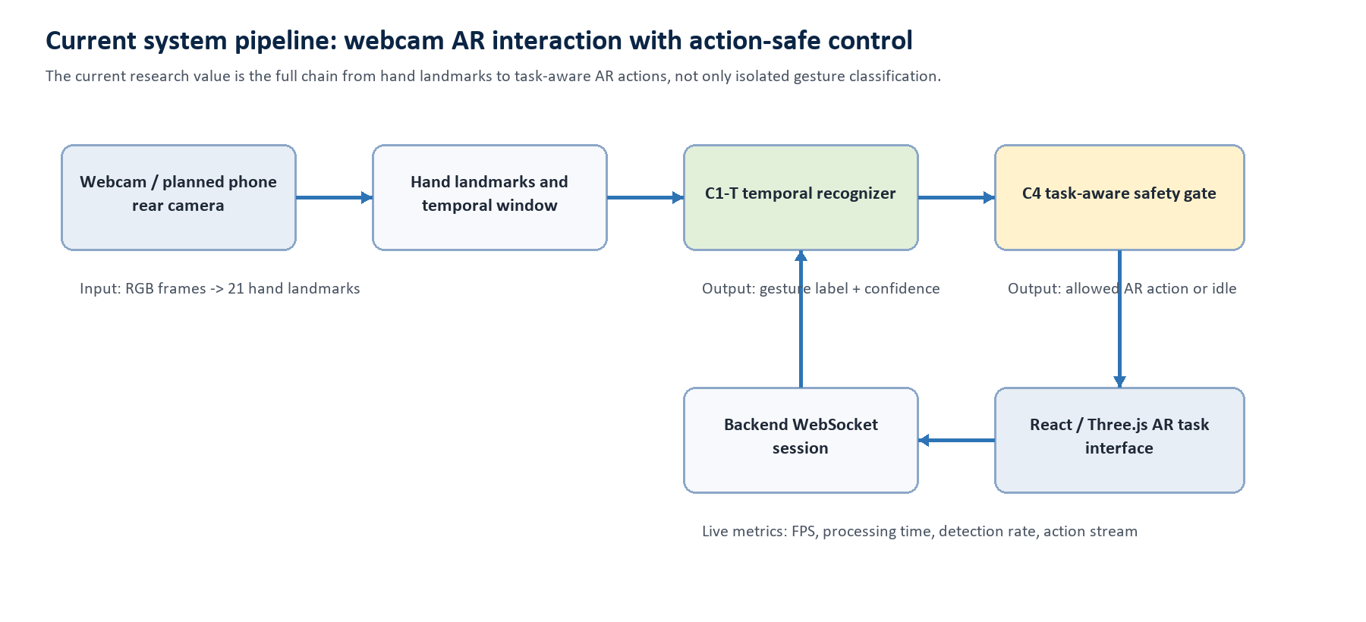
Figure 1. System-level pipeline used in the current C4 snapshot.

Core terminology and formulas
The formulas below are intentionally compact; they define the main quantities used by the implementation and the current evaluation reports.
Formula | Meaning
X_t in R^(T x 21 x 3) | Temporal window of 21 hand landmarks with three coordinates per landmark.
Z_t = phi(X_t) | Feature tensor after normalization, motion features and temporal formatting.
p_t = softmax(f_theta(Z_t)); y_t = argmax p_t | TCN gesture prediction and confidence distribution.
a_t = g(y_t, p_t, s_t, c_t) | Action decision using label, confidence, stability state and task context.
UAR = FP_action / (TP_action + FP_action) | Unintended action rate used to measure interaction safety.
FC = sum_i cost(a_i) * I(false_i) / sum_i cost(a_i) | False action cost rate; risky actions receive higher penalty.

2. Current State of the System
The current repository contains a working research pipeline, a FastAPI backend, a React/Three.js AR frontend, offline recognition reports, C4 task-level benchmarks and a one-command local demo script. The frontend can switch to Camera Stream mode and receive live actions from the backend through WebSocket.
Typical launch command: powershell -ExecutionPolicy Bypass -File .\scripts\start_ar_demo.ps1. After the interface opens, the user selects an AR task, presses Start Task, allows webcam access and performs the highlighted gesture sequence.
Area | Current measurement | Interpretation
Recognizer | Accuracy 90.7%; macro F1 0.8502 | Validated C1-T temporal model is suitable as the live recognizer baseline.
Offline latency | Median 3.93 ms; p95 4.64 ms | Model inference is fast enough for interactive use on pre-extracted landmarks.
Webcam demo | Mean FPS 17.26; processing p95 8.95 ms | Existing live report confirms webcam execution, although the task was not fully completed in that sample.
C4 task-aware | Precision 0.9430; UAR 0.0531 | Task context reduces accidental actions while keeping the task-success level of C3+C2 default.
False action cost | C1-T direct 0.1167; C3+C2 0.0905; C4 task-aware 0.0527 | The task-aware gate cuts costly false actions compared with direct recognition and the C3+C2 policy.
Domain transfer | 35 phone-rear clips planned; 35 still missing | Phone rear-camera validation is planned but not yet recorded.

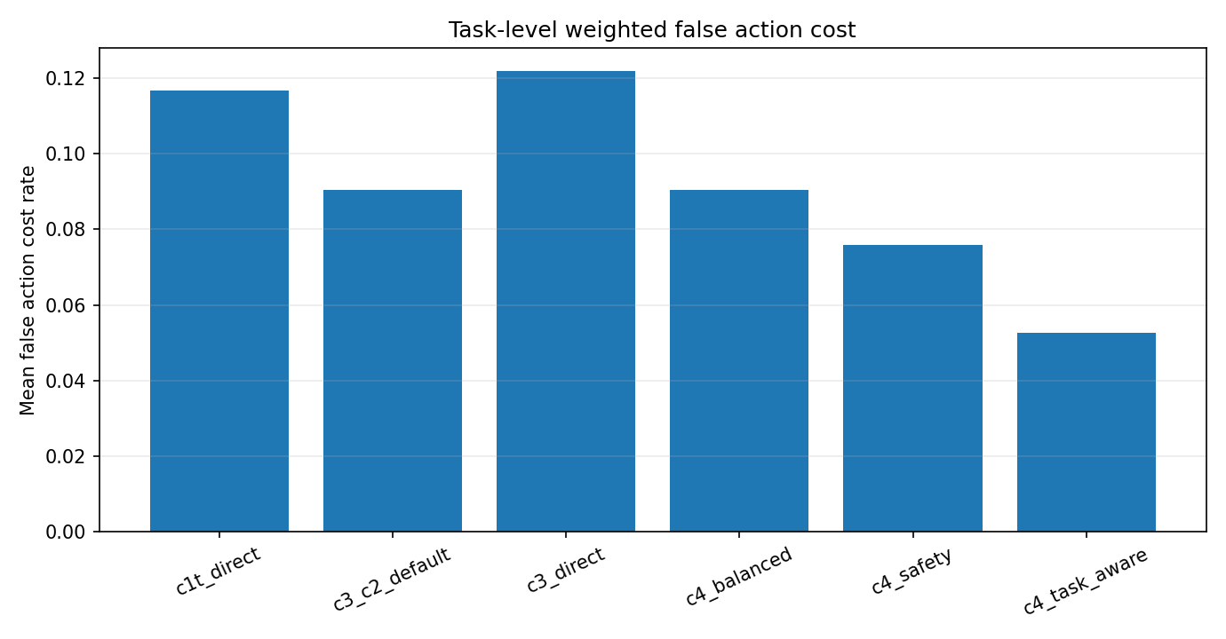
Figure 2. Task-level false action cost rate across interaction policies.
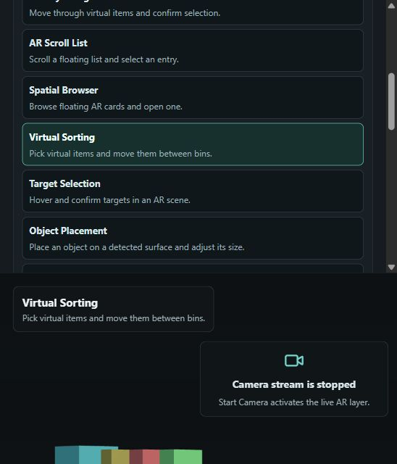
Figure 3. Existing AR interface screenshot from the current demo assets.

Webcam screenshot slots
The report already documents that the system supports webcam interaction. For the next hand-prepared version, insert fresh screenshots from your own run at the marked places below.
Screenshot placeholder 1
Insert a screenshot of the AR task running with Camera Stream visible, a virtual object or scenario overlay, and the Live Status block showing FPS, detection and current action. Replace this box with your own image after running the webcam demo.

Screenshot placeholder 2
Insert a screenshot of Advanced Controls where the selected interaction mode is visible, preferably C4 task-aware or the mode used for the experiment. Replace this box with your own image after running the webcam demo.

Screenshot placeholder 3
Optional: insert a screenshot after a short completed or attempted task, showing the task panel, current step state and any action counters or status messages. Replace this box with your own image after running the webcam demo.

3. Further Development and Expected Final Result
The final master project should present the system as a complete AR interaction stack: dataset preparation, temporal gesture recognition, action-safe control, live webcam demonstration and a measured evaluation across both offline and task-level conditions.
Work item | Purpose | Expected final evidence
Record local phone-rear clips | Check whether the model survives the target AR capture geometry. | Filled local_phone manifest, extracted landmarks and domain-transfer metrics.
Improve task-aware C4 policy | Balance safety and responsiveness for each AR scenario. | Ablation table comparing direct, C3+C2, C4 safety and C4 task-aware modes.
Run repeated webcam sessions | Show that the interface works beyond a single sample run. | Several screenshots plus FPS, latency, detection and completion statistics.
Prepare mobile/export path | Move from desktop prototype toward deployable interaction. | Updated ONNX/Core ML bundle and notes on mobile constraints.
Finalize thesis narrative | Connect implementation, experiments, novelty and limitations. | Three-chapter thesis draft with figures, formulas and final result tables.

Expected final form
A webcam-capable and phone-validated AR gesture-control prototype with a documented recognition model, a risk-aware action policy, repeatable scenario benchmarks and visual proof of live interaction.

Short conclusion
At this project state, the essential idea is already demonstrable: a user can interact with the AR interface through a camera stream, while the research pipeline measures not only gesture labels but also the safety of resulting interface actions. The strongest current result is the C4 task-aware policy: it reduces unintended and costly actions while preserving approximately the same task-success level as the previous guarded baseline. The main remaining work is to collect the planned phone-rear data, repeat webcam demonstrations and tune the final balance between responsiveness and safety.

