Gesture AR Project: Current Academic Snapshot
C6 recognition plus task-aware risk-calibrated AR control
Snapshot date | 28 May 2026
Current prototype | FastAPI live backend, React/Three.js AR interface, webcam mode, C6 Ensemble recognizer and TARC controller.
Research claim | A guided AR interaction pipeline can reduce costly unintended commands without giving up baseline-level task completion.
Evidence status | Offline public-data recognition and replay-based AR task benchmark are ready; live webcam screenshots and repeated user sessions still need to be inserted.

1. Work Description
The project is a gesture-controlled augmented-reality interaction system. It converts a webcam stream into hand landmarks, recognizes command gestures, and applies a task-aware controller before the AR interface executes an action.
The current version is best described as a full interaction pipeline rather than a standalone gesture classifier. The system includes dataset manifests, temporal recognition models, calibrated ensemble fusion, risk-cost action filtering, scripted AR tasks, a local live backend and a web-based AR-style interface.
Academic novelty, stated conservatively
The original contribution is not a new universal neural architecture. It is the integration of a robust gesture recognizer with a task-aware risk controller for guided AR workflows, evaluated with action cost and task completion rather than only classification accuracy.

Boundary of the claim
The current evidence supports public-dataset recognition and replay-based interaction safety. It does not yet prove general open-world AR control or phone rear-camera transfer; those require live session logs and local video data.

Methodological model and formulas
The method treats recognition as one component of a control loop. A gesture prediction becomes only an action proposal; the TARC controller may accept it, delay it, or replace it with idle.
Formula | Role in the project
X_t in R^(T x 21 x 3), T = 32 | Temporal landmark window from one hand: 21 landmarks, three coordinates each.
z_k = f_k(X_t) | Logits from recognizer k. C6 uses the validated TCN and an augmented TCN.
p_C6 = softmax((mean_k z_k + alpha h_geom + b_y) / tau) | Calibrated ensemble fusion with a lightweight geometry-aware correction.
y_t = argmax_y p_C6(y | X_t) | Current gesture label used as an action proposal, not as a direct command.
a_t = pi(y_t) if p_t >= theta_eff and stable(y_t) and cooldown_ok else idle | TARC action gate based on confidence, temporal stability and cooldown.
theta_eff(a,c) = theta_a + delta_context(a,c) | Task context lowers the threshold for expected actions and raises it for unexpected/risky ones.
FC = sum_t cost(a_t) * I(false_t) / sum_t cost(a_t) * I(action_t) | False action cost rate; confirmation and zoom errors carry more cost than hover.
TaskSuccess = completed_trials / all_trials | Scenario-level result across scripted AR tasks, not only frame-level recognition.

2. Current State of the System
Subsystem | Current status | Measurement or evidence
Recognition | C6 Ensemble is used as the robust recognizer in the current interface. | Clean accuracy 0.930; clean macro F1 0.887; robust macro F1 0.859.
Interaction policy | TARC is the proposed task-aware risk-calibrated controller. | False action cost 0.025; task success 0.531.
Webcam prototype | The local demo can run in Camera Stream mode through the webcam. | Existing live sample: 17.26 mean FPS, 8.95 ms processing p95, 0.816 detection rate.

Method | Clean Acc. | Clean Macro F1 | Robust Macro F1 | Robust False Action
C1-TCN validated | 0.907 | 0.850 | 0.826 | 0.097
C3 hybrid validated | 0.908 | 0.851 | 0.828 | 0.094
Augmented TCN | 0.909 | 0.856 | 0.835 | 0.090
Augmented C3 hybrid | 0.913 | 0.866 | 0.838 | 0.086
C6 ensemble calibrated | 0.930 | 0.887 | 0.859 | 0.067

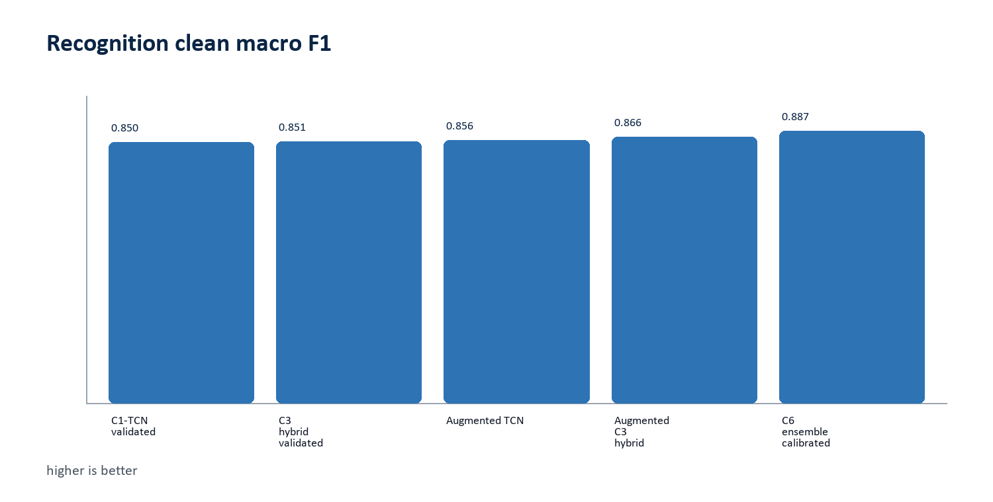
Figure 1. Recognition macro F1 improved after the C6 ensemble upgrade.
Official method | Task success | Precision | Unintended | False cost
M1 Baseline Direct | 0.527 | 0.892 | 0.106 | 0.110
M2 Robust C6 Direct | 0.552 | 0.917 | 0.081 | 0.085
M3 Proposed TARC | 0.531 | 0.974 | 0.024 | 0.025

Main measured result
In the official replay benchmark, M3 Proposed TARC reduces false action cost from 0.110 to 0.025 while keeping task success at 0.531, approximately the same completion level as the direct baseline.

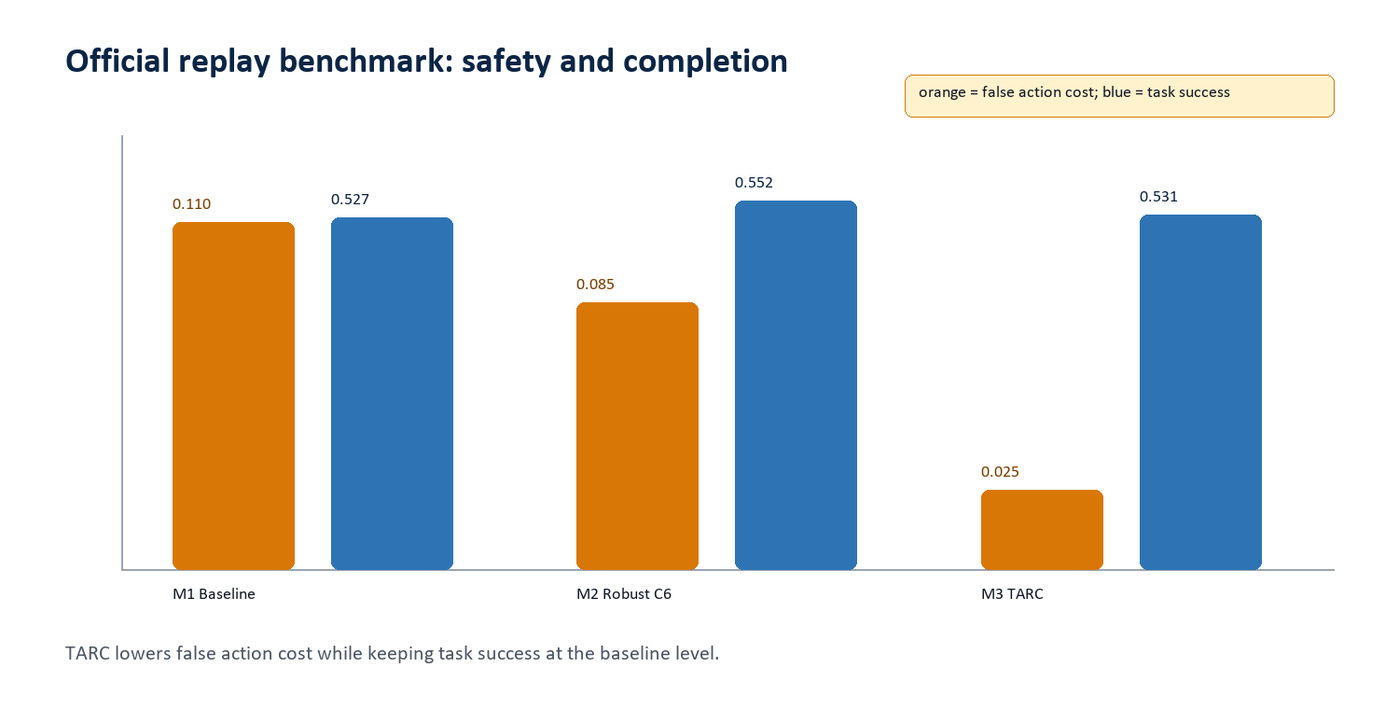
Figure 2. Official-method safety/completion trade-off.
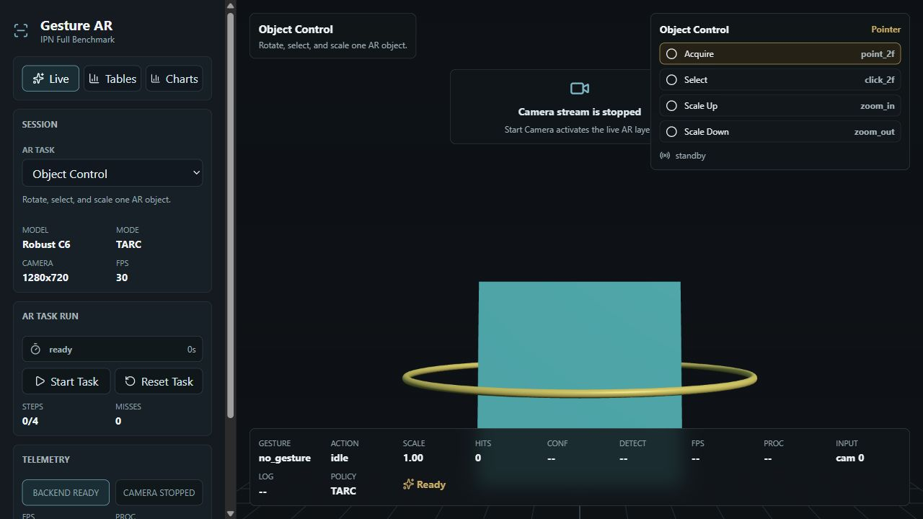
Figure 3. Current live interface viewport with Robust C6 and TARC selected.
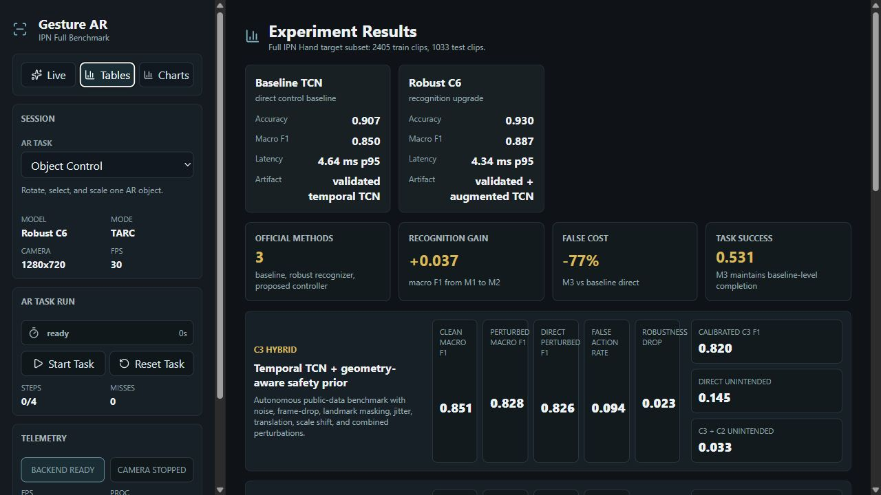
Figure 4. Current experiment-results screen expanded as a wide viewport capture.

Places for your own live interaction screenshots
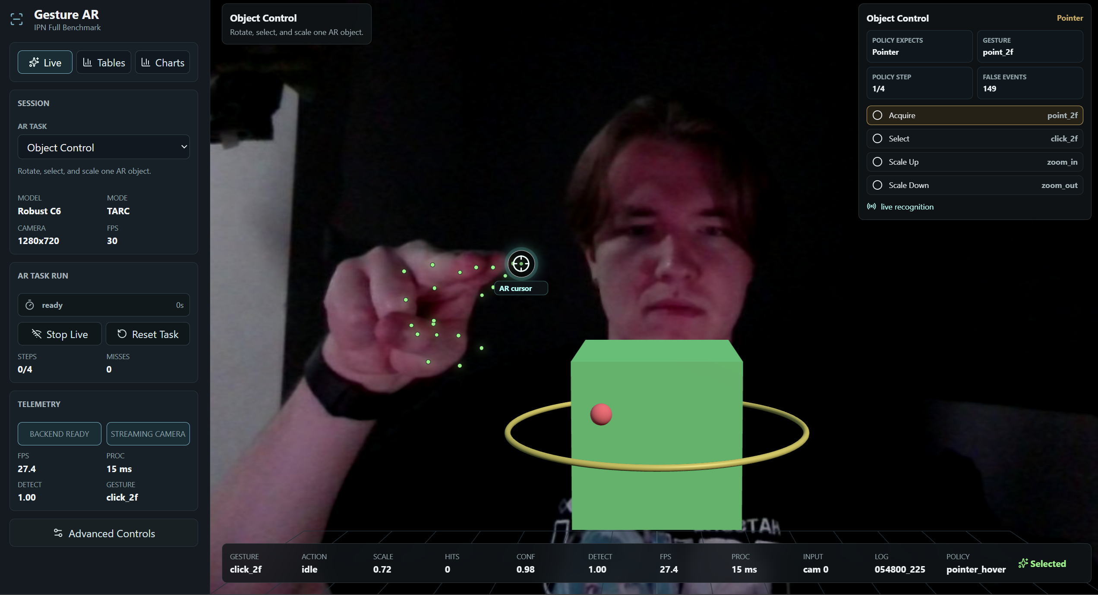
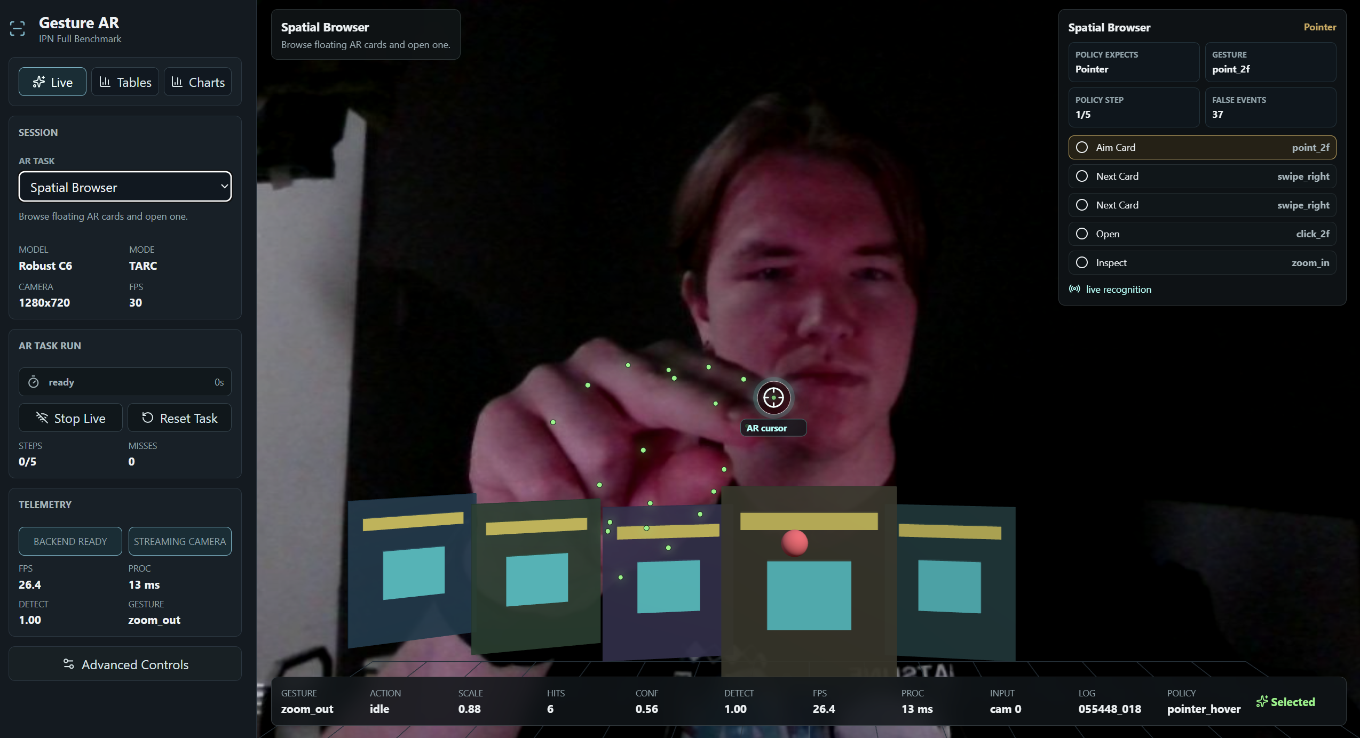

3. Further Development and Final Target
The project should finish as a documented AR gesture-control prototype with repeatable recognition metrics, task-level interaction-safety evaluation and direct visual proof of webcam-based interaction.
Direction | Current state | Expected final result
Recognizer | C6 Ensemble is the default robust recognizer in the interface. | Use it as the main recognizer and report any live-session deviations.
Controller | TARC is the proposed task-aware risk-calibrated controller. | Tune latency and per-task thresholds, especially for weak scenarios.
Evaluation | Recognition and official replay benchmark are reproducible. | Add repeated live webcam sessions and compare logs with replay results.
Phone transfer | 35 local phone-rear clips planned; 35 missing. | Record local clips and rerun landmark extraction/domain-transfer metrics.
Thesis result | Novelty is interaction-risk modeling over guided AR tasks. | Present a cautious final claim: safer guided AR gesture control, not unrestricted open-world control.

Expected final form
A webcam-demonstrated and phone-transfer-tested AR gesture prototype with C6 recognition, TARC action safety, scenario-level benchmarks, live screenshots, and a thesis narrative centered on risk-aware interaction design.

Final summary
The current project state is academically defensible as an applied AR interaction study. The strongest originality is the task-aware risk controller and its evaluation with weighted false-action cost. C6 strengthens the recognition base, but the thesis-level value comes from showing that recognition confidence, action cost and task context can be combined into a safer AR control loop. The remaining work is empirical: insert live webcam evidence, record local phone-rear data, and validate the controller on repeated real interactions.

