Gesture AR Recognition Research Project

1. Work Description
The project is a gesture-controlled augmented-reality interaction system. It converts a webcam stream into hand landmarks, recognizes command gestures, and applies a task-aware controller before the AR interface executes an action.
The current version is best described as a full interaction pipeline rather than a standalone gesture classifier. The system includes dataset manifests, temporal recognition models, calibrated ensemble fusion, risk-cost action filtering, scripted AR tasks, a local live backend and a web-based AR-style interface.
Project objective. The master's project studies how hand gestures can be used as a practical input channel for augmented-reality tasks. The goal is not only to classify hand motion, but to build a controlled interaction loop in which recognized gestures become reliable AR commands.
The central problem is that AR actions have unequal consequences. A wrong frame-level label may be harmless, but a false confirmation, unintended zoom, or navigation command can change the state of a task. Therefore, the project evaluates interaction safety through action costs and scenario completion, not through accuracy alone.

Project components
Component | Role in the project
Data and landmarks | Public IPN Hand clips are converted into temporal landmark tensors; local phone-rear recordings are planned for domain-transfer validation.
Recognition model | C6 Ensemble combines a validated temporal TCN, an augmented TCN, and calibrated fusion with geometry-aware information.
Interaction controller | TARC converts gesture predictions into AR actions only when confidence, temporal stability, cooldown, and task context support the action.
AR prototype | A FastAPI backend streams recognition results to a React/Three.js interface that can run with webcam input.
Evaluation | The project reports clean and robust recognition metrics, false action cost, unintended action rate, and task success over scripted AR scenarios.
Academic novelty, stated conservatively
The original contribution is not a new universal neural architecture. It is the integration of a robust gesture recognizer with a task-aware risk controller for guided AR workflows, evaluated with action cost and task completion rather than only classification accuracy.

Boundary of the claim
The current evidence supports public-dataset recognition and replay-based interaction safety. It does not yet prove general open-world AR control or phone rear-camera transfer; those require live session logs and local video data.

Methodological model and formulas
The methodological idea is a layered pipeline: perception produces landmarks, temporal recognition estimates gesture probabilities, and an interaction policy decides whether the proposed action is safe in the current AR task step.
This separation is important for academic clarity. The recognizer answers "what gesture is likely?", while the controller answers "should the interface execute this command now?". The second question is the original interaction-design contribution of the work.
The method treats recognition as one component of a control loop. A gesture prediction becomes only an action proposal; the TARC controller may accept it, delay it, or replace it with idle.
Formula | Role in the project
X_t in R^(T x 21 x 3), T = 32 | Temporal landmark window from one hand: 21 landmarks, three coordinates each.
z_k = f_k(X_t) | Logits from recognizer k. C6 uses the validated TCN and an augmented TCN.
p_C6 = softmax((mean_k z_k + alpha h_geom + b_y) / tau) | Calibrated ensemble fusion with a lightweight geometry-aware correction.
y_t = argmax_y p_C6(y | X_t) | Current gesture label used as an action proposal, not as a direct command.
a_t = pi(y_t) if p_t >= theta_eff and stable(y_t) and cooldown_ok else idle | TARC action gate based on confidence, temporal stability and cooldown.
theta_eff(a,c) = theta_a + delta_context(a,c) | Task context lowers the threshold for expected actions and raises it for unexpected/risky ones.
FC = sum_t cost(a_t) * I(false_t) / sum_t cost(a_t) * I(action_t) | False action cost rate; confirmation and zoom errors carry more cost than hover.
TaskSuccess = completed_trials / all_trials | Scenario-level result across scripted AR tasks, not only frame-level recognition.

2. Current State of the System
The current implementation contains both research scripts and a runnable prototype. The backend can serve live recognition results, while the frontend presents AR task scenarios, current model/mode status, telemetry, and methodology charts.
At the recognition level, the project has moved from the initial TCN baseline to C6 Ensemble. At the interaction level, the main proposed method is TARC, a task-aware risk-calibrated controller. This makes the present version suitable for demonstrating the thesis idea to a supervisor, even though live user validation is still incomplete.

Interpretation of the current measurements
Measurement |  | Interpretation for the master's project
Clean macro F1: 0.887 |  | C6 improves the base gesture recognizer enough to support the interaction experiments.
Robust false action rate: 0.067 |  | The recognizer is less likely to create active commands under perturbations than earlier baselines.
TARC false action cost: 0.025 |  | The controller strongly reduces costly unintended AR actions in the replay benchmark.
TARC task success: 0.531 |  | Safety is improved without a collapse in scenario completion compared with direct control.
Live sample: 17.26 FPS |  | The webcam prototype is functional, but repeated live sessions are still needed for final evidence.
Subsystem | Current status |  | Measurement or evidence
Recognition | C6 Ensemble is used as the robust recognizer in the current interface. |  | Clean accuracy 0.930; clean macro F1 0.887; robust macro F1 0.859.
Interaction policy | TARC is the proposed task-aware risk-calibrated controller. |  | False action cost 0.025; task success 0.531.
Webcam prototype | The local demo can run in Camera Stream mode through the webcam. |  | Existing live sample: 17.26 mean FPS, 8.95 ms processing p95, 0.816 detection rate.

Method | Clean Acc. | Clean Macro F1 | Robust Macro F1 | Robust False Action
C1-TCN validated | 0.907 | 0.850 | 0.826 | 0.097
C3 hybrid validated | 0.908 | 0.851 | 0.828 | 0.094
Augmented TCN | 0.909 | 0.856 | 0.835 | 0.090
Augmented C3 hybrid | 0.913 | 0.866 | 0.838 | 0.086
C6 ensemble calibrated | 0.930 | 0.887 | 0.859 | 0.067

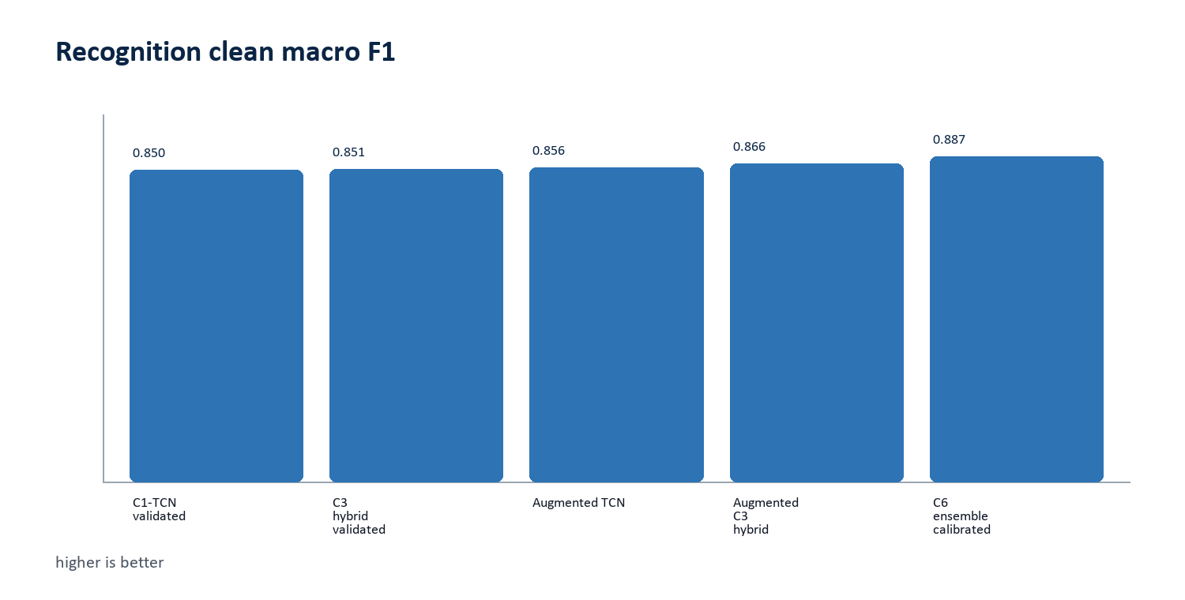
Figure 1. Recognition macro F1 improved after the C6 ensemble upgrade.
Official method | Task success | Precision | Unintended | False cost
M1 Baseline Direct | 0.527 | 0.892 | 0.106 | 0.110
M2 Robust C6 Direct | 0.552 | 0.917 | 0.081 | 0.085
M3 Proposed TARC | 0.531 | 0.974 | 0.024 | 0.025

Main measured result
In the official replay benchmark, M3 Proposed TARC reduces false action cost from 0.110 to 0.025 while keeping task success at 0.531, approximately the same completion level as the direct baseline.

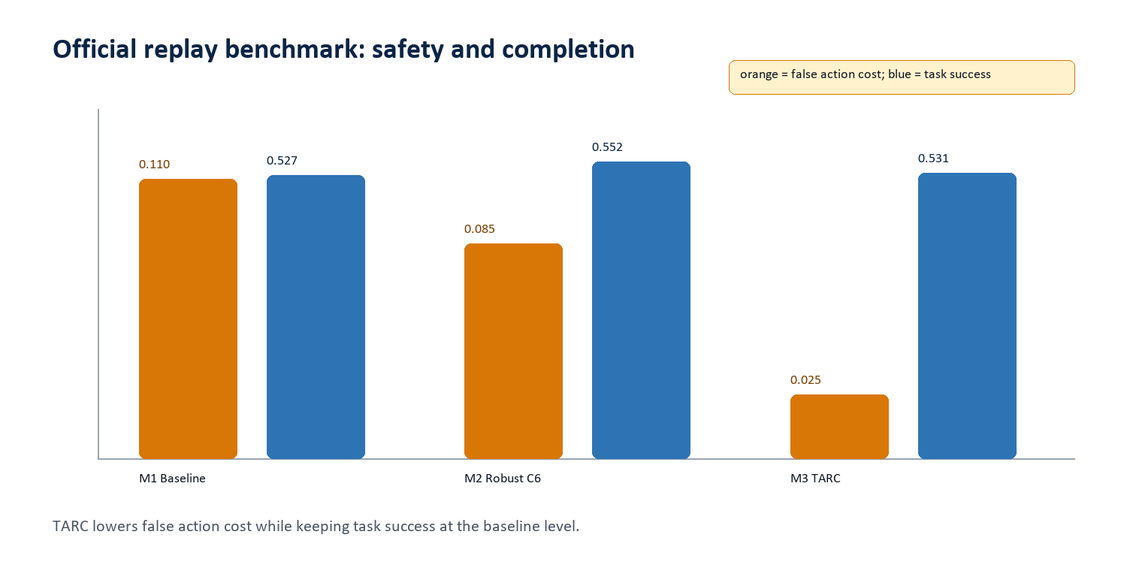
Figure 2. Official-method safety/completion trade-off.
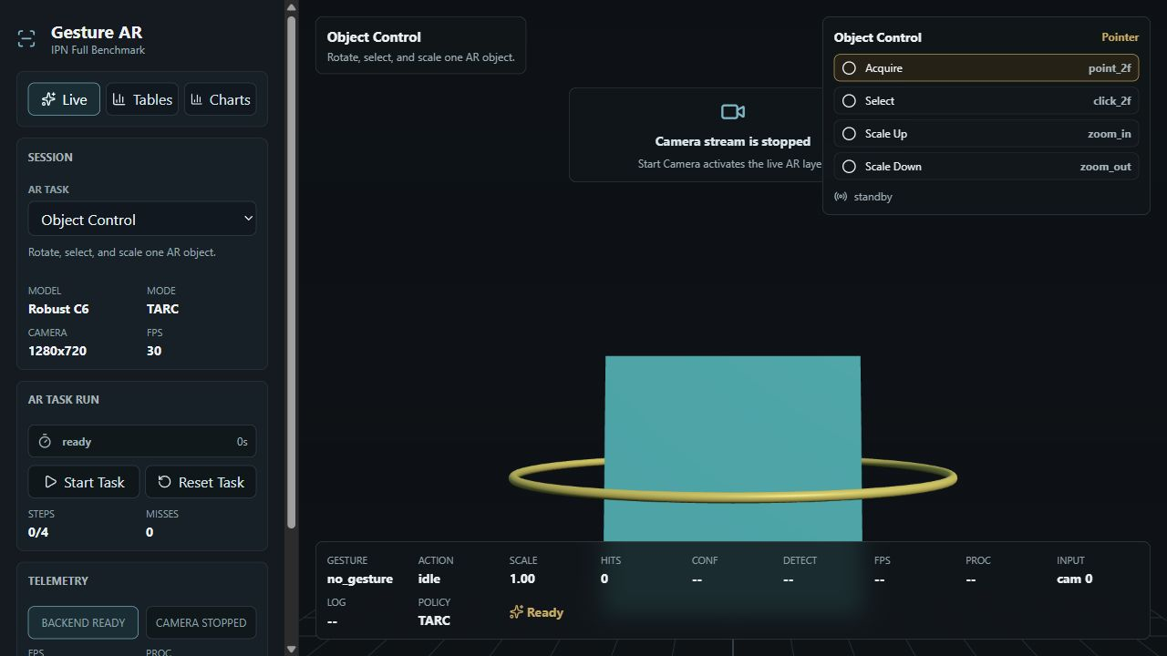
Figure 3. Current live interface viewport with Robust C6 and TARC selected.
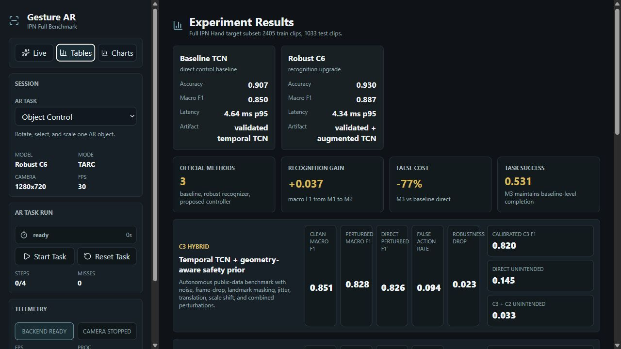
Figure 4. Current experiment-results screen expanded as a wide viewport capture.

Places for your own live interaction screenshots
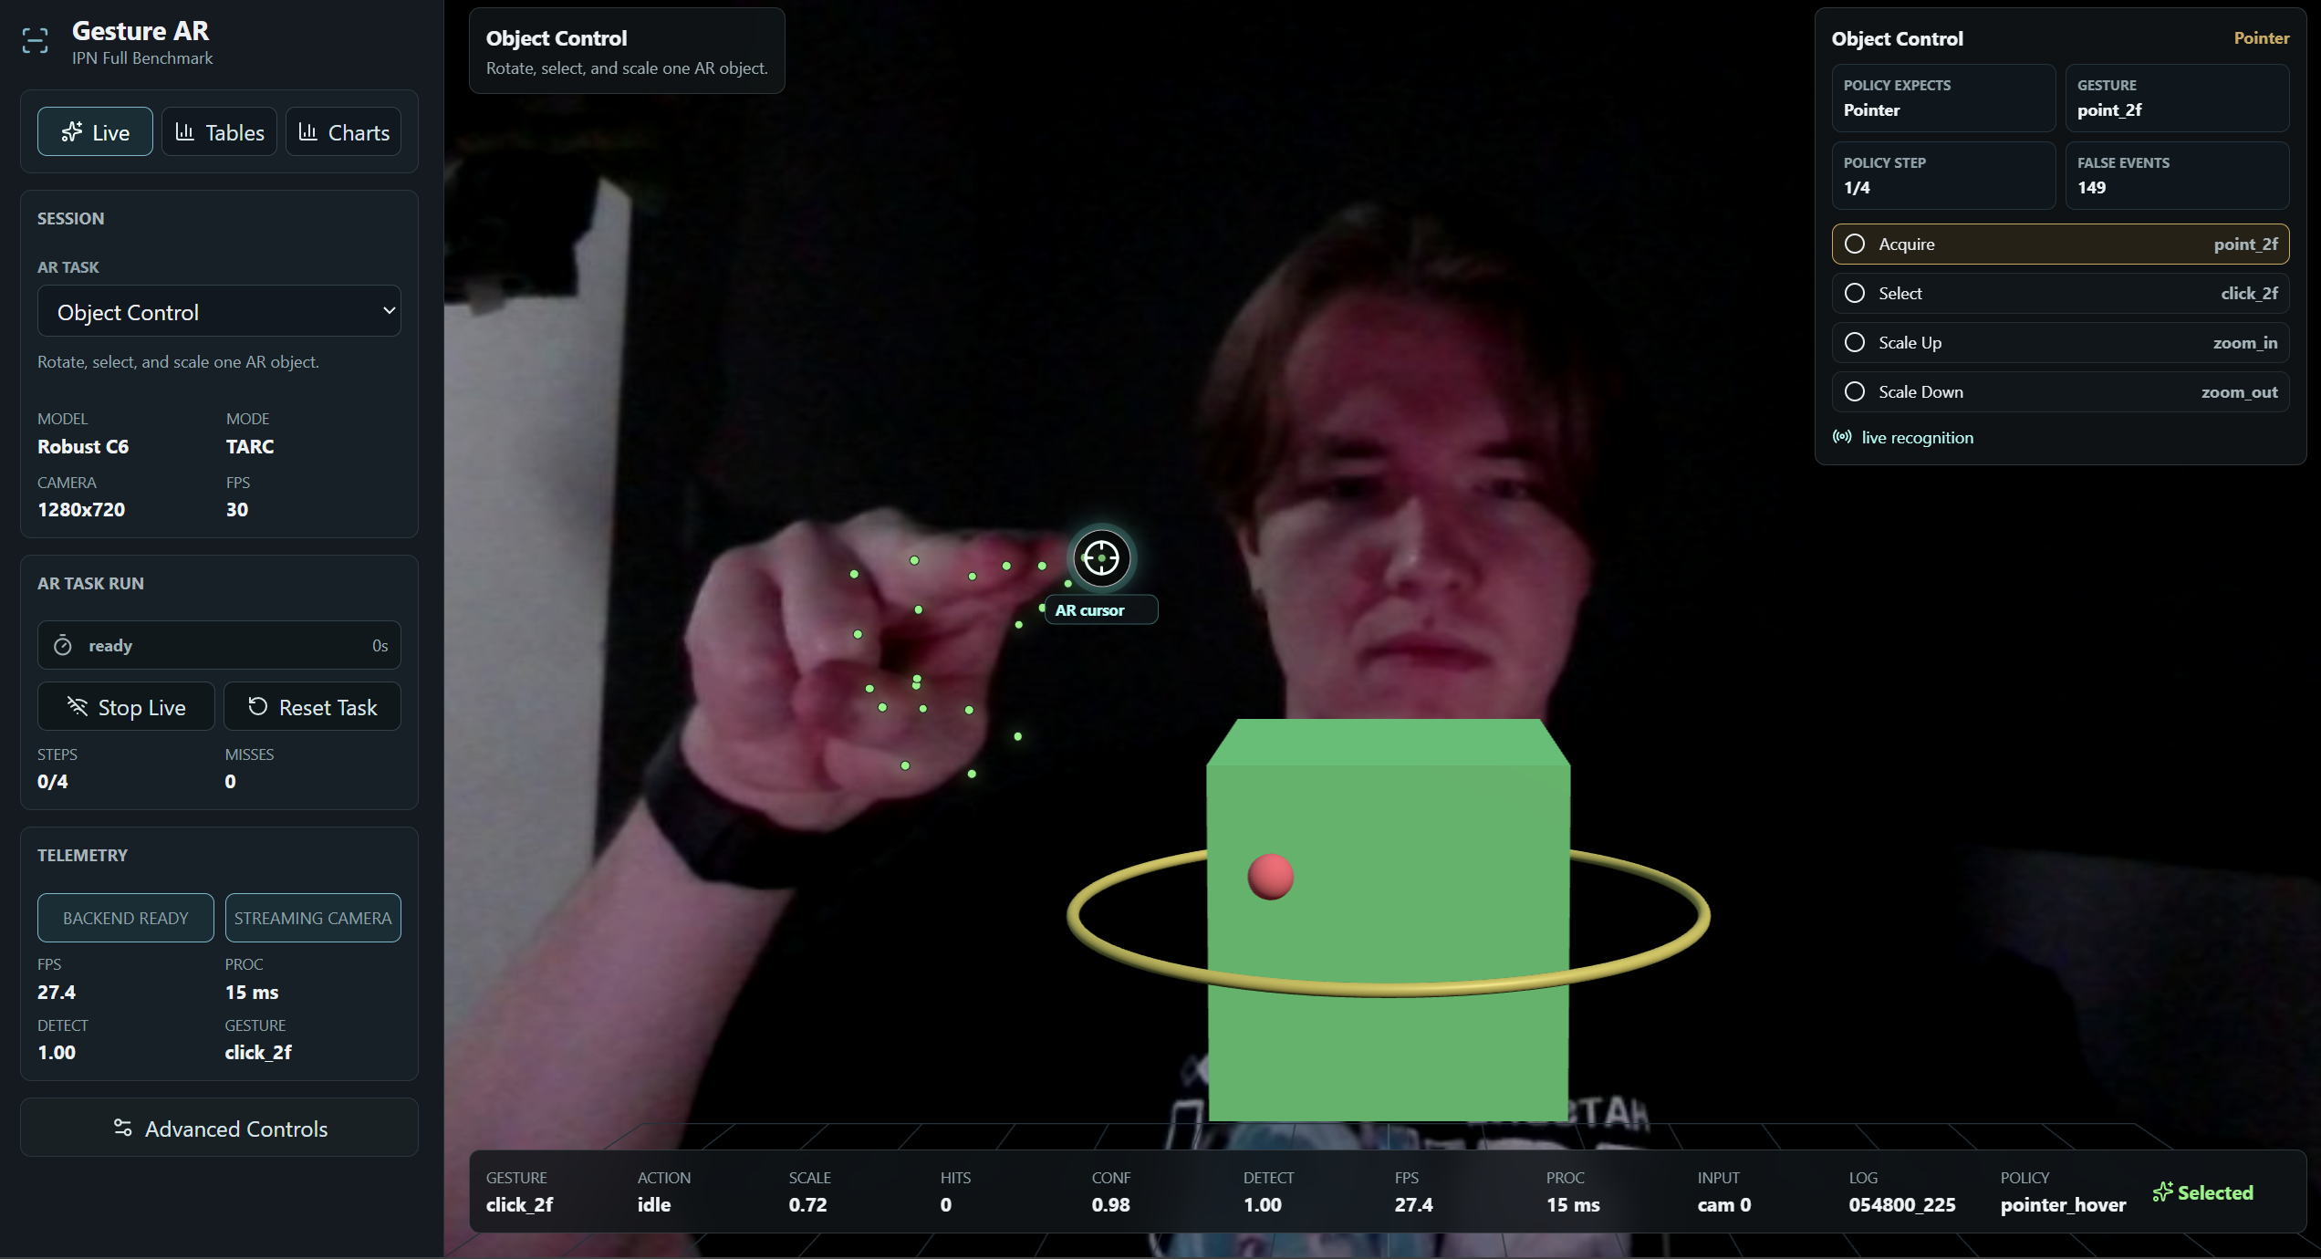
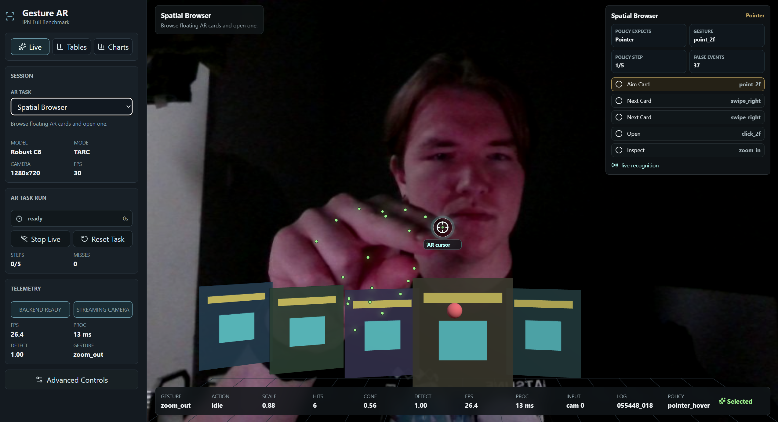

3. Further Development and Final Target
The final version should be presented as an applied research prototype: a reproducible gesture-recognition pipeline, a risk-aware AR interaction controller, and a live demonstration supported by quantitative measurements.
The final academic claim should remain careful. The work should argue for safer guided AR gesture interaction in scripted tasks, not for unrestricted gesture control in arbitrary environments.

Work remaining before the final thesis
Task | Reason
Record repeated webcam sessions | To replace single-sample evidence with repeatable live interaction metrics and screenshots.
Collect planned phone-rear clips | To test whether the approach transfers from webcam-like public data to the intended AR capture geometry.
Tune weak scenarios | Inspection, information panels, transfer, and guided tour tasks should be checked because replay analysis shows weaker completion.
Report limitations explicitly | A supervisor should see that the project separates proven results from planned validation.
Prepare final thesis chapter | The final document should connect recognition, controller design, novelty, experiments, screenshots, and future deployment.
The project should finish as a documented AR gesture-control prototype with repeatable recognition metrics, task-level interaction-safety evaluation and direct visual proof of webcam-based interaction.
Direction | Current state | Expected final result
Recognizer | C6 Ensemble is the default robust recognizer in the interface. | Use it as the main recognizer and report any live-session deviations.
Controller | TARC is the proposed task-aware risk-calibrated controller. | Tune latency and per-task thresholds, especially for weak scenarios.
Evaluation | Recognition and official replay benchmark are reproducible. | Add repeated live webcam sessions and compare logs with replay results.
Phone transfer | 35 local phone-rear clips planned; 35 missing. | Record local clips and rerun landmark extraction/domain-transfer metrics.
Thesis result | Novelty is interaction-risk modeling over guided AR tasks. | Present a cautious final claim: safer guided AR gesture control, not unrestricted open-world control.

Expected final form
A webcam-demonstrated and phone-transfer-tested AR gesture prototype with C6 recognition, TARC action safety, scenario-level benchmarks, live screenshots, and a thesis narrative centered on risk-aware interaction design.

Final summary
The current project state is academically defensible as an applied AR interaction study. The strongest originality is the task-aware risk controller and its evaluation with weighted false-action cost. C6 strengthens the recognition base, but the thesis-level value comes from showing that recognition confidence, action cost and task context can be combined into a safer AR control loop. The remaining work is empirical: insert live webcam evidence, record local phone-rear data, and validate the controller on repeated real interactions.

