Gesture AR Project State Report
Work description, current system state, and target development path
Field | Value
Project | Context-Aware Temporal Landmark Gesture Recognition for AR Interaction
Prepared for | Current research and thesis planning snapshot
Prepared on | 26 May 2026
Language | English
Design preset | standard_business_brief

This document summarizes the current project state as a thesis-oriented engineering and research report. It is not a final dissertation chapter set; it is a structured snapshot used to describe the work, the validated system state, and the intended final target.

Contents
Section | Title
1 | Work Description
2 | Current System State
3 | Further Development and Final Target

1. Work Description
The project develops a Windows-first research pipeline for context-aware gesture recognition in augmented reality. The core idea is to recognize hand gestures from temporal sequences of 21 hand landmarks, transform recognition outputs into safer AR actions, and measure the result not only by classifier accuracy but also by interaction-level risk.
The work is structured around three layers: a temporal recognition layer, a hybrid safety layer, and an interaction policy layer. The temporal layer uses a compact TCN over normalized landmark features. The C3 Hybrid layer adds a lightweight geometry-aware prior and a safety gate. The C2 layer converts gesture predictions into AR actions only after confidence, stability, and cooldown constraints are satisfied.
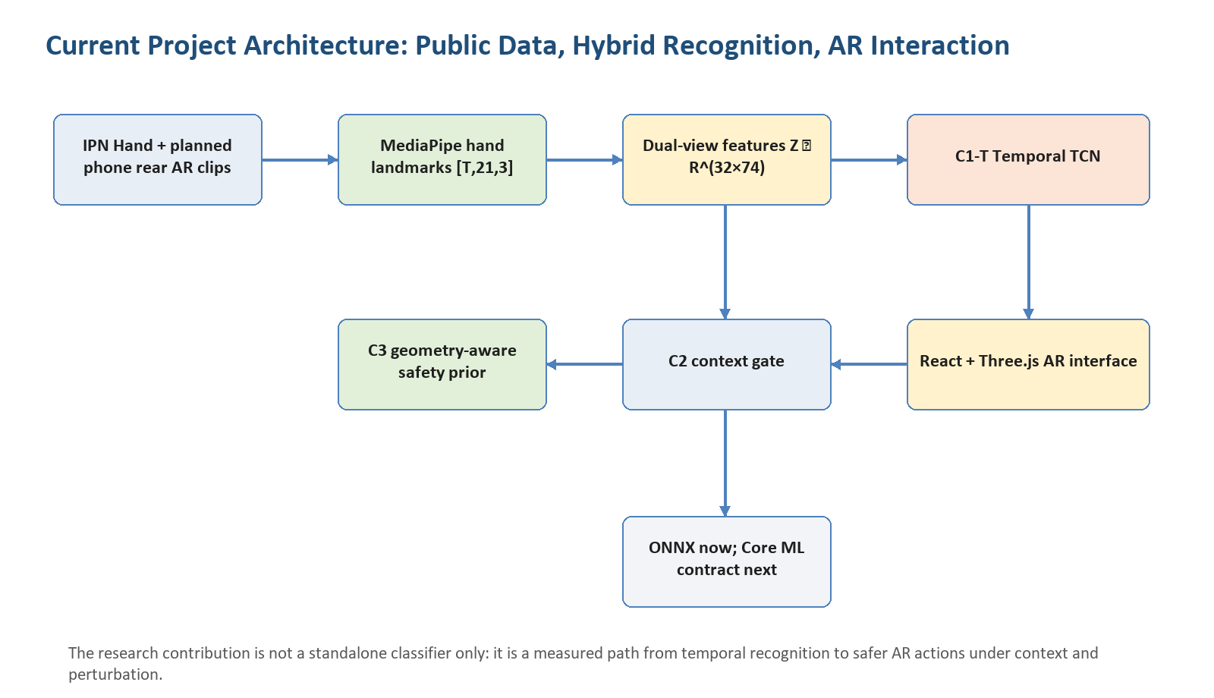
Figure 1. Project architecture and data-to-action flow.
Component | Current role | Why it matters
IPN Hand data | Public benchmark for reproducible recognition and robustness experiments | Avoids relying only on a private demonstration dataset
Landmark tensor | MediaPipe-style [T,21,3] representation | Reduces visual complexity and enables fast temporal modeling
C1-T TCN | Temporal classifier over [32,74] features | Main learned recognizer and ONNX-exported runtime path
C3 Hybrid | Temporal probabilities plus geometry-aware safety prior | Targets false-action risk rather than only clean accuracy
C2 Gate | Context-aware gesture-to-action finite-state policy | Suppresses unstable or repeated accidental commands
AR UI | React + Three.js task interface | Turns recognition into measurable AR task execution

The gesture vocabulary contains seven target classes: no_gesture, point_2f, click_2f, swipe_left, swipe_right, zoom_in, and zoom_out. These classes are deliberately small but operationally complete for pointing, selection, navigation, scaling, and suppression of accidental input.
No. | Formula | Meaning in this project
(1) | P(t) = [p(t,1), ..., p(t,21)], p(t,j)=(x,y,z); X ∈ R^(T×21×3) | Each frame is represented as 21 hand landmarks, and each gesture clip is a temporal landmark tensor.
(2) | s(t)=max(||p5_xy-p17_xy||_2, ||p9_xy-p0_xy||_2, ε) | Palm scale normalizes the hand pose and guards against division by zero.
(3) | p_norm(t,j)=(p(t,j)-p(t,0))/s(t) | Landmarks are represented relative to the wrist and palm scale.
(4) | z(t)=[vec(P_norm), motion, confidence] ∈ R^74; Z ∈ R^(32×74) | The model input combines 63 pose features and 11 motion/confidence features.

2. Current System State
As of 26 May 2026, the project has moved beyond a simple prototype. It contains extracted full IPN landmark benchmarks, trained C1 and C1-T models, validated TCN recognition reports, ONNX export, mobile portability contracts, AR task scenarios, live-session reports, C3 Hybrid robustness experiments, ablation tables, calibration candidates, charts, and UI screenshots.
Measurement | Value | Interpretation
Full IPN subset | 2405 train / 1033 test clips | Primary reproducible public benchmark
Validated C1-T accuracy | 0.9071 | Recognition quality on the full test subset
Validated C1-T macro F1 | 0.8502 | Class-balanced recognition quality
Validated C1-T p95 latency | 4.638 ms | Offline per-sample inference latency
C3 clean macro F1 | 0.8513 | Hybrid clean benchmark score
C3 perturbed macro F1 mean | 0.8283 | Average robustness under synthetic perturbations
C3 mean perturbed false-action rate | 0.0945 | Interaction-relevant risk signal

The current best C3 calibration candidate uses neural_weight=0.96, geometry_weight=0.08, and action_threshold=0.44.
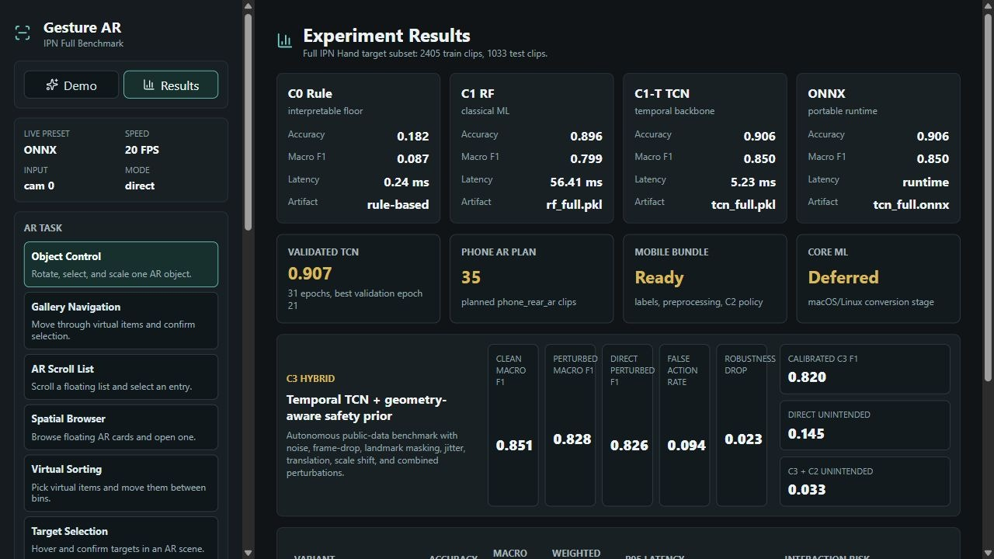
Figure 2. Current experiment results page with C3 Hybrid state.
The current C3 result should be interpreted as a robustness and interaction-risk improvement rather than a dramatic clean-accuracy jump. The validated temporal recognizer already performs strongly on clean public data; the C3 contribution is to make action emission more conservative where AR interaction risk matters.
Method | Clean macro F1 | Perturbed macro F1 mean | Macro F1 drop | Perturbed false-action rate
c1t_direct | 0.8502 | 0.8263 | 0.0239 | 0.0967
c3_hybrid | 0.8513 | 0.8283 | 0.0231 | 0.0945

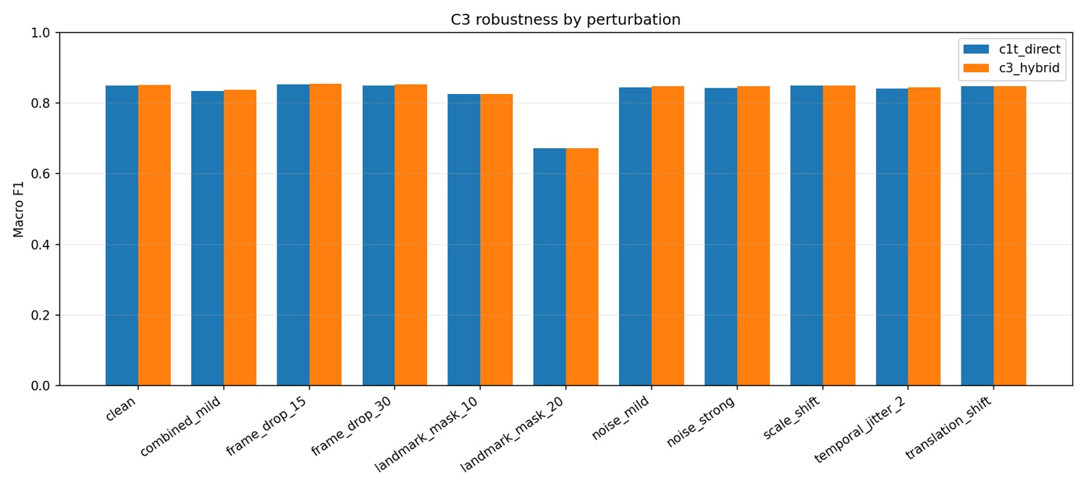
Figure 3. C3 robustness by perturbation scenario.
Method | Clean macro F1 | Perturbed macro F1 mean | Macro F1 drop | Perturbed false-action rate
c1t_direct | 0.8502 | 0.8189 | 0.0312 | 0.1018
c3_hybrid | 0.8522 | 0.8195 | 0.0327 | 0.0995
geometry_only | 0.0873 | 0.0855 | 0.0018 | 0.7600
tcn_geometry_fusion | 0.8513 | 0.8181 | 0.0332 | 0.1018

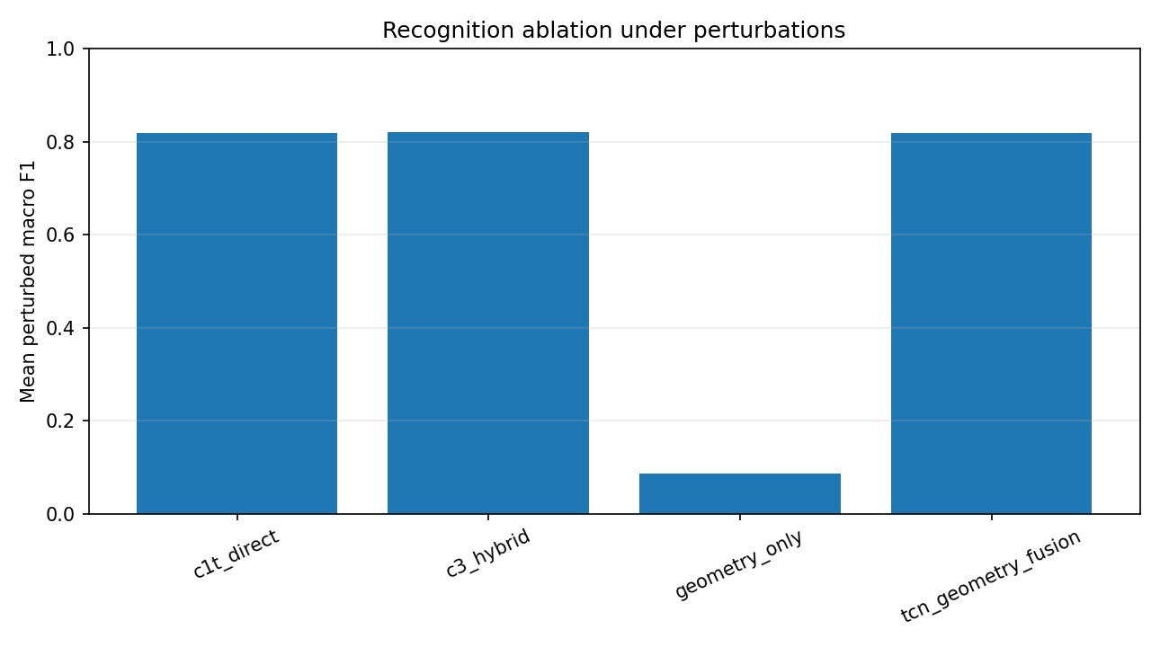
Figure 4. Recognition ablation under perturbations.
Method | Policy | Action precision | Action recall | Unintended action rate | False triggers / min
c1t_direct | c2 | 0.9613 | 0.9485 | 0.0387 | 2.235
c1t_direct | direct | 0.8546 | 0.9084 | 0.1454 | -
c3_hybrid | c2 | 0.9667 | 0.9427 | 0.0333 | 1.900
c3_hybrid | direct | 0.8577 | 0.9084 | 0.1423 | -

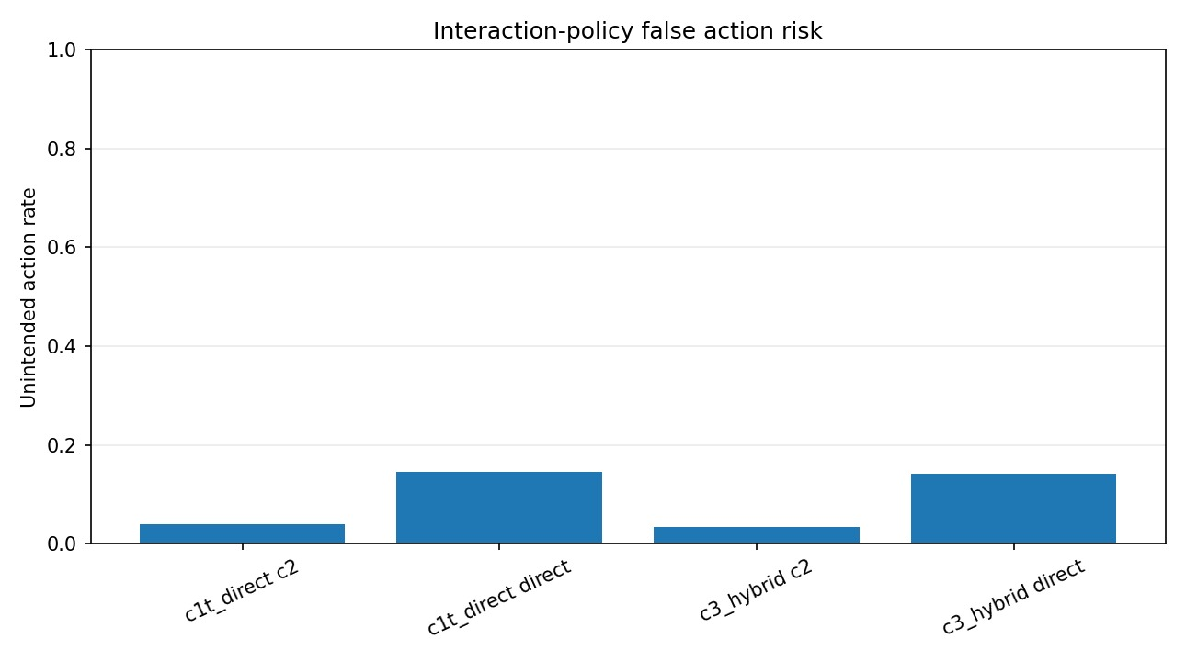
Figure 5. Interaction-policy false action risk.
Live/task metric | Value | Meaning
Session | 20260518_041817_334_webcam_onnx_placement | Latest task-level live report used as a diagnostic snapshot
Frames / duration | 395 / 22.81 s | Captured live loop length
FPS mean / p95 | 17.26 / 20.50 | Camera plus backend loop rate
Processing mean / p95 | 6.596 / 8.949 ms | Backend processing time
Detection-rate mean | 0.8163 | Average hand-detection availability
Pointer coverage | 0.7823 | Frames where AR pointer coordinates were available
Required-action coverage | 0.0000 | Scenario completion was not yet achieved

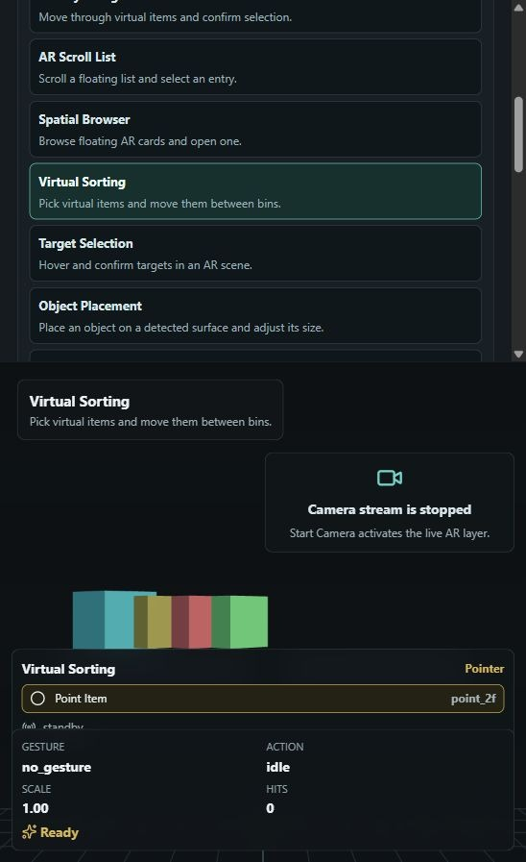
Figure 6. Virtual Sorting AR scenario surface.
No. | Formula | Meaning in this project
(5) | p_k = softmax(W · GAP(TCN(Z)) + b)_k; y_hat = argmax_k p_k | Temporal recognition maps the [32,74] sequence to a gesture label.
(6) | q_k = softmax(w_n log p_k + w_g r_k) | C3 Hybrid fuses neural probabilities with geometry-aware prior scores.
(7) | a(t)=g(y_hat(t)) if p_max≥τ, stable≥S, and t-t_last≥Δ; otherwise a(t)=∅ | C2 emits an AR action only after confidence, stability, and cooldown checks.
(8) | FAR_no = FP_action(no_gesture) / N_no_gesture | False-action risk is measured specifically for frames/clips with no intended gesture.
(9) | Coverage_req = |A_req ∩ A_obs| / |A_req| | Task-level coverage measures whether the expected action set appeared in the live scenario.

Portability item | Current state
Model input contract | [1, 32, 74]
Pose representation | per-frame wrist-centered coordinates divided by palm scale
Motion feature count | 11
C2 threshold / stable frames / cooldown | 0.62 / 2 / 250 ms
ONNX export | Available
Core ML stage | conversion_deferred_to_macos_or_linux
Phone domain status | local_plan_ready_waiting_for_videos
Planned phone rear AR clips | 35
Missing phone raw videos | 35

3. Further Development and Final Target
The final project should be a defensible master-level system rather than only a demonstration. It should show that temporal landmark recognition, a geometry-aware safety prior, and a context-aware action policy jointly improve practical AR interaction.
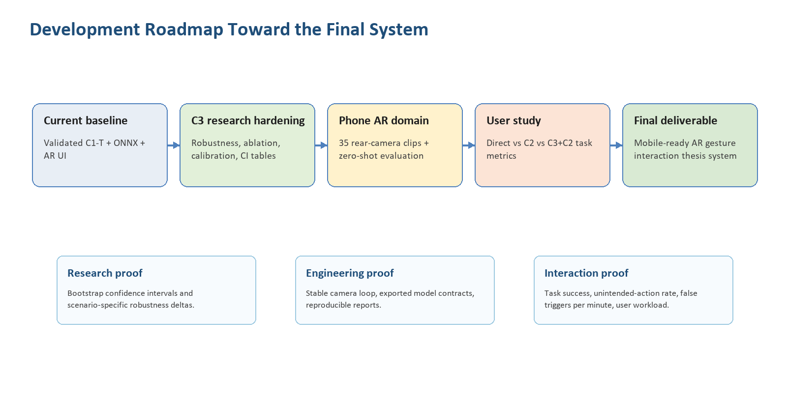
Figure 7. Roadmap from current state to final thesis-ready system.
Development area | Next work | Expected final evidence
Phone rear AR data | Record the planned 35 local clips and extract landmarks | Zero-shot and calibrated domain-shift report
C3 validation | Add bootstrap confidence intervals and scenario-specific sensitivity analysis | Statistically interpretable robustness section
C2 policy | Tune threshold, stable frames, and cooldown against task metrics | Direct vs C2 vs C3+C2 interaction comparison
AR task benchmark | Expand replay/live scenarios beyond placement and Virtual Sorting | Task success, false triggers/min, corrections/task
Mobile runtime | Complete Core ML conversion and iOS/RealityKit integration | Phone AR prototype using the same preprocessing contract
Thesis package | Freeze scripts, reports, charts, and reproducible commands | Repeatable experimental chapter and final defense artifacts

No. | Formula | Meaning in this project
(10) | Accuracy = trace(M) / sum(M) | Base recognition correctness on public and local domains.
(11) | MacroF1=(1/K)·Σ_i F1(i); WeightedF1=Σ_i n_i·F1(i)/Σ_i n_i | Balanced and support-weighted quality for imbalanced gesture classes.
(12) | UAR = N_unintended / N_actions | Unintended-action rate is the main AR safety metric for interaction policy comparison.
(13) | Gap_D(m)=|m_IPN - m_phone| | Domain gap quantifies transfer from public IPN Hand to phone rear-camera AR clips.
(14) | Score = m_robust - λ·FAR - μ·Latency | Final model selection should balance robustness, false actions, and runtime.

The intended final system is an AR gesture interaction stack that can be described, reproduced, measured, and defended: public-data training and robustness, local phone-domain validation, ONNX/Core ML portability, task-level AR evaluation, and a clear statement of remaining limitations.

