**使用方法**

1. 登陆
2. 获取元数据

Byx标点统计页面

<html>

<report-main>

<report-section-content>

<report-content-center>

<report-total-score-count>

<span id="TotalScoreCount">

<svg...>

<g class="fusioncharts-datalabels">

...

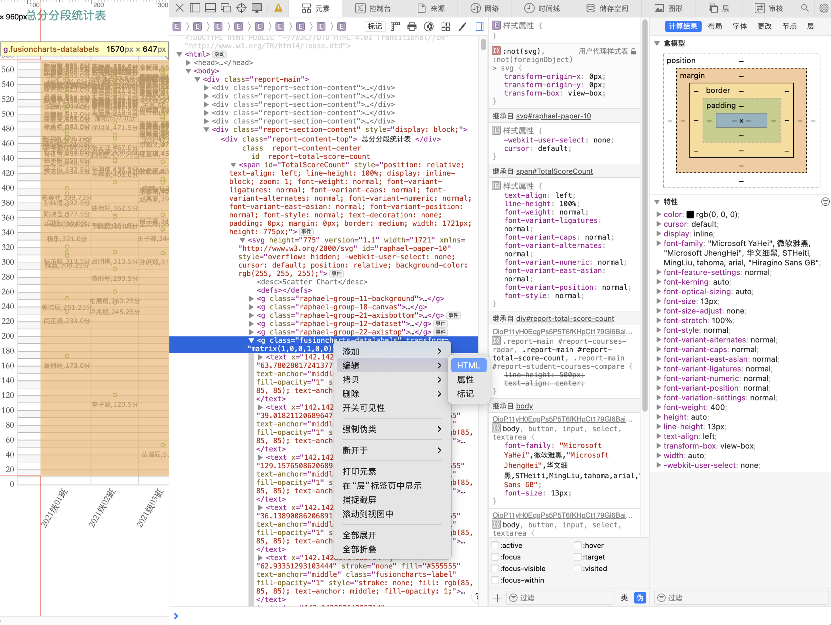

1. 复制到cssj.txt
2. 运行byxxp.py

4、在result中查看

*确保已经 pip3 install os re datetime chardet openyxl pandas