# The University of Hong Kong

# ELEC6604 Neural Networks, Fuzzy Systems and Genetic Algorithms

## Course Forum and Discussion

**Lecturer**: Dr. G. Pang

**Student**: Zhao Yunqing

**UID**: 3035541156

After viewing the referenced TED video release by Dr. G. Pang, I have already summarized the key points in regarding to the related questions.

### Question 1 :

Watch the above video. What is the name of the game that Professor Sepulchre mentioned at the beginning of his talk ? Who invented the idea of the game ?

### Answer :

At the beginning of the video, Professor Sepulchre mentioned about ‘The Imitation Game’, invented by Alan Turing, one of the most famous computer scientists of last century. The process is as follows:

Firstly, you are invited to join the game, but you do not know whether your partner is a machine or a human.Thus, you will be engaged in a conversation to figure out if it is a machine or not. If you successfully figure out it, you will win, otherwise you lose.

Some related knowledge: Alan Turing predicted that by year 2000, computer would win the game at most of the time.

### Question 2 :

What did Professor Sepulchre say regarding the “strength” of our brain when compared with a machine or computer ? How is that strength helping us in coping with complex tasks ?

### Answer :

Even though human beings are weaker than computers in terms of computational capability and memory size and space, Professor Sepulchre said that we have our unique strength: since our brain keep discerning, however computers work poor on this, which means our brain works (especially localization) much better than computers, zooming in and zooming out relevant information by modulating the resolution. This does not need the speed of processing, or enough space we can store.

For me, I know that the phrases “zoom in” and “zoom out” come from the field of camera shooting, meaning the push and pull the camera lens to catch the perfect scene. Hence, in this scenario, I think Professor Sepulchre means humans can seize the most useful information that matters to us, whether it is big or small.and extract appropriate detail from highly abstract situation, that is the strength of human being compared to computer.

### Question 3 :

Search for another interesting YouTube video related to the topic like “introduction to AI”, “machine intelligence” or “artificial intelligence”. Provide the link of the video and share with us any interesting ideas you have picked up from the video.

### Answer :

After seeing the question, I strongly recommend a short video from YouTube, <https://www.youtube.com/watch?v=lXUQ-DdSDoE>, the mentioned video share the chatting situation between **Google AI assistant** and a real hair salon in USA, by Pichai, CEO of Google.

As an audience, either in present or outside the screen, I cannot distinguish the role in the chatting process, and the Google AI successfully finished the task of women haircut booking at specified day, concisely and precisely.

In the introduction, we know that Google used word-to-speech and related deep learning method/algorithm to train the chatbot model, and finally get the satisfied conclusion, which really surprised us. From the video, I find we can also use deep learning to do some interesting design decided by specified scenario, like machine translation, object detection, etc.

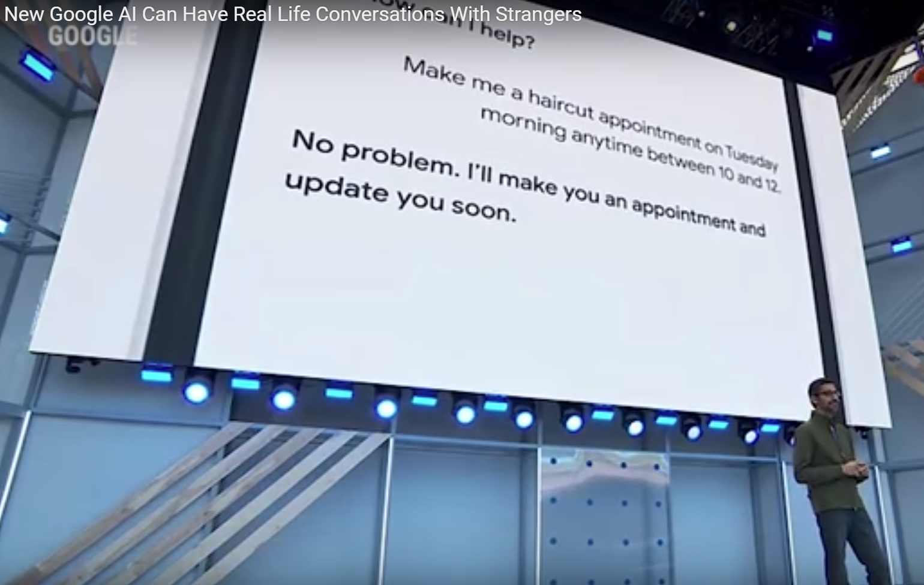

Graph 1

Google Assistant ready for booking

Finally, I have another recommendation for my dear fellow classmates, the film named “***The Imitation Game***”, protagonist by Benedict Cumberbatch (He is also my favorite movie star).

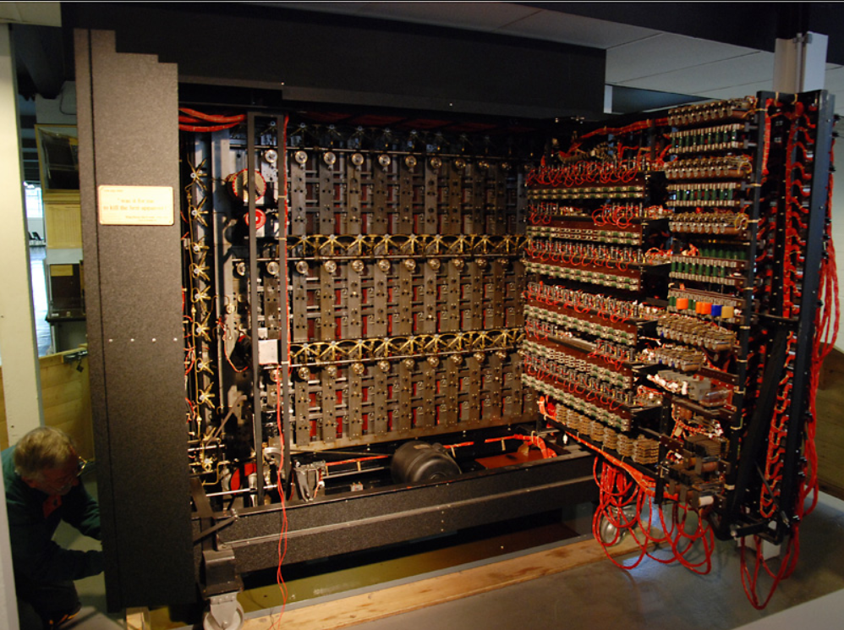

Graph 2

Turing's rebuilt bombe machine, called Christopher in the film, on display at Bletchley Park Museum

***The Imitation Game*** is a 2014 American historical drama film directed by Morten Tyldum and written by **Graham Moore**, based on the biography **Alan Turing: The Enigma by Andrew Hodges**. It stars Benedict Cumberbatch as British cryptanalyst Alan Turing, who decrypted German intelligence codes for the British government during the Second World War. From the film, I learn the core theory that Machine vs machine, the basic theory of Artificial Intelligence and the primary knowledge of control system, the Cryptology, and some method of Mathematics.

Thanks for your attention! As a member in this course, I hope every one of us can enjoy the learning process of AI, and this ELEC6604 course as well.

### Reference

[1] <https://assistant.google.com/>

[2] <https://www.youtube.com/watch?v=lXUQ-DdSDoE&t=302s>

[3] <https://en.wikipedia.org/wiki/The_Imitation_Game>

[4] <https://www.youtube.com/watch?v=OXoJJX3GOaQ&t=977s>

[5] <https://en.wikipedia.org/wiki/Alan_Turing>