# Part 5 Extension of further exploration

**As extension of the task**, I again team up with Mr. CHENG Ming to form our own dataset with several kinds of fruits, making Google Vision Kit to recognize the fruits in real time by shooting photos. This is interesting since we take part in the whole process from dataset construction to train the neural network model, to output the real time prediction result by connection of WeChat Chatting Room automatically.

As has been clarified in Assignment 2, the mechanism of the communication is as follows:

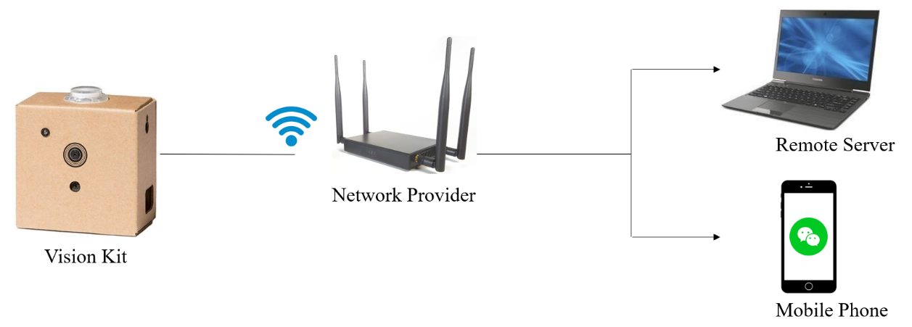

Graph 10 Communication Mechanism

For a detailed information, please refer to: <https://github.com/YunqingRecord/Google-Vision-Kit>.

In this task, we try to construct our own dataset, rather than the classical like MNIST or mentioned CIFAR in the previous part.

The Graph 10 shows below is our own-constructed data samples, containing 4 kinds of fruits.

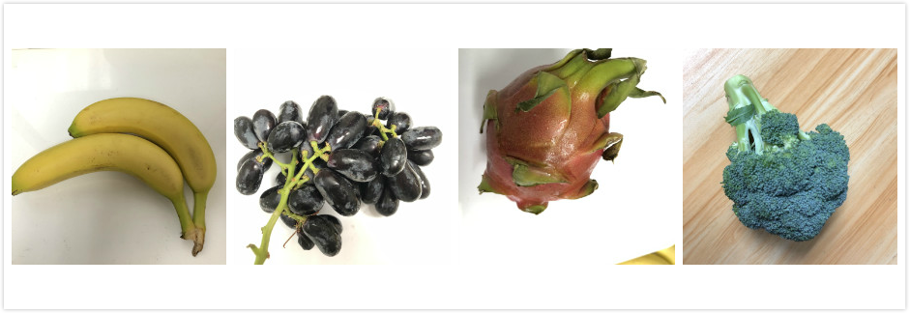

Graph 11 Samples of the Fruits Classes