ELEC6604 Neural Networks, Fuzzy Systems and Genetic Algorithms Assignment 1

# Part 1 Perceptron

## Introduction

The perceptron is an algorithm for supervised learning of binary classifiers, represented by a vector of numbers, being weights of the linear classifier.

## Binary Dataset

The used dataset is of binary format, which will be divided by the well-trained Perceptron. Because the data set is linear separate, so we can see that the result is successful: In this case, the hyper plain shows the well partition of the binary dataset (Graph 1).

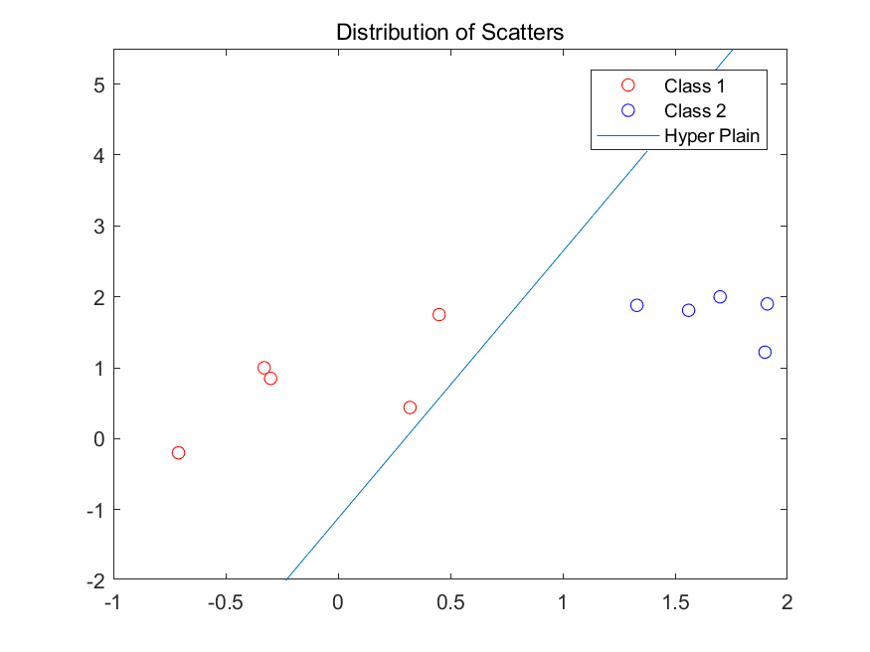

Graph 1

The Graph 2 shows the convergence of the network parameters. Since the dataset is linear separate, so the parameters will be adjusted to appropriate horizon, and no change happens after that all the data can be correctly divided.

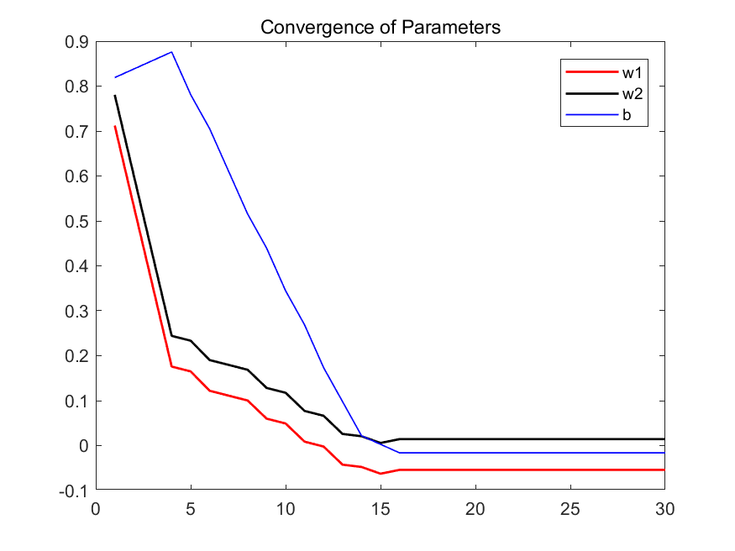

Graph 2

## NOT linearly separable Dataset

As the dataset is non-separate by using hyper plain, so from Graph 3a we can see that the parameters of the perceptron are non-convergence, and the dataset cannot be correctly divided as well.

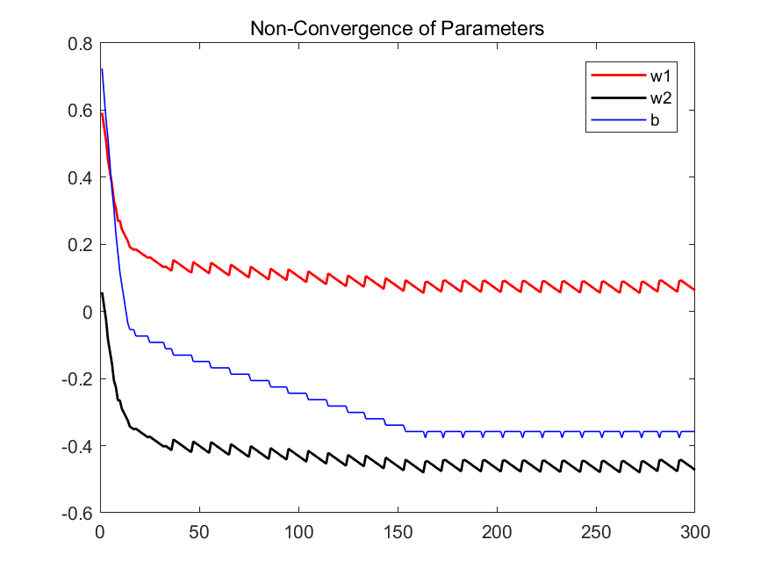

Graph 3a

So far, we show the Non-convergence of the parameters of the perceptron, and the Graph 3b shows the incorrect-partition of the dataset as follows:

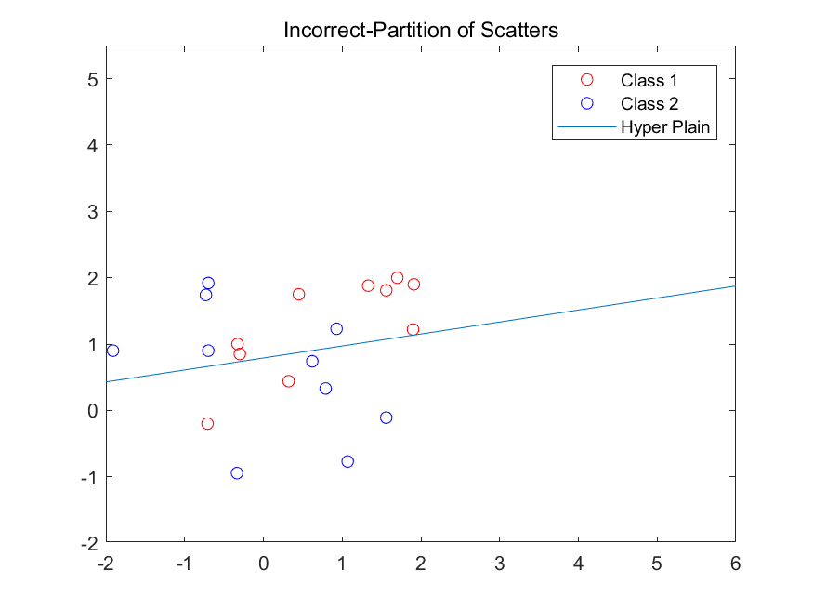

Graph 3b