Arthur Phillip High School

Year 7 Technology
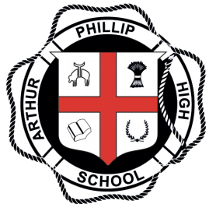

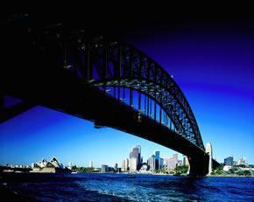

Engineered Systems
BRIDGES

Student Name:__________________ Class:____________________

Bridges - An introduction

Bridges have been with mankind since the start of recorded history. The simplest bridge was probably a beam type bridge formed by a felled tree across a creek. As mankind developed his skills, he was able to manipulate materials, his ingenuity and scientific knowledge allowed him to build bigger, stronger structures for different circumstances.

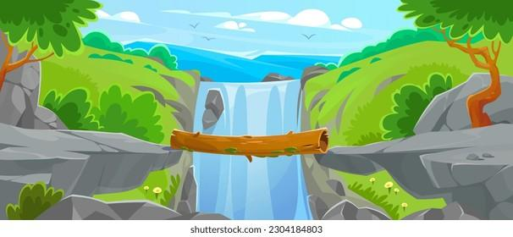

Lets do some research on bridges!

RESEARCH

1. Please visit https://www.pbs.org/wgbh/buildingbig/glossary_head.html
and complete the following:
Word | Definition
Abutment
Aqueduct
Arch Bridge
Beam Bridge
Brace
Brittle
Buckle
Buttress
Cable-Stayed Bridge
Cantilever
Cement
Compression
Concrete
Deform
Masonry
Movable Bridge
Pier
Reinforced Concrete
Shear
Suspension Bridge
Tension
Torsion
Truss

RESEARCH

2. Open the Building Big site https://www.pbs.org/wgbh/buildingbig/bridge/basics.html
Research the information on bridges, complete the chart below and answer the following questions.

Type of structure | Illustration | Description/examples
Beam bridge
Truss bridge
Arch bridge
Suspension bridge

RESEARCH

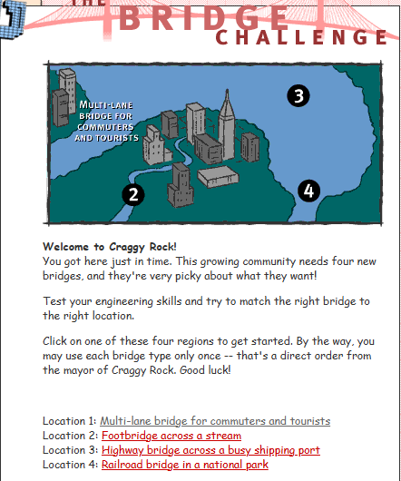
3. Click on this link
https://www.pbs.org/wgbh/buildingbig/bridge/challenge/index.html

Attempt the bridge challenge. What information have you gained about bridges from attempting the challenge?

____________________________________________________________________________________________________________________________________________________________________________________________________________________________________________________________________________
4. List the 4 locations below.
____________________________________________________________________________________________________________________________________________________________________________________________________________________________________________________________________________
RESEARCH

5. List what type of bridge was best suited to each location and why.
________________________________________________________________________________________________________________________________________________________________________________________________________________________________________________________________________________________________________________________________________________________________________________________________________________________________________________________________________________________________________________________________________________________

6. Why did the Tacoma Narrows Bridge collapse?
________________________________________________________________________________________________________________________________________________________________________________________________________________________________________________________________________________________________________________________________________________________________________________________________________________________________________________________________________________________________________________________________________________________

RESEARCH

7. What could have been done during the design and construction stages to improve this bridge and prevent its collapse?
________________________________________________________________________________________________________________________________________________________________________________________________________________________________________________________________________________________________________________________________________________________________________________________________________________________________________________________________________________________________________________________________________________________


RESEARCH

8. Using this link, https://www.pbs.org/wgbh/buildingbig/wonder/structure/browse.html
complete the table below by researching the following bridges.
Bridge | Location | Length | Material used | Date constructed.
Akashi Kaikyo |  | feet
Brooklyn |  | feet
Charles River |  | feet
Firth of Forth |  | feet
Garabit |  | feet
George P Coleman |  | feet
Golden Gate |  | feet
Iron |  | feet
New River Gorge |  | feet
Sunshine Skyway |  | feet
Tacoma Narrows |  | feet
Tower |  | feet

RESEARCH
5. Open this link https://www.pbs.org/wgbh/buildingbig/lab/forces.html
Check out the forces lab section and complete the chart.

Type of force | Technical Name | Description of the effect
Squeezing
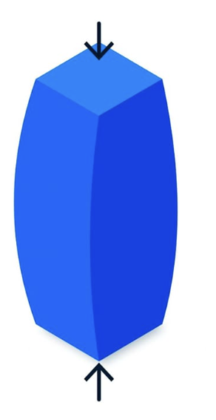
Stretching
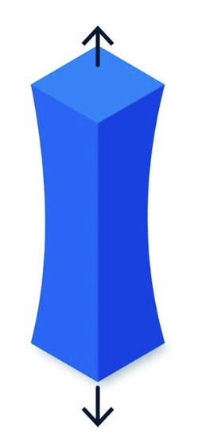
Bending
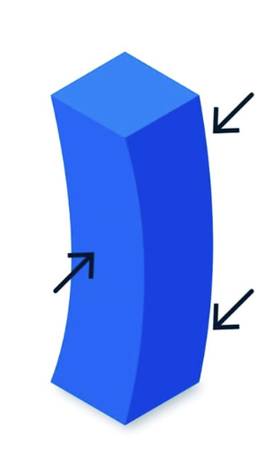
Sliding
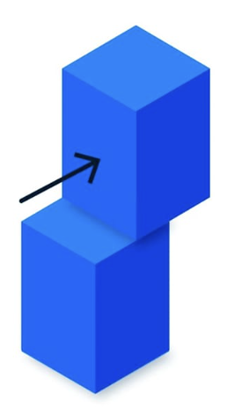
Twisting

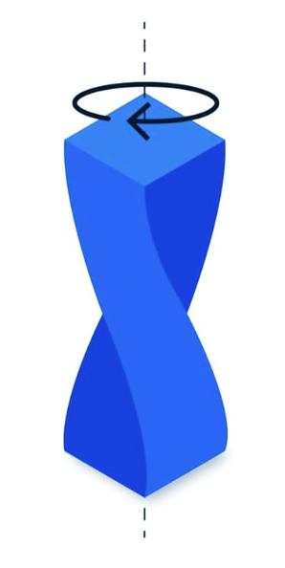

RESEARCH
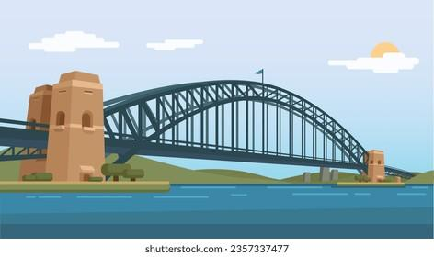
Sydney Harbour Bridge Research

Australia’s most famous bridge is the Sydney Harbour Bridge. Look at the illustrations provided and the following Internet sites to answer the following questions.

http://www.cityofsydney.nsw.gov.au/AboutSydney/HistoryAndArchives/SydneyHistory/HistoricBuildings/SydneyHarbourBridge.asp
http://www.australianexplorer.com/sydney_harbour_bridge.htm
http://www.cultureandrecreation.gov.au/articles/harbourbridge/
http://www.austehc.unimelb.edu.au/tia/426.html

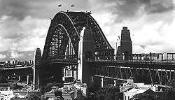
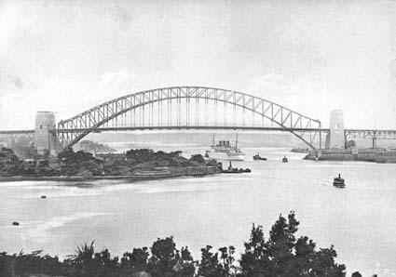

RESEARCH

- When was the Sydney Harbour Bridge opened for public use?

___________________________________________________________________
- What is the span and height of the Sydney Harbour Bridge?

Span
Height of roadway above water
Height from water level to the top of the arch

9. How many nuts and bolts were used in the construction of the Sydney Harbour Bridge?
___________________________________________________________________

10. By what other name is Sydney Harbour Bridge commonly known?
___________________________________________________________________
11. How was the Sydney Harbour Bridge tested before it was opened to the public? Was this a good method of testing? If not, why not?
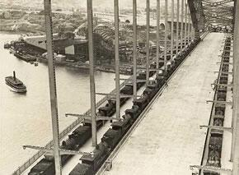
_________________________________________________________________________________________________________________________________________________________________________________________________________

RESEARCH
12. What is the function of the 4 pylons (2 on the north side and 2 on the south side) on the Sydney Harbour Bridge?
_________________________________________________________________________________________________________________________________________________________________________________________________________.

13. How is the roadway supported on the Sydney Harbour Bridge?
______________________________________________________________________________________________________________________________________

14. On the southern end (Sydney City end) of the Sydney Harbour Bridge the roadway is allowed to move in a horizontal motion. Why is this necessary?

__________________________________________________________________________________________________________________________________________________________________________________________________________________________________________________________________________________________________________________________________________________________________________________________________________________

RESEARCH

15. Complete the chart of famous people associated with the Sydney Harbour Bridge.

Name | Reason
John Bradfield
Jack Lang
Francis Greenway
Paul Hogan
Cpt. Francis deGroot

16. The Sydney Harbour Bridge is continuously being painted. Other than to keep it looking good, why is it necessary to do this?

__________________________________________________________________________________________________________________________________________________________________________________________________________________________________________________________________________________________________________________________________________________________________________________________________________________

Course: Yr 7 Bridge Design
Task Type: Portfolio and Practical | Task Number: 1
Topic: Materials and Production Processes
Weighting: 50% | Marks: 50
Issue date: | Due date:
Outcomes Assessed:
TE4-SDP-01- explains relationships between sustainability, design and production
TE4-PDP-01- describes the practices and processes of designers and producers
TE4-MSC-01- explains how materials, systems and components contribute to solutions
TTE4-DES-01- communicates and evaluates design ideas and solutions
E4-PPM-01- applies processes in the planning, management and production of projects
TE4-SAF-01- selects and safely uses tools, materials, technologies and processes
TE4-DIG-01- demonstrates technological literacy to safely interact in digital environments

Task Description: Bridge Design

Design Situation
A new walking track is being built through a national park, but there is a 500 mm wide gorge that people cannot cross safely. The local council has asked your team of student engineers to design and build a model bridge that can safely span the gap.
Your bridge must be free-standing, which means it must sit securely on the supports at each end (called abutments) without any help in the middle. Because the gorge is extremely deep, you cannot use any piers or vertical supports in the centre of your bridge.
To complete this challenge, you must use the knowledge you gained from your research in this booklet about bridge types, materials, and strong structures. You will need to carefully plan your design so your bridge is strong, stable, and uses materials efficiently.

Materials/Restraints
You may only use the materials provided by your teacher:
- Paddle pop sticks, 119 plain and 16 with holes
- Stainless steel clothes pegs
- PV Glue

Submissions - What do I hand in for marking?

Students are to complete the following and submit for assessment:
- The research section of this booklet
- A Design Portfolio

Marking Criteria

Section | Outstanding (5) | High (4) | Sound (3) | Basic (2) | Limited (1)
Design Brief | Clearly explains the problem, users and constraints with detailed explanations. Uses correct terminology. | Clearly explains most areas with good detail. | Explains the problem, users and constraints in a simple way. | Some information missing or unclear. | Very limited information provided.
Specification | Detailed and clear requirements including size, materials, safety and function. | Good list of requirements with minor details missing. | Basic requirements listed. | Few requirements listed or unclear. | Very little evidence of specifications.
Research | Detailed research of bridge types and materials with clear explanations and diagrams. | Good research with some explanation. | Some research with basic notes or pictures. | Limited research with little explanation. | Very little or no research is shown.
Generation of Ideas | 3 or more detailed sketches with clear labels and design thinking shown. | 3 good sketches with some labels. | 2–3 simple sketches with basic labels. | Only 1–2 sketches or limited detail. | Very little evidence of idea generation.
PMI Analysis | Detailed comparison with thoughtful plus, minus and interesting points. | Good comparison with clear PMI points. | Basic PMI completed. | Limited comparison with few points. | PMI incomplete or missing.
Procedural Text (Manufacturing Process) | Clear step-by-step process with materials, safety and diagrams/photos. | Clear steps with most details included. | Basic steps shown in correct order. | Steps unclear or missing details. | Very limited evidence of process.
Practical Work (Construction Skills) | The bridge is constructed to a very high standard showing excellent effort, accuracy and craftsmanship. Joints are neat and the structure is strong and well finished. | The bridge shows good construction skills with mostly neat joints and good effort. The structure is stable. | The bridge is complete and shows sound effort with acceptable construction quality. Some minor faults present. | The bridge shows basic construction with several weaknesses, poor joins or lack of care. | Bridge incomplete or very poor construction quality with minimal effort.
Destruction Video | Clear video showing testing process with detailed explanation of failure. | Clear testing shown with some explanation. | Video shows testing but limited explanation. | Limited evidence of testing. | No clear evidence of testing.
Strength to Weight Ratio (Mechanics) | Correct formula, clear calculations and strong comparison with other bridges. | Mostly correct calculations with comparison. | Correct formula with basic calculations. | Attempt made but errors present. | Very limited attempt.
Evaluation | Detailed reflection covering success, improvements and learning. | Good reflection covering most areas. | Basic reflection with some insight. | Limited reflection. | Very little evaluation provided.
Total Mark and Comment

HINTS on what to put in each section of your folio

- Design Brief | IDENTIFYING AND DEFINING
Purpose: Describe what the project is about answering the following questions
- What is the problem or need? (e.g., design a small bridge that can hold weight using limited materials)
- Who is it for? (e.g., classmates, toy cars)
- What are the constraints? (e.g., size, materials, time, budget)
Sentence Starters

Problem / Need:
- "The challenge I am addressing is… because…"
- "A key problem that needs solving is… in order to…"
- "This project aims to improve/solve… by creating a bridge that…"
Audience / Users:
- "The bridge is designed for… who need…"
- "This project will help… by providing…"
- "The intended users of this bridge are… because…"
Constraints / Limitations:
- "The bridge must… while still…"
- "I need to consider… such as…"
- "One limitation of my design is… but I plan to…"
A design brief is a short sentence that explains what you are making, who it is for, and why.

- Specification | IDENTIFYING AND DEFINING

A design specification is a list of rules or requirements that your project must follow.  In simple terms, it tells:  - What the product must do (e.g., hold weight, fit a space)  - What it must be made from (materials)  - How it should look or work (size, shape, colour)  Think of it as a checklist for your design to make sure it meets the goal. | Purpose: Set clear requirements for your bridge.  - Length, width, and height of the bridge  - Materials allowed  - Minimum weight capacity  - Budget/number of materials  - Safety considerations

Sentence Starters

What it must do / Function:  - "The bridge must be able to…"  - "It should safely…"  - "The design needs to…"  Materials / Construction:  - "It will be made from…"  - "The materials used must be…"  - "The structure should include…" | Size / Shape / Appearance:  - "The bridge must fit…"  - "It should be no bigger than…"  - "The shape of the bridge must…"  Other Rules / Limits:  - "It cannot use more than…"  - "The design must stay within…"  - "It should be completed in…"

3. Research Existing Bridges | Research and Planning

The purpose of researching before designing a bridge is to learn what works and what doesn’t. It helps you:
- Find out what types of bridges are strong and why.
- Understand which materials are best for your design.
- Get ideas from real bridges or other people’s designs.
- Make sure your bridge can do the job you want it to do.
In short: research gives you information so your ideas are smart, safe, and creative.
Investigate existing bridges and materials.
- Look at different types of bridges (beam, truss, suspension, arch)
- Explore why certain materials are strong or light
- Include diagrams or pictures from books or online

How might I research?
1. Look at real bridges
- Find pictures or videos of bridges.
- Note the type of bridge (beam, arch, suspension) and why it’s strong.
2. Explore materials
- List some materials that bridges are made from
- Check which materials are strongest or easiest to use.
3 Investigate construction ideas
- See how parts of bridges are joined or supported.
- Take notes on techniques you could copy.
4. Summarise your research
- Write 1–2 sentences explaining what you learned and what might work best for your bridge.

4. Generation of Ideas | Research and Planning

Initial Ideas
- Sketch at least 3 different ideas (use as many drawing techniques as you can eg 2D, 3D sketches)
- Label important features (supports, spans, joints, list the materials you might use)
- Include digital sketches if possible (Sketchup)
- Create your manual drawings on paper, take a photo or scan your drawing and paste to your folio

5.Analysing Ideas - PMI Analysis | Research and Planning

Compare your ideas in a table
- Plus: Strengths of the design
- Minus: Weaknesses or challenges
- Interesting: What could be improved or experimented with
An example is given below

Idea | Plus | Minus | Interesting
Beam bridge
Truss bridge

Sentence Starters

Plus (What is good about this idea?)
- "One good thing about this design is…"
- "This bridge will be strong because…"
- "I like that this design can…"
- "The benefit of using this material is…"
Minus (What is not so good / problem?)
- "A problem with this design might be…"
- "One thing I’m worried about is…"
- "This material could cause… because…"
- "The difficulty with building this design is…"
Interesting (What is unique or could be improved?)
- "An interesting idea about this bridge is…"
- "I could try… to make it stronger / lighter…"
- "It would be interesting to see what happens if…"
- "This design makes me wonder…"

6. Manufacturing Process - Procedural Text | Production and implementation

Record the steps to build your bridge.
- Include step-by-step instructions
- Include materials and tools used
Note safety precaution

Hints on how to write a procedural text

Step 1: Title your procedure  - Example: “How I Built My Popsicle Stick Bridge”  Step 2: Write an introduction  - Say what the bridge is for and what it will do.  - Example: “This bridge was designed to hold toy cars across a small gap.”  Step 3: List materials  - Make a clear list of everything you used.  Example: “Materials: 20 popsicle sticks, glue, ruler, scissors.”  Step 4: List safety rules  - Mention anything important to stay safe while building.  - Example: “Be careful when using scissors. Work on a flat surface.” | Step 5: Write steps in order  - Number each step and write clearly what you did.  - Use action words like cut, glue, join, place, test.  - Example:  - "Measure the gap for the bridge and mark the length of the sticks."  - "Glue two sticks together to make a longer beam."  "Build the base by connecting beams side by side."  - "Add supports underneath the bridge."  - "Let the glue dry for 10 minutes before testing."  Step 6: Add diagrams or photos  - Draw your bridge or take pictures of each step to make it clear.  Step 7: Write a conclusion  - Say if your bridge worked, how strong it was, and any improvements you could make.  - Example: “My bridge held 2 kg successfully, but I could make it stronger by adding more supports.”

7. Destruction video | Testing and Evaluating

Show how your bridge performs under load.
- Place bridge into Bridge tester and apply the weight gradually until the bridge breaks
- Record load cell video for evidence
Note where it failed and why


8.Mechanics - Strength to Weight Ratio | Testing and Evaluating

Evaluate the efficiency of your bridge.
- Formula: Strength to Weight Ratio = Maximum Load / Bridge Weight
- Show calculations clearly
Compare results between another two bridges in the class and analyse the results
The higher the ratio number, the more successful your bridge

9. Evaluation | Testing and Evaluating
Reflect on your design and building process.
- Did your bridge meet the brief and specification?
- What worked well?
- What could be improved?
- What did you learn about materials, design, and building safely?
Prompts:
- Would you change the design if you did it again?
- How did your choice of materials affect performance?
- How did the construction process go?
Sentence Starters
About the bridge’s performance
- "My bridge was successful because…"
- "The bridge held… which shows that…"
- "One thing that worked well was…"
- "The design was strong enough to…"
About what could be improved
- "One problem with the bridge was…"
- "Next time, I could improve it by…"
- "A weakness I noticed is…"
- "I would change… to make it stronger / lighter / more stable…"
About the materials and design
- "The material I used… was good / not suitable because…"
- "The shape of the bridge helped / didn’t help because…"
- "Using… made a difference because…"
Reflection on the design process
- "I learned that…"
- "This project taught me…"
- "If I did this again, I would…"
- "Overall, my bridge shows that…"
You will be supplied with a digital version of this folio in your Google Classroom
This can be put in their google classroom
https://docs.google.com/presentation/d/1l0TT6JXgdBaQ0LBasqcDcopMuiz_R_RmZbYhTot3fkw/edit?usp=sharing

