CENG 356 – Lab 10 Report
Name: Yunus Cheentavida
Student ID: N01520090
Date: 4/22/2026
GitHub Repo Link: https://github.com/Yunus256/lab7

Part 1 – Cache Timing Sensor
Average cache hit time: 75.30 cycles (18.37 ns)
Average cache miss time: 344.40 cycles (84.00 ns)
Median cache hit time: 82.00 cycles (20.00 ns)
Median cache miss time: 328.00 cycles (80.00 ns)
Hit/Miss ratio: 0.219
Miss/Hit slowdown: 4.57x
Why is the Miss/Hit slowdown usually significant?
A cache hit is much faster because the data is already in a nearby CPU cache. A cache miss is slower because the processor has to fetch the data from a lower cache level or from main memory, which takes much more time.
Why do we use _mm_lfence() before and after reading the time stamp?
_mm_lfence() prevents the CPU from reordering instructions around the timing measurement. That makes the timing more accurate because the measured load happens where it is supposed to happen.
Cache timing sensor output
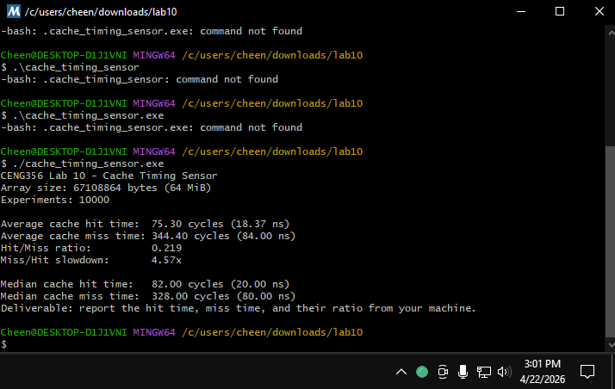

Part 2 – Branch Predictor Audit
Average cycles for trained if branch window: 497.08
Average cycles for mismatched else branch window: 500.18
Observed mismatch penalty: 3.10 cycles
Median cycles for trained if branch window: 489.60
Median cycles for mismatched else branch window: 490.72
Median mismatch penalty: 1.12 cycles
If the branch predictor was 100% accurate, what would the mismatch penalty be?
It would be about zero cycles, because there would be no wrong prediction and no pipeline flush penalty.
How could an attacker use this timing difference to determine the value of a secret boolean variable in a victim program?
If branch depends on a secret boolean, execution time can change depending on whether the branch matches the predictor’s learned pattern or not. By measuring the timing many times, an attacker could use the difference to infer whether the secret condition was true or false.
Branch predictor audit output
