CENG 356 – Lab 9 Report
Name: Yunus Cheentavida
Student ID: N01520090
Date: 4/21/2026
GitHub Repo Link: https://github.com/Yunus256/lab7

Execution output
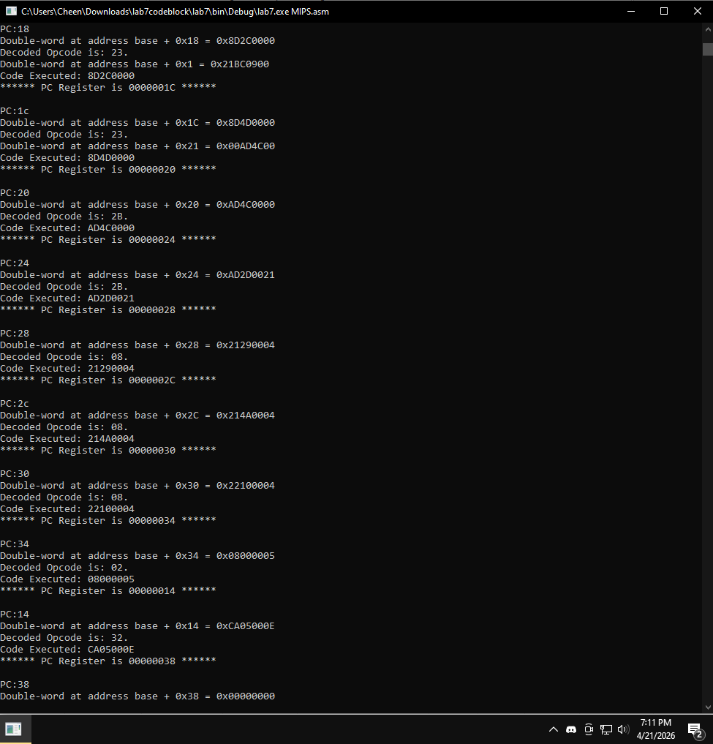
Final register contents
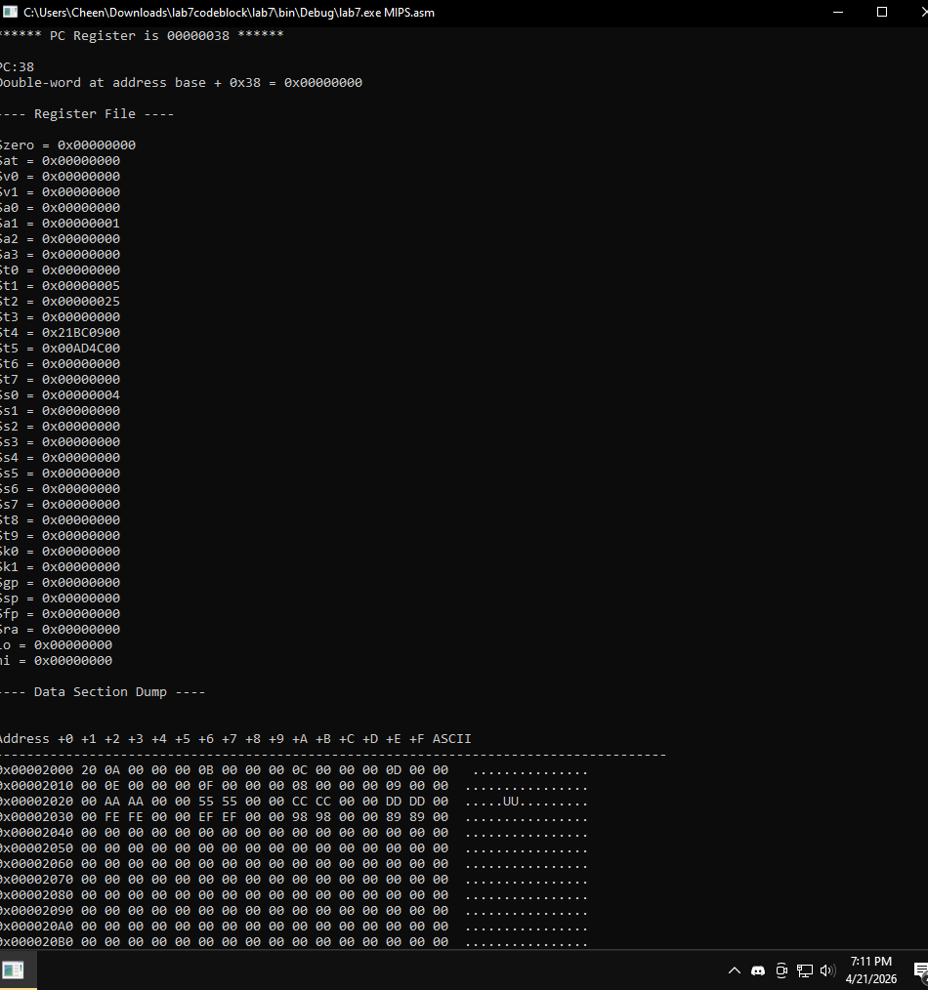
MIPS.asm:
- loads data addresses into registers
- reads byte and word values from memory
- performs arithmetic updates using add and addi
- stores results back into memory
- uses branch and jump instructions to control the flow of execution.
Overall, it demonstrates memory access, arithmetic operations, and control flow.

