CENG 356 – Lab 7

Name: Yunus Cheentavida
Student ID: n01520090
Date: 3/31/2026

Instruction Answers
lb:
Type: I-type
Format: opcode | rs | rt | immediate
Opcode: 100000
bge:
Type: I-type
Format: opcode | rs | rt | address
Opcode: 110010
lw:
Type: I-type
Format: opcode | rs | rt | immediate
Opcode: 100011
sw:
Type: I-type
Format: opcode | rs | rt | immediate
Opcode: 101011
add:
Type: R-type
Format: opcode | rs | rt | rd | shamt | funct
Opcode: 000000
Function: 100000
addi:
Type: I-type
Format: opcode | rs | rt | immediate
Opcode: 001000
j:
Type: J-type
Format: opcode | address
Opcode: 000010

Output Screenshot
All sections:
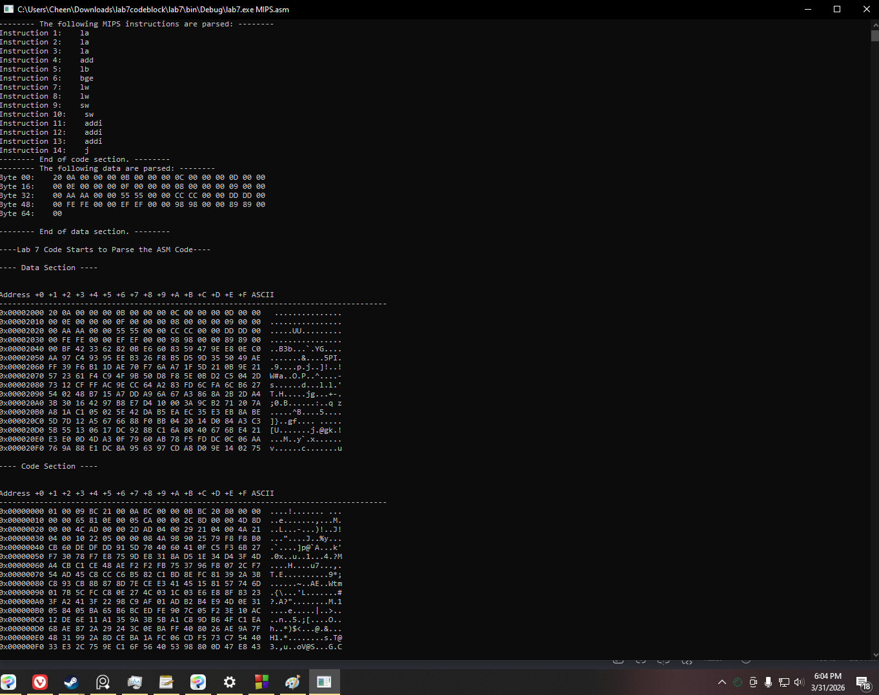
Split sections:
