CENG 356 – Lab 8 Report

Name: Yunus Cheentavida
Student ID: N01520090
Date: 4/11/2026
GitHub Repo Link: https://github.com/Yunus256/lab7

Output Screenshots
Program start and parsed instructions:
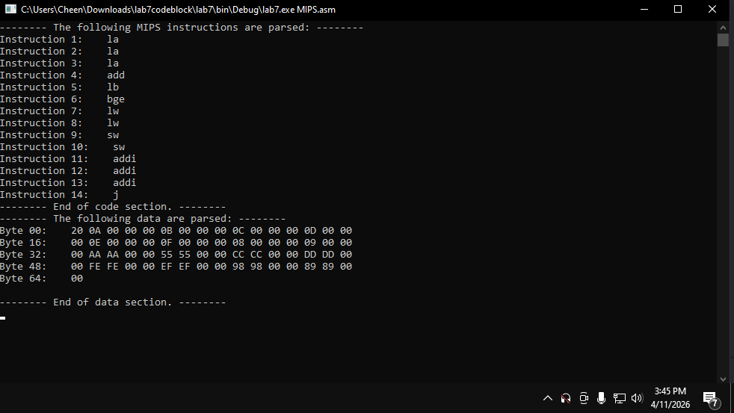

CPU fetch and decode output:
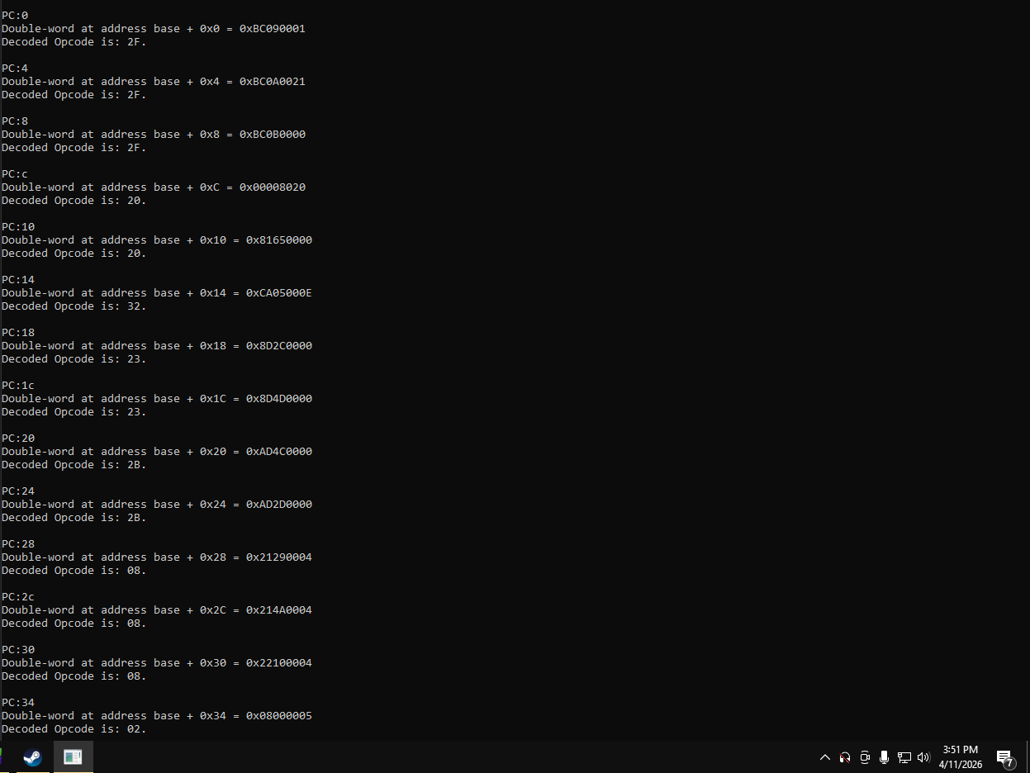

Register file output
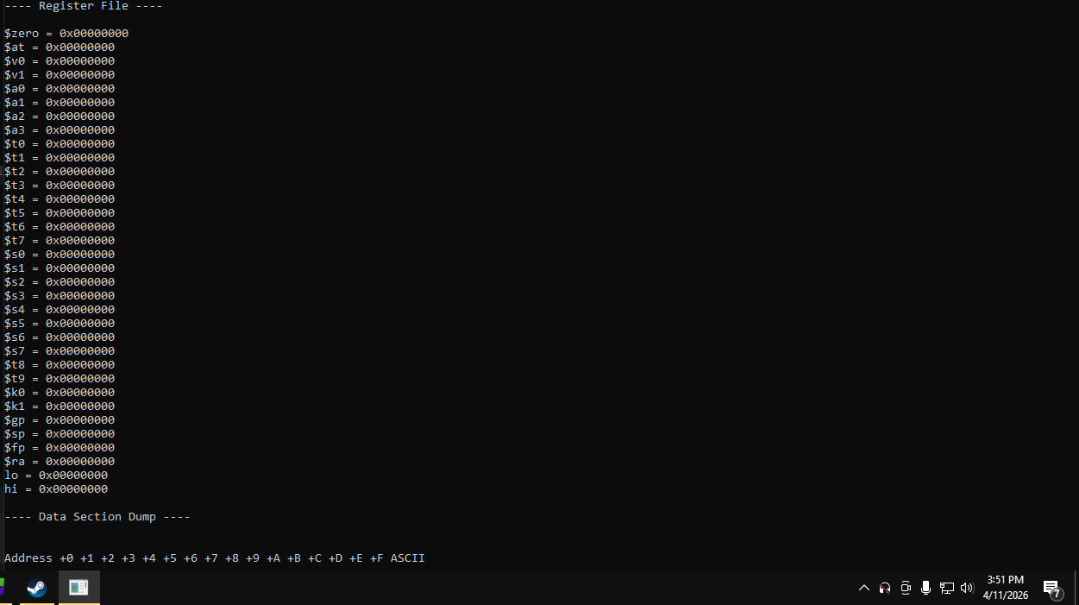
Data section memory dump
