Your Project Name

Course Name Course Code
Department
University

Submitted by

Date Submitted

ABSTRACT

Write your abstract here.
Table of Contents

1. Introduction 1
2. Analysis and Design 1
2.1 Updated Functional Requirements 1
2.2 Updated Non-Functional Requirements 1
2.3 Updated Use Case Requirements 1
2.4 Design Classes 1
2.5 Sequence Diagram 1
2.6 Software Architecture 1
3. Prototype Description 1
3.1 Implementation Platform 1
3.2 Mapping between Requirements and Implemented Functions 2
3.3 Implementation Details 2
3.4 Actual Database Schema 2
4. Testing 2
4.1 Expected Test Scenarios 3
4.2 Unit Test 3
4.3 Functional Test 4
4.4 Usability Test 4
5. Deployment of the System 4
6. Limitation of the System 5
7. Conclusion and Future Work 5
8. Reference 5

List of Figures

Figure 1. Smart room use cases 3
Figure 2. Successful order placement 5
Figure 3. Successful order placement 6
Figure 4. Successful face recognition log in 6
Figure 5. System deployment diagram 7

List of Tables

Table 1. Test Table 2
Table 2. Test Table 8

Introduction

[Here you write what was the problem you were working on? Why it was important to work on this project? What have you accomplished? etc.]

Analysis and Design
[Here you basically provide the updated analysis and design structures of the project.]

Updated Functional Requirements
[Provide functional requirements of your project to incorporate the new changes]

Updated Non-Functional Requirements
[Provide non-functional requirements of your project to incorporate the new changes]

Updated Use Case Requirements
[Provide latest use case diagram]

Design Classes
[Provide the design class diagram with updates]

Sequence Diagram
[Provide the important sequence diagrams to show system behavior]

Sequence Diagram 1

Sequence Diagram n

Software Architecture
[Provide the software architecture diagrams and descriptions]

Prototype Description
[First provide a short description of the prototype to familiarize reader about your development work.]

Implementation Platform
[Provide list of technologies hardware/software in addition to implementation platform used.]

Mapping between Requirements and Implemented Functions
The following table shows a mapping between the projected functionalities of the system and the corresponding implemented modules.

Table 1. Test Table
Functional requirements | Modules/Functions/Class that implemented this feature
Search facility | SearchByKeyword(string str)
 | SearchAdvance(String title, String year)
…………………

Implementation Details
[Here you try to give the details of interface and program main logic. Say what is the starting point of the system and what is the GUI interface (if any). Then you give a walkthrough of the system by showing the sample interfaces to demonstrate other functionalities. At the same time, you try to explain the main logic in each important function. Provide code snippet to show the main logic, do not give the whole code. The following is an example. ]
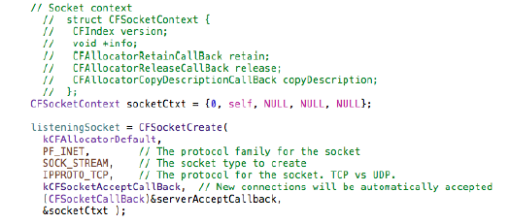
Figure 1. Sample code for creating and connecting to a socket

Actual Database Schema
[Here you give the actual ER diagram for the database you have finally designed. Additionally, you can also provide another view with attribute name and types]

Testing
[First to introduce the test/quality evaluation phase. What test tool you used for different testing? Then the detail will follow. This section is very important]

Expected Test Scenarios
[List the test scenarios, which you want to test]

Unit Test
[Here you should provide the unit test result for all the components of your system that you have implemented. Remember, Unit testing involves testing of each smallest logical unit of the software, which can be a module, a package, a file, or a class. Unit testing typically helps limit the ripple effect when fixing a bug. It also aids in the prevention of new feature implementation breaking the existing system.

Example test results includes the following]

Database Module:
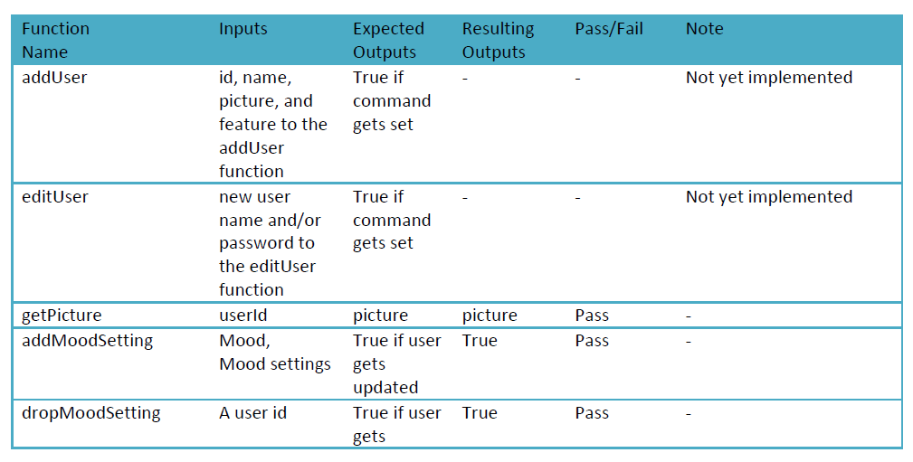

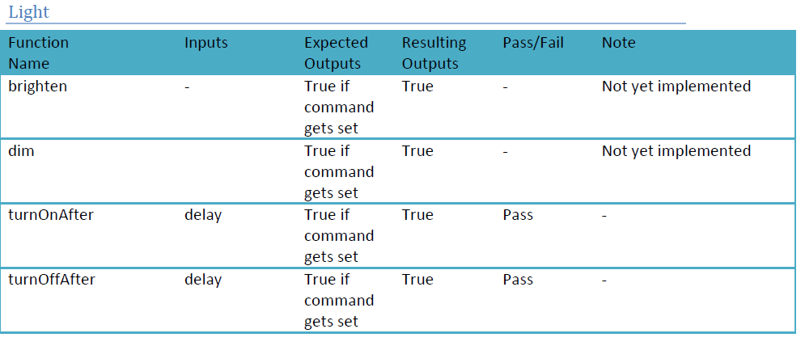

Functional Test
["Does the application deliver the capabilities that users need? Can users successfully complete the tasks they need to perform? Do they receive the correct responses for their requests? If not, a company risks losing significant revenue and customer loyalty. Growing competitive pressures are forcing organizations to ensure that their applications meet their business requirements before they are put into production." (http://www.parasoft.com/jsp/solutions/home.jsp?solution=FunTestSol)

There will be a quite a lot of functional testing to make sure that the system operates as required. A combination of white-box and black-box style testing has been and will continue to be used. We have been using a trial version of NCover to do code coverage testing on our system. Again due to the small nature of this project and the short time frame in which we will be in control of the source code means that the results provided by the NCover code coverage tool are not as important as they would be in a much larger project.
]

Usability Test
[Write what you did to test the usability of the system, what approach you took to correct the usability issues]

Deployment of the System
[Provide a figure/description to clarify the actual deployment of the system]

Limitation of the System
[here you explain what u wanted to do but could not………….]

Conclusion and Future Work
[Summarize the document. Also say where to go next, what can be improved and added in the system]

Reference
Write the references here.

