**GTU Department of Computer Engineering**

**CSE 222/505 - Spring 2022**

**Homework # Report**

**Yunus KARA**

**200104004055**

1. System Requirements

In this Project, we needed to design a java program that allows user to create account, sharing posts, interaction between post such as like or comment and also sending messaging (similar to Twitter).User has to log in in order to view a profile or sending a messages. Bonus part is blocking a user for another user. In this Project, Like and Comment classes require and they have to inherit features of Interaction class. Any other classes isn’t allowed. Just using array, there is no need to use anything else. Design is so important.

1. Class Diagram

Case Diagram:

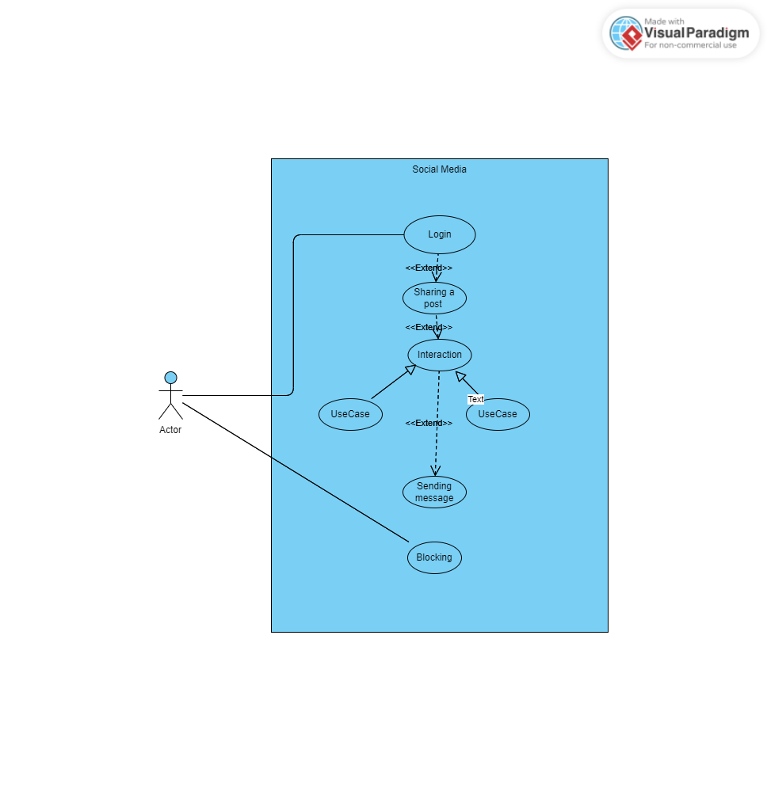

3.Another Diagram

No.

4. Problem Solution Approach

In this Project, Post Message Interaction and Account class “has a” relation between them. Like and Comment classes derived from Interaction class. There are interaction, comment,outbox (was sended messages),inbox(messages that comes from another user) arrays. Size is not dynamic (there is no need to) which have 10 size for each. Without log in doing anything so important so that’s why there is a field which name is “is_login”. It checks whether user login or not. That’s how user is forced being login.Due to the fact that there are Post and Messages object in Account class, methods of Post or Messages are used via Account class. Whenever an account shares a post, Post object is created then it is sended through Account class. For messages, there are 2 field in Account class.First one is inbox and second one is outbox. When a message is sended , it is automatically drops inbox who is receiver and it is appear outbox who is sender.For following, every account has 2 string for followings and followers. When an account follows another second. Following and followers increase automatically for both classes. In this Project size is not important so size are fixed with ten. My algorithm for blocking, Let’s assume that there are Yunus and Ali accounts. If Yunus blocks Ali, Ali isn’t able to send a message to Yunus or viewing his profile. Unlike Ali, Yunus is able to see his profile. It is allowed.

5. Test Cases.

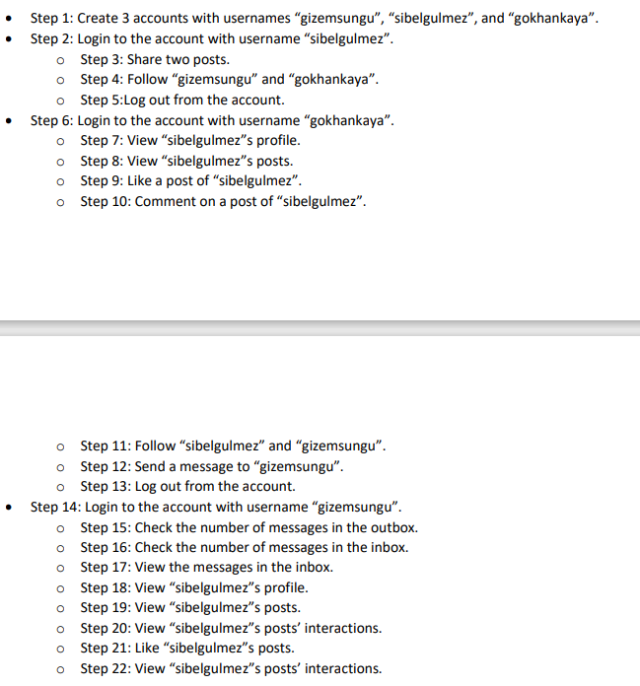

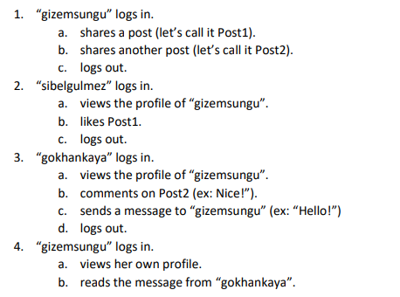

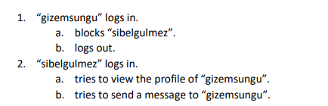

6. Running and Result

