ANALYSIS OF KENYA COVID-19 USING SIR MODEL

Group 1

2022-07-02

## loading Relevant packages and Data Set

library(tidyverse)   
library(readxl)  
library(janitor)  
library(lubridate)  
## loading the csv data set  
S_I_R_V2 <- read_excel("S_I_R V2.xlsx", sheet = "Sheet1")%>%  
 clean_names()%>%  
 select(-6,-7)%>%  
mutate(population = gsub(",", "", population))%>%  
mutate(population = as.numeric(population))

## Sir Models

### Building a two compartment model in R

#Load required libraries  
library(deSolve)  
library(reshape2)  
library(plotly)  
library(ggpubr)

# Model inputs  
  
initial_values1<-c(I=S_I_R_V2$number_of_infected[S_I_R_V2$x2020 == "Total"]/18, R=0)  
  
#initial_values1<-c(I=sum(Owid_Covid_Kenya$cases_new)/18, R=0)  
  
parameters1<-c(beta=round(1/14,2))  
  
# Time points  
  
time1=seq(from=0,t=31,by=1)  
  
# SIR model function  
  
sir_model1 <-function(time1,state,parameters1){  
 with(as.list(c(state,parameters1)),{  
 dI=-beta*I  
 dR=beta*I  
 return(list(c(dI,dR)))  
 }  
)   
}  
  
#Solving the differential equation  
output1<-as.data.frame(ode(y=initial_values1,func = sir_model1,parms=parameters1,times = time1))  
  
#To convert the dataframe to long format  
out_long1=melt(output1,id="time")   
  
ggplot(data = out_long1,   
 aes(x = time, y = value, colour = variable)) +   
 geom_line() +   
 scale_x_continuous(n.breaks = 16)+  
 scale_y_continuous(n.breaks = 13)+  
 labs(title = "Average Infected and Recovered for beta = 1/14",  
 subtitle = "Mar 2021 - Aug 2021",  
 x = "Time (days)",  
 y = "No: of people")+  
 scale_color_discrete(name="State")

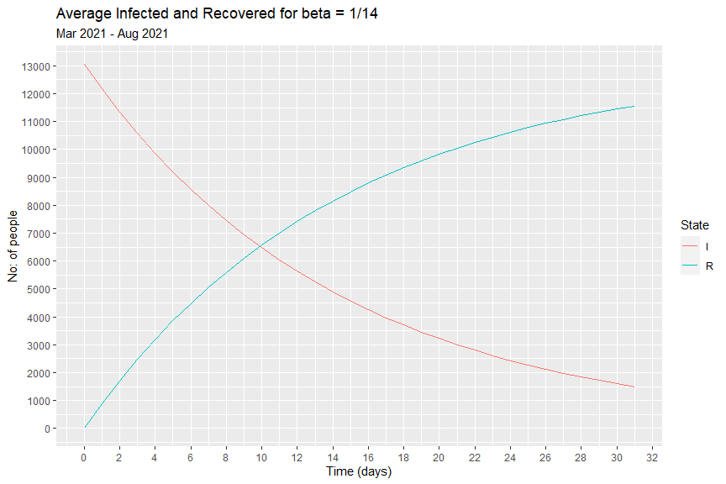 We observe that on a monthly average, half of the infected cohort recovers in around 10 days

### Simple SIR Model

# Model inputs  
initial_state_values=c(S=as.numeric(S_I_R_V2$population[S_I_R_V2$x2020 == "Total"])-1,  
 I=1,R=0)  
parameters=c(beta=round(1/14,2),alpha=round(1/7,2))  
# Time points  
time=seq(from=1,  
 to=length(seq(as.Date("2020/03/13"), as.Date("2021/08/31"), by=1))  
 ,by=1)

# SIR model function   
  
sir_model2 <- function(time,state,parameters){  
 with(as.list(c(state,parameters)),{  
 N=S+I+R  
 dS=-alpha*S*(I/N)  
 dI= alpha*S*(I/N)-beta*I  
 dR= beta*I  
   
 return(list(c(dS,dI,dR)))  
 }  
 )  
}  
  
#Solving the differential equations  
output2<-as.data.frame(ode(y=initial_state_values,func = sir_model2,parms=parameters,times = time))%>%  
 mutate(S = format(S, scientific = F, digits = 1))%>%  
 mutate(I = format(I, scientific = F, digits = 1))%>%  
 mutate(R = format(R, scientific = F, digits = 1))%>%  
 mutate(across(c(2:4), as.numeric))  
  
out_long2 <- melt(output2,id="time")  
# To plot the proportion of susceptible, infected and recovered individuals over time  
ggplot(data = out_long2,   
 aes(x = time,   
 y = value/S_I_R_V2$population[S_I_R_V2$x2020 == "Total"], colour = variable)) +   
 geom_line() +  
 #scale_x_continuous(n.breaks = 20)+  
 scale_x_continuous(breaks = seq(0, length(seq(as.Date("2020/03/13"), as.Date("2021/08/31"), by=1)), by = 30))+  
 scale_y_continuous(n.breaks = 10)+  
 xlab("Time (days)")+  
 ylab("Proportion of the population")+  
 scale_color_discrete(name="State")

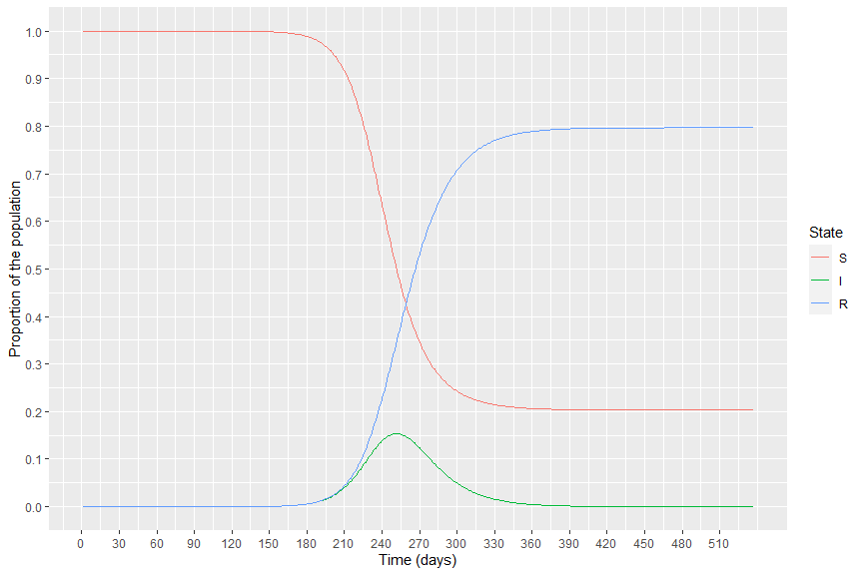

## Estimating Basic reproduction number and infection rate (beta)

### Counting Process

#As at march 2020 - August 2021  
p_Mar20_Aug21 = 1- ((S_I_R_V2$population[S_I_R_V2$x2020 == "Total"]- S_I_R_V2$number_of_infected[S_I_R_V2$x2020 == "Total"]-S_I_R_V2$number_of_recovered[S_I_R_V2$x2020 == "Total"])/(S_I_R_V2$population[S_I_R_V2$x2020 == "Total"]))  
  
theta_Mar20_Aug21 = -log(1-p_Mar20_Aug21)/S_I_R_V2$number_of_recovered[S_I_R_V2$x2020 == "Total"]  
  
R_o_Mar20_Aug21 = S_I_R_V2$population[S_I_R_V2$x2020 == "Total"]*theta_Mar20_Aug21  
  
Beta_Mar20_Aug21 = R_o_Mar20_Aug21 * (1/14)  
  
Ut_Mar20_Aug21 = R_o_Mar20_Aug21 * ((S_I_R_V2$population[S_I_R_V2$x2020 == "Total"]- S_I_R_V2$number_of_infected[S_I_R_V2$x2020 == "Total"]-S_I_R_V2$number_of_recovered[S_I_R_V2$x2020 == "Total"])/(S_I_R_V2$population[S_I_R_V2$x2020 == "Total"]-1))  
  
se_theta_Mar20_Aug21 = (((S_I_R_V2$population[S_I_R_V2$x2020 == "Total"]/((S_I_R_V2$population[S_I_R_V2$x2020 == "Total"]-1)^2 + 0.5))+(S_I_R_V2$population[S_I_R_V2$x2020 == "Total"]/((S_I_R_V2$population[S_I_R_V2$x2020 == "Total"]-1)^2+0.5))-((theta_Mar20_Aug21^2)*Ut_Mar20_Aug21))^(1/2))/S_I_R_V2$number_of_recovered[S_I_R_V2$x2020 == "Total"]  
se_R_o_Mar20_Aug21 = S_I_R_V2$population[S_I_R_V2$x2020 == "Total"] * se_theta_Mar20_Aug21  
R_o_Mar20_Aug21_interval = paste(R_o_Mar20_Aug21 - 1.96*se_R_o_Mar20_Aug21, R_o_Mar20_Aug21 + 1.96*se_R_o_Mar20_Aug21)

#As at beginning   
p_beginning = 1- ((S_I_R_V2$population[S_I_R_V2$x2020 == "Total"]- 84-79)/(S_I_R_V2$population[S_I_R_V2$x2020 == "Total"]))  
  
theta_beginning = -log(1-p_beginning)/79  
  
R_o_beginning = S_I_R_V2$population[S_I_R_V2$x2020 == "Total"]*theta_beginning  
  
Beta_beginning = R_o_beginning * (1/14)

#Total Lockdown  
p_TotalLockdown = 1 - ((S_I_R_V2$population[S_I_R_V2$x2020 == "Total"]- sum(S_I_R_V2$number_of_infected[which(S_I_R_V2$status == "Total Lockdown")])-sum(S_I_R_V2$number_of_recovered[which(S_I_R_V2$status == "Total Lockdown")]))/(S_I_R_V2$population[S_I_R_V2$x2020 == "Total"]))  
  
theta_TotalLockdown = -log(1-p_TotalLockdown)/sum(S_I_R_V2$number_of_recovered[which(S_I_R_V2$status == "Total Lockdown")])   
  
R_o_TotalLockdown = S_I_R_V2$population[S_I_R_V2$x2020 == "Total"]*theta_TotalLockdown  
  
Beta_TotalLockdown = R_o_TotalLockdown * (1/14)  
  
Ut_TotalLockdown = R_o_TotalLockdown * ((S_I_R_V2$population[S_I_R_V2$x2020 == "Total"]- sum(S_I_R_V2$number_of_infected[which(S_I_R_V2$status == "Total Lockdown")])-sum(S_I_R_V2$number_of_recovered[which(S_I_R_V2$status == "Total Lockdown")]))/(S_I_R_V2$population[S_I_R_V2$x2020 == "Total"]-1))  
  
  
se_theta_TotalLockdown = (((S_I_R_V2$population[S_I_R_V2$x2020 == "Total"]/((S_I_R_V2$population[S_I_R_V2$x2020 == "Total"]-1)^2 + 0.5))+(S_I_R_V2$population[S_I_R_V2$x2020 == "Total"]/((S_I_R_V2$population[S_I_R_V2$x2020 == "Total"]-1)^2+0.5))-((theta_TotalLockdown^2)*Ut_TotalLockdown))^(1/2))/sum(S_I_R_V2$number_of_recovered[which(S_I_R_V2$status == "Total Lockdown")])  
  
  
se_R_o_TotalLockdown = S_I_R_V2$population[S_I_R_V2$x2020 == "Total"] * se_theta_TotalLockdown  
  
R_o_TotalLockdown_interval = paste(R_o_TotalLockdown - 1.96*se_R_o_TotalLockdown, R_o_TotalLockdown + 1.96*se_R_o_TotalLockdown)

#Partially opening  
p_Partiallyopening = 1 - ((S_I_R_V2$population[S_I_R_V2$x2020 == "Total"]- sum(S_I_R_V2$number_of_infected[which(S_I_R_V2$status == "Partially opening")])-sum(S_I_R_V2$number_of_recovered[which(S_I_R_V2$status == "Partially opening")]))/(S_I_R_V2$population[S_I_R_V2$x2020 == "Total"]))  
  
theta_Partiallyopening = -log(1-p_Partiallyopening)/sum(S_I_R_V2$number_of_recovered[which(S_I_R_V2$status == "Partially opening")])   
  
R_o_Partiallyopening = S_I_R_V2$population[S_I_R_V2$x2020 == "Total"]*theta_Partiallyopening  
  
Beta_Partiallyopening = R_o_Partiallyopening * (1/14)  
  
Ut_Partiallyopening = R_o_Partiallyopening * ((S_I_R_V2$population[S_I_R_V2$x2020 == "Total"]- sum(S_I_R_V2$number_of_infected[which(S_I_R_V2$status == "Partially opening")])-sum(S_I_R_V2$number_of_recovered[which(S_I_R_V2$status == "Partially opening")]))/(S_I_R_V2$population[S_I_R_V2$x2020 == "Total"]- sum(S_I_R_V2$number_of_infected[which(S_I_R_V2$status == "Total Lockdown")])-sum(S_I_R_V2$number_of_recovered[which(S_I_R_V2$status == "Total Lockdown")])))  
  
se_theta_Partiallyopening = (((S_I_R_V2$population[S_I_R_V2$x2020 == "Total"]/((S_I_R_V2$population[S_I_R_V2$x2020 == "Total"]- sum(S_I_R_V2$number_of_infected[which(S_I_R_V2$status == "Total Lockdown")])-sum(S_I_R_V2$number_of_recovered[which(S_I_R_V2$status == "Total Lockdown")]))^2 + 0.5))+(S_I_R_V2$population[S_I_R_V2$x2020 == "Total"]/((S_I_R_V2$population[S_I_R_V2$x2020 == "Total"]- sum(S_I_R_V2$number_of_infected[which(S_I_R_V2$status == "Total Lockdown")])-sum(S_I_R_V2$number_of_recovered[which(S_I_R_V2$status == "Total Lockdown")]))^2+0.5))-((theta_Partiallyopening^2)*Ut_Partiallyopening))^(1/2))/sum(S_I_R_V2$number_of_recovered[which(S_I_R_V2$status == "Partially opening")])  
  
  
se_R_o_Partiallyopening = S_I_R_V2$population[S_I_R_V2$x2020 == "Total"] * se_theta_Partiallyopening  
  
R_o_Partiallyopening_interval = paste(R_o_Partiallyopening - 1.96*se_R_o_Partiallyopening, R_o_Partiallyopening + 1.96*se_R_o_Partiallyopening)

#Reopening  
p_Reopening = 1 - ((S_I_R_V2$population[S_I_R_V2$x2020 == "Total"]- sum(S_I_R_V2$number_of_infected[which(S_I_R_V2$status == "Reopening")])-sum(S_I_R_V2$number_of_recovered[which(S_I_R_V2$status == "Reopening")]))/(S_I_R_V2$population[S_I_R_V2$x2020 == "Total"]))  
  
theta_Reopening = -log(1-p_Reopening)/sum(S_I_R_V2$number_of_recovered[which(S_I_R_V2$status == "Reopening")])   
R_o_Reopening = S_I_R_V2$population[S_I_R_V2$x2020 == "Total"]*theta_Reopening  
  
Beta_Reopening = R_o_Reopening * (1/14)  
  
Ut_Reopening = R_o_Reopening * ((S_I_R_V2$population[S_I_R_V2$x2020 == "Total"]- sum(S_I_R_V2$number_of_infected[which(S_I_R_V2$status == "Reopening")])-sum(S_I_R_V2$number_of_recovered[which(S_I_R_V2$status == "Reopening")]))/(S_I_R_V2$population[S_I_R_V2$x2020 == "Total"]- sum(S_I_R_V2$number_of_infected[which(S_I_R_V2$status == "Total Lockdown"| S_I_R_V2$status == "Partially opening")])-sum(S_I_R_V2$number_of_recovered[which(S_I_R_V2$status == "Total Lockdown"|S_I_R_V2$status == "Partially opening")])))  
  
se_theta_Reopening = (((S_I_R_V2$population[S_I_R_V2$x2020 == "Total"]/((S_I_R_V2$population[S_I_R_V2$x2020 == "Total"]- sum(S_I_R_V2$number_of_infected[which(S_I_R_V2$status == "Total Lockdown"| S_I_R_V2$status == "Partially opening")])-sum(S_I_R_V2$number_of_recovered[which(S_I_R_V2$status == "Total Lockdown"|S_I_R_V2$status == "Partially opening")]))^2 + 0.5))+(S_I_R_V2$population[S_I_R_V2$x2020 == "Total"]/((S_I_R_V2$population[S_I_R_V2$x2020 == "Total"]- sum(S_I_R_V2$number_of_infected[which(S_I_R_V2$status == "Total Lockdown"| S_I_R_V2$status == "Partially opening")])-sum(S_I_R_V2$number_of_recovered[which(S_I_R_V2$status == "Total Lockdown"|S_I_R_V2$status == "Partially opening")]))^2+0.5))-((theta_Reopening^2)*Ut_Reopening))^(1/2))/sum(S_I_R_V2$number_of_recovered[which(S_I_R_V2$status == "Reopening")])  
  
  
se_R_o_Reopening = S_I_R_V2$population[S_I_R_V2$x2020 == "Total"] * se_theta_Reopening  
  
R_o_Reopening_interval = paste(R_o_Reopening - 1.96*se_R_o_Reopening, R_o_Reopening + 1.96*se_R_o_Reopening)

counting_process_output <- tibble( status = c("Beginning", "Mar2020-Aug2021", "Total Lockdown", "Partially opening", "Reopening" ),  
 Ro = round( c(R_o_beginning, R_o_Mar20_Aug21 ,  
 R_o_TotalLockdown, R_o_Partiallyopening, R_o_Reopening),4),  
 infection_rate_Beta = round(c(Beta_beginning, Beta_Mar20_Aug21 ,  
 Beta_TotalLockdown, Beta_Partiallyopening, Beta_Reopening), 4),  
 Ro_95CI = c( NA,  
 paste("( ", round(R_o_Mar20_Aug21 - 1.96*se_R_o_Mar20_Aug21,4), ", ", round(R_o_Mar20_Aug21 + 1.96*se_R_o_Mar20_Aug21,4), " )", sep = ""),  
 paste("( ", round(R_o_TotalLockdown - 1.96*se_R_o_TotalLockdown,4), ", ", round(R_o_TotalLockdown + 1.96*se_R_o_TotalLockdown,4), " )", sep = ""),  
 paste("( ", round(R_o_Partiallyopening - 1.96*se_R_o_Partiallyopening,4), ", ", round(R_o_Partiallyopening + 1.96*se_R_o_Partiallyopening,4), " )", sep = ""),  
 paste("( ", round(R_o_Reopening - 1.96*se_R_o_Reopening,4), ", ", round(R_o_Reopening + 1.96*se_R_o_Reopening,4), " )", sep = ""))  
 )  
  
library(knitr)  
kable(counting_process_output)

| status | Ro | infection_rate_Beta | Ro_95CI |
| --- | --- | --- | --- |
| Beginning | 2.0633 | 0.1474 | NA |
| Mar2020-Aug2021 | 2.0099 | 0.1436 | ( 1.9286, 2.0913 ) |
| Total Lockdown | 2.0284 | 0.1449 | ( 1.1078, 2.9491 ) |
| Partially opening | 2.0224 | 0.1445 | ( 1.7616, 2.2833 ) |
| Reopening | 2.0259 | 0.1447 | ( 1.8849, 2.1669 ) |

library(readxl)  
library(zoo)  
monthly_data <- read_excel("monthly data.xlsx",   
 col_types = c("text", "date", "numeric",   
 "numeric", "numeric", "numeric",   
 "text")) %>%   
 select(-c(6,7))  
monthly_data$Period<-as.yearmon(monthly_data$Month)

### Computing Ro for monthly values

So=(monthly_data$Population[1]-monthly_data$Infected[1]-monthly_data$Recovered[1])  
n=monthly_data$Population[19]  
Ro_Month<-monthly_data %>%   
 mutate(p=(1-((Population-Infected-Recovered)/Population[Status=="Total"])),  
 theta=(-log(1-p))/Recovered,  
 Ro=Population[Status=="Total"]*theta,  
 infection_rate= Ro*(1/14),  
 ST=Population-Infected-Recovered,  
 UT=Ro*(ST/So),  
 SE_theta=((2*(n/((n-1)^2+0.5)))-((theta^2)*UT))^0.5/Recovered) %>%   
 slice(-19)  
Rdata<-Ro_Month %>% select(Status,Month,Ro) %>%   
 mutate(Time=c(1:18))

### Statistical Analyses of Ro

1. Descriptive Statistics

sumarydata<-monthly_data %>%   
 slice(-19) %>%  
 select(-Period) %>%   
 mutate(Status=as.factor(Status))  
  
sad<-sumarydata %>%   
 group_by(Status) %>%  
 summarise(Total_Infected=sum(Infected),  
 Total_Recovered=sum(Recovered))  
  
ggplot(Rdata) +  
 aes(x = Time, y = Ro) +  
 geom_line(size = 0.5, colour = "#2E80D0") +  
 scale_x_continuous(n.breaks = 18)+  
 labs(x = "Time", y = "Ro", title = "Monthly Values for R0") +  
 theme_minimal()

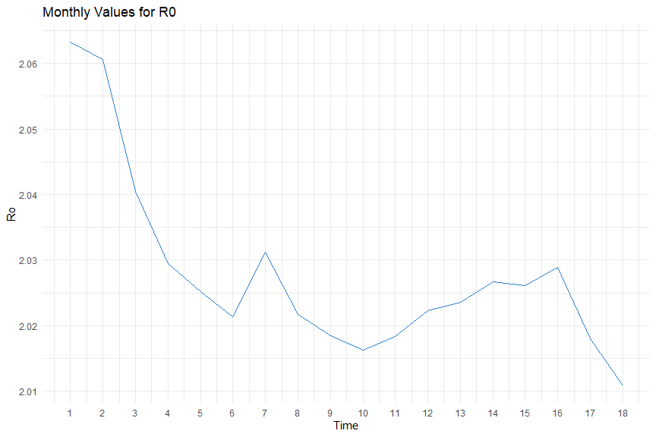

cor(counting_process_output$infection_rate_Beta,counting_process_output$Ro)

## [1] 0.9999092

library(psych)  
counting_process_output %>%   
 select(Ro,infection_rate_Beta) %>%   
 mutate(Infection_Rate=infection_rate_Beta) %>%   
 select(-infection_rate_Beta) %>%   
 pairs.panels()

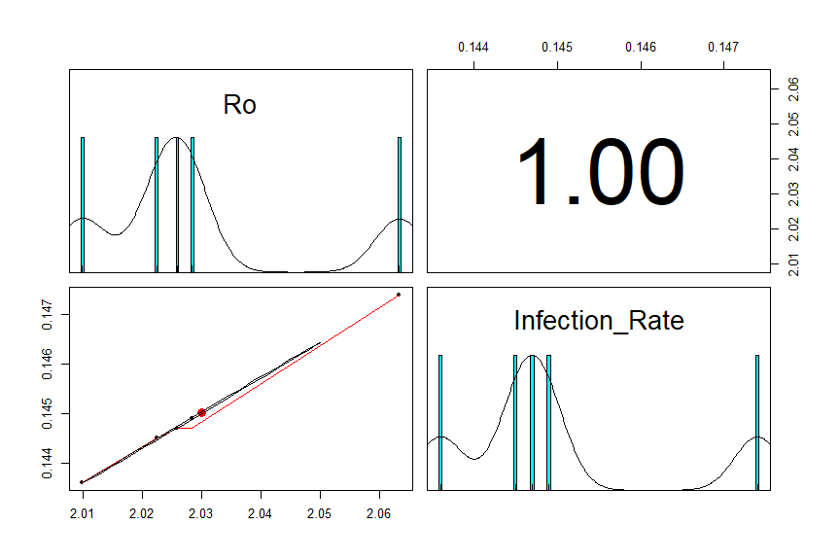

1. Comparing means of r0 QN: Were the lock downs significant in reducing the values of Ro?

Rdata<-Ro_Month %>%   
 select(Status,Month, Ro) %>%   
 slice(-19) %>%   
 mutate(Time=c(1:18))  
write.csv(Rdata, "E:\\4.1\\Project\\SIRModel\\Rdata.csv", row.names = FALSE)  
  
ggplot(Rdata) +  
 aes(x = Status, y = Ro, fill = Status) +  
 geom_boxplot(shape = "circle") +  
 stat_compare_means()+  
 scale_fill_hue(direction = 1) +  
 labs(  
 subtitle = ,  
 x = "Status",  
 y = "R0",  
 title = "Box Plot for R0 Values",  
 fill = "Status"  
 ) +  
 ggthemes::theme_wsj() +  
 theme(plot.title = element_text(face = "bold", hjust = 0.5))

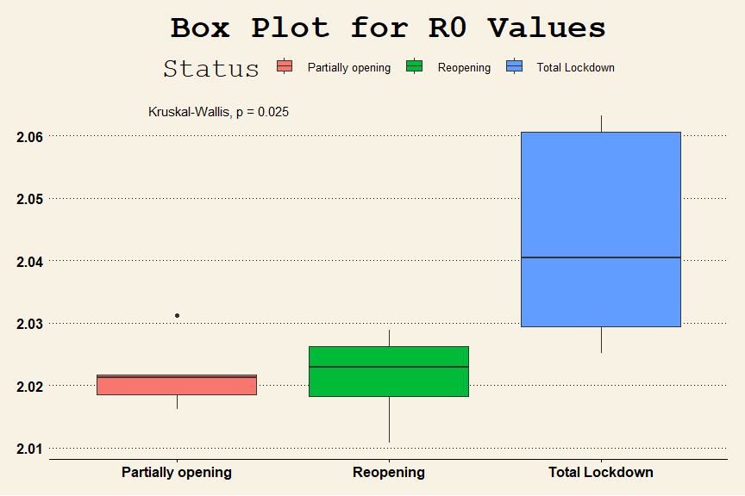

kruskal.test(Ro~Status, data=Rdata)

##   
## Kruskal-Wallis rank sum test  
##   
## data: Ro by Status  
## Kruskal-Wallis chi-squared = 7.3904, df = 2, p-value = 0.02484

pairwise.wilcox.test(Rdata$Ro,Rdata$Status, p.adjust.method = "BH")

##   
## Pairwise comparisons using Wilcoxon rank sum exact test   
##   
## data: Rdata$Ro and Rdata$Status   
##   
## Partially opening Reopening  
## Reopening 0.833 -   
## Total Lockdown 0.048 0.033   
##   
## P value adjustment method: BH

1. Building a time series model

library(astsa)  
Ro_ts<-ts(Rdata$Ro)  
plot(Ro_ts, type="o")

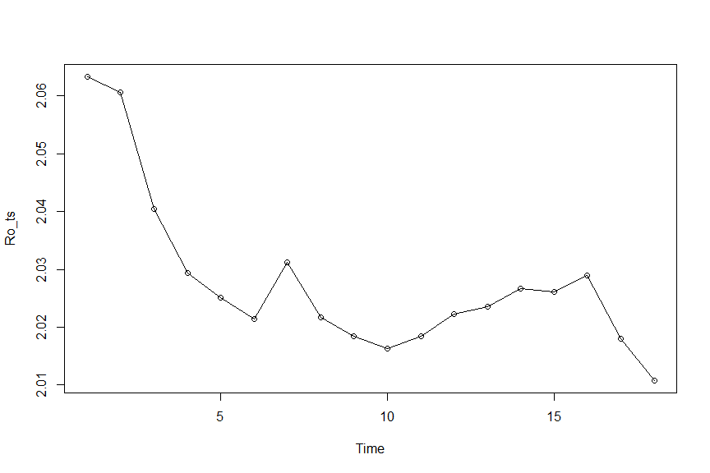 -There is a general downward trend -no visible seasonality -no constancy of variance -There are no outliers in the series

lag1.plot(Ro_ts,1)

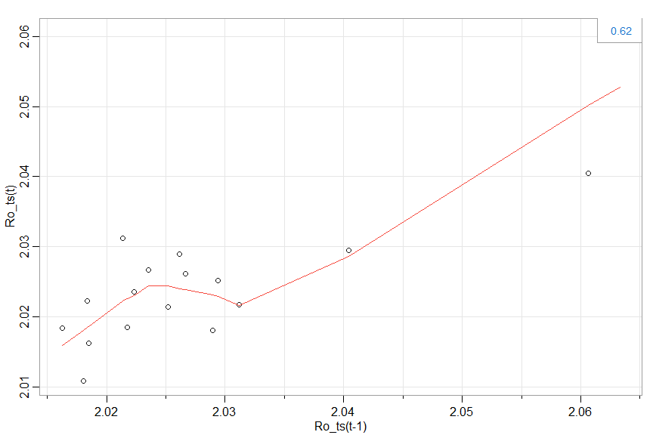

acf2(Ro_ts)

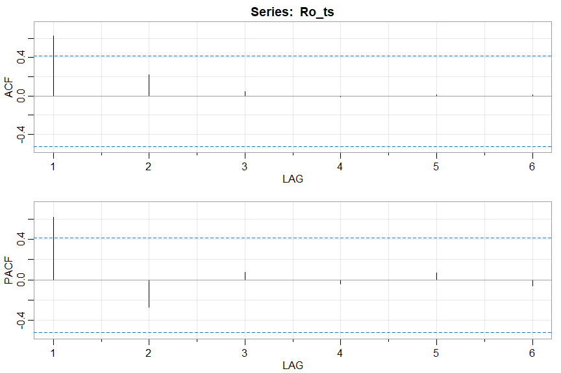

## [,1] [,2] [,3] [,4] [,5] [,6]  
## ACF 0.62 0.22 0.05 -0.01 0.01 0.01  
## PACF 0.62 -0.28 0.08 -0.04 0.07 -0.06

-The acf plot tappers towards zero and the Pacf plot has one significant spike and shuts off the rest of the lags. -This is an AR(1) model.This model predicts future values based on the past values.

sarima(Ro_ts,1,0,0,)

## initial value -4.501493   
## iter 2 value -4.891232  
## iter 3 value -5.107647  
## iter 4 value -5.126948  
## iter 5 value -5.153667  
## iter 6 value -5.172968  
## iter 7 value -5.172999  
## iter 8 value -5.176362  
## iter 9 value -5.177774  
## iter 10 value -5.177876  
## iter 11 value -5.177877  
## iter 11 value -5.177877  
## final value -5.177877   
## converged  
## initial value -4.658199   
## iter 2 value -4.816887  
## iter 3 value -4.827048  
## iter 4 value -4.831663  
## iter 5 value -4.832773  
## iter 6 value -4.832938  
## iter 7 value -4.832963  
## iter 8 value -4.833002  
## iter 9 value -4.833002  
## iter 10 value -4.833004  
## iter 10 value -4.833004  
## iter 10 value -4.833004  
## final value -4.833004   
## converged

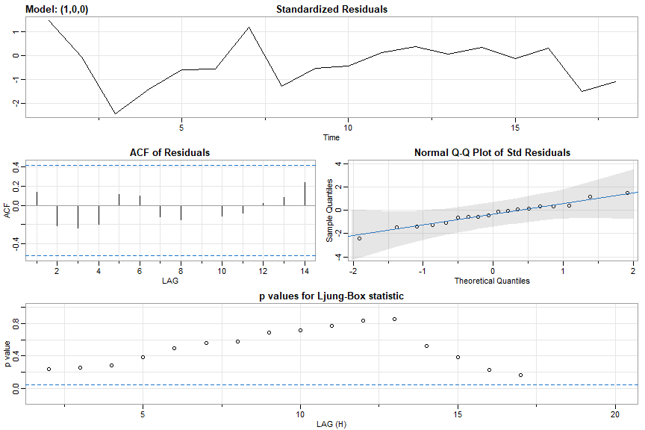

## $fit  
##   
## Call:  
## arima(x = xdata, order = c(p, d, q), seasonal = list(order = c(P, D, Q), period = S),   
## xreg = xmean, include.mean = FALSE, transform.pars = trans, fixed = fixed,   
## optim.control = list(trace = trc, REPORT = 1, reltol = tol))  
##   
## Coefficients:  
## ar1 xmean  
## 0.9294 2.0333  
## s.e. 0.0862 0.0163  
##   
## sigma^2 estimated as 5.676e-05: log likelihood = 61.45, aic = -116.91  
##   
## $degrees_of_freedom  
## [1] 16  
##   
## $ttable  
## Estimate SE t.value p.value  
## ar1 0.9294 0.0862 10.7778 0  
## xmean 2.0333 0.0163 124.8727 0  
##   
## $AIC  
## [1] -6.494798  
##   
## $AICc  
## [1] -6.450354  
##   
## $BIC  
## [1] -6.346403

-The standard residuals plot shows no trend which is a good results - The acf plot for their residuals have all the values insignificant indicating that its a good model for prediction. -The normal qq plot shows normality because all the values lies within the line of fit - All ljung box statistics are insignificant.That’s a good result - the values of BIC,AIC and variance are very low. thats a good results.

Coefficients: ar1 xmean 0.9294 2.0333 s.e. 0.0862 0.0163

c=xmean(1-ar1(coefficient)) = 2.0333(1-0.9294) = 0.1436

Model

y= 0.1436 + 0.9294Xt-1 + Wt

Estimate SE t.value p.value ar1 0.9294 0.0862 10.7778 0 xmean 2.0333 0.0163 124.8727 0

The p value for the ar1 coefficient is zero showing that the coefficient is significant in the model.

sarima.for(Ro_ts,4,1,0,0)

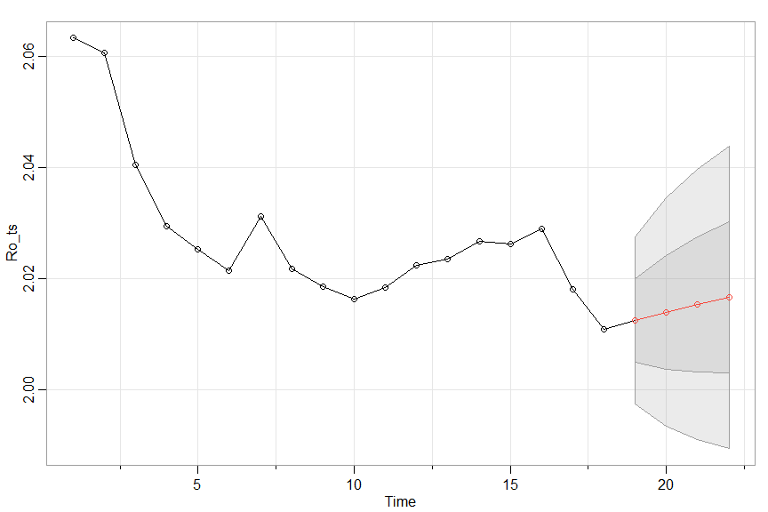

## $pred  
## Time Series:  
## Start = 19   
## End = 22   
## Frequency = 1   
## [1] 2.012399 2.013878 2.015253 2.016531  
##   
## $se  
## Time Series:  
## Start = 19   
## End = 22   
## Frequency = 1   
## [1] 0.007533707 0.010284895 0.012170496 0.013590174