

BAYERO UNIVERSITY, KANO

TECHNICAL REPORT

ON

STUDENT INDUSTRIAL WORK EXPERIENCE SCHEME (SIWES)

BY

**HAMISU SHAAIBU**

**CST/17/IFT/00047**

FACULTY OF COMPUTER SCIENCES AND INFORMATION TECHNOLOGY

DEPARTMENT OF INFORMATION TECHNOLOGY

CONDUCTED

AT

**BLUE SAPPHIRE HUB**

**(DIGITAL CAPACITY BUILDING UNIT),**

**NO. 231 ABH STREET, SHARADA GANDUN, ROAD KANO STATE**

September, 2021

IN PARTIAL FULFILMENT FOR THE AWARD OF

BACHELOR OF SCIENCE (BSC) IN INFORMATION TECHNOLOGY

BAYERO UNIVERSITY, KANO

**Table of content**

**CERTIFICATION PAGE iv**

**DECLARATION vi**

**DEDICATION vii**

**ACKNOWLEDGEMENT viii**

**ABSTRACT ix**

**CHAPTER ONE 1**

**1.1 Background of study 1**

**1.2 Brief history of SIWES 2**

**1.3 Vision Statement 3**

**1.4 Mission Statement 3**

**1.5 AIM OF SIWES 3**

**1.6 OBJECTIVES OF SIWES 3**

**1.7 IMPORTANCE OF SIWES TO INFORMATION TECHNOLOGY 4**

**1.8 JUSTIFICATION FOR CHOICE OF INDUSTRY 4**

**1.9 ABOUT BLUE SAPPHIRE HUB 5**

**MISSION 5**

**VISION 5**

**INFRASTRUCTURES 6**

**AIM 6**

**ORGANIZATION STRUCTURE 7**

**CHAPTER TWO 8**

**2.1 Introduction 8**

**2.2 Introduction to Web Development 8**

**2.2.1 Front-end development 9**

**2.2.1.1 HTML 10**

**2.2.1.2 CSS (Cascading Style Sheet) 12**

**2.2.1.3 BOOTSTRAP 14**

**2.2.2 Back-end development 15**

**2.2.2.1 PHP 15**

**2.2.2.2 MySQL 16**

**2.3 Application of experience acquired 18**

**2.3.1 INTRODUCTION 18**

**2.3.2 SYSTEM ANALYSIS 18**

**2.3.3 THE PROPOSED SYSTEM 19**

**2.3.4 SYSTEM DESIGN 22**

**2.3.5 SYSTEM IMPLEMENTATION (CODING AND TESTING) 23**

**2.3.6 Testing 23**

**2.3.7 System interfaces 25**

**2.3.8 Database Structure 28**

**CHAPTER THREE 29**

**3.1 Summary 29**

**3.2 Conclusion 29**

**3.3 Recommendations 30**

**REFERENCES 31**

# CERTIFICATION PAGE

I hereby certify that this report of student Industrial Work experience (SIWES) was prepared and compiled by **HAMISU SHAAIBU (Reg.No: CST/17/IFT/00047)** from the Department of **INFORMATION TECHNOLOGY, FACULTY OF COMPUTER SCIENCE AND INFORMATION TECHNOLOGY, BAYERO UNIVERSITY KANO** for the successful completion of my six (6) months Industrial Training undertaken at **BLUE SAPPHIRE HUB** **(DIGITAL CAPACITY BUILDING UNIT),** **NO. 231 ABH STREET, SHARADA ROAD GANDUN, KANO STATE**

UNIVERSITY SUPERVISOR: DR. IBRAHIM A. LAWAL

SIGNATURE AND DATE: ……………………………………………………...

SIWES COORDINATOR: KHADIJA SANUSI

SIGNATURE AND DATE: ……………………………………………………...

Department of information technology,

Faculty of computer sciences and info tech,

30th September, 2021.

**Through:**

The Head, Department of information technology

**TO:**

The Coordinator, SIWES unit,

Bayero University,

Kano,

Dear sir,

LETTER OF TRANSMISSION

In compliance with the rules and ethics of the established authority of Bayero University Kano, to prepare a detailed report on the student industrial work experience (SIWES) between the periods of **24th march, 2021 – 30th September, 2021,** I obediently have the pleasure of submitting this report.

Yours faithfully

……………………………………

HAMISU SHAAIBU

# DECLARATION

I hereby declare/ascertain that this compressive report was compiled by me (HAMISU SHAAIBU) and entails precisely what I have done during my SIWES Industrial Training at **BLUE SAPPHIRE HUB** **(DIGITAL CAPACITY BUILDING UNIT),** I withal declare that this report or its content has not been anteriorly submitted to this or any other institution of learning for the purport of consummating the requisites for the award of any degree. All citations and sources of information’s and research are placidly acknowledged by betokens of references.

# DEDICATION

I would relish to dedicate this report to The Almighty ALLAH, who has been my ultimate source of bliss, vigor, sapience, good health and sustenance for visually perceiving me through completion of my SIWES programme in on piece. Would additionally want to dedicate this report to my parents ALH. SHAAIBU ABUBAKAR GARBA and to my lovely MOM for your uncountable love and cares.

# ACKNOWLEDGEMENT

I hereby appreciate God Almighty for giving me Grace, Opportunity and Strength to complete my industrial training successfully.

I acknowledge my parents for being there for me all the time and for providing the necessary support, I appreciate it a lot and I Love you. I acknowledge my wonderful sister; MARYAM TUKUR for your love cares and support it always inspires me.

I also thank the management of at **BLUE SAPPHIRE HUB** **(DIGITAL CAPACITY BUILDING UNIT)** for their exposure, support and assistance, and a chance of prove myself. You are such wonderful and special people, who inspire and impact jubilance in to the lives of others.

I also want to thank all Teaching staffs DEPARTMENT OF INFORMATION TECHNOLOGY

Especially our HOD my SIWES SUPERVISOR (DR. IBRAHIM A. LAWAL) you all have imparted and encouraged me.

# ABSTRACT

This report is a summary of the experience I acquired during my six months Student’s industrial Work Experience Scheme (SIWES) in the **BLUE SAPPHIRE HUB** **(DIGITAL CAPACITY BUILDING UNIT) Gandu, KANO.** My training was on Web Design database and advanced web design. I acquired practical knowledge on to how to design a web site and how to add and manage database. This report discusses the technical skills gained during the training period and justifying the relevance of the scheme in equipping students with needed technical competence to thrive in the real world

# CHAPTER ONE

## 1.1 Background of study

Students’ Industrial Work-experience Scheme (SIWES) is one of the Industrial Training Fund

(ITF) programme which was introduced in 1974 due to the inability of engineering and technology students in Nigeria universities and polytechnics to meet the practical aspects of their training. That is, the needs to enable students match their theoretical school knowledge with the practical aspect of their training in industry. The Training lasts for six months. According to Ekpenyong (2011), one of the principles underlying any industrial work experience scheme for students in institutions of learning is the desire to marry the practical with the theoretical learning which characterizes conventional classroom situations with a view to striking a balance between theory and practice. The author stressed further that it was in realization of this that the ITF when it was established, set out to study the extent to which the theoretical knowledge that students in engineering technology and other allied fields in Nigerian institutions offering technology-based courses related to the kind of work experience expected of them by employers. The result of the ITF survey showed a great disparity between students’ knowledge and their ability to apply it in relevant jobs. In order to bridge the gap between the two, the ITF in 1974 established a co-operative internship programme, which enabled students of technology to spend some part of their courses for relevant on the-job practical experiences in appropriate areas of the Nigerian industry (Ekpenyong, 2011). The author further stressed that the internship programme, SIWES, can therefore be seen as that which is intended to give Nigerian students studying occupationally This need to combine theoretical knowledge with practical skills in order to produce results in the form of goods and services or to be productive is the essence and rationale for industrial training, and a basic requirement for the award B.sc

## 1.2 Brief history of SIWES

In recognition of the shortcomings and weakness in the formation of SET graduates, particularly

with respect to acquisition of relevant production skills (RPSs), the Industrial Training Fund

(Which was itself established in 1971 by decree 47) initiated the Students’ Industrial Work Experience Scheme (SIWES) in 1973. The scheme was designed to expose students to the industrial environment and enable them develop occupational competencies so that they can

readily contribute their quota to national economic and technological development after graduation. Consequently, SIWES is a planned and structured programme based on stated and specific career objectives which are geared toward developing the occupational competencies of participants.

In spite of the challenges faced by SIWES in the four decades of its existence, the Scheme has not

only raised consciousness and increased awareness about the need for training of SET students,

but has also helped in the formation of skilled and competent indigenous manpower which has

been manning and managing the technological resources and industrial sectors of the economy.

Participation in SIWES has become a necessary condition for the award of degrees and diplomas to SET students graduating from higher institutions in Nigeria. It is therefore, not in doubt that SIWES is a veritable means or tool for National Economic Development.

The main thrust of ITF programme and services is to stimulate human performance, improve

productivity, and induce value-added production in industry and commerce. Through its SIWES

and Vocational and Apprentice Training Programme, the Fund also builds capacity for graduates and youth self-employment, in the context of Small-Scale Industrialization, in the economy. The Industrial Training Fund is a grade ‘A’ parasternal operating under the aegis of the Federal Ministry of Industry, Trade and Investment. It has been operating for 42 years as a specialist agency that promotes and encourages the acquisition of industrial and commercial skills required for national economic development.

## 1.3 Vision Statement

To be the prime Skills Training Development Organization in Nigeria and one of the best in the

world.

## 1.4 Mission Statement

To set and regulate standards and offer direct training intervention in industrial and commercial

skills training and development, using a corps of highly competent professional staff, modern

techniques and technology.

## 1.5 **AIM OF SIWES**

The effort is aimed at helping/training students in the Nigerian tertiary institutions the practical

aspect of their field of study by exposing students to machines and equipment, professional work methods and ways of safeguarding the work areas and workers in industries and other organizations.

## 1.6 OBJECTIVES OF SIWES

The Industrial Training Fund’s policy Document No. 1 of 1973 which established SIWES

outlined the objectives of the scheme. The objectives are to:

1. It provides an avenue for students in institutions of higher learning to acquire industrial skills and experience during their course of study.
2. It exposes Students to work methods and techniques in handling equipment and machinery that may not be available in their institutions.
3. It makes the transition from school to the world of work easier and enhance students’ contact for later job placements and a chance to evaluate companies for which they might wish to work.
4. It provides students with the opportunities to apply their educational knowledge in real work and industrial situations, there by bridging the gap between theory and practice.
5. The programmed teaches the students on how to interact effectively with other workers and supervisors under various conditions in the organization.

## 1.7 IMPORTANCE OF SIWES TO INFORMATION TECHNOLOGY

1. It exposes students to more practical work methods and techniques in Information Technology
2. It provides students in information technology with an opportunity to apply their theoretical knowledge to real life situations.
3. It enables students in information Technology to gain experience in Computer Networking.
4. It provides an environment whereby students in Information Technology can develop their creativity and interpersonal skills through software design techniques.
5. It is one of the requirements for the award of Bachelors of Science Degree (B.Sc.) in Information Technology

## 1.8 JUSTIFICATION FOR CHOICE OF INDUSTRY

Theoretical knowledge alone would not usually prepare and prepare an educated person for the world of work. The worker or productive individual must not only be knowledgeable but also be versatile in the application of skills to perform defined jobs or work.

Both education and training are important; there cannot be effective education without some training input and there cannot be effective training without some educational input. The productive individual, particularly in this millennium, must be able to combine and utilize the outcomes from the two forms of learning (Know-How Ability and Do-How Capability) for production of goods and services which is crucial in pursuing careers in science, engineering and technology (SET) disciplines.

related courses experience that would supplement their theoretical learning as a well of equipping the students with the needed skills to function in the world of work.

## 1.9 ABOUT BLUE SAPPHIRE HUB

Blue Sapphire Hub is a computer-based industry that provides many computer services: Software installation, Software creation, project Management, Basic and Advance in web designed, Computer Application, Information System, basic and Advance in Networking And much more.

### MISSION

Is to provide skills and knowledge to our clients to enable them build successful careers in the ICT Business World.

Our Hub is a student centric, world class learning environment to enable trainees to realize their hidden potential adding value to the business or organizations.

We invite you to study this prospectus whether you are a parent, guidance counsellor student business owner freelances workers or corporate organization.

### VISION

To provide quality education, develop innovation, creativity and instill skills in our students. To meet our mission, Continental is Committed to continuous improvement through the following principles:

1. Providing quality training using experience and skilled trainers.
2. Providing a variety of training opportunities and techniques to

Meet our students:

1. Providing well-equipped computer laboratory, e-library and many other learning resources.

### INFRASTRUCTURES

Co-working Space

1. Server room
2. Training room
3. Private offices
4. Reception
5. Wash rooms
6. Security rooms
7. Conference room parking
8. Lounge

### AIM

To provide quality ICT/entrepreneurship skills and develop sustainable innovation

### ORGANIZATION STRUCTURE

**Figure: 1.1 organization structure**

# CHAPTER TWO

## **2.1 Introduction**

As SIWES a platform for student to acquire knowledge and practical skills after taught in the class, got opportunity to interact with people of different nature and class, as part of the experience. Also became exposed to the working environment and how to deal and handle confidential document. Lastly, identify the etiquette of the office and workers, like punctuality, high level of morals and good conducts, working efficiently and perfectly with avoidance of making mistake and finally endurance truthfulness.

## 2.2 Introduction to Web Development

I learnt how to create a Dynamic Webpage using hypertext markup language (HTML5), Cascading Style Sheet (CSS) and JavaScript. HTML is the standard markup language for creating web pages. It describes the structure of web pages using markup language. HTML are presented by tags which are the building block of web pages.

**Figure 6.1 Web Development**

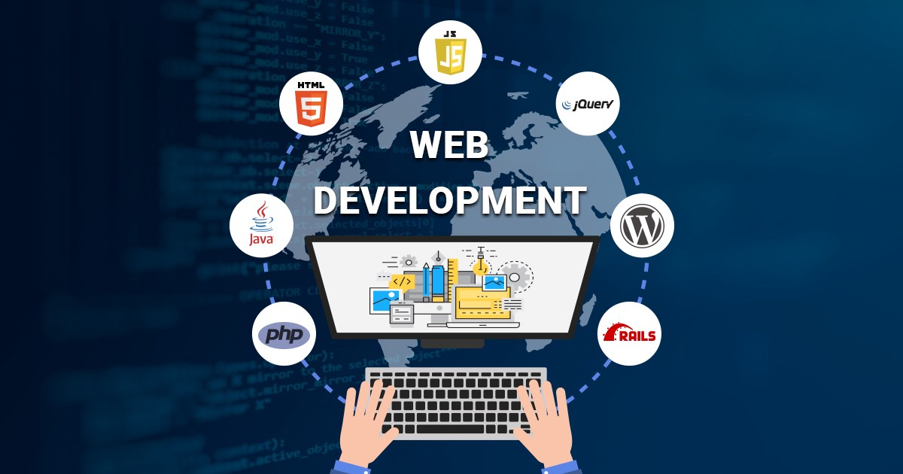

**Categories of Web Development:**

We have three main categories of web development, which are front-end development, back-end development and full-stack development.

### 2.2.1 Front-end development

Front-end web development, also known as client-side development is the practice of producing HTML, CSS and JavaScript for a website or Web Application so that a user can see and interact with them directly. The challenge associated with front end development is that the tools and techniques used to create the front end of a website change constantly and so the developer needs to constantly be aware of how the field is developing.

The objective of designing a site is to ensure that when the users open up the site they see the information in a format that is easy to read and relevant. This is further complicated by the fact that users now use a large variety of devices with varying screen sizes and resolutions thus forcing the designer to take into consideration these aspects when designing the site.

**Front-end development Tools and Software**

Front-end development is one of the most important aspects of creating user-friendly applications for mobile and web applications.

**Advantages of frontend programming**

The advantages of frontend programming include:

1. **Quick Development**

The main advantage of front-end programming is that it can be performed faster. The cutting-edge technological advancements and frameworks available for front-end development make tasks faster. As a result, creating the final product takes a lot less time. Creating a front-end for an application that already has a ready and robust backend is a fast and easy proposition. As a result, developing fully functional front-ends is rarely a challenge for experienced developers.

1. **Secure Environment**

Front-end development is also beneficial because all front-end frameworks offer a highly secure environment for coding. It is particularly advantageous for users as they can preserve code and websites across multiple browsers.

1. **Fast Response**

The new framework technology used by developers to lets them easily create fast response features that facilitate the efficient reaction, response, and functioning of applications.

Top 10 Front End Programming Languages are:

1. HTML
2. CSS
3. JAVASCRIPT
4. React
5. VUE
6. Typescript
7. Elm
8. JQuery
9. Angular
10. Swift

For my SIWES I learnt more about:

#### 2.2.1.1 HTML

HTML, an abbreviation of Hypertext Markup Language, is a programming language for creating electronic documents referred to as pages featured across the web. Every page has multiple connections to hyperlinks or links to other pages.

All web pages across the Internet have been crafted by the use of some form of HTML. It is an essential requirement for browsers to learn how to display texts or perform the loading of different elements.

The following are some of the HTML tags and their respective description.

|  |  |
| --- | --- |
| **Tag** | **Description** |
| <!DOCTYPE…> | This tag represents the document type, and helps browsers to display web pages correctly. |
| <html> | This tag encloses the complete HTML document and mainly comprises of document header which is represented by <head>…</head> and document body which is represented by <body>…</body> tags. |
| <body> | This tag represent the document’s body which keeps other HTML tags like <h1>, <div>, <p> , <table> etc. |
| <h1> | This tag represents a heading. |
| <p> | This tag represents a paragraph. |
| <b>, <i>, <u> | Bold, italic, underline. |

#### 2.2.1.2 CSS (Cascading Style Sheet)

CSS is a programming language used for styling how documents are offered to users in terms of layout and style. A document generally refers to a text file structure utilizing a markup language such as the widely used HTML and others such as XML or SVG.

CSS is used for converting a document to a usable form for audiences. This is particularly significant for browsers such as Chrome, Firefox, and Edge built to deliver documents onto screens, printers, and projectors visually.

**Types of CSS:**

1. 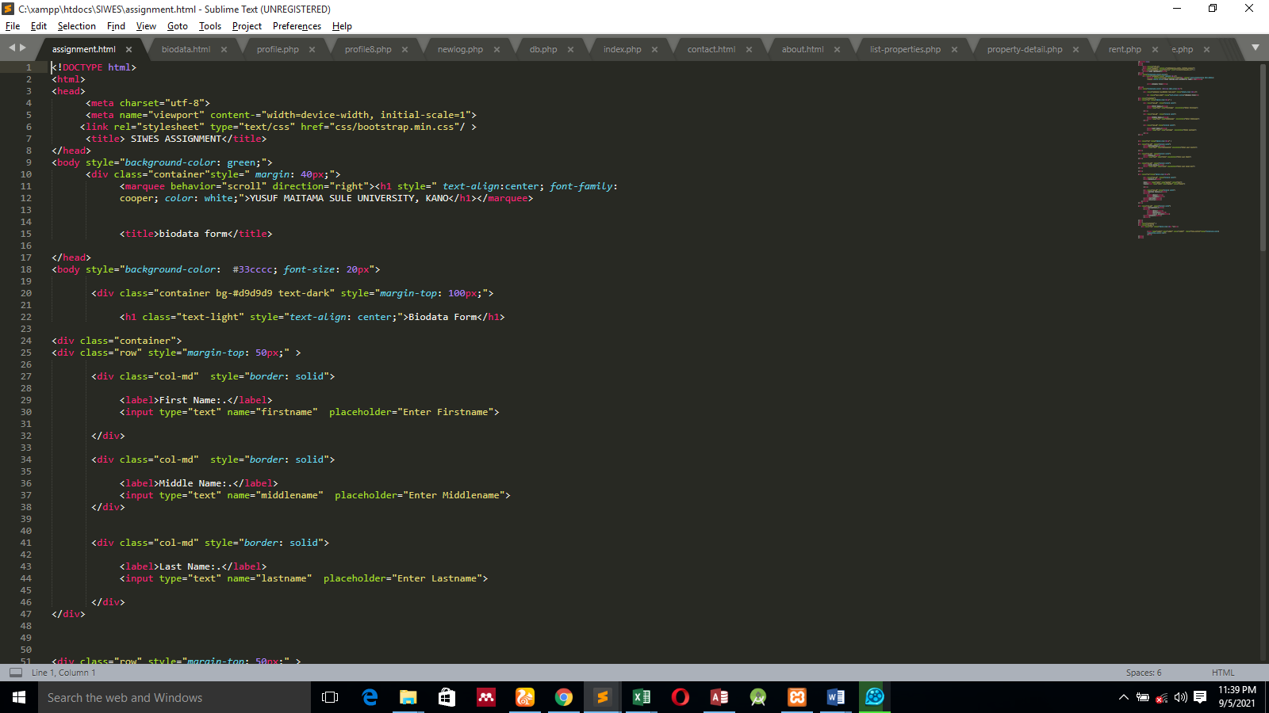**Inline CSS:** It is used to apply a unique style to a single HTML element. An inline CSS uses the style attribute of an HTML element. Here is the generic syntax:

**Figure 6.2 CSS Codes**

1. 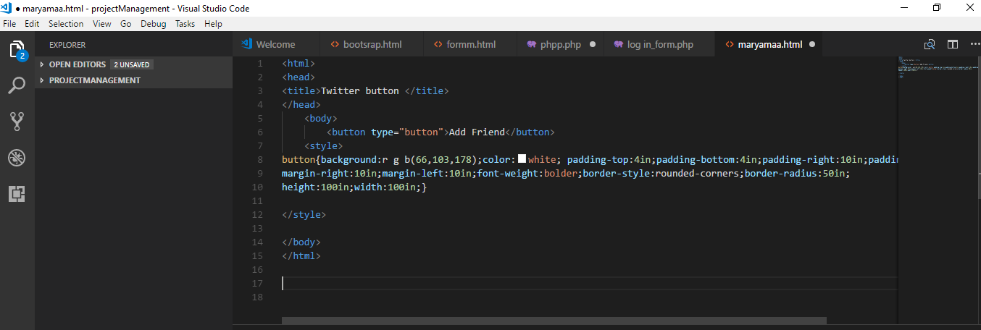**INTERNAL CSS:** It is used if one page has a unique style. Internal styles are defined within the <style> element, inside the <head> section of an HTML page. Generic syntax:

External CSS:An external style sheet is a separate text file with .**css** extension. You define all the style rules within this text file and then you can include this file in any HTML document using <link> element. Here is the generic syntax of including external CSS file:

**Figure 6.3 Internal Stylesheet**

**CSS Selectors:**

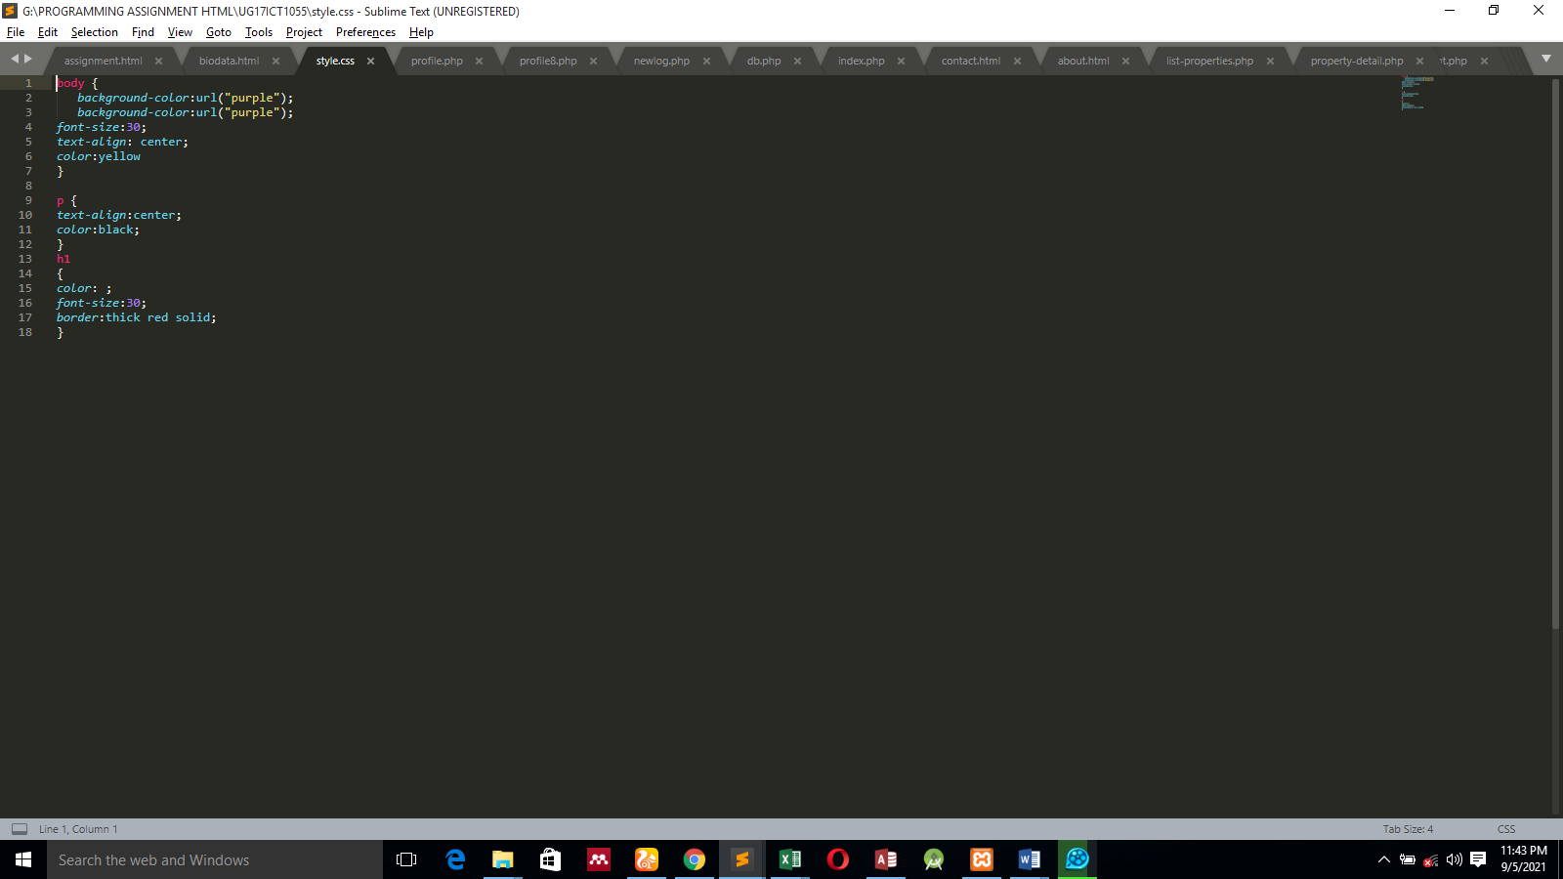CSS Selectors are used to find or select HTML elements based on their element name, id or class.

**Figure 6.4 External CSS**

1. Element Selector:Theelement selector selects elements based on the element name.
2. Id Selector: The id selector uses the id attribute of an HTML element to select a specific element. The id of an element should be unique within a page, so the id selector is used to select one unique element. e.g., id= “hello” #hello {color; red;}
3. Class Selector: The class selector selects element with specific class attribute. To select elements with a specific class, write a period (.) character followed by the name of the class. e. g center {text-align: center;}

#### 2.2.1.3 BOOTSTRAP

Bootstrap is the most popular HTML, CSS and JavaScript framework for developing responsive, mobile-first websites. It is a front-end framework for faster and easier web development. It also gives you the ability to easily create responsive designs.

Ways of using bootstrap:

* Downloading its files from getbootstrap.com
* Including the files from Content Delivery Network (CDN)

**Some of our examples during bootstrap class**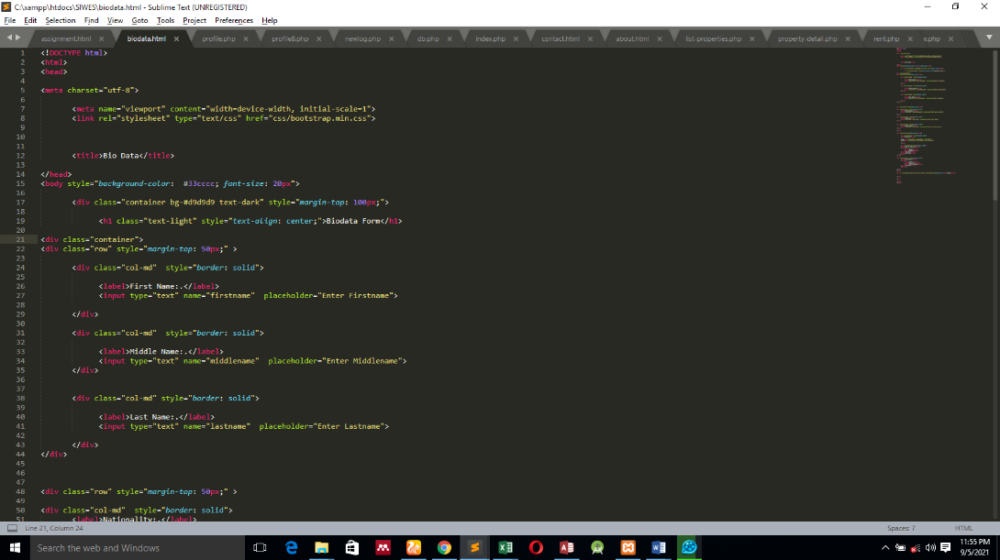

**Figure 6.5 bootstrap**

**Front-end Development Software’s**

1. Sublime text: A first-rate code editor – one that features a well-designed, super-efficient, and ultra-speedy user interface. There are several that do this well, but arguably the best (and most popular) is Sublime Text.

Artfully run by a one-man development team, the secret to Sublime’s success lies in the program’s vast array of keyboard shortcuts – such as the ability to perform simultaneous editing (making the same interactive changes to multiple selected areas) as well as quick navigation to files, symbols, and lines. And when you’re spending 8+ hours with your editor each day, those precious few seconds saved for each process really add up.

1. Chrome Developer Tools: Chrome and Safari, they allow developers access into the internals of their web application. On top of this, a palette of network tools can help optimize your loading flows, while a timeline gives you a deeper understanding of what the browser is doing at any given moment.
2. Visual Studio Code: Visual Studio Code is a **source-code editor** made by Microsoft for Windows, Linux and MacOS. Features include support for debugging, syntax highlighting, intelligent code completion, snippets, code refactoring, and embedded Git.

### 2.2.2 Back-end development

Backend Development is also known as server-side development. It is everything that the users don’t see and contains behind-the-scenes activities that occur when performing any action on a website. It focuses primarily on databases, backend logic, APIs, and Servers.

#### 2.2.2.1 PHP

PHP, an acronym for Hypertext Preprocessor, is a server-side scripting language and is one of the most widely used programming languages for backend web development. We can validate this statement by letting you know that platforms like Wikipedia, Word Press, Facebook, and many others are relying on PHP. This particular language is preferred for web development because of various prominent reasons such as cross-platform compatibility, OOPs features, easy integration with HTML, CSS, JavaScript, etc., huge community support, better flexibility & security, and many more. In addition, the language is quite easy to learn and use.

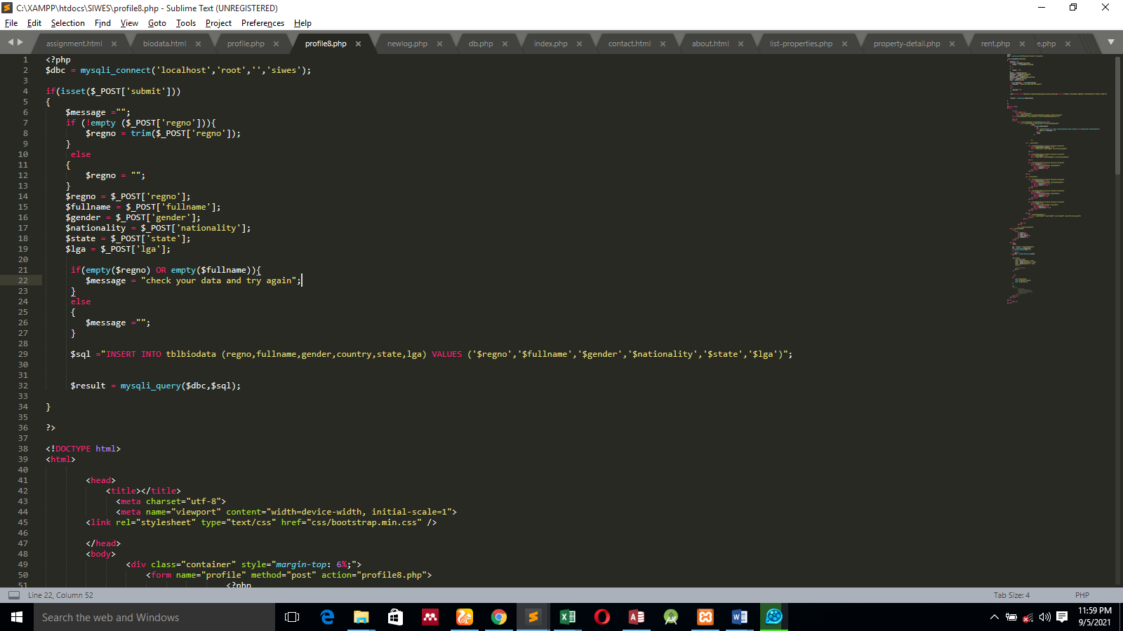**Figure 6.6 PHP**

#### 2.2.2.2 MySQL

MySQL is another open-source relational database management system that is widely used for web-based applications. It is a fast and high-performance database that provides better scalability, usability, and reliability. Also, MySQL provides cross-platform compatibility, strong indexing support, SSL support for secured connections, powerful data encryption and accuracy, built-in replication support, and various other features. Meanwhile, MySQL can work on various distinct operating systems and is compatible with many popular languages like PHP, Java, etc. Let us tell you this as well that this particular framework, MySQL, is used by various renowned websites like Flickr, Twitter, Facebook, Drupal, Joomla, and many others.

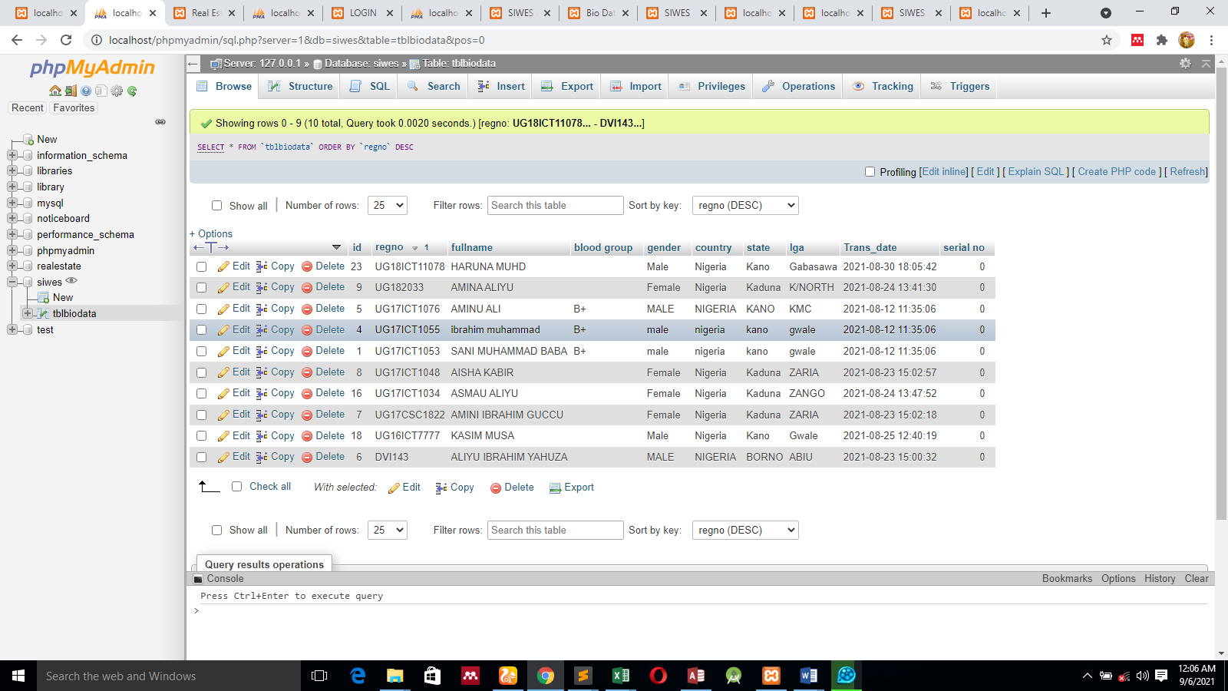**Figure 2.7 Mysql Database**

## 2.3 Application of experience acquired

**FCIT Online Examinations**

### 2.3.1 INTRODUCTION

**Online examination** is the process of taking (write) examination from a website. The examination can be done anywhere in the world. The aim of developing Online exam system project is to replace the traditional way of taking exams with computerized system. Another important reason for developing this project is to prepare and take exams quickly and in correct format at any point of time when required. Online exams System has a very lot of scope. This PHP project can be used by any admins and students for keeping their exams records. This project is easy, fast and accurate. It requires less disk space. Online Exams System uses MYSQL Server as backend so there is not any chance of data loss or data security. A students can choose different courses (subject) to be taking. The process consists of a student choosing the subject that he or she to be write, searching tag is also provided for quick accessing the website, choosing an exam, and finally ready to start the exam. The website and app inform and showing the students the accurate and reliable result, duration of each question is showing preparation, when you finished your score will appear in your dashboard and you can check your level of answered by checking rank position.

### 2.3.2 SYSTEM ANALYSIS

**Existing System**

Since the traditional has many ways has many drawbacks such as time consuming. Difficulty analyzing test manually. More observers are required to take exams of many students, result is not accurate since calculations is done manually. The chance of losing exam’s result is higher in current system.

**Problems of existing system**

Considering the above section, there are many problems associated with the existing manual system, they include the following:

* Duplication in records of the students.
* There is a problem of storage data storage.
* Information retrieval from these sources is not easy
* It is difficult to reach a wide range of people using the manual system

### 2.3.3 THE PROPOSED SYSTEM

Online examination system saves exams information in a database. Lectures can add/delete questions set correct answers, specify exam period, student can register and take exams everywhere around the globe. With the development of **information Technology** and use it in an orderly and properly helps to overcome the existing.

**Requirements Analysis**

**User Requirements**

It is very important to get users of the system fully involved such that the problem of change management does not arise. The system is expected to be:

* Easy to learn and use
* Improve on the efficiency of information storage and retrieval
* Produce results faster i.e., measurements submission or checking clothe status, therefore reducing on time wasted during TO and FRO travelling.
* Provides attractive interfaces with easy navigation throughout the system
* Faster, flexible and convenient.
* A system that stores data and produces reports timely and accurately

**Functional Requirements**

Functional requirements capture the intended behavior of the system. This behavior may be expressed as services, tasks or functions the system is required to perform. Therefore, the proposed system is able to:

* Capture customer information, store it and make it available at the time of need.
* Present the users with a real-time display on the garment’s status.
* Display all available styles.
* Search and display customer information details
* Computes the total cost of a garment depending on the selected fabric, type of material, quantity and duration and avails that information to the customer.
* It provides a job opportunity for professionals.
* It provides a platform for leaners (Novice) to register without going to the shop.

**Non-functional Requirements**

Non-functional requirements are requirements which specify criteria that can be used to judge the operation of a system, rather than specific behaviors. This is contrasted with functional requirements that specify specific behavior or functions. Systems must exhibit software quality attributes, such as accuracy, performance, cost, security and modifiability plus usability, i.e., easy to use for the intended users. NFRs help to achieve the functional requirement of a system. Thus, the proposed system does the following:

* The system has high performance and reliability level. The mean time between failures, mean time to repair, and accuracy are very high.
* The system has user-friendly interfaces. This ensures the ease with which the system can be learned or used. The system can allow users to install and operate it with little or no training.
* Handles growing amounts of work in a graceful manner as can be readily enlarged i.e., the ease, with which the system can be modified to handle a large increase in users, workload or transactions.
* The system prevents unauthorized access to the system with user authentication via login- on system.

**Use Case Diagram**

A use case diagram shows the interaction between the system and its environment. The components of a use case diagram are:

* Actors: Represent external entities of the system i.e. People who interact with the system that is being modeled. For example, customers and system administrator will be the actors of the proposed system.
* Use Cases: Use cases are functional parts of the system. Examples are recording and submitting measurements.
* Associations: Associations are shown between actors and use cases, by drawing a solid line between them. This only represents that and actor uses the use case.

Log in

Sign Up

Take course

Take exams

View results

Update records

Response

Administrator

Student

**Figure: 2.8 System use-case**

### 2.3.4 SYSTEM DESIGN

**Introduction**

This involves transforming the software requirements into an architecture that describes its top- level structure and identifies the software components and developing a detailed design for each software components. For each requirement, a set of one or more design elements will be produced.

A model is a representation of reality and can be built for existing systems as a way to better understand those systems or proposed systems as a way to document business requirements or technical design.

**Data modeling**

This is a technique for organizing and documenting a system’s data.

**Conceptual Design**

Conceptual design is the very first phase of design, in which drawings or solid models are the dominant tools and products. The conceptual design phase provides a description of the proposed system in terms of set of integrated ideas and concepts about what it should do, behave and look like, that will be understandable by the users in the manner intended.

Registers

User

Clients

System

**Figure 2.9 Diagram of a Conceptual Design of the system**

### 2.3.5 SYSTEM IMPLEMENTATION (CODING AND TESTING)

**Introduction**

It is the processes of putting the proposed system in operation. Some of the Activities undertaken by the analyst are Training personnel who will use the system. There is also provision of user manual and help page for efficient use of the system. Next is to install Computer Equipment and internet to help them connect with their clients in the globe. This will facilitate the full functionality of this proposed system. Equipment should be acquired from recognized vendor. These include central processing unit (CPU), Ethernet cables, routers, output and input devices e.g., keyboard, mouse, monitor and all secondary storage devices. The hardware and software vendors have major responsibility for installing this equipment. The analyst then determines the functional changes. E.g., may analyze the job function changes caused by the computerized system.

**Coding**

Coding is the construction of the actual system using specific language. For this proposed system, I have used PHP to actualize the system. It is a scripting language, more secure and web based.

**Application and Database Connection**

The constructed system is connected to the MySQL Database through a data environment. The tables should be created and normalized. The data should also be validated. A connection should also be set and established in the design of the respective forms.

### 2.3.6 Testing

Testing is the process of verifying and validating the system with specification and meeting the customer’s requirements. The objectives of testing are to ensure that the system programs are error free, guarantee the system end users can interact with the system well and ensure that the components of the system interface are working well.

**Functional Testing**

The purpose of functional testing is to ensure that the program performs all the functions that were originally specified, that all the input is correctly accepted. It relates to the whole system and does not require a technical understanding of the system. All the functions of the system as originally specified are systematically tested to ensure that nothing has been accidentally omitted or misinterpreted. A positive attempt is made to anticipate errors than an inexperienced user might make, and tests made to check the effect of such errors and ensure that they do not result in incorrect actions or bad data being stored in the database.

**System Testing**

This is where the system is checked whether it has met the user requirements and performs as per expectations. The following are the tests to be used. On completion of the whole system, each of it is tested to ensure no errors have been introduced. The system is tested with a realistic amount of test data; although the researcher is not expected to spend days typing in hundreds of records, the system should be tested with about 50 records in each of the main tables.

**Recovery Testing**

Recovery testing can be carried out to determine what happens, for example if there is a power failure in the middle of data entry.

**Acceptance Testing**

The user is invited to test the system to ensure that it fulfills the stated objectives. If possible, the researcher should observe this testing and not stop the user from mistakes. The system should cope with unexpected user behavior.

**User Acceptance Testing**

This is testing of the system by the user department after the system has passed the systems test

**Unit Testing**

After the parts of the system are completed, they are first tested. All the new hardware, procedural manuals and all system interfaces must be tested to ensure that they meet the required standards.

**Test Data**

The purpose of test data is to verify and make sure that the system is operating well and according to the standards set. It involves checking the new system if it is working correctly. It is tested in modules to establish if there is any problem in any module. This is whereby each module is tested on its own. While testing entries should be inputted as they are so as to be acceptable in the database else errors will occur. As an example, if customer’s name should be in text so the field should not accept number.

**File Conversion**

The analyst changes the existing files into a form where it can be used by the new system. The procedure is as follows; the analyst first records the file data then Transcribe the documents to suitable media and Verifies data to ensure it is error free.

**Control**

Control measures to be put in place for the system is; Password where the user is required to enter his/her password to log in. It is only to authorize users. The antivirus software should be used to clean up the viruses harmful to the application. Physical security such as keeping the system in a safe room- Ensure that there are firm windows and Doors and guarding the place.

### 2.3.7 System interfaces



**Figure 2.10 home page**

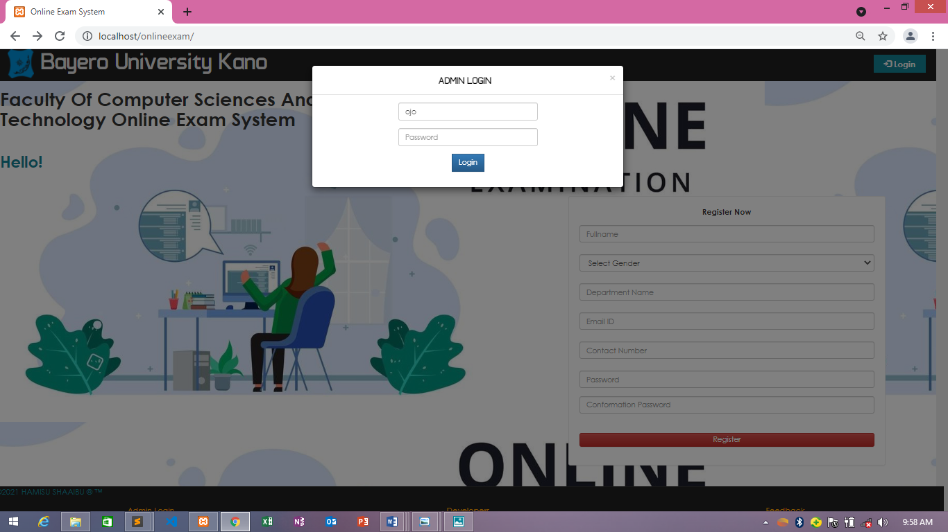**Figure 2.11 admin Login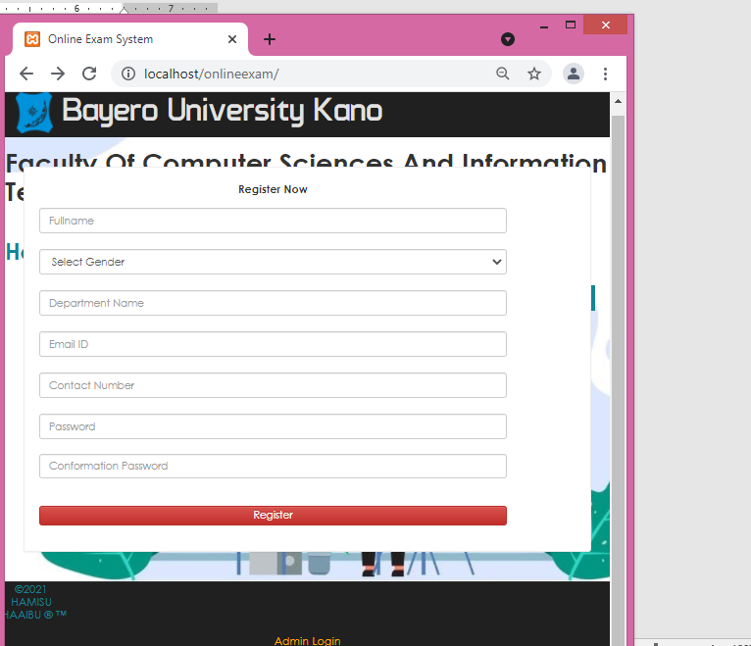 Figure 2.12 User Sign Up page**

### 2.3.8 Database Structure

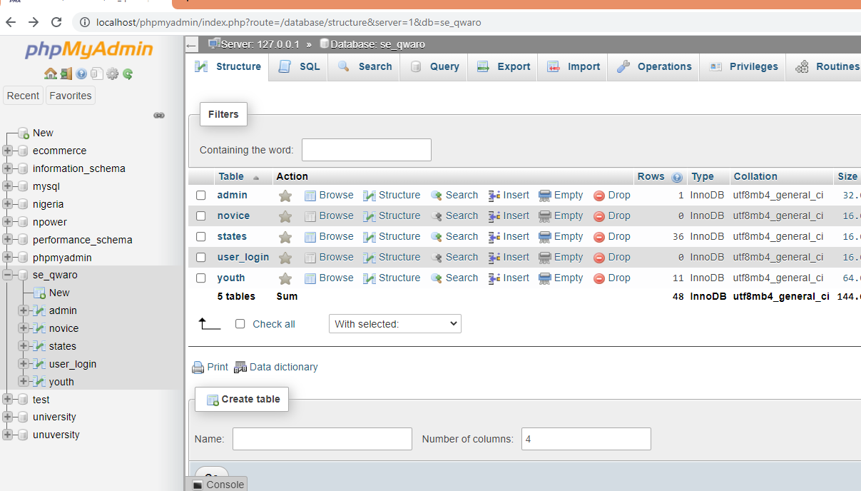

**Figure 2.13 Database structure**

# CHAPTER THREE

**SUMMARY, CONCLUSION AND RECOMMENDATION**

## 3.1 Summary

In this report, I have explained the experience and listed the knowledge acquired during my Six-month SIWES Programme at Centre for Information Technology, starting with the first chapter which contains the foundation of SIWES programme; why it is needed and its objectives, the organizations and bodies involved with SIWES such as the ITF, the history of place of attachment; their goals, services and management structure.

The second chapter was basically about the experience gained during the course of my SIWES in Blue Sapphire Hub**.** I was assigned variety of jobs or tasks, these tasks include computer Networking, Computer maintenance, software installation, network troubleshooting and developing an online exam management system.

## 3.2 Conclusion

The Industrial training program have exposed me to how really the world of works. I have learnt a lot from the staffs of the Blue Sapphire Hub. It has been an honor and an opportunity working in the Centre. In the twenty-six weeks of working there, the Centre has taught me many things I never knew before. This new knowledge and experience that I had gained will significantly help me and give me a competitive advantage in my future endeavors.

Moreover, I have gained new knowledge and practical experience all of which could not have been taught in the classroom. I have also improved my communication skills, where I have confidence to communicate with the peoples more effectively, and have been able to voice out my opinions and suggestions clearly.

## 3.3 Recommendations

1. For subsequent trainees I recommended Blue Sapphire Hub attachment.
2. The University should help list out relevant places of attachment for students, so that student will not go for the wrong place or organization that is not relevant to their field of study.
3. The school and the coordinator of SIWES scheme could assist students in securing IT placement, because so many students find it difficult to secure placement on time.
4. The fund should be given immediately before the program starts in order to help student secure transportation fairs and to jet more courage to students.
5. The places of attachment should be strict in maintaining the punctuality and attendance of students.

# REFERENCES

* Ebenezer, A. (2019). A TECHNICAL REPORT ON STUDENT INDUSTRIAL WORK EXPERIENCE SCHEME (SIWES) HELD AT INFORMATION TECHNOLOGY AND COMMU ...
* Jimoh, A. (2010). Industrial Training Report.
* Ebenezer, A. (2019). A TECHNICAL REPORT ON STUDENT INDUSTRIAL WORK EXPERIENCE SCHEME (SIWES) HELD AT INFORMATION TECHNOLOGY AND COMMU ...
* Jimoh, A. (2010). Industrial Training Report.