**This is the details description for assignmen3 because there are too many functions. To avoid lacking any function, I write everything here.**

**There are two kinds of input in my system, one is for audio, another is for image, and four dynamic effects**

**Please open assignment3 first**

1. In main page

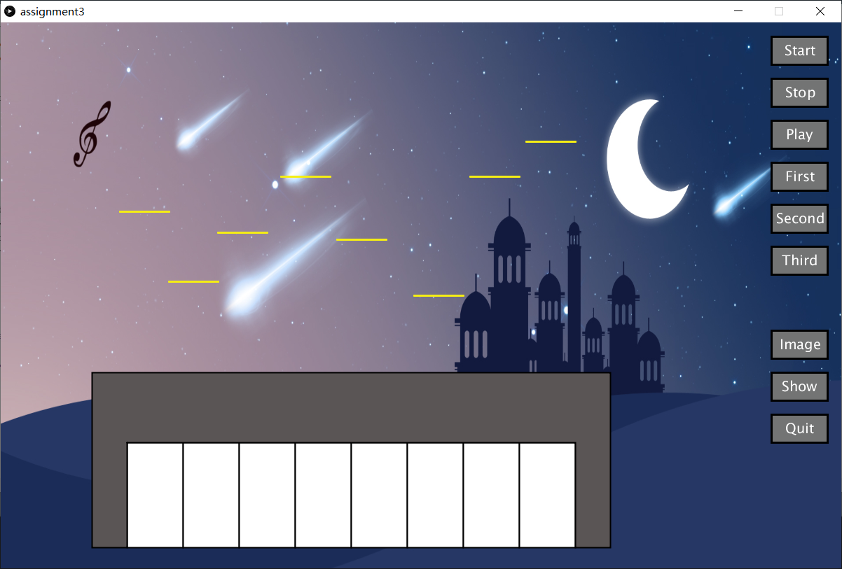

* 1. when press 1-8 in keyboard, there will come out the sound of each key music of which key you pressed
  2. Also, when pressing 1-8, the musical notes will present above
  3. Also, when pressing 1-8, the pitch will present above (do,re,mi,fa…)
  4. When click “Start” button, the system will start to record
  5. When click “Stop” button, the system will stop recording
  6. When click “Play” button, the system will play what you have recorded, and save the file name “myrecording”
  7. When click “First” button, the system will go to first function (Press R to return)

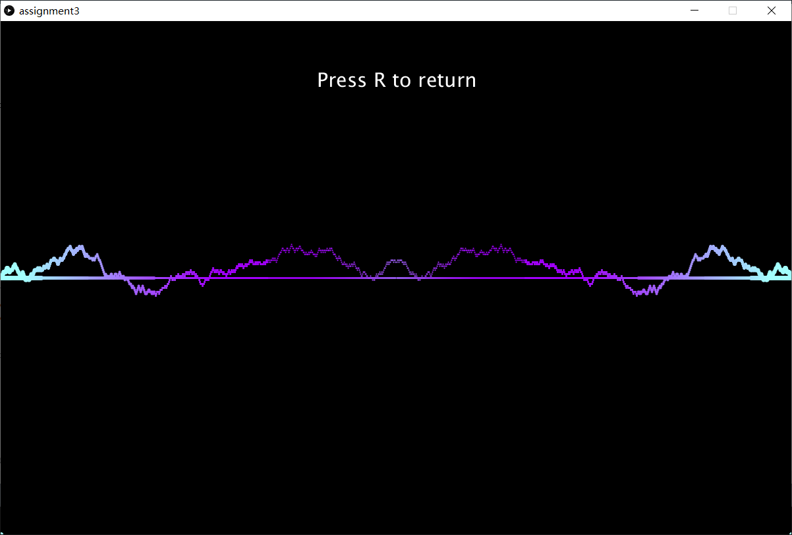

* 1. When click “Second” button, the system will open “file1” to start the second function (Press R to return)
  2. When click “Third” button, the system will open “file2” to start the third function (Press R to return)
* Why I choose to open other sketches (button “Second” “Third”)? Because the Beads is conflict with Minim, and it is impossible to fix, so create two more sketches.

So, when you use button “Second” “Third”, please change the url in line

811 and 819

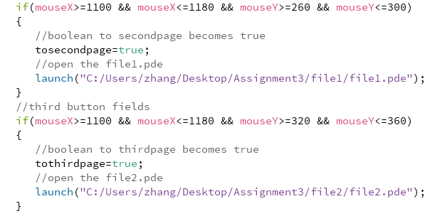

* 1. When click “Image” button, the user can input to create his own staff (Press R to return), and save the image file name “MyImage”
  2. When click “show” button, the user can view the staff he created (Press R to return)
  3. When click “Quit”, the user can quit the system.

1. In creating staff page (after pressing “image” button)

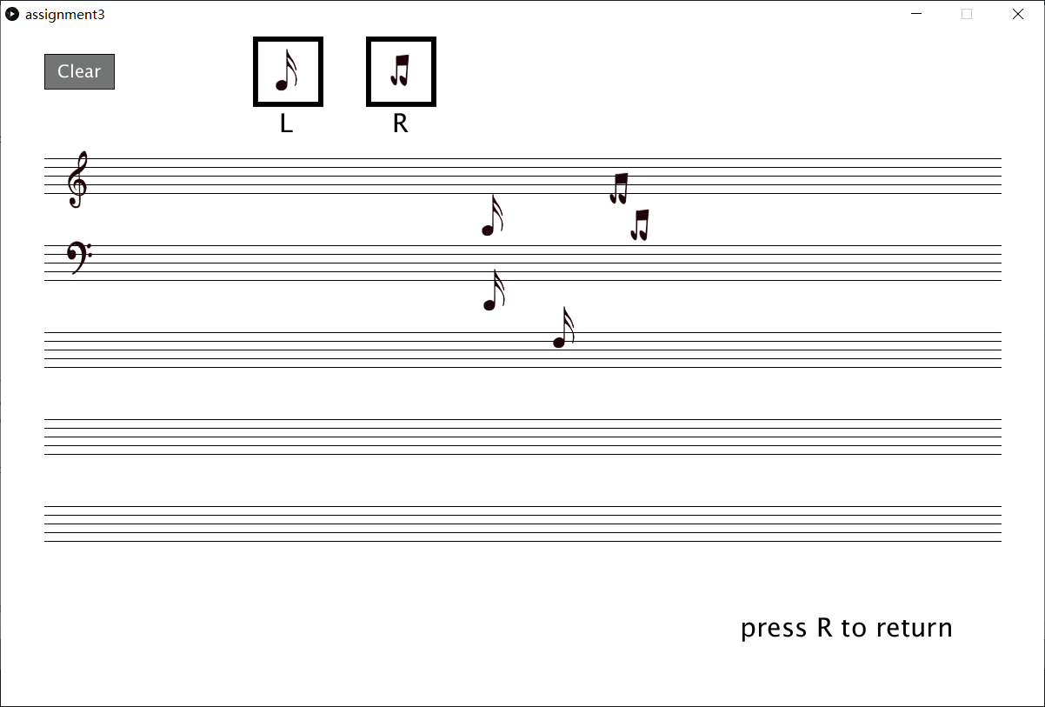

* 1. Click left mouse to draw the left musical note
  2. Click right mouse to draw the right musical note
  3. Click “Clear” Button to clear you drawing

1. In viewing staff page (after pressing “Show” button)
   1. Press ‘v’ or ‘V’ for vague effect
   2. Press ‘v’ or ‘V’ for changing colour effect
2. In second function (after pressing “Second” button to “file1” sketch)
   1. After running it, select the audio file which is the audio just recorded

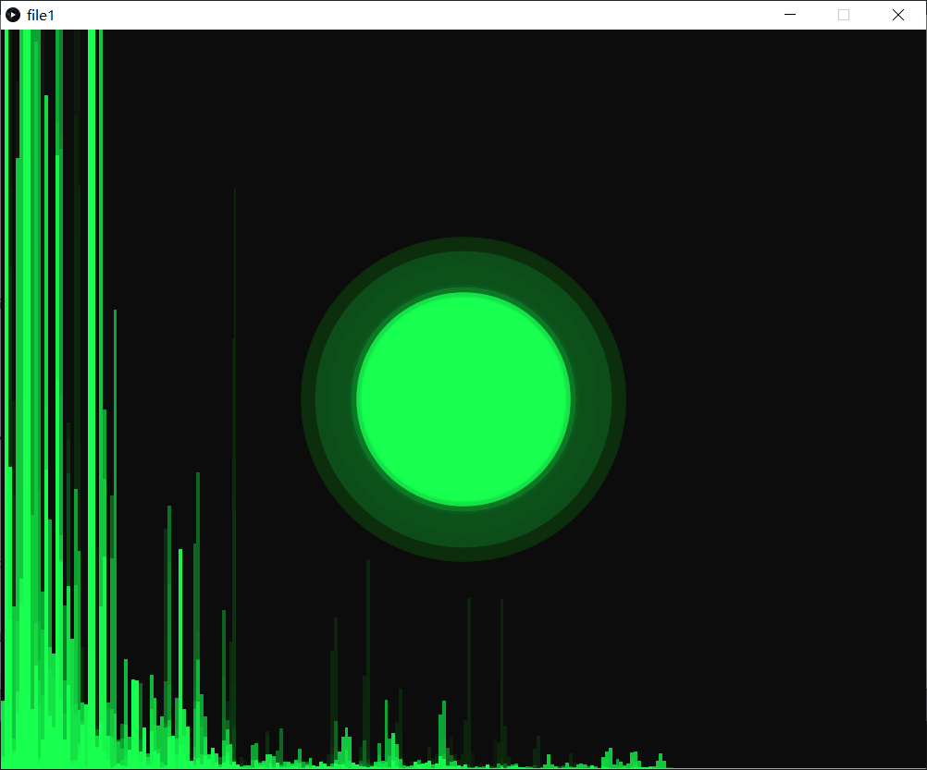

1. In third function (after pressing “Third” button to “file2” sketch)

