In the proposal, GUI was showed as matlab format, which was not in C++ language. In this week 1 update, Graphical User Interface (GUI) was designed and implemented by using Qt software.

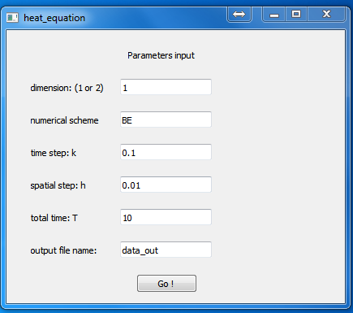

Figure GUI by Qt software

In this part, user can specify the dimension of the problem, numerical scheme, step sizes of time space, total time and the name of output data file. Upon clicking the button ‘Go’, the input data would be sent into variables defined in C++ environment. Then the variables can be used in the main function to solve the heat equation.