Three 1D algorithms were implemented during the past week. They were Euler algorithm, Crank-Nicolson algorithm, and Dufort-Frankel algorithm. The numerical scheme for each algorithm was summed up as follows:

Euler: 

Crank-Nicolson: 

Dufort-Frankel: 

Four basic 1D numerical algorithms have been implemented so far. All ingredients are ready for the convergence, stability and accuracy test. Among them, Backward Euler and Crank-Nicolson are implicit methods, Euler and Dufort-Frankel are explicit methods. Implicit methods are unconditionally stable, while explicit methods must have the parameter  within a certain range to ensure the stability. Computational results could be used to demonstrate the theoretical properties on convergence, stability and accuracy of each algorithm.

Future work on algorithm includes add convergence, stability and accuracy module for the four numerical algorithm and implement 1D finite element discretization on space, which will conclude the one dimensional work.

|  |  |
| --- | --- |
| Major tasks accomplished | Description |
| whole project | finish all four basic 1D numerical algorithm. Using Qt instead of MATLAB for GUI design. Set up visualization module. Set up ccv git repository. |
| Zhi Li | 1D numerical algorithm |
| Helena Liu | set up ccv git. Visualization module |
| Yunxing SU | Qt design for one dimensional problem |

|  |  |
| --- | --- |
| Tasks scheduled for next week | Description |
| whole project | finalize 1D problem. Finish certain 2D numerical algorithms |
| Zhi Li | 1D finite space discretization. 1D convergence, stability, accuracy module. |
| Helena Liu | Basic 2D numerical algorithm (Euler, Backward Euler, Crank-Nicolson). 2D visualization module |
| Yunxing Su | finalize 1D input, output, test module. 2D input, output module |

In the proposal, GUI was showed as matlab format, which was not in C++ language and not convenient for coding in c++ format with all the libraries and solvers. In this week 1 update, Graphical User Interface (GUI) was designed and implemented by using Qt software.

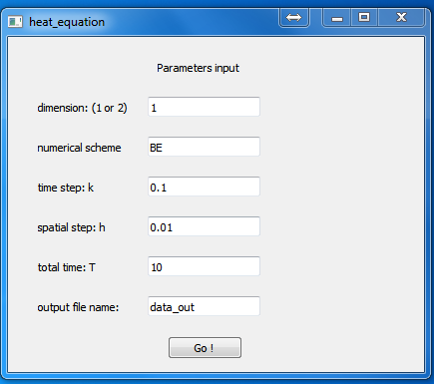

Figure GUI by Qt software

In this part, user can specify the dimension of the problem, numerical scheme, step sizes of both time and space, total time T and the name of output data file. Upon clicking the button ‘Go’, the input data will be sent into variables defined in C++ environment. Then the variables can be used in the main function to solve the heat equation.