Evolving a Bayesian-Like Disperser: integrating genetically-coded information with personally-acquired local environmental information

Kamil A. Bartoń

María del Mar Delgado

Otso Ovaskainen

Justin M. J. Travis

Max: 250 words. **In today’s changing world, gaining information about the environment is crucial from both a behavioral and evolutionary perspective. Evidence is accumulating that organisms condition their dispersal strategy on informative cues from the environment. Yet, evolutionary ecologists interested in the theory of dispersal evolution have not considered consistent concepts of information value, let alone applied explicit frameworks to generate hypotheses about adaptive informed dispersal behavior. Therefore, how individuals acquire and use information in order to make more adaptive dispersal decisions is still largely an open question. This question is essential for achieving progress in a variety of fields ranging from gene flow and speciation to the global persistence of species in the face of local extinction. Theory suggests that animals may use a combination of genetically – encoded (i.e. innate knowledge) and acquired information (i.e. obtained by organisms through experience) to guide their behavior. Importantly, it is expected that under some environmental conditions the information stored in the genes may be more useful than under other conditions, where the information an individual acquires itself is more useful. By formulating a Bayesian model, we take a keen interest in understanding (1) how much weight should an organism put on the sampling information as opposed to innate information to make optimal settlement decisions under different environmental characteristics, and (2) how well the evolution of these parameters works in terms of individual fitness or population abundance.[…]**

Keywords: ancestral information | informed dispersal | natural selection| prospecting |environmental change| statistical decision theory

**Significance Statement.** *Authors must submit a 120-word-maximum statement about the significance of their research paper written at a level understandable to an undergraduate-educated scientist outside their field of specialty. The primary goal of the Significance Statement is to explain the relevance of the work in broad context to a broad readership. The Significance Statement appears in the paper itself and is required for all research papers.*

**/body**

'I have never separated what I knew from my parents and what I discovered for myself in books, at school or somewhere else...Knowledge of my ancestors and knowledge of learned men are always together, always as a whole' (Galina Butyreva, member of the Union of Writers of the Russian Federation)

Information, recently defined as a ‘fitness enhancing resource’ (1), is key to organisms’ adaptive behavior (2); the better informed individual, the better it can develop and adjust its behavior to meet the demands of a variable world (2). Evidence is accumulating that individuals make adaptive use of information during dispersal, from departure to settlement (3, 4). Yet, theory on the evolution of dispersal has almost entirely been constructed either on the assumption that individuals have no knowledge of the possible destination patches to which they might recruit if they emigrate (i.e. blind or no information) or that they have perfect information about the environment (i.e. they are ‘omniscient’). Only recently few modeling studies have highlighted the need to integrate the acquisition and use of information as traits that may evolve across space and time as a function of the balance between costs and benefits of informed dispersal (5-7) in order to predict spatial dynamics of populations in a realistic manner (7, 8). However, most of these studies have used different assumptions about the type of information that an individual makes use of, and then analyzed how different information situations might influence the evolution of dispersal strategies.In reality, individuals need to update their perception of the biotic and abiotic environments to be able to compare different alternatives and thus benefit to increasing their likelihood of choosing the best-matching dispersal strategy(7).

It is reasonable to assume that organisms can encode information about the environment into their genome, so they are born with an innate desire for surviving and reproducing (refs). This ‘worldview’ of an organism, set by the environment experienced by its ancestors, may however restrict the flexibility with which the organism responds to local conditions. As the world is always changing, organisms should accordingly show plasticity and change strategies depending on the circumstances as part of their natural evolutionary inheritance. Therefore, organisms willing to implement an optimal dispersal strategy need to update its ancestral information through their own experience in order to respond in an adaptive way to different specific novel situations they may face (9). Theory suggests that a combination of innate and acquired information is often used by organisms to guide their behavior (10). Yet, to what extent and under which circumstances individuals use genetically-coded or personally-acquired information for dispersal decisions remains unclear.

Gaining a more sophisticated understanding of dispersal require special attention to biologically possible mechanisms for gathering information (11), which ultimately promises to improve our ability to predict and manage how species will respond to multiple environmental changes. One way, though not the only one, an organism might combine previous experience with sampling information is to follow standard Bayesian rules (refs). As Bayesian updating provides more accurate estimates of parameters than estimates based solely on sample information under most conditions (12), we should therefore expect to see “Bayesian-like”’ dispersers evolved in nature (10). Whilst there is abundant evidence that many behaviors from both vertebrates and invertebrates can be interpreted as Bayesian-like(13), these ideas have never explicitly been questioned into the theory on the evolution of dispersal. For example, if the environment is stable over time, individuals may use ‘prior opinions’ hardwired by natural selection in making dispersal decisions. However, this innate information may no longer be valid if the environment is new or highly dynamic (9), and then the optimal strategy should be to devote time to acquire and update the ecological information (i.e. prospecting; (14)) in order to make adaptive dispersal decisions. Despite the long-term benefits of acquiring information, it may entail costs at the individual level. These costs include energy and time to information gathering at the expense of other basic biological demands(1). Thus, there is a pressing need to develop a greater body of theory that considers how dispersal evolves when individuals use genetically-coded or acquired information, and additionally to ask how much weight an organism should put on the sampling information as opposed to innate information to make optimal dispersal decisions as a function of the spatio-temporal pattern of habitat variability.

Our first objective was to quantify explicitly how the combination of innate information and personally-acquired information influence the evolution of dispersal strategies. We used a Bayesian model where an individual is able to update its inherited rules based on its sampling of the environment and the rate at which it adapts its rule (based on the personally-acquired information) is controlled by a gene that itself evolve under different environmental characteristics. Importantly, we expect that under some environmental conditions the information stored in the genes may be more useful than under other conditions, where the information an individual acquires itself is more useful. Second, by looking at […], we address our attention to the individual and population consequences of the evolved informed dispersal strategies to examine how well the evolution of these parameters works in terms of individual fitness or population abundance. The use of information has been theoretically undertaken by applying Bayesian statistical decision-making theory (13). In particular, this fruitful approach has been extensively used to approximate an optimal foraging rule (2, 15). Here, by combining genetically-coded information in the form of a probability distribution with personally-acquired information to arrive at a ‘posterior dispersal decision’ concerning e.g. the quality of a given destination patch, we aim to take some initial steps to building up the Bayesian dispersal theory.

# Discussion

For more than two decades, the use of information has been theoretically undertaken by applying Bayesian statistical decision-making theory (13). This fruitful approach allows one to combine prior knowledge in the form of a probability distribution with current sample information to arrive at a ‘posterior opinion’ concerning e.g. the quality of a given food patch (2, 15).

# Methods

The individuals emigrate, move across the landscape, settle and reproduce. They follow a correlated random walk on a regular grid. Generations are discrete, individuals reproduce when all survivors (who escaped the movement mortality) have settled. The adults die before the next generation emerges.

Before the disperser starts moving in the landscape, its information about the landscape comes from three genes. These code for the mean landscape quality ($μ_{0}$), standard deviation of landscape quality ($σ_{0}^{2}$), and the (effective) number of data points by which these information are to be trusted ($k_{0}$). While moving in the landscape, the individual collects further information on the mean and variance of landscape quality. We denote the individuals phenotype (its assessment of mean and variance) after $n$ steps by $μ_{n}$ and $σ_{n}^{2}$. Before any own observations ($n=0$), the phenotype equals the genotype. In the $n:$ th step, the phenotype is updated by the formulae

$μ_{n}=\frac{k_{0}+n-1}{k_{0}+n}μ_{n-1}+\frac{1}{k_{0}+n}q_{n},$ Equation 1

$σ_{n}^{2}= \frac{\left[\left(k_{0}+n-1\right)σ_{n-1}^{2}+\frac{k_{0}+n-1}{k_{0}+n}{\left(q_{n}-μ_{n-1}\right)}^{2}\right]}{k_{0}+n}$, Equation 2

where $q_{n}$ is the new data point on landscape quality. These formulae are based on Bayesian updating rules for the mean and variance of a normally distributed variable (REF). As they relate to the posterior mean only, not the entire distribution, they ignore the fact that parameter uncertainty decreases as the sample size increases. In other words, we assume that the individual cares only about the best point estimates of these parameters, but not about certainty of those estimates.

The individual settles when the new patch it encountered meets the settlement criterion. The criterion is that the quality of the new patch has to be at least $α$ standard deviations higher than mean quality,

$q_{n+1}≥μ_{n}+ασ_{n}$ Equation 3

Here $α$ is the fourth inherited parameter.

**Reproduction and mutations**. Generations are non-overlapping and the individuals reproduce asexually. Traits (parameters *α, μ₀, σ2₀* and *k₀*) are inherited with a mutation, which is the value of each genetic parameter is changed by a random normal value Normal(*g*, *σg*), where *g* is the mother’s trait value, and *σg* is the trait-specific standard deviation. The resulting value of the parameter is kept within ranges specific for each parameter (*α*= [‑10, 10], *μ₀*= [‑10, 100]*, σ²₀* = [0, 100], and *k₀*= [0, 100])*. σg* is different for each trait (*σα=* 1, *σμ₀* = 5.0*, σσ²₀* = 5.0, and *σk₀*= 10.0).

**Patch quality $q$** is a function of the carrying capacity and population size. While dispersing, the individual perceives quality of patch *i* as

$q_{i}=K_{i}-m,$ Equation 4

where $K_{i}$ is the cells carrying capacity, and $m$ is the number of other individuals present at that grid cell, settled or still moving. Quality of an empty patch is equal to its carrying capacity. Patch quality may change at every movement step, as the individuals move about.

The dispersal phase lasts until either all individuals settle, die (due to per-step mortality $p_{mort}=0.001$) or until they make a maximum of 1000 steps (whichever comes first). Only those individuals who settled take part in reproduction. Reproductive output of an individual is distributed as $Poisson \left({K_{i}}/m\right)$, where $m$ is the number of individuals settled in grid cell $i$. Parents die immediately after reproducing (non-overlapping generations).

**The landscape** is a regular, two-dimensional grid. Habitat quality is denoted by yi(t) for grid cell i for time step t. Grid cells’ carrying capacity K defined by a 3-dimensional Gaussian-blurred point pattern (see Figure2). The parameters β and γ are the characteristic spatial and temporal scales at which landscape variation occurs. Parameter β controls spatial blur (i.e. size) of the clusters while parameter γ controls ‘temporal blur’ or temporal spread of the clusters (i.e. how long the cluster persist).

Carrying capacity *K* of a cell *i* is calculated as:

$K_{i}=A\sum_{k=1}^{C}{\left(exp⁡\left(-\frac{{\left(x_{i}-x_{k}\right)}^{2}}{2β}-\frac{{\left(y_{i}-y_{k}\right)}^{2}}{2β}-\frac{{\left(t_{i}-t_{k}\right)}^{2}}{2γ}\right)\right)}$, Equation 5

where *A* is the carrying capacity of the cluster centre; *xi*, *yi* are spatial coordinates; *ti* is the ‘temporal coordinate’; xk, yk and tk are coordinates of a cluster centre k; and C is the number of clusters. Cluster centres are distributed (uniformly) randomly in the 3-dimensional space (i.e. space-time). In a landscape of size Sx ×Sy and over St time-steps, C is calculated as:

$C=Poisson\left(\frac{\overline{K}(S_{x}S_{y}S_{t})}{2Aπ\sqrt{2πβ^{2}γ}}\right)$, Equation 6

where K̄ is the mean landscape carrying capacity, which was held constant for a given set of simulations. Note that in the implementation, S includes a margin of 1β in the x and y dimensions, and 1γ in dimension t to avoid diminishing the cluster density close to the edges or beginning and end of simulation. The landscape had a reflecting boundary, if an individual was about to escape from the landscape area, it was redirected in a random direction.

## Simulations

Simulations were run for 4000 generations on dynamic landscapes with different characteristics. Landscapes consisted of 512×512 cells, each simulation was initialized with 8000 individuals with random combinations of genetic parameters (values within the allowed ranges described above). At the end of simulation, statistics (mean, range, 2.5%, 25%, 50% [median], 75% and 97.5% quantiles) of individual genetic parameters (*, , σ20* and *k0*), and derived phenotype: minimum accepted quality, Qmin both at the emigration time (prior, Qmin,0) and at settlement (posterior, Qmin,Z) (following Equation 3), trajectory length (number of steps made before settlement), straight line dispersal distance (between starting cell and settlement cell), as well as total population size, and actual patch quality (according to Equation 4) at the end of generation were recorded.

Four scenarios were investigated, with two temporal scales of the ‘bubbly’ landscape, and two movement types:

1. stable landscape (γ = 5.0) and volatile landscape (γ = 0.5, i.e. each cluster lasts about 3 generations)
2. more tortuous movement (ρ = 0.2) and more straight movement (ρ = 0.6).

Common parameters were the peak carrying capacity A = 7, average patch carrying capacity K = 0.25, and per-step mortality was set to very low M = 0.0001. In each scenario, simulations were run in a range of landscape spatial autocorrelation (i.e. cluster size, β) from 0.5 to 25 (20 values with logarithmic intervals, each value replicated 25 times).

?

## Results

What happens during the dispersal movement?

At the beginning of dispersal stage, individuals who inherited lowest Qmin,₀ settle as first. During dispersal, population mean of the accepted quality threshold Qmin,₀ increases as the individuals with highest Qmin,₀ travel largest distances, because it may take several steps to bring the posterior estimate Qmin,Z down to a level when settlement is possible. Therefore the difference of the inherited quality threshold to the available patch quality regulates how far the dispersers move. This, however can be achieved through interaction of all the four parameters. Figure 3 shows distribution of the parameters during dispersal stage.

### Evolutionary simulations

[Description below relates to the traits evolved in the scenarios described above.]

Patch quality. Between simulations, there was very little variation in actual mean quality of encountered patches (Q̄1:Z, mean = 0.3±0.075, range from *−*0.04 to 0.81), and Q̄1:Z does not match nor correlate with evolved μ₀ (Kendall’s τ = 0.13), or indeed appears to be negatively correlated when Q̄1:Z ≲ 0.2 (τ = *−*0.67). (see Working figure 4). Within simulation, Q̄1:Z was typically in range [0, 2] (see Figure 4).

Posterior Qmin was on average smaller than the prior inherited value (Qmin,Z*−*Qmin,0 = *−*0.58 ± 0.29 in volatile landscape, and 0.26 ± 0.29 in stable landscape). Mean values of posterior Qmin,Z nonlinearly related to prior Qmin,0, and the relationship differs strongly depending whether it was a stable or volatile landscape (Working figure 1).

Inter-correlations between evolved variables. The evolved μ₀ was positively correlated with k₀, negatively with σ₀. σ₀ is strongly negatively correlated with alpha, and less with k₀. α is weakly related to k₀. Qmin,₀ is positively related to μ₀ and σ₀, but negatively to α (*?!*). In the volatile landscape, travel length *Z* was correlating with Qmin,0. See Working figure 3.

#### ***Evolved variables along spatial autocorrelation gradient***

Dispersal distance. Obviously, the resulting dispersal distance (and travelled distance) was considerably higher in volatile environment, where individuals are forced to move away from their natal patch due to short-lasting clusters. As the average carrying capacity was set to very low (K̄=0.25), new clusters rarely emerged close to the diminishing ones. In stable landscapes (with long-lasting clusters) dispersal distance reached its peak by much lower spatial-autocorrelation *β* than in volatile landscapes (very short-lasting clusters). See also Working table 1.

Genetic parameters. The evolved μ₀ was lower than zero over most of the spatial autocorrelation gradient (mean μ₀ = −2.38 and−1.81, for volatile and stable landscapes, respectively), and increased with increasing cluster size. Negative quality represents over-populated patches.  
The evolved variance, σ₀ varied largely between simulations, but there is a clear increasing trend with increasing cluster size (Working figure 5). Together with increasing variance, the acceptance threshold α decreased (recall that α is strongly correlated with σ₀ (Pearson *rp* = −0.89 with log‑transformed σ₀).

Interestingly, in stable landscape k₀ is clearly negatively correlated with the threshold quality Qmin,0 (*rp* = −0.93 for k₀ < 10), this relationship was entirely different with volatile clusters (Working figure 6).

In volatile landscapes, mean k₀ was about 25 when clusters are small (*β*< 10) and increased with increasing *β* (mean k₀ = 50 by *β*< 10). On the other hand, in stable landscapes, k₀ increases slowly with increasing cluster size (from mean of 21 to 35), also its variance between simulations increases, reaching its peak value at *β* ≈ 10, above which k₀ drops abruptly. In both landscape types the relationship is very similar for both types of movement (Working figure 5).

Evolved resulting phenotype Qmin,0 was little variable, with 95% of cases falling in range [0.30, 1.75] in volatile, and [0.05, 2.59] in stable landscape. Mean of Qmin,0= 1.1 ± 2.9 in volatile, and 0.54 ± 2.4 in stable landscape. While the mean quality of encountered patches *Q̄1:Z*, did not show any marked trend (Working figure 5)., the resulting phenotype Qmin,0, increased with spatial autocorrelation *β*.

Acknowledgements. The work was financially supported by the Academy of Finland grants 250243 and 250444 (OO), and Kone Foundation grant 44-6977 (MD); the European Research Council, ERC Starting Grant 205905 (OO). Marie-Curie IEF Fellowship, grant PIEF-GA-2011-302546 (KB) and TenLamas.

Author Contributions:K.A.B., M.M.D, O.O. and J.M.J.T. conceived and discussed together the idea. K.A.B developed the model. All authors contributed in writingthe paper.

# Tables and Figures:

Working table 1. Summary statistics for distance travelled (i.e. number of steps, Z)

|  |  |  |  |  |  |  |
| --- | --- | --- | --- | --- | --- | --- |
| **ρ** | **landscape** | **Mean** | **Sd** | **median** | **min** | **Max** |
| *0.2* | *stable* | 68.9 | 22 | 65.4 | 24.4 | 122.5 |
| *0.6* | *stable* | 60.2 | 17.5 | 57.4 | 4.2 | 101.8 |
| *0.2* | *volatile* | 162.1 | 45.6 | 151.2 | 104.5 | 343.1 |
| *0.6* | *volatile* | 155.9 | 57.5 | 142.9 | 89.9 | 379.9 |

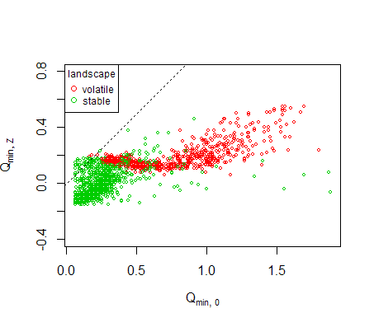

Working figure 1. Correlation of prior and posterior threshold quality *Qmin*. Dashed line shows the identity line.

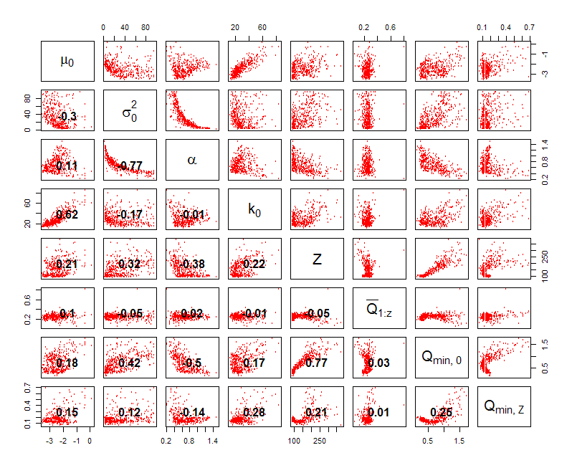

Working figure 2. Correlation between the resulting variables for volatile landscape. Values in the lower triangle panels show correlation coefficients τ. See caption to Working figure 3 for more details.

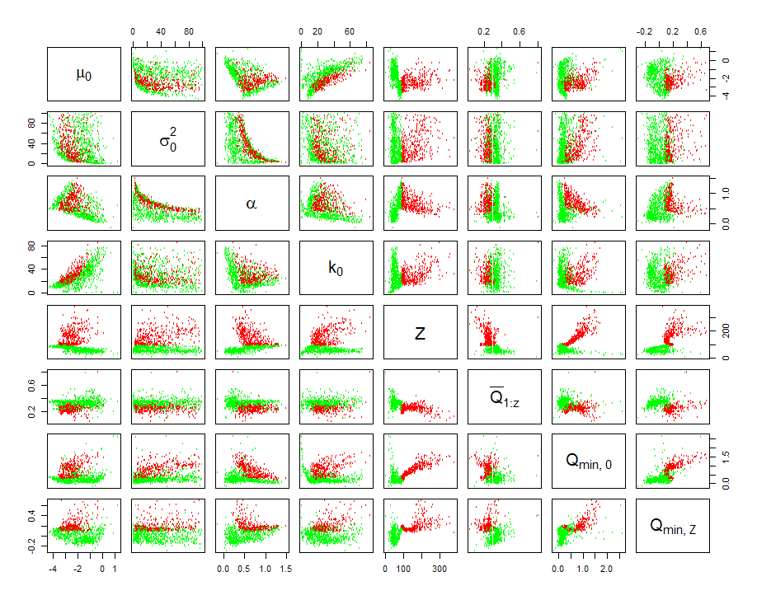

Working figure 3. Correlation between the resulting variables. Each point represents a value evolved in one simulation. Simulations were run over a range of landscape spatial autocorrelation (cluster scale, *β* ranging from 1 to 25). Green dots – stable landscape (temporal scale *γ* = 5.0) red dots - volatile landscape *γ* = 5.0). *μ0*, σ0,α0, and*k0*are the genetic parameters, Z is a number of steps individuals make before deciding to settle (dispersal path length), *Q̄1:Z* is a mean patch quality *Q* encountered en-route, *Qmin* is the patch quality acceptance threshold:*Qmin,0*–prior (inherited), *Qmin,Z*– posterior (after *Z* steps).  
Results for less (ρ = 0.6) and more tortuous (ρ = 0.2, not shown in this figure) tortuous movement are qualitatively very similar.

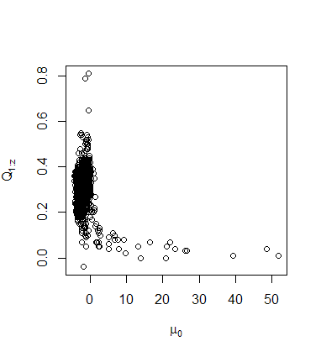

Working figure 4. Correlation between evolved μ₀ and actual patch quality (i.e. the mean quality Q̄1:Z of patches encountered during movement). Data from all scenarios pooled.

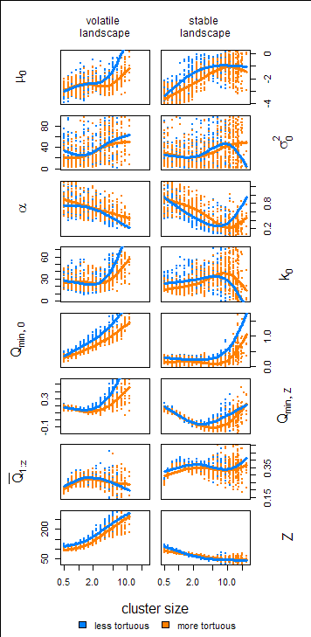

Working figure 5. Evolved traits along the spatial autocorrelation gradient in the four scenarios. Each point is mean value at the end of single simulation, lines are fitted by smoothing splines. In volatile landscape no populations persisted above cluster size of *β* = 10.

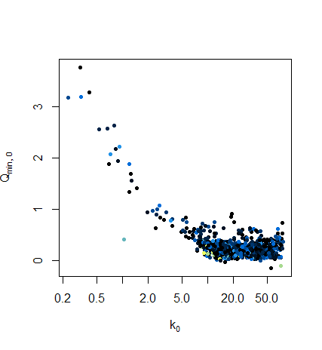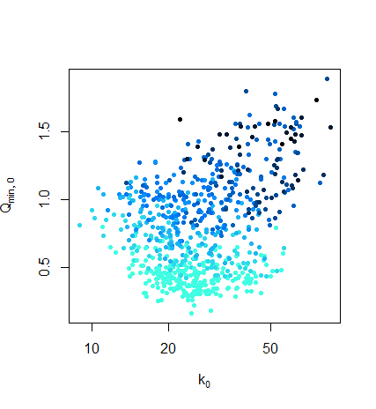

Working figure 6. Correlation between k₀ and *Qmin* in stable (left hand side) and volatile (right hand side) landscape (colour intensity represents cluster size: darker is for larger clusters). Each point is mean value at the end of single simulation.

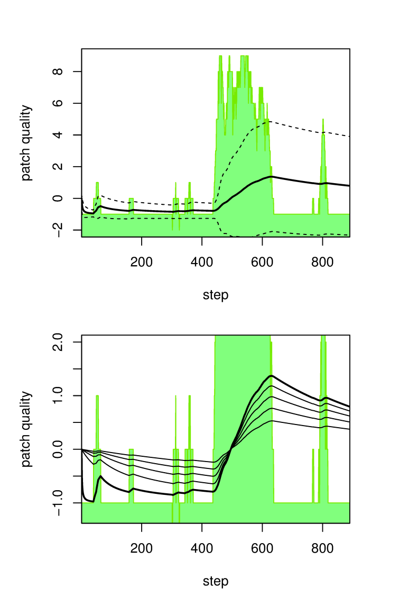

Figure 1. Example of Bayesian updating. Green area represents quality of encountered patches. Quality of −1.0 typically means uninhabitable ‘matrix’, i.e. patch of K=0.  
(upper panel) Updating with low *k0*: thick line is the mean quality *μ* at each step, dashed lines depict *μ±σ*. For instance, with acceptance level α=1, the individual would settle when the patch quality exceeds *μn+σn*, which is delimited by the upper dashed line (in the case shown, that would happen after about 70 steps).  
 (lower panel) Updating *μ* with different values of *k0*: thick line is for *k0*=0, thin lines are for *k0*={ 100, 250, 500, 1000 } .  
Interpretation of parameter *k0* is that it is a initial number of sampled points, to which the actual sampled points are appended, and mean and variance of the whole sample is taken. For instance, with *k0*=0 the sampling proceeds as if there was no sampled points at the beginning. On the contrary, as *k0→∞* updated mean changes very little because the number of points sampled is much smaller in comparison with the initial (prior) sample.

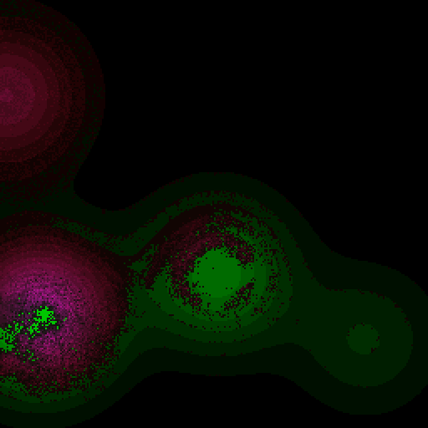

Figure 2. Snapshot of a simulation in the ‘bubbly’ landscape (high spatial correlation *β = 25.0*, moderate temporal correlation γ = 5.0, low peak carrying capacity A = 7), during colonization phase (patch in the center of the plot is expanding, patch on the left is in its peak size). Green areas are uninhabited (intensity of green represents carrying capacity), purple pixels are inhabited cells (intensity represents population size).

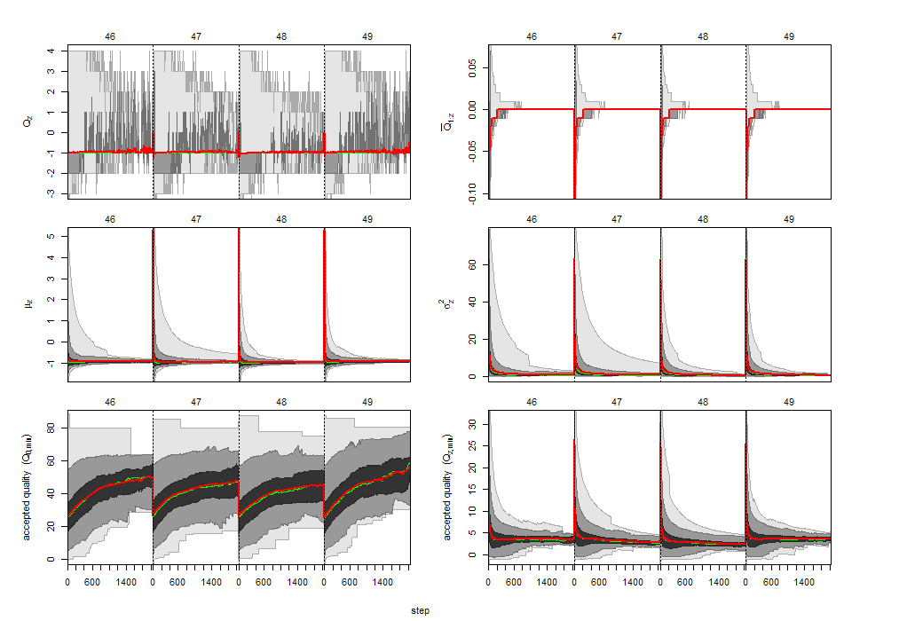

Figure 3. Example of (stepwise) distribution of the traits of moving individuals during 4 generations. Red line – mean, Green line median, shading shows 50%, 95% and 100% coverage. Panels show: quality of patch at step *z*(*Qz*), mean quality up to step *z*(${\overline{Q}}_{1:z}$), mean and variance at step *z*(*μz*, *σz2*), prior accepted quality (*Qmin,0*), posterior accepted quality at step *z*(*Qmin,z*). Note that the distribution does not include individuals who have settled already (this explains why distribution of *Qmin,0* changes during movement). [In these simulations max. allowed number of steps was 2000 (rather than 100 as previously)]

fig x. patch dynamics (low-high , spatial-temporal)

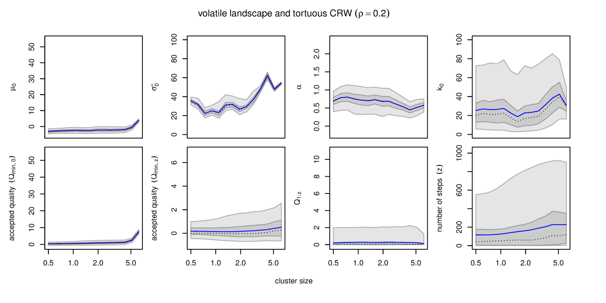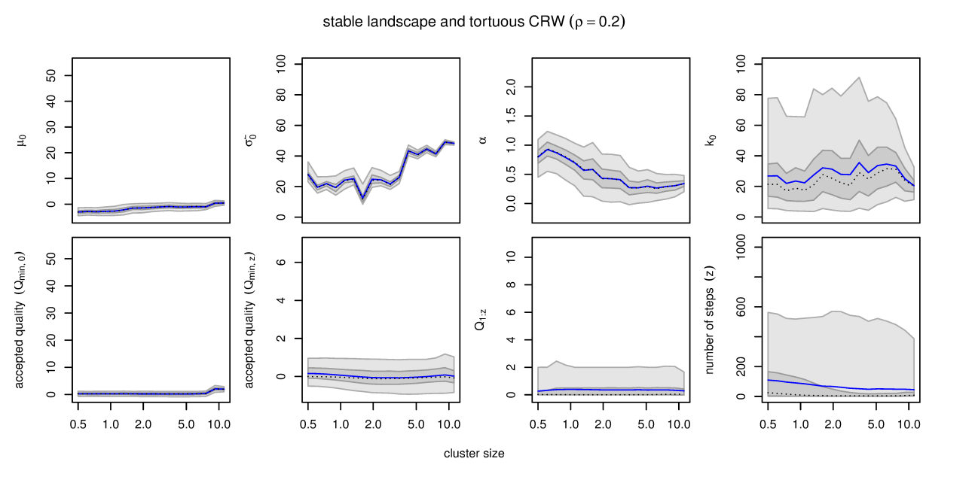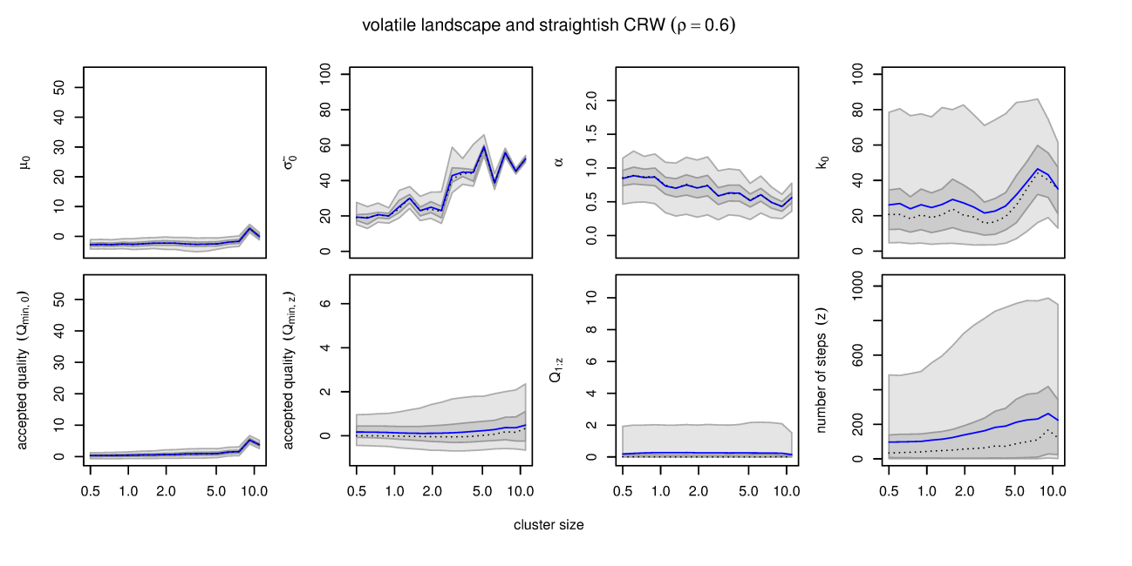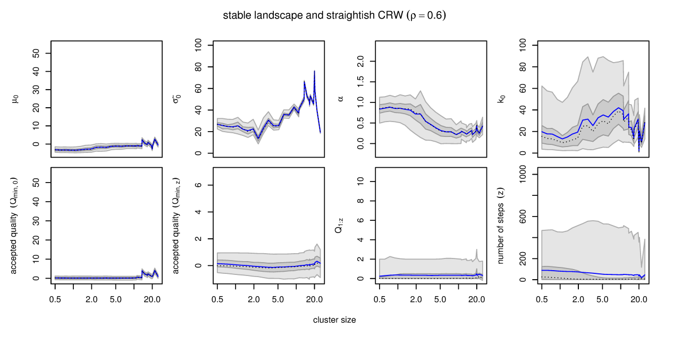

Figure 4. Values evolved in ‘bubbly’ landscapes in a range of spatial autocorrelation (cluster size, β) in the four scenarios (see Methods for details). Population mean is represented by blue line, median by black dashed line, shaded areas represent 50% and 95% intervals. Per-population statistics for each of the 29 cluster sizes are averaged over up to 25 replicates (less for larger β, at which not all populations survived).

# References

1. McNamara JM & Dall SRX (2010) Information is a fitness enhancing resource. *Oikos* 119(2):231-236.

2. Dall SRX, Giraldeau LA, Olsson O, McNamara JM, & Stephens DW (2005) Information and its use by animals in evolutionary ecology. *Trends Ecol Evol* 20(4):187-193.

3. Clobert J, Le Galliard JF, Cote J, Meylan S, & Massot M (2009) Informed dispersal, heterogeneity in animal dispersal syndromes and the dynamics of spatially structured populations. *Ecol Lett* 12(3):197-209.

4. Bowler DE & Benton TG (2005) Causes and consequences of animal dispersal strategies: relating individual behaviour to spatial dynamics. *Biol Rev* 80(2):205-225.

5. Schjorring S (2002) The evolution of informed natal dispersal: Inherent versus acquired information. *Evol Ecol Res* 4(2):227-238.

6. Enfjall K & Leimar O (2009) The evolution of dispersal - the importance of information about population density and habitat characteristics. *Oikos* 118(2):291-299.

7. Delgado MM, Barton K, Bonte D, & Travis JMJ (in press) Prospecting and dispersal: their eco-evolutionary dynamics and implications for population patterns *Proc R Soc Lond B*.

8. Chaine AS, Legendre S, & Clobert J (2013) The co-evolution of multiply-informed dispersal: information transfer across landscapes from neighbors and immigrants. *PeerJ* 1:e44.

9. Mcnamara JM & Houston AI (1987) Memory and the Efficient Use of Information. *J Theor Biol* 125(4):385-395.

10. McNamara JM, Green RF, & Olsson O (2006) Bayes' theorem and its applications in animal behaviour. *Oikos* 112(2):243-251.

11. Schmidt KA, Dall SRX, & van Gils JA (2010) The ecology of information: an overview on the ecological significance of making informed decisions. *Oikos* 119(2):304-316.

12. Luttbeg B (2002) Assessing the robustness and optimality of alternative decision rules with varying assumptions. *Anim Behav* 63:805-814.

13. Valone TJ (2006) Are animals capable of Bayesian updating? An empirical review. *Oikos* 112(2):252-259.

14. Reed JM, Boulinier, T.,Danchin, E.&Oring, L. W.(1999) Informed dispersal: prospecting by birds for breeding sites. *Current Ornithology* 15:189–259.

15. Mcnamara J & Houston A (1980) The Application of Statistical Decision-Theory to Animal Behavior. *J Theor Biol* 85(4):673-690.