LEDs

# Specifications

* 3 of each color (red, green, blue) per room
* Uses constant current (270-300mA per diode)
* Red LEDs drop ~2.5V per
* Blue and green LEDs drop ~3.5V per

# Options (Series or Parallel)

## Series:

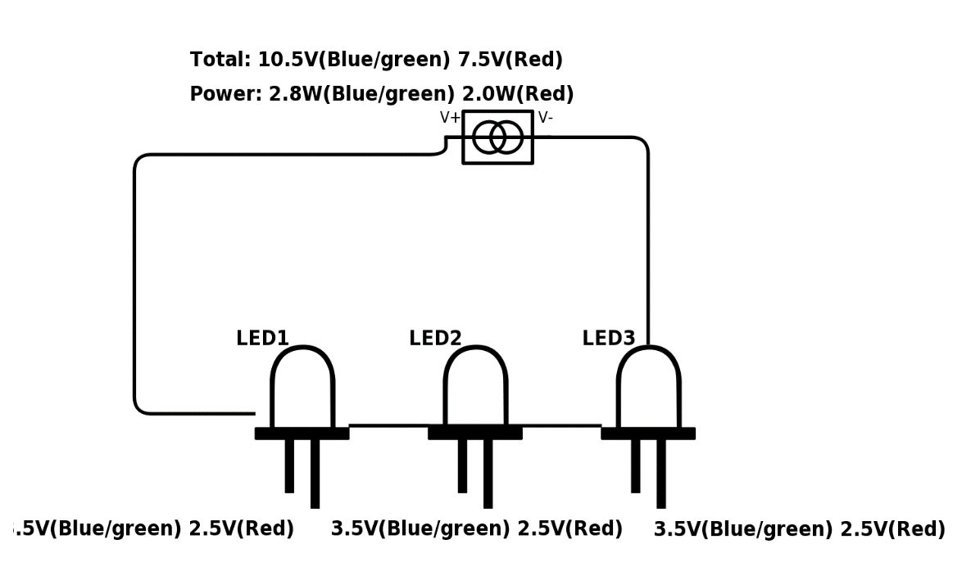

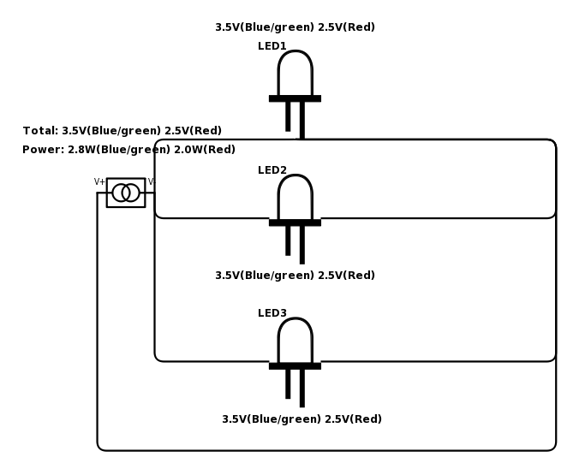

## Parallel: