Proof of Design

* **LightBar**
  + Lightbar designed similar to original *Tower of Lights* one

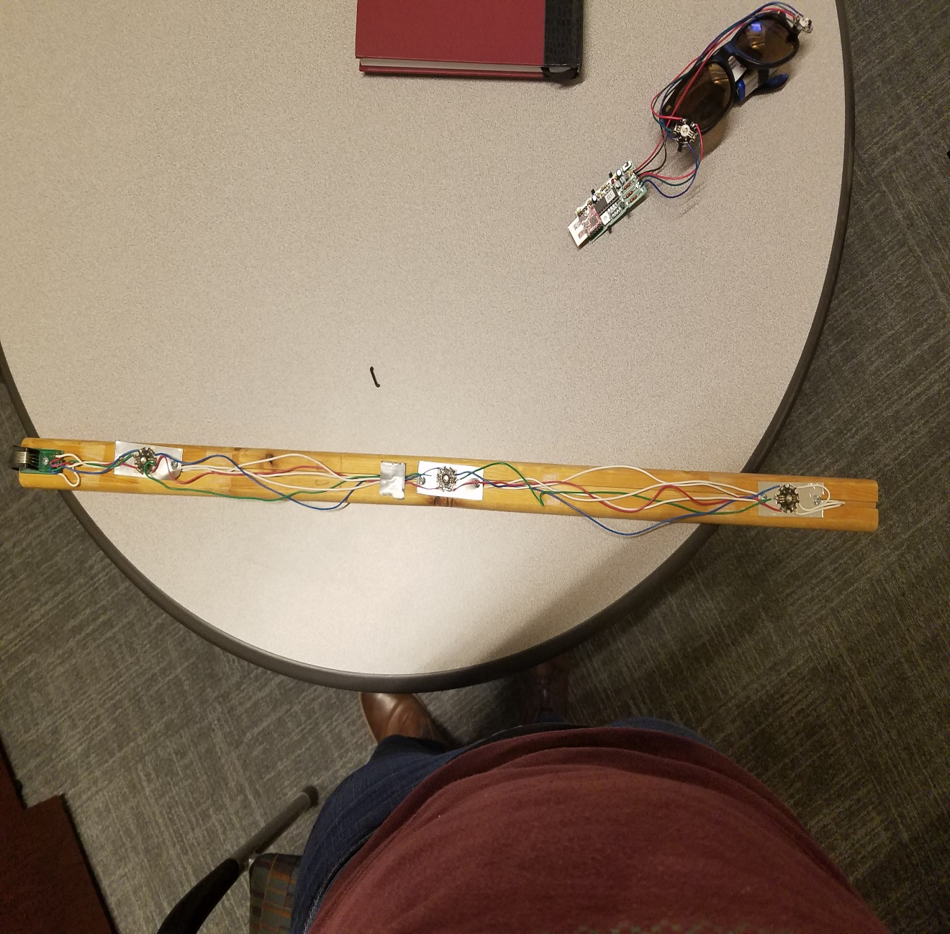

* 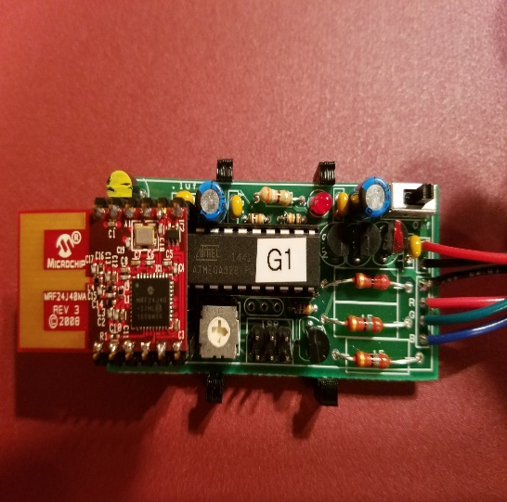**LED Driver Circuit**
  + Similar to *Goofy Glasses* circuit, similar schematic
* **Towerplayer program**
  + Modifed *towerarduino.ino*, *towerplayer.cpp*
* 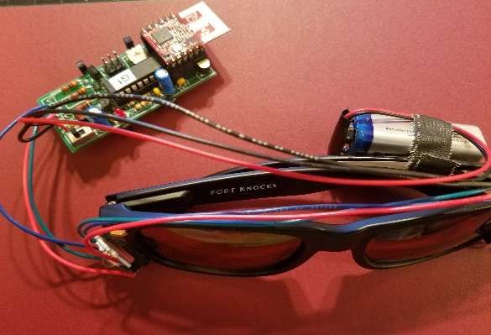**LED**
  + Functioning on *Goody Glasses* with 9V Battery